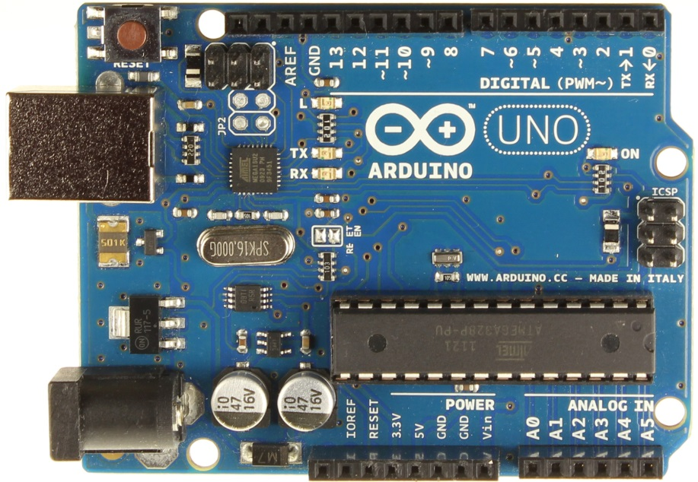
1602 LCD using i2c connection.
On a Uno A4 is SDA, A5 is SCL.
Connect 5V and GND to LCD
Push to make buttons pin 8 is Advance, pin 9 is Select.
A0, A1, A2 can be used to connect start lights. Don't forget correct resistor to drop from 5V.
KTIR0611S Photo Interrupter the connections are as follows:-
5V to pin 1 on 0611
GND to pin 2 on 0611
Pin 2/3 to pin 3 on 0611
GND to pin 4 on 0611

Ensure a 200Ohm resistor or greater is used otherwise to connect the 5V to the Photo Interrupter.

NOTE a resistor of 1000-2000Ohm may help the sensor detect non-black guides i.e. scaleauto, NSR etc.

Slingshot 2L Arduino Uno R3 Wiring Diagram

This diagram provides a suggested wiring diagram for track sensors, buttons and LCD display for a single or 2 lane standalone lap counter and timer.

The diagram suggests the use of slotted optical sensors for the car sensor since they are relatively easy to install in both wooden tracks and commercially produced plastic track, they are relatively cheap and they are hidden so no problem with accidently knocking a light bridge. There is no reason that other sensors won't work just as well, so traditional optical transistors and light bridge may be used, dead strips (will require isolating from track power) or reed sensors may be used.

Once connected, the Arduino must have a sketch uploaded to from a PC ia the USB cable, if you are new to the Arduino platform then it may be useful to take a look at the introduction on the Arduino site http://arduino.cc/en/Guide/Windows.

The sketch requires a couple of extra third party libraries bounce2 and LiquidCrystal_I2C copied into the libraries subfolder of the Arduino software installation. The libraries are available at the web site provided below, or can be found on the arduino.cc site.

The LCD display has an adjustable contrast control pot on the reverse, often the board is supplied with this control turned completely off, if when connecting the display no text appears first check that this adjuster has been turned up to an appropriate value.

If at a later stage you wish to use a computer to record and display lap times, simply uploading the Arduino sketch provided with Race Coordinator will disable the LCD display and then Race Coordinator can be configured to use the sensors on pins 2 and 3.

More information, the Arduino sketch and third party libraries for this project can be found at www.slngshotx.wix.com/slingshot-racing.

