This is a **dektop application** which is designed by using **Java NetBeans.** This applicationcan be opened and used by compiling the “**Homework3**” project with **NetBeans IDE.** You can find the project in the zip file.

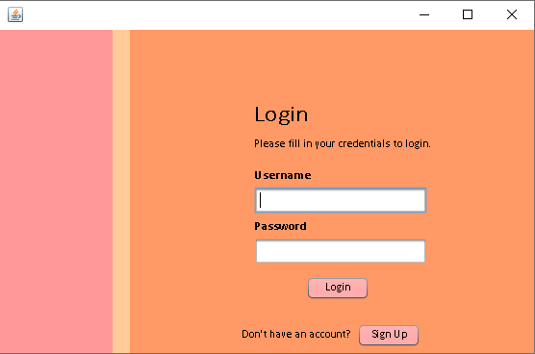

This is the Login Page of our application, if the users already have an account, they can easily log in by entering their username and password. If they don’t have an account, they should create one by clicking the Sign Up button in this screen.

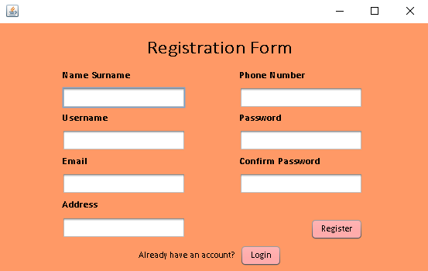

This is the Sign Up Page that expects some detailed information from user to write it to database. In this page, if the username they write is already taken, system is giving an error message which says “This username is already taken”. If user left one or more spaces empty, the system is giving an error again. If everyting is fine, users will receive a message says “Your account is created!”, then they can press the button Login and go back to Login Page.

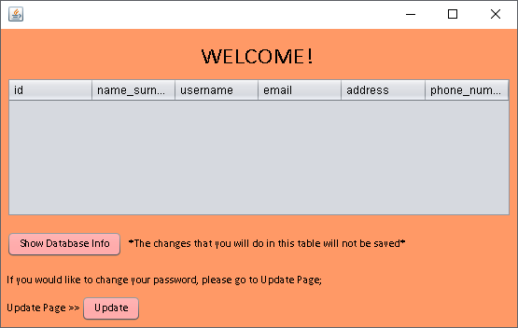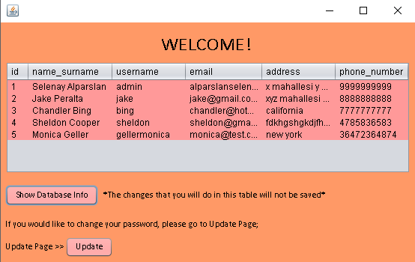

If the users are authenticated, they will be able to go to Home Page, which includes a table of database. If the users want, they can see the database and all of the users. **(Passwords will not be displayed)**

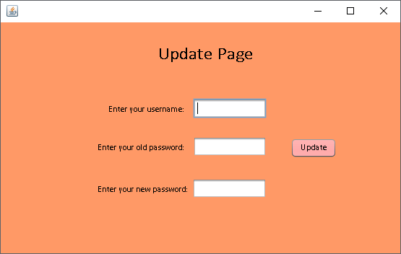

This is the Update Page which can be accessed from Home Page. **Here, users will enter their username and password to change their password. If either username or old password is wrong, the system will give an error and will not change the password.** So, both username and password should be true to do an update on database.

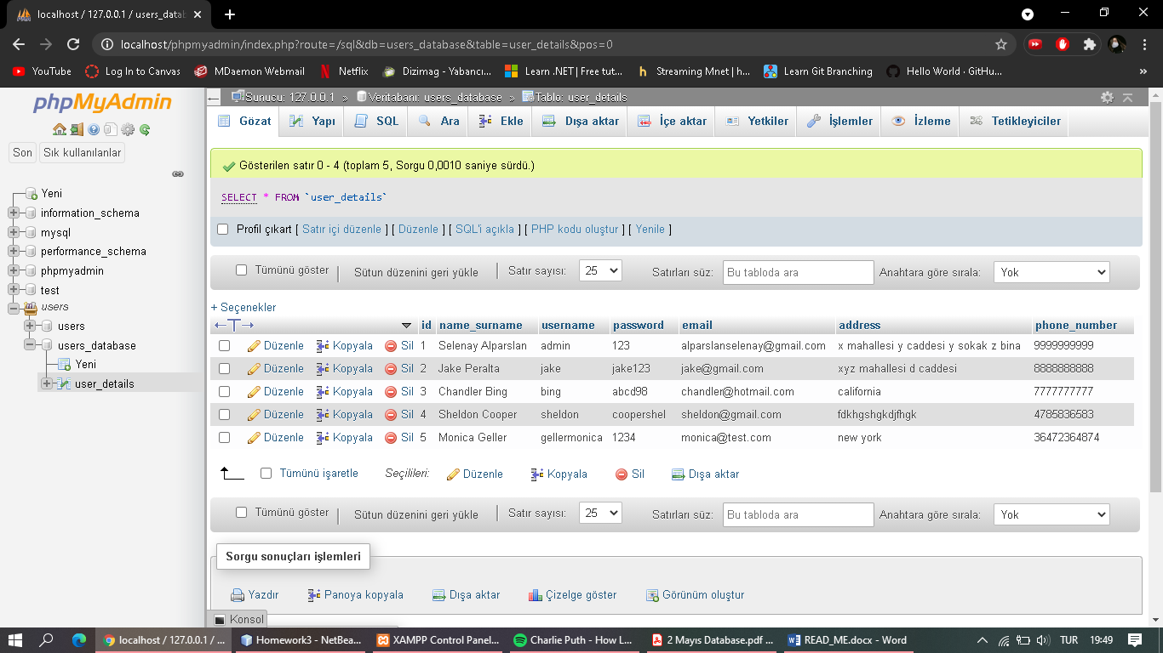

This is how our database looks like. We have **id, name_surname, username, password, email, address and phone_number** columns. We have only one database named **“users_database”** and only one table which is called **“user_details”** and every operation in this application is handled by using this table and database.

**Mark:** In this project, while fetching data from database, PreparedStatements are used to prevent SQL injection attacks.