SQL Server Configuration Manager : Cannot connect to WMI provider – Invalid class [0x80041010]
Following error dialog pops up today, when I tried connecting to SQL Server Configuration Manager on my SQL Server 2008 production server:
Cannot connect to WMI provider. You do not have permission or the server is unreachable. Note that you can only manage SQL Server 2005 and later servers with SQL Server Configuration Manager. Invalid class [0x80041010]

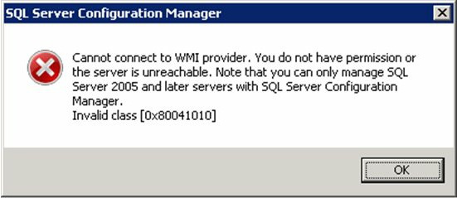
This error appears to happen when .mof files (Managed Object Format (MOF)) don’t get installed and registered correctly during set-up. To resolve this issue, I executed the following mofcomp command in command prompt to re-register the *.mof files:

mofcomp.exe "C:\Program Files (x86)\Microsoft SQL Server\100\Shared\sqlmgmproviderxpsp2up.mof"

Note: mofcomp.exe is responsible for registering and storing the data associated with .mof files
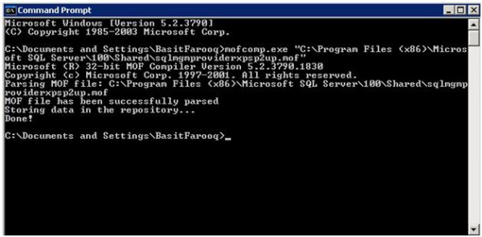
This error disappeared after the MOF file has been successfully parsed and I can now access SQL Server Configuration Manager without any problem ;0).
Sometimes issues mofcomp.exe against CMD goes wrong returning this message:
“‘mofcomp’ is not recognized as an internal or external command
Workaround:
Open CMD as Administrator, and follow the steps above:
1) cd c:\windows\system32\wbem
2) mofcomp “C:\Program Files (x86)\Microsoft SQL Server\100\Shared\sqlmgmproviderxpsp2up.mof”.
The number 100 can be 90 or 110 (if SSCM Shared Tools come from 2012)
…………………………………………………………………………………………………………………………………………………..

