Krystyna | Skarbek | Intelligence | EditDetailsDelete
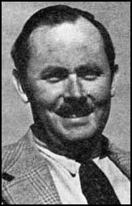 | Andrzej | Kowerski | Andrzej Kowerski was born in Poland in 1912. His father Stanislas Kowerski, was one of the country's largest landowners. He served in Poland's only mechanized brigade during the early weeks of the Second World War. While fighting against the German Army Kowerski was awarded Poland's highest award for bravery, Virtute Militari. Kowerski (who now took the name of Andrew Kennedy) and Christine both joined the Special Operations Executive (SOE). Kowerski was the SOE's first one-legged parachutist when he was dropped in Italy to help with the training of Poles. | EditDetailsDelete
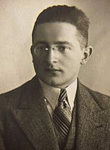 | Marian | Rejewski | (16 August 1905Bromberg, German Empire – 13 February 1980,Warsaw, People's Republic of Poland) was a Polish mathematician and cryptologist who reconstructed the Nazi German military Enigma cipher machine sight-unseen in 1932. The cryptologic achievements of Rejewski and colleagues Jerzy Rózycki and Henryk Zygalski enabled the British to begin reading German Enigma-encrypted messages at the start of World War II, seven years after Rejewski's original reconstruction of the machine. The intelligence that was gained by the British from Enigma decrypts formed part of what was code-named Ultra and contributed—perhaps decisively—to the defeat of Germany. | EditDetailsDelete
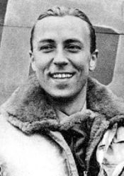 | Zdzislaw | Henneberg | Zdzislaw Henneberg(11 May 1911, Warsaw, Poland-12 April 1941, English Channel) was a Polish airman who flew with the Royal Air Force during the Battle of Britain and a flying ace of the Second World War. On 15 September 1940 (later known as Battle of Britain Day), Henneberg was attacked by a number of Bf 109s. He defended himself and destroyed one Do 17. Henneberg temporarily took command of No. 303 Squadron RAF from Witold Urbanowicz on 21 September 1940. In a ceremony on 15 December he was awarded a DFC for bravery and claiming 8 victories in the Battle of Britain by the Air Officer Commanding Fighter Command Air Chief Marshal Sholto Douglas. | EditDetailsDelete
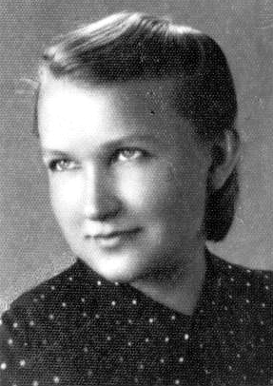 | Elzbieta | Zawadzka | Elzbieta Zawadzka ( 19 March 1909 Thorn – 10 January 2009 Thorn) known also by her war-time nom de guerre Zo, was a Polish university professor, scouting instructor, SOE agent and a freedom fighter during World War II. She was also a Brigadier General of the Polish Army (the second and last woman in the history of the Polish Army to hold this rank). She was also a deputy of Zagroda — the Department of Foreign Communication of the Home Army. In February 1943 she traveled across Germany, France and Spain to Gibraltar, where she was transported by air to London. In Great Britain she went through parachute training, and on 10 September 1943, dropped into Poland, as the only woman in the history of the Cichociemni. | EditDetailsDelete
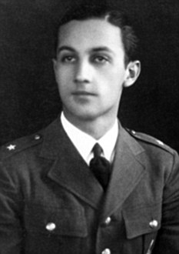 | Tadeusz_Wladyslaw | Sawicz | Tadeusz Wladyslaw Sawicz (13 February 1914 – 19 October 2011) was a Polish World War II fighter pilot. He served in the Polish Air Force, and after the fall of Poland, he served in the Polish and allied units in France and United Kingdom. He participated in the Battle of Britain and was ranked as the 82nd highest scoring Polish fighter pilot of the war. As well as receiving Poland's highest military decoration, the Virtuti Militari, he was awarded a British Distinguished Flying Cross, an American Distinguished Flying Cross and the Dutch equivalent, the Airman's Cross or Vliegerkruis. In 2006 Sawicz was appointed honorary brigadier-general in the Polish Air Force. After the war he emigrated to Canada. At his death he was believed to have been the last surviving Polish pilot to have fought in the Battle of Britain. | EditDetailsDelete
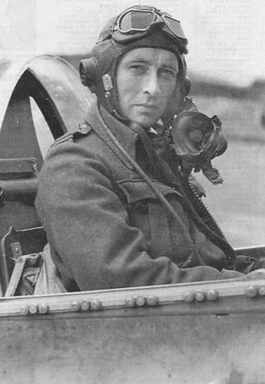 | Stanislaw | Skalski | Stanislaw Skalski (27 November 1915 – 12 November 2004) was the top Polish fighter ace of the war and the first Allied fighter ace of the war, credited, according to official lists, with 18 11/12 victories and two probable. In late October 1940. During the Battle of Britain, he was credited with four planes shot down and one shared. On 29 April 1942 Flight Lieutenant Skalski was made Commanding Officer of the 317 (Polish) Squadron. In October 1942 he was given command of the Polish Fighting Team (PFT), or so called "Cyrk Skalskiego" (Skalski's Circus) - a Special Flight consisting of fifteen experienced Polish fighter pilot volunteers. Skalski then became commander of 601 (County of London) Squadron the first Pole to command an RAF Squadron. | EditDetailsDelete
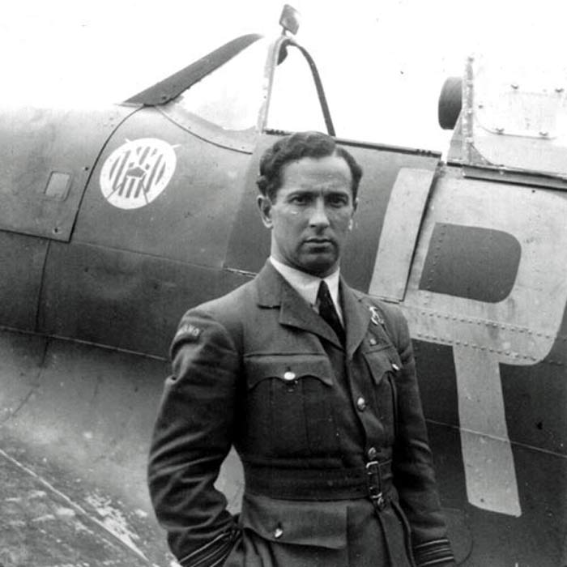 | Zdzislaw | Krasnodebski | Zdzislaw Krasnodebski alias King (10 July 1904 in Wola Osowinska – 3 July 1980 in Toronto) was a pilot, founder and commander of Squadron 303. he earned a reputation from both his peers and superiors as a good pilot and officer. His masterful piloting skills helped him to gain respect and admiration. No. 303 Squadron had claimed 126 kills during the Battle of Britain – the most successful record for a RAF Squadron in this period. | EditDetailsDelete
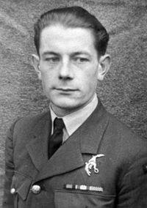 | Aleksander | Chudek | Aleksander Chudek (17 August 1914 – 23 June 1944) was a Polish fighter ace of the Polish Air Force in World War II. After the Soviet invasion of Poland on 27 June 1940, arrived in the United Kingdom. He has been assigned to an auxiliary unit of the RAF as a pilot distributing new or refurbished aircraft at airports across the UK. In July he was assigned to No. 315 Polish Fighter Squadron where he flew Spitfires. In July 1943 he was posted in No. 303 Polish Fighter Squadron. On 23 June 1944 he flew over Normandy and never came back. Initially it was thought that his plane fell into the sea, but in 2009 it was found that the plane crashed between the towns of Le Plessis-Grimoult and Roucamps. Awards: Virtuti Militari; Cross of Valour; Distinguished Flying Medal (UK) | EditDetailsDelete
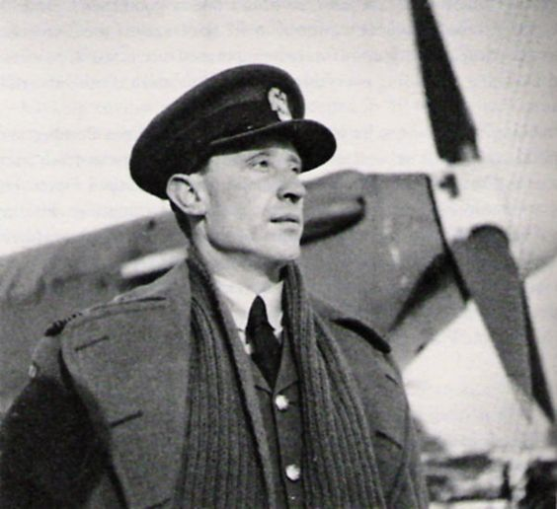 | Witold | Urbanowicz | Witold Urbanowicz (30 March 1908 Olszanka, Augustow County,Poland - 17 August 1996 New York City, United States) was a Polish fighter ace of the Second World War. According to the official record, Witold Urbanowicz was the second highest-scoring Polish fighter ace, with 17 confirmed wartime kills and 1 probable, not counting his pre-war victory. He was awarded with several decorations, among others the Virtuti Militari and British Distinguished Flying Cross. A fibreglass Hawker Hurricane gate guardian was unveiled at RAF Uxbridge in September 2010 in the colours of Urbanowicz's aircraft from the Battle of Britain. | EditDetailsDelete
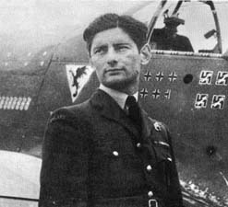 | Eugeniusz | Horbaczewski | Eugeniusz Horbaczewski (28 September 1917 Kiev – 18 August 1944) was a Polish fighter pilot, a flying ace of World War II, also known as "Dziubek". According to official lists, Horbaczewski was the third highest scoring Polish fighter ace. He was awarded several decorations, among others Virtuti Militari IV class (posthumously) and V class, four times Polish Cross of Valour, Distinguished Service Order (posthumously) and Distinguished Flying Cross (twice). Circumstances about his death are not clear. Horbaczewski went missing during the dogfight. In 1947 the wreck of his Mustang with his body was found crashed near Velennes (Oise). | EditDetailsDelete
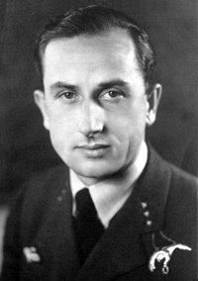 | Edward | Jaworski | Edward Jaworski (18,May 1920 in Trzebinia - 26,September, 2012 in Zielona Góra ) - Lieutenant Colonel of the People's Army of Poland. He flew Hurricanes and Spitfires with 605 Squadron and 315(Polish) Squadron. In August 1944 he was posted to 302 Squadron and than became tactical officer with 131 Fighter Wing. By wars end he had flown 200 sorties one of the highest amounts for a Polish airman in WW2. Orders and decorations: Silver Cross of the Virtuti Militari Military Order,Cross of Valor (three times), Knight's Cross of the Order of Polonia Restituta, Officer's Cross of the Order of the Rebirth of Poland, Silver Cross of Merit, Medal for Sacrifice and Courage, Bronze Medal for Merit for National Defense, For participation in the 1939 defense war, Cross of the Battle of the Polish Armed Forces in the West, British Star 1939-1945 Star, British star Atlantic Star, British Distinguished Flying Cross, British Defense Medal, British War Medal 1939-1945. | EditDetailsDelete
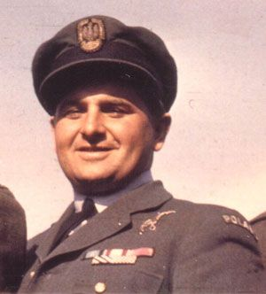 | Antoni(Tony) | Glowacki | Antoni Glowacki( Nicknames: Antek (Polish nicknames), Toni (RAF nickname) Born 10 February 1910 Warsaw,Poland - 27 April 1980 Wellington, New Zealand) was a Polish Second World War fighter pilot flying with Polish Squadrons attached to the RAF, who is notable for shooting down five German aircraft on 24 August 1940 during the Battle of Britain, becoming one of only three pilots who gained "ace-in-a-day" status during that battle. The term "ace in a day" is used to designate a pilot who has shot down five or more airplanes in a single day. | EditDetailsDelete
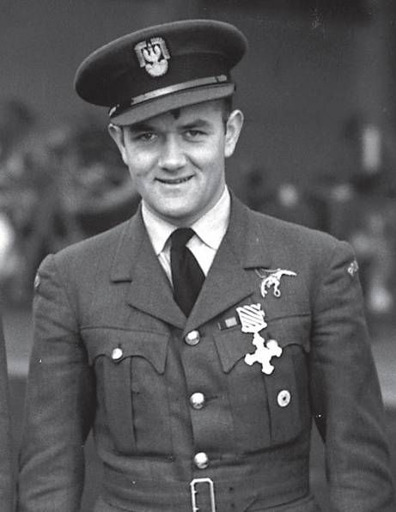 | Jan | Zumbach | Jan Eugeniusz Ludwig Zumbach (14 April 1915, Ursynów, Congress Poland, Russian Empire – 3 January 1986, France) was a Polish fighter pilot who became an ace during the Second World War. During the Battle of Britain, Zumbach scored eight confirmed kills and one probable, mostly against Messerschmitt Bf 109 fighters. Zumbach was shot down by a JG 3 Bf 109 over Dover on 9 May 1941 when returning from a mission, but he was again able to bail out unharmed. Zumbach became one of the first Allied pilots to engage in combat with a German Focke-Wulf Fw 190, which he damaged. In May, he was promoted to Squadron Leader and took command of the squadron, a post Zumbach held from 19 May 1942 until 30 November 1943. Awards: Virtuti Militari, Polish Cross of Valour (4 awards), Distinguished Flying Cross & Bar. | EditDetailsDelete
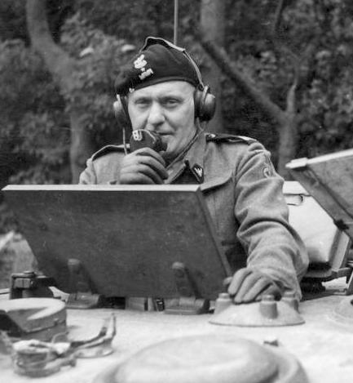 | Stanislaw | Maczek | Stanislaw Maczek (31 March 1892, Szczerzec near Lwow – 11 December 1994, Edinburgh, Scotland, UK) was a Polish tank commander of World War II. He was the commander of the famous 1st Polish Armoured Division, and later of the I Polish Army Corps under Allied Command in 1942–45. Maczek should be remembered for his pioneering use of mixed armour and infantry units as well as the early use of commando-style units during the Polish border wars of 1918-1920. He should be also be recognised as being the saviour of the Normandy Campaign, which by August 1944 was seriously bogged down. Initially, Baca’s tanks served in defence of the Scottish coast between Montrose and the Firth of Forth.Years after his death, in 2013 a campaign in Edinburgh to recognise Maczek’s vital contribution to the UK and Allied Forces. | EditDetailsDelete
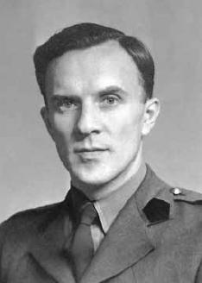 | Jozef | Kosacki | Józef Stanisław Kosacki (1909–1990) was a Polish professor engineer, inventor, and an officer in the Polish Army during World War II. He is best known as the inventor of the Polish mine detector, the first man-portable mine detector, whose basic design has been in use with various armies for over 50 years. It was to be used for the first time in action on Second Battle of El Alamein. Five hundred of these detectors were issued to Eighth Army. After the war he returned to Poland, where he became a pioneer of electronics and nuclear machinery. | EditDetailsDelete
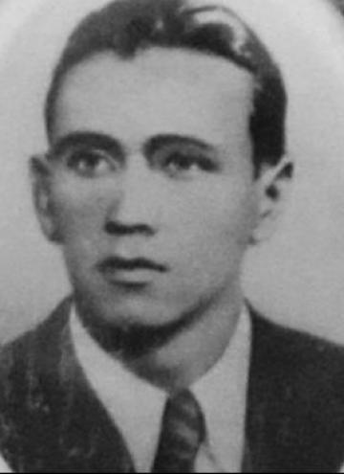 | Jerzy | Iwanow-Szajnowicz | (14 Dec 1911- 4 Jan 1943) Iwanow-Szajnowicz was fluent in Polish, Greek, French, and Russian, and also learned to speak excellent English and German. A world-class swimmer. His dual citizenship and his unusual set of skills, however, led to his recruitment by Polish military intelligence. He was then seconded to the British Special Operations Executive (SOE). Iwanow-Szajnowicz's fluency in Greek proved a valuable asset. After receiving training in spycraft, diversion, and sabotage, the young Pole was sent back to Greece in October 1941 as SOE Agent 033B. Until his capture and execution in 1943, Jerzy Iwanow-Szajnowicz was one of the most daring and effective British agents in Nazi-occupied Greece. According to British officials, this single agent was worth an entire division of soldiers. | EditDetailsDelete
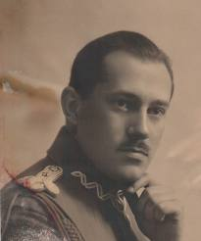 | Rudolf | Gundlach | Rudolf Gundlach (1894–1957) was a Polish engineer, inventor and tank designer. He headed the design division of the Armored Weapons Development Office (Biuro Badań Technicznych Broni Pancernych). He held the military rank of major in the Corps of Engineers of the Polish Army.He is famous for his invention of the Gundlach Rotary Periscope (Polish: Peryskop obrotowy Gundlacha), patented in 1936, which made possible 360° vision. It was first implemented in TKS and 7TP Polish tanks. As a part of Polish-British pre-war military cooperation.Even today, original Gundlach periscopes are used in some tanks and APCs. | EditDetailsDelete
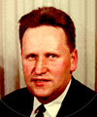 | Henryk | Magnuski | He received his degree from Warsaw University of Technology in 1934 and started working for the State Tele and Radiotechnical Works (Państwowe Zakłady Tele i Radiotechniczne) in Warsaw. In 1940 he started working for the Galvin Manufacturing Corporation in Chicago (the company changed the name in 1947 to Motorola). He is credited with three patents related to the design of Motorola's SCR-300 FM "Walkie-Talkie" radio, a hugely popular unit with American forces in Europe, and he received a U. S. Navy Certificate of Commendation for Outstanding Service for development of the AN/CPN-6 Radar Beacon, a microwave device which aided carrier pilots to find their ship during low visibility conditions. | EditDetailsDelete
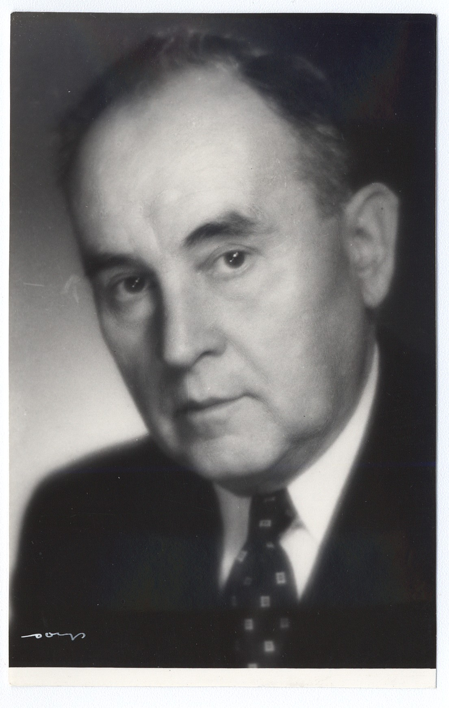 | Marceli | Struszynski | Marceli Struszyński (born January 16, 1880, in Winnica – September 1, 1959, in Warsaw) was a Polish chemist and Professor of Warsaw University of Technology from 1938-1939 and 1945-1959.His research was in analytical chemistry; he developed an original classification of anions. During the Second World War he worked with Polish resistance. He analyzed fuel for V-2 rockets during Operation Most III. He was the father of Wacław Struszyński. Waclaw escaped to England in the war, and made exceptional technical contributions to direction finding at sea which enabled the rapid location of U-boats when they made HF radio transmissions to Europe. | EditDetailsDelete
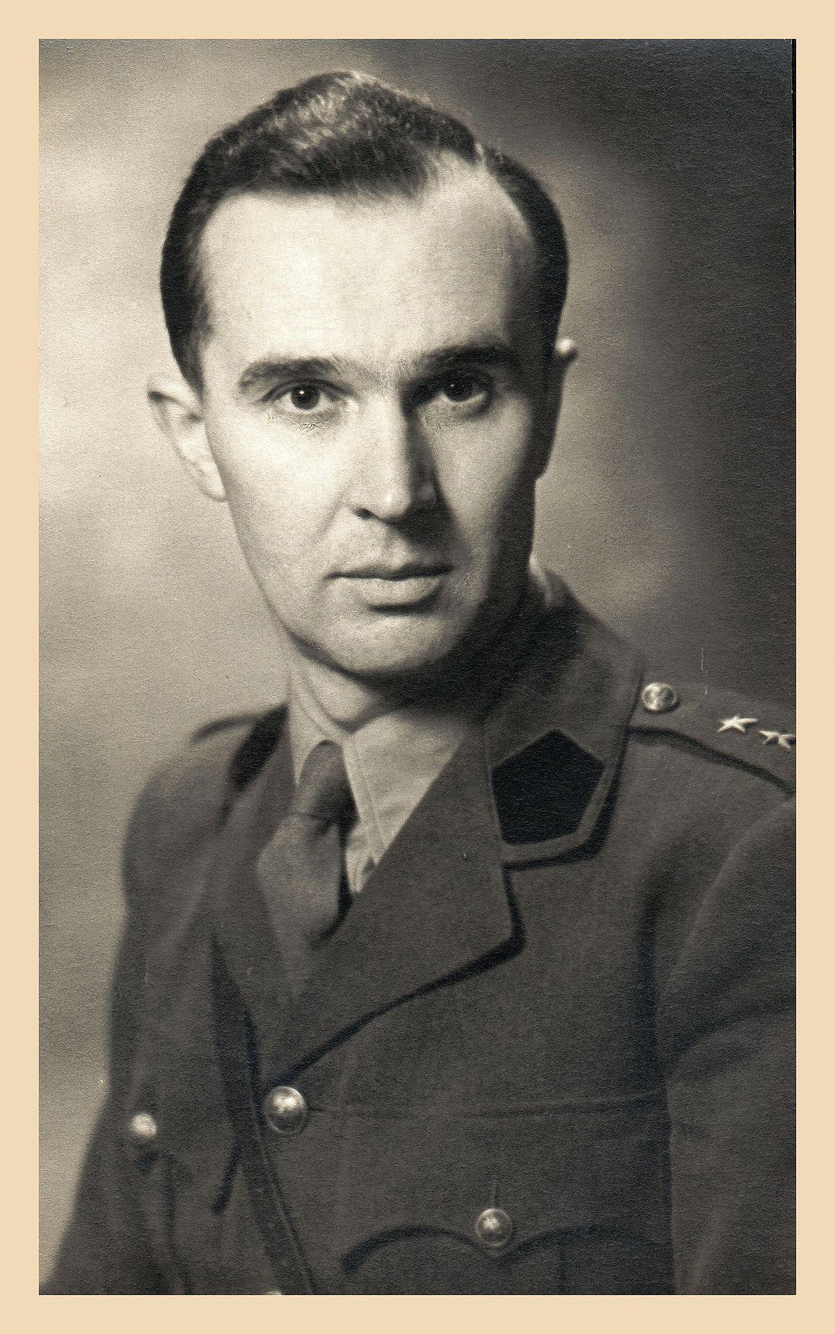 | Waclaw | Struszynski | Waclaw Struszynski (1905 - 1980) was a Polish electronic engineer. He worked at the British Admiralty Signal Establishment during World War II where he led a team of scientists in the development of a sophisticated high frequency radio direction finding system, also known as HF/DF (nick-named Huff-Duff). The team encountered initial engineering problems with the system due to the effects of the superstructure on the wave front of arriving radio signals but these problems were overcome with Struszynski;s technical leadership. Whenever the Germans transmitted a message, the Huff Duff was able to pick up on the bearing giving an approximate position of the enemy vessel. | EditDetailsDelete
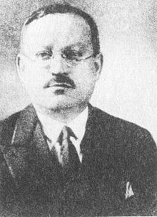 | Piotr | Wilniewczyc | Piotr Wilniewczyc (1887–1960) was a Polish engineer and arms designer. Among his most successful designs were the Vis-35 pistol, commonly known as the Radom for the arsenal in which it was produced, and the Mors submachine gun. The Vis was one of the best military pistols of the period. Production began in 1935 in Poland’s Fabryka Broni, at Radom and a year later it was introduced as the standard weapon for the Polish Army. By 1942 all other handguns were withdrawn from service. Before the Invasion of Poland, roughly 49,000 were delivered to the Polish Army (90,000 had been ordered). | EditDetailsDelete
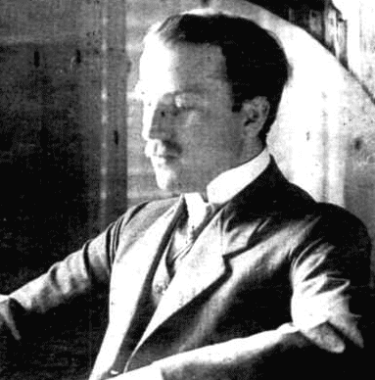 | Jan | Czochralski | Jan Czochralski (pronounced cho-HRAL-skee) was born October 23, 1885 Kcynia - died April 22, 1953 Poznań) He was a Polish chemist who invented the Czochralski process, which is used to grow single crystals and is used in the production of semiconductor wafers. During World War II he was one of a team of engineers involved in the development and construction of the R wz. 42 hand grenade, or Sidlowka, for the Home Army (Armia Krajowa). It was first produced in 1942 at the Warsaw University of Technology under his leadership.Its primer and the detonator were designed by two Polish engineers in Warsaw, pyrotechnician Władysław Pankowski and engineer Józef Michałowski | EditDetailsDelete
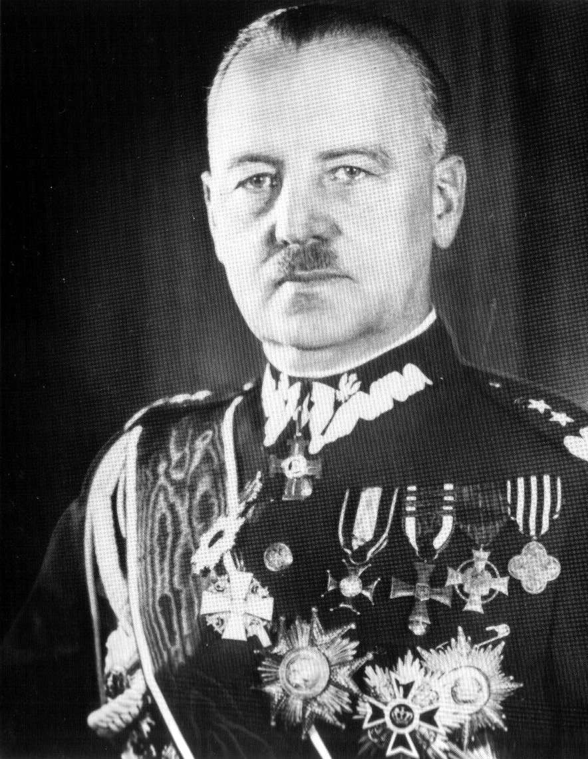 | Wladyslaw | Sikorski | Władysław Eugeniusz Sikorski (20 May 1881 – 4 July 1943) was a Polish military and political leader. On June 19, 1940 Prime Minister Sikorski met with Winston Churchill, and pledged to provide Polish forces to fight alongside those of Britain. By August, Sikorski and Churchill signed the Polish-British Military Agreement calling for the creation, and training of the Polish Armed Forces. Most renowned were the Polish pilots who fought in the Battle of Britain the summer of 1940, and whose pilots scored the highest ratio of kills. Most famous was the 303 squadron (the Kosciuszko squadron). | EditDetailsDelete
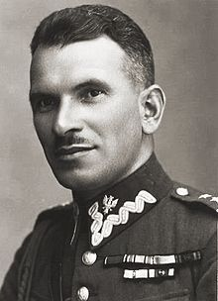 | Stanislaw | Sosabowski | Stanisław Franciszek Sosabowski (8 May 1892 – 25 September 1967) was a Polish general in World War II. He fought in the Battle of Arnhem (Netherlands) in 1944 as commander of the Polish 1st Independent Parachute Brigade. Upon his arrival in London, Sosabowski turned up at the Polish General Staff and was assigned to 4th Rifles Brigade that was to become a core of the future 4th Infantry Division.Their objective was to assist in the national uprising in Poland and were planning to be the first wave of the troops from the Polish army-in-exile to reach the fatherland. | EditDetailsDelete
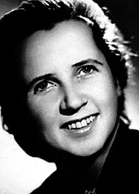 | Halina | Szymanska | Halina Szymańska (1906–1989) was a Polish spy, working for the British government, known as the Allies conduit to Nazi German Admiral Wilhelm Canaris. Szymańska, as a British agent, met several times with Canaris in Switzerland and Italy. Then she met with his courier, Hans Bernd Gisevius. Szymańska played an important role, as an intermediary, in secret contacts between the Allies and German anti-Nazi conspirators (e.g., the Schwarze Kapelle). In April 1940 she received information about the coming German attack on France and the Benelux countries. In mid-June 1941 Szymańska received information about the coming German attack on the Soviet Union. During World War II she became one of the most effective MI6 agents. | EditDetailsDelete
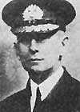 | Jerzy | Swirski | Jerzy Włodzimierz Świrski (5 April 1882, Kalisz – 12 June 1959, London) was a Polish vice admiral and officer in the Russian Imperial Navy and later the Polish Navy. As Chief of the Polish Naval Command (1925-1947), he was a member of an elite group of high ranking Polish naval officers from foreign navies who became founder members of the re-established naval forces of the newly independent Poland after World War I. During World War II, Polish naval forces under his command, were embedded with the Royal Navy and contributed significantly to the success of Britain's maritime war effort. He was awarded the Order of the Bath. | EditDetailsDelete
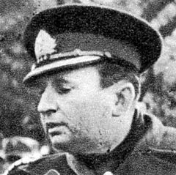 | Wlodimierz | Steyer | At that post Steyer served during the German Invasion of 1939, successfully defending the area between September 1 and October 2, 1939. The units under his command were among the last ones to capitulate in 1939. Taken prisoner of war by Nazi Germany, Steyer spent the rest of the war in various prisoner-of-war camps | EditDetailsDelete
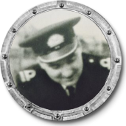 | Kazimierz | Sadowski | Sub-Lieutenant Kazimierz Sądowski. On 24th August 1939, in anticipation of a German invasion, Polish Navy submarine ORP Zbik was mobilized. Sub-Lieutenant Sądowski was assigned as Torpedo Officer and the Captain was Komandor ppor. Michael Zebrowski. ORP Zbik took 6 torpedoes (plus 4 extra), 22 mines and 114 shells for 100 mm gun. On 1st September 1939 when war broke out, according to “Operation Worek”, Zbik was patrolling the area to North-East of Jastamia. The defence of the Polish coast remains one of the epics of the war. Oksywie, Hel and Westerplatte will stand for all time in gold among the battle honours of the Polish Navy. | EditDetailsDelete
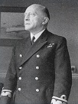 | Karol | Korytowski | Karol Walerian Franciszek (January 28th, 1892 Krakow, Austro-Hungarian Empire - October 11th, 1966 United Kingdom, London). June 1940 he directed the evacuation of the Polish Forces to the British Isles. On 11 October 1939, he was nominated to vice Chief of Directorate of the Polish Navy [or the Polish Navy Command – another translation]-(KMW-Kierownictwo Marynarki Wojennej) in France. In 1945 , Korytowski became a rear-admiral (kontradmiral) and the second vice Chief of the Directorate of the Polish Navy (KMW). , recently released from the labour camp in Germany. After the war, he became Chief of the Naval Section of the Polish Resettlement Corps and later a director of the Polish Naval Association in London. | EditDetailsDelete
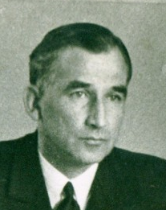 | Stanislaw | Nahorski | Stanislaw Nahorski(1897-09-24, Soviet Union, St Petersburg - 1969-11-12, United Kingdom, London).From 1939 - October 1942 Nahorski was a destroyer Commander. In October 1942 he was promoted to full Captain rank and to command the Polish Naval HQ, South, at Devonport, Plymouth. Nahorski escaped to G.B. on the 30th August 1939 as Commander of ORP Burza. In February 1940 Nahorski took command of ORP Błyskawica, taking part in the Narvik Campaign of April-May 1940 and also the evacuations from Dunkirk in June 1940. For his participation in these campaigns Nahorski was awarded the British DSO and also the Virtuti Militari for bravery. He held various shore postings in Plymouth until becoming Captain in 1942 and commander of Polish Naval HQ, South. | EditDetailsDelete
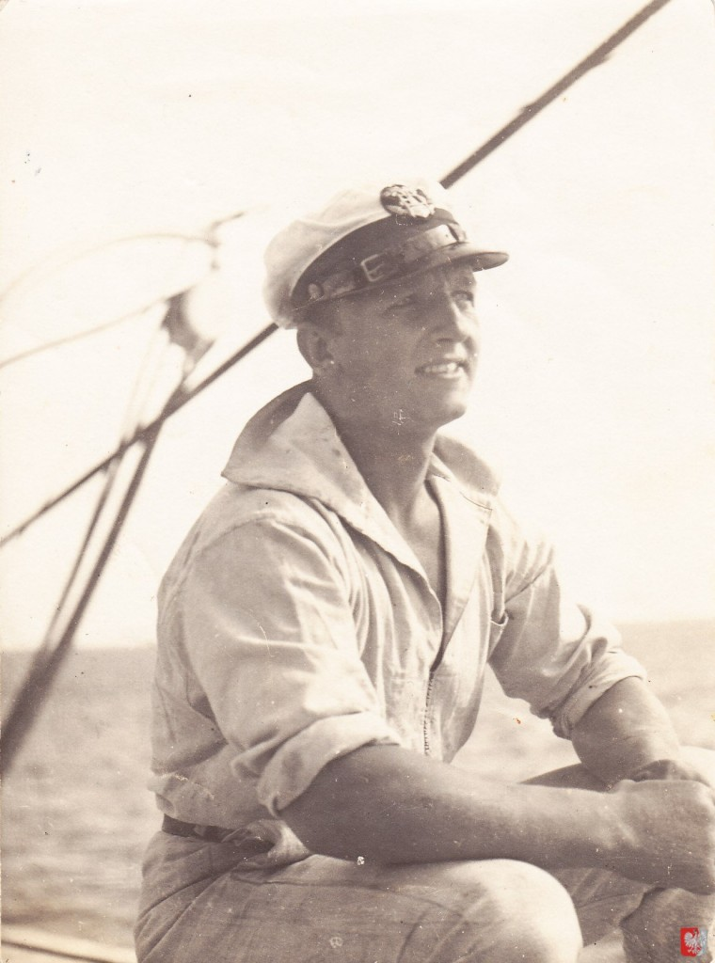 | Jozef | Dabkowski | Jozef Dabkowski (1908-01-11, Poland,,Warsaw - 1999, Australia, Geelong) At the outbreak of war Jozef and his ship were in the South Atlantic and promptly put into a neutral port - Pernambuco in Brazil. A month later the ship sailed for UK to become one of the 36 Polish vessels operating under the British Ministry of War Transport handling cargo, passengers and troop transportation. On Chrobry, a magnificent Polish passenger liner completed just before Germany invaded Poland, Jozef had a hand in transporting First and Second Canadian Division soldiers to Britain, under orders from the British Admiralty.

