Lab Report

ECPE 170 – Computer Systems and Networks – Fall 2021

Name: Sloan Kim

Lab Topic: Version Control (Lab #: 2)

Question #1:
Take a Screenshot (using the Ubuntu Screenshot tool) showing what the BitBucket source view looks like at this point.
Answer:
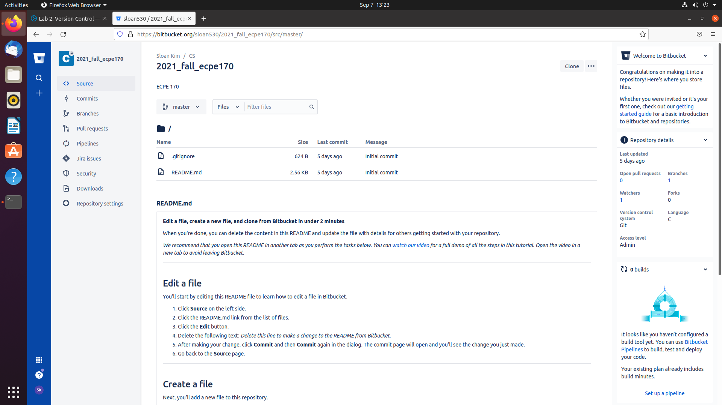
Question #2:
Take a Screenshot (using the Ubuntu Screenshot tool) showing what the BitBucket source view looks like at this point.
Answer:
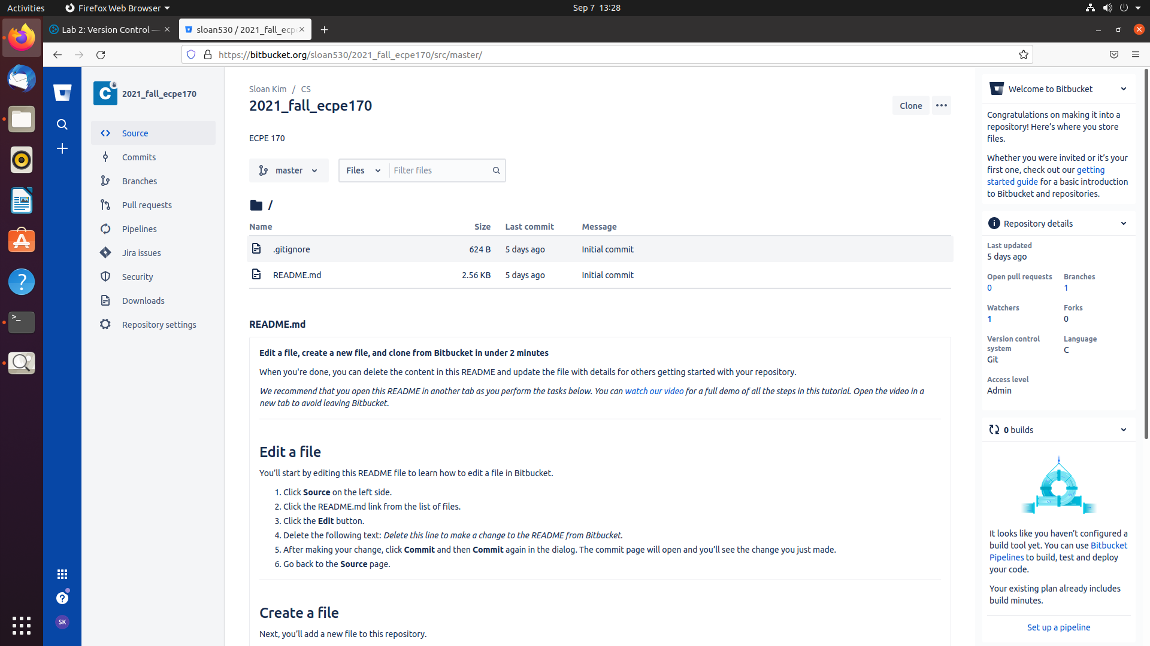
Question #3:
Take a Screenshot showing what the BitBucket source view looks like at this point.
Answer:
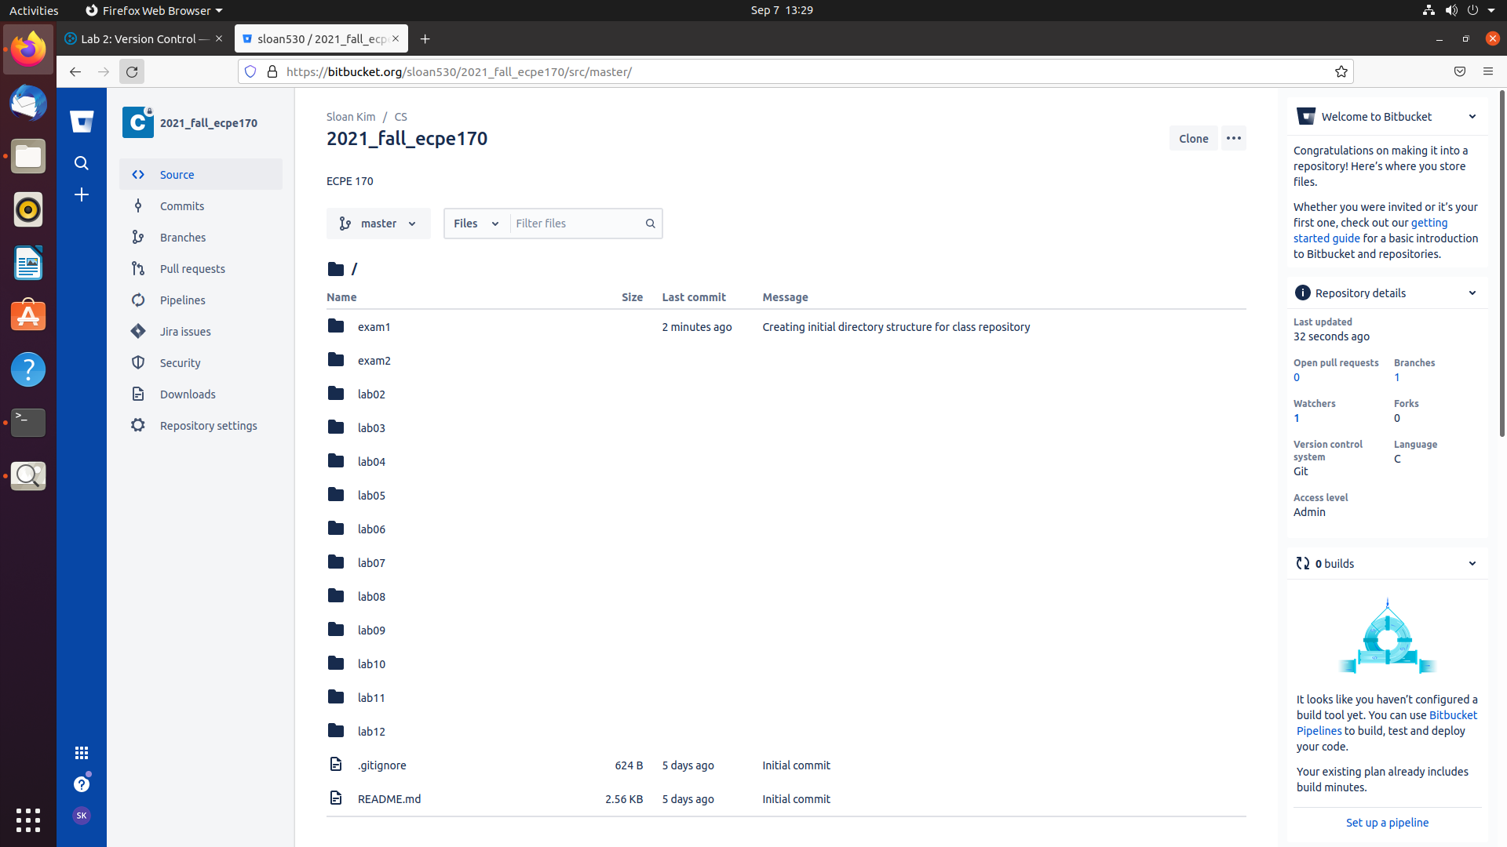
Question #4:
Take a Screenshot showing what the BitBucket version history looks like at this point (under the Commits tab)
Answer:
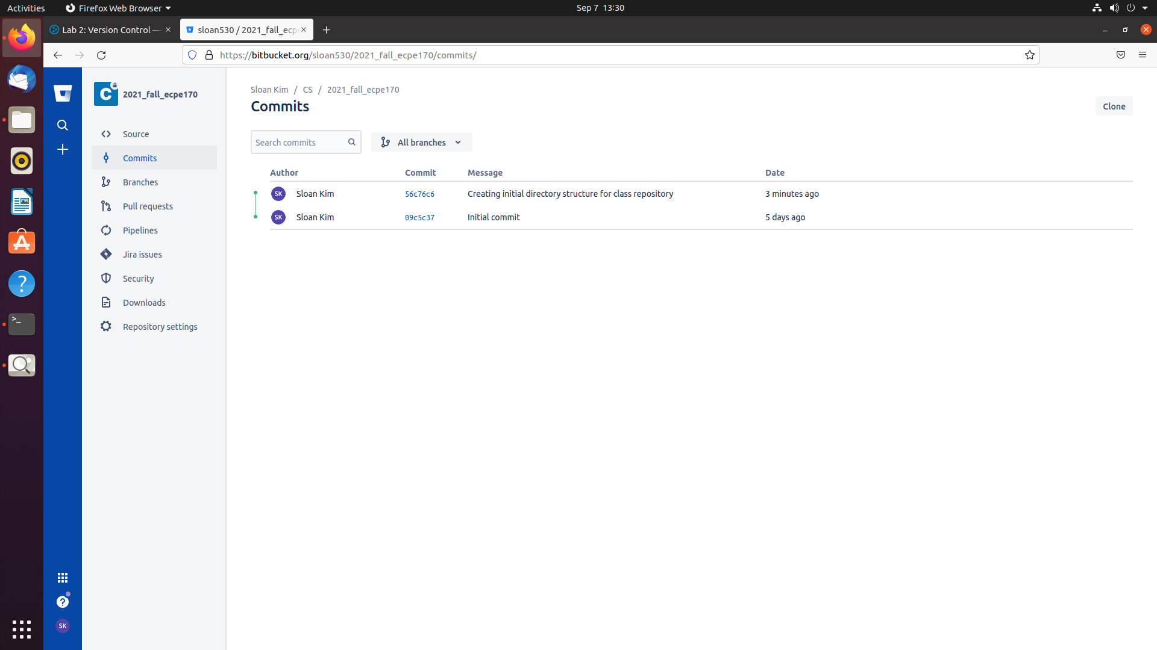
Question #5:
Take a Screenshot showing what the BitBucket version history looks like at this point (under the Commits tab)
Answer:
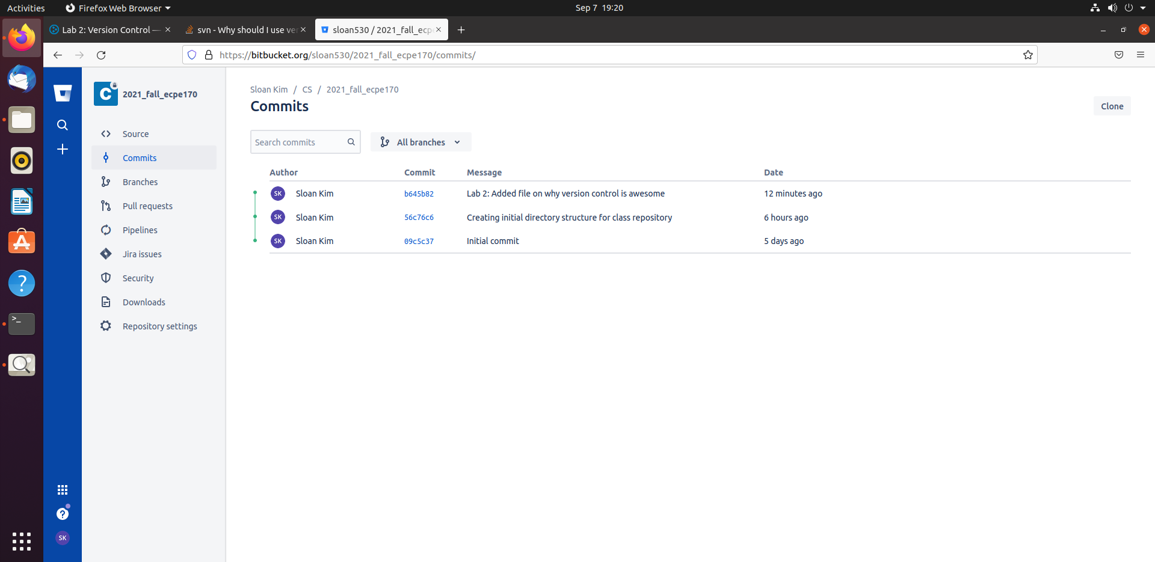
Question #6:
What does the line starting in --- represent?
Answer:
It assigns symbol - to diff input source which are changes from a/lab02/reasons_to_use_vcs.txt.
Question #7:
What does the line starting in +++ represent?
Answer:
It assigns symbol + to diff input source which are changes from b/lab02/reasons_to_use_vcs.txt.

Question #8:
What do the lines starting in + represent?
Answer:
The line after + is from b/lab02/reasons_to_use_vcs.txt.

Question #9:
Can you guess what a line starting in - would represent? (Depending on the edits you made, you might have a few of these lines too)
Answer:
The line after – is from a/lab02/reasons_to_use_vcs.txt.

Question #10:
What benefits would a large team of developers get from version control? Identify at least two.
Answer:
It is easier to see who wrote the code for certain part.
It allows to branch and merge the differences created by multiple developers.

Question #11:
What benefits would a single developer (working alone) get from version control? Identify at least two.
Answer:
It allows you to experiment with codes.
It allows you to revert the mistakes and broken code.

Question #12:
What kind of files should you put in version control?
Answer:
Program source code, verilog /VHDL, matlab, html, server configuration files

Question #13:
What kind of files should you not put in version control? Why?
Answer:
Binary data, executables, anything auto generated by compiler, text editor temp files.
You cannot see the changes made in the binary data. Auto-generated files create noise that makes it harder to focus on the real changes.

Question #14:
What is the difference between an add, commit and a push?
Answer:
add adds your modified files to the queue to be committed later.
commit commits the file that has been added and creates a new revision with a log. You can do both add and commit by git commit -a.
push pushes your changes to the remote repository.

Question #15:
Why is it better to use git mv instead of plain-old regular mv to copy a file within the repository?
Answer:
Because git mv preserve version history meaning you can see the changes and history of the file.

