Lab Report

ECPE 170 – Computer Systems and Networks – Fall 2021

Name: Sloan Kim

Lab Topic: Performance Measurement (Lab #: 5)

Question #1:
Create a table that shows the real, user, and system times measured for the bubble and tree sort algorithms.
Answer:
 | Bubble sort | Tree sort
Real time | 0m35.286s | 0m0.086s
User time | 0m35.235s | 0m0.077s
System time | 0m0.000s | 0m0.009s

Question #2:
In the sorting program, what actions take user time?
Answer:
When the program loops through an array, when it allocate the memory by malloc, it takes user time.

Question #3:
In the sorting program, what actions take kernel time?
Answer:
When the program executes a system call such as allocating a large block of memory, opening or closing a file, reading or writing a file, pulling data over the network, creating a new process or thread. In the sorting program, there is no particular actions that take kernel time.

Question #4:
Which sorting algorithm is fastest? (It's so obvious, you don't even need a timer)
Execute both the bubble sort and tree sort algorithms for array sizes: 100, 1000, 10,000, and 100,000. The speedup achieved by tree sort over bubble sort is S=(Tbubble/Ttree) where Tbubble is the execution time of the bubble sort and Ttree is the execution time of the tree sort. Create a scatter plot for speedup vs. array-size using LibreOffice. Make thorough comments (in 5-6 lines) on any trend(s) that you observe (speed grows linearly? exponentially? something else?).
Answer:

The speedup of T_{bubble}/T_{tree} is 0.5, 2, 60.4 and 425.8 at array-size 100, 1000, 10000, and 100000 respectively. According to LibreOffice Calc, the trend line of the dataset of speed up is the image at the bottom.

The trend is polynomial. It shows that tree sort has 0.5x, 2x, 60x, and 425 x speedup over the bubble sort at array-size 100, 1000, 10000, and 100000. Higher the array-size speedup of tree sort over the bubble sort will grow polynomial.

Question #5:
Create a table that shows the total Instruction Read (IR) counts for the bubble and tree sort routines. (In the text output format, IR is the default unit used. In the GUI program, un-check the "% Relative" button to have it display absolute counts of instruction reads).
Answer:
New array-size: 100
 | Bubble | Tree
IR | 373,611 | 272,185

Question #6:
Create a table that shows the top 3 most active functions for the bubble and tree sort programs by IR count (excluding main()) - Sort by the "self" column if you're using kcachegrind, so that you see the IR counts for *just* that function, and not include the IR count for functions that it calls.
Answer:
 | Bubble | Tree
1st | 158,951 helper_functions.c:bubbleSort [/home/gkim23/bitbucket/2021_fall_ecpe170/lab05/part1/sorting_program] | 16,284 your_functions.c:insert_element'2 [/home/gkim23/bitbucket/2021_fall_ecpe170/lab05/part1/sorting_program]
2nd | 1,901 helper_functions.c:verifySort [/home/gkim23/bitbucket/2021_fall_ecpe170/lab05/part1/sorting_program] | 5,172 your_functions.c:inorder'2 [/home/gkim23/bitbucket/2021_fall_ecpe170/lab05/part1/sorting_program]
3rd | 1,122 helper_functions.c:initArray [/home/gkim23/bitbucket/2021_fall_ecpe170/lab05/part1/sorting_program] | 3,089 your_functions.c:free_btree'2 [/home/gkim23/bitbucket/2021_fall_ecpe170/lab05/part1/sorting_program]

Question #7:
Create a table that shows, for the bubble and tree sort programs, the most CPU intensive line that is part of the most CPU intensive function. (i.e. First, take the most active function for a program. Second, find the annotated source code for that function. Third, look inside the whole function code - what is the most active line? If by some chance it happens to be another function, drill down one more level and repeat.)
Answer:
 | Bubble | Tree
Most CPU intensive line | 74,250 if (array_start[j-1] > array_start[j])  in  helper_functions.c:bubbleSort | 29,133 => your_functions.c:insert_element'2 (79x)  in  your_functions.c:insert_element'2

Question #8:
Show the Valgrind output file for the merge sort with the intentional memory leak. Clearly highlight the line where Valgrind identified where the block was originally allocated.
Answer:
==5232== Memcheck, a memory error detector
==5232== Copyright (C) 2002-2017, and GNU GPL'd, by Julian Seward et al.
==5232== Using Valgrind-3.15.0 and LibVEX; rerun with -h for copyright info
==5232== Command: ./sorting_program merge
==5232== Parent PID: 2078
==5232==
==5232==
==5232== HEAP SUMMARY:
==5232== in use at exit: 400 bytes in 1 blocks
==5232== total heap usage: 2 allocs, 1 frees, 1,424 bytes allocated
==5232==
==5232== 400 bytes in 1 blocks are definitely lost in loss record 1 of 1
==5232== at 0x483DD99: calloc (in /usr/lib/x86_64-linux-gnu/valgrind/vgpreload_memcheck-amd64-linux.so)
==5232== by 0x10934B: main (sorting.c:42)
==5232==
==5232== LEAK SUMMARY:
==5232== definitely lost: 400 bytes in 1 blocks
==5232== indirectly lost: 0 bytes in 0 blocks
==5232== possibly lost: 0 bytes in 0 blocks
==5232== still reachable: 0 bytes in 0 blocks
==5232== suppressed: 0 bytes in 0 blocks
==5232==
==5232== For lists of detected and suppressed errors, rerun with: -s
==5232== ERROR SUMMARY: 1 errors from 1 contexts (suppressed: 0 from 0)

Question #9:
How many bytes were leaked in the buggy program?
Answer:
400 bytes

Question #10:
Show the Valgrind output file for the merge sort after you fixed the intentional leak.
Answer:
==5247== Memcheck, a memory error detector
==5247== Copyright (C) 2002-2017, and GNU GPL'd, by Julian Seward et al.
==5247== Using Valgrind-3.15.0 and LibVEX; rerun with -h for copyright info
==5247== Command: ./sorting_program merge
==5247== Parent PID: 2078
==5247==
==5247==
==5247== HEAP SUMMARY:
==5247== in use at exit: 0 bytes in 0 blocks
==5247== total heap usage: 2 allocs, 2 frees, 1,424 bytes allocated
==5247==
==5247== All heap blocks were freed -- no leaks are possible
==5247==
==5247== For lists of detected and suppressed errors, rerun with: -s
==5247== ERROR SUMMARY: 0 errors from 0 contexts (suppressed: 0 from 0)

Question #11:
Show the Valgrind output file for your tree sort.
Answer:
==5249== Memcheck, a memory error detector
==5249== Copyright (C) 2002-2017, and GNU GPL'd, by Julian Seward et al.
==5249== Using Valgrind-3.15.0 and LibVEX; rerun with -h for copyright info
==5249== Command: ./sorting_program tree
==5249== Parent PID: 2078

==5249== HEAP SUMMARY:
==5249== in use at exit: 0 bytes in 0 blocks
==5249== total heap usage: 101 allocs, 101 frees, 3,424 bytes allocated
==5249==
==5249== All heap blocks were freed -- no leaks are possible
==5249==
==5249== For lists of detected and suppressed errors, rerun with: -s
==5249== ERROR SUMMARY: 0 errors from 0 contexts (suppressed: 0 from 0)

Question #12:
How many seconds of real, user, and system time were required to complete the amplify program execution with Lenna image (Lenna_org_1024.pgm)? Document the command used to measure this.
Answer:
Command: time ./amplify IMAGES/Lenna_org_1024.pgm 11 1.1 2
real 0m1.010s
user 0m0.801s
sys 0m0.205s

Question #13:
Research and answer: why does real time != (user time + system time)?
Answer:
It is because several processes were done concurrently. The program might be concurrent, multi-threaded or parallel.
Question #14:
In your report, put the output image for the Lenna image titled output<somenumber>.pgm.
Answer:

Question #15:
Excluding main() and everything before it, what are the top three functions run by amplify executable when you do count sub-functions in the total? Document the commands used to measure this. Tip: Sorting by the "Incl" (Inclusive) column in kcachegrind should be what you want.
Answer:
Command: kcachegrind callgrind.out &
1. void convolve<float>(float*, int, int, float*, int, float*)
2. mean_keeping(float*, float*, int, int, int, float*, float*, float*)
3. double_thresh(float*, float*, int, int)
Question #16:
Include a screen capture that shows the kcachegrind utility displaying the callgraph for the amplify executable, starting at main(), and going down for several levels.
Answer:
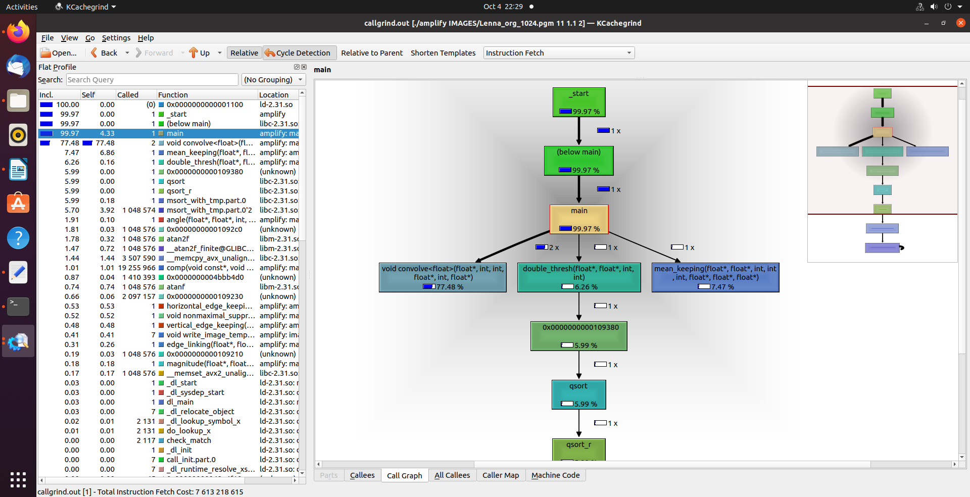
Question #17:
Which function dominates the execution time? What fraction of the total execution time does this function occupy?
Answer:
void convolve<float>(float*, int, int, float*, int, float*)
77.48%

Question #18:
Does this program show any signs of memory leaks? Optional: Remove as many memory leaks as possible for 5 extra credits. Document the specific leak(s) you found and the specific code change(s) you made in your lab report.
Answer:
Yes, total 50,332,668 bytes in 10 blocks are memory leaks.
1.
==5911== 16 bytes in 1 blocks are definitely lost in loss record 1 of 10
==5911== at 0x483B7F3: malloc (in /usr/lib/x86_64-linux-gnu/valgrind/vgpreload_memcheck-amd64-linux.so)
==5911== by 0x10AE87: mean_keeping(float*, float*, int, int, int, float*, float*, float*) (amplify.h:34)
==5911== by 0x109E29: main (main.c:158)
I freed memory of patchaxa by putting free(patchaxa); at line 130 at amplify.h.

2.
==5911== 36 bytes in 1 blocks are definitely lost in loss record 2 of 10
==5911== at 0x483B7F3: malloc (in /usr/lib/x86_64-linux-gnu/valgrind/vgpreload_memcheck-amd64-linux.so)
==5911== by 0x10AE6F: mean_keeping(float*, float*, int, int, int, float*, float*, float*) (amplify.h:32)
==5911== by 0x109E29: main (main.c:158)
I freed memory of patch3x3 by putting free(patch3x3); at line 129 at amplify.h.

3.
==5911== 484 bytes in 1 blocks are definitely lost in loss record 3 of 10
==5911== at 0x483B7F3: malloc (in /usr/lib/x86_64-linux-gnu/valgrind/vgpreload_memcheck-amd64-linux.so)
==5911== by 0x1097CB: main (main.c:60)
I freed memory of Gx_mask by putting free(Gx_mask); at line 238 at main.c.

4.
==5911== 484 bytes in 1 blocks are definitely lost in loss record 4 of 10
==5911== at 0x483B7F3: malloc (in /usr/lib/x86_64-linux-gnu/valgrind/vgpreload_memcheck-amd64-linux.so)
==5911== by 0x1097D6: main (main.c:61)
I freed memory of Gy_mask by putting free(Gy_mask); at line 239 at main.c.

5.
==5972== 4,194,304 bytes in 1 blocks are definitely lost in loss record 1 of 5
==5972== at 0x483B7F3: malloc (in /usr/lib/x86_64-linux-gnu/valgrind/vgpreload_memcheck-amd64-linux.so)
==5972== by 0x10996E: main (main.c:79)
I freed memory of Vmap by putting free(Vmap); at line 245 at main.c.

6.
==5972== 4,194,304 bytes in 1 blocks are definitely lost in loss record 2 of 5
==5972== at 0x483B7F3: malloc (in /usr/lib/x86_64-linux-gnu/valgrind/vgpreload_memcheck-amd64-linux.so)
==5972== by 0x10998E: main (main.c:80)
I freed memory of Hmap by putting free(Hmap); at line 246 at main.c.

