Lab Report

ECPE 170 – Computer Systems and Networks – Fall 2021

Name: Sloan Kim

Lab Topic: Performance Optimization (Lab #: 6)

Question #1:
What is the total physical RAM installed in the system? (In MB)
Answer:
8000MB

Question #2:
With no applications running (beyond the web browser with this page), how much RAM is used by the native operating system? (e.g. Windows)
Answer:
3800MB

Question #3:
With no applications running (beyond the web browser with this page), how much RAM is available?
Answer:
4000MB

Question #4:
Check the virtual machine configuration. How much RAM is currently allocated to Linux in your virtual machine?
Answer:
3900MB

Question #5:
Try to increase your virtual machine memory allocation, if possible, to the maximum allowed based on your free RAM. Leave ~256MB free for the virtual machine program itself. Now how much RAM is allocated to Linux in your virtual machine?
Answer:
5900MB

Question #6:
Boot Linux. With no applications running in Linux, how much RAM is available inside the virtual machine? The "System Monitor" program should report that information. This is the space that is actually available for our test application.
Answer:
5600MB in total, 1100MB in use with no application running, 4500MB available

Question #7:
What is the code doing? (Describe the algorithm in a paragraph, focusing on the combine1() function.)
Answer:
The function combine1 takes two arguments which are vector pointer and the pointer of final result. It sets the final result to IDENT which is specified in config.h either 0 if the operation is sum or 1 if the operation is product. The for loop in combine1 iterates each element in the vector and assign the each vector element to the variable val and update the final result by <final result operation val > which is final result + val if the operation is sum or final result * if the operation is product.

Question #8:
What is the largest number of elements that the vector can hold WITHOUT using swap storage (virtual memory), and how much memory does it take? Be sure to leave enough memory for Firefox and LibreOffice, since you'll need those when running this lab as well.
Answer:
1200000000

Question #9:
What vector size are you using for all experiments in this lab?
Answer:
1,000,000,000

Question #10:
How much time does the compiler take to finish with (a) no optimization, (b) with -O1 optimization, (c) with -O2 optimization, and (d) with -O3 optimization? Report the Real time, which is the "wall clock" time. Create both a table and a graph in LibreOffice Calc.
Answer:
(a) 0.814s
(b) 0.346s
(c) 0.379s
(d) 0.397s

compiler | Default | O1 | O2 | O3
Real time | 0.814 | 0.346 | 0.379 | 0.397
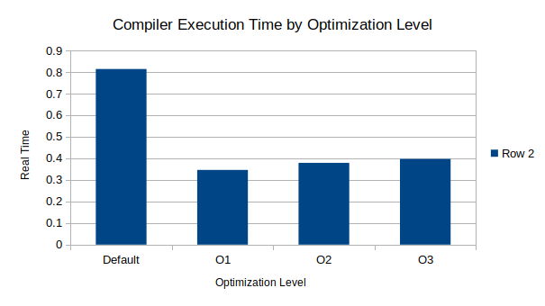
Question #11:
How much time does the program take to finish with (a) no optimization, (b) with -O1 optimization, (c) with -O2 optimization, and (d) with -O3 optimization? Report the Real time, which is the "wall clock" time. Create both a table and a graph in LibreOffice Calc.
Answer:
(a) 0.007s
(b) 0.002s
(c) 0.003s
(d) 0.006s

program | Default | O1 | O2 | O3
Real time | 0.007 | 0.002 | 0.003 | 0.006
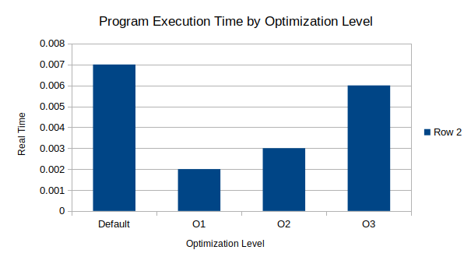
Question #12:
After implementing each function, benchmark it for a variety of data types and mathematical operations. Fill in the table below as you write each function.
Answer:
configuration | vector size(elements) | vector size(MB) | time for integer add | time for integer multiply | time for float add | time for float multiply
combine1 | 1000000000 | 3814.7 | 4.073 | 3.901 | 3.831 | 3.763
combine2 | 1000000000 | 3814.7 | 2.192 | 2.316 | 3.336 | 3.526
combine3 | 1000000000 | 3814.7 | 2.078 | 2.775 | 3.301 | 3.288
combine4 | 1000000000 | 3814.7 | 0.852 | 1.141 | 6.017 | 6.197
combine5x2 | 1000000000 | 3814.7 | 0.455 | 1.14 | 3.819 | 3.802
combine5x3 | 1000000000 | 3814.7 | 0.479 | 1.119 | 3.162 | 3.168
combine6 | 1000000000 | 3814.7 | 0.476 | 0.582 | 3.126 | 3.102

Question #13:
Using LibreOffice Calc, make two graphs:
Graph 1: Create a single graph that shows the data in the table created, specifically the four time columns. You don't need to plot vector size.
Graph 2: For FP (float) multiply only, plot a line graph that shows the speed-up of combine2(), combine3(), combine4(), combine5x2(), combine5x3(), and combine6() over combine1() for the vector size tested in Question 12. Plot speed-up on the y axis and function names on the x-axis. Note that the speed-up of program A over program B is defined as (TB/TA) where TB is the execution time for program B and TA is the execution time for program A.
Answer:
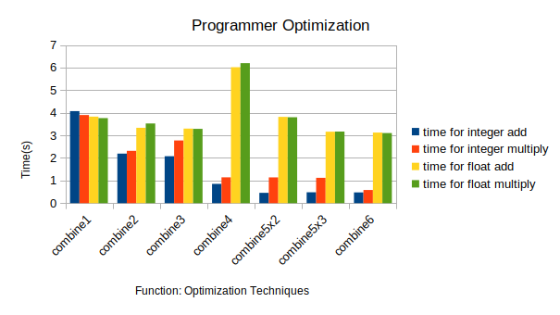

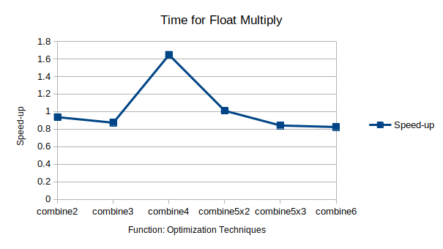

Question #14:
As a reminder, you should be using version control to track your code, and ensure that the final code is checked in along with your report PDF.
Answer:
Yes

