Lab Report

ECPE 170 – Computer Systems and Networks – Fall 2021

Name: Sloan Kim

Lab Topic: Performance Optimization(Memory Hierarchy) (Lab #: 7)

Question #1:
Describe how a two-dimensional array is stored in one-dimensional computer memory.
Answer:
C is row major therefore the two-dimensional array is stored row by row in to one-dimensional computer memory. As last column in first row element is stored linearly, the first column in next row element is stored right next to it.

Question #2:
Describe how a three-dimensional array is stored in one-dimensional computer memory.
Answer:
Three-dimensional array is multiple two-dimensional arrays. First two-dimensional array is stored and next two-dimensional array is stored. When two-dimensional array is stored, it follows the rule of row major.

Question #3:
Copy and paste the output of your program into your lab report, and be sure that the source code and Makefile is included in your Git repository.
Answer:
two-dimensional array[4][5]:
row 0: 1 2 3 4 5
row 1: 6 7 8 9 10
row 2: 11 12 13 14 15
row 3: 16 17 18 19 20

There are 4 rows and 5 columns.
However, the memory is linear and C is row major which means the each row will be stored in order.

Memory[0]: 0x557a7bb4e2d0 is the address of twoD array element 1
Memory[1]: 0x557a7bb4e2d4 is the address of twoD array element 2
Memory[2]: 0x557a7bb4e2d8 is the address of twoD array element 3
Memory[3]: 0x557a7bb4e2dc is the address of twoD array element 4
Memory[4]: 0x557a7bb4e2e0 is the address of twoD array element 5
row 0 has been stored
Memory[5]: 0x557a7bb4e2f0 is the address of twoD array element 6
Memory[6]: 0x557a7bb4e2f4 is the address of twoD array element 7
Memory[7]: 0x557a7bb4e2f8 is the address of twoD array element 8
Memory[8]: 0x557a7bb4e2fc is the address of twoD array element 9
Memory[9]: 0x557a7bb4e300 is the address of twoD array element 10
row 1 has been stored
Memory[10]: 0x557a7bb4e310 is the address of twoD array element 11
Memory[11]: 0x557a7bb4e314 is the address of twoD array element 12
Memory[12]: 0x557a7bb4e318 is the address of twoD array element 13
Memory[13]: 0x557a7bb4e31c is the address of twoD array element 14
Memory[14]: 0x557a7bb4e320 is the address of twoD array element 15
row 2 has been stored
Memory[15]: 0x557a7bb4e330 is the address of twoD array element 16
Memory[16]: 0x557a7bb4e334 is the address of twoD array element 17
Memory[17]: 0x557a7bb4e338 is the address of twoD array element 18
Memory[18]: 0x557a7bb4e33c is the address of twoD array element 19
Memory[19]: 0x557a7bb4e340 is the address of twoD array element 20
row 3 has been stored

three-dimensional array[2][4][5]:
Array 0:
row 0: 1 2 3 4 5
row 1: 6 7 8 9 10
row 2: 11 12 13 14 15
row 3: 16 17 18 19 20

Array 1:
row 0: 21 22 23 24 25
row 1: 26 27 28 29 30
row 2: 31 32 33 34 35
row 3: 36 37 38 39 40

There are 2 two-dimensional arrays of 4 rows and 5 columns.
However, the memory is linear so two-dimensional arrays will be stored in order and each row of two-dimensional array in order.

Memory[0]: 0x557a7bb4e310 is the address of threeD array element 1
Memory[1]: 0x557a7bb4e314 is the address of threeD array element 2
Memory[2]: 0x557a7bb4e318 is the address of threeD array element 3
Memory[3]: 0x557a7bb4e31c is the address of threeD array element 4
Memory[4]: 0x557a7bb4e320 is the address of threeD array element 5
Array 0 row 0 has been stored
Memory[5]: 0x557a7bb4e2f0 is the address of threeD array element 6
Memory[6]: 0x557a7bb4e2f4 is the address of threeD array element 7
Memory[7]: 0x557a7bb4e2f8 is the address of threeD array element 8
Memory[8]: 0x557a7bb4e2fc is the address of threeD array element 9
Memory[9]: 0x557a7bb4e300 is the address of threeD array element 10
Array 0 row 1 has been stored
Memory[10]: 0x557a7bb4e2d0 is the address of threeD array element 11
Memory[11]: 0x557a7bb4e2d4 is the address of threeD array element 12
Memory[12]: 0x557a7bb4e2d8 is the address of threeD array element 13
Memory[13]: 0x557a7bb4e2dc is the address of threeD array element 14
Memory[14]: 0x557a7bb4e2e0 is the address of threeD array element 15
Array 0 row 2 has been stored
Memory[15]: 0x557a7bb4e810 is the address of threeD array element 16
Memory[16]: 0x557a7bb4e814 is the address of threeD array element 17
Memory[17]: 0x557a7bb4e818 is the address of threeD array element 18
Memory[18]: 0x557a7bb4e81c is the address of threeD array element 19
Memory[19]: 0x557a7bb4e820 is the address of threeD array element 20
Array 0 row 3 has been stored
Memory[20]: 0x557a7bb4e860 is the address of threeD array element 21
Memory[21]: 0x557a7bb4e864 is the address of threeD array element 22
Memory[22]: 0x557a7bb4e868 is the address of threeD array element 23
Memory[23]: 0x557a7bb4e86c is the address of threeD array element 24
Memory[24]: 0x557a7bb4e870 is the address of threeD array element 25
Array 1 row 0 has been stored
Memory[25]: 0x557a7bb4e880 is the address of threeD array element 26
Memory[26]: 0x557a7bb4e884 is the address of threeD array element 27
Memory[27]: 0x557a7bb4e888 is the address of threeD array element 28
Memory[28]: 0x557a7bb4e88c is the address of threeD array element 29
Memory[29]: 0x557a7bb4e890 is the address of threeD array element 30
Array 1 row 1 has been stored
Memory[30]: 0x557a7bb4e8a0 is the address of threeD array element 31
Memory[31]: 0x557a7bb4e8a4 is the address of threeD array element 32
Memory[32]: 0x557a7bb4e8a8 is the address of threeD array element 33
Memory[33]: 0x557a7bb4e8ac is the address of threeD array element 34
Memory[34]: 0x557a7bb4e8b0 is the address of threeD array element 35
Array 1 row 2 has been stored
Memory[35]: 0x557a7bb4e8c0 is the address of threeD array element 36
Memory[36]: 0x557a7bb4e8c4 is the address of threeD array element 37
Memory[37]: 0x557a7bb4e8c8 is the address of threeD array element 38
Memory[38]: 0x557a7bb4e8cc is the address of threeD array element 39
Memory[39]: 0x557a7bb4e8d0 is the address of threeD array element 40
Array 1 row 3 has been stored

Question #4:
Provide an Access Pattern table for the sumarrayrows() function assuming ROWS=2 and COLS=3.
The table should be sorted by ascending memory addresses, not by program access order.
Answer:
Note 1: Address assumes array starts at memory address 0.
Note 2: Table is sorted by ascending memory addresses, not by program access order.
Memory Address | 0 | 4 | 8 | 12 | 16 | 20
Memory Contents | a[0][0] | a[0][1] | a[0][2] | a[1][0] | a[1][1] | a[1][2]
Program Access Order | 1 | 2 | 3 | 4 | 5 | 6

Question #5:
Does sumarrayrows() have good temporal or spatial locality?
For your answer to receive full credit, you must discuss the locality of both the array itself, and the scalar variables such as i that are present in the function.
Answer:
The array has good spatial locality but not good temporal locality because program access the array element in order row by row but it does not access the element more than once. For variable i and sum, they have good temporal locality as they are accessed more than once.

Question #6:
Provide an Access Pattern table for the sumarraycols() function assuming ROWS=2 and COLS=3.
The table should be sorted by ascending memory addresses, not by program access order.
Answer:
Note 1: Address assumes array starts at memory address 0.
Note 2: Table is sorted by ascending memory addresses, not by program access order.
Memory Address | 0 | 4 | 8 | 12 | 16 | 20
Memory Contents | a[0][0] | a[0][1] | a[0][2] | a[1][0] | a[1][1] | a[1][2]
Program Access Order | 1 | 3 | 5 | 2 | 4 | 6

Question #7:
Does sumarraycols() have good temporal or spatial locality?
For your answer to receive full credit, you must discuss the locality of both the array itself, and the scalar variables such as i that are present in the function.
Answer:
The array in sumarraycols() does not have good spatial locality nor temporal locality. As the for loop starts with column and reads column by column, the linear memory that stores the array row by row does not access the nearby memory address but has to find the memory address little far away. Also, the program does not access array element more than once. For the variable i and sum, they have good temporal locality because they are accessed more than once in the for loop.

Question #8:
Inspect the provided source code. Describe how the two-dimensional arrays are stored in memory, since the code only has one-dimensional array accesses like: a[element #].
Answer:
As the computer memory stores the two-dimensional array in C program, the two-dimensional array is stored in row major order in one-dimensional array, row by row.

Question #9:
After running your experiment script, create a table that shows floating point operations per second for both algorithms at the array sizes listed in Table 2.
Answer:
Array size | FLOP for Algorithm 1 | FLOP for Algorithm 2
256 | 7.47E+08 | 2.39E+09
512 | 5.42E+08 | 2.44E+09
768 | 4.95E+08 | 2.06E+09
1024 | 1.86E+08 | 1.88E+09
1280 | 2.57E+08 | 1.89E+09
1536 | 1.41E+08 | 1.85E+09
1792 | 1.06E+08 | 1.88E+09
2048 | 8.44E+07 | 1.77E+09

Question #10:
After running your experiment script, create a graph that shows floating point operations per second for both algorithms at the array sizes listed in Table 2.
Answer:

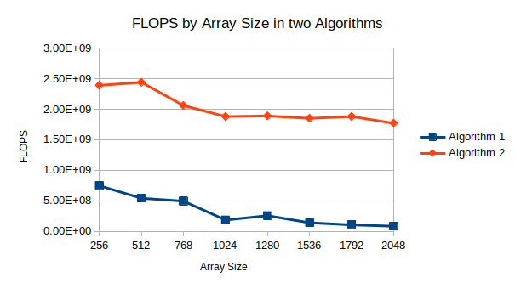

Question #11:
Be sure that the script source code is included in your Git repository.
Answer:
Yes

Question #12:
Place the output of /proc/cpuinfo in your report. (I only need to see one processor core, not all the cores as reported)
Answer:
processor : 0
vendor_id : GenuineIntel
cpu family : 6
model : 78
model name : Intel(R) Core(TM) i5-6300U CPU @ 2.40GHz
stepping : 3
microcode : 0xcc
cpu MHz : 2496.001
cache size : 3072 KB
physical id : 0
siblings : 1
core id : 0
cpu cores : 1
apicid : 0
initial apicid : 0
fpu : yes
fpu_exception : yes
cpuid level : 22
wp : yes
flags : fpu vme de pse tsc msr pae mce cx8 apic sep mtrr pge mca cmov pat pse36 clflush mmx fxsr sse sse2 ss syscall nx pdpe1gb rdtscp lm constant_tsc arch_perfmon nopl xtopology tsc_reliable nonstop_tsc cpuid pni pclmulqdq ssse3 fma cx16 pcid sse4_1 sse4_2 x2apic movbe popcnt tsc_deadline_timer aes xsave avx f16c rdrand hypervisor lahf_lm abm 3dnowprefetch cpuid_fault invpcid_single pti ssbd ibrs ibpb stibp fsgsbase tsc_adjust bmi1 avx2 smep bmi2 invpcid rdseed adx smap clflushopt xsaveopt xsavec xgetbv1 xsaves arat md_clear flush_l1d arch_capabilities
bugs : cpu_meltdown spectre_v1 spectre_v2 spec_store_bypass l1tf mds swapgs itlb_multihit srbds
bogomips : 4992.00
clflush size : 64
cache_alignment : 64
address sizes : 45 bits physical, 48 bits virtual
power management:

Question #13:
Based on the processor type reported, obtain the following specifications for your CPU from cpu-world.com or cpudb.stanford.edu
You might have to settle for a close processor from the same family. Make sure the frequency and L3 cache size match the results from /proc/cpuinfo!
Answer:
(a) L1 instruction cache size
2 x 32 KB
(b) L1 data cache size
2 x 32 KB
(c) L2 cache size
2 x 256 KB
(d) L3 cache size
3 MB
(e) What URL did you obtain the above specifications from?
https://www.cpu-world.com/CPUs/Core_i5/Intel-Core%20i5-6300U%20Mobile%20processor.html

Question #14:
Why is it important to run the test program on an idle computer system?
Explain what would happen if the computer was running several other active programs in the background at the same time, and how that would impact the test results.
Answer:
It is to see how fast CPU reads the array when CPU is doing minimum other work. When the computer was running several other active programs, the read bandwidth, total number of bytes read from the array in a given second, will be much smaller as CPU is doing other work while trying to read from the array.

Question #15:
What is the size (in bytes) of a data element read from the array in the test?
Answer:
8 bytes

Question #16:
What is the range (min, max) of strides used in the test?
Answer:
min: 0 to max: 64

Question #17:
What is the range (min, max) of array sizes used in the test?
Answer:
min: 2KB to max: 32MB

Question #18:
Take a screen capture of the displayed "memory mountain" (maximize the window so it's sufficiently large to read), and place the resulting image in your report
Answer:
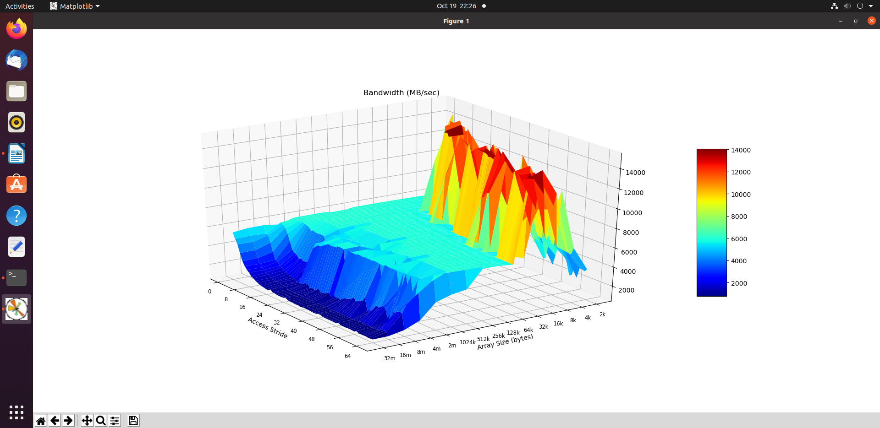
Question #19:
What region (array size, stride) gets the most consistently high performance? (Ignoring spikes in the graph that are noisy results...) What is the read bandwidth reported? Annotate your figure by drawing an arrow on it.
Answer:
When array size is between 2KB to 32KB and when stride was between 32 to 40, it showed consistently high performance showing read bandwidth between 12000 and 14000.
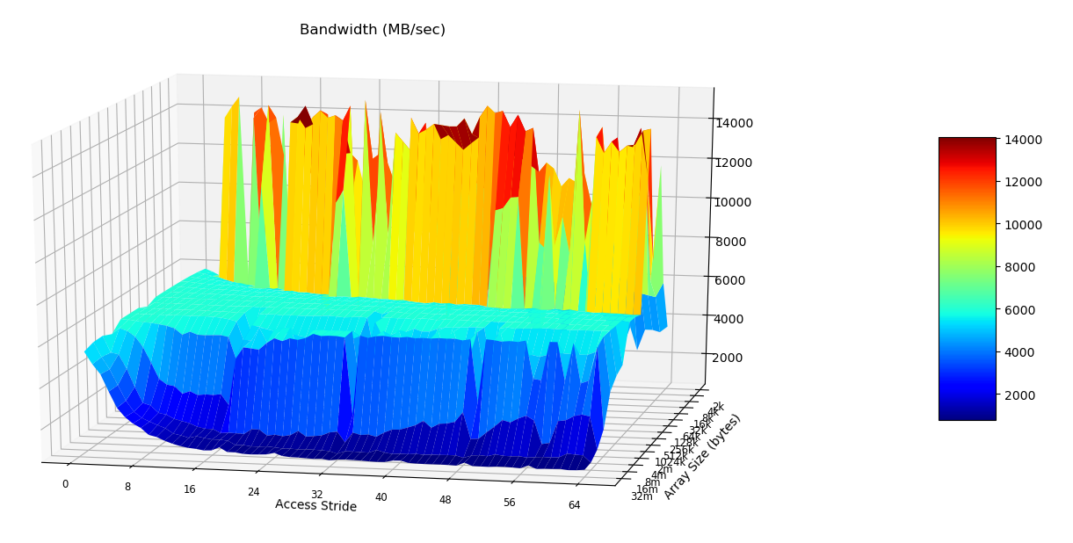

Question #20:
What region (array size, stride) gets the most consistently low performance? (Ignoring spikes in the graph that are noisy results...) What is the read bandwidth reported? Annotate your figure by drawing an arrow on it.
Answer:
When array size is between 16MB to 32MB and when stride is between 16 to 64, it showed consistently low performance showing read bandwidth under 2000.

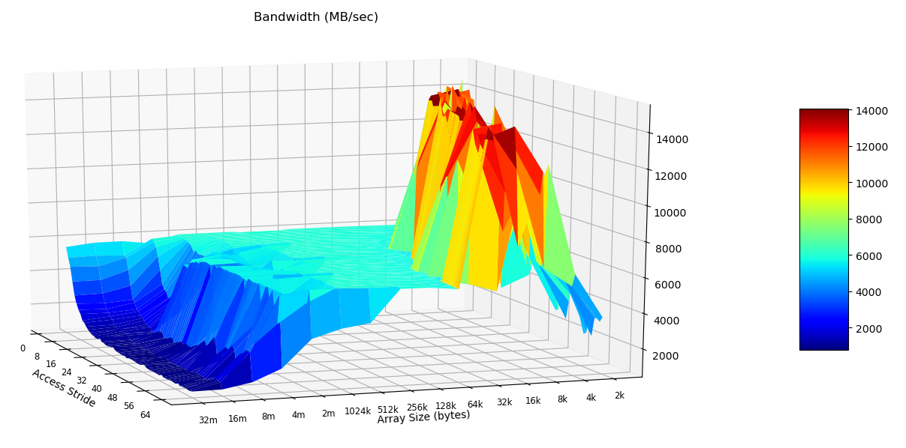

Question #21:
Using LibreOffice calc, create two new bar graphs: One for stride=1, and the other for stride=64. Place them side-by-size in the report.
No credit will be given for sloppy graphs that lack X and Y axis labels and a title.
You can obtain the raw data from results.txt. Open it in gedit and turn off Text Wrapping in the preferences. (Otherwise, the columns will be a mess)
Answer:
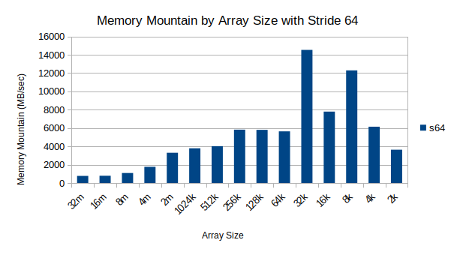
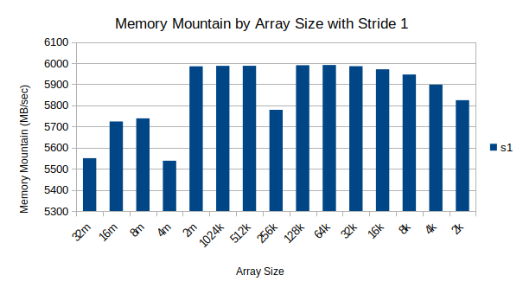
Question #22:
When you look at the graph for stride=1, you (should) see relatively high performance compared to stride=64. This is true even for large array sizes that are much larger than the L3 cache size reported in /proc/cpuinfo.
How is this possible, when the array cannot possibly all fit into the cache? Your explanation should include a brief overview of hardware prefetching as it applies to caches.
Answer:
The reason that is shows high performance with stride=1 compared to stride=64 even in large array size is because of the better spatial locality. Computer processor prefetch the array memory from the original storage in slower memory to cache in faster local memory to use in the near future and the array memory is taken to cache row by row. Therefore, accessing the nearby array element is faster with stride=1 as it can just go to next element while when it is stride=64, depends on cache size, it will have to keep take array memory from main memory to cache each time it wants the next 64th element.

Question #23:
What is temporal locality? What is spatial locality?
Answer:
Temporal locality is when there is high possibility that memory is visited or used multiple times. Spatial locality is when there is high possibility that nearby memory will be visited.

Question #24:
Adjusting the total array size impacts temporal locality - why? Will an increased array size increase or decrease temporal locality?
Answer:
Smaller array size results better temporal locality because as the array size is smaller, chance to revisit the each array element is bigger than big array size. Increased array size will decrease temporal locality.

Question #25:
Adjusting the read stride impacts spatial locality - why? Will an increased read stride increase or decrease spatial locality?
Answer:
Smaller stride results better spatial locality because when stride is smaller, the nearby memory will be visited. If stride is big, the processor have to take memory from main memory to cache every time it needs next element. Increased read stride will decrease spatial locality.

Question #26:
As a software designer, describe at least 2 broad "guidelines" to ensure your programs run in the high-performing region of the graph instead of the low-performing region.
Answer:
1. Try to increase spatial locality by accessing nearby memory with smaller stride and row major order of accessing memory.
2. Try to increase temporal locality by using more scalar values and have smaller array size.

