I cheched if nagios is on server   
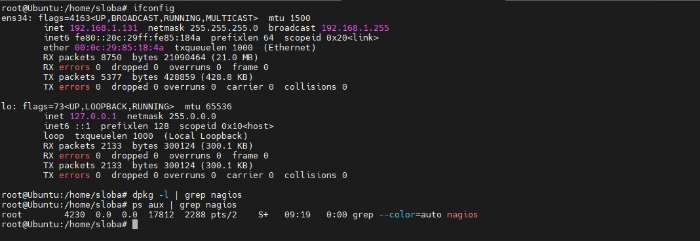  
  
We are getting nagios sudo apt install -y wget build-essential apache2 php openssl perl make php-gd libgd-dev libapache2-mod-php libperl-dev libssl-dev daemon autoconf libc6-dev libmcrypt-dev libssl-dev libnet-snmp-perl gettext unzip   
  
wget <https://assets.nagios.com/downloads/nagioscore/releases/nagios-4.4.6.tar.gz>

Then we are creating a user   
**Create a user**  
sudo useradd nagios  
sudo groupadd nagcmd  
sudo usermod -a -G nagcmd nagios  
sudo passwd nagios

I am extrating the stuff I download and getting in the same file   
tar -xzf nagios-4.4.6.tar.gz  
cd nagios-4.4.6  
  
I am updating the system and install nagios-plugins   
sudo apt update  
sudo apt install nagios-nrpe-server nagios-plugins  
  
We are cofigure nagios In cd/Nagios   
sudo ./configure --with-httpd-conf=/etc/apache2/sites-enabled

sudo make all  
sudo make install  
sudo make install-init  
sudo make install-commandmode  
sudo make install-config   
Sudo /usr/bin/install -c -m 644 sample-config/httpd.conf /etc/apache2/sites-enabled/nagios.conf  
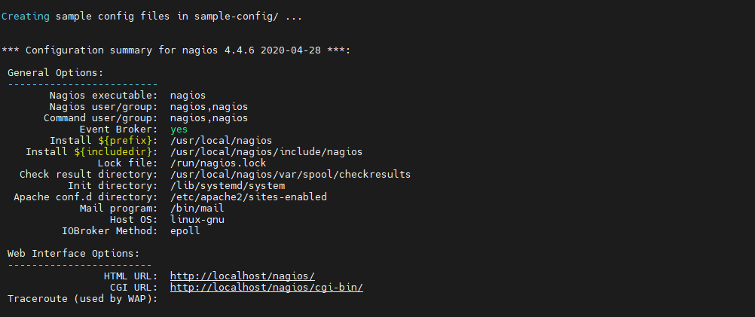  
  
Step 6: Configure Apache Configure Apache by running the following commands:  
sudo a2enmod rewrite  
sudo a2enmod cgi  
sudo systemctl restart apache2

Step 7: Install the Nagios plugins Install the Nagios plugins by running the following commands:  
cd /tmp  
wget <https://nagios-plugins.org/download/nagios-plugins-2.3.3.tar.gz>tar -xzf nagios-plugins-2.3.3.tar.gz  
cd nagios-plugins-2.3.3  
sudo ./configure --with-nagios-user=nagios --with-nagios-group=nagios --with-openssl  
sudo make  
sudo make install  
  
apache and nagios are up and running  
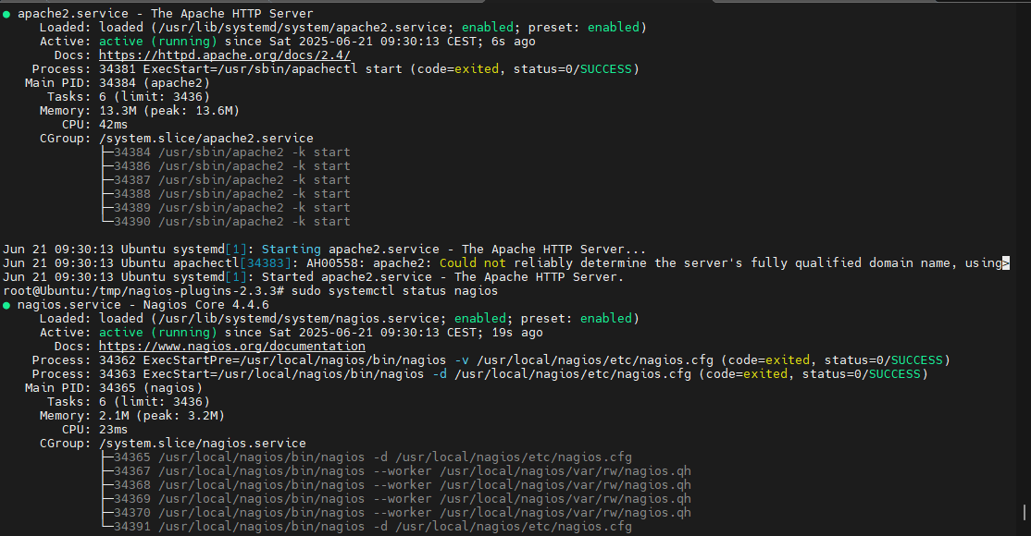  
  
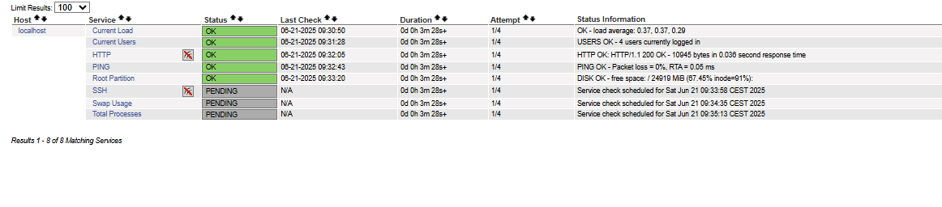  
everything is up and running :) …you need to configure with you plan and desire :)