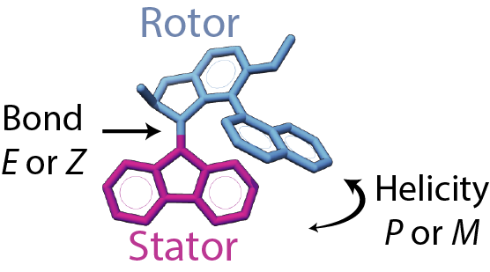

Figure . Here’s some text.

## What are the mechanical properties of synthetic molecular motors?

The ability of light-driven molecular motors to switch between two or more states makes them suitable for new forms of optical data storage1, as "wheels" on nano-scale cars2, trains3, worms [(Sasaki and Tour 2008)](https://paperpile.com/c/mRyPNm/kKPS), and walkers4, or in new forms of responsive materials [(Lucas et al. 2001)](https://paperpile.com/c/mRyPNm/Nthr). Unlike switches, whose work is reversed after every full cycle, molecular motors can be used to progressively move systems away from thermal equilibrium5. The synthetic molecular motors of Ben Feringa operate by converting light and heat into directional rotary motion. These motors belong to a class of molecules called overcrowded alkenes, with two stable enantiomers, and adopt a helical shape due to steric strain around the central double bond. The two sets of conjugated rings rotate relative to each other, with the central bond acting as an axle. For simplicity, one set of rings is designated the “stator” while the other set is called the “rotor”. The directional motion of these molecules can be analyzed in terms of two degrees of freedom: *E* and *Z* for the isomerization of the double bond (analogous to *cis* and *trans*) and *P* and *M* for the overall twist or helicity of the molecule (Figure 1).

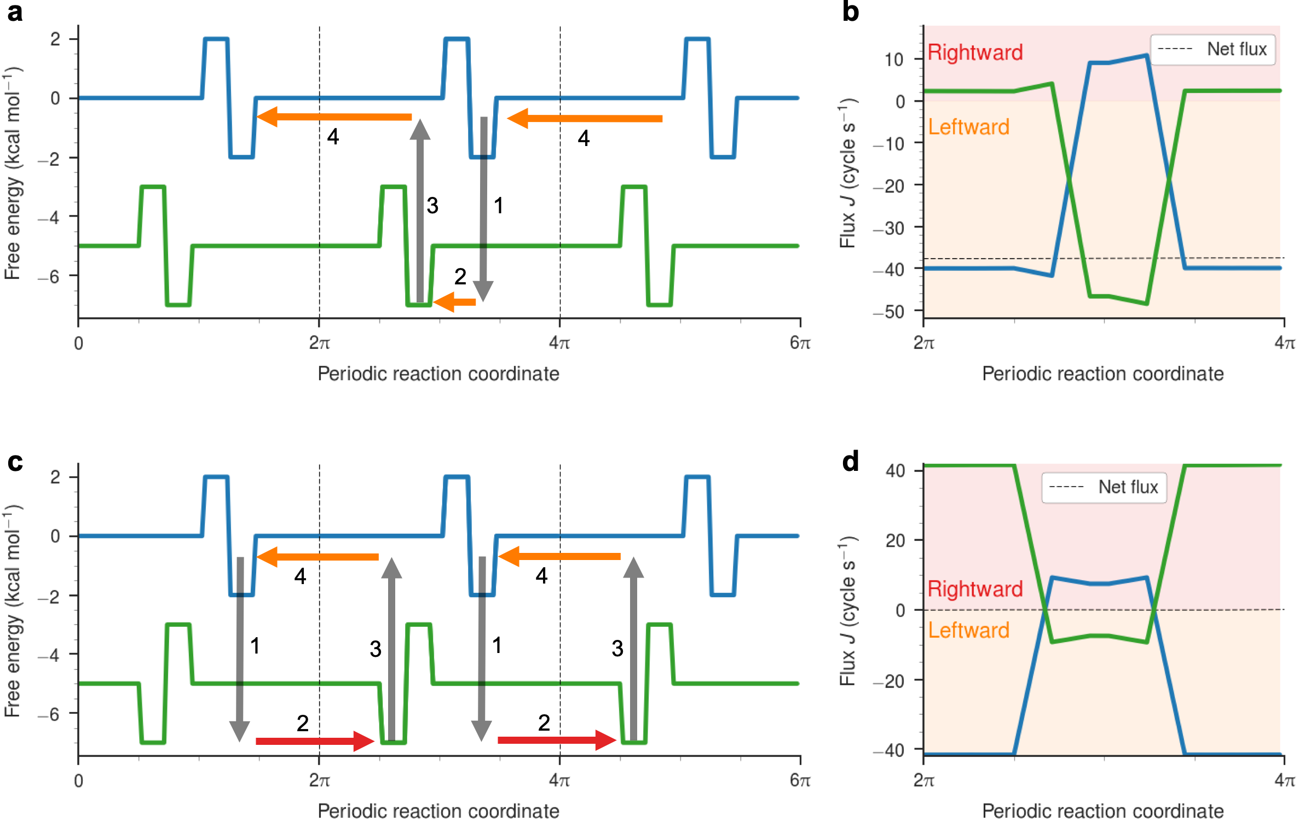

Figure . Asadfsdfsadfdsa

### Calculate the speed, torque, and efficiency of molecular motors.

In 2006, it was shown that light driven molecular motors can rotate a glass rod that is more than 10,000 times their size upon irradiation with light and when included as a dopant in a liquid crystal film6. While it is clear that artificial motors, when aligned appropriately so their individual effects are magnified, can produce macroscopic effects, it is not known how much force an individual molecular motor can generate. I will use the nonequilibrium model I developed to quantify directional motion in biological motors with these artificial molecular motors. I will focus on the “second generation” class of motors from Ben Feringa and colleagues, which possess symmetric stators that enable easier functionalization, and a lower energy cost for the thermal helix inversion step.

The four ground states of the motor can be seen in Figure 2. On the left are the four structural states of the motor, depicting movement of the upper rotor relative to the fixed stator. On the right, the four states have been mapped onto a fictional energy landscape, depicting the light and heat perturbations that drive the system out of equilibrium and between the four numbered states.

The free energy profiles along a given surface represent the energy barrier for changing the helicity of the structure while maintaining the same orientation of the double bond, essentially sliding the stator past the biaryl rings connected to the rotor. This barrier can be considerable, on the order of tens to hundreds of kJ/mol, and each state can have a half life of months to years at room temperature [(Kassem et al. 2017)](https://paperpile.com/c/mRyPNm/vbDy).

The input parameters to the model are the energy surfaces for each state of the motor in addition to the rate constants for moving between and along each surface. The model works by creating a Markov matrix that contains the probability of moving between discrete bins. The eigenvector of this matrix with eigenvalue equal to one contains the nonequilibrium steady state population distribution across both surfaces.

Previously, we used microsecond-scale molecular dynamics simulations to determine the energy landscapes based on equilibrium population distributions. Because the barriers here are expected to be much higher, I will directly determine the energy barriers using a dihedral scan.

Quantum calculations scanning the central dihedral will be used to calculate this energy landscape. The energy gap between the surfaces can be determined by determining the single point energy differences between the two isomers for a given helicity angle. Again, I will employ quantum calculations at the XXX level to acquire these data.

From the probability flow across the periodic boundary, we can determine the rate of rotation as a function of the input light source that is driving the system away from equilibrium. By imposing a large barrier on the surface, we can determine the effective force on the barrier due to population movement, and hence the stall torque of the motor. Motors that rotate the fastest, might not generate the most torque, similar to how bicycle gearing works.

### Design better molecular motors.

As demonstrated by Richard Feynman in a lecture on Brownian ratchets, the challenge of designing molecular motors is not how to create motion, but how to control the directionality of movement, the so-called “gating” [(Astumian 2018; Browne and Feringa 2006)](https://paperpile.com/c/mRyPNm/4VhN+Mjjw). Our

Using the nonequilibrium model, we can quickly and easily test how alterations in the free energy profiles affects the net directional flux and maximum torque. Using the free energy profiles from the quantum calculations as a baseline, I will optimize the energy surfaces using gradient descent.

I will optimize the energy surfaces for specific properties.

The thermodynamic and kinetic properties of molecular motors depends on the substituents of the rotor and the stator.

I will couple the knowledge of how surfaces affect the motor function with the chemical knowledge of how different chemical groups affect the electron withdrawing and electron donating conjugation.

## References

(1) Feringa, B. L. In Control of Motion: From Molecular Switches to Molecular Motors. *Acc Chem Res* **2001**, *34* (6), 504–513.

(2) Kudernac, T.; Ruangsupapichat, N.; Parschau, M.; Maciá, B.; Katsonis, N.; Harutyunyan, S. R.; Ernst, K.-H.; Feringa, B. L. Electrically Driven Directional Motion of a Four-Wheeled Molecule on a Metal Surface. *Nature* **2011**, *479* (7372), 208–211.

(3) Sasaki, T.; Guerrero, J. M.; Leonard, A. D.; Tour, J. M. Nanotrains and Self-Assembled Two-Dimensional Arrays Built from Carboranes Linked by Hydrogen Bonding of Dipyridones. *Nano Res.* **2008**, *1* (5), 412–419.

(4) von Delius, M.; Leigh, D. A. Walking Molecules. *Chem Soc Rev* **2011**, *40* (7), 3656–3676.

(5) Kassem, S.; van Leeuwen, T.; Lubbe, A. S.; Wilson, M. R.; Feringa, B. L.; Leigh, D. A. Artificial Molecular Motors. *Chem Soc Rev* **2017**, *46* (9), 2592–2621.

(6) Eelkema, R.; Pollard, M. M.; Vicario, J.; Katsonis, N.; Ramon, B. S.; Bastiaansen, C. W. M.; Broer, D. J.; Feringa, B. L. Molecular Machines: Nanomotor Rotates Microscale Objects. *Nature* **2006**, *440* (7081), 163.