

Thousand Smiles Foundation
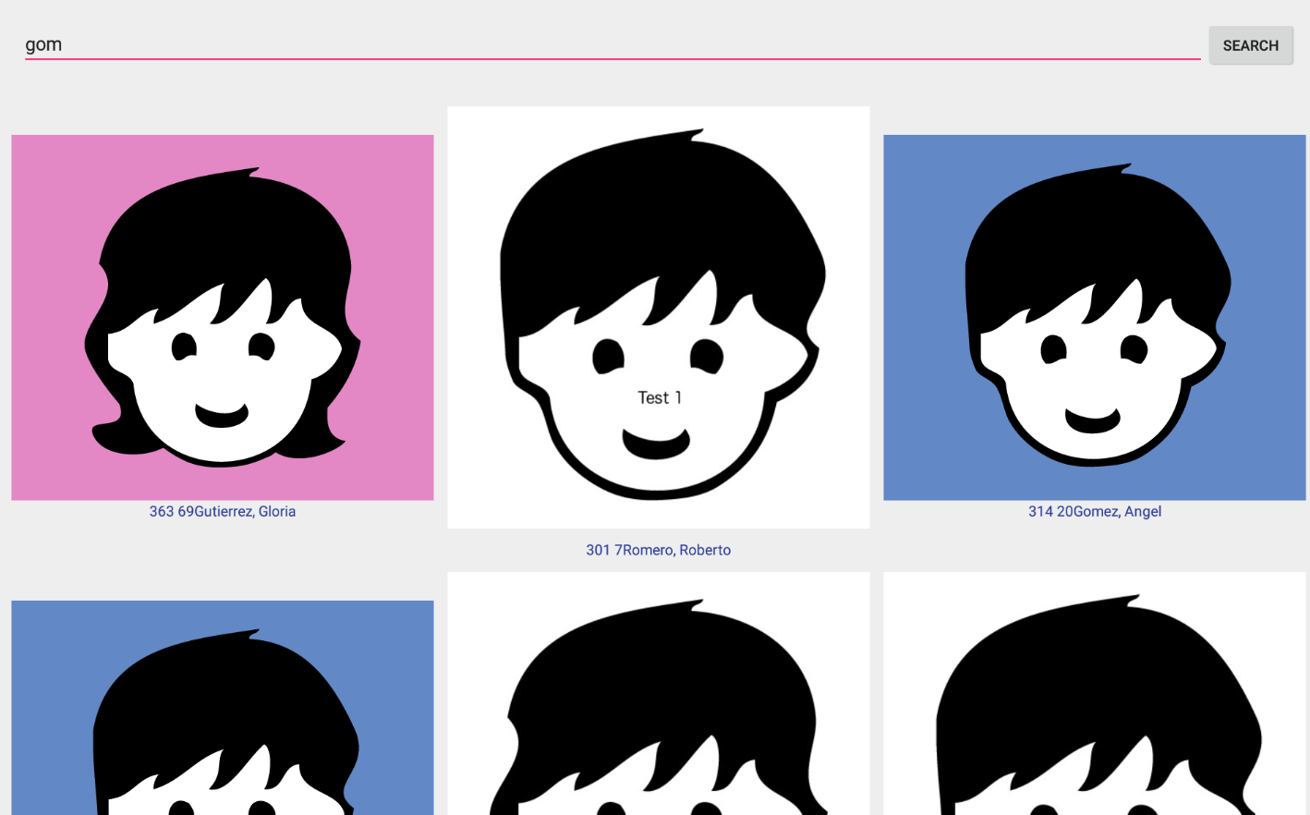
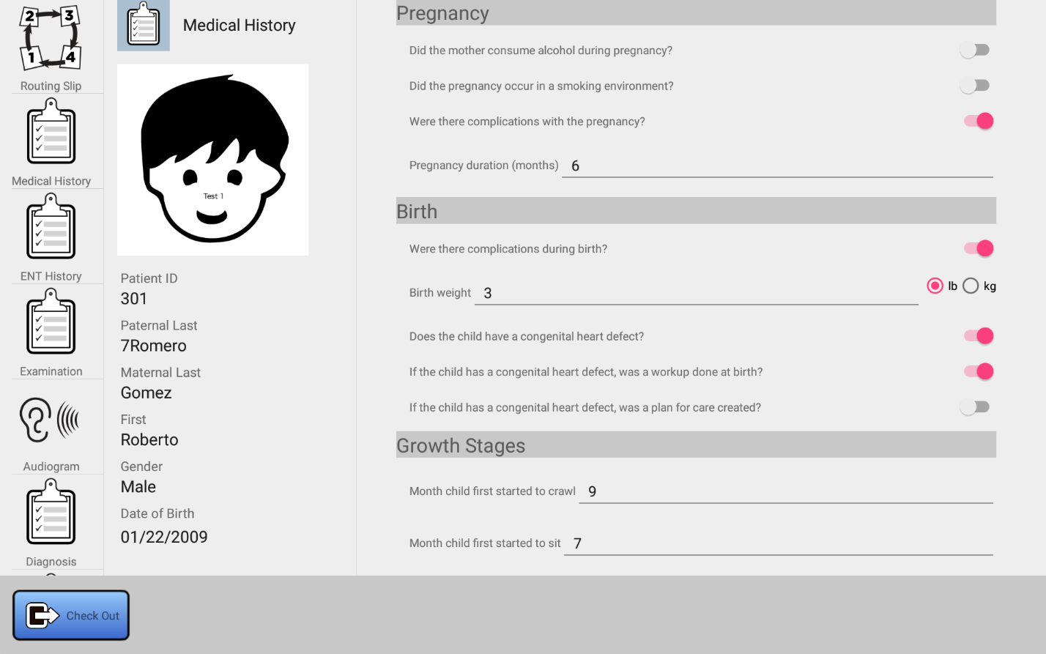

EMR Charts App User Manual
Version 1.2.9 – November 26, 2022

Table of Contents
1. Introduction 1
1.1 Purpose 1
1.2 Primary Intended Audience 1
1.3 Assumptions 1
2. Organization and Quick Start 1
2.1 Organization 1
2.2 Quick Start Instructions 3
2.2.1 Quick Start for Runners 3
2.2.2 Quick Start for Dentists 3
2.2.3 Quick Start for Dental Hygiene 4
2.2.4 Quick Start for ENT 4
2.2.5 Quick Start for Paper Charts 5
2.2.6 Quick Start for Audiology 5
2.2.7 Quick Start for Surgery Screening 6
2.2.8 Quick Start for X-Ray/Radiology 6
2.2.8.1 Film-based images 7
2.2.8.2 Digital-based images 7
2.2.9 Quick Start for Orthodontics 8
3. Common Functions 8
3.1 Selecting The Language 8
3.2 Starting the Application 9
3.3 Logging in 10
3.4 Changing the IP Address of the Server 11
3.5 Selecting a Station 13
3.6 Patient Flow 14
3.6.1 Categorization of patients 14
3.6.2 Runner Responsibilities 14
3.7 Patient Search 15
3.7.1 Example: Search for Dental Patients by Name 16
3.7.2 Example: Find all patients waiting for Dental 19
3.7.3 Example: Find a Dental Patient based on Date of Birth 19
3.8 Patient Checkin, Data Access, and Checkout 25
3.8.1 Checkin 25
3.8.2 Accessing Chart Data 27
3.8.3 Checking out the Patient 28
3.9 Routing Slips 30
3.9.1 Introduction 30
3.9.2 Changing the Routing Slip 30
3.10 Removing a Patient from the Clinic 33
3.11 Recording the Paper Chart ID 34
3.12 Retrieving the Patient Paper Chart ID 36
3.13 Removing X-Ray from the Routing Slip 37
3.14 Exiting and Restarting the Application 38
3.14.1 Exiting by Swiping Away the Application 38
3.14.2 Exiting via the Options Menu 40
3.15 Changing the Station Type 41
3.16 Logging Out 41
4. Dental Chart 42
4.1 Overview 42
4.2 X-Rays 43
4.2.1 Viewing A Set of X-Rays 45
4.3 Creating and Viewing Dental Treatment Records 48
4.4 Dental Record Organization 50
4.5 Editing CDT Codes 51
4.5.1 Overview 51
4.5.2 Searching For Codes 52
4.5.3 Adding a CDT Code 54
4.5.4 Removing a CDT Code 56
4.5.5 Marking a Tooth Missing 56
4.6 Dental Treatment 57
4.6.1 Organization of the Dental Treatment Chart 57
4.6.2 Editing the Dental Treatment Form 58
4.7 Tooth Chart 58
5. ENT Chart 61
5.1 Overview 61
5.2 ENT History 62
5.2.1 Adding Extra History Items 62
5.2.2 Viewing Extra History Items 63
5.2.3 Removing Extra History Items 65
5.3 ENT Examination 66
5.4 ENT Diagnosis 67
5.5 Treatment Plan 68
5.6 Viewing Audiograms 69
6. Audiology Chart 70
6.1 Overview 70
6.2 Viewing ENT Data 71
6.3 Creating Audiograms 72
6.4 Viewing and Editing Existing Audiograms 73
7. X-Ray Chart 75
7.1 Overview 75
7.2 X-Ray Data Stored 76
7.3 Adding an X-Ray Record 76
7.4 Viewing and Editing an Existing X-Ray Record 78
8. Appendices 79
8.1 Dental CDT Codes 79
8.1.1 PERSONS SERVED (ENCOUNTER CODES) 79
8.1.2 DIAGNOSTIC SERVICES 79
8.1.3 PREVENTIVE SERVICES 80
8.1.4 RESTORATIVE DENTISTRY 80
8.1.5 PERIODONTICS 81
8.1.6 ENDODONTICS 81
8.1.7 REMOVABLE PROSTHODONTICS 81
8.1.8 FIXED PROSTHODONTICS 82
8.1.9 ORTHODONTICS 82
8.1.10 ORAL SURGERY 83
8.1.11 ADJUNCTIVE GENERAL SERVICES 84
8.2 Patient Categories 85

Revision History
Name | Date | Reason For Changes | Version
Syd Logan | 12/15/2020 | Initial, write general section, coarse outline of remainder. Corresponds to Version 3.0 of the application | 0.1
Syd Logan | 12/17/2020 | Describe logout, change station context menu items | 0.2
Syd Logan | 12/19/2020 | Add description for exiting via options menu item | 0.2.1
Syd Logan | 12/26/2020 | Add more detail on general layout of chart section, start work on Dental | 0.2.2
Syd Logan | 12/27/2020 | Minor Edits | 0.2.3
Syd Logan | 12/28/2020 | Complete Dental section | 0.3
Syd Logan | 1/5/2021 | Complete ENT section | 0.4
Syd Logan | 1/7/2021 | Complete Audiology and X-Ray Section, v1.0 | 1.0
Syd Logan | 1/8/2021 | Add “Quick Start” instructions for each station | 1.1
Syd Logan | 1/15/2021 | Add Patient Categories table to the appendices | 1.2
Syd Logan | 1/17/2021 | Add some detail on using calendar control to select patient date of birth. | 1.2.1
Syd Logan | 3/29/2021 | Illustrate error message displayed if search term is incorrectly formatted | 1.2.2
Syd Logan | 4/13/2021 | Update docs for account related/login changes | 1.2.3
Syd Logan | 4/16/2021 | Document the Remove <station> from routing slip checkbox present in the Checkout Patient dialog. | 1.2.4
Syd Logan | 5/20/2021 | Correct documentation about Ears category. | 1.2.5
Syd Logan | 7/03/2021 | Add information about vaccinations. | 1.2.6
Syd Logan | 7/13/2021 | Add videos for x-ray and account creation | 1.2.7
Syd Logan | 8/19/2021 | Document changes for runners | 1.2.8
Syd Logan | 11/27/2022 | Changes for X-ray | 1.2.9

Introduction

Purpose
The purpose of this document is to document the user functions of the Thousand Smiles EMR Chart Application.

Primary Intended Audience
The primary users of the EMR Chart App include the following:

Caregivers: Caregivers provide care to patients. Caregivers include X-Ray, ENT, Dentists, Audiologists, Surgery Screeners, Hygienists, etc., as well as those who support them directly and might need access to the chart, for example dental assistants and nurses. Each caregiver has a section of the EMR chart application that supports the viewing and recording of patient data specific to the class of care provided by that caregiver.

Runners: Runners are users which take a registered patient from the waiting area to a caregiver for care. They monitor stations for vacancy, identify patients in need of care, and ensure that the routing slip maintained in the chart accurately reflects the movement of the patient through the clinic.

Assumptions
The manual assumes some basic familiarity with the use of Google’s Android OS or Kindle Fire OS (the tablets in use at our clinic are Kindle Fire HD 10 models). People with iOS (iPhone) experience will be able to adapt easily to Android after a little use.

Organization and Quick Start

Organization
The document is organized into two broad sections. The first section details basic functionality of the system that is of interest to all users, regardless of their function. This includes items such as the following:

- Starting the application
- Logging in
- Selecting a station (Dental, ENT, etc.)
- Searching for patients
- Patient checkin and checkout
- Exiting the application

Following this, there are a series of “quick start” sections that describe the chart app in terms of its individual users:

- Runners
- Dentists
- ENT

and so on.

Each user, for example a dentist, is supported directly in the application with screens which allow for the viewing and editing of clinical data that is relevant to their function only. For example, a dentist can view and edit a tooth chart, while ENT is able to view audiograms obtained for the patient. The reverse is not the case, e.g., ENT cannot edit tooth charts, and dentists cannot view audiograms. This simplifies navigation of the charts by focusing the content to areas which are meaningful to the individual users of the system, and it protects the integrity of the chart by only allowing changes to a specific area of the chart to be made by the specialists who provide the care. Finally, isolation of chart data based upon speciality allows us to conform to Standard Official Mexicana NOM-024-SSA3-2010 regulations which state that patient data only be viewed on a need-only basis.

Each of these sections will go into detail of how to use the chart app to record clinical data for a specific patient type (e.g., Dental), and how to view patient data from previous clinics, again based on the type of the patient. These sections will detail each screen available.

Quick Start Instructions
In this section, we present a series of quick start steps that indicate how specific users of the system should use the chart application.

Quick Start for Runners
- After identifying who you will be running for (e.g., a dentist, audiology, etc.), login to the tablet (see Section 3.3). The rest of these instructions assume you are supporting a dentist.
- On the next screen, select Runner (see Section 3.5)

The following steps are performed for each patient you run to a station.

- Select Dental (see Figure 3.8) to filter search results to include patients with Dental in their routing slip. Note: You may also select Search All, but this will include all patients registered for the clinic, even those not registered as Dental or those without Dental in their routing slip, so use it as a last resort.
- Optionally, enter part of the patient’s last name or use the calendar control to select the patient to refine the search results.
- Hit the Search button.
- Scroll through the results, using the name and headshots to identify the patient.
- Choose the patient, and click on the patient headshot to confirm the name, date of birth, etc. See Figure 3.30.
- To view the routing slip, click on the routing slip button. See Figure 3.17.
- Escort the patient to the Dental chair. Assist the Dentist in finding the same patient on their tablet, and using it to check in the patient for access to the chart.

Quick Start for Dentists
Note: if you are taking digital xrays at the chair, you will need to follow the steps outlined in Section 2.2.8 Quick Start for Radiologists

- Login to the tablet (see Section 3.3).
- On the next screen, select Dental (see Section 3.5). This will allow you to access the dental portion of the patient chart.

The following steps are to be performed for each patient you see.

- Select Dental (see Figure 3.8) to filter search results to include patients with Dental in their routing slip. Note: You may also select Search All, but this will include all patients registered for the clinic, even those not registered as Dental or those without Dental in their routing slip, so use it as a last resort.
- Optionally, enter part of the patient’s last name or use the calendar control to select the patient to refine the search results.
- Hit the Search button.
- Scroll through the results, using the name and headshots to identify the patient.
- Choose the patient, and click on the patient headshot to confirm the name, date of birth, etc. See Figure 3.30.
- Check the patient in using the checkin button. See Figure 3.17.
- If the runner has not done so already, remove Dental from the routing slip of the patient (see Section 3.9). This will ensure the patient will no longer be seen in dental search results.
- View Medical History, Vaccinations and X-Rays (Section 4.2) as desired by clicking on the appropriate buttons on the left of the screen.
- Record full mouth or per-visit data as described in Section 4.6. Enter appropriate CDT codes to indicate care given.
- Enter tooth-specific chart data as desired, using the tooth chart described in Section 4.7. Enter appropriate CDT codes to indicate care given.
- When prompted, save any changes using the Save button.
- (Optional) Add Hygiene to the routing slip as indicated (see Section 3.9.2).
- When done, checkout the patient using the Checkout button, as described in Section 3.8.3.

When you are done for the day, or before giving your tablet to another dentist to use, logout of the tablet (see Section 3.16).

Quick Start for Dental Hygiene
- Login to the tablet (see Section 3.3).
- On the next screen, select Hygiene (see Section 3.5). This will allow you to access the hygiene portion of the patient chart.

The following steps are to be performed for each patient you see.

- Select Hygiene (see Figure 3.8) to filter search results to include patients with Hygiene in their routing slip. Note: You may also select Search All, but this will include all patients registered for the clinic, even those not registered as Dental or those without Hygiene in their routing slip, so use it as a last resort.
- Optionally, enter part of the patient’s last name or use the calendar control to select the patient to refine the search results.
- Hit the Search button.
- Scroll through the results, using the name and headshots to identify the patient.
- Choose the patient, and click on the patient headshot to confirm the name, date of birth, etc. See Figure 3.30.
- Check the patient in using the checkin button. See Figure 3.17.
- If the runner has not done so already, remove Hygiene from the routing slip of the patient (see Section 3.9). This will ensure the patient will no longer be seen in hygiene search results.
- View Medical History, Vaccinations and X-Rays (Section 4.2) as desired by clicking on the appropriate buttons on the left of the screen.
- Record full mouth or per-visit data as described in Section 4.6. Enter appropriate CDT codes to indicate care given.
- Enter tooth-specific chart data as desired, using the tooth chart described in Section 4.7. Use appropriate CDT codes to indicate care given.
- When prompted, save any changes using the Save button.
- (Optional) Add Dental to the routing slip as indicated (see Section 3.9.2) if the patient needs to be returned to a Dentist.
- When done, checkout the patient using the Checkout button, as described in Section 3.8.3.

When you are done for the day, or before giving your tablet to another person to use, logout of the tablet (see Section 3.16).

Quick Start for ENT
- Login to the tablet (see Section 3.3).
- On the next screen, select ENT (see Section 3.5). This will allow you to access the ENT portion of the patient chart.

The following steps are to be performed for each patient you see.

- Select ENT (see Figure 3.8) to filter search results to include patients with ENT in their routing slip. Note: You may also select Search All, but this will include all patients registered for the clinic, even those not registered as Cleft or those without ENT in their routing slip, so use it as a last resort.
- Optionally, enter part of the patient’s last name or use the calendar control to select the patient to refine the search results.
- Hit the Search button.
- Scroll through the results, using the name and headshots to identify the patient.
- Choose the patient, and click on the patient headshot to confirm the name, date of birth, etc. See Figure 3.30.
- Check the patient in using the checkin button. See Figure 3.17.
- View Medical History and Vaccinations as desired by clicking on the appropriate buttons on the left of the screen.
- Record ENT history, exam, diagnosis and treatment plan data as described in Section 5 of this document.
- When prompted, save any changes using the Save button.
- If the runner has not done so already, remove ENT from the routing slip of the patient (see see Section 3.9). This will ensure the patient will no longer be seen in ENT search results.
- (Optional) Add Audiology, Surgery Screening, and other stations to the routing slip as indicated (see Section 3.9.2). This will allow runners to know that the patient needs to be seen by these stations.
- When done, checkout the patient using the Checkout button, as described in Section 3.8.3.

When you are done for the day, or before giving your tablet to another person to use, logout of the tablet (see Section 3.16).

Quick Start for Paper Charts
TBD

Quick Start for Audiology
- Login to the tablet (see Section 3.3).
- On the next screen, select Audiology (see Section 3.5). This will allow you to access the audiology portion of the patient chart.

The following steps are to be performed for each patient you see.

- Select Audiology (see Figure 3.8) to filter search results to include patients with Audiology in their routing slip. Note: You may also select Search All, but this will include all patients registered for the clinic, even those not registered as Ears patients, or without Audiology in their routing slip, so use it as a last resort.
- Optionally, enter part of the patient’s last name or use the calendar control to select the patient to refine the search results.
- Hit the Search button.
- Scroll through the results, using the name and headshots to identify the patient.
- Choose the patient, and click on the patient headshot to confirm the name, date of birth, etc. See Figure 3.30.
- Check the patient in using the checkin button. See Figure 3.17.
- If the runner has not done so already, remove Audiology from the routing slip of the patient (see Section 3.9). This will ensure the patient will no longer be seen in audiology search results.
- View Medical History, Vaccinations, or ENT data as desired in Section 6.2 by clicking on the appropriate buttons on the left of the screen.
- Create and record an audiogram using the build in camera of the tablet, as described in Section 6.3.
- When prompted, save any changes using the Save button.
- (Optional) Add ENT to the routing slip as indicated (see Section 3.9.2). This typically needs to be done so that the patient can be sent back to ENT where the audiograms you just recorded can be viewed (ENT almost certainly added audiology to the routing slip for this patient at some point, now you need that patient to be returned so the evaluation by ENT can continue).
- When done, checkout the patient using the Checkout button, as described in Section 3.8.3.

When you are done for the day, or before giving your tablet to another person to use, logout of the tablet (see Section 3.16).

Quick Start for Surgery Screening
- Login to the tablet (see Section 3.3).
- On the next screen, select Surgery Screening (see Section 3.5). This will allow you to access the surgery screening portion of the patient chart.

The following steps are to be performed for each patient you see.

- Select Surgery Screening (see Figure 3.8) to filter search results to include patients with Surgery Screening in their routing slip. Note: You may also select Search All, but this will include all patients registered for the clinic, even those not registered as Cleft patients or those without Surgery Screening in their routing slip, so use it as a last resort.
- Optionally, enter part of the patient’s last name or use the calendar control to select the patient to refine the search results.
- Hit the Search button.
- Scroll through the results, using the name and headshots to identify the patient.
- Choose the patient, and click on the patient headshot to confirm the name, date of birth, etc. See Figure 3.30.
- Check the patient in using the checkin button. See Figure 3.17.
- If the runner has not done so already, remove Surgery Screening from the routing slip of the patient (see Section 3.9). This will ensure the patient will no longer be seen in surgery screening search results.
- Since Surgery Screening does not have digital chart support as of this writing, have someone locate the paper chart for the patient.
- View Medical History or Vaccinations as desired by clicking on the appropriate button on the left of the screen.
- (Optional) Add Audiology, ENT, or other stations to the routing slip as indicated (see Section 3.9.2). Cleft patients are first seen either by Surgery Screening or ENT, and so it is expected that you will performing an initial triage/assessment and as a result, will add other stations, as needed, to the routing slip.
- When done, checkout the patient using the Checkout button, as described in Section 3.8.3.
- Return the paper chart for filing, or store it for use during surgery or other processes.

When you are done for the day, or before giving your tablet to another person to use, logout of the tablet (see Section 3.16).

Quick Start for X-Ray/Radiology
What you do is based on if you are capturing images on film, or digitally.

Film-based images

- Login to the tablet (see Section 3.3).
- On the next screen, select X-Rays (see Section 3.5). This will allow you to access the X-Ray portion of the patient chart.

The following steps are to be performed for each patient you see.

- Select X-Rays (see Figure 3.8) to filter search results to include patients with X-Ray in their routing slip. Note: You may also select Search All, but this will include all patients registered for the clinic, even those without X-Ray in their routing slip, so use it as a last resort.
- Optionally, enter part of the patient’s last name or use the calendar control to select the patient to refine the search results.
- Hit the Search button.
- Scroll through the results, using the name and headshots to identify the patient.
- Choose the patient, and click on the patient headshot to confirm the name, date of birth, etc. See Figure 3.30.
- Check the patient in using the checkin button. See Figure 3.17.
- View Medical History or Vaccinations as desired by clicking on the appropriate button on the left of the screen.
- Take digital X-Rays, and upload them into the database using the provided application on the PC that controls the digital X-Rays.
- Create a new X-ray record and use it to record data about the X-Rays taken as described in Sections 7.2 and 7.3
- When prompted, save any changes using the Save button.
- When done, checkout the patient using the Checkout button, as described in Section 3.8.3.

When you are done for the day, or before giving your tablet to another person to use, logout of the tablet (see Section 3.16).

Digital-based images

The following steps are to be performed for each patient you see.

- The runner (or you) must check the patient in using the checkin button See Figure 3.17. OR the runner must use his or her tablet to remove x-ray from the patient’s routing slip.
  - (Optionally) Once the patient is checked in, view Medical History or Vaccinations for the patient as desired by clicking on the appropriate button on the left of the screen.
- Use the XDR software to locate the patient based on the patient ID given to you by the runner. XDR allows you to search based on patient name, but using the ID is best since it will reduce mistakes. If the patient is not in the XDR system, create a new patient and assign a patient ID that matches the patient ID for this patient displayed on the tablet (the runner should be able to provide this ID).
- Acquire the xrays using the XDR software.
- Notify the person who is using the PC in the hallway when you are done. They will use the XDR software on their PC to find the patient, export the xrays, and upload them into the patient record so they can be viewed on tablets at the dental chair.
- The runner (or you) should checkout the patient once the patient is no longer in the chair (if the patient was checked in). This will remove xray from the patient’s routing slip, ensuring that they are not called a second time to xray by mistake. Alternately, the runner can use his or her tablet to remove x-ray from the routing slip.

Quick Start for Orthodontics
- Login to the tablet (see Section 3.3).
- On the next screen, select Orthodontics (see Section 3.5). This will allow you to access the orthodontics portion of the patient chart.

The following steps are to be performed for each patient you see.

- Select Ortho (see Figure 3.8) to filter search results to include patients with Orthodontics in their routing slip. Note: You may also select Search All, but this will include all patients registered for the clinic, even those not registered as Ortho patients or those without Orthodontics in their routing slip, so use it as a last resort.
- Optionally, enter part of the patient’s last name or use the calendar control to select the patient to refine the search results.
- Hit the Search button.
- Scroll through the results, using the name and headshots to identify the patient.
- Choose the patient, and click on the patient headshot to confirm the name, date of birth, etc. See Figure 3.30.
- Check the patient in using the checkin button. See Figure 3.17.
- If the runner has not done so already, remove Ortho from the routing slip of the patient (see see Section 3.9). This will ensure the patient will no longer be seen in orthodontics search results.
- Since Orthodontics does not have digital chart support as of this writing, have someone locate the paper chart for the patient.
- View Medical History or Vaccinations as desired by clicking on the appropriate button on the left of the screen.
- (Optional) Add Audiology, ENT, or other stations to the routing slip as indicated (see Section 3.9.2).
- When done, checkout the patient using the Checkout button, as described in Section 3.8.3.
- Return the paper chart for filing as appropriate.

When you are done for the day, or before giving your tablet to another person to use, logout of the tablet (see Section 3.16).

Common Functions
The following subsections describe functionality common to all users of the EMR Chart application.

Selecting The Language
This application has been localized for both English and Spanish language speakers. From the desktop, click the Settings icon, then select the Keyboard and Language category, and finally, use Language to select the language. At this point, the entire tablet will display text in the selected language. For best results, restart the chart application after changing the language of the tablet.

Starting the Application
To start the application, first ensure that the tablet is powered on. The power button is located in the upper right hand corner. Once powered on, the tablet will boot showing the main desktop. Navigate the desktop and locate the following icon (Figure 3.1), and with your finger, double tap it.



Figure 3.1 Application Icon

You will then see a splash screen similar to Figure 3.2, identifying the Chart application and its version. After a few seconds, you will be taken to the login screen.


Figure 3.2 Splash Screen

Logging in
Figure 3.3 illustrates the login screen. You will use this screen to create an account, then click on the SIGN IN button to login.

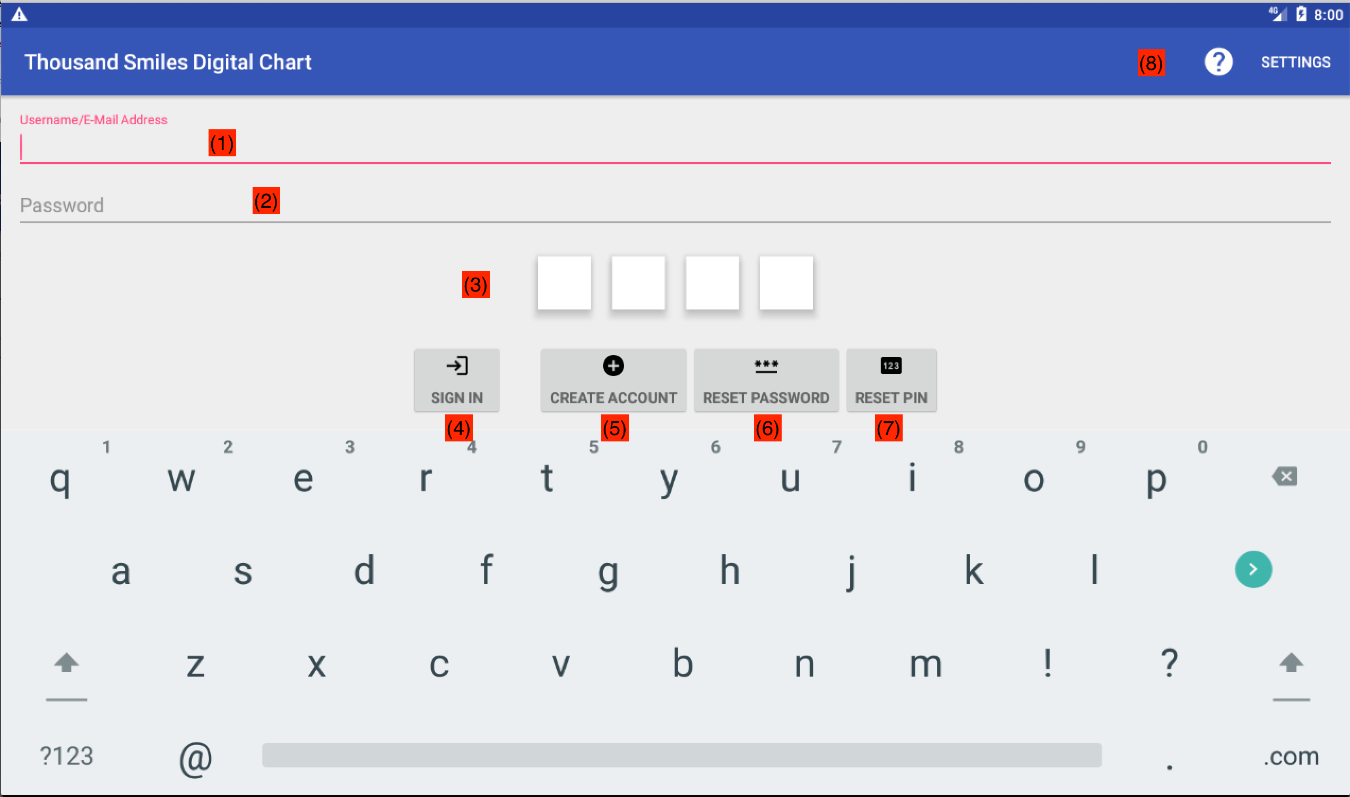

Figure 3.3 Login Screen

Your chart account is different than the account used to register as a volunteer with Thousand Smiles. Therefore, the very first time you use the tablet, you must create an account. Use (5) to create the account. You will be asked for your e-mail address, a password, and a 4-digit PIN (Figure 3.3.1). Most items require a duplicate, as each duplicate item is entered, a checkbox will display to verify correct entry. Once completed, the account can be used immediately to login. Your account can be used to log into any tablet in the clinic.

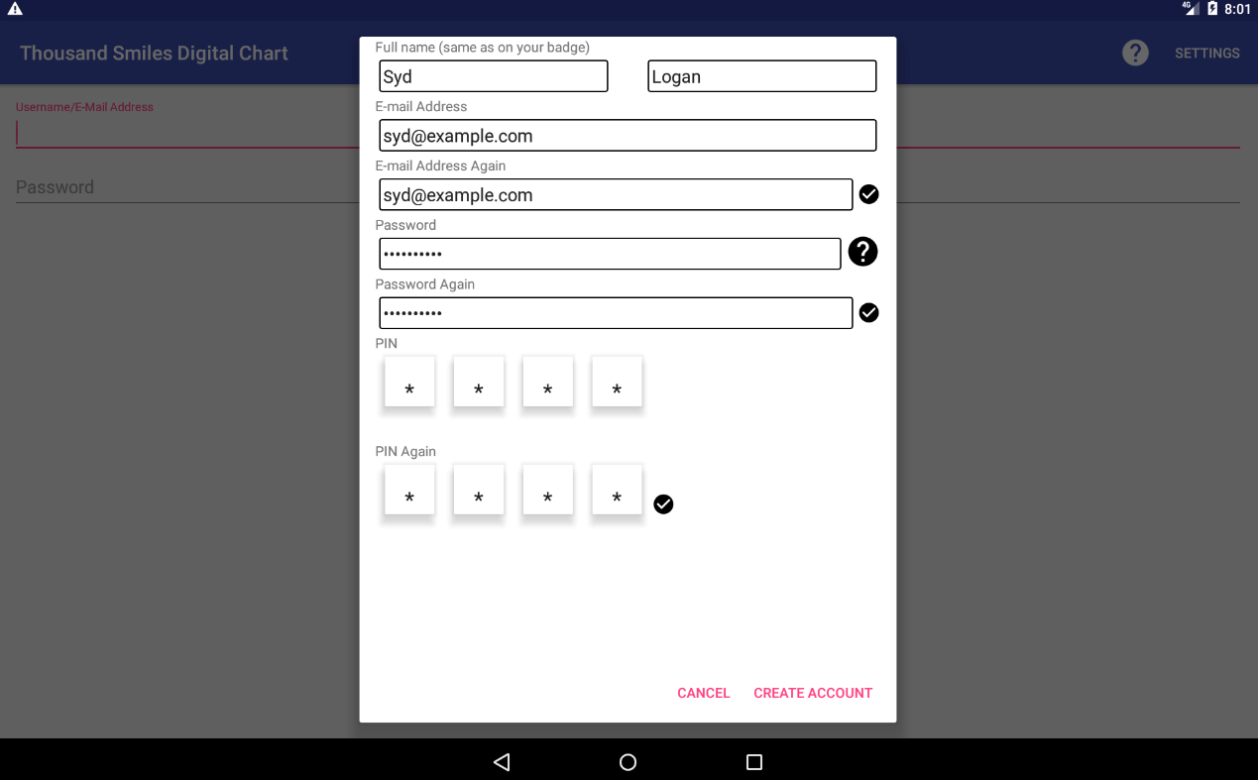

Figure 3.3.1 Create account dialog

Referring to Figure 3.3, if you already have an account, enter your e-mail address in (1) and either enter your password (2) or PIN (3), and then click SIGN IN (4).

If you forgot your login password or PIN, you can reset your password or PIN by clicking (6) or (7), respectively. You will then be returned to the login screen. Use (8) to obtain help.

Once you create your account, remember the e-mail address you used, it will be required for logins. If in the future you change your e-mail address, just create a new account.

A video illustrating this process is available at Creating an account

Changing the IP Address of the Server
In most cases, the IP address of the server hosting the clinic data will be set prior to the clinic. For new tablets, or if instructed by an administrator to do so, the IP address can be changed by clicking on the Settings link (see Figure 3.3) in the login screen, or by pressing and holding down the options button on the patient search screen. Figures 3.4 and 3.5 illustrate changing the IP address to the default for our clinics, which is 192.168.0.128. Click on the item (IP address or Port), edit the value using the built in keyboard, and click OK to save.

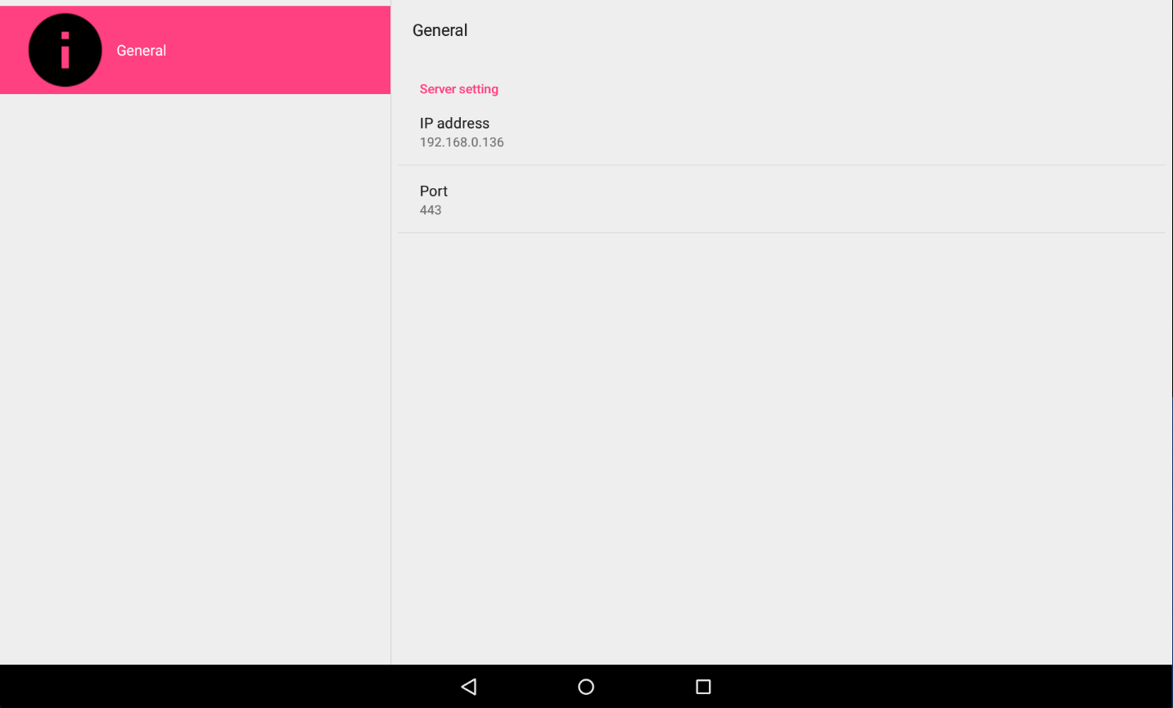

Figure 3.4 General Settings Dialog

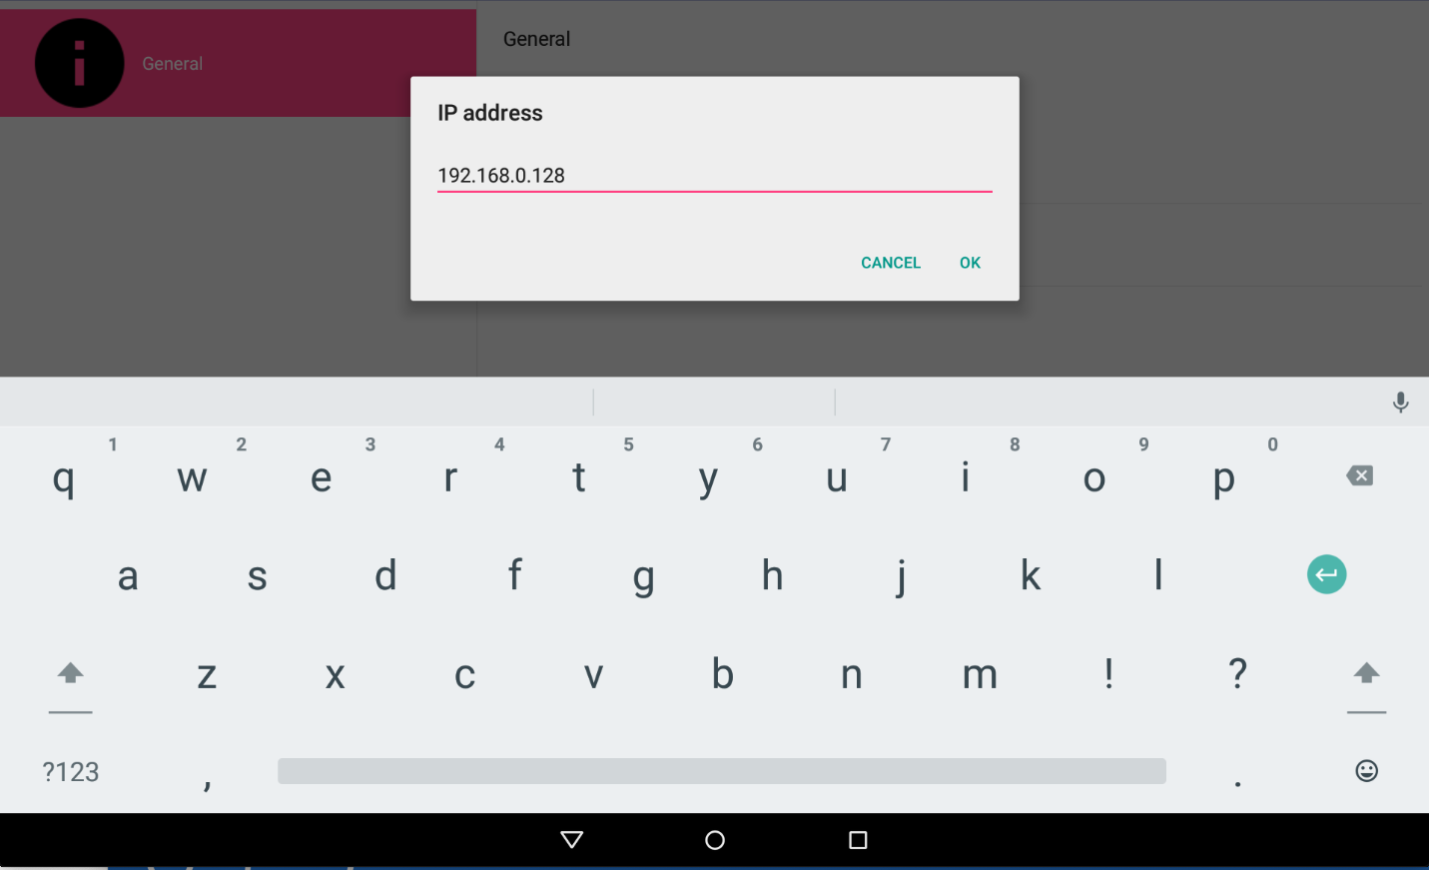

Figure 3.5 Changing the IP address of the server

Selecting a Station
Once you are logged in, you will need to select your station. The station selection controls what views you will have into the charts. For example, selecting ENT will configure the application to show only those portions of the chart that are relevant to ENT practitioners. Runners should select the Runner icon, regardless of the specialty they are supporting. See Figure 3.6, below.

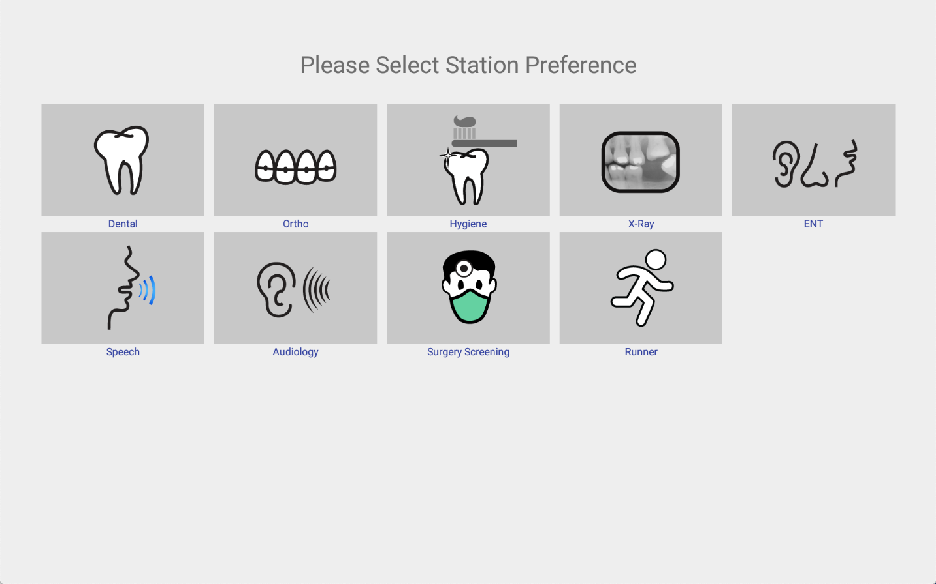

Figure 3.6 Station Selection Screen

To change your selection, you can either restart application, re-login, and make a new selection, or refer to “Changing the Station Type” later in this document. You only need to make the selection once for each login.

Patient Flow
Before we continue, it helps to briefly go over how patients flow in the clinic. In general:
- Patients are categorized at registration time based on the care needed.
- Headshots of the patient are taken at time of registration. These headshots are an aid to identifying the patients, visible in all patient searches, and at all times when the patient chart is being viewed.
- Registered patients are staged in a waiting area until called.
- The system assigns at registration time a routing slip consisting of stations the patient should visit based on that care. That routing slip is viewable and editable by runners and caregivers on the tablet.
- Runners are assigned to a specific station or set of stations, and they use the chart app to find a patient which needs to be seen by the station(s) that they support.
- Patients are checked in by the specialist (who also has a tablet) at the station in order to gain access to the chart. Access to chart data is based on the station type.
- Once a patient is seen, the runner or station must remove the patient from the routing slip.
- The patient is then checked out by the specialist.
- The runner then takes the patient to the staging area, or, if there is no longer an item in the routing slip, discharges the patient.
The following sections provide details of the above steps.

Categorization of patients
When patients are registered at the beginning of the day, they are categorized based on the general care they are to receive, based on input from the patient (“I need to see a dentist”) or a best estimate made by the registration personal. Categories include dental, surgery, hearing aids (patient is here to receive a hearing aid), and so on. The selection of a category will pre-fill in the chart, for this visit, a routing slip (See Section 3.6). The routing slip for a dental patient might include X-Ray and Dental, or for a cleft patient, Surgery Screening and ENT.

Runner Responsibilities

The main job of a runner is to make sure that patients are routed to stations based on the routing slip. To do this, they will:

- Identify a station to support for the day. See Section 3.4 for details. For example, a specific runner might support X-Ray. Each station should have one of more runners supporting it.
- Identify when a patient needs to be taken to the station(s) the runner is supporting. For example, a dental station may be staffed with a dentist and assistant, and be ready for the next patient.
- Search for a patient that has “Dental” in the routing slip. See Section 3.6, Patient Search.
- Locate the patient in the staging area, either by name, comparing to the photo displayed in the search result, or patient ID.
- Escort the patient to the station (e.g., dental chair)
- Remove the station from the patient’s routing slip. Once removed from the routing slip, the patient will not be listed in subsequent searches made by the runner for that station. For example, once Dental has been removed from the patient’s routing slip, the patient will no longer appear in search results for dental patients.

Patient Search
When a patient is not checked in at the station, the main screen of the EMR Chart application consists of a search screen. See Figure 3.7. This search screen is used by the runner to find patients to escort to a station, and at the station it is used to find patients to check in and gain access to the contents of the chart.
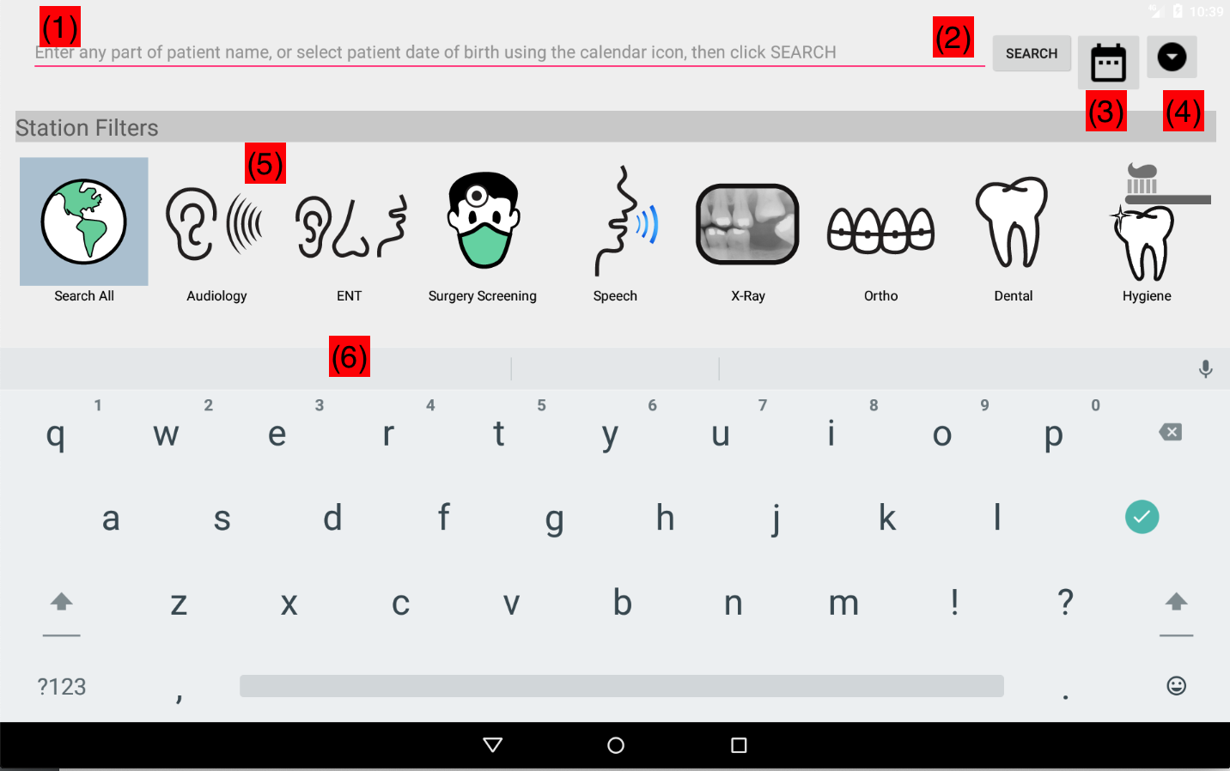

Figure 3.7 Main Search Screen

The search screen consists of the following sections (numbers are highlighted in Figure 3.7):
- (1) Patient search field. Here, enter 2 or more letters from the patient’s name (first, middle, last) or a date of birth. Search results will be filtered accordingly.
- (3) Calendar – use this to select the patient date of birth when searching by date of birth of the patient rather than by name. Note that you can only search by name OR by date of birth, not by both.
- (4) Options menu. Press and hold to access a menu to logout, change settings such as host IP address, or change your station type.
- (5) Station Filters. Selecting a station will filter the search results so that only patients that have that station in their routing slip will be displayed. Click “Search All” to search all patients registered at today’s clinic, regardless of the content of the routing slip.
- (2) Search button. Clicking this will cause the tablet to search for, and display, patients matching the search criteria specified in (1). If no search criteria was specified, all patients registered for today’s clinic matching the specified Station Filter in (4) will be displayed.
- (6) Results area. Headshots of matching patients will be displayed below the station filters. Click on a headshot to get more information about the patient, and the check the patient in.
If you enter a search term that contains whitespace, or is longer than a few characters, an error will be displayed as shown in the following figure:

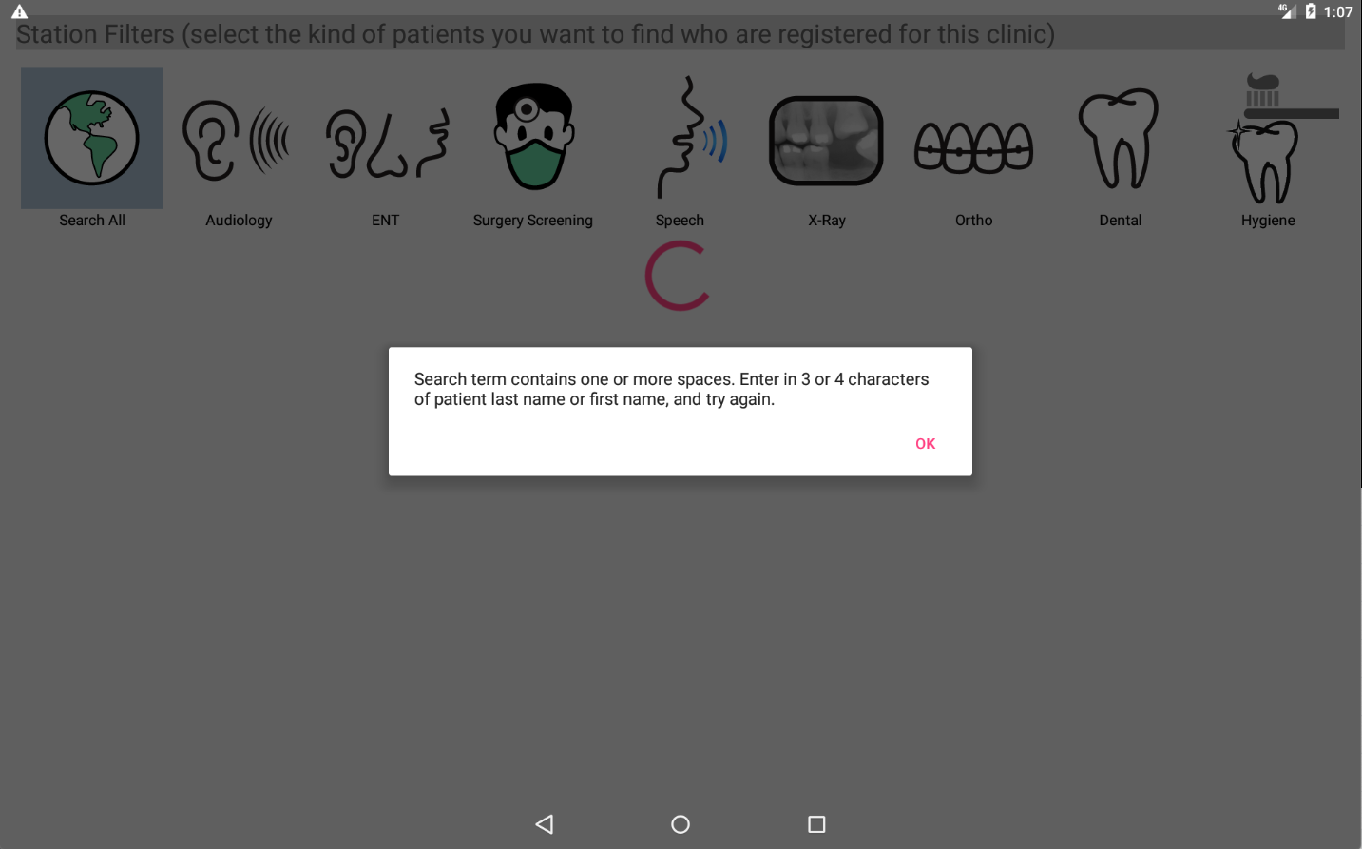

Example: Search for Dental Patients by Name
The following shows steps that can be used to find Dental patient 788 based on the father’s last name Gomez. This can be used by a runner to find a specific patient based on knowing the name of the patient. A station would use similar steps to find a patient to checkin (view and edit the chart) when presented with the patient by a runner.

1) Select Dental in the Station Filters. See Figure 3.8
2) Enter “gom” into the search field. See Figure 3.9.
3) Hit the Search button.
4) Using your finger, scroll through the headshots looking for a match based on the photo, or name of the patient. See Figure 3.10.
5) Click on the matching photo (Figure 3.11 and 3.12) to get more details and verify the patient (runners) or check the patient in (station).
6) Repeat steps 1 – 5 until you are able to find the patient. If unable, verbally verify that the patient has registered for the clinic, sending them back to the registration table if necessary. You might also use the “Search All” filter to search for the patient in case they were mis-categorized as Dental at registration, or for whatever reason, Dental was removed from the routing slip.

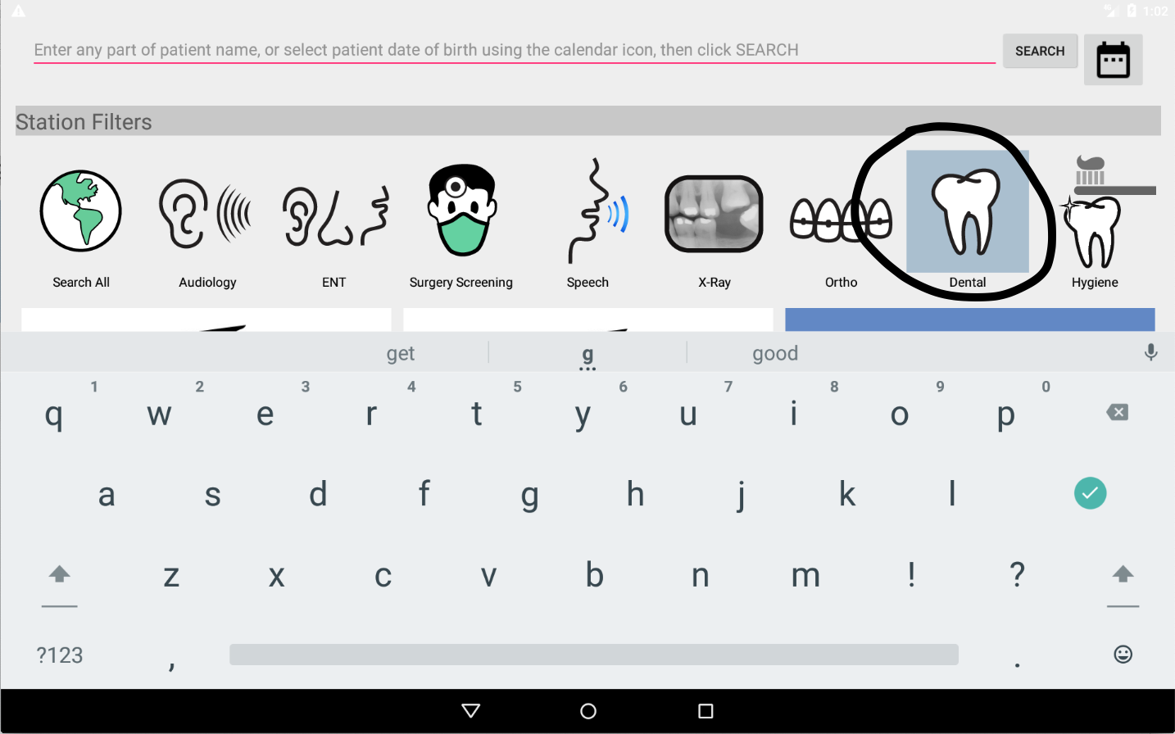

Figure 3.8 Selecting Dental Station Search Filter

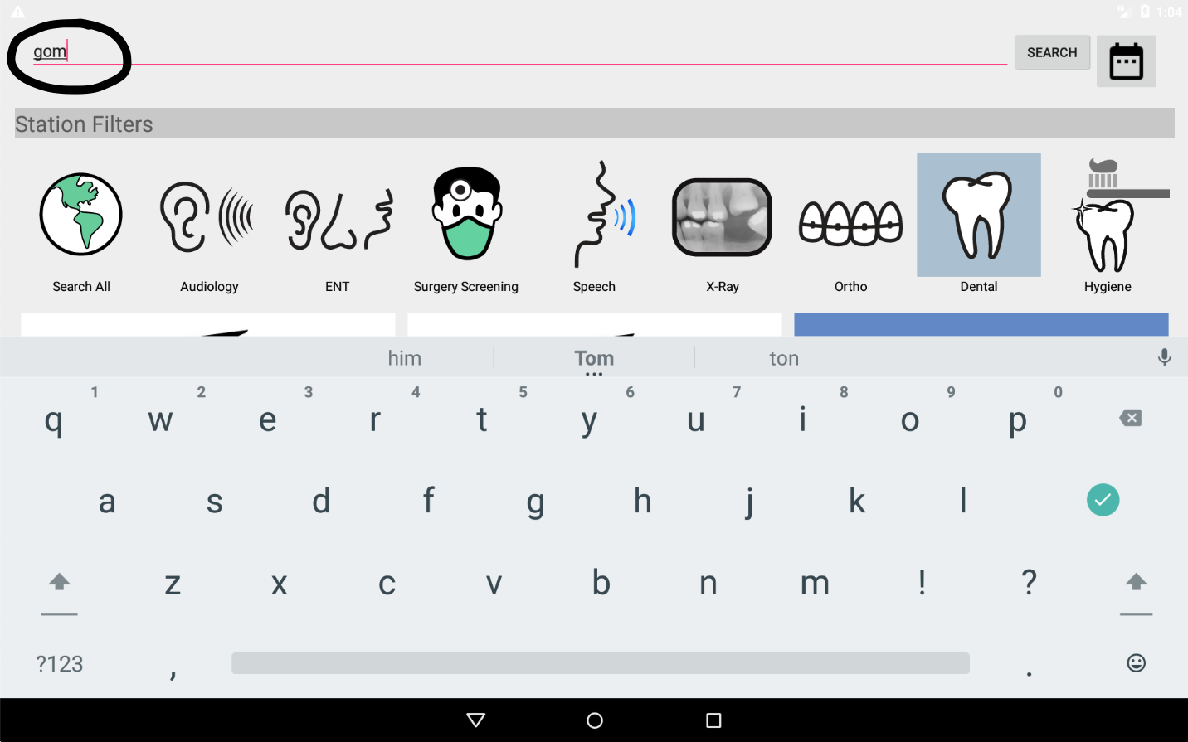

Figure 3.9 Entering Search Term “gom”

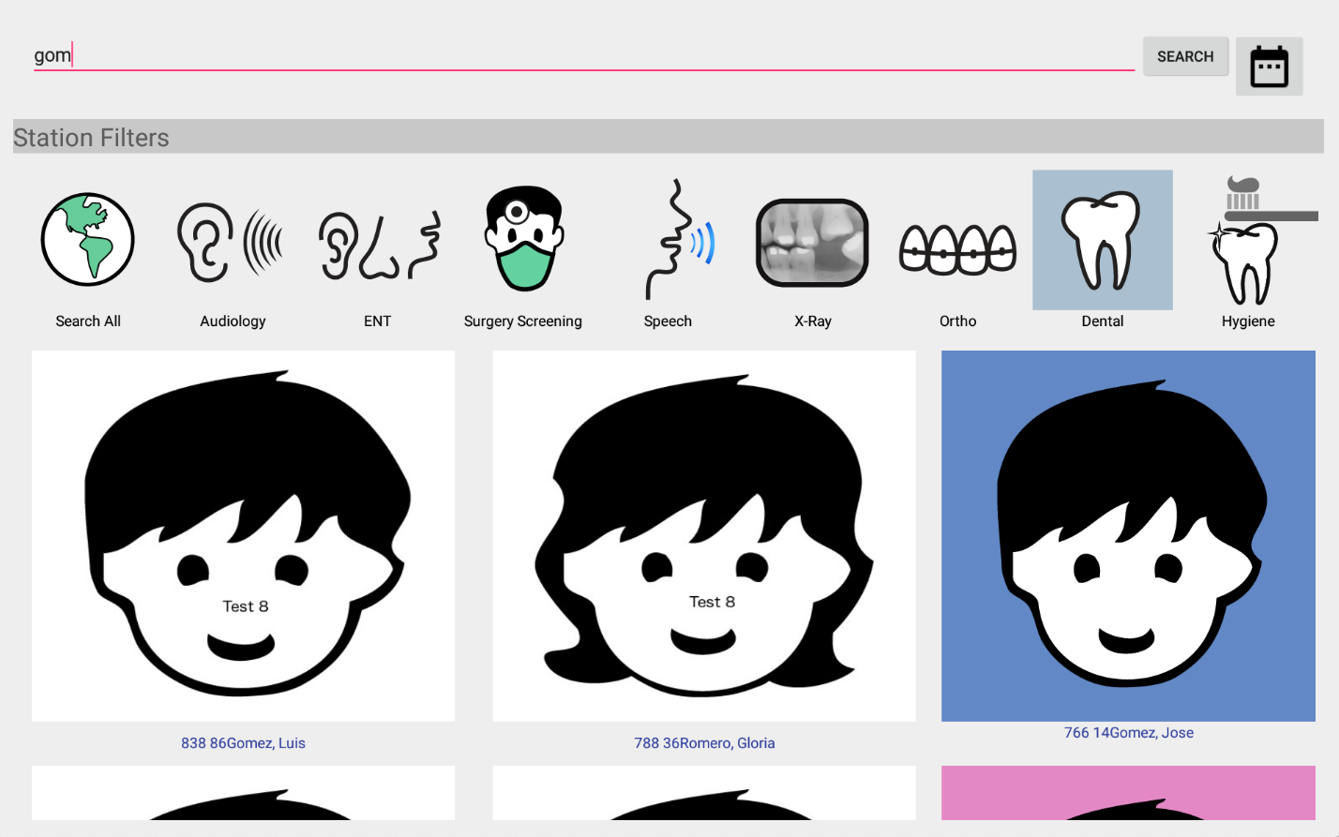

Figure 3.10 Search Results

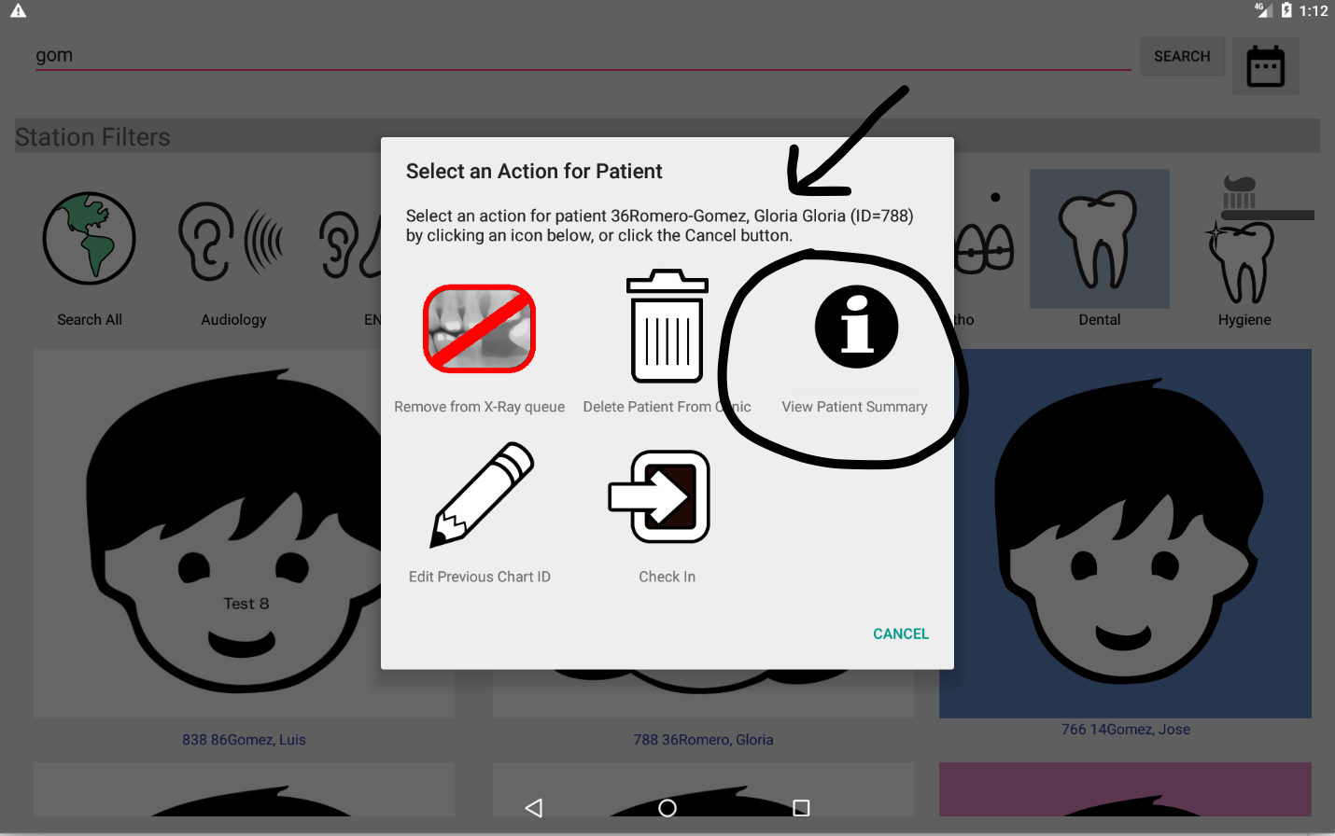

Figure 3.11 Clicking on headshot leads to full name and DOB of patient, plus options

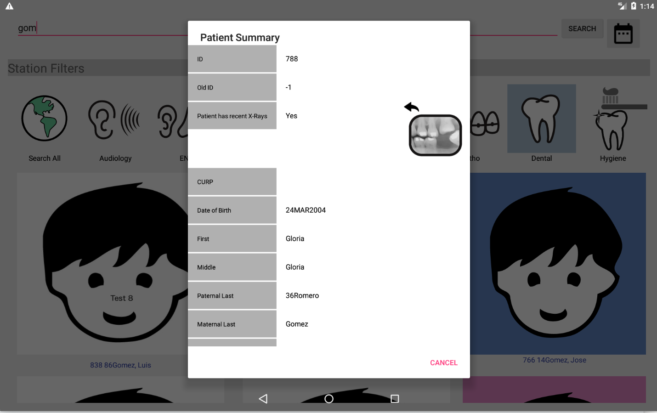

Figure 3.12 Clicking the “View Patient Summary” button for more patient info

Example: Find all patients waiting for Dental

This is the typical way a runner will find the set of patients with a specific station in their routing slip. Use this when you want to find a patient to route and it doesn’t matter which patient it is. Otherwise, search by name or date of birth.

1) Select Dental in the Station Filters. See Figure 3.8
2) Hit the Search button. You do not need to use a search term to see all patients that have Dental in the routing slip.
3) Using your finger, scroll through the headshots. See Figure 3.10.
4) Click on any photo (Figure 3.11 – Figure 3.12) to get full patient details, check in the patient, or perform other tasks.

Example: Find a Dental Patient based on Date of Birth
These steps are identical to search by name, but instead of entering part of the patient name, you want to search by patient date of birth.

1) Select Dental in the Station Filters. See Figure 3.8
2) Click on the Calendar Icon, locate and select the patient DOB. See Figure 3.7.1 and 3.7.2.
3) After dismissing the date selector, the DOB will display in the search field (Figure 3-15).
3) Hit the Search button.
4) Using your finger, scroll through the headshots looking for a match based on the photo, or name of the patient. With date of birth searches, only one or two results will usually match, making this the preferred way to search if the patient date of birth is known. See Figure 3.16.
5) Click on the matching photo (Figure 3.11 and 3.12) to get more details and verify the patient (runners) or check the patient in (station).
6) Repeat steps 1 – 5 until you are able to find the patient. If unable, verbally verify that the patient has registered for the clinic, sending them back to the registration table if necessary. You might also use the “Search All” filter to search for the patient in case they were mis-categorized as Dental at registration, or for whatever reason, Dental was removed from the routing slip.

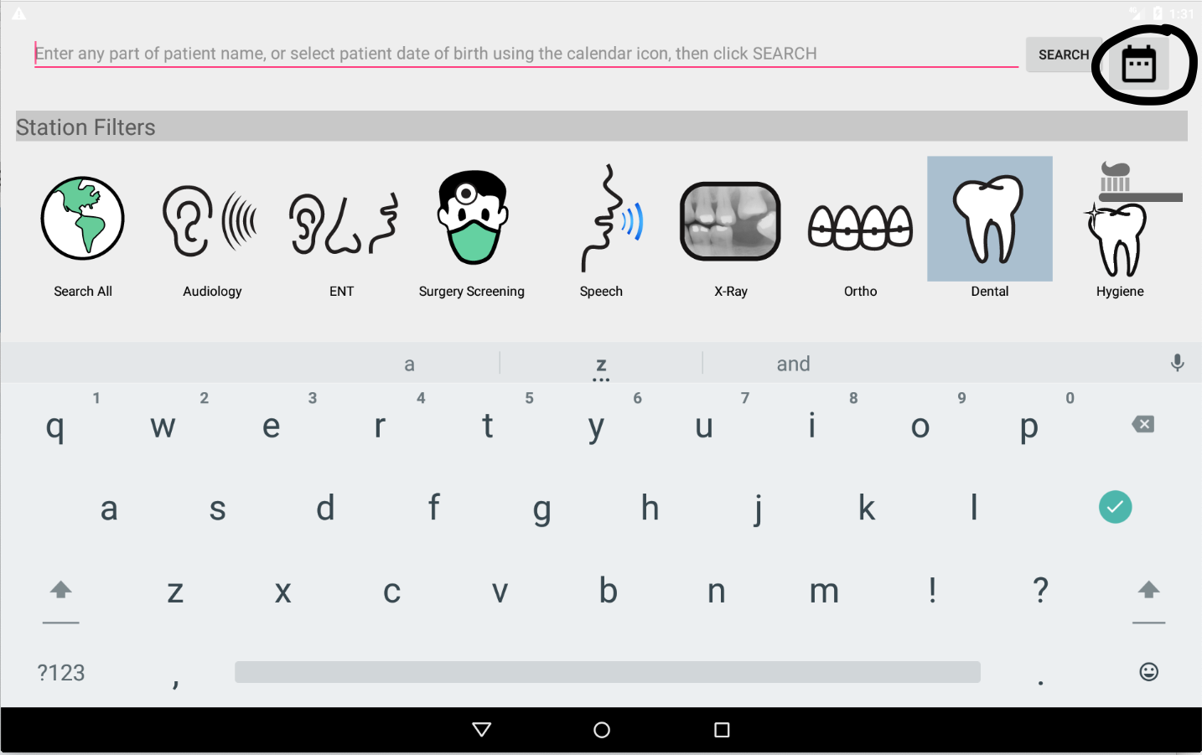

Figure 3.7.1 Location of the Calendar Icon

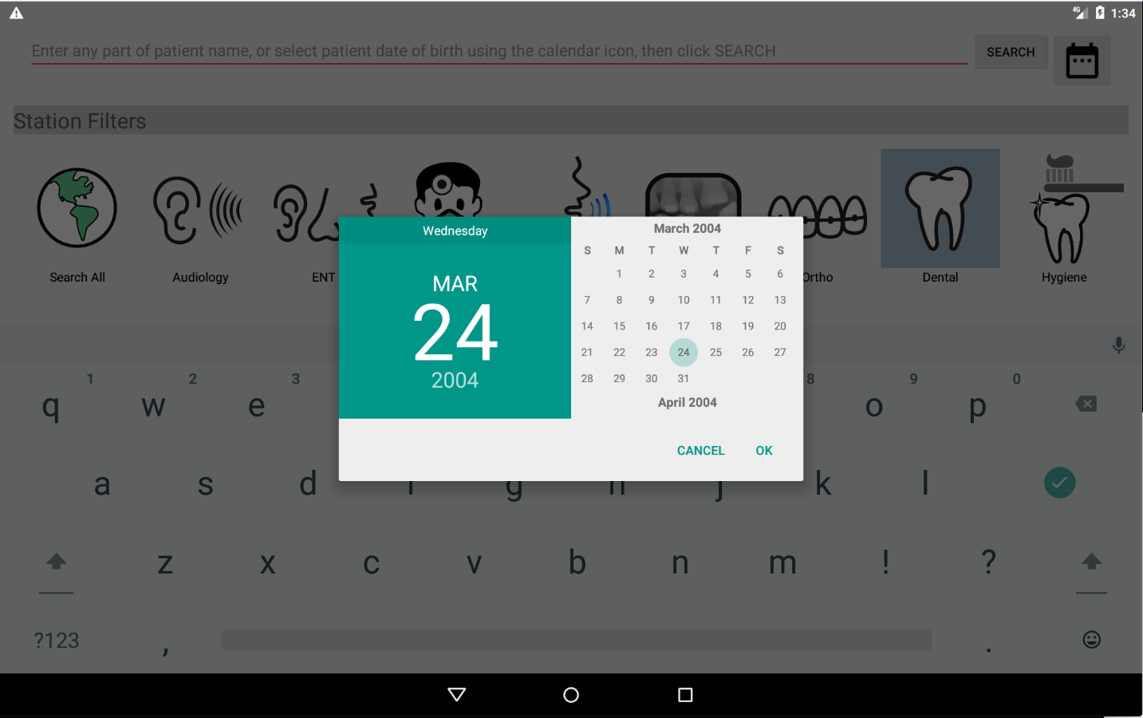

Figure 3.7.2 Calendar/Date of Birth Selection
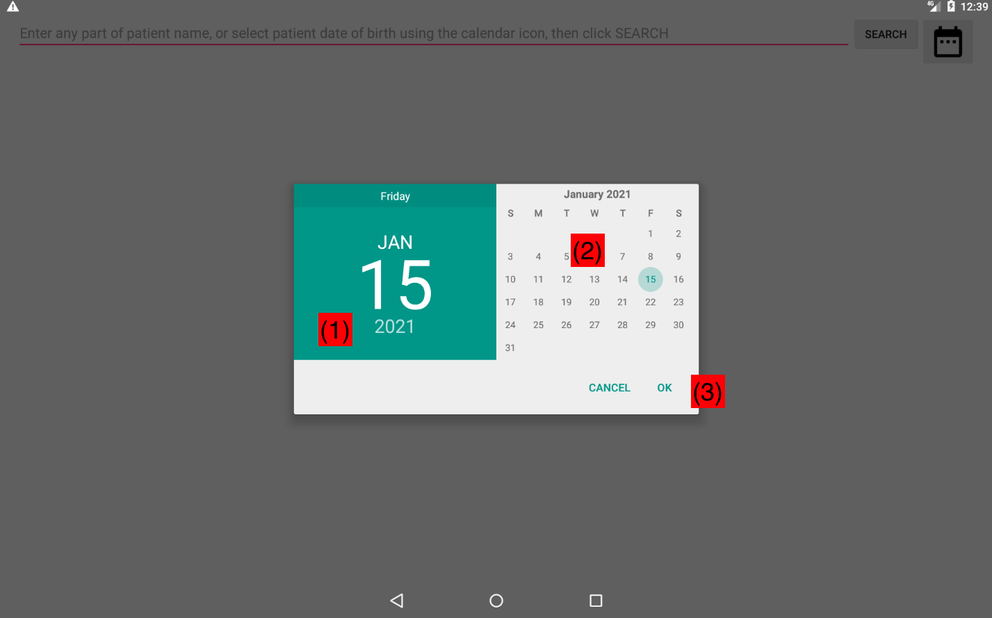

Figure 3.7.3 Date of Birth Selector

In Figure 3.7.3:

- Click on the year in area (1) to change the birth year. The control will change as shown in Figure 3.7.4. Scroll the years shown and select the correct year by touching it.
- Once the year is selected, area (2) can be scrolled with your finger to find the month of birth.
- Once the calendar for the month of birth is visible in area (2), click on the day of the month in area (2)
- Verify the date shown on area (1), repeat above steps if date is not correct.
- Click OK (3) to accept the patient date of birth.

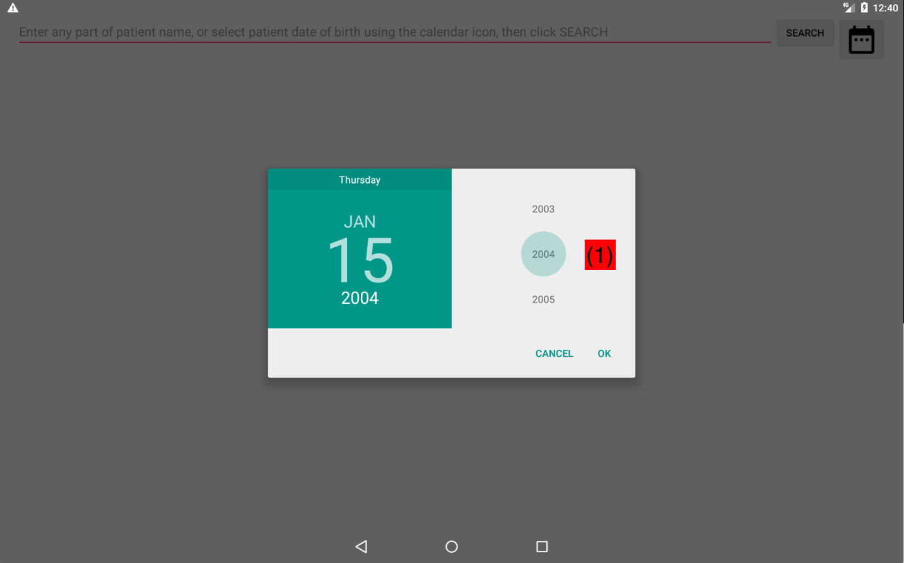

Figure 3.7.4 Select the year of birth in area (1)

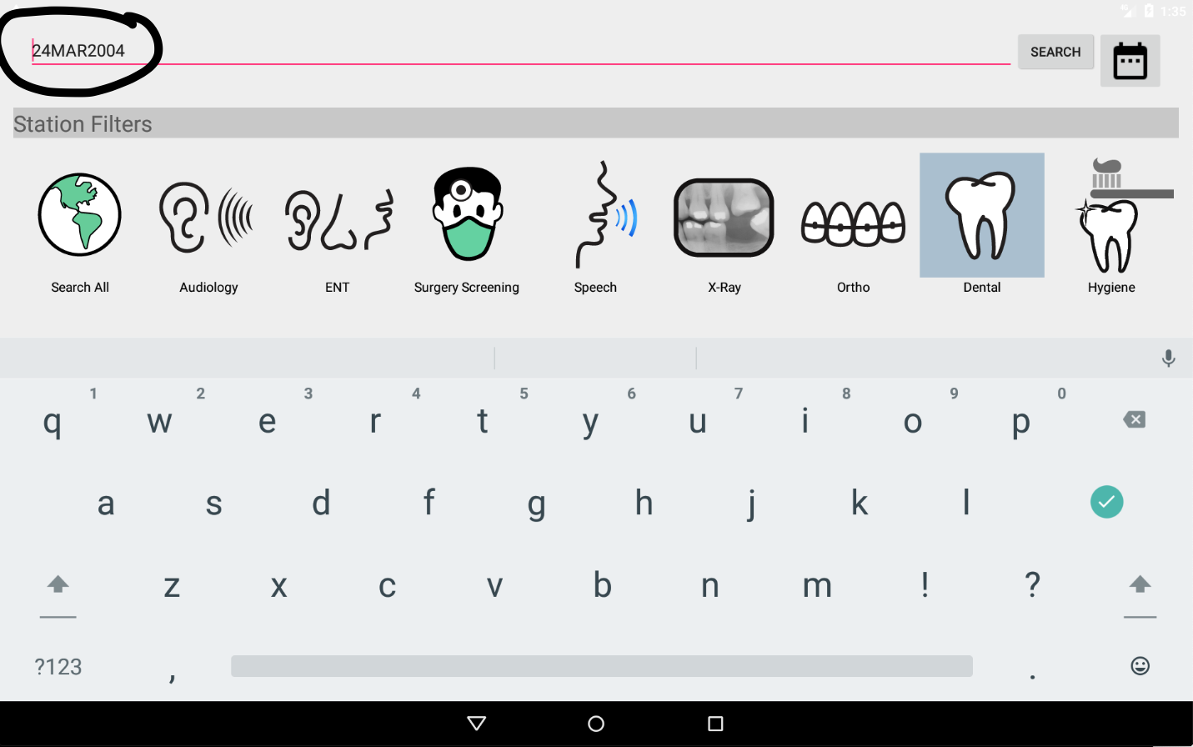

Figure 3.15 Search Field is set to Date of Birth Selected in Calendar Control

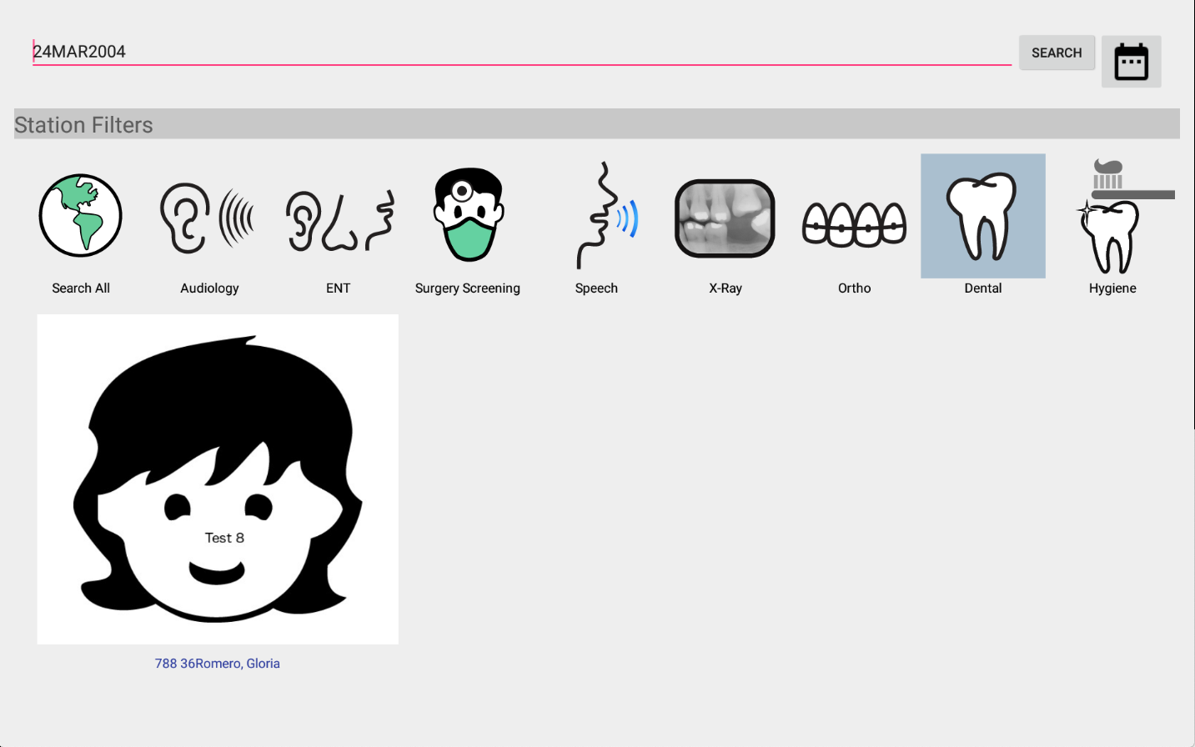

Figure 3.16 Patient registered for the clinic that has dental in routing slip and matches enter DOB

Patient Checkin, Data Access, and Checkout
Once a patient is identified at the staging area and taken by a runner to a station (e.g., a dental chair, X-Ray, etc..) that patient must be “checked in” in order to view and edit the patient’s digital chart. After the patient care has been provided at the station, the patient must be “checked out” in order to close the chart for that patient and return the tablet to the search screen where the process can be repeated for the next patient.

Checkin
A patient is checked in using the “Check in” button as shown in Figure 3.17 (a) (runners will see a Routing Slip button, as in Figure 3.17 (b). To get to this dialog, simply click on a headshot in the search results screen. When this button is touched, you will be asked to verify the checkin (Figure 3.18). By clicking “Yes”, you will be taken to the content of the patient’s chart, tailored to your station, for viewing or editing. If you are signed in as a runner, you will be able to access the routing slip. Refer to Section 4 for more details on viewing and editing the patient chart for your specific station.

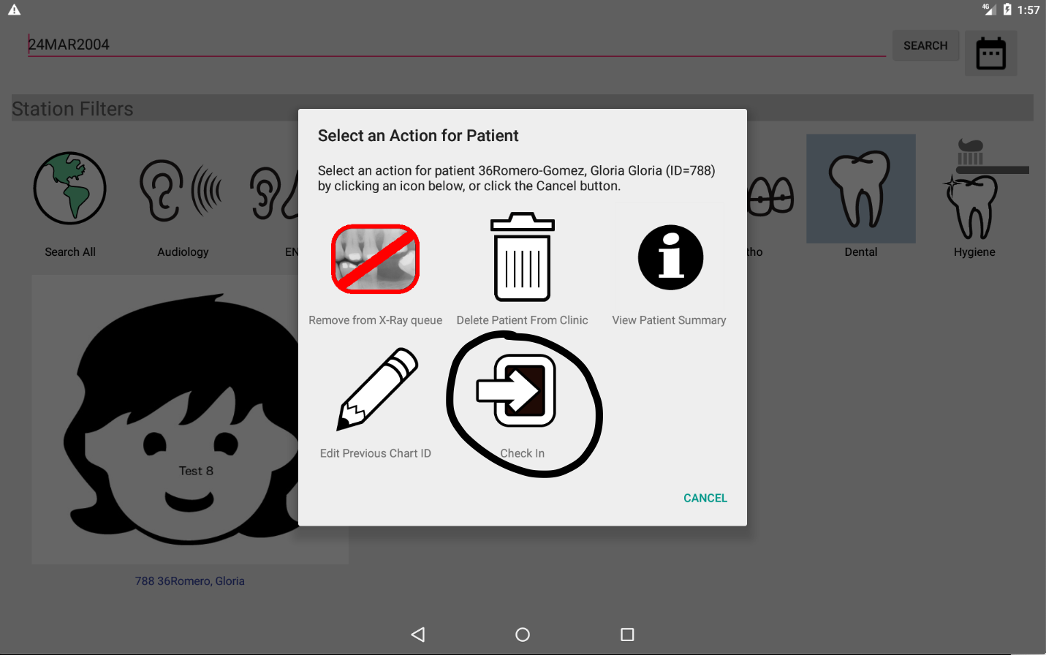

Figure 3.17 (a) Patient Check In Button

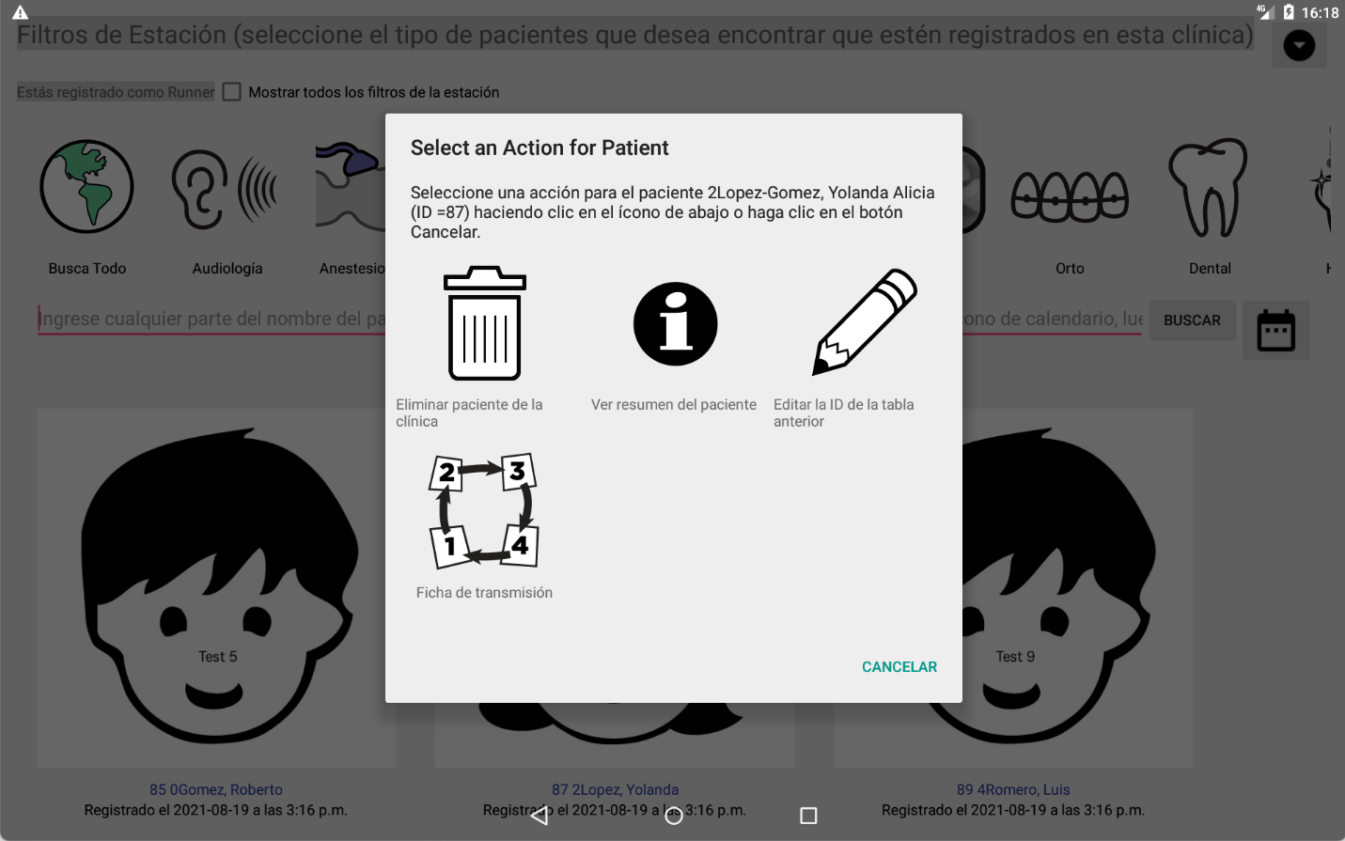

Figure 3.17 (b) Runners can view the routing slip.

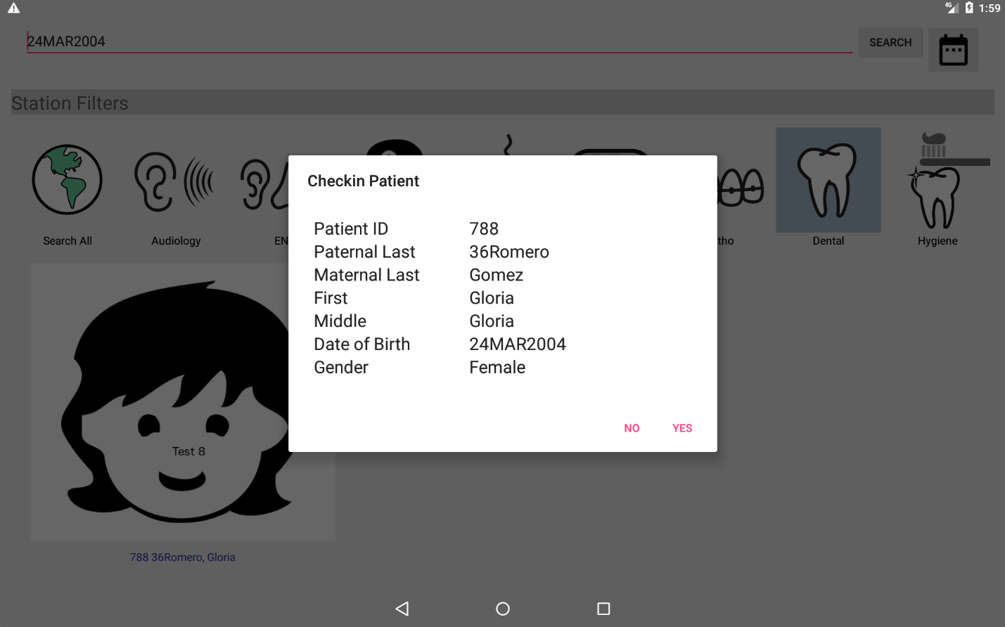

Figure 3.18 Verifying the Patient Checkin (a similar dialog confirms viewing the routing slip for runners)

Accessing Chart Data
Upon patient checkin, the screen of the device is split into four basic sections, illustrated in Figure 3.19.
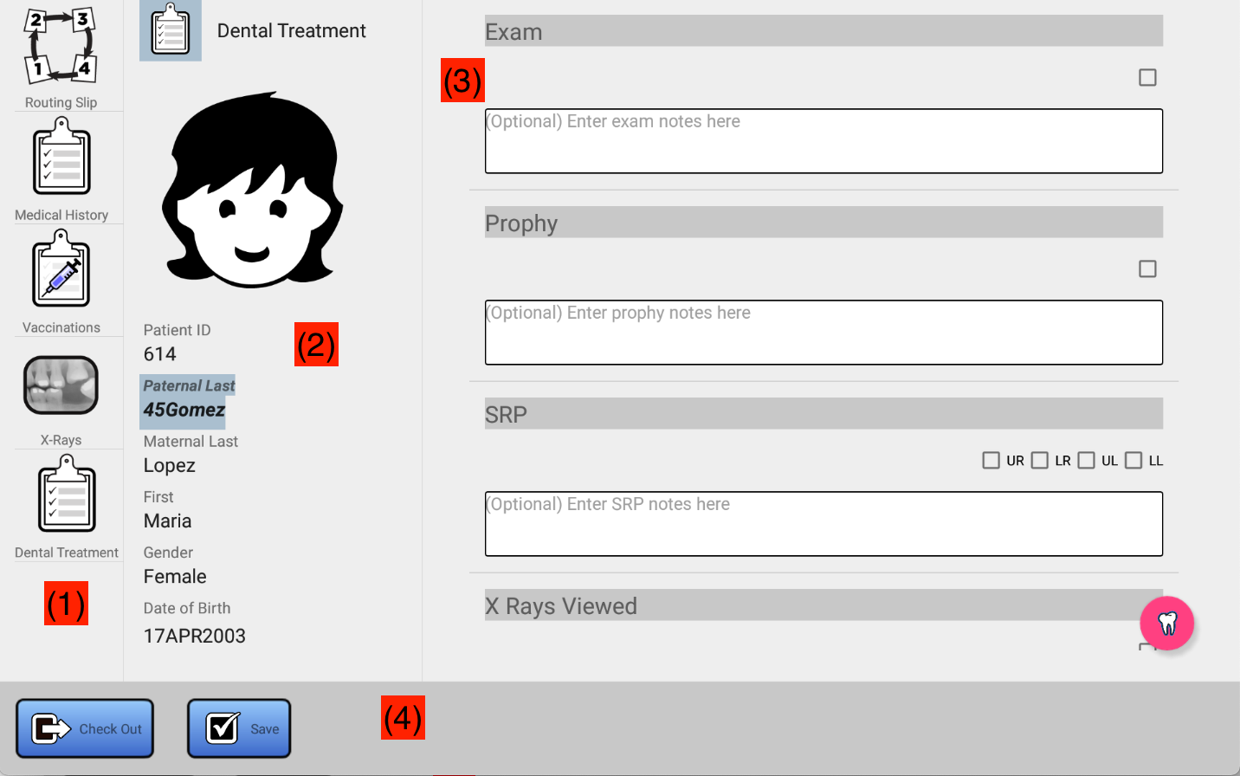

Figure 3.19 Patient Chart Screen Layout

(1) is the chart selector. Click on any item to access that part of the patient chart, each item represents a distinct view into the chart. The items which are displayed in (1) are based on the station that was selected (see Section 3.4). For example, if the station selected is Dental, then the items displayed in (1) will represent the patient dental chart. In all cases, these items will include Routing Slip, Medical History, and Vaccinations since both are relevant to a patient regardless of the care that is being given. Items relevant to the station located elsewhere in the chart, relevant to the station are also available here. For example, Dental will have access to the data recorded and stored in the X-Ray portion of the chart for the patient selected. Runners will only see the Routing Slip.
Making a selection in (1) controls what is displayed in area (3).
(2) is the patient information. This section identifies the patient to which the chart data corresponds. The headshot will be that of the patient taken the day of the clinic. The ID, name, gender, and data of birth should match that which is found on the patient wristband, if present.
(3) is the chart data. What displays here depends on the item selected in (1). For example, if X-Ray is selected in (1), patient X-Ray data will be shown. This area can be used to view records, and at times create new records. The data displayed here is typically read/write, meaning you can add or edit items in the chart, or view them. In some cases, however, it is read-only. For example, X-Ray staff can add or view X-ray data for the patient, but this data can only be viewed by Dental staff. Similarly, Audiology can create audiograms, but ENT can only view them. This is to maintain the integrity of the data in the chart. Items in the chart cannot be deleted, this is also to ensure the integrity of the chart. Starting with Section 4 of this manual you can find detailed documentation for each area of the chart (X-Ray, Dental, ENT, and so forth).
(4) is the menu area. Here, you will see buttons displayed that allow you to save data, check out the patient, and perhaps other functions.

Checking out the Patient
You must “check out” the patient once all patient data has been added to the chart at the station, and you have removed your station (Dental, X-Ray, etc.) from the patient routing slip. Once the patient is checked out, you will be returned to the search screen, allowing you to search for, and check in, the next patient. In Figure 3.20, we have completed (but not saved) the dental treatment record for patient 788, and are ready to dismiss the patient back to the staging area. This can be done by clicking on the “Check Out” button that is circled in Figure 3.20. If there are changes to be saved (as there are in this case, since there is a Save button displaying), then you will be prompted to save those changes as a part of the check out process (Figure 3.21). You will also be given a dialog allowing you to add final notes and specify a return to clinic interval. See Figure 3.22. Once that dialog is dismissed, you will return to the search screen where you can search for the next patient.

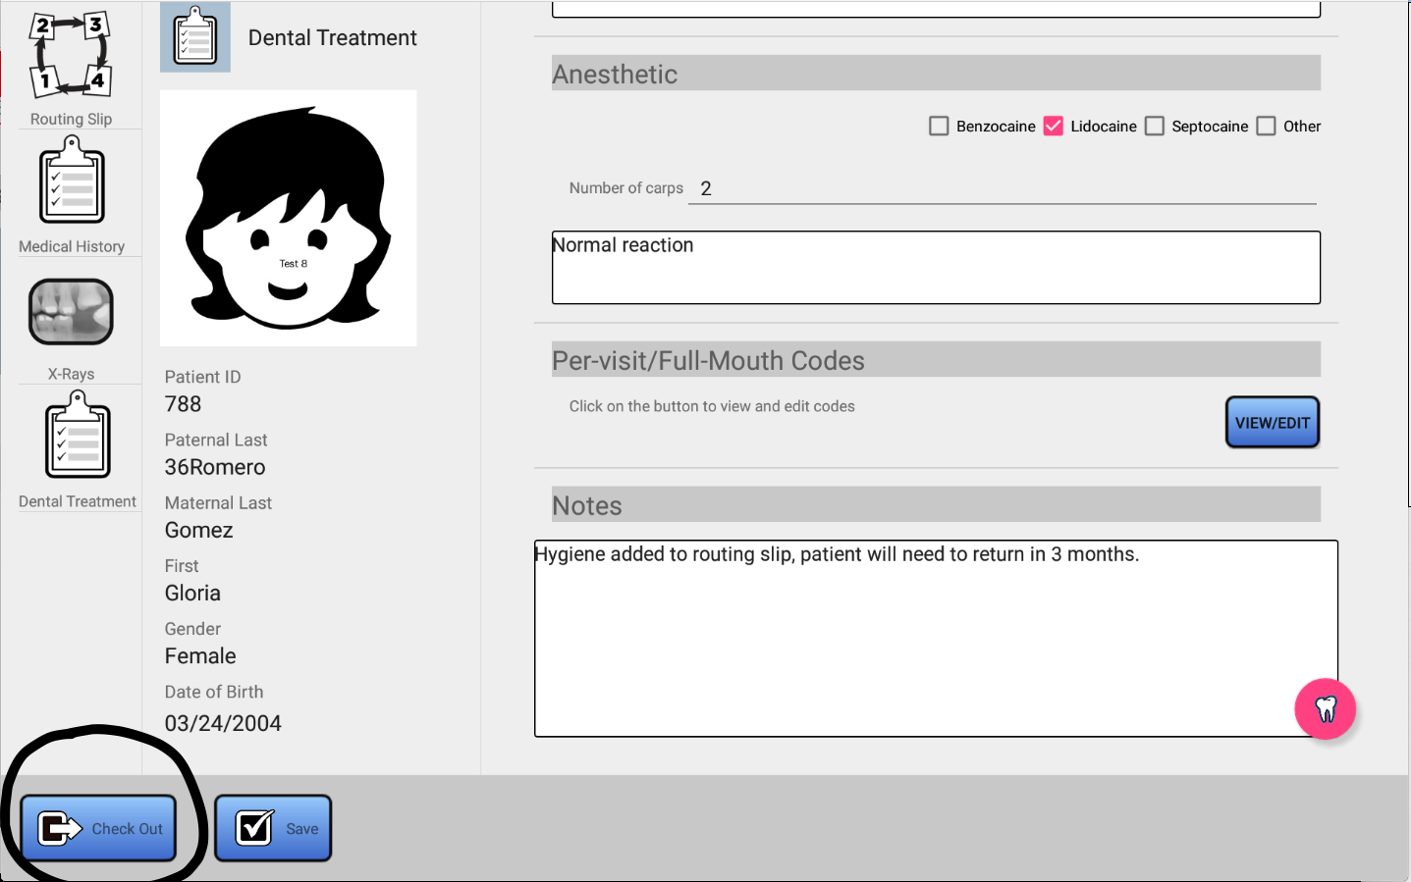

Figure 3.20 Patient Checkout Button (For runners, this will be a Return to Search button)

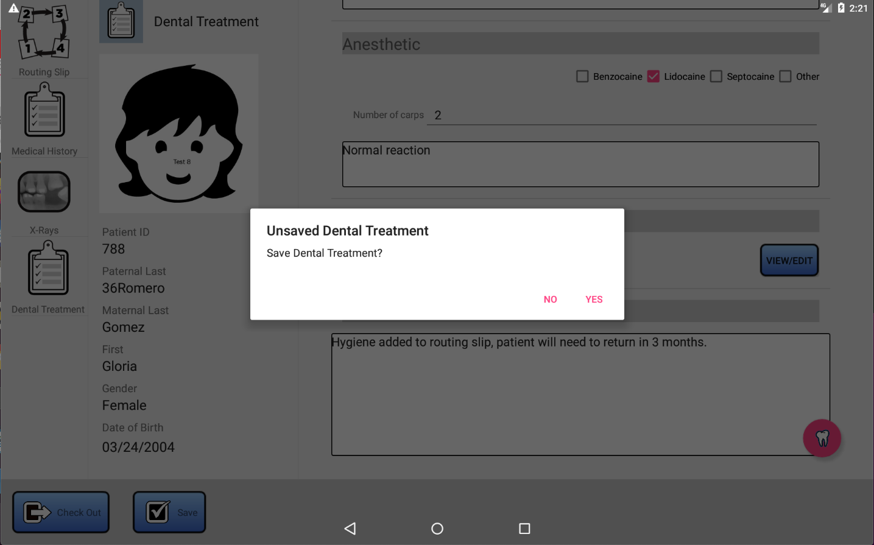

Figure 3.21 Handling unsaved changes at patient checkout

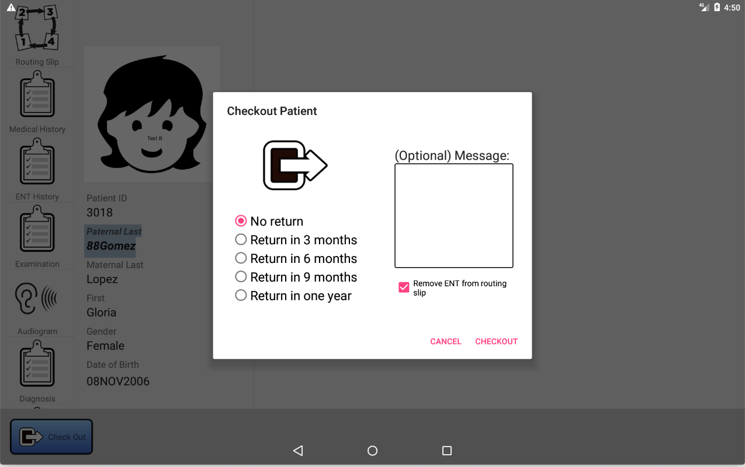

Figure 3.22 Checking Out – Return to Clinic and Final Notes
Notice in Figure 3.22 that a checkbox is present indicating that ENT will be removed from the routing slip. This is present in the dialog because the user is signed in as ENT, and ENT was not removed from the routing slip before the Check Out button was pressed. Leaving the checkbox checked will result in mentioned station (here ENT) being removed from the routing slip. To keep your station in the routing slip, uncheck the checkbox. In almost all cases, you will want to remove the patient from the routing slip at checkout.

Routing Slips

Introduction

When a patient is registered, he or she is categorized based on care needed. The categories are:
- Dental
- Orthodontics (Ortho)
- Ears (not cleft, but has hearing issues)
- Hearing Aids (returning Ears patient for hearing aid dispensing)
- Cleft (Initial visit)
- Cleft (Returning visit)
- Other
The category is assigned based on discussion with the patient, family, or perhaps consultation with a caregiver present in the registration area. Each category implies a sequence of steps in the care of the patient, and a list caregivers/stations that the child should visit while at the clinic. For example, a dental patient may visit X-rays, a dentist, and hygiene before the day is complete. These stations are all present in the patient routing slip.
Runners use the routing skip to find patients to take to the station(s) that they are supporting.
Caregivers use the routing slip to add additional points of care that were not assigned by default at registration. For example, a dentist may add hygiene to the routing slip of a dental patient after determining a child’s teeth are in need of cleaning. Or, ENT may add audiology to the routing slip in order to get an audiogram taken for a child that he or she has seen.

Changing the Routing Slip
Both runners and caregivers, working together, ensure that the routing slip is accurate by removing stations from the routing slip of a patient once work is completed. It doesn’t matter who actually performs this step, but not doing so will make the job harder on a runner because a patient who has already seen dental, for example, will see that patient in dental search results, leading to confusion. Once removed from the routing slip, say dental, a patient will no longer show in the list of patients needing to be taken to a dental chair when a search is performed.
To see the routing slip, the caregiver or runner must check in the patient (a runner can check in patients just like any of the caregivers, but the only part of the chart they have access to is the routing slip). Figure 3.23 identifies the location of the routing slip portion of the chart. Click on that icon to view and modify the routing slip, as shown in Figure 3.24.

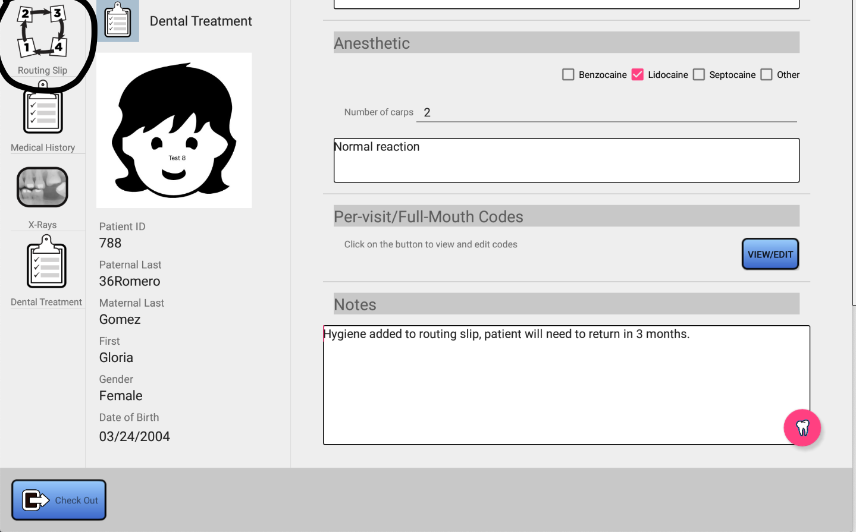

Figure 3.23 Routing Slip Icon

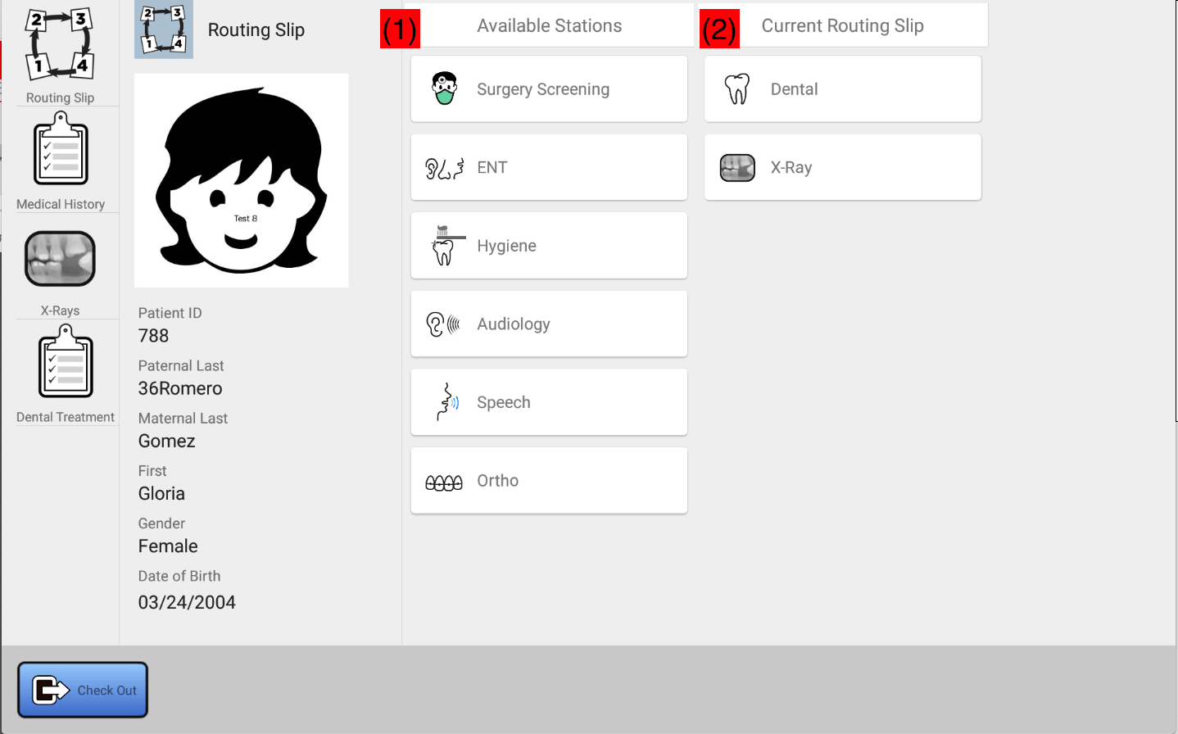

Figure 3.24 Routing Slip

In Figure 3.24, you can see that the routing slip consists of two columns. The left column (identified by (1) in the figure) list stations that are available in the clinic, but not a part of the current routing slip. Searches made for patients filtered by any of these stations will result in the patient not being shown in the results. The right columns (identified by (2) in the figure) contains the current patient routing slip.
You can use your finger to drag and drop items from one list and drag them to the other. Hold your finger down over the item for about 1 second, then you will see it detach from the current list (Figure 3.25). Then, while still holding your finger down, drag it to the other list and lift your finger. It will then be added to the destination list (Figure 3.26).
You can make as many changes as necessary. Use the Save button on the lower left corner of the screen to save changes.

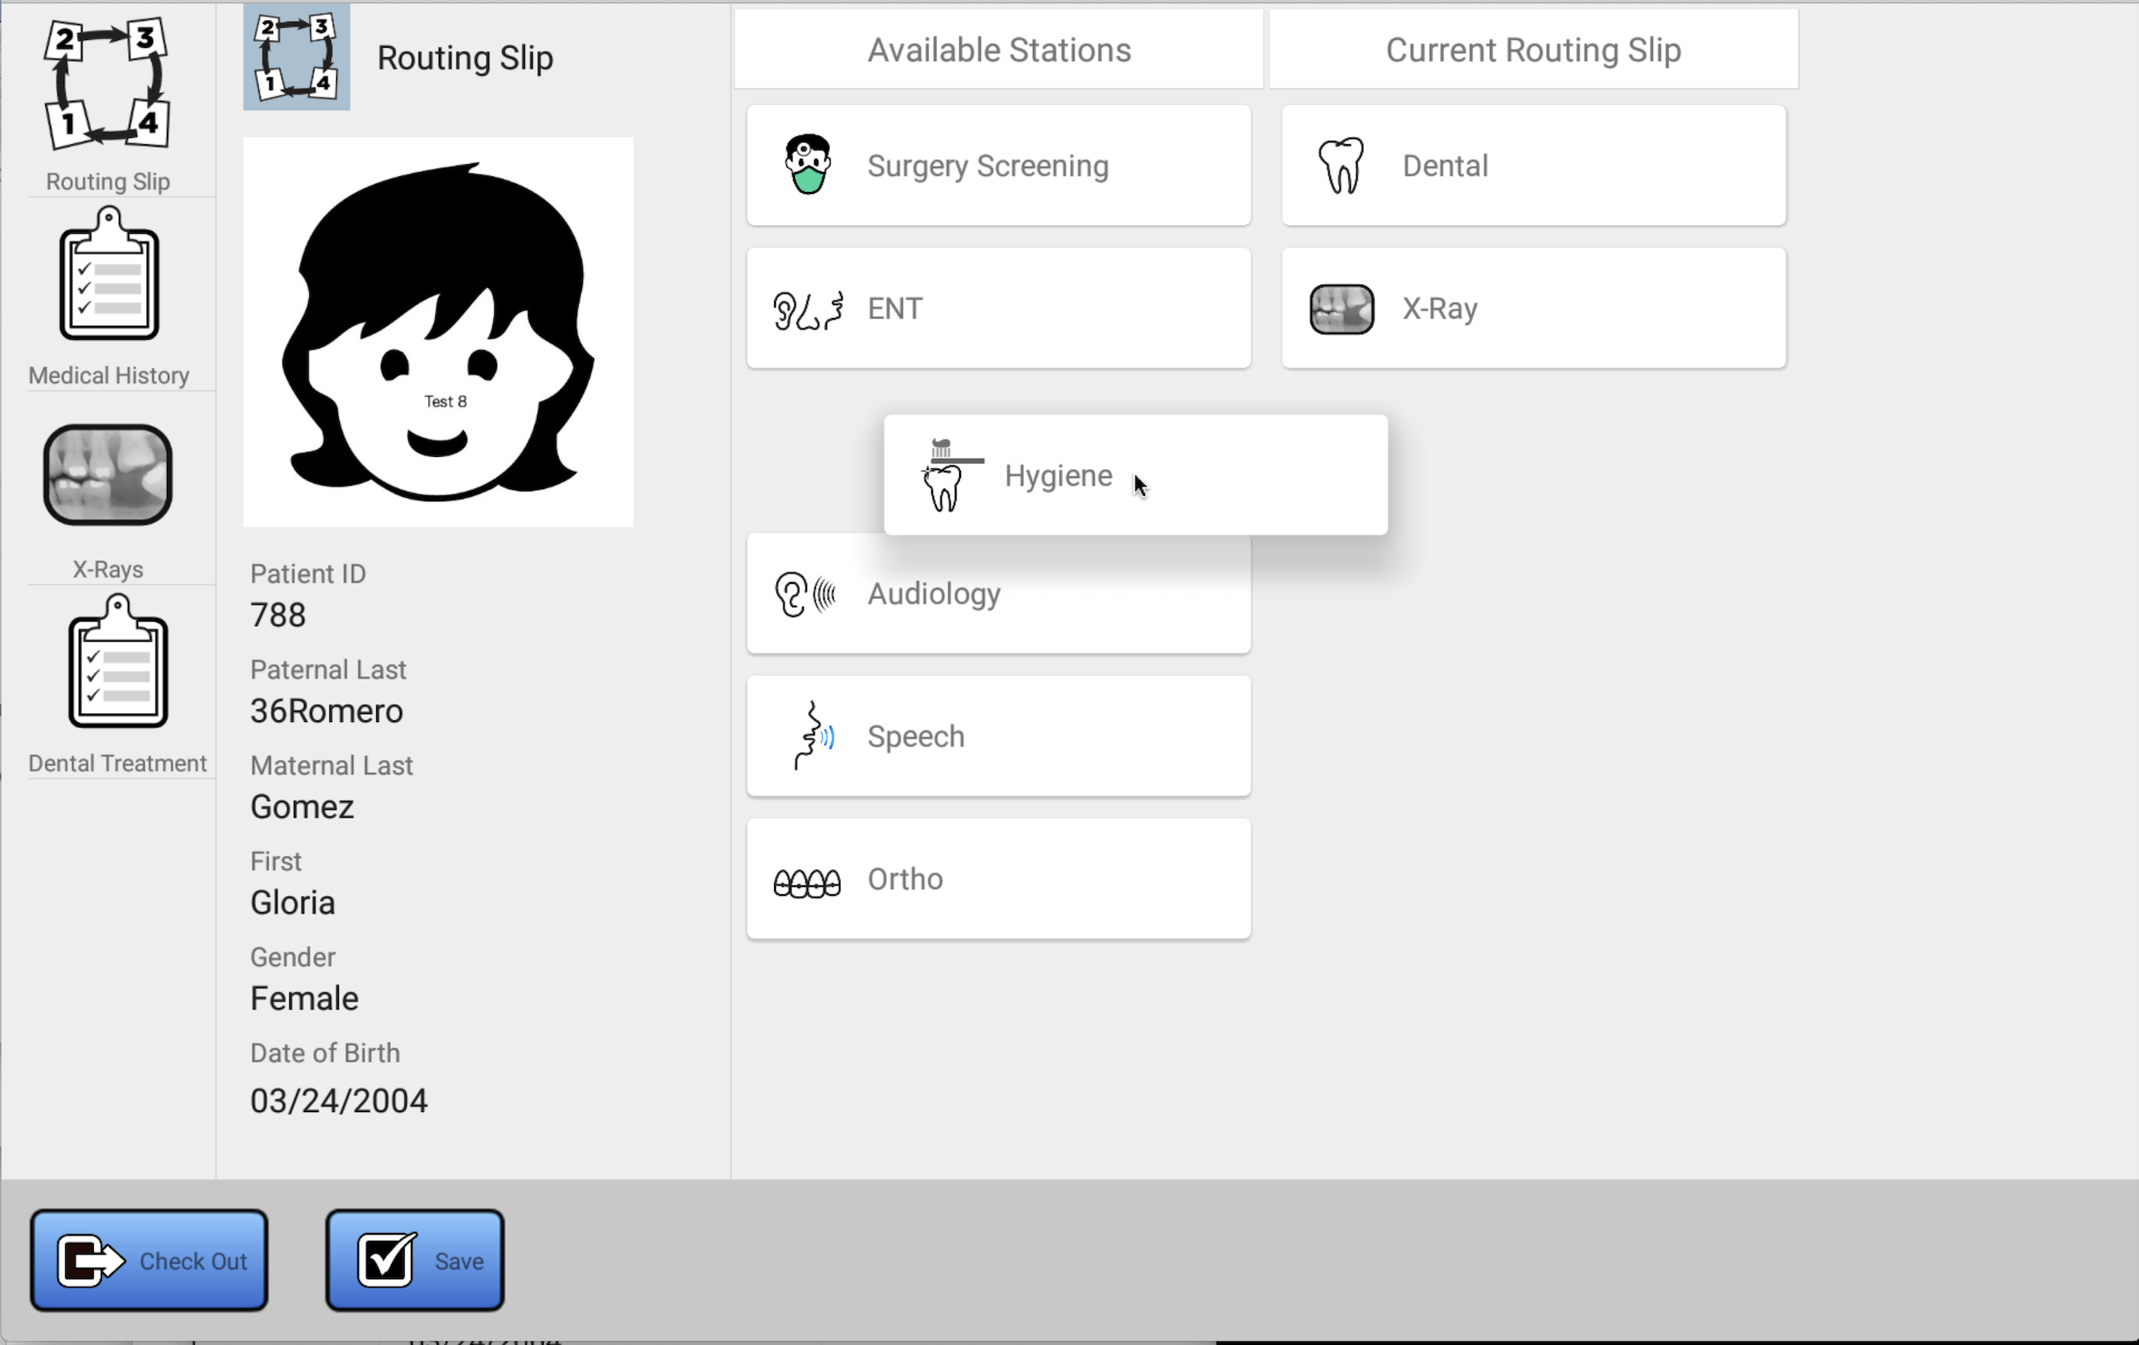

Figure 3.25 Dragging Hygiene from the available list to the routing slip

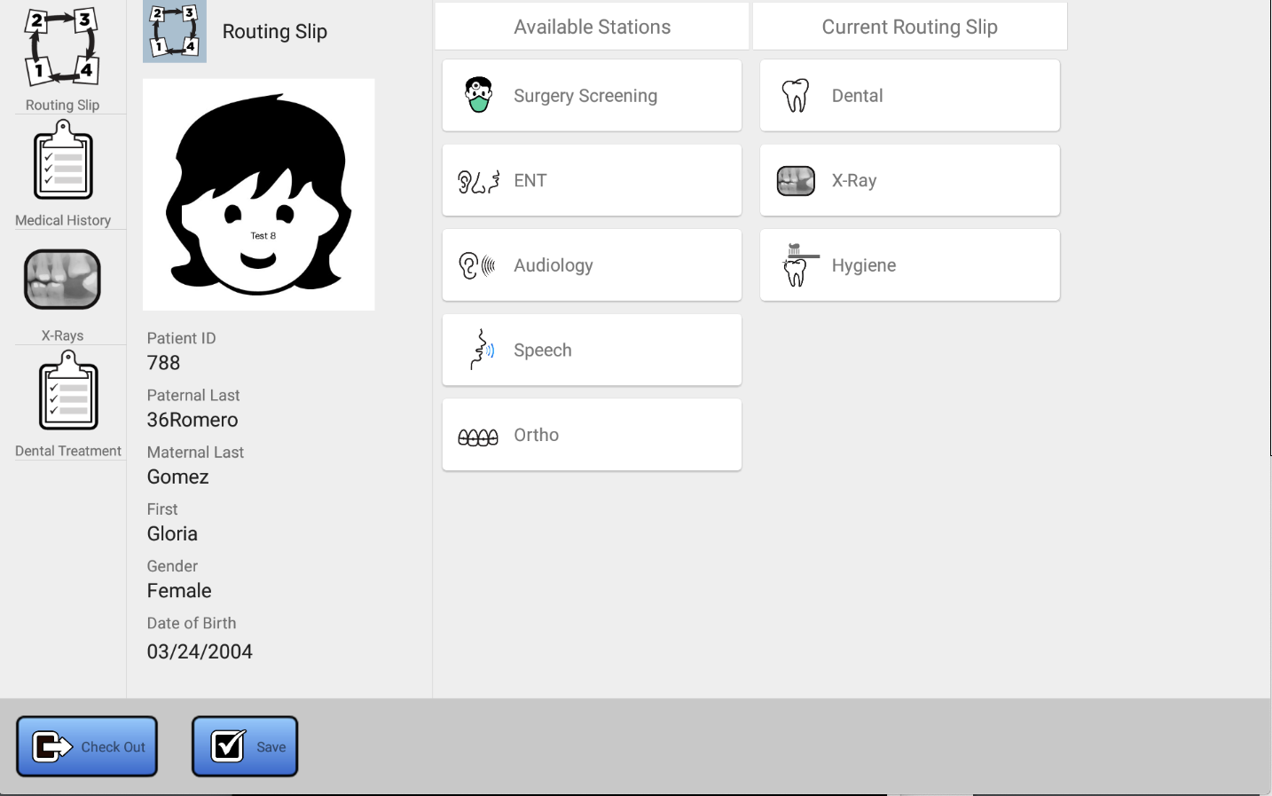

Figure 3.26 Hygiene is now on the routing slip

Removing a Patient from the Clinic
On occasion, patients will leave the clinic without notice prior to visiting each station on the routing slip. When this child is called by the runner, there is no response after repeated attempts. Or, a child may need to be discharged at the discretion of staff (for example, the child might have a fever and needs to be sent home).
This can be done by the following steps:
- Search for the patient using the search screen.
- Select the patient.
- Click on the “Delete Patient From Clinic” button and follow the instructions (Figure 3.27).
Note: none of the data that was obtained (X-Rays, chart entries) will be removed. The patient will simply no longer be listed in search results.

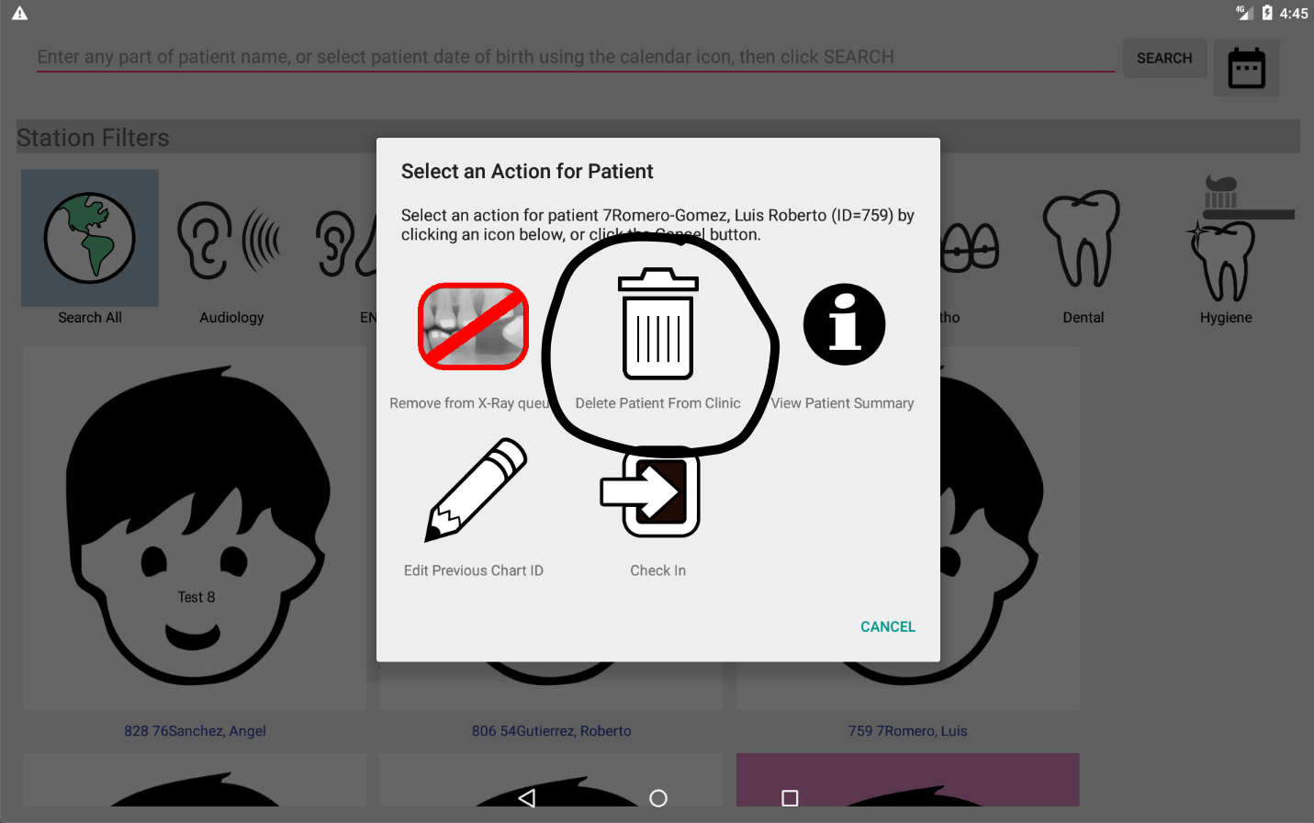

Figure 3.27 Removing a Patient from the Clinic

Recording the Paper Chart ID
As of this version of the chart application, surgery screening is not yet supported, so while the tablet should be used by the runner supporting surgery screening to locate patients that have registered at the clinic in need of surgery screening (via the routing slip), paper charts will still need to be retrieved. This, it is necessary to map the paper chart (or previous) ID that was assigned to the patient in the legacy database with the patient as recorded in the new system. The older ID number is affixed to each paper chart, and having it will assist the runner in finding the paper charts for the patient. The ID assigned by the tablet-based EMR is a different number than that used in the older system. It is recommended that once the paper chart is retrieved, that the new number be affixed to the chart, so that a lookup of the older number is no longer necessary.
This paper chart number might also be used to record the paper chart number for charts in archive, in case we are completely digital yet for some reason, there is a need to go back and look at something in the older paper charts. There can only be one “paper” chart ID recorded for each patient.
Regardless of the reason, you can record a paper chart number by following these steps:

- Search for the patient using the search screen.
- Select the patient.
- Click on the “Edit Previous Chart ID” button (Figure 3.28).
- Edit and save the previous chart ID (Figure 3.29)

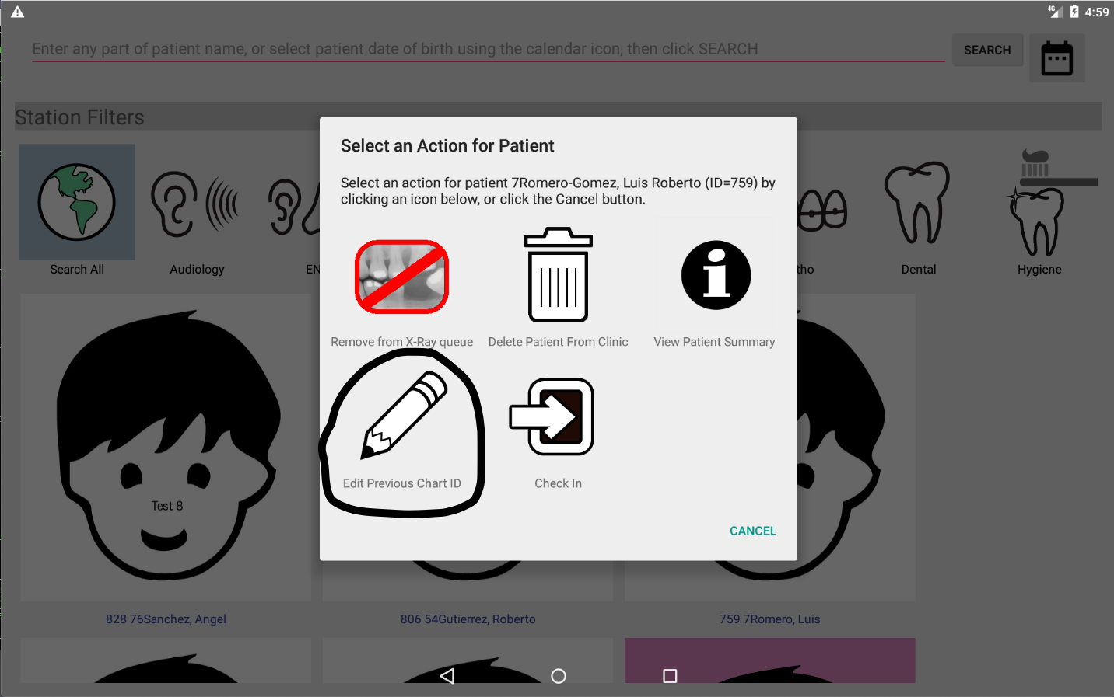

Figure 3.28 Edit Previous Chart ID

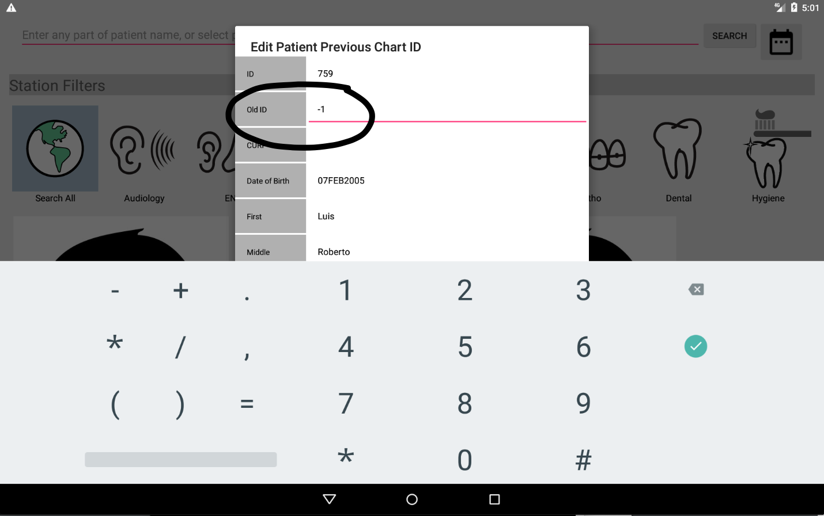

Figure 3.29 Editing Previous Chart ID

Note that the chart ID “-1” is reserved to indicate that no such chart exists.

Retrieving the Patient Paper Chart ID
As described in the previous section, patients may have previous paper charts, and their ID may be stored in the database. Looking up this paper ID chart may help in searching for that chart. The expected use case for this at this point is surgery screening and perhaps orthodontics, which currently are not supported in the digital charts. To view the previous paper chart ID, follow these steps:
- Search for the patient using the search screen.
- Select the patient.
- Click on the “View Patient Summary” button (Figure 3.30).
- The patient ID is displayed as shown in Figure 3.31

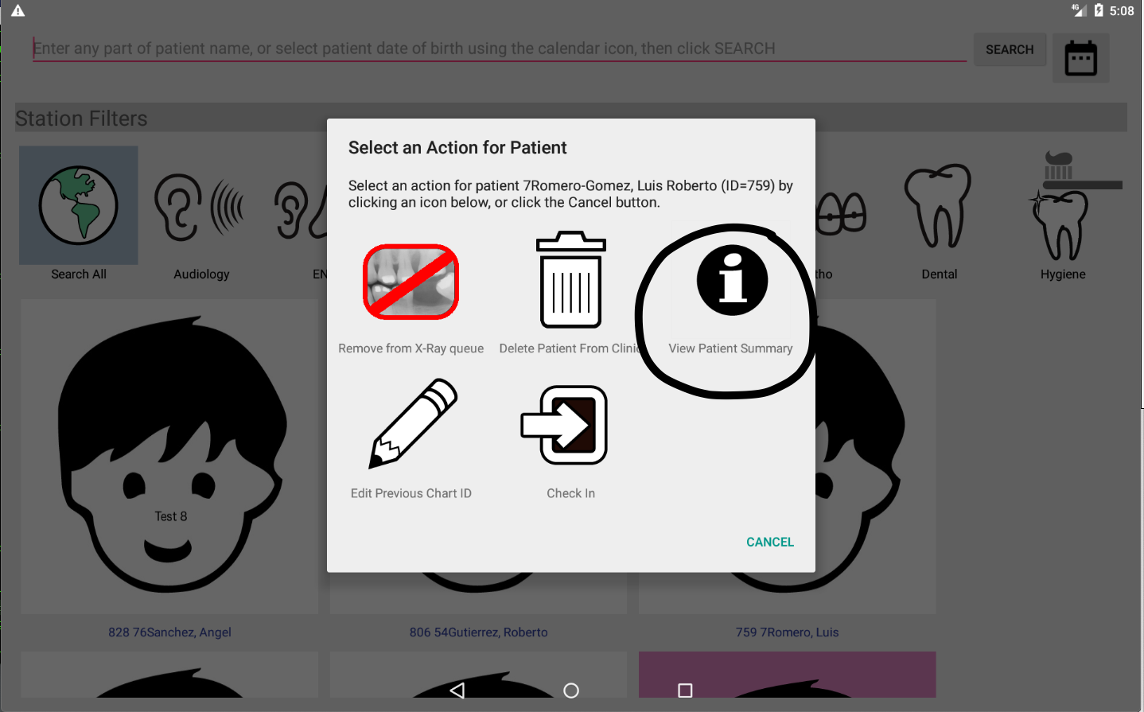

Figure 3.30 View Patient Summary button

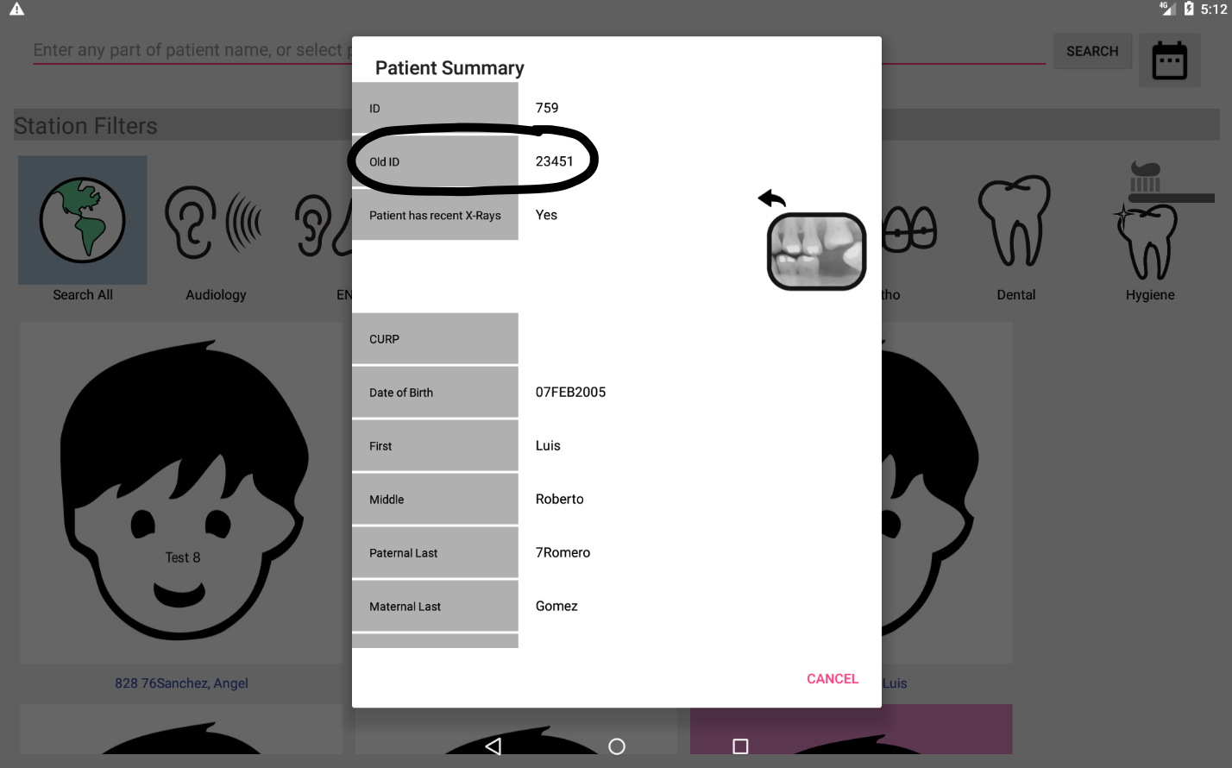

Figure 3.31 Old Chart ID (-1 indicates there is none recorded for this patient)

Removing X-Ray from the Routing Slip
The policy of Thousand Smiles is that patients are given no more than 1 set of x-rays per 12 month (1 year) period. However, all dental patients, regardless of this status, will have x-ray added to their routing slip automatically at time of registration (this may change in the future).

Any patient that has x-ray in their routing slip. yet has recent x-rays will be flagged in the following ways:

- On the action dialog that is displayed when a headshot is clicked in the search results page, a button will be displayed allowing the runner or any caregiver to see that the patient has recent x-rays, and x-ray is in the current routing slip. This button can be used to remove x-ray from the patient’s routing slip, if desired. See Figure 3.32.
- The patient info screen will indicate with an icon and status that the patient has had x-rays in the past year. See Figure 3.32.

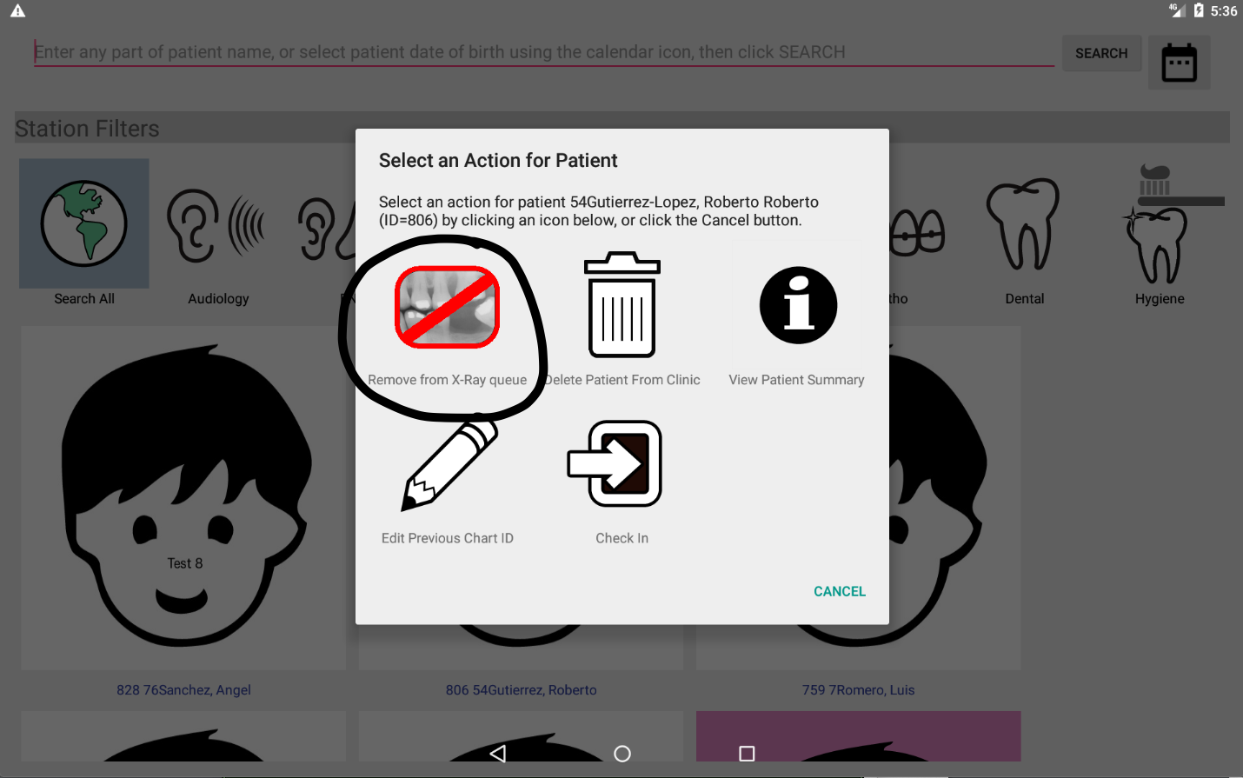

Figure 3.32 Patient with Recent X-Rays showing button for removing x-ray from routing slip

Exiting and Restarting the Application
When you are no longer using the application, you should exit the application. This will ensure that the next user has to log in, and any patient chart accesses performed by that person are not logged as having been done by you. Exiting the application can be done in two ways:

- Minimizing the application and swiping it away
- Using the options menu on the search screen and selecting the exit function

Exiting by Swiping Away the Application
You can exit in this way by:

- Swiping up from the bottom of the screen (but don't swipe too far up or the app drawer opens).
- Tapping the small square icon on the bottom of the screen. See Figure 3.33.
- Swiping left or right as though you are trying to flick the application off the screen. See Figure 3.34

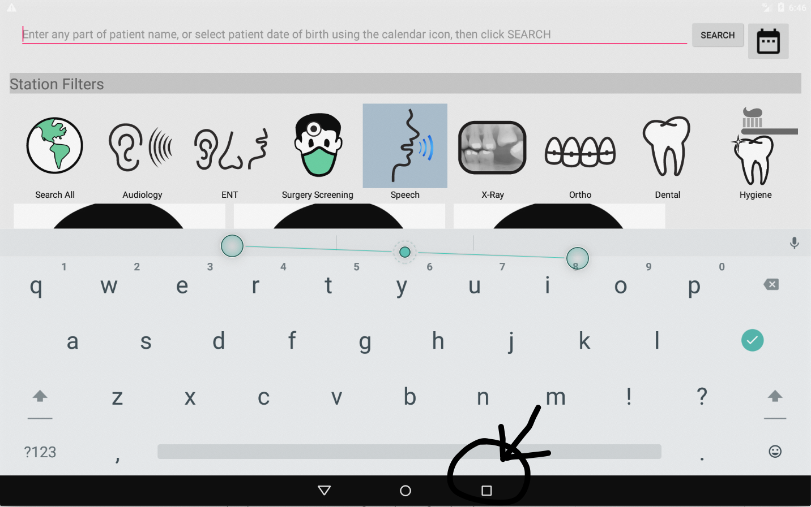

Figure 3.33 Location of the Square Icon.

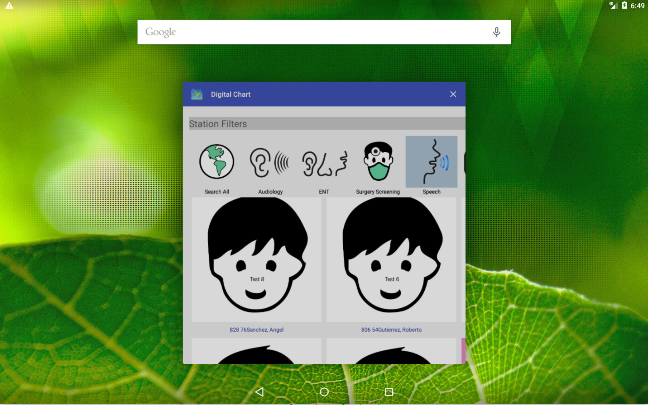

Figure 3.34 Swipe the minimized application left or right with your finger to exit.

Exiting via the Options Menu
From the search screen, press and hold down on the options menu button in the upper right hand corner of the screen, then select the Exit menu option from the menu that appears to exit the application. This method will ask for confirmation before exiting. See Figure 3.35.

Changing the Station Type
In rare circumstances, you may want to change your station type. This will allow you to see portions of the chart associated with a different caregiver. To do so, press down on the options menu and select the “Change Station” item (Figure 3.35). This will return you to the station selection screen.

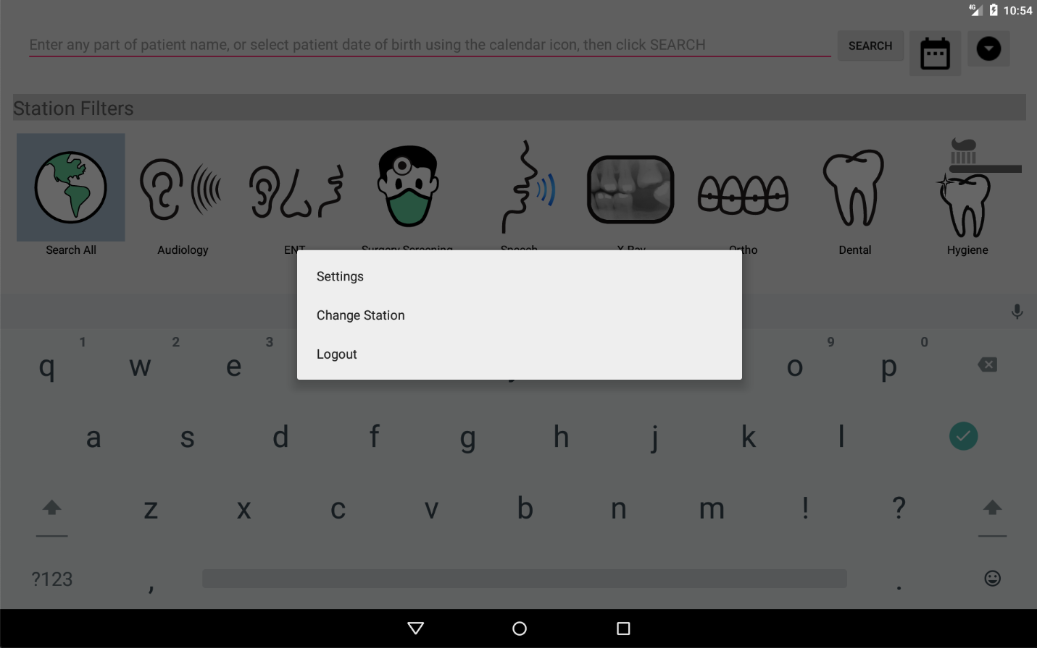
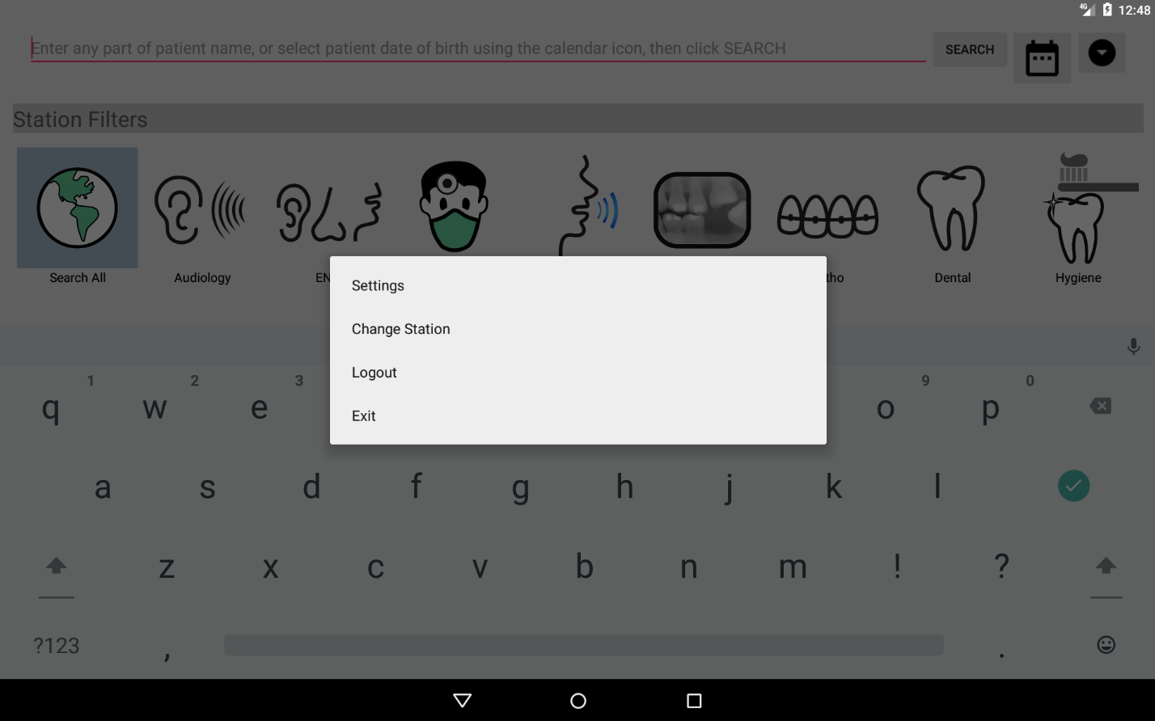

Figure 3.35 Patient Search Screen Option Menu

Logging Out
To log out (return to the login screen), press down on the options menu on the patient search screen, and select “Logout” from the menu that displays (Figure 3.35). The application will return to the login screen, allowing another user to login. This is advised whenever you are done for the day, or someone else is going to use your tablet. If someone else uses a tablet to which you are currently logged in, and viewing of chart data or changes made will be logged as though you were the one performing them, which is not desirable.

Dental Chart

Overview

The dental chart screen layout is shown in Figure 4.1.

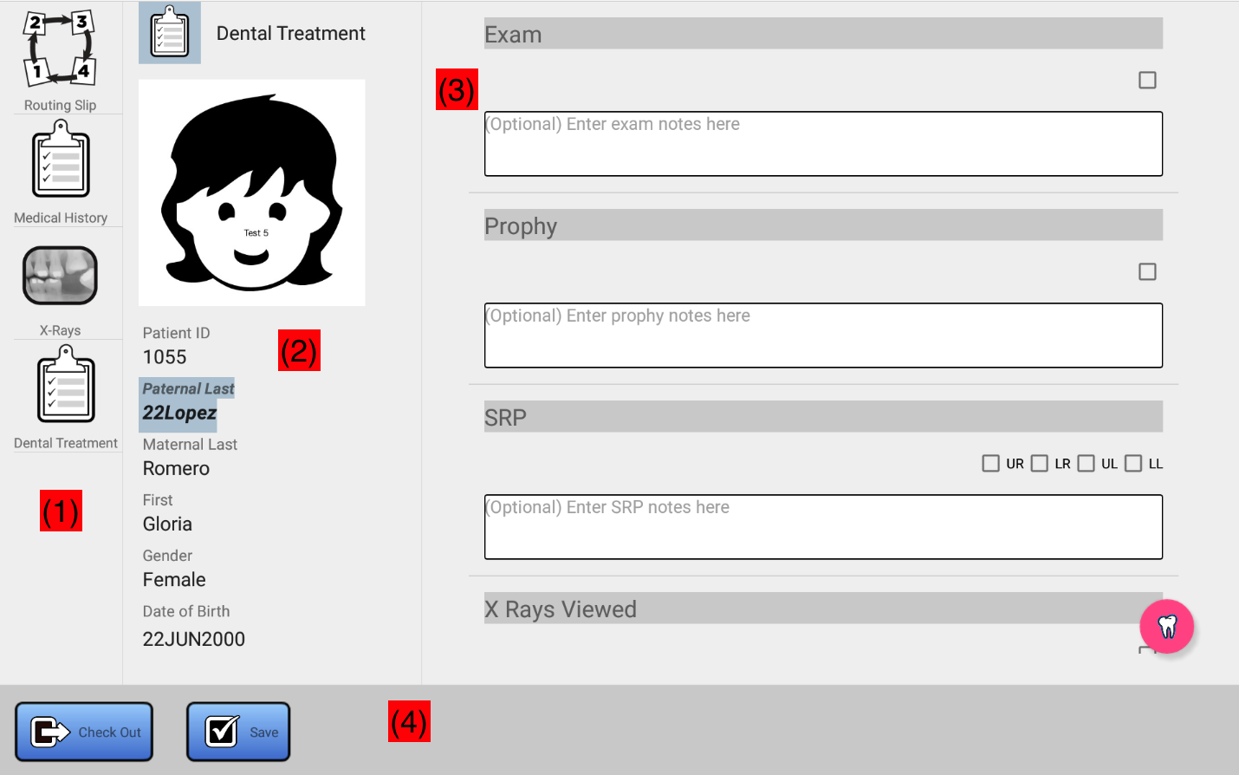

Figure 4.1 Dental Chart Screen Layout

(1) Allows you to select a view into the chart. Common options include the ability to view and modify the patient Routing Slip (see Section 3.8), and to view and edit the patient Medical History. Options which are specific to Dental include the viewing of X-Rays (Section 4.1.2) and the creation of dental treatment records (Section 4.1.4).
(2) Is the patient information. This area identifies the patient to which the data being viewed corresponds. The headshot will be that of the patient taken the day of the clinic. The ID, name, gender, and data of birth should match that found on the patient wristband, if present.
(3) This area can be used to select a specific record for the patient corresponding to selection made in area (1). For example, clicking on the X-Rays icon in area (1) will display a list of X-Ray records obtained at the current, and previous clinics. Area (3) is also where the actual dental chart data for the patient can be viewed or modified.

(4) Use the “Check Out” button to check the patient out (see Section 3.7.3) and use the “Save” button to save any edits that you make to the patient chart.

X-Rays
Selecting the X-Rays button (Figure 4.1) will display a list of X-Ray records that were obtained at the current and any past clinics for the patient (Figure 4.2). These will be ordered in clinic order, with the most recent clinic displayed first. If no X-Ray data is present in the chart for the patient, a message will display indicating that no X-Rays were found, and this area will be blank.

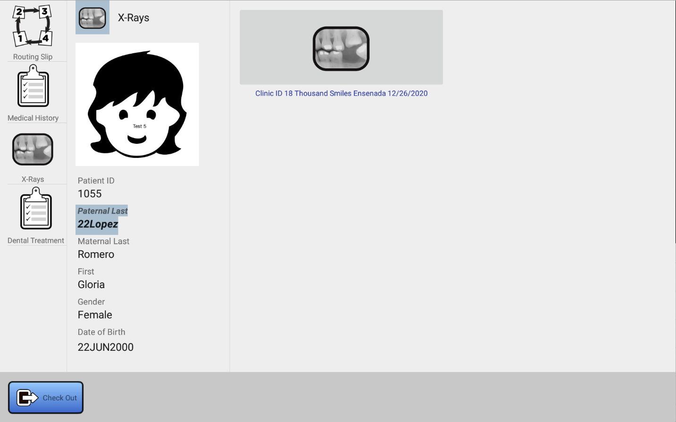

Figure 4.2 List of X-Ray records for Patient 1055

Use your finger to scroll up and down through the list should there be more X-Ray records than can fit on the screen.
To view a dental record, simply touch it with your finger. You will see a screen similar to that in Figure 4.3.

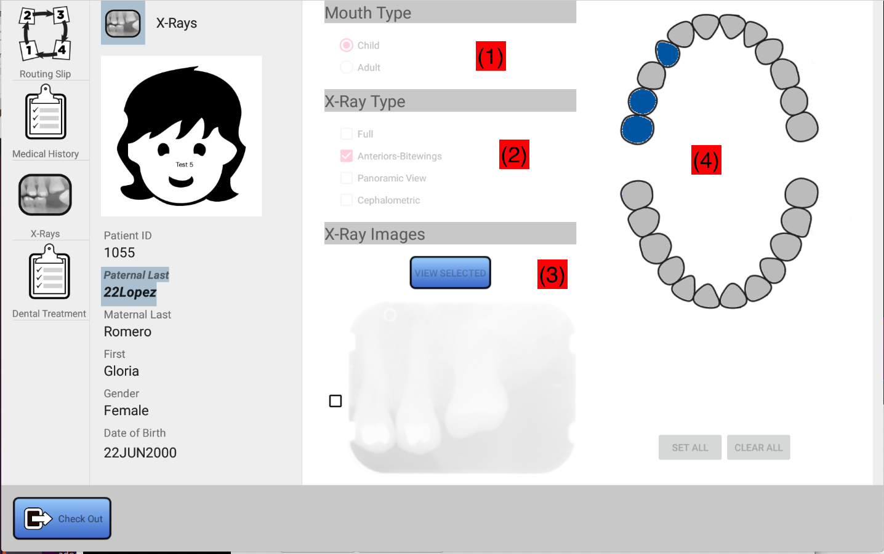

Figure 4.3 X-Ray Data

In Figure 4.3:

(1) is the mouth type
(2) is the X-Ray types that were taken for this patient at the selected clinic.
(3) is a scrollable list of X-Ray thumbnails for the patient. This list includes not only the X-Rays taken at this clinic, but X-Rays taken at all previous clinics for the patient. Use your finger to scroll the list up and down. Use the checkbox to select individual X-Rays to view. More than one X-Ray can be selected for viewing, simply click on the checkboxes. When X-rays are selected, the “View Selected” button will be enabled. See section 4.1.3.
(4) is the coverage chart. This gives a general representation of the teeth which are covered in the X-Rays taken at the selected clinic only.

Viewing A Set of X-Rays
To view one of more of the X-Rays (area (3) in Figure 4.3. follow these steps.

- Using your finger, scroll through the thumbnails.
- Select the X-rays to view by clicking on the checkbox(es) to the left of each X-Ray you wish to view.
- Click on the “View Selected” button.

The result is shown in Figure 4.4:

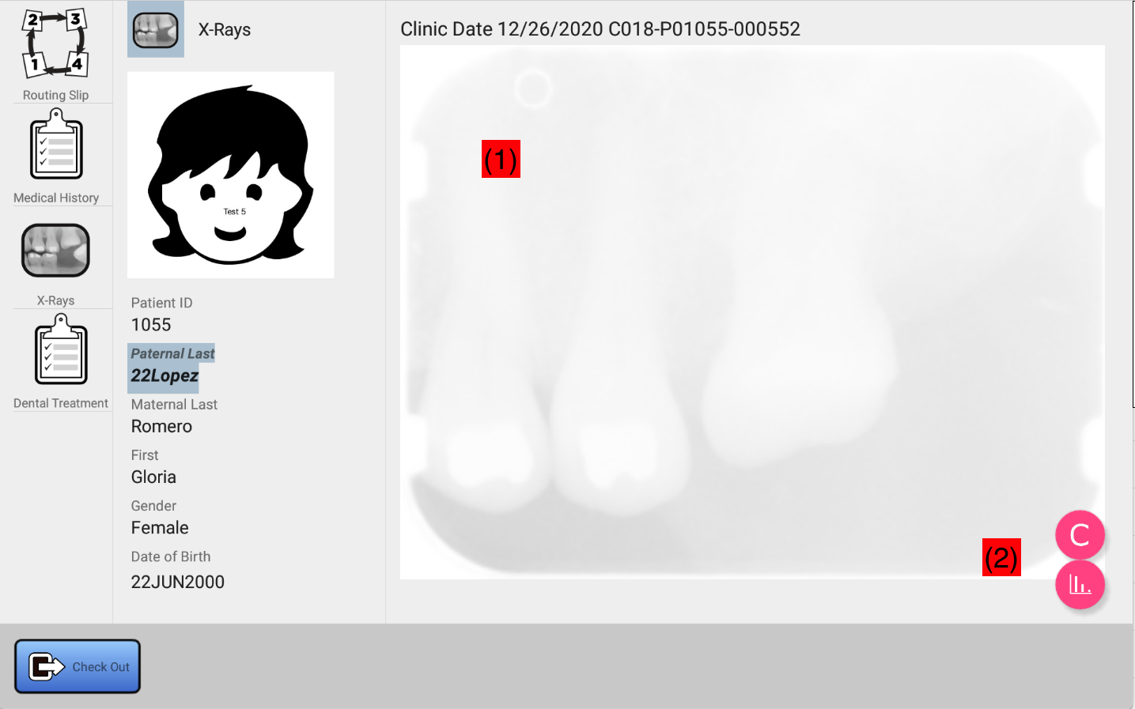

Figure 4.4 Viewing Selected X-Rays

(1) is the X-Ray viewing area. This area will display one of the selected X-Rays at a time. Above the X-Ray is displayed metadata corresponding to the image, including the X-Ray ID and the clinic at which the X-Ray was taken. The X-Ray ID is of the form CXXX-PYYYYY-ZZZZZZ where:
- XXX is the clinic number (in this case 18)
- YYYYY is the patient ID (in this case 1055)
- ZZZZZZ is the ID of the X-Ray image in the database (in this case, 552)
Use your finger to flick the displayed X-Ray image left to right (or right to left) to view the next selected X-Ray image, if any. As you flick left or right, any enhancements that were made to the image will be removed.
You can zoom in on the image by placing your thumb and index finger on the display and pinching. Pinching in will zoom the image out, while pinching out will zoom the image in. Pinching in should completely restore the original image.
When zoomed in, you can use your finger to pan around the zoomed in image. Do this by pressing your finger on the screen, and while holding down your finger, move it in any direction.
(2) are the image enhancement buttons. The “C” button will perform a false coloring of the X-Ray being viewed. See Figure 4.5. Below the “C button is the histogram equalization button. This button can be used to enhance the luminosity of the image, and its overall contrast. See Figure 4.6. Results will vary based upon the image being processed. The enhancement applied will be preserved as you pinch zoom and pan the image with your fingers. Flicking left or right to view other X-Rays will discard any changes made. Changes made with these buttons cannot be saved in the chart, as they are viewing enhancements only.
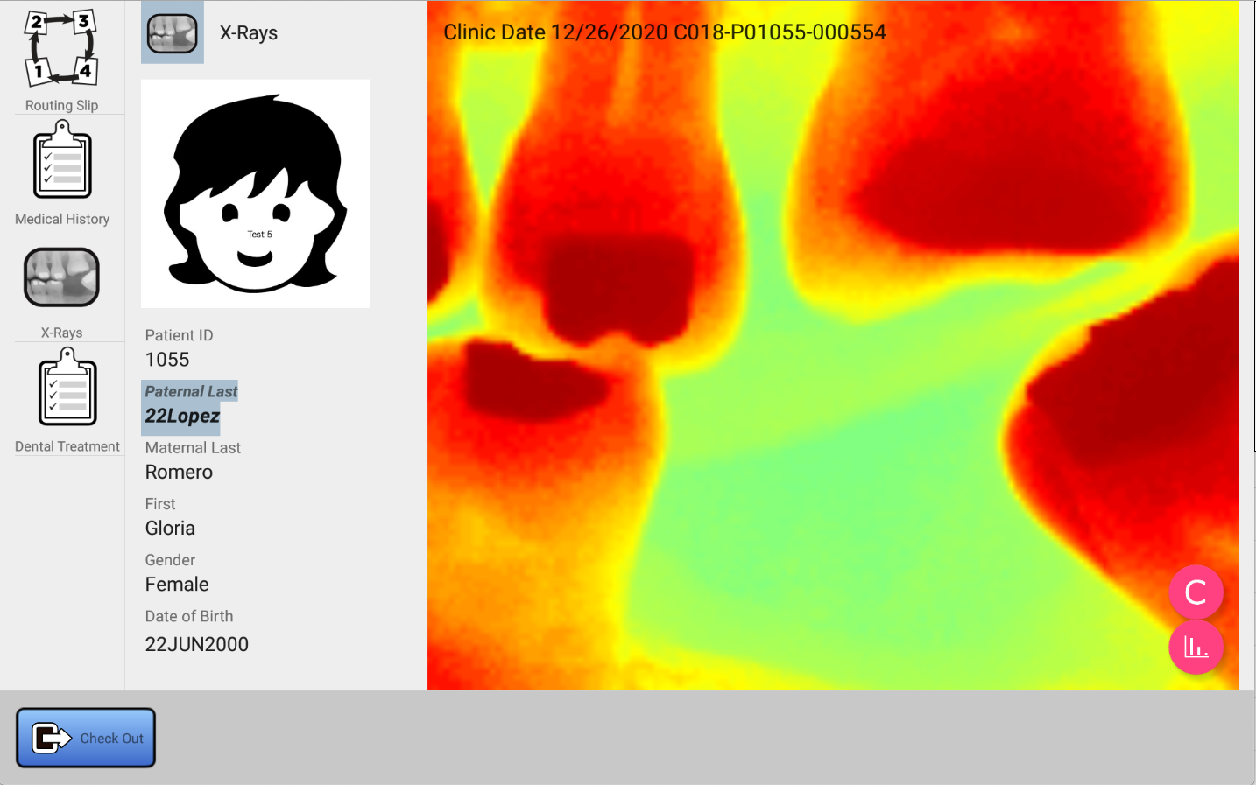

Figure 4.5 False Coloring

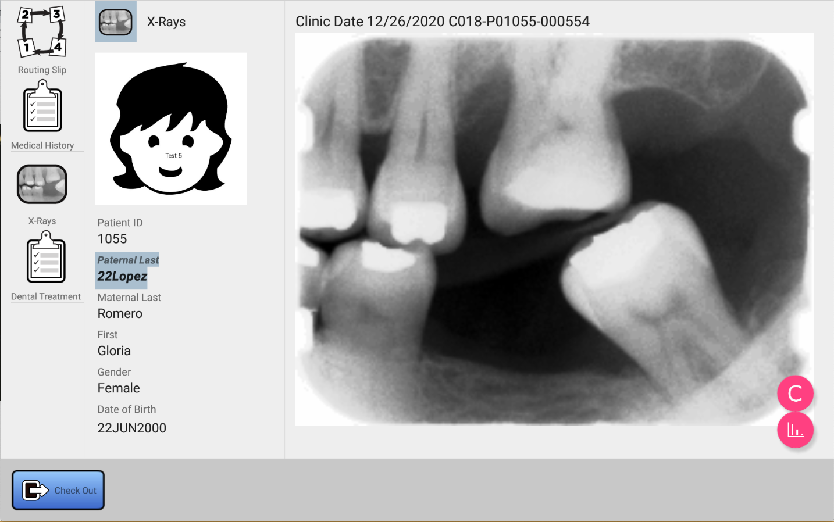

Figure 4.6 Histogram Equalization

Creating and Viewing Dental Treatment Records

Dental treatment records document diagnosis and treatment performed at a specific clinic. To view a list of treatment records, select the Dental Treatment icon (Figure 4.7). The work area will display a button allowing you to create a new Dental Treatment Record for this clinic, and it will list all previously created dental treatment records for this patient. This list will display with the most recently created dental treatment record first. If there are more dental treatment records than can be displayed on the screen, use your finger to scroll the list up and down to locate the dental treatment record of interest. The data and location of the clinic is displayed below each record to aid in identification.

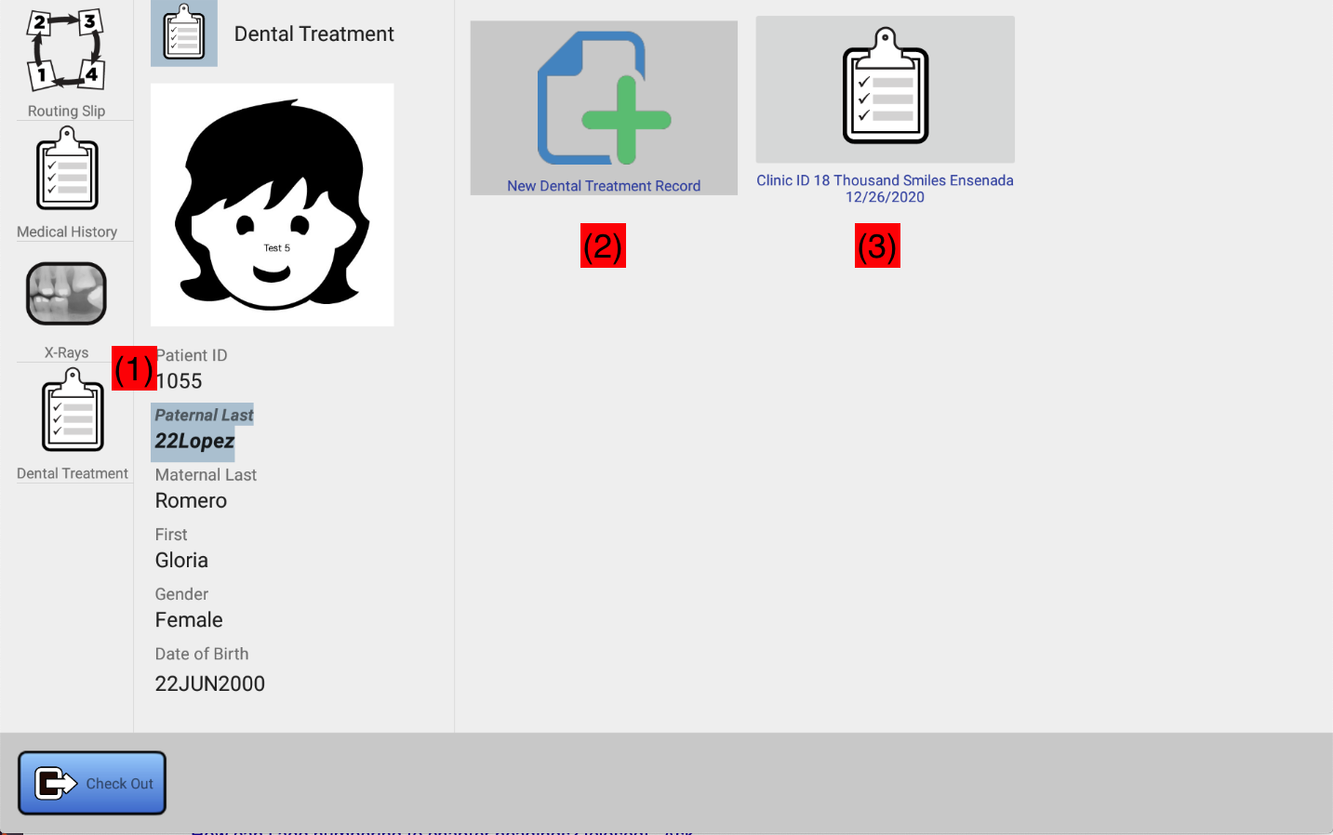

Figure 4.7 Dental Treatment Selector

In Figure 4.7:

(1) Dental Treatment button. Click this to view a list of dental treatment records, and a button that can be used to create a new one.
(2) Click the “New Dental Treatment Record” icon to create a chart entry for this clinic.
(3) Click on an existing chart record from a prior clinic to view data for the specified clinic.

Dental Record Organization
Dental records are organized into two sections.
The first section is the Dental Treatment, or per-visit chart. This portion of the chart allows a dentist or assistant to record data that pertains to the general visit. Here, text fields and checkboxes are present which can be used to record data that applies to a visit by a patient, or that applies to the entire mouth. See Figure 4.8.

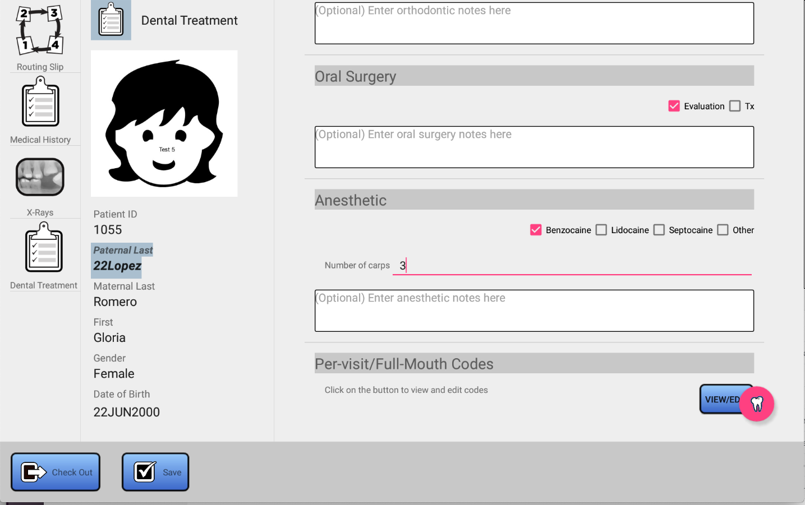

Figure 4.8 Per-Visit Dental Chart

The second section is the per-tooth (tooth chart) chart, shown in Figure 4.9. This portion of the chart records work that is scheduled, or has been completed, for a specific tooth. It can be accessed by clicking on the red tooth icon located at the lower right corner of the per-visit chart (see Figure 4.8). Each tooth can have an infinite list of work associated with it. Work can be added, removed, and marked compete, on a per-tooth basis, by clicking on the tooth and entering the data using CDT codes. The tooth chart uses colors to indicate, on a per-tooth basis, what tooth has work that has been completed, partially completed, or completed entirely. This tooth state show is cumulative, it follows the patient from clinic to clinic. Therefore, at a glance, the tooth chart will give you an overview of the state of treatment for the child.

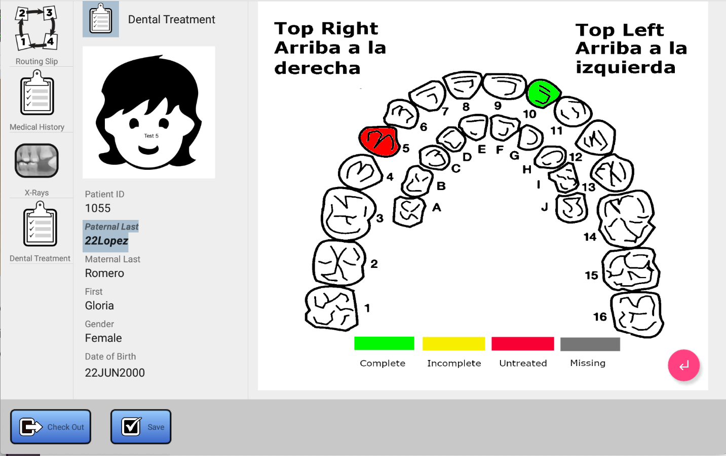

Figure 4.9 Tooth Chart

The following section documents how to edit CDT codes, which apply to both the Per-Visit and Tooth Charts. Following that, the Per-Visit and Tooth Charts are documented in detail.

Editing CDT Codes

Overview
A Dental Procedure, or CDT code defines a dental treatment. These codes are standardized by the American Dental Association (ADA). There are several hundred of these codes defined. Thousand Smiles maintains a database of several dozen of the most commonly used codes. See Appendix 8.1 for the full list of supported codes.

Each code consists of a number in the format DnXXX, and a description. The DnXXX code is formatted as follows: D is always the first character in a CDT code, n indicates the category, and XXX is a 3-digit code which indicates a specific treatment within that category. For example, D4342 can be broken down as follows:

D – constant, all CDT codes start with the letter D.
4 – PERIODONTICS
342 – Root Planing (1 to 3 teeth)

The following categories are supported in our database as of this writing (Table 4.1):

Code (n in DnXXXX) | Meaning
1 | Preventative Services
2 | Restorative Dentistry
3 | Endodontics
4 | Periodontics
5 | Removable Prosthodontics
6 | Fixed Prosthodontics
7 | Oral Surgery
8 | Orthodontics
9 | Persons Served (Encounter Codes)

Table 4.1 CDT Code Categories

The CDT code editor is aware of all of the codes in the database, and can be easily searched to add codes to the per-visit or tooth chart. Details on how to access the CDT code editor are provided in sections 4.17 (Per-Visit Chart) and 4.18 (Tooth Chart), but regardless, the operation is the same within the editor itself.

Searching For Codes
To find a code, you may type any portion of the code, the category, or the specific treatment. For example, to find all the codes in Periodontics, type in “D4” (Figure 4.10). Or you can start typing the word “periodontics” and it will display after a few characters have been typed (see Figure 4.11). If you know a code, for example D4342, typing that in will display the associated code and description (Figure 4.12).

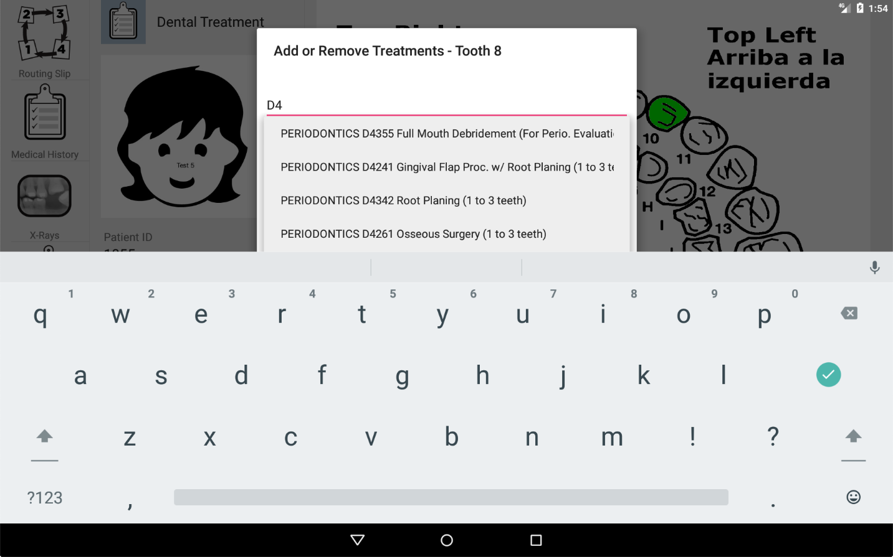

Figure 4.10 Search Using Portion of CDT Code

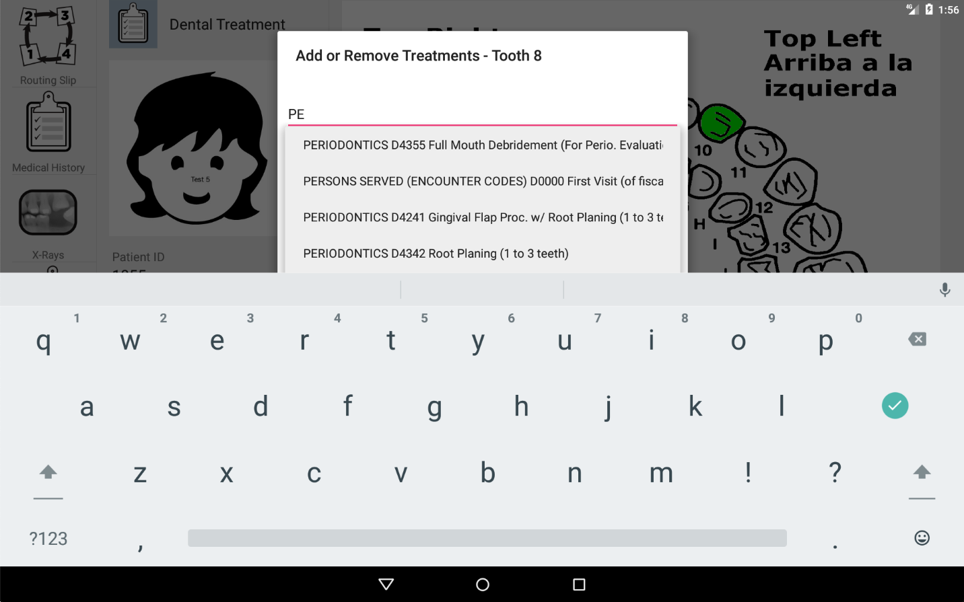

Figure 4.11 Search Using Letters in Category Name

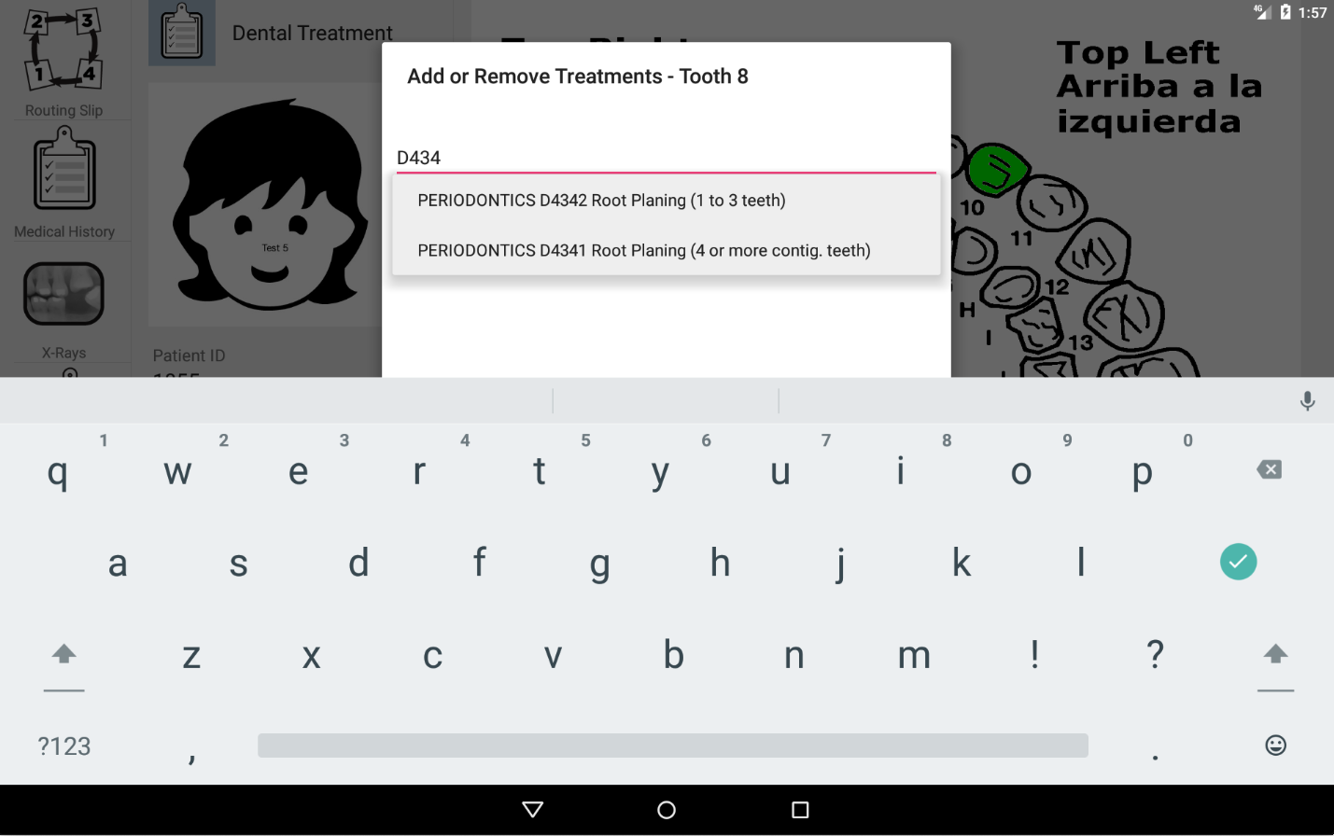

Figure 4.12 Search using portion of CDT code number

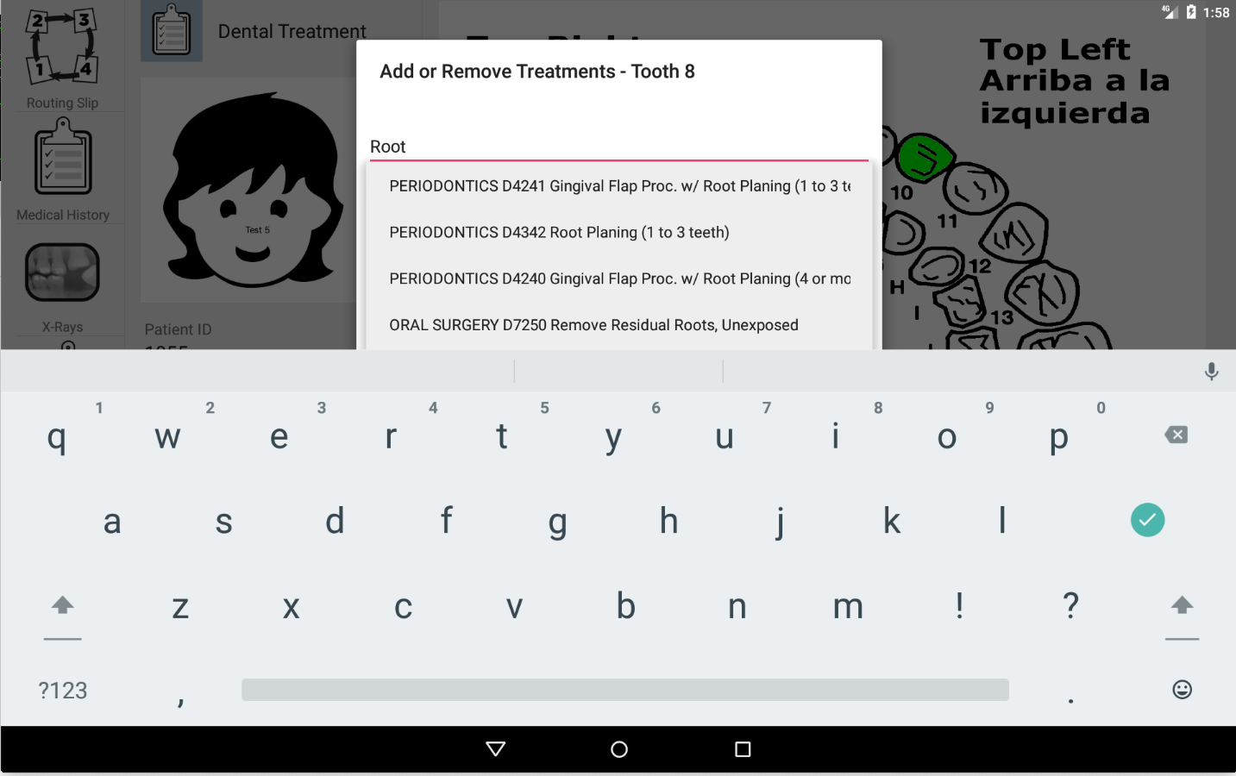

Figure 4.13 Search by Description

Adding a CDT Code
Matching codes, as can be seen in Figure 4.13, will display in a list. To select a code, touch it with your finger. See Figure 4.14. You can then click the Add button to add it to the list of treatment codes for this patient or the selected tooth. Clicking add results in a dialog (Figure 4.15) which allows you to provide more data for this treatment, including selecting the surfaces affected by the condition or treatment, and whether or not the treatment has been repaired.

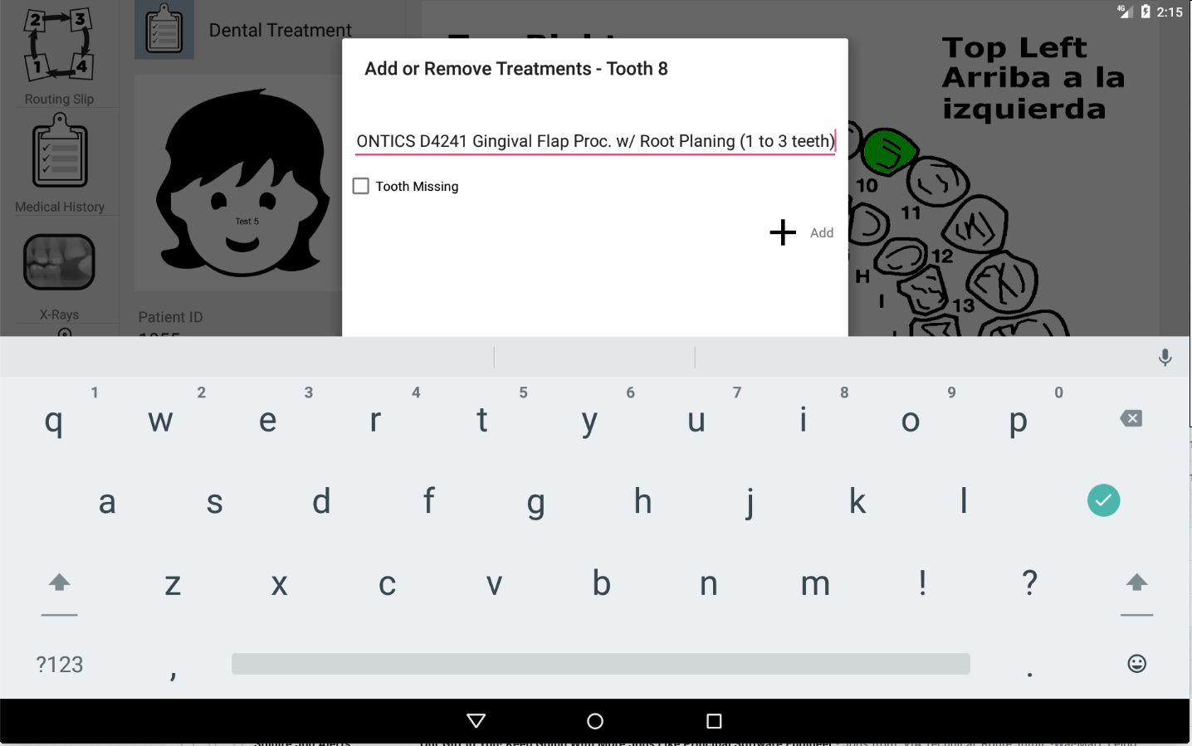

Figure 4.14 Selecting a Treatment

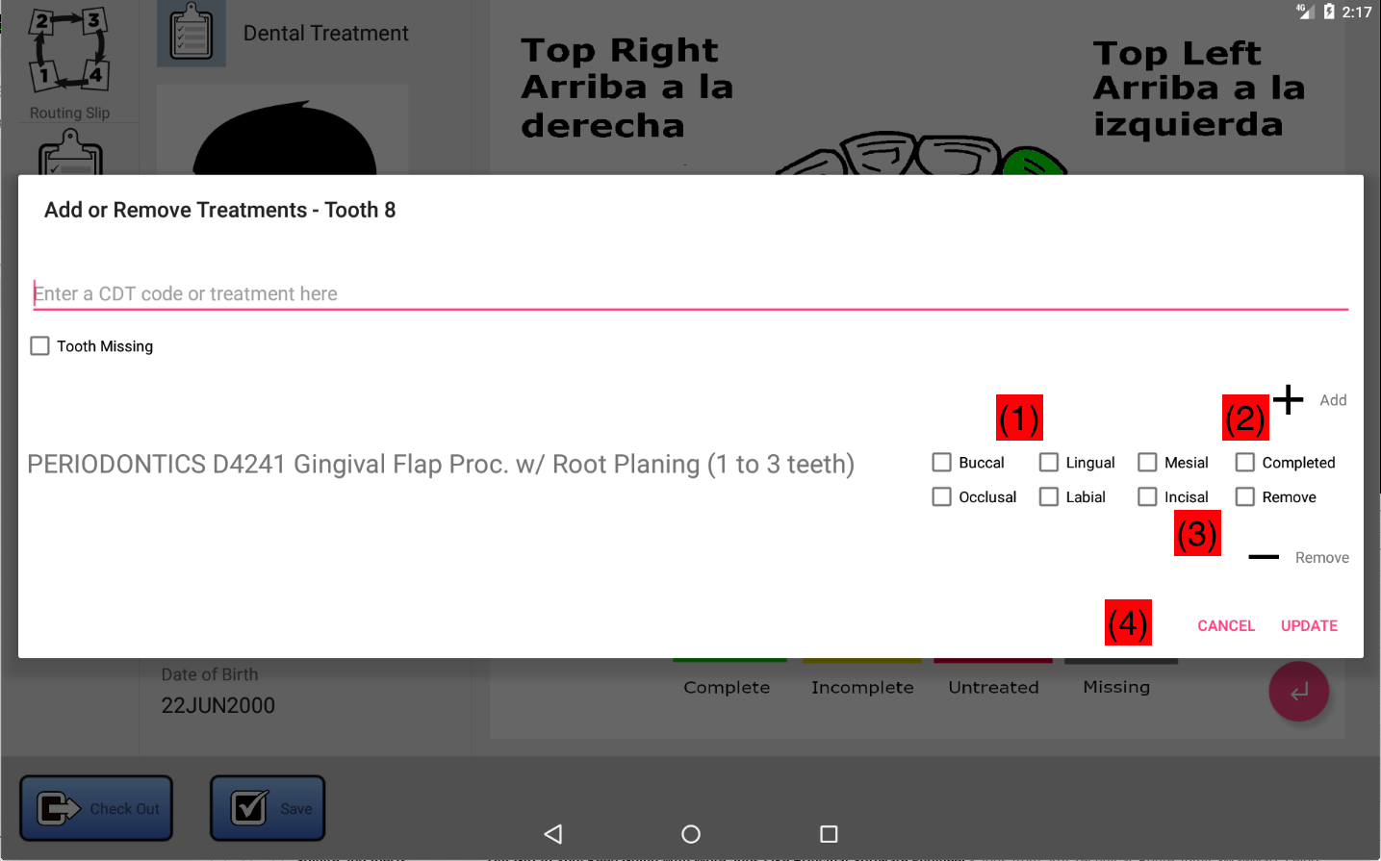

Figure 4.15 Treatment Editor Layout (See text which follows)

In Figure 4.15:

(1) Check all sides of the tooth surface which apply to the condition. This portion of the editor is not available when editing whole-mouth conditions.
(2) Check “Completed” if the work on the condition is complete.
(3) Check on remove to remove the condition from the list (as described in the next section).
(4) Use the UPDATE button to save your changes, or use CANCEL to cancel.

Removing a CDT Code
To remove one or more treatments using the CDT code editor, click on the “Remove” checkbox for each treatment you wish to remove, then click on the “Remove” button (3) in Figure 4.15. The dialog will update with the checked items removed. Finally, when all changes for the tooth are complete, make sure to click the “Update” button. Removed treatments are not made permanent in the chart unless you click the Save button.

Marking a Tooth Missing
To mark a tooth missing, click the “Tooth Missing” checkbox in the CDT editor, and then click UPDATE button to save your changes. See Figure 4.16. Missing teeth will be shown in gray on tooth charts.

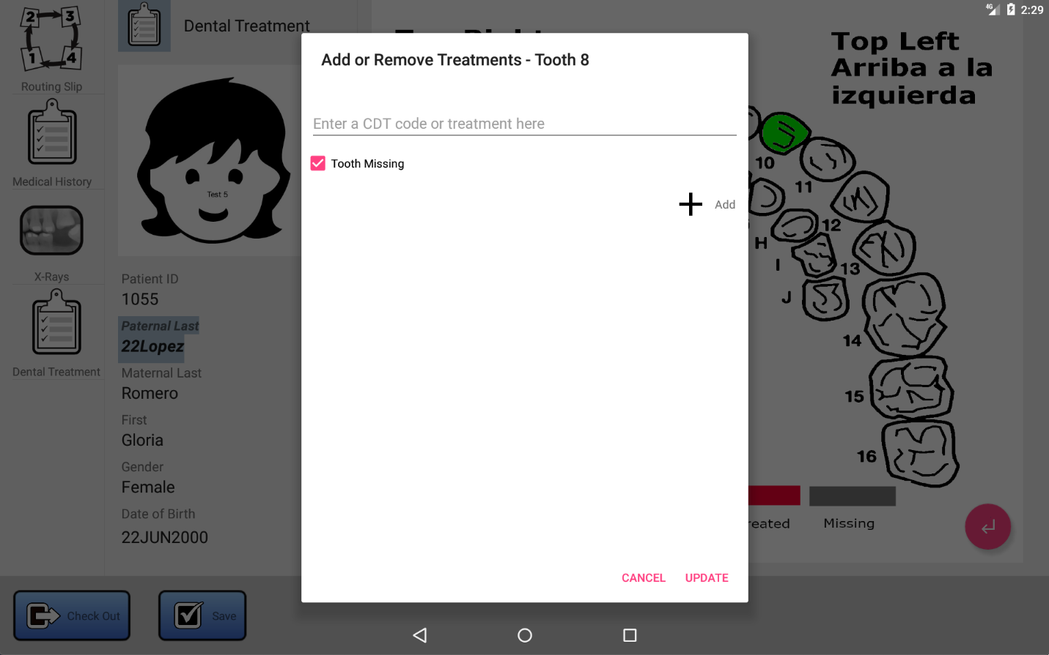

Figure 4.16 Marking Tooth 8 As Missing

Dental Treatment
The Dental Treatment (or per-visit) chart generally mimics the paper charts that were in use by Dental at Thousand Smiles prior to going digital, with the added support of supporting whole-mouth, or per-visit CDT codes (see Section 4.5 for details on editing CDT codes). The Dental Treatment chart effectively is used to record general comments and notes in a variety of categories related to the dental care given to a patient on a per-visit basis. To edit any per-tooth conditions and treatments, use the Tooth Chart, which is described in Section 4.7.

Creating a Dental Treatment Chart is described in section 4.3. In this section, we describe in detail how to edit the chart.

Organization of the Dental Treatment Chart

The following figure illustrates the layout of the Dental Treatment Chart screen

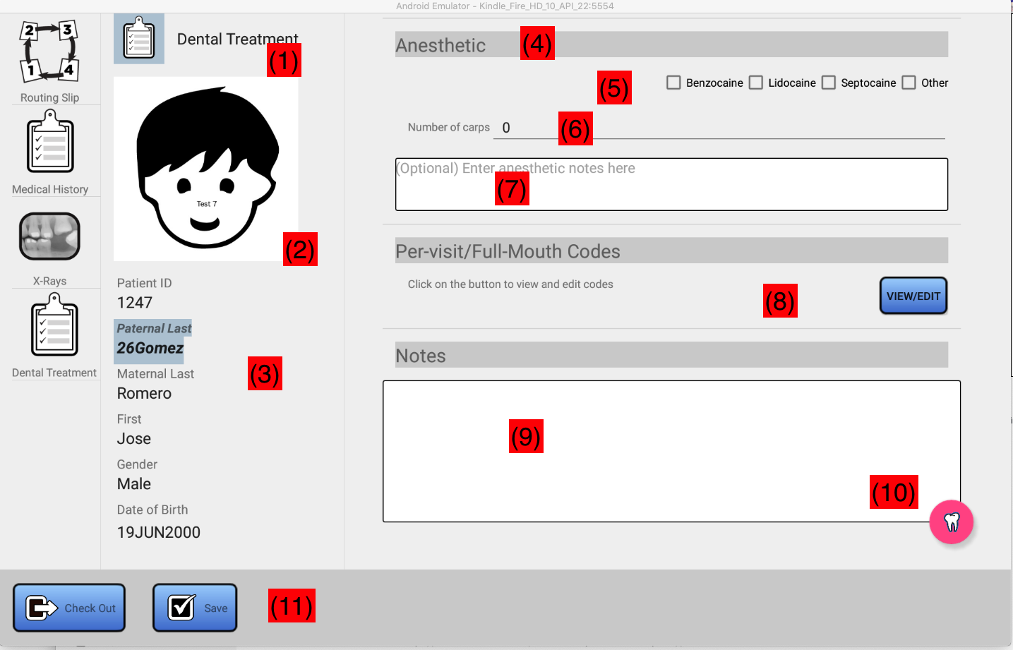

Figure 4.17 Per-Visit Dental Treatment Screen

On the left hand side of the form, you will find identifying information for the patient.

(1) This label confirms you are viewing or editing a Dental Treatment
(2) Most recent patient headshot
(3) Patient ID, name, DOB. Father’s last name is highlighted. Data should match parent/patient wristband, if any.

On the right hand side of the form is the chart data, organized in sections. Each section can be used to indicate that a specific treatment or examination was performed.

(4) Item Header. This identifies a specific piece of data stored in the Dental Treatment, usually corresponding to a treatment or examination performed on the child the day that care was provided.
(5) Check boxes. Click the checkbox to check or uncheck. Usually there is a single checkbox provided. Checking the checkbox indicates that the care was provided. Leave it unchecked to indicate that the care was not provided. When multiple checkboxes are present, this can be used to provide more detail on the type of treatment that was administered.
(6) In some cases, additional fields are present to allow further detail on the care provided for this particular item.
(7) Free-form notes. Clicking on this box will display a soft-keyboard that can be used to enter free-form notes for the specific care provided for this item.

Note that the form consists of multiple sections consisting of items organized as described in (4) – (7). You can use your finger to scroll the form vertically in order to access each item.

(8) Per-visit CDT codes. Use of this item is not typical, but it is provided to allow you to view and edit CDT codes that apply only to per-visit or whole mouth treatments, rather than treatments corresponding to a specific tooth or tooth surface. Codes that you add here generally should come from the D9XXX PERSONS SERVED (ENCOUNTER CODES) CDT category. Use the Tooth Chart button (10) to enter codes for a specific tooth or surface.
(9) Per-Visit notes. Enter any free-text here that you wish. Use your finger to scroll vertically for notes that extend beyond the size of the text area provided.
(10) Tooth Chart. Click on this icon to access the tooth chart (see section 4.7 for details)
(11) Save button. When done editing, use the Save button to save all changes made on this form, and in the tooth chart.

Editing the Dental Treatment Form

For each treatment, check the corresponding checkbox (5), and enter optional comments in the provided text area (7). Use (9) to enter general notes for the visit. Use (8) to enter CDT codes that pertain to whole mouth codes. Click on (10) to access the tooth chart to enter per-tooth and per-surface codes.

When done, click on the Save button (11) to save your changes.

Tooth Chart
The tooth chart is where per-tooth and per-surface treatments can be applied.

To access the tooth chart, click on (10) in Figure 4.17. You will then be shown the tooth chart (Figure 4.18).

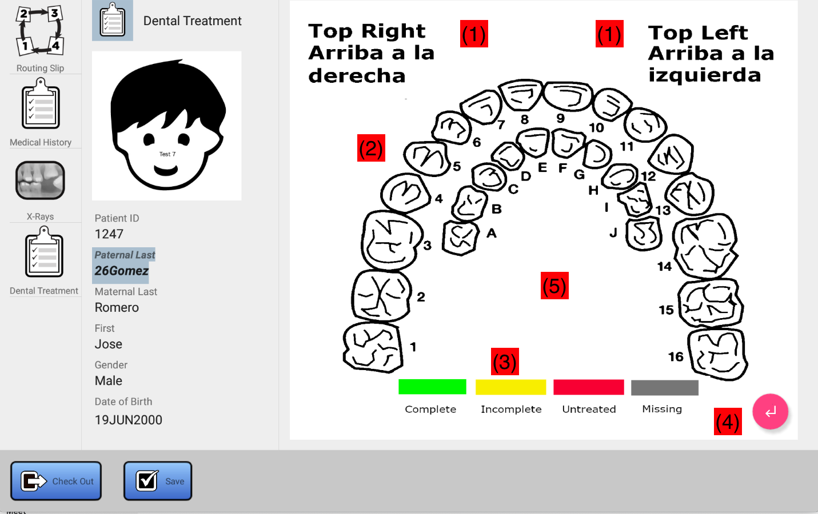

Figure 4.18 Tooth Chart

In Figure 4.18:

(1) Identifies the orientation of the mouth (upper/lower, left/right) depicted by the chart.
(2) Teeth. Touch a tooth to access the CDT code editor for that tooth. For details on editing tooth codes, see Section 4.5 of this document. See Figure 4.19. The data associated with the tooth is an aggregation of all care given the patient, up to and including the current clinic (assuming the data was entered for that patient). Thus, it can be used to view work that was diagnosed at a previous clinic, but has yet to be completed.
(3) Legend. Each tooth in (2) may display a color. Use this legend to decode the color displayed on teeth.

- No Treatments (White) - A white tooth indicates that no treatments are associated with the tooth, and the tooth is present
- Complete (Green) – treatments have been marked complete for this tooth
- Incomplete (Yellow) – some, but not all treatments are marked complete for this tooth
- Untreated (Red) – no treatments are completed yet for this tooth
- Missing (Grey) – the tooth was marked missing in the CDT editor

(4) Back Button. Use this button to return to the main Dental Treatment chart (Section 4.6)
(5) Swipe area. Use your finger here to swipe between upper mouth and lower mouth views.

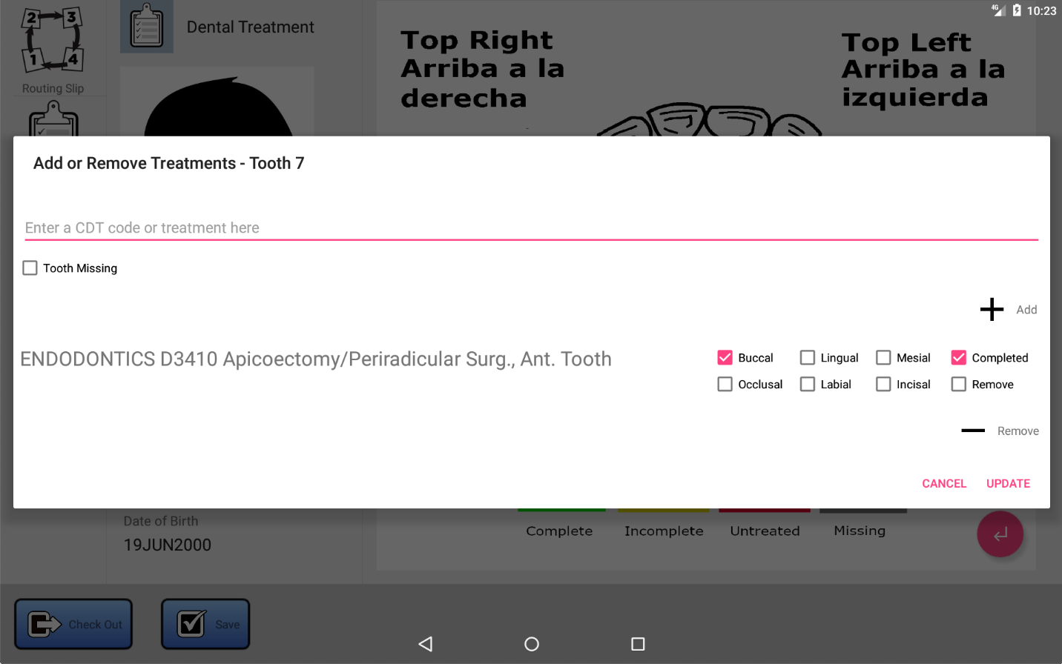

Figure 4.19 Click on a tooth to access the CDT codes for that tooth.

ENT Chart

Overview

The main UI for ENT is organized as show in Figure 5.1, below.

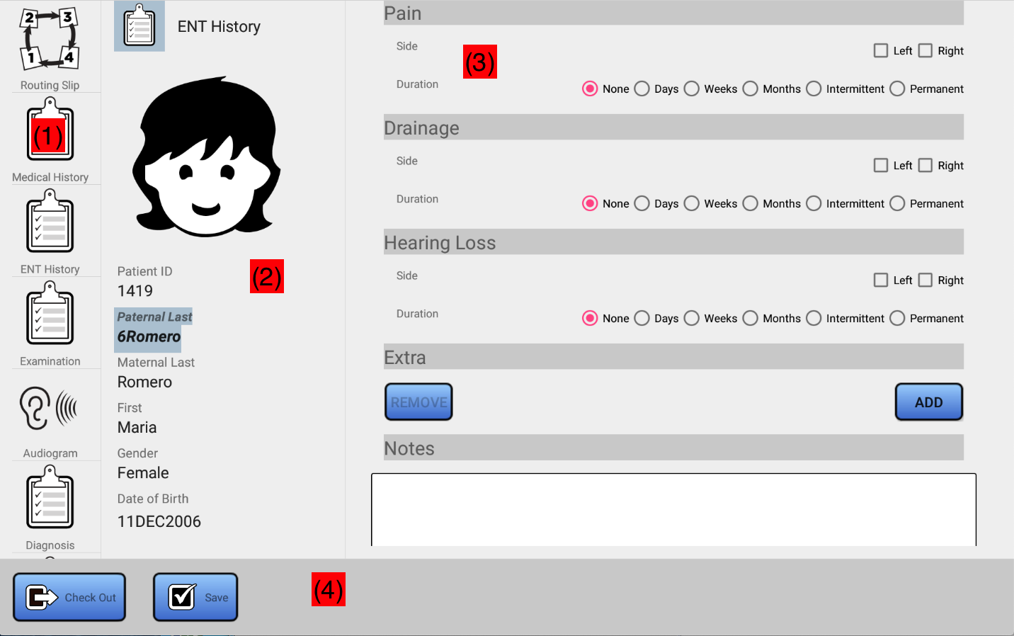

Figure 5.1 ENT Chart Layout

(1) allows you to select a view into the ENT chart (ENT History, Examination, Diagnosis, etc.) as well as the general chart data shared for this patient (Routing Slip, Vaccination record, and Medical History taken at registration, and Audiograms if any). (2) is the patient info panel. This depicts the recent headshot for the patient, as well as personal identifying information such as name, date of birth, and gender. Above the headshot is displayed the current view into the chart. (3) is the work area. Here, you can select a chart entry from a past clinic, or create a new chart entry for the current clinic. What displays here corresponds to the item selected in (1). For example, if Diagnosis is selected in (1), then (3) will represent a view into the Diagnosis data for the patient. (4) is the command area. This area contains buttons that can be used to Save any changes, and checkout the patient (see 3.8.3).

The remaining sections will cover each of the views specific to ENT selectable in (1).

ENT History
The ENT History panel is shown in Figure 5.2.

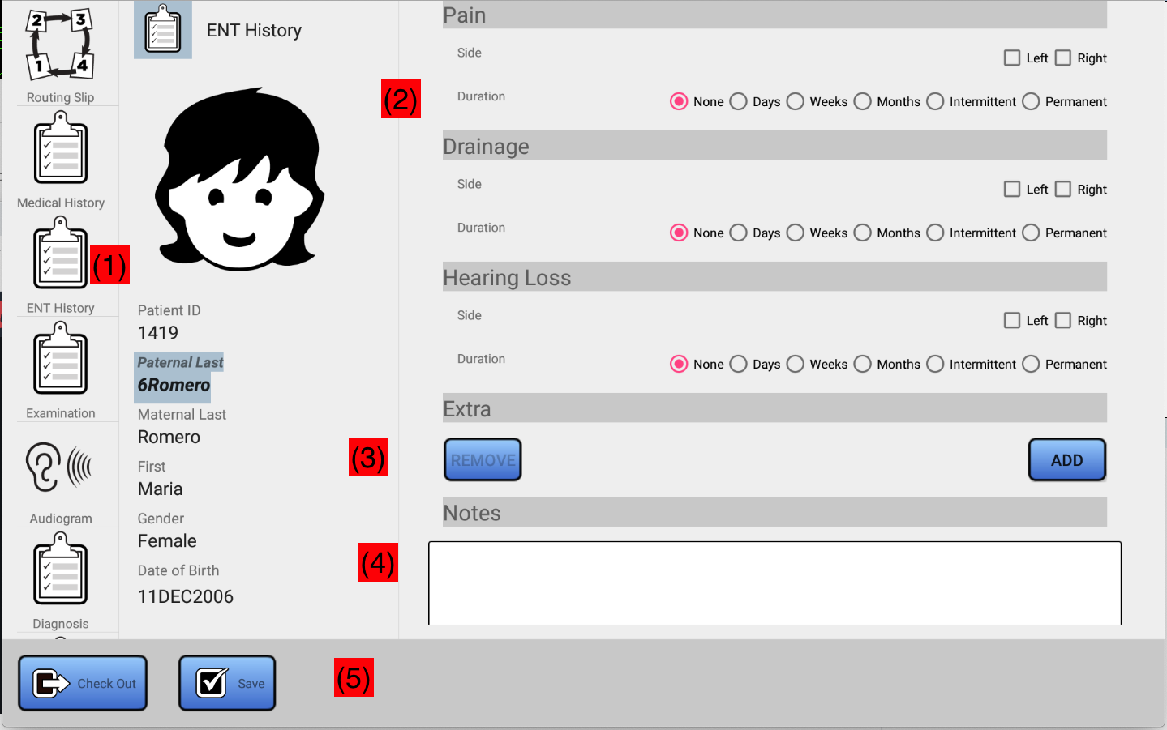

Figure 5.2 ENT History

(1) Click on ENT History to access the panel shown in Figure 5.2. You will be given an opportunity to create a new ENT history for the patient, or you can select and view/edit an ENT history record from a previous clinic. (2) For each history item, select the applicable sides, and duration. (3) is the extra items area. Here, any extra items will be listed. If there are items which are not accounted for in (2), use the ADD button in (3) to include them in this section. Any previously entered extra items can also be selected and removed here. See description below. Use (4) to add any notes for this exam record. Finally, if changes are made (5) will display a Save button which can be used to store the changes for a new record in the database, or save changes if you are viewing a record from a previous clinic. Note that changes are not saved until the Save button is pressed and confirmed.

Adding Extra History Items
In Figure 5.2, (3) indicates the Extra items work area. Here you can view, add, or remove extra items. To add a new item, click on the ADD button. You will be presented a dialog as shown in Figure 5.3:

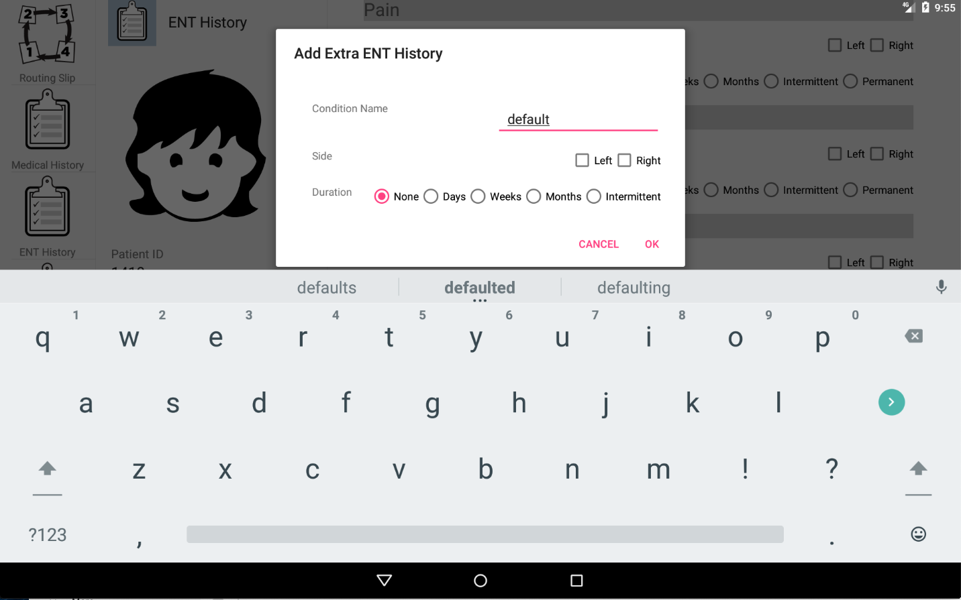

Figure 5.3 Adding an Extra Item

Fill in the item name, select the applicable sides, and select a duration. When done, click on OK to dismiss the dialog and accept the changes, or click CANCEL to cancel.

Viewing Extra History Items

If any extra history items have been added, they will be listed in the Extra section, as shown in Figure 5.4.

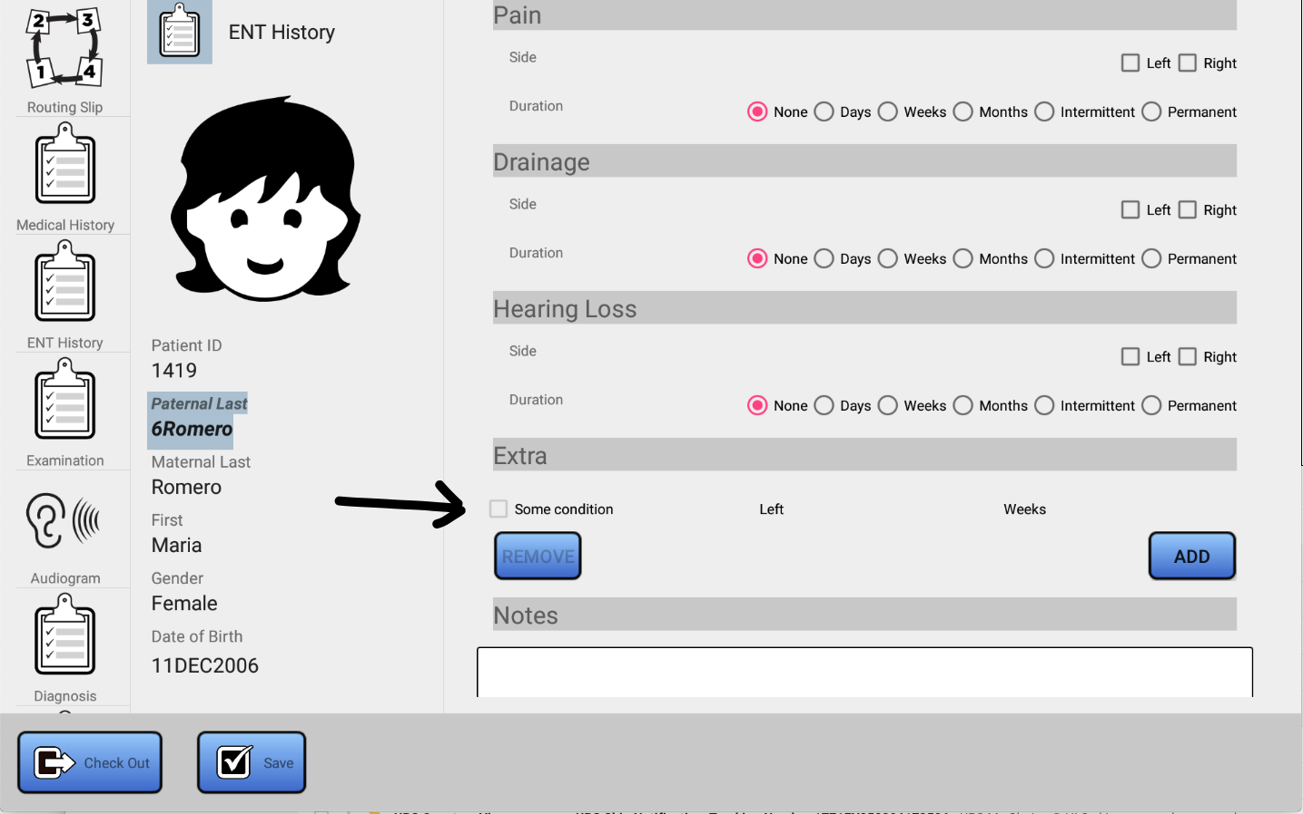

Figure 5.4 List of Extra History Items

Removing Extra History Items

To remove an Extra history item, select the conditions by clicking on the checkbox to the left of the item you wish to remove, and then click the REMOVE button (see Figure 5.5). The item(s) selected will be removed and the database will be updated immediately. Items removed cannot be restored once they have been deleted from the database.

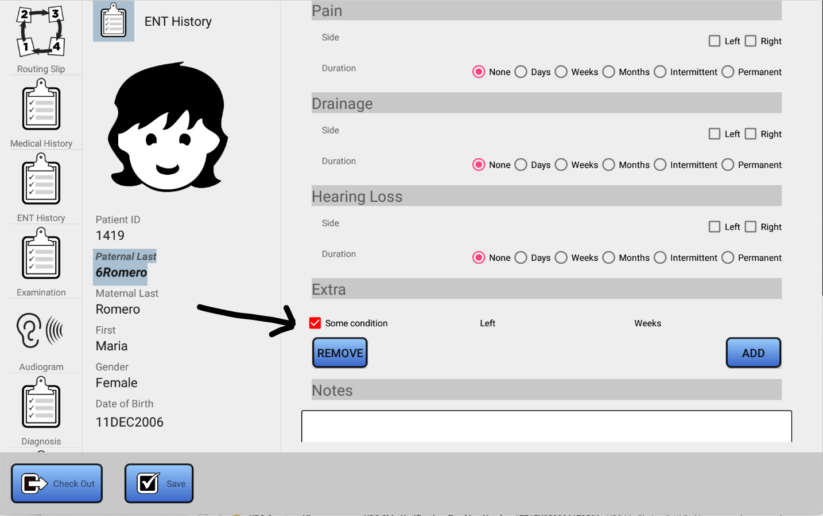

Figure 5.5 Removing Extra History Items

ENT Examination
Figure 5.6 illustrates the ENT Examination view. Obtain this view by clicking on Examination in the view selector (1). Area (2) consists of a scrollable list of various exam items. You can scroll vertically through the form using your index finger to swipe up and down. Simply click on the relevant checkboxes and radio buttons, and add any Notes in the area which is provided (3). A soft keyboard will display to enter your notes by touching your finger in the Notes area. When done, click Save (4) to save any changes.

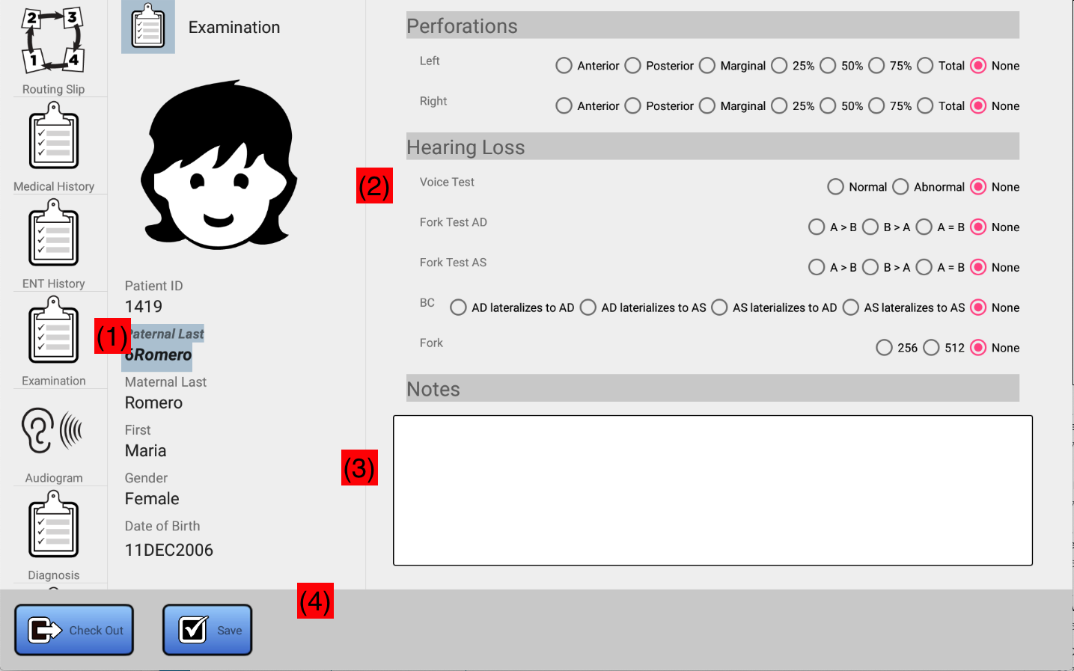

Figure 5.6 ENT Examination

ENT Diagnosis
Figure 5.7 illustrates the ENT Diagnosis view. Obtain this view by clicking on Diagnosis in the view selector (1). Area (2) consists of a scrollable list of various diagnosis items. You can scroll vertically through the form using your index finger to swipe up and down. Simply click on the relevant checkboxes and radio buttons. For diagnosis items not accounted for in (2) you can add them using the Extra area (3) by clicking on the ADD button. See sections 5.2.1 – 5.2.3 for details on how to use the Extra area, which is used similarly to that function which is provided by the Examination view. Add or edit any Notes you may have in the area which is provided (4). A soft keyboard will display to enter your notes by touching your finger in the Notes area. When done, click Save (5) to save any changes.

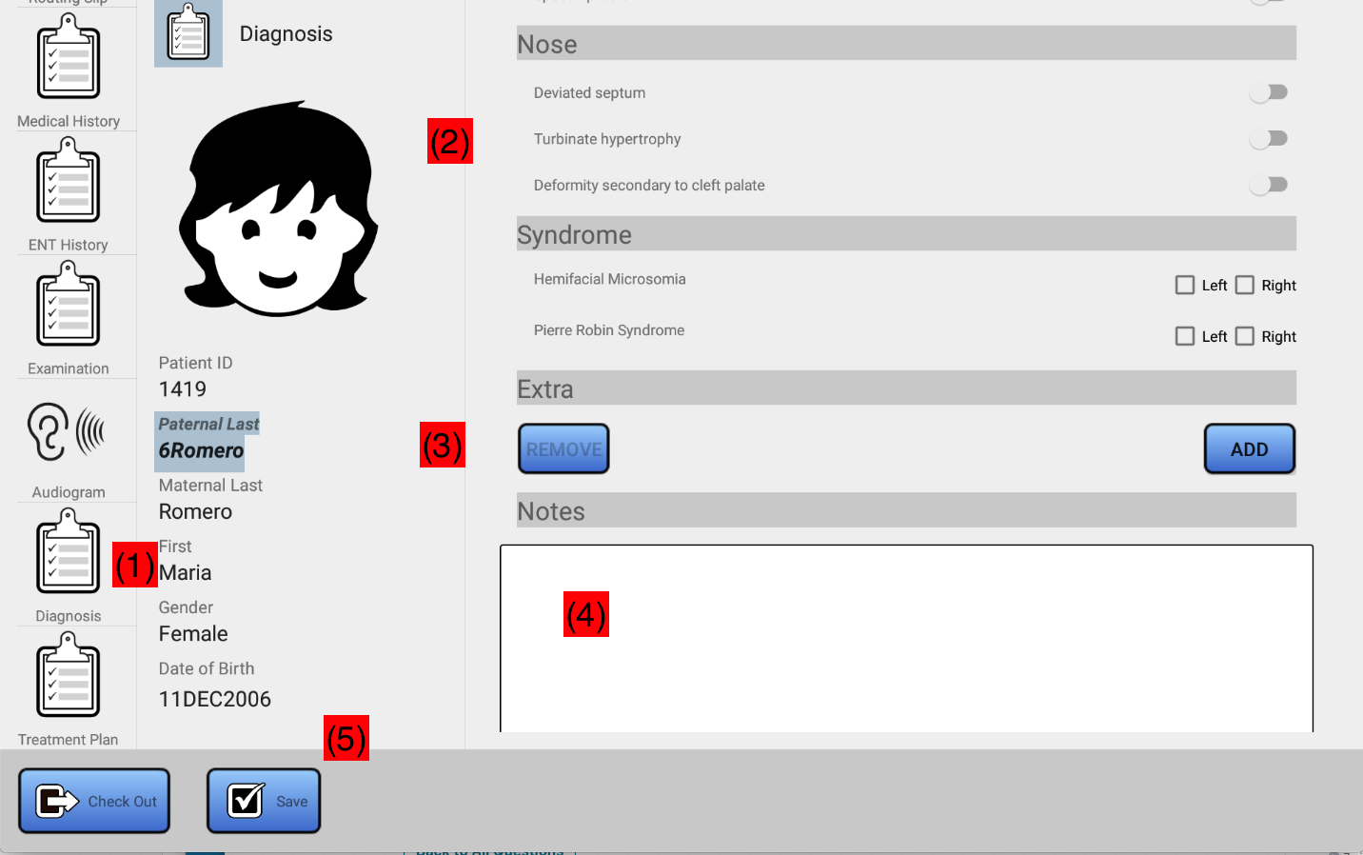

Figure 5.7 ENT Diagnosis View

Treatment Plan
The treatment plan is depicted in Figure 5.8.

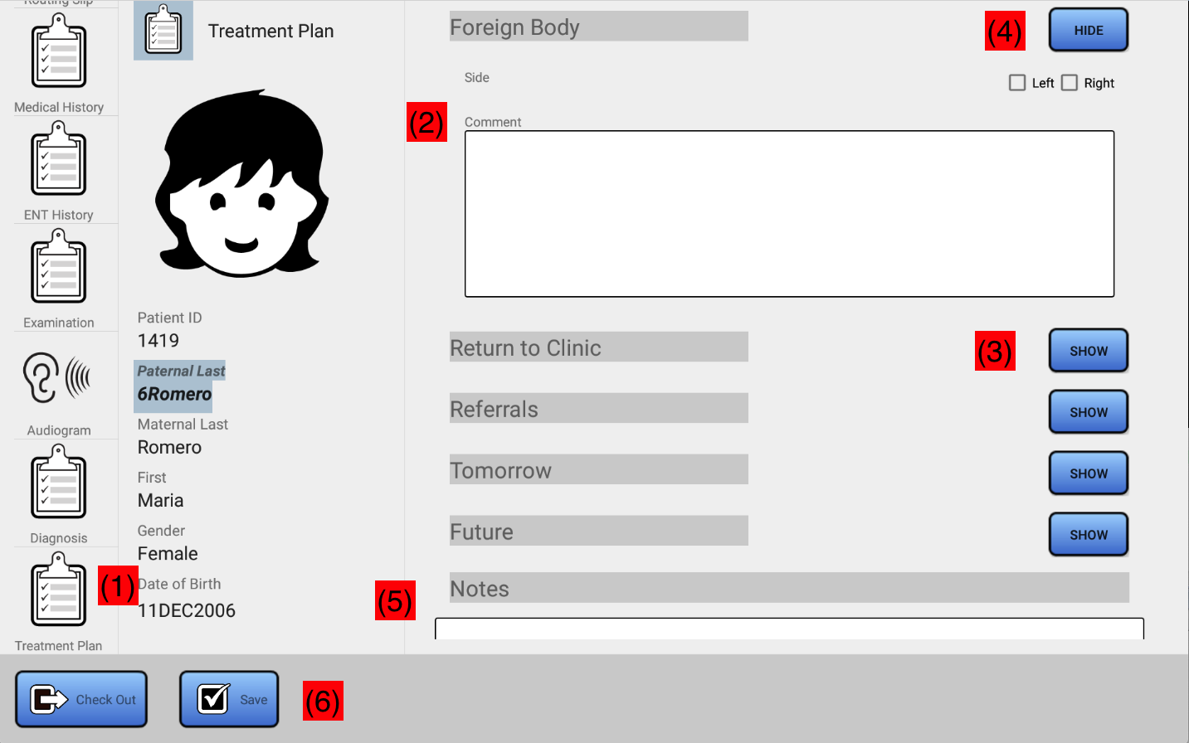

Figure 5.8 ENT Plan View

Obtain this view by clicking on Treatment Plan in the view selector (1). Area (2) consists of a scrollable list of various treatment items. You can scroll vertically through the form using your index finger to swipe up and down. Because of the large number of data associated with a treatment plan, each treatment item has an associated SHOW button (3). Clicking the SHOW button will expand the corresponding item. For each item that is shown, this button will became a HIDE button (4). Click on the HIDE button to hide an item in the treatment plan. Within a treatment plan item, click on the relevant checkboxes and radio buttons. Add or edit any Notes you may have in the area which is provided (5). A soft keyboard will display to enter your notes by touching your finger in the Notes area. When done, click Save (6) to save any changes.

Viewing Audiograms

If any audiograms for this patient have been save by Audiology, they are available by clicking the Audiogram button (see (1) in Figure 5.9).

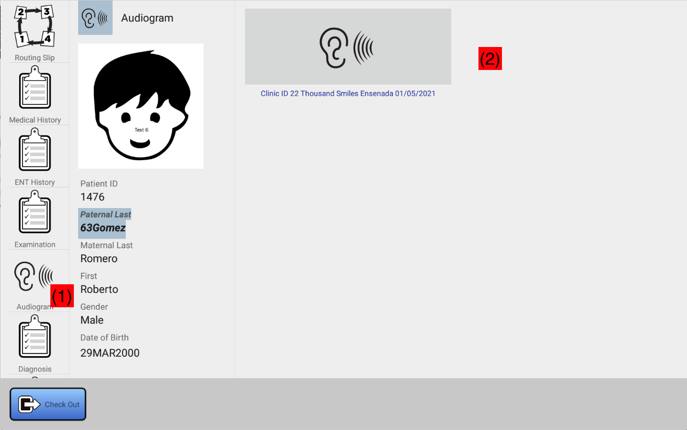

Figure 5.9 Viewing Audiograms

If any audiograms have been recorded for this patient over the history of the patient, they will be visible in area (2). Below each is a label which identifies the clinic and date at which the audiogram was recorded. Items in this area are sorted so that the most recent audiogram is listed first. If not audiograms are present, or there was some problem reading them from the database, this area will be blank and a short message will be displayed to that effect at the time the audiogram button (1) was pressed.

Audiology Chart

Overview
The main user interface for Audiology is organized as shown in Figure 6.1, below.
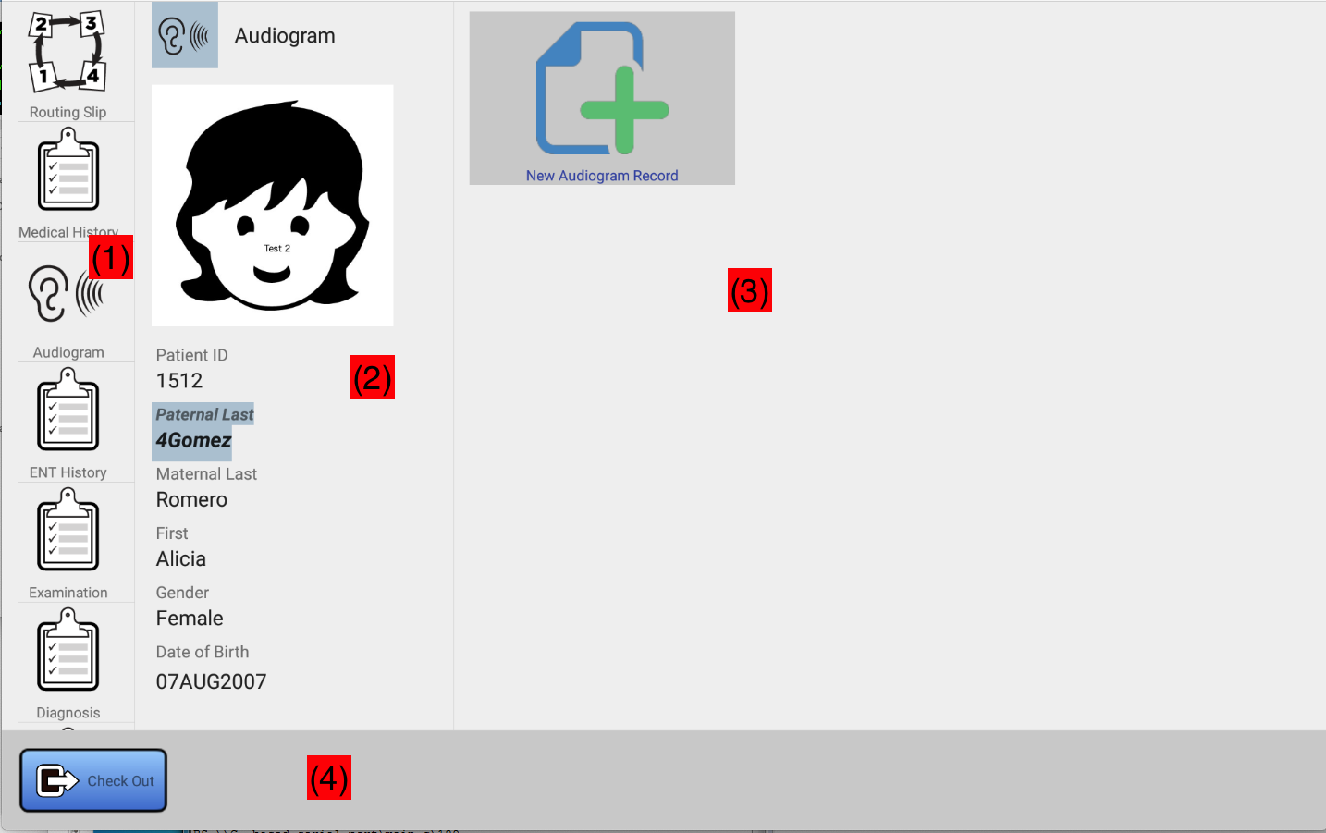

Figure 6.1 Audiology Chart
(1) can be used to select the view into the chart. For audiology, audiograms can be created, the routing slip can be viewed and edited (refer to Section 3.9), the medical history can be viewed and edited, and various portions of the ENT chart for the patient can be viewed (but not edited). (2) is the patient info panel. This depicts the recent headshot for the patient, as well as personal identifying information such as name, date of birth, and gender. Above the headshot is displayed the current view into the chart. (3) is the work area. Here, you can select a chart entry from a past clinic, or create a new chart entry for the current clinic. What displays here corresponds to the item selected in (1). For example, if Audiogram is selected in (1), then (3) will represent a view into the Audiogram data for the patient. (4) is the command area. This area contains buttons that can be used to Save any changes, and checkout the patient (see Section 3.8.3).
The remaining sections will cover each of the views specific to Audiology selectable in (1).

Viewing ENT Data
Because of the highly collaborative nature of ENT and Audiology, the following views into the ENT chart for the patient are provided. Buttons to access these are located below the Audiograms button in area (1) of Figure 6.1. These include
- ENT History
- Examination
- ENT Diagnosis
- Treatment Plan
Refer to Sections 5.2 – 5.5 for details on the layout of these views. Note that Audiology can only view these portions of the charts, not edit them.

Creating Audiograms
The main function of the audiogram portion of the digital chart is to store images of audiograms that were obtained for the patient. The system is capable of storing audiograms obtained for the entire history of the patient. Refer to Figure 6.2. When the Audiogram button (1) is selected, a list of all audiograms obtained for the patient (2), as well as a button that can be used to record a new audiogram (3) is displayed.
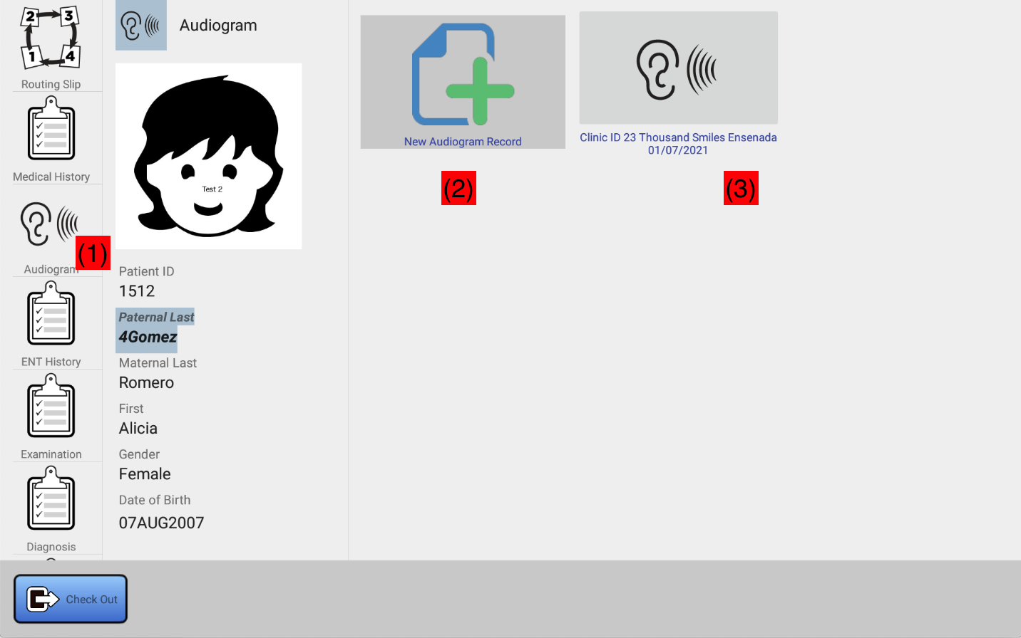

Figure 6.2 Selecting the Audiogram Button
To create a new audiogram, click on (2). You will be asked to confirm. Confirm by clicking on YES in the confirmation dialog that displays. You will then be shown the screen in Figure 6.3:

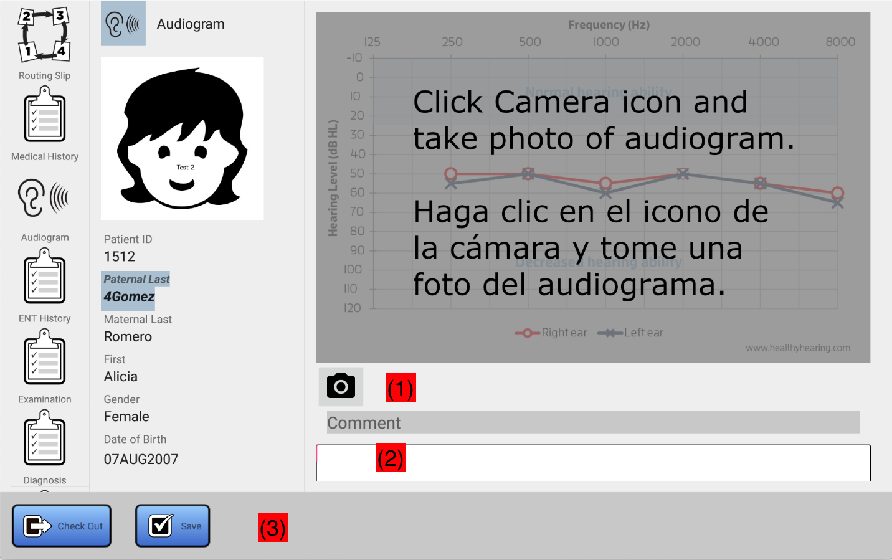

Figure 6.3 New Audiogram screen
Use the Camera icon (1) to use the built in camera of the tablet to record a photo of the audiogram. Ensure that the recorded audiogram is adequately lighted, and position the camera to ensure that the audiogram occupies the full frame of the camera. Optionally, enter any comments that you might wish to record for the audiogram in the provided text area (2). Clicking in the text box will cause a soft keyboard to be displayed to allow these comments to be added. Finally, when you are done, click on the Save button (3).

Viewing and Editing Existing Audiograms
Refer to Figure 6.2, area (3). Here you will find a list of all audiograms that were saved for this patient, if any. Each will be represented with an icon that identifies the clinic and the date during which the audiogram record for the patient was created. The list is ordered so that the most recently created audiogram is displayed first. This list may be larger than the screen, use your index finger to scroll the list vertically to view the entire list, if necessary. You may click on any of these to view or edit the corresponding audiogram. If you wish to re-record the image, or modify the comment, or both, you may use the same steps that were detailed (see Figure 6.3). Repeating these steps associated with Figure 6.3 below:
Use the Camera icon (1) to use the tablet’s built in camera to record a photo of the audiogram. Optionally, enter any comments that you might wish to record for the audiogram in the provided text area (2). Clicking in the text box will cause a soft keyboard to be displayed to allow these comments to be added. Finally, when you are done, click on the Save button (3).

X-Ray Chart

Overview
The main user interface for X-Ray is organized as shown in Figure 7.1, below.
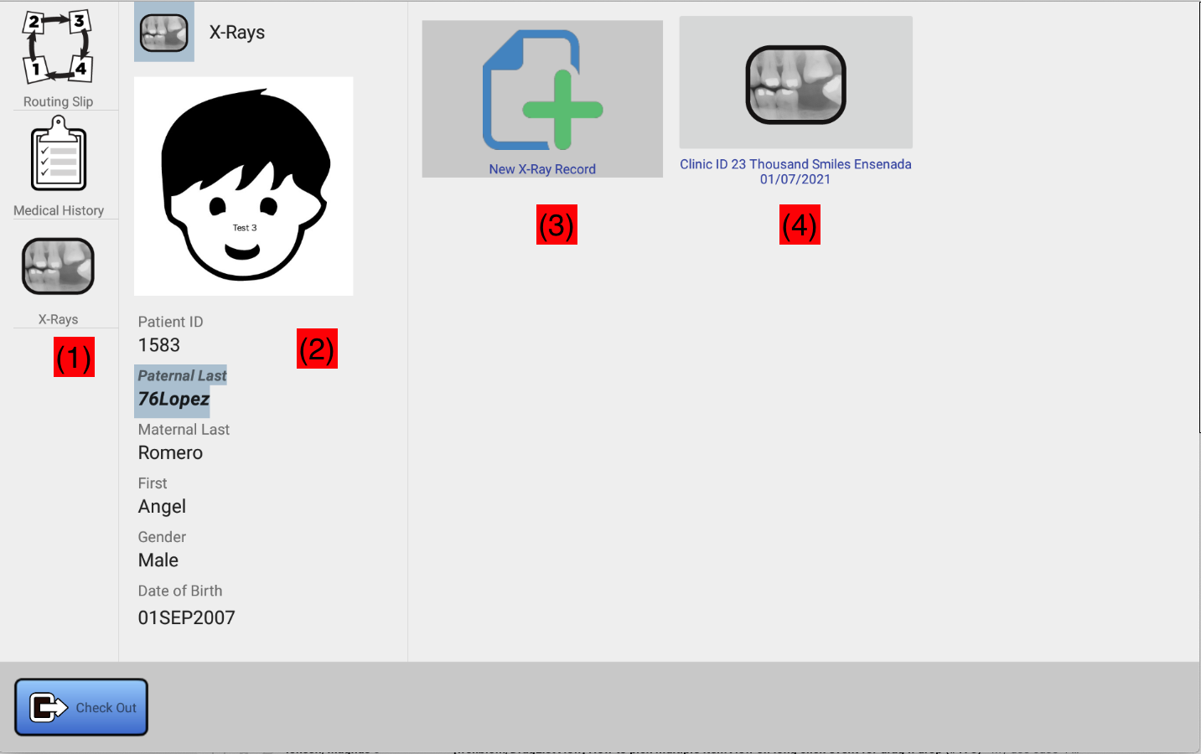

Figure 7.1 X-Ray Chart
(1) can be used to select the view into the chart. For X-Ray, x-ray records can be created, the routing slip can be viewed and edited (refer to Section 3.9), and the medical history and vaccination record for the patient can be viewed and edited. (2) is the patient info panel. This depicts the recent headshot for the patient, as well as personal identifying information such as name, date of birth, and gender. Above the headshot is displayed the current view into the chart. (3) is the work area. Here, you can select a chart entry from a past clinic, or create a new chart entry for the current clinic. What displays here corresponds to the item selected in (1). For example, if X-Rays is selected in (1), then (3) will represent a view into the X-Ray data for the patient. (4) is the command area. This area contains buttons that can be used to Save any changes, and checkout the patient (see Section 3.8.3).

The remaining sections will cover each of the views specific to the X-Ray portion of the chart selectable in (1).

X-Ray Data Stored
The X-Ray data for a patient consists of a number of items recorded by the radiologist for a patient’s visit to X-ray at any given clinic.

- The type of X-Ray(s) taken (Full, Anteriors-Bitewings, Panoramic, or Cephalometric)
- The X-Ray images (these are uploaded in a separate application running on the PC used to capture and store the digital X-Rays. See Figure 7.2. This application is not documented here. See the following video for a demo: Uploading X-Rays Using the Dashboard app
- The mouth type (child or adult)
- The specific teeth which were recorded, as a visual representation

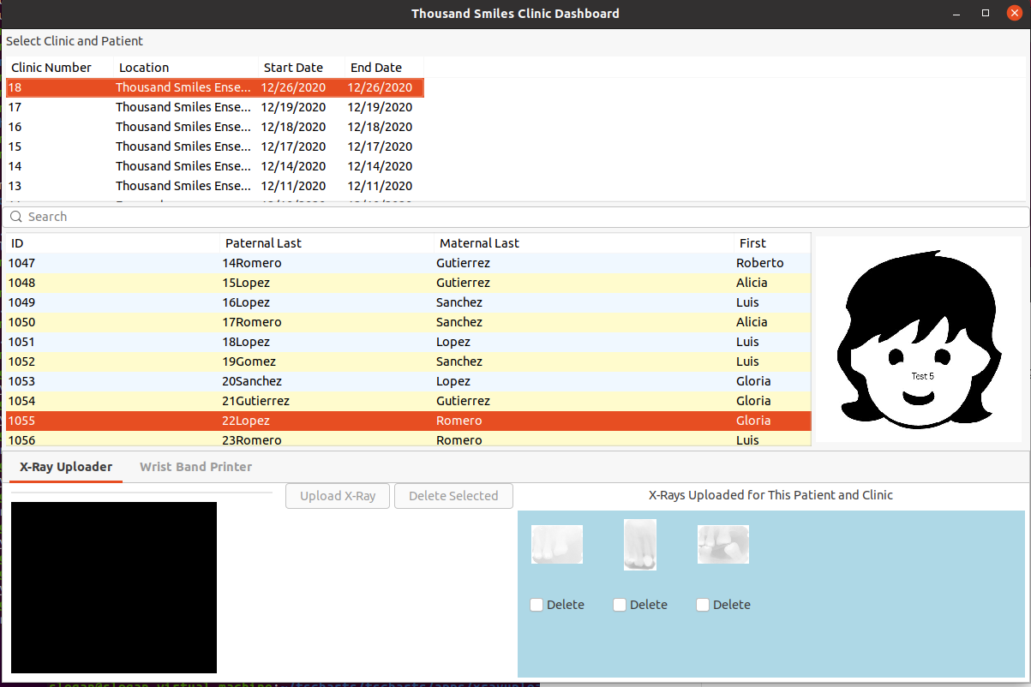

Figure 7.2 Clinic Dashboard X-Ray Upload Function

Adding an X-Ray Record
If digitals are taken, an X-ray record for the patient and clinic is automatically created when the image is uploaded to the database using the dashboard app. For film-based x-rays, you will need to do this step yourself. You can also edit the xray-record that was automatically created, or create the record before xrays are uploaded. To add an X-Ray record, click on X-Rays in area (1) of Figure 7.1, then click on the new X-Ray button (3), also depicted in Figure 7.1. You will be given the following screen (Figure 7.3):

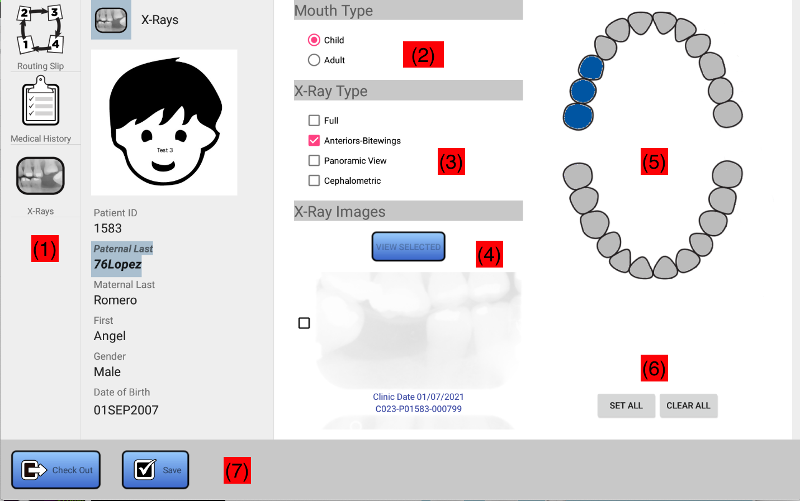

Figure 7.3 X-Ray Chart Editor

In Figure 7.3 (2) can be used to select the mouth type (child or adult). The mouth image in area (5) will change to correspond to this selection. Select the X-Ray types that were recording at this clinic for the patient using the checkboxes in area (3). Area (5) is the hit chart. Use your finger to touch specific teeth covered by the X-Rays taken at this clinic. Touching a tooth will toggle the color of the tooth between blue and grey. A blue tooth is used to indicate that a tooth was included in the set of X-Rays. A grey tooth indicates that the tooth was not included. This can be used as an aid to dentists when the record is viewed. Use (6) to set or clear all of the selected teeth in the mouth rendering. SET ALL will color all teeth in blue, while CLEAR ALL will render them in grey.

Section (4) can be used to view any X-ray images that were uploaded for the patient using the application shown in Figure 7.2. The most recent images are listed first. The area can be scrolled vertically to see all images recorded for the patient. Use your index finger to swipe the set of X-Rays up and down. You can use the checkboxes to select specific images, then use the VIEW SELECTED button to view the selected images full screen. Refer to Section 4.2.1 of this document for specific details on viewing the X-Rays.

When you have filled out this form, use the Save button (7) to save it in the database.

A video showing the process of creating a basic x-ray recorded is available here: Creating a basic X-Ray Record for a Patient

Viewing and Editing an Existing X-Ray Record
To view and edit or correct any existing X-Ray records, touch the X-Ray record you wish to access in area (4) of Figure 7.1. The X-Ray record will be depicted as shown in Figure 7.3. You may then view or edit the X-Ray record as described in Section 7.3. Any changes made will enable the Save button, which must be used to make these changes permanent in the database.

Appendices

Dental CDT Codes
This appendix lists the set of CDT codes directly supported by the full-mouth dental chart and tooth charts. See Section 4.5, 4.6, and 4.7 for details.

PERSONS SERVED (ENCOUNTER CODES)

D0000 First Visit (of fiscal year by the patient)
D0190 Dental Revisit (For Any Reason)
D0003 BBTD/ECC Dental Patient
D0004 Head Start Program Dental Patient
D0007 High-risk Periodontal Patient
D9320 Diabetic Screening Procedures
D9321 Diabetic Referral Or Follow-up
D9330 Hypertension Screening
D9331 Hypertension Referral Or Follow-up
D9340 Dental Visit, Pre-Natal Mother
D9341 Dental Visit, Nursing Mother
D9990 Planned Treatment Completed
D9991 Patient Refuses Recommended Treatment

DIAGNOSTIC SERVICES

D0120 Periodic Oral Evaluation (update existing chart)
D0140 Limited Evaluation-Problem Focused (Emerg. Exam)
D0145 Oral Evaluation for Patient under 3 years of age
D0150 Comprehensive Oral Evaluation (new chart made)
D0160 Extensive Oral Evaluation-Problem Focused
D0180 Comprehensive Periodontal Evaluation
D0210 Intraoral Complete Series
D0220 Intraoral Periapical, Single Film
D0230 Intraoral Periapical, Additional Film
D0240 Intraoral Film
D0270 Bitewings, Single Film
D0272 Bitewings, Two Films
D0273 Bitewings, Three Films
D0274 Bitewings, Four Films
D0330 Panoramic-Maxilla And Mandible Film
D0340 Cephalometric Film
D0350 Oral/Facial Images
D0425 Caries Susceptibility Test
D0460 Pulp Vitality Tests (Per Quad)
D0470 Diagnostic Casts (Per Set)
D0471 Diagnostic Photographs

PREVENTIVE SERVICES

D1110 Prophylaxis, Adult (Permanent Dentition)
D1120 Prophylaxis, Child (Primary or Mixed Dentition)
D1203 Topical Fluoride Not Including Prophy-Child
D1204 Topical Fluoride Not Including Prophy-Adult
D1206 Topical Fluoride Varnish (mod to high risk pts)
D1310 Nutritional Counseling For Oral Health
D1320 Tobacco Use Counseling
D1330 Oral Hygiene Instructions
D1351 Sealant (per tooth)
D1510 Space Maintainer, Fixed Unilateral
D1515 Space Maintainer, Fixed Bilateral
D1550 Space Maintainer, Recementation
D1555 Removal of Fixed Space Maintainer

RESTORATIVE DENTISTRY

D2140 Amalgam, One Surface (Perm or Primary)
D2150 Amalgam, Two Surface (Perm or Primary)
D2160 Amalgam, Three Surface (Perm or Primary)
D2161 Amalgam, Four+ Surfaces (Perm or Primary)
D2330 Composite Resin, One Surface, Anterior
D2331 Composite Resin, Two Surfaces, Anterior
D2332 Composite Resin, Three Surfaces, Anterior
D2335 Composite Resin, Four Surfaces or Incisal
D2390 Composite Resin Crown, Anterior
D2391 Comp Resin, One Surf., Post., Perm or Prim (includes PRR)
D2392 Composite Resin, Two Surfaces, Post. (Perm or Primary)
D2393 Composite Resin, Three Surfaces, Post. (Perm or Primary)
D2394 Composite Resin, Four Surfaces, Post. (Perm or Primary)
D2740 Crown-Porcelain/Ceramic Substrate
D2750 Crown-Porcelain Fused To High Noble Metal
D2751 Crown–Porcelain Fused to Base Metal
D2752 Crown-Porcelain Fused To Noble Metal
D2790 Crown- Full Cast High Noble Metal
D2791 Crown-Full Cast Base Metal
D2792 Crown-Full Cast Noble Metal
D2799 Provisional Crown
D2915 Recement Cast/Prefab Post and Core
D2920 Recement Crowns
D2930 Crown-Stainless Steel, Primary Tooth
D2931 Crown-Stainless Steel, Perm. Tooth
D2932 Crown-Prefab. Resin, Primary Tooth
D2940 Sedative Filling
D2950 Core Buildup, Including Any Pins
D2951 Pin Retention (Per Tooth) Excludes Restoration
D2954 Post And Core (Prefab.), Excl Crown
D2970 Temporary Crown (fractured tooth)

PERIODONTICS

D4210 Gingivectomy Or Gingivoplasty (4 or more contig. teeth)
D4211 Gingivectomy Or Gingivoplasty (1 to 3 teeth)
D4240 Gingival Flap Proc. w/ Root Planing (4 or more contig. teeth)
D4241 Gingival Flap Proc. w/ Root Planing (1 to 3 teeth)
D4249 Crown Lengthening Proc. - Hard Tissue
D4260 Osseous Surgery (4 or more contig. teeth)
D4261 Osseous Surgery (1 to 3 teeth)
D4263 Bone Replacement Graft, First Site In Quadrant
D4274 Distal Prox. Wedge Procedure (w/o other Surg)
D4341 Root Planing (4 or more contig. teeth)
D4342 Root Planing (1 to 3 teeth)
D4355 Full Mouth Debridement (For Perio. Evaluation)
D4381 Controlled Release Of Chemo. Agents, Per Site
D4910 Periodontal Maintenance After Therapy

ENDODONTICS

D3110 Pulp Cap, Direct (Excluding Final Restoration)
D3220 Vital Pulpotomy, Primary or Perm. Tooth
D3221 Pulpal Debridement, Primary or Perm Tooth
D3230 Pulp Therapy, Primary Anterior
D3240 Pulp Therapy, Primary Posterior
D3310 Endodontic Fill, Anterior
D3320 Endodontic Fill, Bicuspid
D3330 Endodontic Fill, Molar
D3346 Retreat Previous Endo Fill - Anterior
D3347 Retreat Previous Endo Fill -Bicuspid
D3348 Retreat Previous Endo Fill -Molar
D3351 Apexification/Recalcify, Initial Visit
D3352 Apexification/Recalcify, Interim Visit
D3353 Apexification/Recalcify, Final Visit
D3410 Apicoectomy/Periradicular Surg., Ant. Tooth
D3430 Retrograde Filling, Per Root
D3950 Fitting For Preformed Dowel
D3960 Bleach Discolored Tooth (Vital or Non-Vital)

REMOVABLE PROSTHODONTICS

D5110 Complete Denture - Maxillary
D5120 Complete Denture - Mandibular
D5130 Immediate Denture - Upper
D5140 Immediate Denture - Lower
D5211 Upper Partial, Resin Base incl. Clasps
D5212 Lower Partial, Resin Base Incl. Clasps
D5213 Upper Partial, Cast Frame, Resin Bases, Clasps
D5214 Lower Partial, Cast Frame, Resin Bases, Clasps
D5410 Adjust Full Denture, Upper or Lower
D5421 Adjust Partial Denture, Upper or Lower
D5510 Repair Full Denture Base, Upper or Lower
D5520 Replace Missing/Broken Denture Teeth (Per Tooth)
D5610 Repair Resin Partial Denture Base
D5640 Replace Missing/Broken Denture Teeth (Per Tooth)
D5710 Rebase, Full Denture
D5720 Rebase, Partial Denture
D5750 Reline, Full Denture (Laboratory Procedure)
D5760 Reline, Partial Denture (Laboratory Procedure)
D5850 Tissue Conditioning (Per Arch)
D5860 Overdenture, Full

FIXED PROSTHODONTICS

D6080 Implant Maintenance Procedures
D6210 Pontic – Cast High Noble Metal
D6211 Pontic – Cast Base Metal
D6212 Pontic – Cast Noble Metal
D6240 Pontic - Porcelain Fused To High Noble Metal
D6241 Pontic - Porcelain Fused To Base Metal
D6242 Pontic - Porcelain Fused To Noble Metal
D6545 Retainer-Cast Metal For Resin Bonded Pros.
D6740 Abutement-Porcelain/Ceramic
D6750 Abutment – Porcelain Fused To High Noble Metal
D6751 Abutment – Porcelain Fused To Base Metal
D6752 Abutment – Porcelain Fused To Noble Metal
D6790 Abutment - Full Cast High Noble Metal
D6791 Abutment - Full Cast Base Metal
D6792 Abutment - Full Cast Noble Metal
D6930 Recement Bridge
D6972 Post and Core, (Prefab.) Excl. Retainer
D6973 Core Buildup For Retainer, Incl. Pins
D6980 Bridge Repair (By Report)

ORTHODONTICS

D8010 Limited Ortho. TX, Primary Dentition
D8020 Limited Ortho. TX, Transitional Dentition
D8030 Limited Ortho. TX, Adolescent Dentition
D8040 Limited Ortho. TX, Adult Dentition
D8050 Interceptive Ortho. TX, Primary Dentition
D8060 Interceptive Ortho. TX, Transitional Dentition
D8070 Comprehensive Ortho. TX, Transitional Dentition
D8080 Comprehensive Ortho. TX, Adolescent Dentition
D8090 Comprehensive Ortho. TX, Adult Dentition
D8210 Habit Control, Removable Appliance
D8220 Habit Control , Fixed Appliance
D8660 Pre-Orthodontic Treatment Visit
D8670 Periodic Orthodontic Treatment Visit
D8680 Ortho. Retention, Remove Appl. & Make Retainer
D8691 Repair of Orthodontic Appliance
D8692 Replacement of Lost or Broken Retainer
D8693 Rebond/Recement/Repar Fixed Retainer

ORAL SURGERY

D7111 Coronal Remnants (Primary Tooth)
D7140 Extraction (Erupted Tooth or Exposed Root)
D7210 Surgical Extraction, Erupted Tooth
D7220 Surgical Extraction, Soft Tissue Impaction
D7230 Surgical Extraction, Bony Impaction
D7240 Surgical Extract, Bony Impact.-Section Tooth
D7241 Surgical Extract, Bony Impact-Section-Unusual
D7250 Remove Residual Roots, Unexposed
D7270 Reimplant/Stabilize Avulsed Teeth
D7280 Surgical Exposure to Attach Ortho Wire
D7283 Placement of Device to Facilitate Eruption
D7286 Biopsy of Oral Tissue (Soft or Hard Tissue)
D7288 Brush Biopsy
D7291 Transeptal Fiberotomy
D7310 Alveoloplasty w/Extractions (4 or more teeth/spaces)
D7311 Alveoloplasty w/Extractions (1-3 teeth/spaces)
D7320 Alveoloplasty w/o Extractions (4 or more teeth/spaces)
D7321 Alveoloplasty w/oExtractions (1-3 teeth/spaces)
D7410 Excision of Benign Lesion (up to 1.25 cm)
D7420 Excision of Benign Lesion (greater than 1.25 cm)
D7460 Remove Nonodontogenic Cyst
D7465 Destroy Lesion by Physical or Chemical Means
D7471 Removal of Exostosis, Maxilla or Mandible
D7510 Incision And Drainage of Abscess, Intraoral
D7520 Incision And Drainage of Abscess, Extraoral
D7530 Removal Foreign Body
D7620 Fracture, Closed Reduction - Maxilla
D7630 Fracture, Open Reduction - Mandible
D7640 Fracture, Closed Reduction - Mandible
D7650 Fracture, Arch/Open - Malar/Zygomatic
D7660 Fracture, Arch/Closed - Malar/Zygomatic
D7670 Fracture, Alveolus Open Reduction
D7830 Manipulation of TMJ Under Anesthesia
D7880 Occlusal Orthotic Appliance
D7899 Unspecified TMD Therapy
D7910 Suture Traumatic Wounds (Any Size)
D7960 Frenectomy, As Separate Procedure
D7970 Excise Hyperplastic Tissue/Arch
D7971 Excise Pericoronal Gingiva
D7997 Appliance Removal (not by dentist who placed app)

ADJUNCTIVE GENERAL SERVICES

D9110 Palliative TX of Dental Pain (Minor Procedure)
D9130 Broken Appointment (No Show)
D9140 Canceled Appointment
D9170 Emerg. Encounter (Report w/ any exam code)
D9210 Local Anesthesia, Not In Conjunction w/ Other Proc.
D9211 Regional Block Anesthesia
D9212 Trigeminal Division Block
D9215 Local Anesthesia
D9220 General Anesthesia
D9221 General Anesthesia, Each Add. 15 Min.
D9230 Analgesia, Includes Nitrous Oxide
D9241 Intravenous Sedation (first 30 minutes)
D9242 Intravenous Sedation (each additional 15 minutes)
D9248 Non-intravenous Conscious Sedation (includes IM)
D9260 Premedication, Oral Only
D9310 Consultation Provided (Per Session)
D9420 Hospital Call, Includes Admissions
D9430 Office Visit, Observation Only (During Office Hours)
D9440 Office Visit, After Office Hours
D9610 Therapeutic Injection (Sedatives/Antibiotics)
D9630 Other Drugs/Medicaments
D9910 Apply Desensitizing Medicaments
D9911 Application of Desensitizing Resin for Cervical/Root Surface
D9920 Behavior Management
D9930 Treat Post-surgical Complications
D9940 Occlusal Guard
D9941 Athletic Mouth Guard
D9942 Repair/reline Occlusal Guard
D9951 Occlusal Adjustment, Limited
D9973 External Bleaching (per tooth)
D9974 Internal Bleaching (per tooth)

Patient Categories
The following table lists the possible categories that a patient can be classified in at registration time. The initial routing slip entries will be added automatically by the system when the patient is registered. Caregivers and runners modify the routing slip as the patient visits various stations during his or her visit, as described earlier in this document.

Category | Description | Routing Slip Entry
Dental | Patient is here to see a dentist, or for X-rays. Patients coming from orphanages are typically Dental | Dentist, X-Rays. Runners may remove X-Rays if the patient has had them in past year. Hygiene may be added to routing slip by Dentists.
Hearing Aids | Patient is here because in a previous visit, hearing aids were prescribed, and they are now ready to be dispensed. | Audiology
Ears | Patient is having problems hearing. | ENT
Ortho | Orthodontics – Braces. Patient is only here to see ortho. If the patient is here to see multiple stations including ortho, select Returning Cleft. | Orthodontics
New Cleft | Cleft surgery candidate – first visit. Typically an infant < 1 year of age. | Surgery Screening and  ENT. These stations will assess the patient and may add others stations to the routing slip.
Returning Cleft | Cleft patient that is returning for additional procedures, surgery, or evaluation. | Surgery Screening and  ENT. These stations may add others to the routing slip.
Other | None of the above or unknown. Will be routed to Surgery Screening and ENT to determine purpose of visit. | Surgery Screening and  ENT. These stations may add others to the routing slip.

Table 8.2.1 Patient Categories

