
Software Requirements Specification
for
Thousand Smiles Digital Charts
Version 1.1
Prepared by Syd Logan
Thousand Smiles Foundation
05/20/2015
Table of Contents
1.Introduction 1
1.1Purpose 1
1.2Document Conventions 1
1.3Intended Audience and Reading Suggestions 1
1.4Product Scope 1
1.4.1Registration 1
1.4.2Routing 2
1.4.3Medical Specialties (ENT, audiology, etc.) 2
1.4.4General Requirements 2
1.5References 3
2.Overall Description 4
2.1Product Perspective 4
2.1.1Database 4
2.1.2User Interface 4
2.1.3Registration and Patient Flow 4
2.2Operating Environment 5
2.3Design and Implementation Constraints 5
2.4User Documentation 5
2.5Assumptions and Dependencies 5
3.External Interface Requirements 5
3.1User Interfaces 5
3.2Hardware Interfaces 10
3.3Software Interfaces 10
3.4Communications Interfaces 10
4.Registration Requirements 10
5.Routing Requirements 11
6.Medical Specialties Requirements 12
7.Database 13
7.1High-level Structure 13
7.2Volunteer 14
7.3Patient 14
7.4Chart 15
8.General Requirements 16
9.Other Nonfunctional Requirements 17
9.1Performance Requirements 17
9.2Safety Requirements 17
9.3Security Requirements 17
9.4Software Quality Attributes 18
9.5Business Rules 18
10.Other Requirements 18

Revision History
Name | Date | Reason For Changes | Version
Syd Logan | 01/17/2015 | Original | 1.0
Syd Logan | 05/20/2015 | Mention something about implementation process | 1.1

Introduction

Purpose
The purpose of this document is to outline the basic requirements associated with the Thousand Smiles Digital Chart. This document focuses on the system as a whole with an emphasis on patient registration, search, and flow requirements. Other documents define requirements for the various stations a patient may visit at the clinic (e.g., Dental, ENT, Audiology, Surgery Screening) and the hospital (e.g., patient intake, surgery, recovery and discharge).

Document Conventions
There are no specific conventions associated with this document.

Intended Audience and Reading Suggestions
The intended audience includes:

Thousand Smiles Board Members: Board members should read this document to become familiar with the overall overall scope of registration in the digital charts project. This knowledge may prove helpful as background when evaluating logistics and expenditures associated with the implementation of the system, e.g., equipment purchases.

Implementation Team: This document spells out requirements which guide the implementation of the system. It is not intended to be a design document, rather it spells out the requirements that a design must follow to be considered valid.

Users: This document must be read and approved by the end user(s) of the system. This document will likely go through some number of revisions towards eventual approval. If asked to review, comment on, or approve this document, please read the document critically and identify any omissions, errors, and changes so that they can be dealt with.

Note that this document lays out requirements only. It does not specify a design to implement the requirements, nor does it pre-suppose a solution that meets the (non-existent) requirements. Subsequent phases of the project will commence once all requirements have been gathered and approved. These phases, roughly, cover the following (and may or may not be executed in the below order):

Search for an Off-The-Shelf Solution
Once requirements are in hand, an existing solution in the marketplace can be sought out. Without requirements, it is difficult if not impossible to evaluate potential solutions (since there are no requirements against which the solution can be measured).

It is unlikely that any off the shelf solution will exactly meet the requirements in this document. More likely, we will find solutions that meet some, or not all of the requirements. Possible ways to resolve missing or less-than ideal meeting of requirements might include:

- Working with the vendor to modify their software to meet requirements
- Designing our own code that works alongside of the solution to provide the missing requirements (the degree to which this is achievable is based on the software in question and whether or not it can be interfaced with in a suitable manner or extended in some fashion by the end user).
- Rejecting the solution and designing and implementing our own software to meet the requirements.

User Experience Design
Once requirements are in hand, should no suitable off the shelve solution become available, user interface design can be undertaken. The phase results in a document that describes the look and feel of the software, and defines user interactions. The work should be done by a professional user interface designer (volunteer or for fee) to ensure the best result. The results of the design need to be presented to the stakeholders/user to get agreement on overall usability before moving to the implementation phase.

Implementation
Should no suitable off the shelf component be found, software engineers (volunteer or paid) will be engaged to develop the software. Particularly if the work is done for fee, the developer will be first paid to sketch out an implementation plan and overall design, and scope out a schedule for the implementation and deployment.

Reduction of Scope and/or Requirements
We may find it advantageous to revisit or eliminate requirements specified in this document in order to allow for the use of an off-the-shelf solution.

Product Scope
The following sections briefly summarize the scope of the system. Detailed requirements for each will be presented later in this document.

Registration
The system must support registration functions, described in Section 4 of this document. Such functions include:

- searching for patients
- adding new patients to the database
- updating data for returning patients
- tracking the attendance of a patient at a given clinic
- reporting the status of the clinic in terms of patients registered (e.g., list and count of patients)
- maintain a history of patient attendance

Routing
The system must support routing functions:

- maintain a routing slip for a patient that is registered for a clinic. The routing slip is a plan for a patient's visit to a clinic, and the care to be received.
- report the status of patients during the clinic (e.g., what station they are currently visiting)
- report the status of stations (busy with patient, or idle)

More is said about routing in Section 5 of this document.

Medical Specialties (ENT, audiology, etc.)
Medical specialists/care providers are the main users of the system. They require:

- ability to view medical data that has been collected for the patient during the current clinic, as well as during previous clinics. This includes data that has been entered by other specialists
- view and modify the routing slip for the patient
- create and edit medical data that corresponds to their area of care.

Each specialist has specific requirements that relate to their area of expertise. The system must allow for the design of screens and data that is best suited to the needs of the specialty (while maintaining a certain amount of consistency with the system as a whole so that people outside of the speciality are able to view the data in meaningful ways). Separate requirement documents and designs will be produced for each of the following specialities:

- ENT
- Audiology
- Speech
- Registration, Search, Routing, Medical History
- Orthodontics
- Dental
- Surgery
  - Checkin
  - OR
  - Recovery
  - Discharge

This document talks about the general requirements that pertain to all of the above specialties in Section 6. Refer to the specific requirements document for the corresponding speciality for more detailed requirements of that speciality.

General Requirements
The system has a number of general requirements related to user management (accounts, passwords, etc.) and the use of the system.

References
This document does not refer to any external references.

Overall Description

Product Perspective
The digital chart is intended to replace the existing registration system, patient flow management, and paper charts that are currently used by Thousand Smiles with an all digital system. The goal is to implement a system that is entirely hosted on site (no Internet connection required) and that can be accessed via tablet computers during the operation of the clinic.

The system consists of several subsystems, listed below.

Database
The system is centered on a database. The data stored in this database consists of general information about the patient, such as name and DOB, medical history, and a clinic attendance history. The database also contains medical data associated with the patient. Each of the specialities (ENT, dental, etc.) that provides care to the patient is represented by its own tables in this database. Finally, the database contains a certain amount of information about our volunteers – what areas of speciality they are involved with, what access they have to patient data, and records of their activity (login, logoff, etc.)

In short, the major components in the database include:

- Volunteer information (name, contact, area of speciality, permissions, usage history)
- Patient (similar to what we track now for the patient, name, dob, gender, contact info, registration history) plus return to clinic information
- Clinical Data (per-patient, per-visit, per-speciality diagnosis and workflow)

The database is defined in more detail in Section 7.

User Interface

There is a common user interface that is used to search for, select, and view general information associated with the patient in the database. In addition, this common user interface provides access to patient registration and routing functions.

Each speciality (ENT dental, etc.) has a dedicated subsystem that consists of some number of screens that have been designed by the specialty based on their needs. These subsystems are documented in separate requirements specifications. The overall goal is to implement a system that provides a user interface that is flexible, and allows medical personnel to enter, update, and view patient data in a way that is best suited to the needs of their particular area of expertise and preferred workflow. This flexibility is a key component of the system, and will be achieved by involving the end users (surgeons, dentists, etc.) in the design of the user interface. Some general ideas about the user interface are presented in Section 3.1.

Registration and Patient Flow
Registering new or previous patients, deciding and tracking their flow through the clinic, and discharging the patient once care has been provided are all key aspects of this component.

Operating Environment
Data entered at registration will be stored in a database which is located on the premises. The data will be immediately available at all other other stations within the clinic.

At clinic start, the database will be populated with a backup that was made at the end of the prior clinic. This implies that the database is read-only between the close of the prior clinic and the start of the current clinic.

At clinic end, the database will be exported so that it may be accessed by stakeholders between clinic, who have appropriate access rights, and for purposes of backup. This backup will form the initial state of the database at the beginning of the next clinic.

Each station in the clinic will have a tablet computer which provides access to the database, and which runs an application that implements the digital chart functionality. The system will be based on Android API version 17, supporting min version 11. The reasons for using Android:

- Does not require Apple approval or hosting for distributing applications. We cannot be rejected by Apple, and we can update the software on our own schedules (vs. being subjected to delays due to Apple's approval process).
- We can self-host the application on our website, and at the clinic, so that people bringing their own devices can install on the day of the clinic if desired.
- More tablet device choices across multiple vendors
- As of this writing, high quality devices available for < $200

Design and Implementation Constraints
Since we are providing the implementation for the system, there are no known constraints.

User Documentation
Documentation for the overall system, and the registration subsystem, shall be provided via YouTube videos and written documentation on the Thousand Smiles Wiki.

Assumptions and Dependencies
There are no specific assumptions or dependencies associated with the registration subsystem.

External Interface Requirements

User Interfaces
The following few figures summarize the basic layout of a hypothetical tablet user interface, illustrating the major aspects of the user interface that are common to all subsystems. It is important to note that this section is included only for purposes of context; it does not reflect final design decisions (recall this document is intended to communicate requirements, not design). Rather, it illustrates an idea as to how the tablet UI is likely to be organized. Details on the user interface of the system is TBD and will be supplied separately.

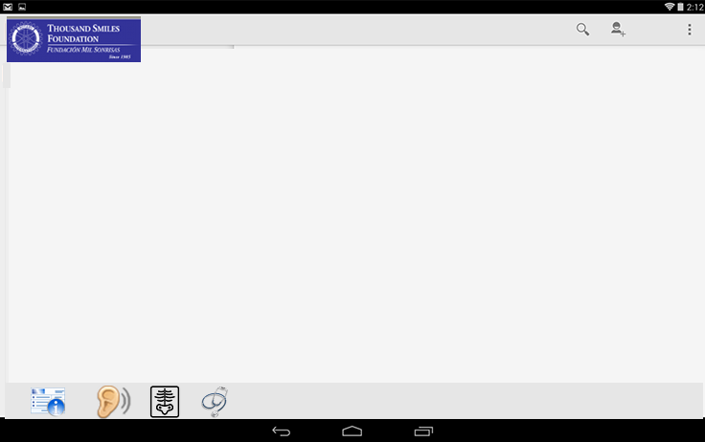
Patient Search
Settings
Subsystem Chooser

In the above figure, Patient Search is available on all screens. Selecting this icon takes the user to the patient search subsystem, where patients can be located (or, at registration time, new patients can be added to the database). Settings allows the user to set various parameters of the system, including host and port of the database server. The subsystem chooser allows the user to navigate among the various subsystems. Here, left to right, the icons depict examples for the following subsystems:

- Medical History
- ENT
- Radiology
- Surgery

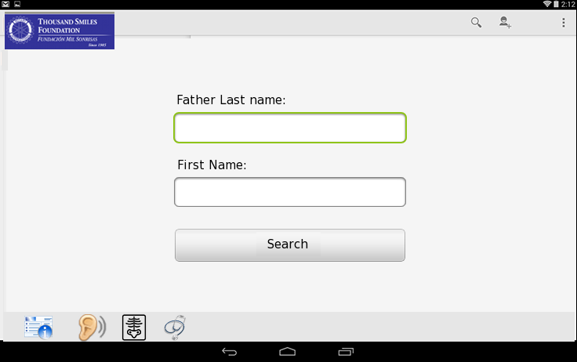

The screen above illustrates one of the search-related screens. The volunteer enters first and last name information, and presses the search button.

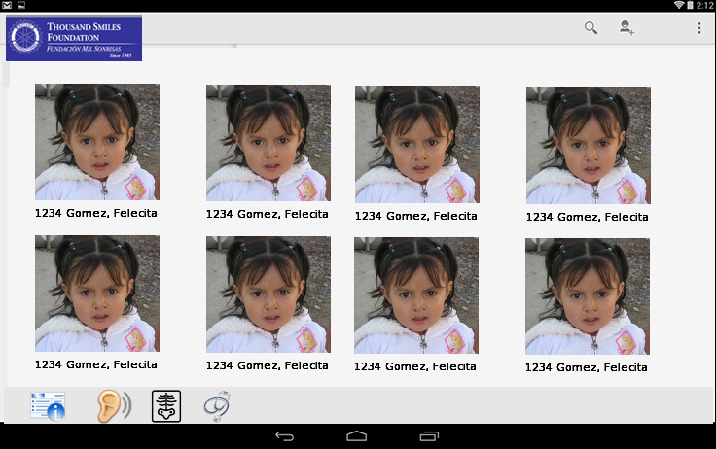
The screen above illustrates the result of clicking search. The screen displays nearest matches based on the provided search parameters at the time the user clicked the Search button. The user can access additional matches (if present) by vertically scrolling with his or her fingertip. Pressing the finger on the desired image will make the selected patient the current patient. Subsystems from this point on will allow viewing and editing of chart data for the selected patient. The name and ID of the patient will display on all screens once the child has been selected.

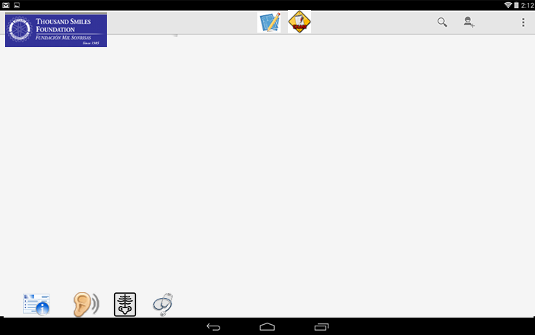

Patient Search
Settings
Subsystem Chooser
ENT Subsystem
Occupies this region
ENT Specific Functions
ENT Subsystem
Work Area
ENT Specific Function Access

The above screen illustrates the region that is dedicated to the charting functions of the ENT subsystem. ENT specific functions (diagnosis, history, plan, etc..) are accessed via icons that are located in the top button bar. Left to right, the example icons here depict “Plan” and “Exam”.

The ENT subsection top row icons should include and be ordered as follows: Past Surgical History, Past Medical History, (Today's) History, (Today's) Exam, (Today's) Diagnosis, (Today's) Plan.

Hardware Interfaces
The registration subsystem has no specific hardware requirements.

Software Interfaces
The database to which the user authenticates and which host the patient data will be accessible via REST API over HTTP connection to the hosting server. Access to the server is made via wireless network connection. The system shall allow users to configure the IP address and port of the server from their devices. The server will be hosted on a typical Linux system. Backups of the server and the database should be made to a mirroring host on the Internet.

The user interface should be designed to run on mobile devices provided by Thousand Smiles. It should depend only on the RESTful API to the database for its data/model implementation. This separation (commonly known as model/view/controller) ensures that clients can be written, if needed, to support multiple platforms (desktop, web, mobile) and various operating systems (iOS, Android). The first implementation will be for Android tablets.

Communications Interfaces
See section 3.3 above.

Registration Requirements

For those tasked with registering patients prior to being seen by medical personnel, the system must provide the ability to:

- search for a patient in the database based on name
- if the patient is not found in the database, create a new record in the database and populate it with the patient's current data. Such data includes:
  - name
  - address
  - parent's name and address
  - name of responsible party
  - gender
  - date of birth
  - phone (if available) of responsible party
  - e-mail (if available) of responsible party
- if the patient is found in the database, update the database with the patient's current data (see above), if needed
- determine if a specific patient is registered at the current clinic
- register a patient as having attended the current clinic
- view a list of patients registered for the current clinic
- view the clinic attendance history for a specific patient
- view, update, or create the medical history for a patient
- take and store a headshot of the volunteer at time of registration

The system should support marking a patient “inactive”.

- An inactive patient is filtered during patient searches (to reduce the number of matches for a search and simplify locating patients that are currently active)
- Search result should allow for the display of inactive patients at the descretion of the user, and identify which patients are inactive or not.
- The system should support displaying of a list of inactive patients
- For each inactive patient, the basic information about that patient (photo, name, date of birth, gender, visitation history) should be displayable
- The system should support making an inactive patient active directly from the search results.

Routing Requirements

The system should allow for the creation and management of a digital routing slip for the patient.

- The routing slip should allow for the creation and modification of a list of the various stations that a patient registered for the current clinic should visit during the clinic.
- It should display what stations the patient has or has not visited as the clinic progresses.
- The routing slip should be modifiable by any specialist during the clinic (items can be added, or deleted from the routing slip as deemed necessary).

The system should maintain a history of the routing slips from previous clinics for a patient and should allow the volunteer to view any of the routing slips from previous clinics.

The system should allow personnel to check in or check out a patient as the patient arrives, or leaves, a specific station at the clinic, respectively. For example, if the patient arrives at ENT, it should allow the ENT personnel to check in the patient, and when the patient leaves ENT, it should allow the ENT personnel to checkout the patient.

The system should allow a volunteer to view the location of a patient at any given time in the clinic (e.g., where the patient is currently checked in).

The system should allow a volunteer to determine if a station (e.g., ENT) is currently seeing a patient.

The system should display each station as being inactive, busy, or unavailable. An inactive station is able to accept a patient. A busy station is currently active with a patient. An unavailable station is unable to accept a patient (for example, the specialist may be at lunch).

- The system will automatically mark a station as active or inactive as patients are checked in and check out of the station.
- The specialist can toggle the unavailable state of the station as required.

The system should support the creation of a return to clinic plan for the patient by a specialist, which consists of:

- date of return (specific clinic calendar date (e.g., May 3, 2015) based on selection of 3 month, 6 month, 9 month, 1 year interval (or user defined interval if desired interval is not provided by the user interface).
- the station/speciality that is requesting the return
- notes that identify the reason for the return

The return to clinic plan is aggregated for all stations, e.g., ENT might specify a return in 3 months, surgery 1 year, dental 9 months. Each of these is stored separately for the patient.

The return to clinic plan must be viewable at subsequent clinics.

When creating a routing slip, the system should automatically add stations that were a part of a previous return to clinic plan for the patient if the date of current clinic corresponds to the return date for any of the items in the return to clinic plan from a previous clinic. E.g., if at the previous clinic (3 months prior) the ENT specialists asked the patient to return in 3 months, the routing slip for the patient at the current clinic should automatically have ENT selected. When the patient is checked out (seen) by ENT, ENT is removed by the system from the patient's return to clinic plan.

The system should display a summary page for the patient's visit to the current clinic, consisting of at least the following:

- positives in the medical history
- name, gender, DOB of patient
- stations visited during the clinic
  - for each station, a summary of the findings
- routing plan for the clinic

The system should allow a user to view a list of the clinics previously attended by each patient, sorted by date. The system should allow a user to view a summary of the work performed on that patient for each clinic in the list.

Medical Specialties Requirements

Those who provide services to the patient (e.g., ENT, dental, audiology, surgery screening) must be able to:

- search for patients in the database and select a patient from the search results as the “current” patient
- view (and if needed, update) any of the information collected at registration time for the selected patient

The system must provide a section of the chart that corresponds to each speciality that provides care for the patient.

- Dental
- Surgery Planning/Screening
- ENT
- Audiology
- Orthodontics
- Surgery (checkin, recovery, checkout)

Each of the above specialties represents the items on the routing slip that can be selected for a patient.

Each of the above specialties must have a portion of the digital chart that is dedicated solely to maintaining data pertaining to that speciality for the patient being seen. E.g., ENT will have an ENT portion of the digital chart, as will dental and others.

Once checked in at a station, the system should allow personnel to read or modify the portion of the chart that corresponds to the station the patient is currently checked into. For example, if the patient is checked in as visiting ENT, the ENT specialist should be able to read or modify the ENT data associated with the patient.

The system should allow personnel to view (but not modify) data associated with areas outside their speciality. E.g., speech should be able to read, but not modify, the ENT data that is stored in the database.

Database

High-level Structure
As previously mentioned, the major components in the database include:

- Volunteer information (name, contact, area of speciality, permissions, usage history)
- Patient (similar to what we track now for the patient, name, dob, gender, contact info, registration history) plus return to clinic information
- Clinical Data (per-patient, per-visit, per-speciality diagnosis and workflow)

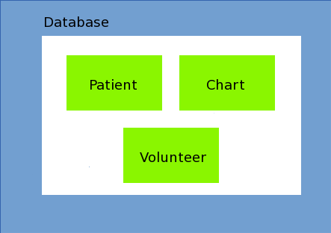

Volunteer
The volunteer portion of the database consists of the following logical components:

- Basic volunteer information (name, contact info, area of specialty (ENT, Radiology, etc..)
- Log/state information (login/logoff history, history of transactions made against the database). This information can be used to determine who changed what in the database.
- Access Control. Indicates what rights the volunteer has related to viewing and modifying patient data. As an example, this portion of the database might restrict registration personnel from viewing audiology data for the patient, or restrict ENT from modifying audiology data.

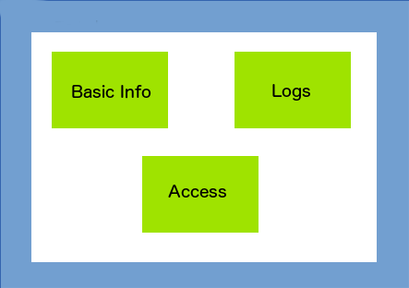

Patient
The patient portion of the database consists logically of tables that represent the following information:

- Name, DOB, gender, address, etc. of the patient. Information about the patient's family is also stored in this portion of the database. This data is obtained from the patient/family during registration.
- Medical history for the patient. This is a general medical history for the patient describing the health of the patient at the time of the clinic, and any conditions that might be of interest to those providing care ahead of an examination. This data is also obtained at the time of registration, but a copy of the medical history for the patient from previous clinic visits is also kept.
- Registration history. A history of the clinics visited by the patient is kept in the database.

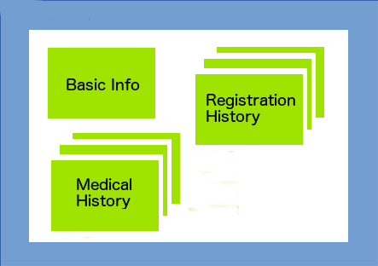

Chart
The chart portion of the database contains information about the diagnosis and care of patients seen at the clinic, organized by speciality. Each speciality (ENT, Audiology, Dental, etc.) has one or more tables in the database for storing data that is specific for the patient. Such data consists of, but is not limited to:

- Visitation history
- Diagnosis, per visit
- Care given, per visit
- Plans for future care
- Return to clinic date
- Custom data specific to speciality

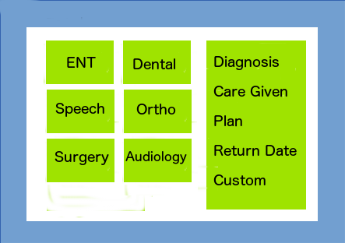
As mentioned above, and as with registration data, the database shall maintain a history of the patient's chart data over time. In effect, the user of the system should be able to go back in time and reconstruct a view of the chart state for the patient at the some previously held clinic. This history can be used, for example, to analyze changes in the patient from clinic to clinic, or enumerate a history of the care that has given to the patient over a specified period of time.
It's important to note that each specialty's portion of the digital chart is designed specifically for the specialty, and has it's own requirements which may be different than other specialties. Separate requirements documents, one for each specialty, define these specific chart requirements.

General Requirements
The system must support the users of the system in the following ways:

- ability to create an account
- ability to deactivate an account
- ability to reactivate a deactivated account
- ability to sign on to the system
- ability to log off the system
- ability to set, change, and recover a password
- view a list of his or her access rights (what portions of the chart the user can read, create, or modify data in)

The system must support an admin or super user function. An admin user has the ability to:

- list users of the system
- grant or deny users specific access to portions of the chart
- assign or revoke admin powers to other users, including his or herself
- view access rights of a specific user

The system should support the ability to add, view, or delete photographs of the patient.

- the chart photos are independent of the headshot that is taken of the patient for purposes of registration
- the resolution of a chart photo is typically limited by the resolution of the camera on the tablet used to take the photograph, and the amount of memory in the device. Stations that take clinic photos should generally be given tablets with sufficient memory and camera resolution for the requirements (this should be defined in the requirements documentation for the speciality involved)
- the system should allow for upload of images not taken by a tablet, perhaps via a website that is dedicated to this task

The system should allow for printing of any of the major portions of the system (patient data, routing slip, medical history, chart for a specific specialty or visit, return to clinic plan).

The entire chart should be printable in a form that allows it to be used at the next clinic as a replacement for the digital chart (in case the system is down for whatever reason).

In case a clinic was run by paper (due to system, power, networking failures that rendered the digital chart inoperable), the system should allow the significant portions of the paper chart to be entered into the system at a later time, so that the digital chart can be brought back up to date with the data collected at that clinic.

The system should support both English and Spanish languages (i.e., the system should be completely usable by a speaker of either language).

Other Nonfunctional Requirements

Performance Requirements
- The system should provide 99.9999% “5 nines” uptime during the clinical
- Search and access to the database should occur with a latency of no more than 5 seconds.

Safety Requirements
There are no specific safety requirements associated with this subsystem.

Security Requirements
We assume that the patient digital chart, and the ENT sub-system in particular, does not need to adhere to HIPAA requirements, and does not require HIPAA certification. We assume there are no regulatory requirements of the state of Baja, or of the Mexican government, to which this system must conform, or which governs how it is designed, implemented, or used by Thousand Smiles and its volunteers.

The system communication on the day of the clinic will occur over a subnet that has no routes to the Internet.

Users of the system will have accounts and must authenticate prior to using the digital chart. The usernames and password are unique to this system and are not the same used by the volunteer system; only a subset of our volunteers should be granted access to patient data. The database itself is physically and administratively separate from the volunteer database. Passwords will be encryted on the system, and logging will be used to track account creation, login, and logoff activity.

Software Quality Attributes
There are no specific SQA attributes associated with this subsystem.

Business Rules
Access to the system during the clinic will be limited to authenticated users. There are no specific rules associated with who can authenticate.

Between clinics, database access will be restricted to the administrator of the system for purposes of backup and maintenance only. The patient data, and user account information, will not be accessible on the Internet except for purposes of backup and maintenance.

Other Requirements
No additional requirements have been identified for this subsystem as of now.

Appendix A: To Be Determined List
<Collect a numbered list of the TBD (to be determined) references that remain in the SRS so they can be tracked to closure.>

