INTERNSHIP REPORT
HTML & CSS RESPONSIVE LANDING PAGE

Submitted to
School of Computer Science and Engineering
IILM University, Greater Noida, U.P.

In partial fulfilment of the requirements for the degree of
Bachelor of Technology in Computer Science and Engineering

Name of Student | Slok Gupta
Roll Number | 25SCS1003003228
Batch | 2025–2029
Internship Provider | Just Internship
Internship Domain | HTML & CSS Responsive Landing Page
Internship Period | 18 September 2026 – 20 September 2026
Certificate ID | JI-2026-000023
Academic Year 2026–27

1. CANDIDATE'S DECLARATION
I, Slok Gupta, hereby declare that the internship report titled “HTML & CSS Responsive Landing Page” documents the work completed by me during my internship with Just Internship. The report has been prepared as part of my academic internship requirement for the Bachelor of Technology in Computer Science and Engineering.
I confirm that the work described in this report reflects my internship activities and learning experience. The project was developed using frontend technologies and the implementation was carried out for the purpose of practical learning. Wherever external documentation or resources have been used, they are acknowledged in the references section.
I further declare that this report has not been submitted by me to another institution for the award of any degree or diploma.

Student Name | Slok Gupta
Roll No. | 25SCS1003003228
Batch | 2025–2029
Signature | ______________________________
Date | 20 September 2026

2. ACKNOWLEDGEMENT
I would like to express my sincere gratitude to Just Internship for providing me with the opportunity to undertake a practical internship in frontend web development. The internship gave me an opportunity to work on a responsive landing-page project and to apply concepts of HTML, CSS and JavaScript in a structured project environment.
I am thankful to the internship mentors and coordinators for providing the task requirements and guidance that helped me understand semantic HTML, CSS styling, responsive layouts, navigation and basic deployment practices.
I also express my gratitude to IILM University, Greater Noida, and the School of Computer Science and Engineering for encouraging practical learning alongside academic studies.
Finally, I am thankful to my family and everyone who supported and encouraged me during this internship and throughout my academic journey.

Student Name | Slok Gupta
Roll No. | 25SCS1003003228
Signature | ______________________________

3. TABLE OF CONTENTS
Chapter | Chapter Name | Page
1. | Candidate's Declaration | i
2. | Acknowledgement | ii
3. | Table of Contents | iii
4. | Internship Completion Certificate | iv
5. | Project Description | 1
5.1 | Introduction | 1
5.2 | Organization / Internship Profile | 2
5.3 | Problem Statement | 3
5.4 | Project Objectives | 3
5.5 | Scope of the Project | 4
5.6 | Tasks and Requirements | 4
5.7 | Technologies and Tools Used | 6
5.8 | System Architecture | 7
5.9 | Methodology | 8
5.10 | Implementation and Features | 9
5.11 | Testing and Responsive Verification | 11
5.12 | Learning Outcomes | 12
5.13 | Certificate and Supporting Evidence | 13
6. | Conclusion | 14
7. | Bibliography / References | 15
Note: Page numbers are organized for the report structure and may shift slightly if the document is edited further.

4. INTERNSHIP COMPLETION CERTIFICATE
Certificate issued by Just Internship
Certificate ID: JI-2026-000023
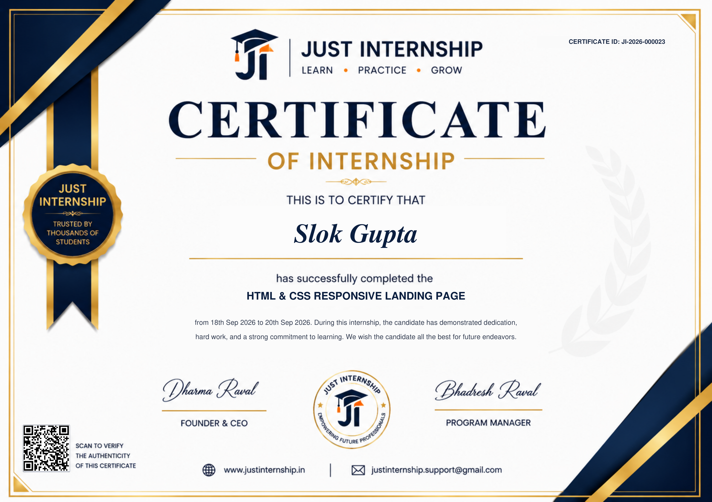
The supplied certificate identifies Slok Gupta as the recipient of the internship certificate for “HTML & CSS RESPONSIVE LANDING PAGE” and records the internship period as 18 September 2026 to 20 September 2026. The certificate ID is JI-2026-000023.

5. PROJECT DESCRIPTION

5.1 Introduction
This report presents a detailed account of my frontend development internship with Just Internship. The internship was focused on creating a responsive product landing page using core web technologies. The project was designed as a practical exercise to combine semantic HTML structure, CSS styling, responsive layout techniques and JavaScript-based interface behaviour.
The final project, named Nexa, was designed as a modern SaaS/product landing page. It includes a responsive navigation bar, hero section, dashboard-style product preview, feature cards, workflow section, statistics, customer stories, pricing cards, call-to-action area and footer.
The development approach intentionally avoided frontend frameworks. The project was organized into three main files—index.html, style.css and script.js—so that the underlying HTML, CSS and JavaScript concepts remained clear and demonstrable.

5.2 Organization / Internship Profile
The supplied internship certificate identifies the internship provider as Just Internship. The certificate states that Slok Gupta successfully completed the HTML & CSS Responsive Landing Page internship from 18 September 2026 to 20 September 2026.
The internship activity, as reflected in the supplied task requirements, was project-oriented and focused on practical frontend implementation. The work covered semantic page structure, CSS theme development, responsive Flexbox/Grid layouts, navigation behaviour and preparation for static deployment.
This report limits the organization profile to information supported by the supplied internship certificate and task material rather than introducing unsupported corporate details.

5.3 Problem Statement
A common challenge for students learning frontend development is moving from individual HTML, CSS and JavaScript concepts to a complete responsive website. The internship addressed this challenge by requiring the development of a structured landing page that combines content hierarchy, visual design, responsive behaviour and basic interaction.
The project also required the interface to remain usable across desktop and mobile screen sizes. Therefore, the implementation had to account for navigation changes, multi-column layouts, spacing, text wrapping and component behaviour at different viewport widths.

5.4 Project Objectives
- Create a clean semantic HTML5 structure for a product landing page.
- Apply a consistent visual theme using CSS variables, typography, spacing, colours and reusable components.
- Use CSS Flexbox and Grid to build responsive page layouts.
- Implement media queries for desktop, tablet and mobile screen sizes.
- Create a responsive hamburger navigation using Vanilla JavaScript.
- Add interactive behaviour such as menu toggling, active navigation, scroll reveal and form validation.
- Prepare the project structure for GitHub and static deployment on platforms such as Vercel or Netlify.

5.5 Scope of the Project
The scope of the internship project was frontend web development. The work covered the structure, styling, responsiveness and client-side interaction of a static product landing page. The project did not require a database, backend server, authentication system or advanced frontend framework.
The final scope included semantic HTML5, CSS custom properties, typography, reusable UI components, CSS Grid, Flexbox, media queries, responsive navigation and Vanilla JavaScript interactions. The page was also prepared with static hosting in mind.

5.6 Tasks and Requirements
Task | Objective | Key Requirements / Work Completed
Task 1 — Project Setup & Semantic HTML | Set up the project and create the structural skeleton. | Created the project files; used header, nav, main, section and footer; added internal navigation anchors.
Task 2 — CSS Theme & Styling | Create a visually clean and consistent interface. | Defined theme variables; integrated fonts; configured typography, spacing, colours, margins, padding and reusable styles.
Task 3 — Flexbox/Grid Responsiveness | Adapt the page to different screen widths. | Added media queries; used Grid for multi-column sections; used Flexbox for flexible UI groups; adjusted margins and overflow.
Task 4 — Navigation & Deployment | Add responsive menu behaviour and prepare the site for hosting. | Implemented hamburger navigation, menu toggling, active-section detection, scroll effects, form interaction and static deployment preparation.

Task 1 — Project Setup & Semantic HTML
The first task established the foundation of the website. The page was divided into meaningful semantic areas so that the structure was understandable and maintainable. Internal anchor links were also added to connect navigation items with the corresponding sections.

Task 2 — CSS Theme & Styling
The second task focused on the visual language of the landing page. CSS custom properties were used for the main colours and reusable values. Typography, cards, buttons, borders, shadows, spacing and background treatments were then applied consistently across the interface.

Task 3 — Flexbox/Grid Responsiveness
The third task concentrated on responsive behaviour. CSS Grid was used for major content layouts, while Flexbox was used for navigation, button groups, avatar groups and smaller UI rows. Media queries change the layout at smaller widths so that content remains readable and usable.

Task 4 — Navigation & Deployment
The fourth task added responsive navigation and final frontend interactions. The hamburger button opens and closes the mobile navigation. JavaScript also observes page sections, reveals content as it enters the viewport, and handles the demonstration signup form.

5.7 Technologies and Tools Used
Category | Technology / Tool | Use in Internship
Markup | HTML5 | Semantic page structure, content sections and navigation.
Styling | CSS3 | Theme, typography, spacing, components and visual design.
Layout | CSS Flexbox | Flexible navigation, rows, controls and component alignment.
Layout | CSS Grid | Hero, feature, testimonial and pricing layouts.
Responsive Design | CSS Media Queries | Desktop, tablet and mobile adaptations.
Programming | Vanilla JavaScript | Menu interaction, observers, navigation state and form behaviour.
Typography | Google Fonts | Modern font families for the landing page.
Repository | Git / GitHub | Project version management and repository preparation.
Deployment | Vercel / Netlify | Static hosting preparation for the final landing page.

5.8 System Architecture
The final application follows a lightweight client-side architecture. The user interacts with the browser interface. HTML provides the semantic structure, CSS controls presentation and responsive layout, and JavaScript adds interactive behaviour. Because the project is a static frontend, no backend service or database is required for the core landing page.
User | HTML Structure | CSS Styling | JavaScript | Browser UI | Static Hosting
Figure 5.1 Frontend Architecture of the Nexa Landing Page
The flow begins with the user accessing the landing page. HTML establishes the content structure, CSS applies the responsive visual system, and JavaScript manages interactive behaviour. The completed static website can then be maintained in a repository and published using a static hosting service.

5.9 Methodology
The internship followed a practical, task-based methodology. Each stage was approached by first understanding the requirements, implementing the structure, applying the design system, testing responsive behaviour, adding interactions and preparing the final project for submission.
Phase / Task | Description
1. Requirement understanding | Reviewed the internship objectives and identified structural, styling, responsive and navigation requirements.
2. Semantic structure | Created the HTML document and divided the landing page into meaningful sections.
3. Theme and styling | Defined colours, typography, spacing, buttons, cards and reusable component styles.
4. Responsive layout | Applied Grid, Flexbox and media queries to adapt the interface across screen sizes.
5. Navigation interaction | Implemented the mobile hamburger menu and navigation state using JavaScript.
6. UI interaction | Added scroll-reveal behaviour, active section detection and signup form interaction.
7. Testing and refinement | Checked layouts, navigation, overflow, form behaviour and mobile presentation.
8. Repository/deployment preparation | Kept the final implementation in the required three-file structure and prepared it for static hosting.

5.10 Implementation and Features

Responsive Navigation
The navigation contains links to the major sections of the landing page. On smaller screens, the navigation changes to a hamburger menu. JavaScript toggles the menu state and closes it when a user selects a link or clicks outside the navigation area.

Hero Section
The hero section introduces Nexa as a modern product workspace. It includes a primary call-to-action, secondary action, social proof and a CSS-built dashboard preview that visually communicates the product concept.

Feature Cards
The feature section presents the main value propositions through reusable cards. The cards use consistent spacing, icons, typography and visual containers while adapting to smaller screen sizes.

Workflow Section
The workflow section explains how the product helps teams organize work and maintain focus. A mobile-style interface mockup is paired with explanatory text and a checklist.

Statistics and Customer Stories
The statistics section presents sample product metrics, while the customer story section uses testimonial cards to create a realistic product landing-page experience.

Pricing and Call to Action
The pricing section contains Starter, Growth and Scale cards. The final CTA contains an email input and client-side validation, with JavaScript displaying a confirmation message after valid submission.

5.11 Testing and Responsive Verification
Testing focused on the functional and visual requirements of a static responsive landing page. The implementation was designed to handle common desktop, tablet and mobile viewport conditions.
- Verified that internal navigation links target the correct sections.
- Verified hamburger menu opening and closing behaviour.
- Verified that the mobile menu closes after selecting a navigation link.
- Verified outside-click closing behaviour for the mobile navigation.
- Verified the signup form's browser email validation.
- Verified that a valid form submission displays a confirmation message.
- Checked multi-column layouts for smaller screen sizes.
- Adjusted spacing and stacking behaviour to reduce the risk of text cutoff and horizontal overflow.
- Included reduced-motion support for users who prefer less animation.

Responsive Breakpoint Strategy
Screen Type | Layout Behaviour | Main Adaptations
Desktop | Multi-column layouts | Full navigation, multi-column hero/features/testimonials/pricing and larger spacing.
Tablet | Reduced columns | Content columns reduce and spacing/visual elements scale down.
Mobile | Single-column layouts | Hamburger navigation, stacked cards, compact dashboard and vertically arranged form controls.

5.12 Learning Outcomes
- Improved understanding of semantic HTML5 structure.
- Practical experience creating reusable CSS component styles.
- Better understanding of CSS variables and visual theme management.
- Practical use of Flexbox and Grid for responsive layouts.
- Experience using media queries to adapt interfaces to different screen widths.
- Improved understanding of JavaScript DOM events and class-based UI state.
- Practical use of IntersectionObserver for lightweight scroll-reveal behaviour.
- Experience creating client-side form validation and feedback.
- Better understanding of static frontend project organization and deployment preparation.
- Greater confidence in developing responsive websites without relying on frontend frameworks.

5.13 Certificate and Supporting Evidence
The official internship certificate supplied with this report is issued by Just Internship. It carries Certificate ID JI-2026-000023 and identifies Slok Gupta as the candidate who successfully completed the HTML & CSS Responsive Landing Page internship from 18 September 2026 to 20 September 2026.

6. CONCLUSION
The Just Internship provided a focused practical opportunity to apply frontend development concepts in a complete responsive landing-page project. The internship connected academic learning with an implementation workflow involving requirements, semantic HTML, CSS design, responsive layouts, JavaScript interaction, testing and deployment preparation.
The Nexa landing page demonstrates the practical use of HTML5, CSS3 and Vanilla JavaScript to create a modern interface without depending on a frontend framework. The project strengthened my understanding of responsive design, reusable styling, browser interaction and frontend project organization.
The experience has provided a useful foundation for continuing into larger frontend projects and learning more advanced topics such as component-based frameworks, APIs, backend integration, accessibility testing and production deployment.

7. BIBLIOGRAPHY / REFERENCES
1. Just Internship, “Certificate of Internship,” Certificate ID JI-2026-000023, 2026.
2. Just Internship, “HTML & CSS Responsive Landing Page” internship task requirements, 2026.
3. MDN Web Docs, “HTML: HyperText Markup Language,” https://developer.mozilla.org/en-US/docs/Web/HTML
4. MDN Web Docs, “CSS: Cascading Style Sheets,” https://developer.mozilla.org/en-US/docs/Web/CSS
5. MDN Web Docs, “JavaScript,” https://developer.mozilla.org/en-US/docs/Web/JavaScript
6. MDN Web Docs, “CSS Flexible Box Layout,” https://developer.mozilla.org/en-US/docs/Web/CSS/CSS_flexible_box_layout
7. MDN Web Docs, “CSS Grid Layout,” https://developer.mozilla.org/en-US/docs/Web/CSS/CSS_grid_layout
8. MDN Web Docs, “Intersection Observer API,” https://developer.mozilla.org/en-US/docs/Web/API/Intersection_Observer_API
9. GitHub Documentation, https://docs.github.com/
10. Vercel Documentation, https://vercel.com/docs/
11. Netlify Documentation, https://docs.netlify.com/

Student | Slok Gupta
Roll No. | 25SCS1003003228
Batch | 2025–2029
Internship | Just Internship
Project | HTML & CSS Responsive Landing Page
Period | 18 September 2026 – 20 September 2026

