SPEEDY

Game Design Document

Salim Bouassida

March, 2015

Revision 1.0

Comp 369 Athabasca University

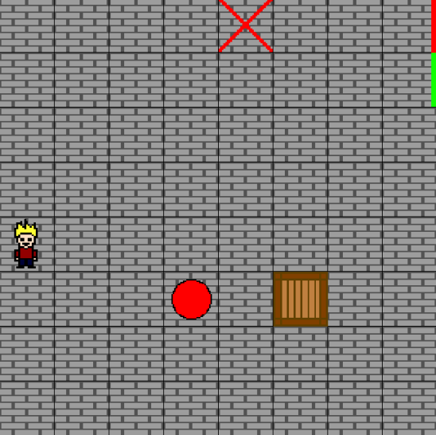

***General Overview***

I wanted to make a puzzle game for this project. I was inspired by the puzzles that were available in Pokemon Red and Blue, where you had to move rocks to unlock a door. In this game, the player needs to finish the 4 levels as fast as possible.

***Target System and Requirements***

For now the target system is the windows system, but it might be developed for phones and tables in the near future.

***Story***

Charlie wanted to play at the arcades before going to school. However, he got lost in the building and needs to quickly find the exit. He will use the resources available to find a way to escape the place.

***Theme: Graphics and Sound***

The game will take place in a dark basement, with a speed and catchy music.

***Menus***

The Menu will contain 3 parts:

* Start/resume
* Reset //reset all the variable, and start from scratch
* Exit

***Playing a Game***

The player starts in the middle of the first room. He will be able to move to the next room when he gets the ball on the target mark. To reach his goal, Charlie has a few movements available:

* Arrows UP DOWN LEFT RIGHT
* Q kick (the ball)
* W place a box to change the pattern ( a max of three boxes)

The game will handle the collision between the character, ball, and boxes. If the player get stuck, he can reset the game in the menu by pressing the ESC key.

***Characters and NPCs Description***

Charlie is the only character in this game. He is a high school kids that loves video games and solving problems.

***Artificial Intelligence Overview***

There is currently no AI at the moment. There will be one implanted in Assignment 4:

A ghost will be following Charlie, after each level the ghost’s speed will increase. If the ghost touches Charlie, he dies….

***Conclusion***

I have learned a lot from making this game! The game might be simple, but it was very challenging. I had to do a lot of testing to figure out how to implement some feature (example unit collision). Coding in Allegro seems easier now. I might be able to add some new features in assignment 4:

* AI ghost
* Keep a ladder score in a document
* Add more levels
* Make sure that that the ball stop ON the target, instead of going through it