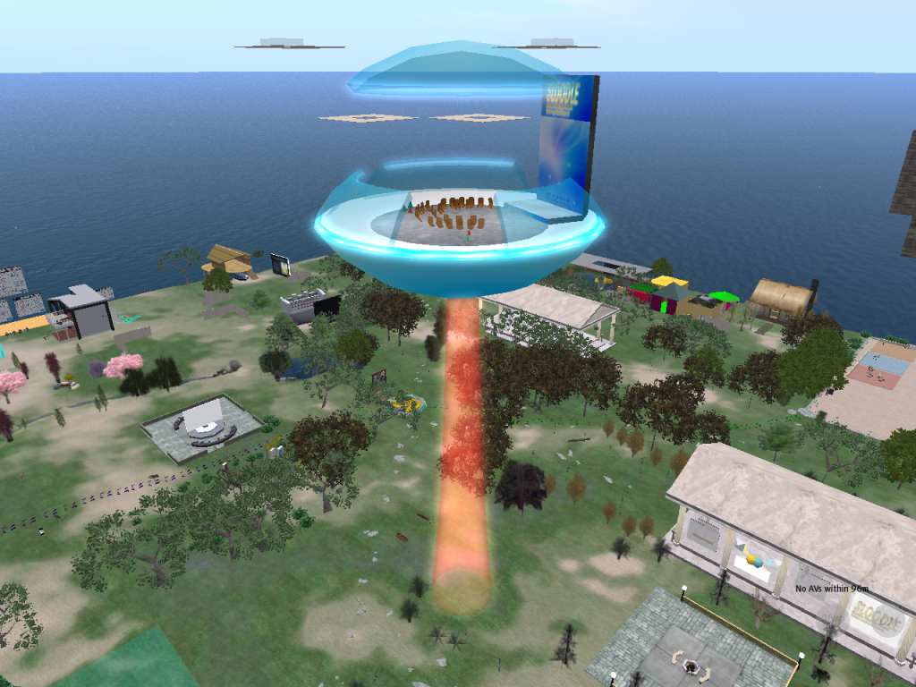
Online Learning in
Virtual Environments
with SLOODLE
Final Project Report

SLOODLE is funded and supported by Eduserv


SLOODLE is supported by the San Josė State University School of Library and Information Science


SLOODLE is supported by the University of the West of Scotland


SLOODLE is an Open-Source project, released under GNU Public License. See http://www.sloodle.org/about

This work is licenced under the Creative Commons Attribution-No Derivative Works 2.5 UK: Scotland License. To view a copy of this licence, visit
http://creativecommons.org/licenses/by-nd/2.5/scotland/ or send a letter to Creative Commons, 171 Second Street, Suite 300, San Francisco, California 94105, USA.
Individual images used in this document may have differing terms covering reuse. Please refer to image credits at end.

Second Life® and SL™ are trademarks of Linden Research, Inc.
Foreword

From the 31st of July 2007 till the 31st of October 2009, the Eduserv funded project 'Online Learning in Virtual Environments with SLOODLE' has been keeping me very busy. The extra few months added to the two years funding (to accommodate delays with recruitment processes) vanished remarkably quickly. The demands of a project which was almost as much about developing a community as it was about developing a piece of software proved greater than initially expected. As challenging as it has been, it has also been incredibly rewarding – never more so than when hearing about how SLOODLE is already being put to use to support classes using virtual worlds from around the globe. We happily recognised early that supporting the community would be vital to the success of SLOODLE itself – as can be seen in the presentation used in the original application to Eduserv (left)

Although the Eduserv project has now come to an end, SLOODLE continues to keep me busy – with regular conference and workshop presentations in both physical and virtual form. Community support and development remains as important today as it was, and can now be even more challenging – with SLOODLE tools now available on multiple virtual world platforms, and with the approach of large scale installations on university faculty and central Virtual Learning Environments.

I would like to thank all involved with SLOODLE over the past three years for their tremendous efforts, and most especially my co-founder Jeremy Kemp for his grand vision – without which SLOODLE would not be here at all.

Daniel Livingstone (Primary Investigator),
University of the West of Scotland,
November 2009

Table of Contents
Online Learning in Virtual Environments with SLOODLE 1
What is SLOODLE? 2
SLOODLE in Numbers 4
Integrating Moodle and Second Life 5
QuizHUD 8
Collaborative Browsing in Second Life 9
Awards 10
SLOODLE Research 11
A SLOODLE Bibliography 12
SLOODLE's International Reach: Localisation 14
Cast of Characters 15
User Stories 18
SLOODLE Tracker 19
Intel Ireland - skoool.ie 20
Cypris Chat 21
eLearningProject @ KAIST 22
MUVEnation 23
The Open University 24
Giannina Rossini and SLOODLEMoot 25
Credits 26

Online Learning in Virtual Environments with SLOODLE

There has been a somewhat stratospheric growth in the use of virtual worlds in education over the past few years. For evidence of this, one need look no further than the Virtual World Watch reports, compiled by John Kirriemuir (and also funded and supported by Eduserv). While popular media outlets are busy announcing the death of virtual worlds in general (and Second Life in particular), Virtual World Watch is continuing to show steady growth in adoption within education.

A few years ago Jeremy Kemp and Daniel Livingstone wrote a short paper which compared some of the different ways in which web-based virtual learning environments and 3D user-generated virtual worlds could support learning and education (Livingstone and Kemp, 2006). From this work came the notion of building on the strengths of the two very different types of environment by somehow integrating them (Kemp and Livingstone, 2006). This paper laid the groundwork for the SLOODLE project.

Although the concepts and tools provided by SLOODLE have evolved considerably from the initial idea, the core ideas presented there remain in SLOODLE today. In the past two years funding and support from Eduserv has enabled and powered significant development and growth – allowing the project to reach a version 1.0 milestone, and see it entering trials for installation onto the production Moodle systems used by major universities around the world.

Online Learning in Virtual Environments with SLOODLE was funded and supported by the Eduserv Foundation over 27 months, from the end of July 2007 until the end of October 2009. Funding was initially awarded for 12 months, with a further 12 months funding awarded on the basis of progress made. (A three month extension to the final deadline was agreed to accommodate a number of delays in administration and recruitment)

Over this period activity was split between software development (seeing four significant point update releases of the SLOODLE software – concluding with version 1.0 in August 2009), community development and research. This report outlines some of the activities from the past two years, and details some of the project's achievements – starting with the question: What is SLOODLE?

What is SLOODLE?

"One of the things that I’m most excited about is a mashup between
Second Life and the learning management system, Moodle."
- Joe Miller, VP Platform, Linden Lab

SLOODLE is a software package which integrates the Moodle web-based virtual learning environment and the 3D virtual world platform Second Life. SLOODLE blends these two distinct platforms into a single blended 3D/web virtual learning environment Activities can be blended across both platforms: Moodle's mature web-based tools can be used to support virtual world classes and Second Life can be used to bring richer engagement and immersion into online Moodle courses activities.

With SLOODLE, Second Life can be used as an alternative 3D client for Moodle,
replacing normal text-predominant webpages.

SLOODLE allows tutors to use Moodle as a back-end database for virtual world courses.

SLOODLE is the acronym of Simulation-Linked
Object Oriented Dynamic Learning Environment

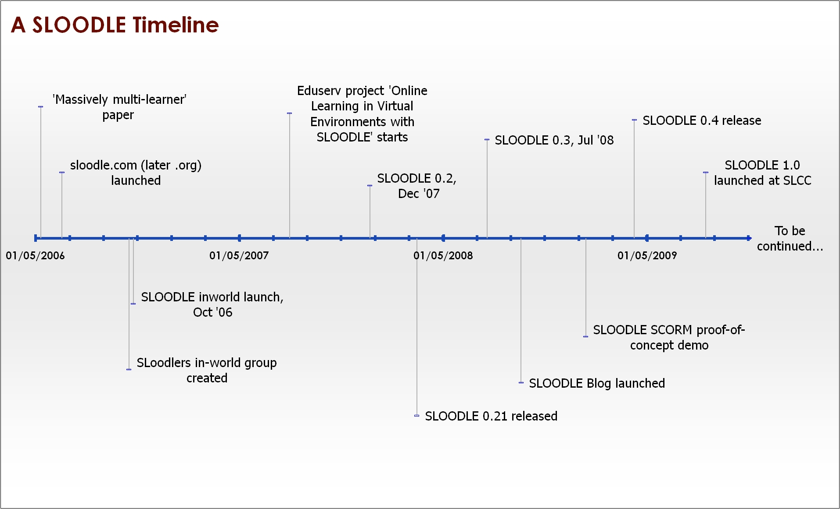
SLOODLE in Numbers

1.0.01
7
111
168
198
1,256
5,563
6,084
68,600

Current SLOODLE version number
Languages with SLOODLE documentation and/or tools available
Videos on YouTube mentioning SLOODLE
SLOODLE_News followers on Twitter
Downloads of SLOODLE 1.0
Members of SLoodlers group in Second Life
Average monthly site visits to SLOODLE.org*
Registered accounts at SLOODLE.org
Hits for SLOODLE on Google search

*Feb to Oct 2009 (average pages per visit: 3.73)

Integrating Moodle and Second Life
More than one approach is possible in attempts to integrate virtual worlds and virtual learning environments. For example, the software client used to access the virtual world could be modified to connect directly to the VLE system. Alternatively, an open-source virtual world could be used – allowing the virtual world server software to be modified to directly access the VLE database. Indeed, if the number of users in both the virtual world and VLE were low enough, both systems could potentially run side-by-side on a single server.

The approach taken by SLOODLE is to use custom built objects in Second Life use the LSL 'http' functions to communicate to scripts running on a Moodle server. For a number of reasons, it is not possible to directly call the standard Moodle API from scripted objects in Second Life (lack of cookies, limits on the amount of data sent or received in http calls, and the need to parse the HTML formatted data normally returned by Moodle). Thus custom 'linker' scripts coded in PhP are installed on the Moodle webserver. SLOODLE provides both the scripted objects for use in Second Life and the scripts for installing on Moodle. Thus, SLOODLE comprises both Moodle modules and blocks and Second Life objects.

Future plans are to develop a more robust and complete SLOODLE 'API' library of functions for communications between the virtual world and Moodle. This will allow developers to create new virtual world objects without having to write new linker scripts – making it easier to extend the functionality of SLOODLE.
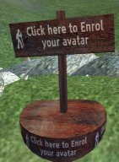
The core SLOODLE objects and modules are:
- SLOODLE Controller. This Moodle module can be added to a course by a teacher or admin. This module is used to enable the use of SLOODLE in a course and to control the authorisation of SLOODLE objects in Second Life. This allows Moodle course administrators to control and limit which objects in Second Life can access the course's Moodle data.
- SLOODLE set. This Second Life object contains a set of the various SLOODLE Second Life objects. It can be used by tutors to 'rez' (instantiate) SLOODLE objects in Second Life.
- SLOODLE Registration Booth (right). One of the most fundamental tasks for SLOODLE is to pair Moodle users to their virtual world avatars. When a user clicks on the Second Life registration booth, while logged in with their avatar, they are prompted to visit a Moodle registration page. This allows Moodle to verify the Second Life identity of the Moodle user, and this data is then stored in Moodle. Alternatively, a 'Login Zone' object in Second Life allows avatar registration to be driven from Moodle, followed by logging into Second Life.

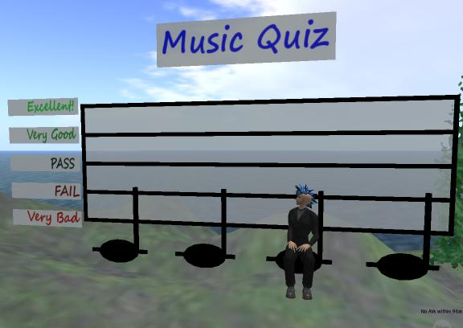
Tools for Teaching and Learning
There are a wide range of SLOODLE tools and features available. This list is not exhaustive, but briefly outlines some of the most commonly used and more central tools.
- Web-intercom. A chat-room that brings Moodle chatroom and Second Life chats together. Students can participate in chats in Second Life using the accessible Moodle chatroom. Discussions can be archived securely in a Moodle database.
- Quiz chair (and Pile-on Quiz). Assess in Second Life – grade in Moodle. The quiz tools allow tutors to author quizzes in Moodle, but allow students to take the quiz in a more engaging 3D environment. Tutors can review grades quickly and easily in the standard Moodle gradebook. These use the standard Moodle quiz module for the backend, although valid question types are restricted (multiple choice, true-false, numerical and simple text questions can be supported).
- Distributor. A Second Life vending machine can be filled with items by a tutor, allowing students easy access to pre-selected items. A web-interface allows students to select items from Moodle – or for the tutor to send items to the students registered in the class.
- Multi-function SLOODLE Toolbar. Enhances the Second Life user interface. Use a range of classroom gestures, quickly get a list of the Moodle user names of the avatars nearby or write notes directly into to a Moodle blog from Second Life.
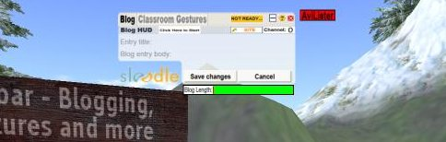
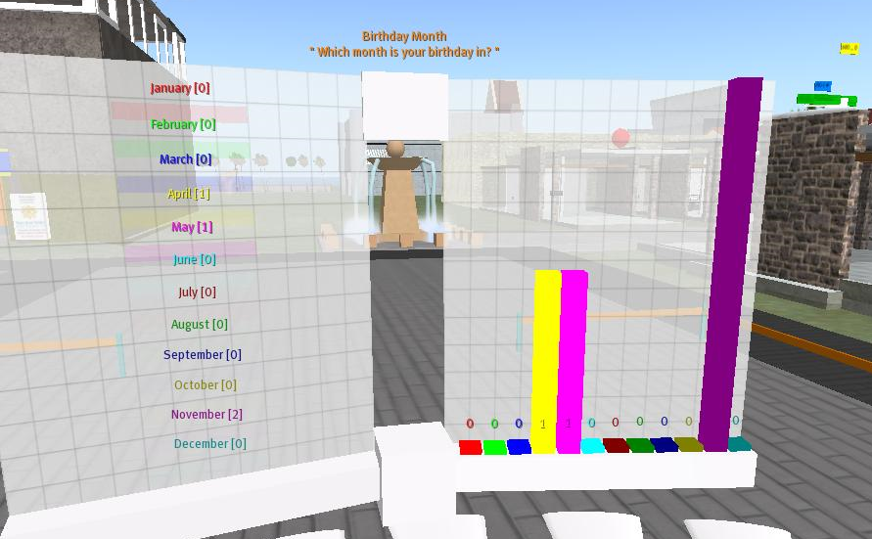
- Choice tool (right). This allows students to vote (and see results) in Second Life as well as in Moodle. Uses the standard Moodle 'Choice' module for the backend.
- Presenter (below). Quickly author Second Life presentations of slides, videos (including YouTube) and/or web-pages on Moodle. Present in Second Life without having go through lengthy processes to convert or upload images. Plug-in functionality for the Presenter can enable the quick conversion of presentations from PDF format to a set of images stored in Moodle for viewing in Second Life. Presentations can also be viewed via a Moodle page, allowing students to review presentation online at their convenience.
- Postcard Blogger. Additional plug-in functionality for Moodle allows users to send photo 'postcards' from Second Life – and have the screenshots and accompanying text automatically uploaded to their Moodle blog. This depends on the availability of additional software libraries on the Moodle server.
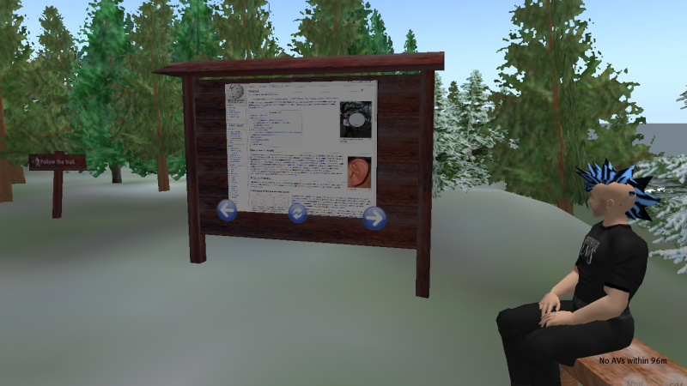

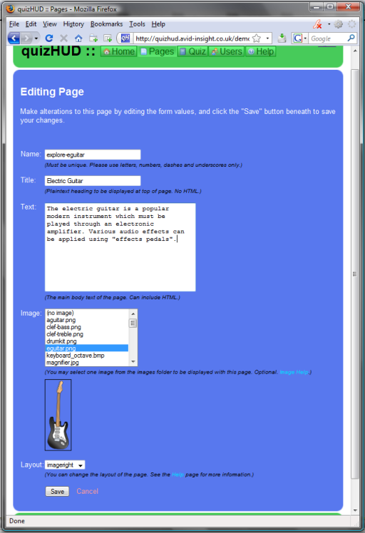
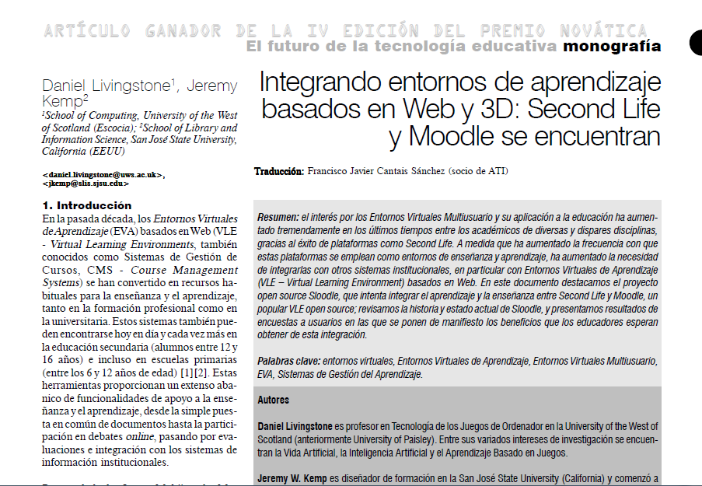
QuizHUD
Some of the prototype tools trialled over the past two years have been released as standalone tools, independently of the main SLOODLE releases. One such tool is the QuizHUD.

The QuizHUD provides a web-based authoring environment for creating educational content in Second Life, and a user-interface 'HUD' to be used by students. Students can explore custom built environments in Second Life, and learn about aspects of the environment by clicking on objects around them. Quizzes can be built which include mixtures of multiple choice questions (answered using tabs on the QuizHUD object itself) or questions to be answered by identifying and clicking on objects in the 3D space.

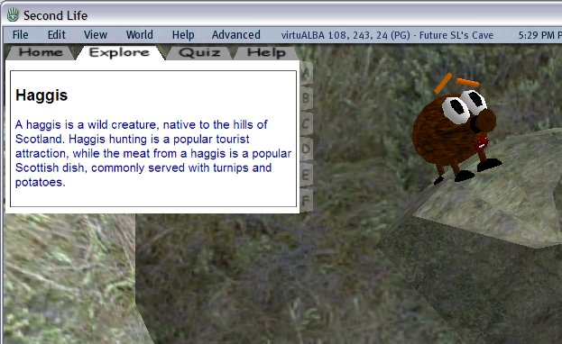
Web-authoring for pages of information about the environment and evaluation questions greatly simplifies the development of new eLearning content in Second Life.

QuizHUD is available from http://www.sloodle.org/quizhud/

QuizHUD is appropriately licensed so that it may be fully integrated into SLOODLE in future releases.


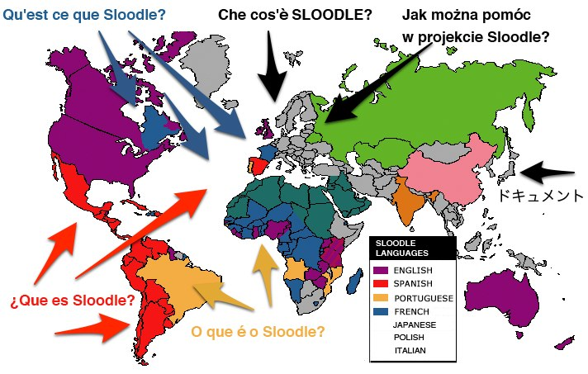
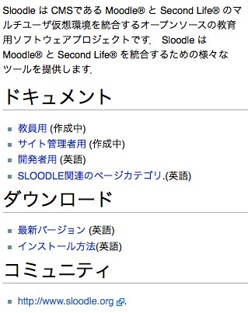
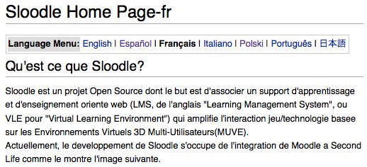
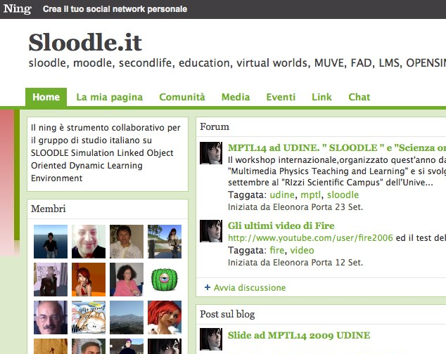
Collaborative Browsing in Second Life
Another standalone tool developed thanks to funding support from Eduserv is the SLOODLE Browser. Some virtual world platforms (e.g. TelePlace or Wonderland) include fully functional browsers, allowing users to view and co-browse the web from within the virtual world. Second Life, in contrast, offers a markedly limited web-browsing experience in-world.

A web page may be rendered onto the surface of an object using the media capabilities of Second Life, but the rendered page is non-interactive. It is not possible to click on links, or even to scroll the page.

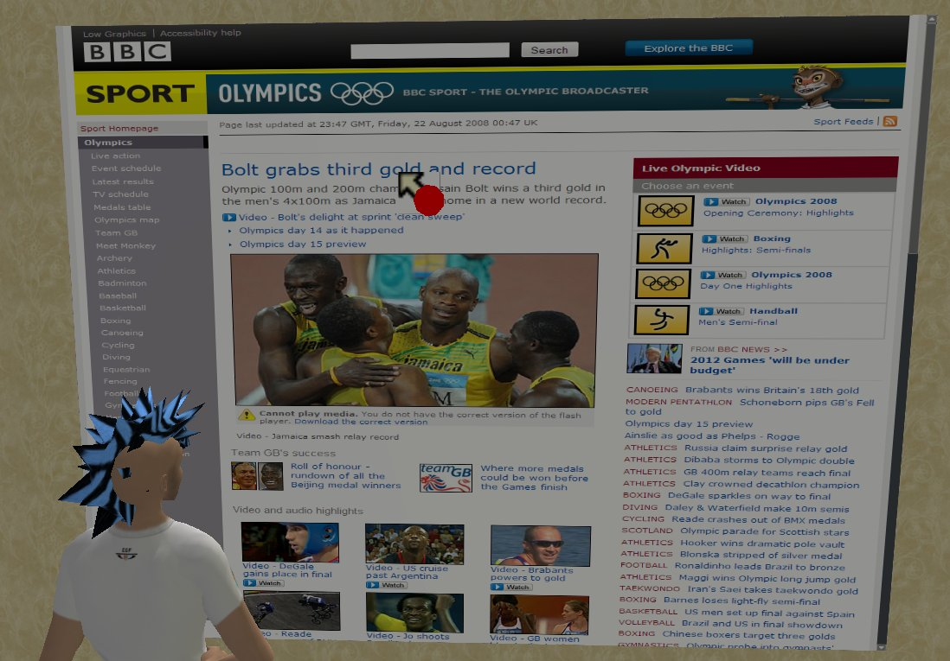
Using a specially developed proxy server as an intermediary in web-browsing, the SLOODLE Browser is able to overcome these limitations. A virtual mouse can be moved over the surface of a page, and when clicked can report to the proxy which can then determine the correct link to follow. Clicking on a text-entry box prompts users to enter text via chat in Second Life – allowing web-forms to be completed in the virtual world. The proxy can also render different sections of a web-page in response to user scrolling.

Use of a proxy also ensures that different users meeting in Second Life actually see the same content as each other – an important feature when many major web-sites and search engines actually deliver different results to users depending on their global location.

The SLOODLE browser is available from http://www.sloodle.org/browser

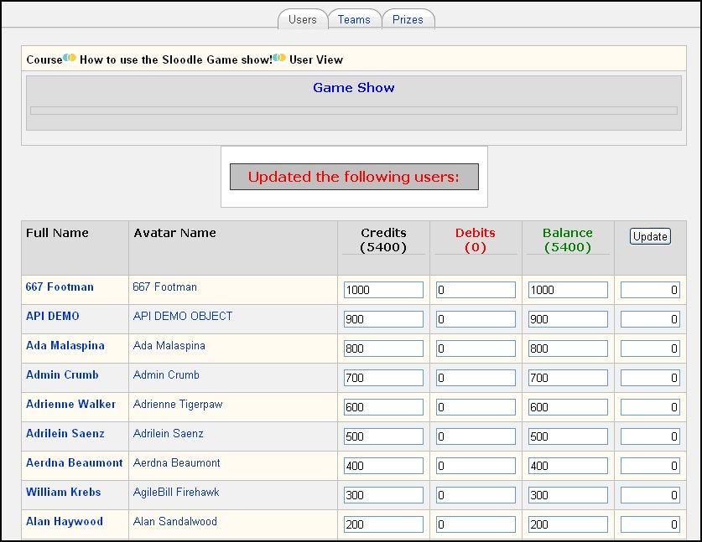
Awards
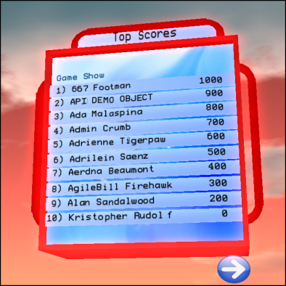
The SLOODLE Awards System enables the use of points (or in-world micropayment currency) rewards to enhance engagement and achievement in online classes. At the heart is a Moodle scoreboard module which lists points earned by students. The award system allows facilitators to award points, automatically or manually, to students in Second Life for completing course-related tasks. Points earned by a student in Second Life can also be fed into the Moodle grade book, and optionally may count toward the students' final grade.
As part of the Awards system, there are also a number of SLOODLE items which connect directly to the scoreboard in Second Life. The scoreboard itself is a textual display unit which displays a high-score table. The scoreboard can also be configured for use with team competitions – with teams based on Moodle groups. The 300 character display will then list the cumulative total points achieved by the members in each group.

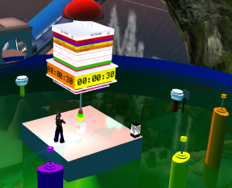
Another system that has been recently developed which integrates the Award system into a live game show. The game show consists of a countdown timer, a buzzer, and several chairs which move the students around the game environment. To get points, a student must answer questions given by their facilitators in a live learning activity. If they answer correctly before the timer reaches zero, the teacher can manually add points to a student’s total.

The awards system has also been trialled with systems for monitoring and rewarding attendance, and a scavenger hunt activity.

SLOODLE Research

An important part of the project over the past two years has been a programme of research. The goal of this research is twofold. Short-term practical research is focussed on R&D activities, focussed on the development of the SLOODLE system itself.

Shortly after the project began, an online survey was posted to determine which potential SLOODLE features had the highest demand. Participants were asked which standard Moodle modules would be most useful if somehow brought to Second Life, what Second Life content should be visible via Moodle, and so on. Feedback from this survey was used to direct much of the subsequent development effort, and results were published in the sister journals Upgrade and Novatica. The Novatica paper ('Integrando entornos de aprendizaje basados en Web y 3D: Second Life y Moodle se encuentran') won the Novatica award for best paper published in the journal during 2008, from a pool of over 50 papers.

More generally, there is an interest in research which investigates the topic of web and 3D learning environment integration more broadly – and that may be applied to any virtual world paired with any virtual learning environment. This work is obviously very open ended, and is ongoing, but has been outlined in a number of papers.

Two further surveys (one for tutors, one for students) are still collecting data, but will close shortly. Survey data has been enhanced with a number of interviews and focus group events. As we have found that people using SLOODLE do not always run to the same timetables of the investigators' institutions, the collection periods have been deliberately made more open-ended. The issues encountered, and some of the approaches to solve them, were described in the paper 'Engaging Globally Distributed User Groups for Extended Evaluation Studies' - contributing to a much more general research problem, that of conducting research in online global communities in virtual worlds. An extended version of this paper is due in 2010.

The following bibliography of SLOODLE papers lists all the papers resulting from the current project alongside some earlier papers.

A SLOODLE Bibliography
Book Chapters
Blueprint for a Mashup: Corporate Education in Moodle, Sloodle and Second Life, Peachey, A., Livingstone, D. and Walshe, S., in Ritke-Jones, W. (ed) Handbook of Research on Virtual Environments for Corporate Education USA: IGI Global (in press, due Spring 2010)
Mixed-Methods and Mixed-Worlds: Engaging Globally Distributed User Groups for Extended Evaluation Studies, Livingstone, D. and Bloomfield, P.R., in Peachey, A., Gillen, J., Livingstone, D. and Smith-Robbins, S. (eds.) Researching Learning in Virtual Worlds London: Springer, (in press, 2010)
Multi-User Virtual Environments for Learning meet Learning Management, Livingstone, D., Kemp, J., Edgar, E., Surridge, C. and Bloomfield, P. In Games-Based Learning Advancements for Multi-Sensory Human Computer Interfaces: Techniques and effective practices, ed. Thomas Connolly, Mark Stansfield, and Liz Boyle. Hershey, PA: Information Science Reference (IGI Global), 2009, pp34-50. ISBN: 978-1-60566-360-9

Journal Papers
SLOODLE: Connecting VLE tools with Emergent Teaching Practice in Second Life, Livingstone, D., Kemp, J. and Bloomfield, P., British Journal of Educational Technology, British Journal of Educational Technology 40, no. 3 (2009): 551-555. http://dx.doi.org/10.1111/j.1467-8535.2009.00938.x
From Multi-User Virtual Environment to 3D Virtual Learning Environment, Livingstone, D., Kemp J. and Edgar, E. ALT-J. 16(3):139-150. 2008 http://www.informaworld.com/10.1080/09687760802526707
Integrating Web-Based and 3D Learning Environments: Second Life Meets Moodle, Livingstone, D., Kemp, J., UPGRADE – The European Journal for the Informatics Professional, 2008, IX(3), pp 8-14. (ISSN 1684-5285)
Integrando entornos de aprendizaje basados en Web y 3D: Second Life y Moodle se encuentran, Daniel Livingstone & Jeremy Kemp, Novatica, issue 193 (May-June) 2008, pp 7-12 ISSN: 0211-2124 (translator: Francisco Sanchez)

Conference Papers
Engaging Globally Distributed User Groups for Extended Evaluation Studies, Livingstone, D., In proceedings of Researching Learning in Virtual Environments – ReLIVE08, Open University, Milton Keynes, 20th - 21st November 2008.
Learning Support in Multi-User Virtual Environments, Livingstone D. and Kemp, J., The European Conference on Games Based Learning, Glynhill Hotel, Paisley, 25-26 October 2007

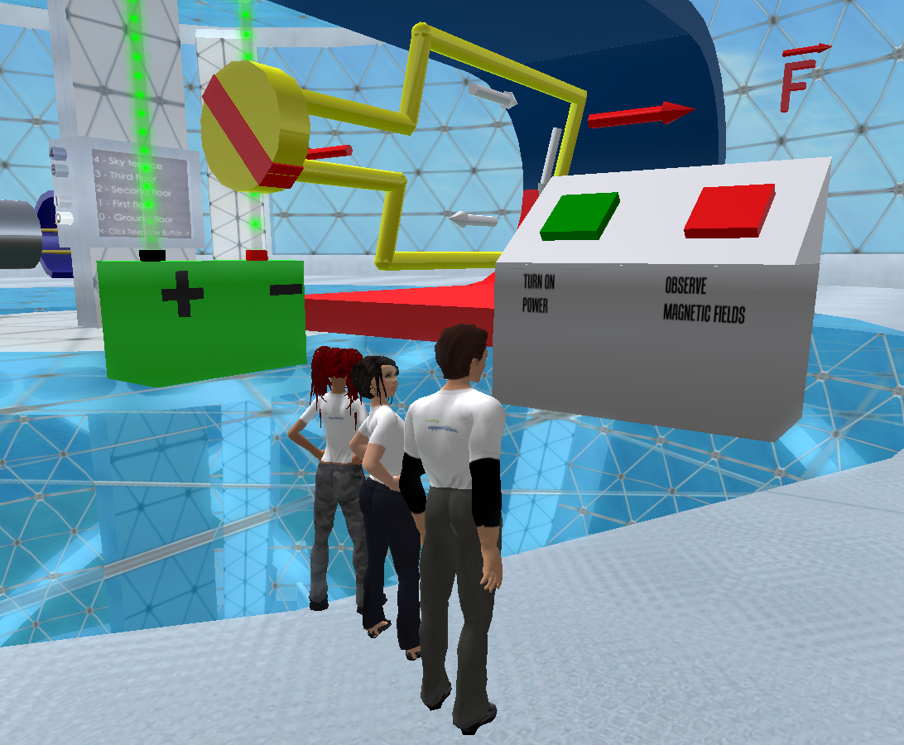
Sloodle – Merging Moodle and Second Life, Livingstone, D. MoodleMoot UK 2007, Milton Keynes, October 23rd-25th 2007
Bridging 3D and web-based learning environments, Livingstone, D. and Kemp, J. Presented at ALT-C 2007, University of Nottingham. 2007
A richer blend: Integrating Web-based and 3D Learning Environments, Livingstone, D. and Kemp, J. Blended Learning 2007, University of Hertfordshire, June 14th, 2007
Putting a Second Life “Metaverse” Skin on Learning Management Systems, Kemp, J. and Livingstone, D., in proceedings of the Second Life Education Workshop at SLCC, Livingstone and Kemp (eds.), San Francisco, August 2006, p.13-18.

Posters
Multi-modal learning and assessment in Second Life with quizHUD, Bloomfield, P. R., & Livingstone, D., In Proceedings of the 1st IEEE Conference in Games and Virtual Worlds. VS Games 09, Coventry, UK: IEEE. March 23rd - 24th 2009.

Collaborative Web-Browsing in a Virtual World, Crowe, M. and Livingstone, D. In Proceedings of the 1st IEEE Conference in Games and Virtual Worlds. VS Games 09, Coventry, UK: IEEE. March 23rd - 24th 2009.

Other
Virtual Learning Environments: Blending Web and 3D Technologies, Daniel Livingstone, Proceedings of the Research Conference, 9-10 May 2007, University of Paisley 2007
Massively multi-learner: recent advances in 3D social environments, Livingstone, D. and Kemp, J., Computing and Information Systems Journal, School of Computing, University of Paisley, Volume 10, No 2, May 2006

Left: 'Integrando entornos de aprendizaje basados en Web y 3D: Second Life y Moodle se encuentran', winner of the 4th Novatica Award. http://www.ati.es/novatica/2008/193/193-8-IV-Premio-Novatica-ganador.pdf

SLOODLE's International Reach: Localisation
SLOODLE support documentation and tools (in-world tools and
Moodle modules and blocks) have been translated into seven
different languages. SLOODLE.org itself hosts forums for
Spanish and Italian speakers, and additional localised group
support can be found on the wiki, in Ning groups and inworld.

World map image from
www.geographic.org,
used with permission

Cast of Characters

Daniel Livingstone aka Buddy Sprocket

Primary Investigator, SLOODLE co-founder
Dr. Daniel Livingstone teaches Computer Game Development at the University of the West of Scotland. Daniel is a co-founder of SLOODLE, and led the project 'Online Learning in Virtual Worlds with SLOODLE'.
Daniel's first experiences of virtual worlds led to him becoming a wizard in a MUD at the University of Strathclyde – despite which he managed to graduate from the university with a degree in Computer and Electronic Systems. This was followed by a Masters in Artificial Intelligence from the University of Essex and then a PhD in the computer modelling of the evolution of language and languages at the University of Paisley (now University of the West of Scotland) – since when his active research interests have taken him back to virtual worlds.
In recent years, Daniel co-chaired the Second Life Education Workshops in 2006 and 2007, and founded the Massively Multi-Learner series of workshops for the HEA-ICS in the UK, and recently completed co-editing a volume on Researching Education and Learning in Virtual Environments (RE-LIVE) to be published in 2010 by Springer.
http://dlivingstone.info

Jeremy Kemp aka Jeremy Kabumpo
SLOODLE co-founder
Jeremy W. Kemp is an instructional designer at San José State University and started teaching online in 1999. Jeremy is a co-founder of SLOODLE and he also keeps the wiki for educators using Second Life — www.simteach.com. He is a doctoral student at Fielding Graduate University in Santa Barbara, CA working on educational and social issues in immersive environments. Kemp has master's degrees from Stanford and Northwestern University.


Malcolm Crowe aka Malcolm Glasgow
Professor Malcolm Crowe is chair of the Computing Subject Development Group at the University of the West of Scotland. An experienced researcher, Malcolm supported the project during the first year of Eduserv funding, and developed a number of prototype tools for SLOODLE. The SLOODLE Browser is still available in-world, and Malcolm continues to improve and update this tool as comments and feedback are received from users.


Peter Bloomfield aka Pedro McMillan
Peter Bloomfield is a doctoral student at the University of the West of Scotland. His current research is on HCI issues relating to the integration of web and 3D learning technologies, and he is working with SLOODLE as part of this work. Previously Peter worked full time as a developer and community support liason for the Eduserv project during the first year of funding. He continues to work on developing SLOODLE in a voluntary capacity.
http://peter.avid-insight.co.uk


Paul Priebisch aka Fire Centaur
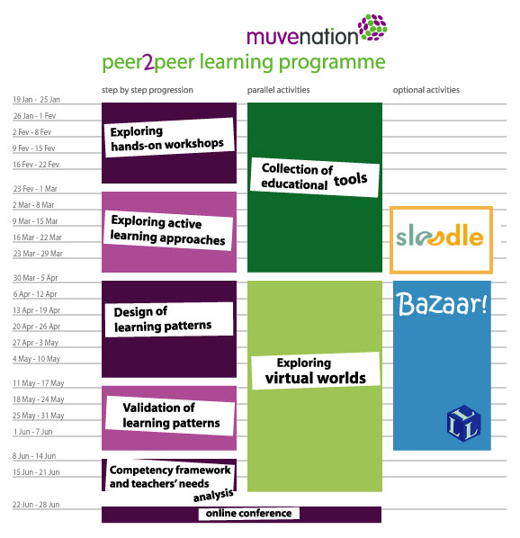
Since 2006, Paul has owned and operated his ESL learning environment, English Village, in Second Life. Paul also is the founder of Second Life Link for Facebook, and responsible for creating the largest Second Life for Educators group on Facebook today. For 10 months in 2009, Paul was hired as a research assistant for the SLOODLE. During his time on the SLOODLE Project, Paul worked on maintaining SLOODLE Code, worked with the community of SLOODLE users, and created a points-based award and scoreboard system for SLOODLE. Paul also designed an LSL API system for SLOODLE, to give more developers access to creating SLOODLE tools. Paul works remotely from his Vancouver office in Canada, and continues to contribute to the SLOODLE code base and also supports SLOODLE users.
fire@b3dMultiTech.com - http://b3dmultitech.com/

Dr. Ewan MacArthur

Dr. Ewan MacArthur is a Senior Lecturer at the University of the West of Scotland. Dr. MacArthur teaches undergraduate and postgraduate courses on research methods, and has been providing some assistance to the SLOODLE team to support the collection and analysis of data during the second year of funded support from Eduserv. Ewan is continuing to provide support to the team to complete the analysis of data collected to date, and provides additional advice on an ad-hoc basis.

Edmund Edgar aka Edmund Earp

Edmund Edgar is an independent eLearning developer and consultant based in Japan. Edmund has been volunteering on the SLOODLE development since early 2006, and developed the initial versions of a number of core SLOODLE tools – including the registration booth and quiz chair. During the Eduserv funded period, Edmund provided hosting services to SLOODLE users requiring Moodle/SLOODLE web hosting. Edmund continues to collaborate voluntarily to SLOODLE and is the project version control manager.
http://www.socialminds.jp/

User Stories

The community of SLOODLE users and developers have been vital to the success of SLOODLE.

From providing essential feedback on SLOODLE through focus groups or surveys, helping lead the development goals and focus of the project, sharing their experiences of using SLOODLE and helping contribute to case-studies and best practice through to contributing code and developing their own plugins and extensions, users have helped form SLOODLE into the mature system it is today.

With thanks to every member of the SLOODLE community for their individual contributions, we briefly present just a handful of user stories here. These stories are by no means exhaustive, and we will continue to add to these over coming months with the publication of more case-studies. But the following stories should help give a sense of where SLOODLE is today. After all, the tools themselves are not very important. It is whether (and how) they are used that counts....

SLOODLE Tracker
SLOODLE Tracker is a plug-in which allows interactions with objects in Second Life to be tracked and recorded to a SLOODLE webpage. It has been developed by the Serious Games and Virtual World Research team, University of Ulster (Magee), to help facilitate teaching and learning in Second Life. Students and facilitators both have a view of the recorded results. SLOODLE Tracker scripts can be applied to any object in Second Life.

SLOODLE Tracker has been applied to a range of demos in Second Life, including:
- DC motor simulation
- Virtual Lab Demonstration
- Giant PC replica / PC architecture

- CPU visualisation: Fetch, Decode & Execute cycle
- Intel/Skoool.ie project – catapult exercise
- Hardware integration – washing machine simulation

The demos can be visited in Second Life: http://slurl.com/secondlife/University%20Ulster%20Magee/250/151/37

Michael Callaghan is a Lecturer in the School of Computing and Intelligent Systems at the University of Ulster. Michael currently leads the activities of the Serious Games & Virtual Worlds Research Team at Intelligent Systems Research Centre (ISRC) at the University of Ulster. His main research interests include remote experimentation and virtual worlds.

Kerri McCusker is a Research Associate within the Serious Games & Virtual Worlds research team at the Intelligence Systems Research Centre, University of Ulster. Kerri is an active researcher in virtual worlds with a particular focus on the teaching of STEM subjects and the integration of virtual learning environments/virtual worlds.

Julio Lopez Losada is a placement student within the Serious Games and Virtual world Research Team. Julio comes from a programming background, with a keen interest in SLOODLE, helping in the creation of SLOODLE Tracker

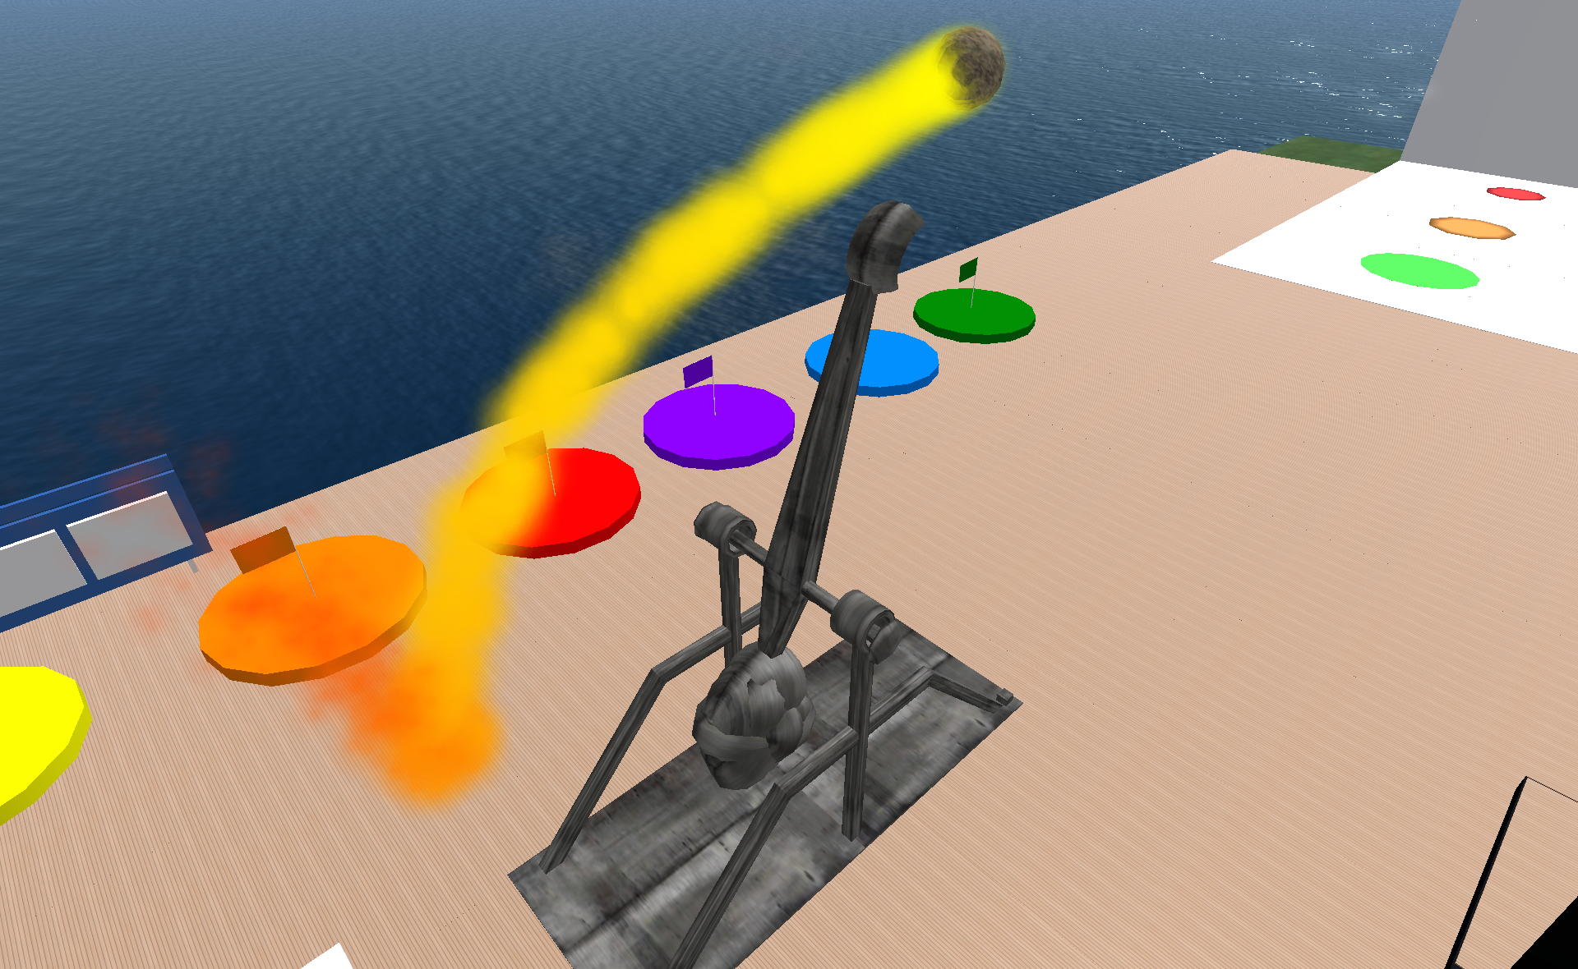
Intel Ireland - skoool.ie
skooolTM is an award-winning international online education program developed by a group in Intel called Intel Performance Learning Solutions (IPLS). Launched originally in Ireland in 2002, it is now in over 30 countries worldwide and in 12+ languages. Focusing on Science and Maths subjects, skoool provides content and tools for students from 10-16 years.

Most recently, skoool has collaborated with the School of Computing and Intelligent Systems in the University of Ulster on a virtual world pilot. The purpose of the pilot was to create a virtual space with the aim of providing an opportunity for students to collaborate on a challenge. This provides students with an opportunity to acquire life skills whilst leveraging curriculum content.

A key consideration of the pilot was the ability of teachers to track and measure the students’ progress and this was done through the SLOODLE tracker. At various stages of the challenge, the activities are logged to the MOODLE environment.

Barry McAdam, Intel Ireland Innovation Centre, Performance Learning Solutions. Barry is the Lead Designer and a User Experience Expert consultant for the IPLS group. He has been at the forefront of many new pilot programs, usage model development, online simulations and technology deployments for the group.

Anna O'Donovan, Learning Development Manager, Intel Performance Learning Solutions. Anna is Learning Development Manager with IPLS with over eight years’ experience with this group. Anna has worked on the content strategy, design and overseeing development of a number of education programs including online training for Intel engineers and the skoool program.

You can learn more about skoool at www.skoool.com and www.skoool.ie

Cypris Chat
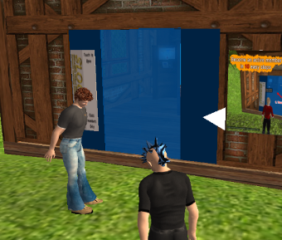
Cypris Chat is an informal collaborative English language learning community in Second Life. There are over 300 members, a mixture of language learners and native English speakers from across the globe. Some members are qualified teachers of English interested in learning how virtual worlds can be used to support teaching and learning. You can learn more about Cypris Chat online at http://cypris.ning.com/ .

Cypris Chat was founded by Mike McKay, who coordinates and plans many of the community activities, including setting up virtual scavenger hunts, discussion groups and quiz nights. Mike has been working closely with Paul Priebsch in testing and trialling the SLOODLE Awards system.
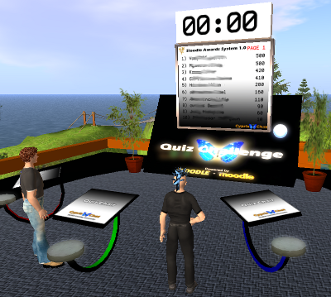
Mike notes that “The SLOODLE project is absolutely necessary for us as educators to be able to assess what our students do in virtual worlds. Recently there has been a sudden surge of interest in SLOODLE after the development of an awards system by Fire Centaur (Paul Preibisch). This system allows teachers to award points, or even Lindens, to participators that are directly recorded in the Moodle gradebook. AMAZING!! We are very willing to explore the opportunities Second Life and Moodle have to offer. This project MUSTcontinue!”
Mike McKay is known as Professor Merryman in Second Life. He conducts workshops on Moodle in the English department of his University in Japan as well as leading Cypris Chat in Second Life.

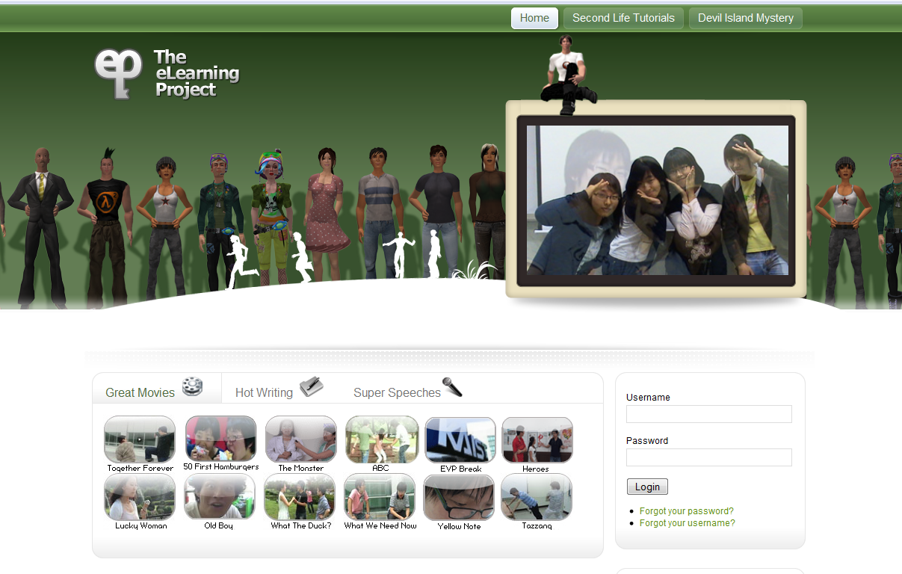
eLearningProject @ KAIST
“At the Korea Advanced Institute of Science and Technology (KAIST) we’re using SLOODLE tools to power a 10-mission, adventure-based learning interaction in Second Life. “Devil Island Mystery” challenges teams of students to piece together the clues of a 20-year-old mystery in order to escape from Devil Island. It is being run in two parts: as a local program, and as a collaborative effort involving Steven Moinester and his students at Kwansei Gakuin University in Japan.

… A more advanced application of SLOODLE tools involves the use of the new SLOODLE Award System. We configure this system to allow us to track our students’ interactions with certain key objects on Devil Island. In several missions, students are required to explore Devil Island in search of various clues and objects. In Mission #8, for example, they are tasked to find six special plants and touch them to collect their leaves. Using a modified version of the SLOODLE Awards System, we are able track student-object interactions, as well as to award points to the students. A centrally placed scoreboard increases interest in the mission and keeps the students motivated and on task.”
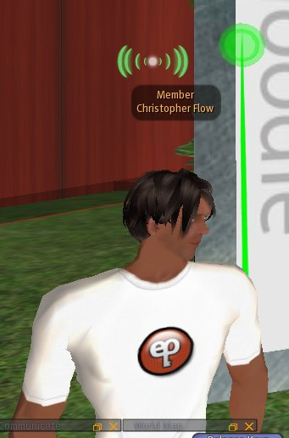
Devil Island Mystery is currently being deployed in Second Life and will be ported for use in Open Simulator in the near future. It is hoped that a bundled version including Open Simulator objects, supporting Moodle course content, and SLOODLE tools can be created and distributed for free to interested educators.
Chris Surridge is an educator at KAIST. He has been using SLOODLE tools since 2007. Chris' first course taught using SLOODLE was documented in the first published SLOODLE case study – available from www.sloodle.org.


MUVEnation
MUVEnation delivered a one year postgraduate online programme on ‘Teaching and learning with MUVEs’, for future and in-service teachers who wanted to use innovative methods and tools to address motivation and participation issues in compulsory education and to consider the impact of 3D virtual worlds on learning and teaching. MUVEnation was funded by the European Commission under the 2007 Lifelong Learning programme. Some 240 teachers from across the world participated in the project.

MUVEnation used a wide range of online resources to support teaching and learning – including a number of Web 2.0 technologies. Home for the three taught modules was a Moodle site. SLOODLE was used in MUVEnation to support the teaching and learning activities and the third module included SLOODLE specific activities – where participants learned about SLOODLE itself. 107 teachers from some 27 countries were admitted to this course, with 66 active participants completing all activities.

MUVEnation partners were from CELFI-Centro E-Learning (Università di Macerata), MENON Network EEIG, Florida Centre de Formació, SCIENTER Soc. Consortile a R.L., Institute for Innovation in Learning (FIM NewLearning, University of Erlangen-Nürnberg), University of Reading and King’s College London. Jaime Alamo Serrano (Alpha Lorgsval), Universitat de València, started as a participant but his involvement with the project grew - resulting in his leading the project's use of SLOODLE.

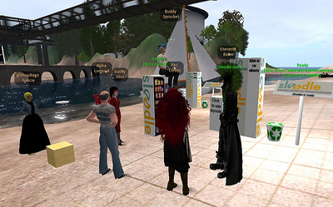
MUVEnation was coordinated by Margarita Pérez-García (SL: Paz Lorenz), a researcher in education science, working with MENON Network EEIG in Brussels, Belgium. Margarita is currently coordinating several projects on digital identity and reputation, user-centric implementation of Europass ePortfolio, online job search user behavior, social directories, social sectoral libraries, social technologies in education and ePortfolios. Her research interests are focussed on the analysis of teachers practices related to the design and implementation of educational experiences in massively multi-user virtual environments.

The Open University
The Open University is the only University in the UK that is dedicated to distance learning, and has been providing distance learning for some 40 years. In recent years a number of research projects at the Open University have been exploring the use of virtual worlds to support distance learning, and a number of pilots and trials have been conducted – with some tutor groups meeting regularly in the OU's virtual campus in Second Life. The Open University is also home to the world's largest university Moodle system – with over 250,000 users registered. This is second in user numbers only to Moodle.org itself, but with a significantly higher number of courses and modules.

A new level one sixty credit course is being introduced from early 2011 to replace two existing thirty credit courses 'T175 Networked living: exploring information and communication technologies', and M150 ' Data, Computing and Information'. This new course will include a dedicated section on virtual worlds, to be supported by SLOODLE. Several thousand students are expected to take the new module annually, which will be offered to science and arts students. SLOODLE will be piloted and trialled with a small number of T175 tutor groups in 2010.

This represents an important milestone for SLOODLE, which is to be installed on the production Moodle system used by the university. It also introduces new challenges – as the smaller projects typical of SLOODLE use until now have not had to consider issues of load or efficiency. SLOODLE has passed initial trials at the university, and the Moodle experts at the OU have contributed a number of issue reports which are helping to enhance and improve SLOODLE.

Anna Peachey is a contributing course editor on the new TU100 course. Anna has taken responsibility for overseeing and coordinating all Open University activity in virtual worlds and her company, Eygus Ltd, now project manages this process under contract with the Learning Innovation Office. In 2008 the project reached the final of the Times Higher Education Award for Outstanding Innovation in ICT. Anna has been researching identity and community in virtual worlds with the COLMSCT CETL at the OU since 2006, and has published widely in the field. She is on the editorial board for 3 international journals.

Giannina Rossini and SLOODLEMoot

Giannina Rossini is a volunteer with the SLOODLE project.
Giannina was born on the 7th June 2007 after accidentally stumbling over the SLOODLE project on a blog. To someone who Moodles for a living, Moodle in 3D sounded like a fascinating idea. The description of SLOODLE as a "chocolate and peanut butter combination" on the project's homepage did the rest to lure her into the virtual world. Gia skipped Orientation Island, headed straight for Sloodleville and very quickly became part of the education community in Second Life.

In January 2008 Gia organised the first SLOODLE Moot, a global 24hr community event in Second Life, which featured a total of 33 presentations and workshops. The event covered a diverse range of Second Life/Moodle/VLE related topics and attracted an audience of educators from as many as 14 countries, with more than 100 participants counted on the website alone.

Gia also landscaped and developed the original SLOODLE island in Second Life.

Over the past two years she has led several workshops and represented the project at a number of events:

* ISTE in Second Life (Weekly Speaker Series), January 2008
* London Virtual World Meet Up (Speaker Series), January 2008
* Moodle Moot in Slovenia, June 2008
* HE Academy/Open University Workshop, June 2008
* Second Life Workshop, NECC in San Antonio, Texas, June 2008
* Virtual Policy ‘08 (Innovations in Virtual Worlds Panel) in London, July 2008
* Marlboro College Graduate Center Workshop, Vermont, July 2008
* ISTE Educators Tour Group, January 2009
* Faculty Training Day, Long Island University, New York, February 2009

Credits
Online Learning in Virtual Environments with SLOODLE was funded and supported by Eduserv.
Early work on SLOODLE was supported by the Carnegie Trust for the Universities of Scotland.

SLOODLE.org is hosted courtesy of SJSU SLIS, with thanks to Stanley Laufer and Dale David.
SLOODLE island in Second Life is now supported by The University of the West of Scotland.
SLOODLE was co-founded by Jeremy Kemp and Daniel Livingstone.

Thanks to the many individuals who have contributed their time and effort to support SLOODLE. From contributing code, porting SLOODLE to other virtual worlds, translating scripts, documentation and videos, producing new help materials, to spreading the SLOODLE word in Second Life, at conferences and elsewhere online, the SLOODLE team would like to thank (in no particular order, and with apologies to the names we've missed):
Paul Andrews, Jordan Guinaud (Jowo Rajal), Chris Collins (Fleep Tuque), Alja Sulčič, Eleonora Porta (Elisa Rubino), Biancaluce Robbiani, Salahzar Stenvaag, Jaime Alamo Serrano, Mari Cruz Garcia, D.I. von Briesen, DKA Aeon, Bluewall Slade, Giancarla Loon, Raul Antonio Mojica, Junta Kohime, Pablo Hugo Acevedo, Tom Willans, Mike McKay (Professor Merryman), Chris Surridge (Christopher Flow), Giannina Rossini, Aerdna Beaumont, Esme Qunhua and all at MUVEnation.

Image Credits
QuizHUD images courtesy of Peter Bloomfield
SLOODLE Awards images courtesy of Paul Priebisch
International Reach images provided by Jeremy Kemp, World map image from www.geographic.org, used with permission
SLOODLE Tracker & skoool.ie images courtesy of Kerri McCusker
eLearningProject images courtesy of Chris Surridge
MUVEnation images courtesy of Margarita Perez (http://www.flickr.com/photos/pazlorenz/3140362993/ cc by-nc-sa)
Open University image courtesy of Anna Peachey
Giannina Rossini image courtesy of Giannina Rossini
SLOODLE cast images (p14-16) courtesy of Daniel Livingstone and the project members
All other images provided by Daniel Livingstone
Online Learning In Virtual Environments with SLOODLE, Daniel Livingstone (ed.), Computing and Information Systems Technical Reports,
No 50 (Dec 2009).
ISSN 1461-6122

