B. The spak driver is horizontally scaled to increase overall processing throughput. – Driver is just one node, vertically scaled.

E. Worker nodes are machines that host the executors responsible for the execution of tasks.

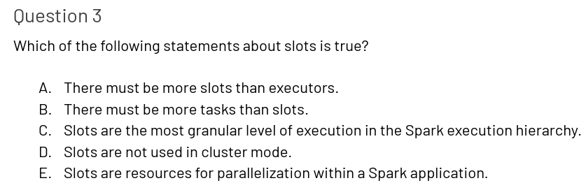

E. Slots are resources for parallelization within a Spark application.

D. Task.

E. Stage

A. A shuffle is the process by which data is compared across partitions

1. Performance will be suboptimal because not all executors will be utilized at the same time.

E. Dataframe.count() because is an action, not a transformer.

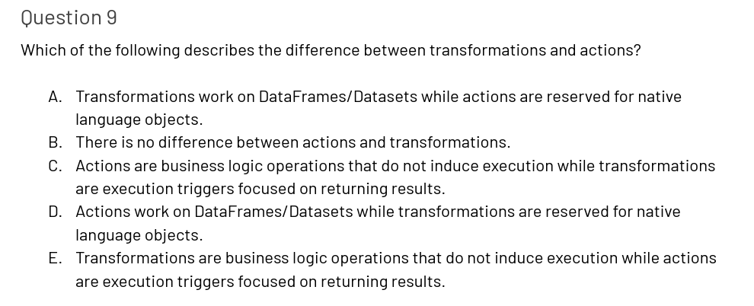

E. Transformations are business logic operations that do not induce execution while actions are execution triggers focused on returning results.

In Spark: a wide transformation is a transformation that requires data to be shuffled between executors, while a narrow transformation is a transformation that does not require data to be shuffled - [What is Wide and Narrow Transformation in Apache Spark - Nixon Data](https://nixondata.com/knowledge/apache-spark-fundamentals/apache-spark-wide-and-narrow-transformation/#:~:text=In%20Apache%20Spark%2C%20a%20wide%20transformation%20is%20a,that%20does%20not%20require%20data%20to%20be%20shuffled.).

D. Dataframe.select()

A. Spark’s execution/deployment mode determines where the driver and executors are physically located when a Spark application is run.

B. They should all ensure completion because worker nodes are fault-tolerant.

A. An out-of-memory error occurs when either the driver or an executor does not have enough memory to collect or process the data allocated to it.

A. MEMORY_AND_DISK / [pyspark.sql.DataFrame.persist — PySpark 3.3.1 documentation (apache.org)](https://spark.apache.org/docs/latest/api/python/reference/pyspark.sql/api/pyspark.sql.DataFrame.persist.html#pyspark.sql.DataFrame.persist)

MEMORY is for streaming. [Spark Streaming - Spark 3.3.1 Documentation (apache.org)](https://spark.apache.org/docs/latest/streaming-programming-guide.html#caching--persistence).

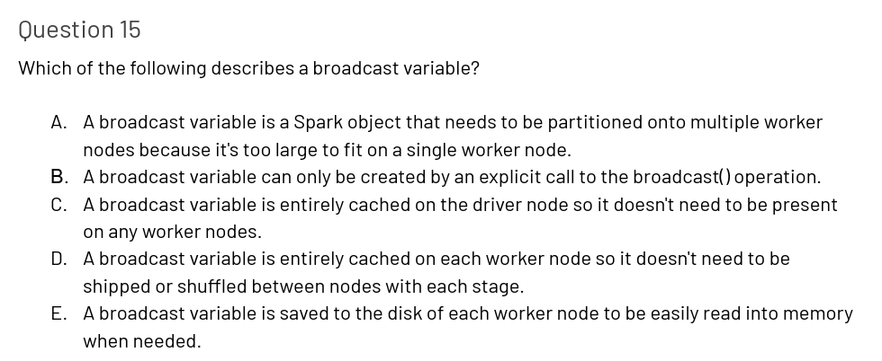

D. A broadcast variable is saved to the disk of each Worker node to be easily read into memory when needed.

[What are broadcast variables in Spark and when to use them? – Hadoop In Real World](https://www.hadoopinrealworld.com/what-are-broadcast-variables-in-spark-and-when-to-use-them/)

D. Dataframe.coalesce(n)

C. RDDs.

C. storesDF.select(“storeId”, “division”)

1. storesDF.drop(“sqft”, “customerSatisfaction”)

B. storesDF.filter( col(“sqft”) <= 25000

A. storedDF.filter( (col(“sqft”) <= 25000 ) | ( col(“customerSatisfaction”) >= 30 ) )

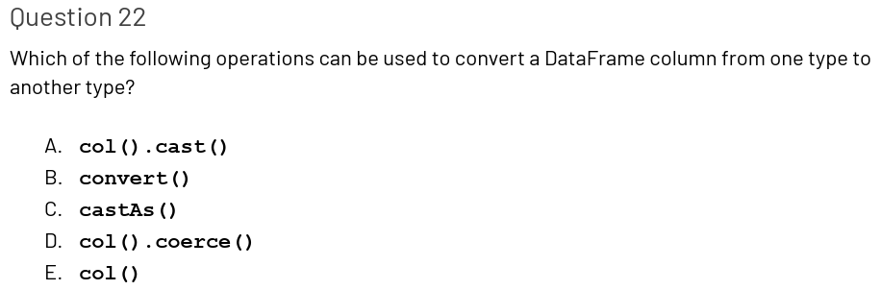

A. col().cast()

D. storesDF.withColumn(“sqft100”, col(“sqft) / 100)

C. storesDF.withColumn( “numberOfManagers”, lit(1) )

B. The split() operation comes from the imported functions object. It accepts a Column object and split character as arguments. It is not a method of a Column object.

C. explode()

A. storesDF.withColumn(“storeCategory”, lower(col(“storeCategory”)))

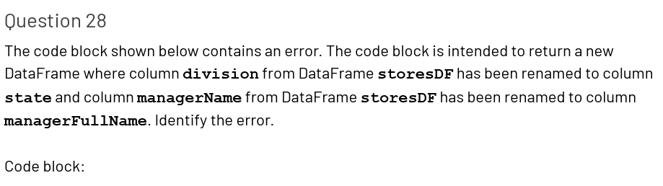

D. The first argument to operation withColumnRenamed() should be the old column name and the second argument should be the new column name

E. storesDF.na.drop(“all”) [pyspark.sql.DataFrame.dropna — PySpark 3.3.1 documentation (apache.org)](https://spark.apache.org/docs/latest/api/python/reference/pyspark.sql/api/pyspark.sql.DataFrame.dropna.html#pyspark.sql.DataFrame.dropna)

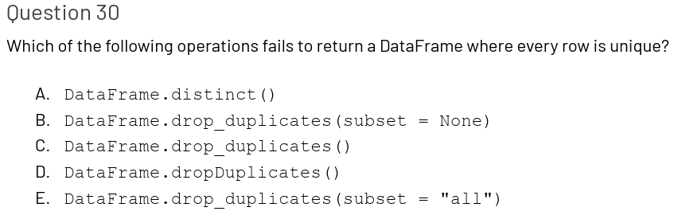

E. DataFrame.drop_duplicates(subset = “all”)

A. storesDF.agg(approx_count_distinct(col(“division”)).alias(“divisionDistinct”)) [pyspark.sql.functions.approx_count_distinct — PySpark 3.3.1 documentation (apache.org)](https://spark.apache.org/docs/latest/api/python/reference/pyspark.sql/api/pyspark.sql.functions.approx_count_distinct.html#pyspark.sql.functions.approx_count_distinct)

A. storesDF.agg(mean(col(“sqft”)).alias(“sqftMean”))

D. storesDF.count()

E. storesDF.groupBy(“division”).agg(sum(col(“sqft”)))

B. storesDF.describe(“sqft”)

[pyspark.sql.DataFrame.describe — PySpark 3.3.1 documentation (apache.org)](https://spark.apache.org/docs/latest/api/python/reference/pyspark.sql/api/pyspark.sql.DataFrame.describe.html#pyspark.sql.DataFrame.describe)

A. sort() and orderBy()

E. The first argument True sets the sampling to be with replacement

[pyspark.sql.DataFrame.sample — PySpark 3.3.1 documentation (apache.org)](https://spark.apache.org/docs/latest/api/python/reference/pyspark.sql/api/pyspark.sql.DataFrame.sample.html#pyspark.sql.DataFrame.sample) [pyspark.sql.DataFrame.sampleBy — PySpark 3.3.1 documentation (apache.org)](https://spark.apache.org/docs/latest/api/python/reference/pyspark.sql/api/pyspark.sql.DataFrame.sampleBy.html#pyspark.sql.DataFrame.sampleBy)

B. Dataframe.take(n) [pyspark.sql.DataFrame.take — PySpark 3.3.1 documentation (apache.org)](https://spark.apache.org/docs/latest/api/python/reference/pyspark.sql/api/pyspark.sql.DataFrame.take.html#pyspark.sql.DataFrame.take)

D. storeDF.first().

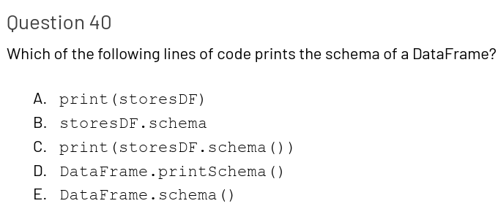

D. DataFrame.printSchema()

B. 1, 4

[Spark SQL UDF (User Defined Functions) - Spark By {Examples} (sparkbyexamples.com)](https://sparkbyexamples.com/spark/spark-sql-udf/)

Question 42

1. 3, 4

C. spark.sql()

B. spark.createDataFrame(years, IntegerType())

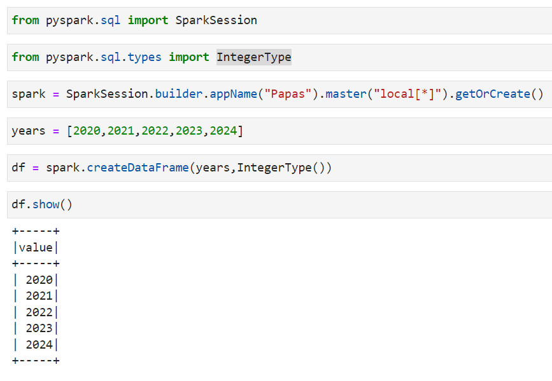

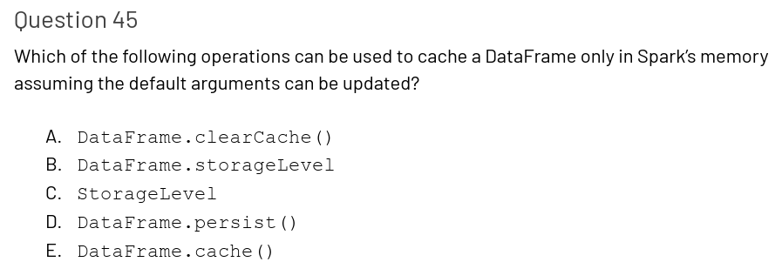

D. DataFrame.persist(…) [DataFrame — PySpark 3.3.1 documentation (apache.org)](https://spark.apache.org/docs/latest/api/python/reference/pyspark.sql/dataframe.html)

D. The repartition operation induced a full shuffle. The coalesce operation should be used instead.

C. storesDF.repartition(12) -> shuffle tasks to secure you always get N-partitions

A. spark.sql.shuffle.partitions -> [performance - What is the difference between spark.sql.shuffle.partitions and spark.default.parallelism? - Stack Overflow](https://stackoverflow.com/questions/45704156/what-is-the-difference-between-spark-sql-shuffle-partitions-and-spark-default-pa)

B. 2,1

1. storesDF.withColumn(“openDateFormat”, col(“openDate”).cast(“Date”)).withColumn(“month”, month(col(“openDateFormat”)))

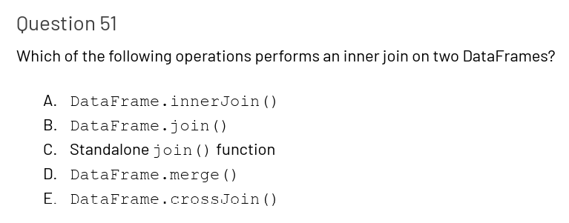

B. DataFrame.join()

A. storesDF.join(employeesDF, “storeId”,”outer”)

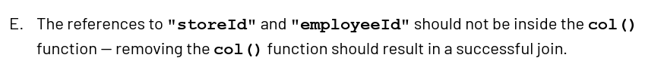

E. The references to “storeId” and “employeeId” should not be inside the col() function – removing the col() function should result in a successful join.

- [pyspark.sql.DataFrame.join — PySpark 3.3.1 documentation (apache.org)](https://spark.apache.org/docs/latest/api/python/reference/pyspark.sql/api/pyspark.sql.DataFrame.join.html#pyspark.sql.DataFrame.join)

A. Spark.sql.autoBroadcastJoinThreshold

[Does spark.sql.autoBroadcastJoinThreshold work for joins using Dataset's join operator? - Stack Overflow](https://stackoverflow.com/questions/43984068/does-spark-sql-autobroadcastjointhreshold-work-for-joins-using-datasets-join-op)

E. storesDF crossJoin employeesDF

E. DataFrame.union()- [pyspark.sql.DataFrame.unionByName — PySpark 3.3.1 documentation (apache.org)](https://spark.apache.org/docs/latest/api/python/reference/pyspark.sql/api/pyspark.sql.DataFrame.unionByName.html#pyspark.sql.DataFrame.unionByName)

E. storesDF.write.parquet(filePath)

C. There is no repartition() operation for DataFrameWriter – the partitionBy() operation should be used instead.

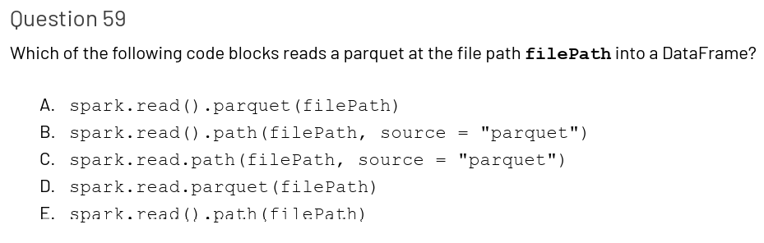

D. spark.read.parquet(filePath)

E. spark.read.schema(schema).format(“json”).load(filePath)