Green Corridor Ammonia Bunkering

Infrastructure Optimization Report
MILP Model Analysis & Results (2030-2050)
November 2025

Executive Summary
This report presents a comprehensive MILP optimization analysis for ammonia bunkering infrastructure at Busan Port over a 20-year planning horizon (2030-2050). The analysis evaluates 270 system configurations across three scenarios to minimize Net Present Cost (NPC).

Key Findings
Case | Shuttle (m3) | Pump (m3/h) | NPC ($M)
Case 1: Busan | 2,500 | 2,000 | 153.5
Case 2-1: Yeosu | 5,000 | 2,000 | 158.2
Case 2-2: Ulsan | 5,000 | 2,000 | 94.9

Strategic Recommendation: Case 2-2 (Ulsan) offers 38% cost advantage over Case 1, representing the most cost-effective bunkering solution.

1. Introduction

Background
The maritime industry is transforming towards decarbonization. Ammonia has emerged as a viable zero-carbon fuel for deep-sea shipping. This study optimizes ammonia bunkering infrastructure at Busan Port, a critical hub in the Green Shipping Corridor.

Objectives
- Determine optimal fleet composition and port infrastructure
- Minimize Net Present Cost over 20-year horizon
- Compare three operational scenarios
- Provide actionable infrastructure investment recommendations

2. Methodology

MILP Model Framework
Mixed Integer Linear Programming (MILP) solves: Minimize NPV = Sum[DISC(t) x (CAPEX(t) + OPEX(t))]
Subject to demand satisfaction, operational capacity, and infrastructure constraints.

Key Parameters
Time Period: 2030-2050 (20 years)
Discount Rate: 7%
Fleet Growth: 50 vessels (2030) to 500 vessels (2050)
Ammonia Price: $600/ton baseline

3. System Scenarios

Case 1: Busan Port Storage
Port-side 35,000-ton storage tank with shuttle-to-ship bunkering. Absorbs demand variability and enables economies of scale.

Case 2-1: Yeosu Production
Long-distance (86 nm, 5.73 hours) shuttle transport from Yeosu ammonia facility. Requires larger vessels.

Case 2-2: Ulsan Production
Short-distance (25 nm, 1.67 hours) shuttle transport from Ulsan. Minimizes operational costs.

4. Optimization Results

Figure 1: NPC Landscape
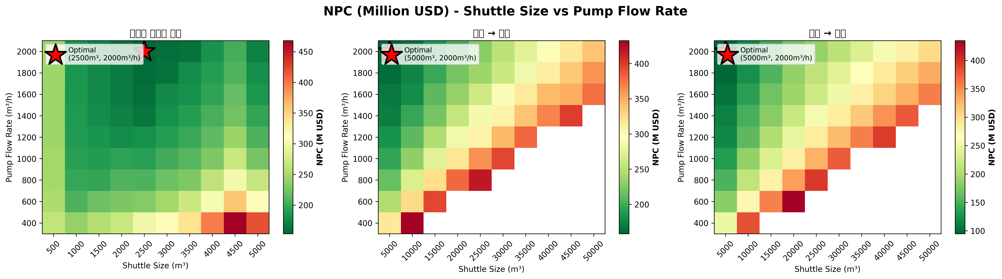

Figure 2: Cost Breakdown
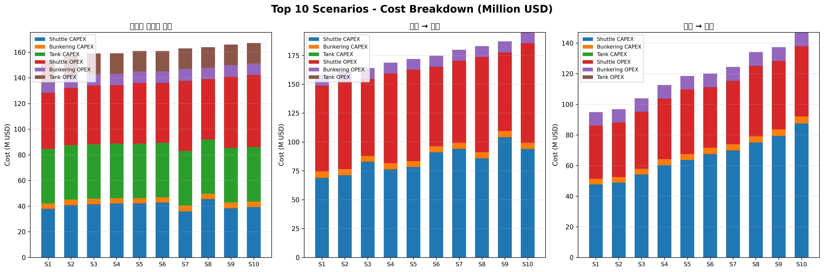

Figure 3: Case Comparison
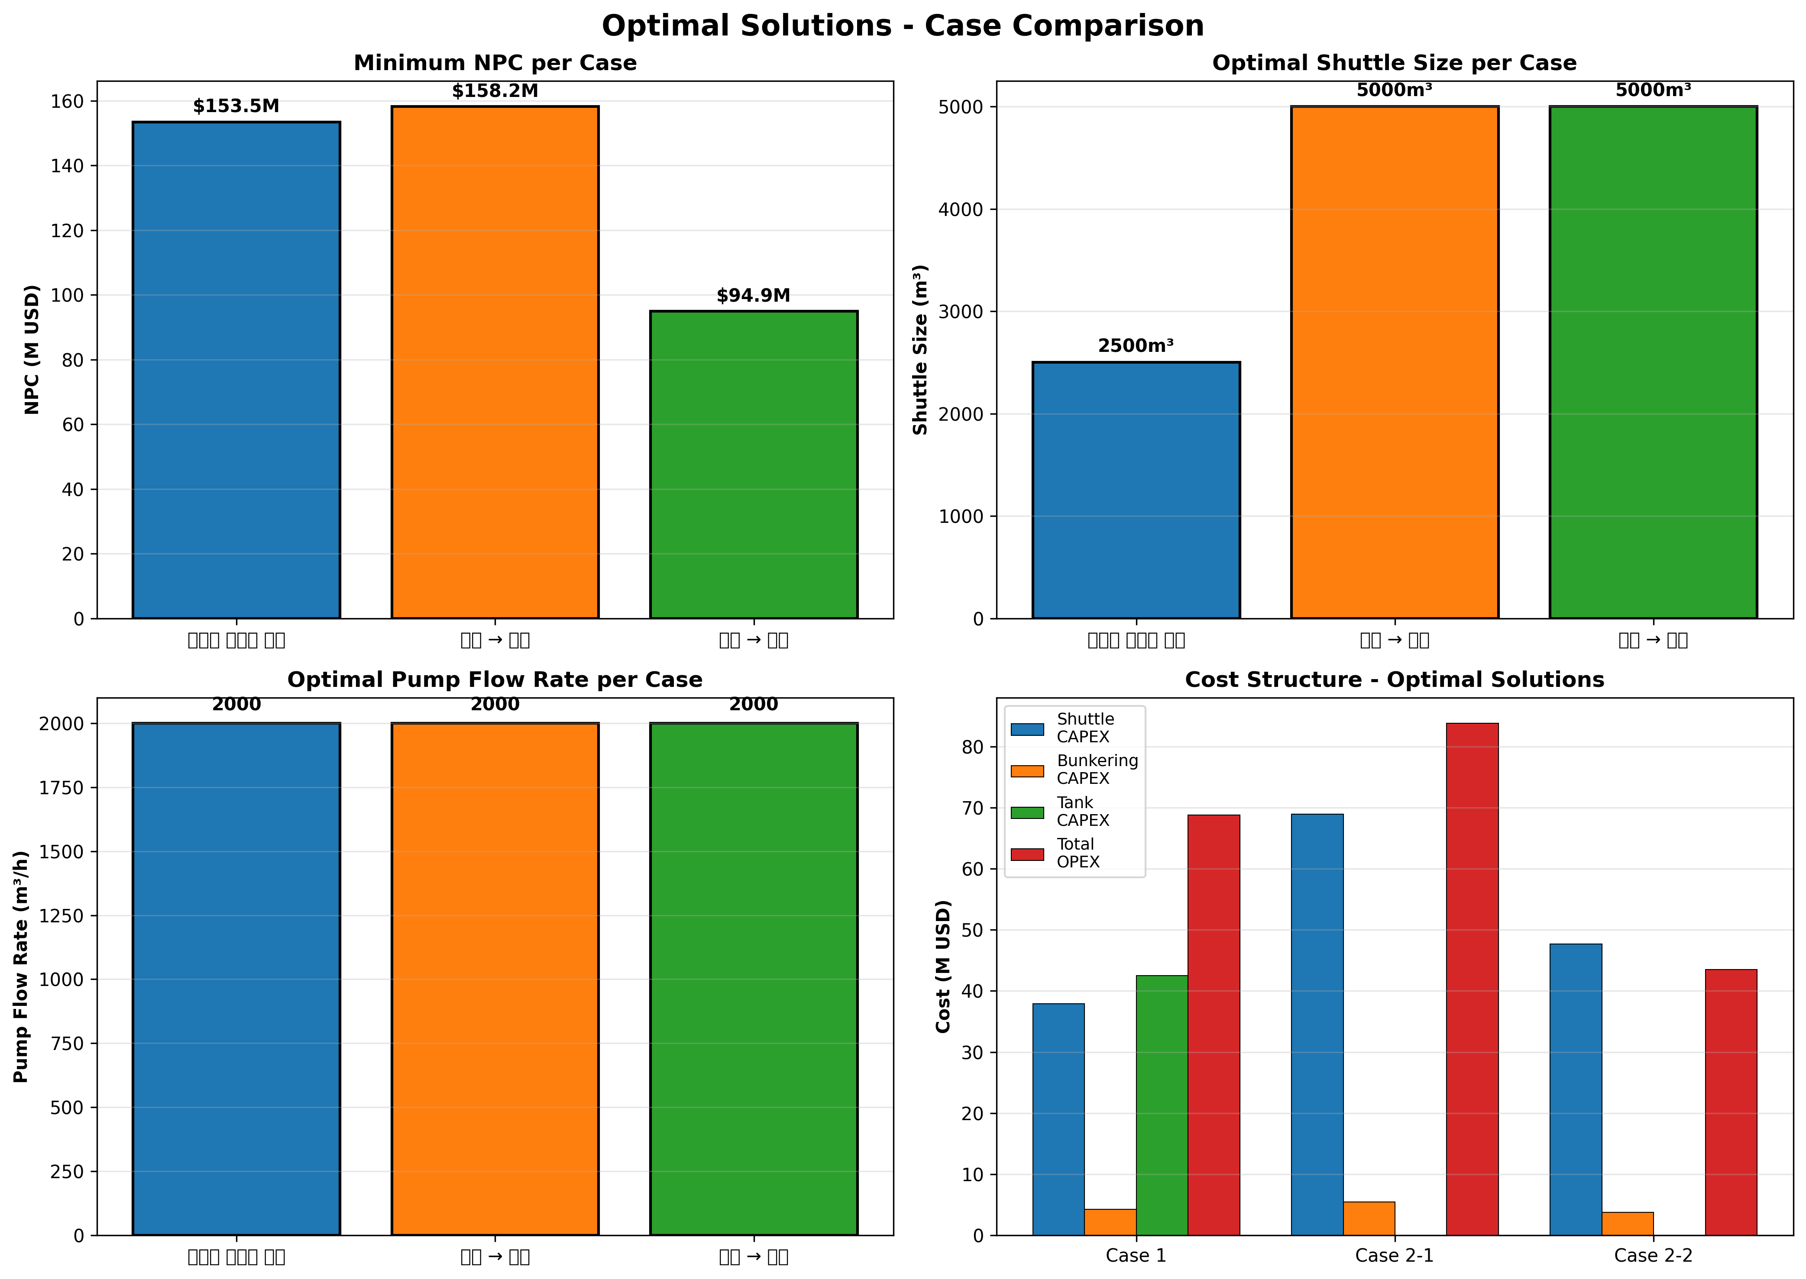

Figure 4: NPC Distribution
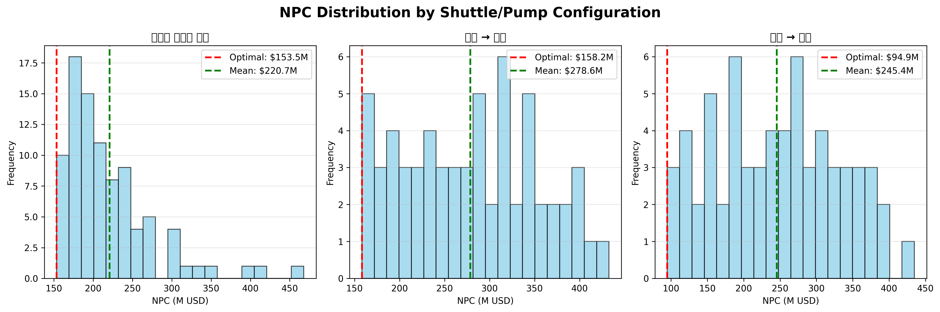

Figure 5: Sensitivity Analysis
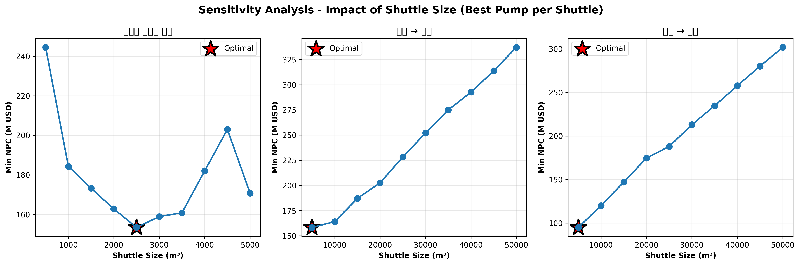

5. Detailed Analysis

Case 1: Busan Storage
Configuration: 2,500 m3 shuttle, 2,000 m3/h pump
Total NPC: $153.5M USD
- Shuttle CAPEX: $37.91M (24.7%)
- Bunkering CAPEX: $4.27M (2.8%)
- Tank CAPEX: $42.53M (27.7%)
- Total OPEX: $68.67M (44.8%)

Case 2-1: Yeosu
Configuration: 5,000 m3 shuttle, 2,000 m3/h pump
Total NPC: $158.2M USD (+3.0% vs Case 1)
- Shuttle CAPEX: $68.94M (43.6%)
- Bunkering CAPEX: $5.45M (3.4%)
- Total OPEX: $83.81M (53.0%)

Case 2-2: Ulsan (OPTIMAL)
Configuration: 5,000 m3 shuttle, 2,000 m3/h pump
Total NPC: $94.9M USD (-38.2% vs Case 1)
- Shuttle CAPEX: $47.67M (50.2%)
- Bunkering CAPEX: $3.77M (4.0%)
- Total OPEX: $43.46M (45.8%)

6. Key Insights
- Distance Critical: Short-distance operations reduce NPC by 38%
- Shuttle Sizing: Larger shuttles (5,000 m3) optimal for inter-facility transport
- CAPEX Dominance: Infrastructure costs drive 70-80% of NPC
- Operational Efficiency: Optimized pump sizing (2,000 m3/h) balances costs

7. Recommendations
- Prioritize Ulsan corridor as primary supply route
- Invest in 5,000 m3 shuttle vessels
- Coordinate with ammonia producers for integrated logistics
- Implement demand-responsive infrastructure sizing

8. Conclusion
This MILP optimization study demonstrates that short-distance ammonia supply chains significantly outperform port-based infrastructure models. The 38% cost advantage of Case 2-2 indicates that integrated logistics coordination with production facilities offers superior economic returns.
Infrastructure planners should prioritize the Ulsan route, standardize on 5,000 m3 shuttle vessels, and implement flexible pump systems to accommodate demand growth through 2050.
---
Report Generated: November 2025
Green Corridor MILP Optimization Model v2.0

