Chapter 6: Cross-Case Comparison

6.1 Overview
This chapter compares the three supply scenarios using visualizations from the D-series figures.

6.2 Optimal Configuration Summary
Case | Shuttle Size | NPC (20yr) | LCOAmmonia | Travel Time | Vessels/Trip
Case 1 | 2,500 m3 | $237.05M | $1.01/ton | 1.0 hr | N/A (multi-trip)
Case 2-1 | 10,000 m3 | $747.18M | $3.17/ton | 5.73 hr | 2
Case 2-2 | 5,000 m3 | $402.37M | $1.71/ton | 1.67 hr | 1

6.3 D-Series Figures

Figure D1: NPC vs Shuttle Size
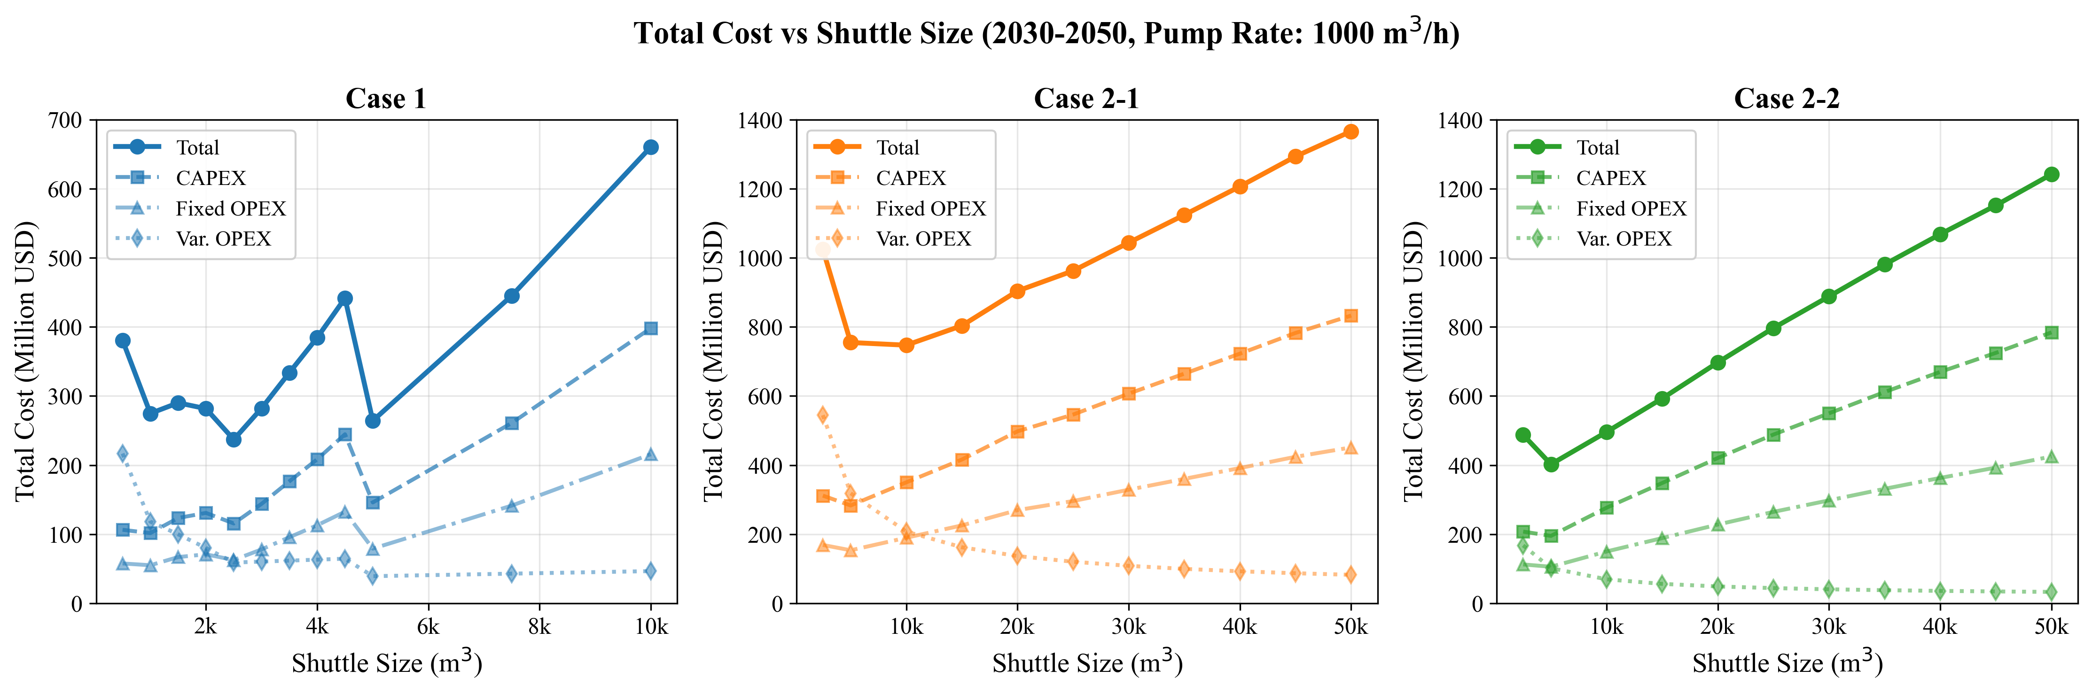
D1: NPC vs Shuttle Size
Key Observations: - Case 1 shows clear minimum at 2,500 m3 - Case 2-1 (Yeosu) minimum at 10,000 m3 - Case 2-2 (Ulsan) minimum at 5,000 m3 - All cases show U-shaped cost curves

Figure D2: Annual Cost Evolution
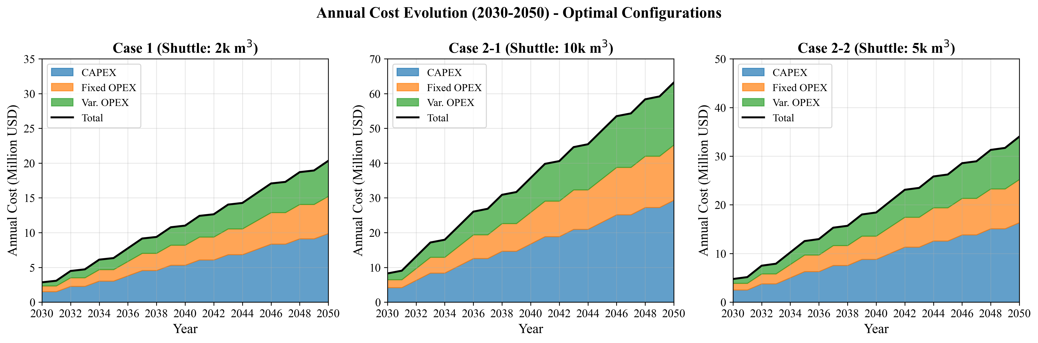
D2: Yearly Cost Evolution
Key Observations: - Costs scale linearly with demand growth (50 to 500 vessels) - Case 1 consistently lowest cost across all years - Case 2-1 consistently highest cost

Figure D3: Fleet Size & Annual Supply
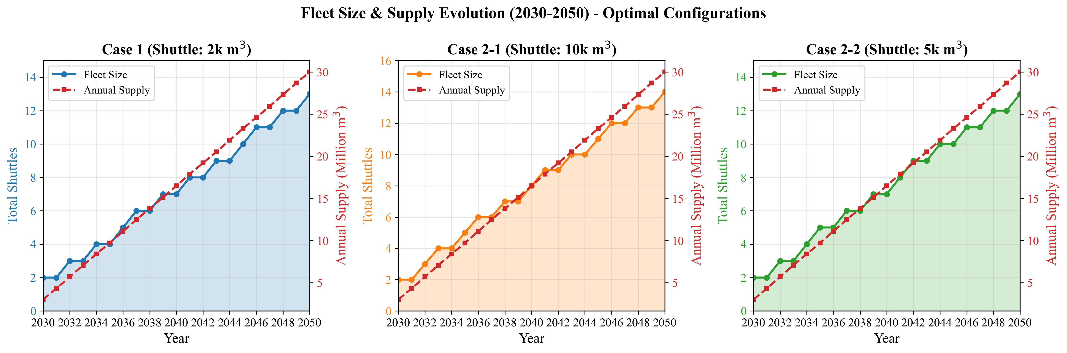
D3: Fleet & Demand
Key Observations: - Fleet size grows proportionally with demand - Case 1 requires more shuttles (smaller size) but lower total cost - Case 2 cases require fewer but larger shuttles

Figure D4: Annual Cycles
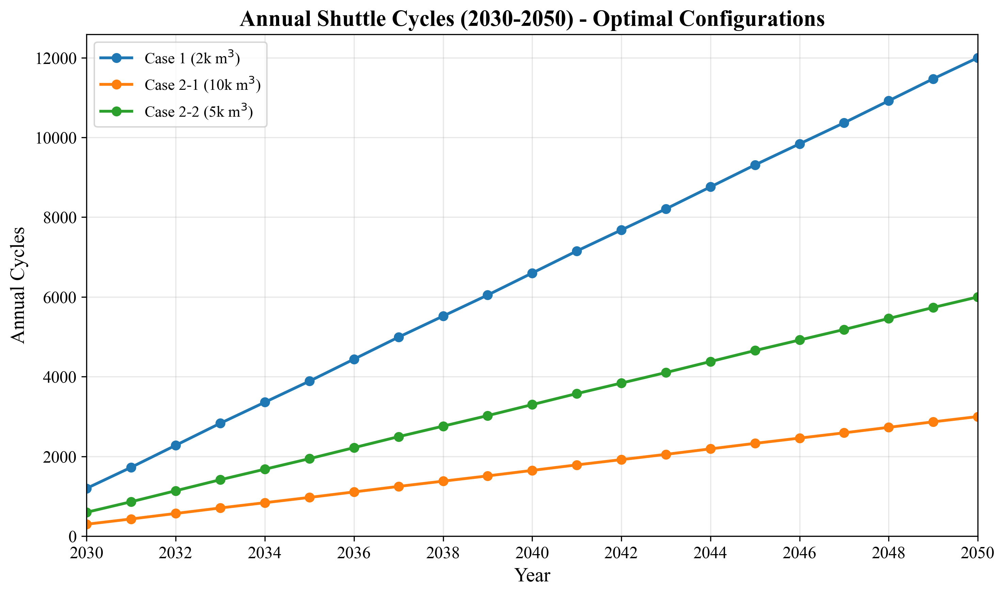
D4: Yearly Cycles
Key Observations: - Case 1 has highest cycle frequency (shorter cycles) - Case 2-1 has lowest frequency (longest cycles) - Higher frequency = better asset utilization

Figure D5: Utilization Rate
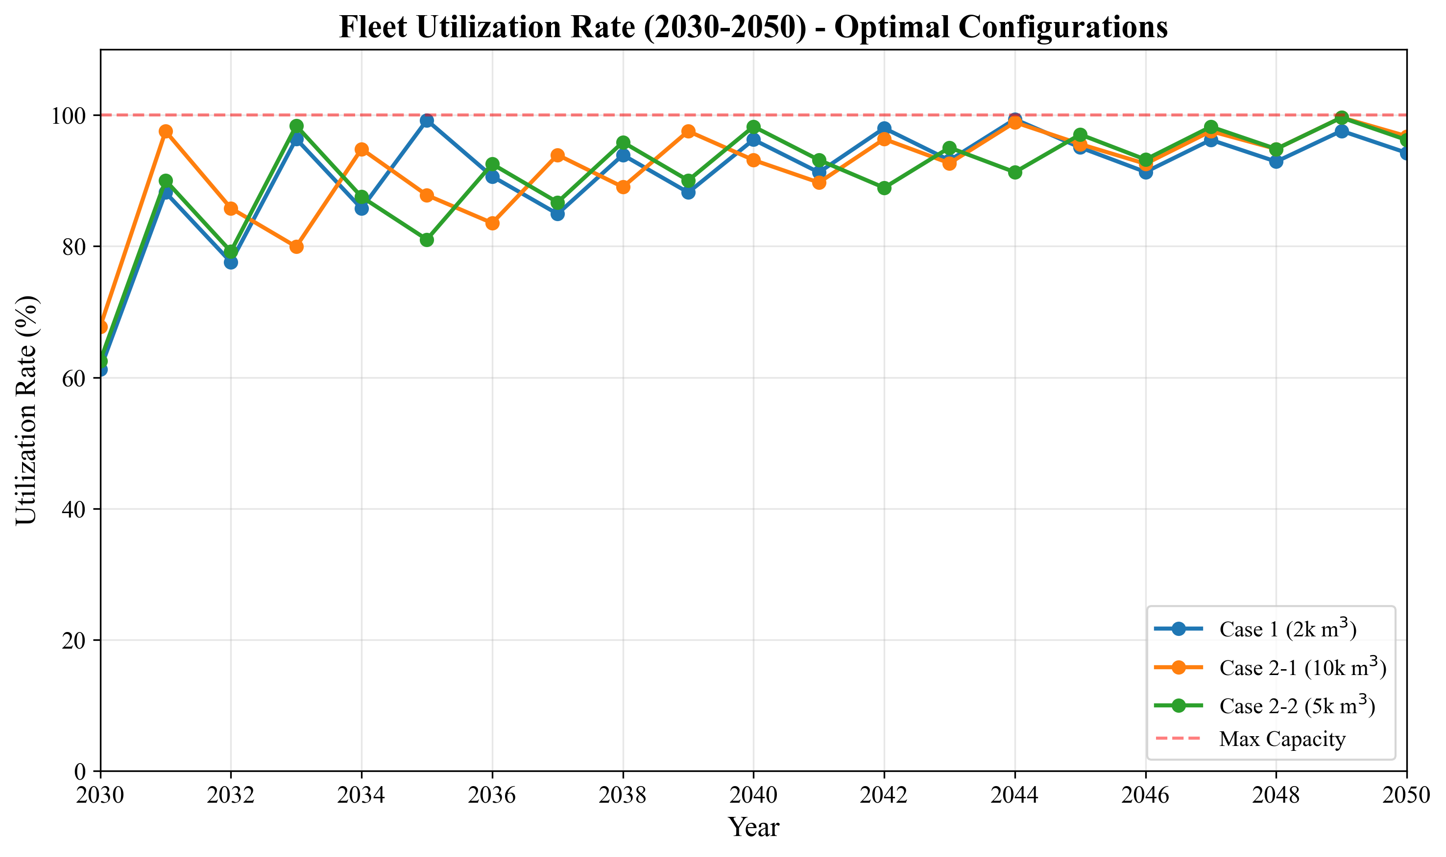
D5: Yearly Utilization
Key Observations: - All optimal configurations achieve 100% utilization - No wasted capacity in optimal scenarios

6.4 Additional Figures (Optional)

Figure D6: Cost Breakdown
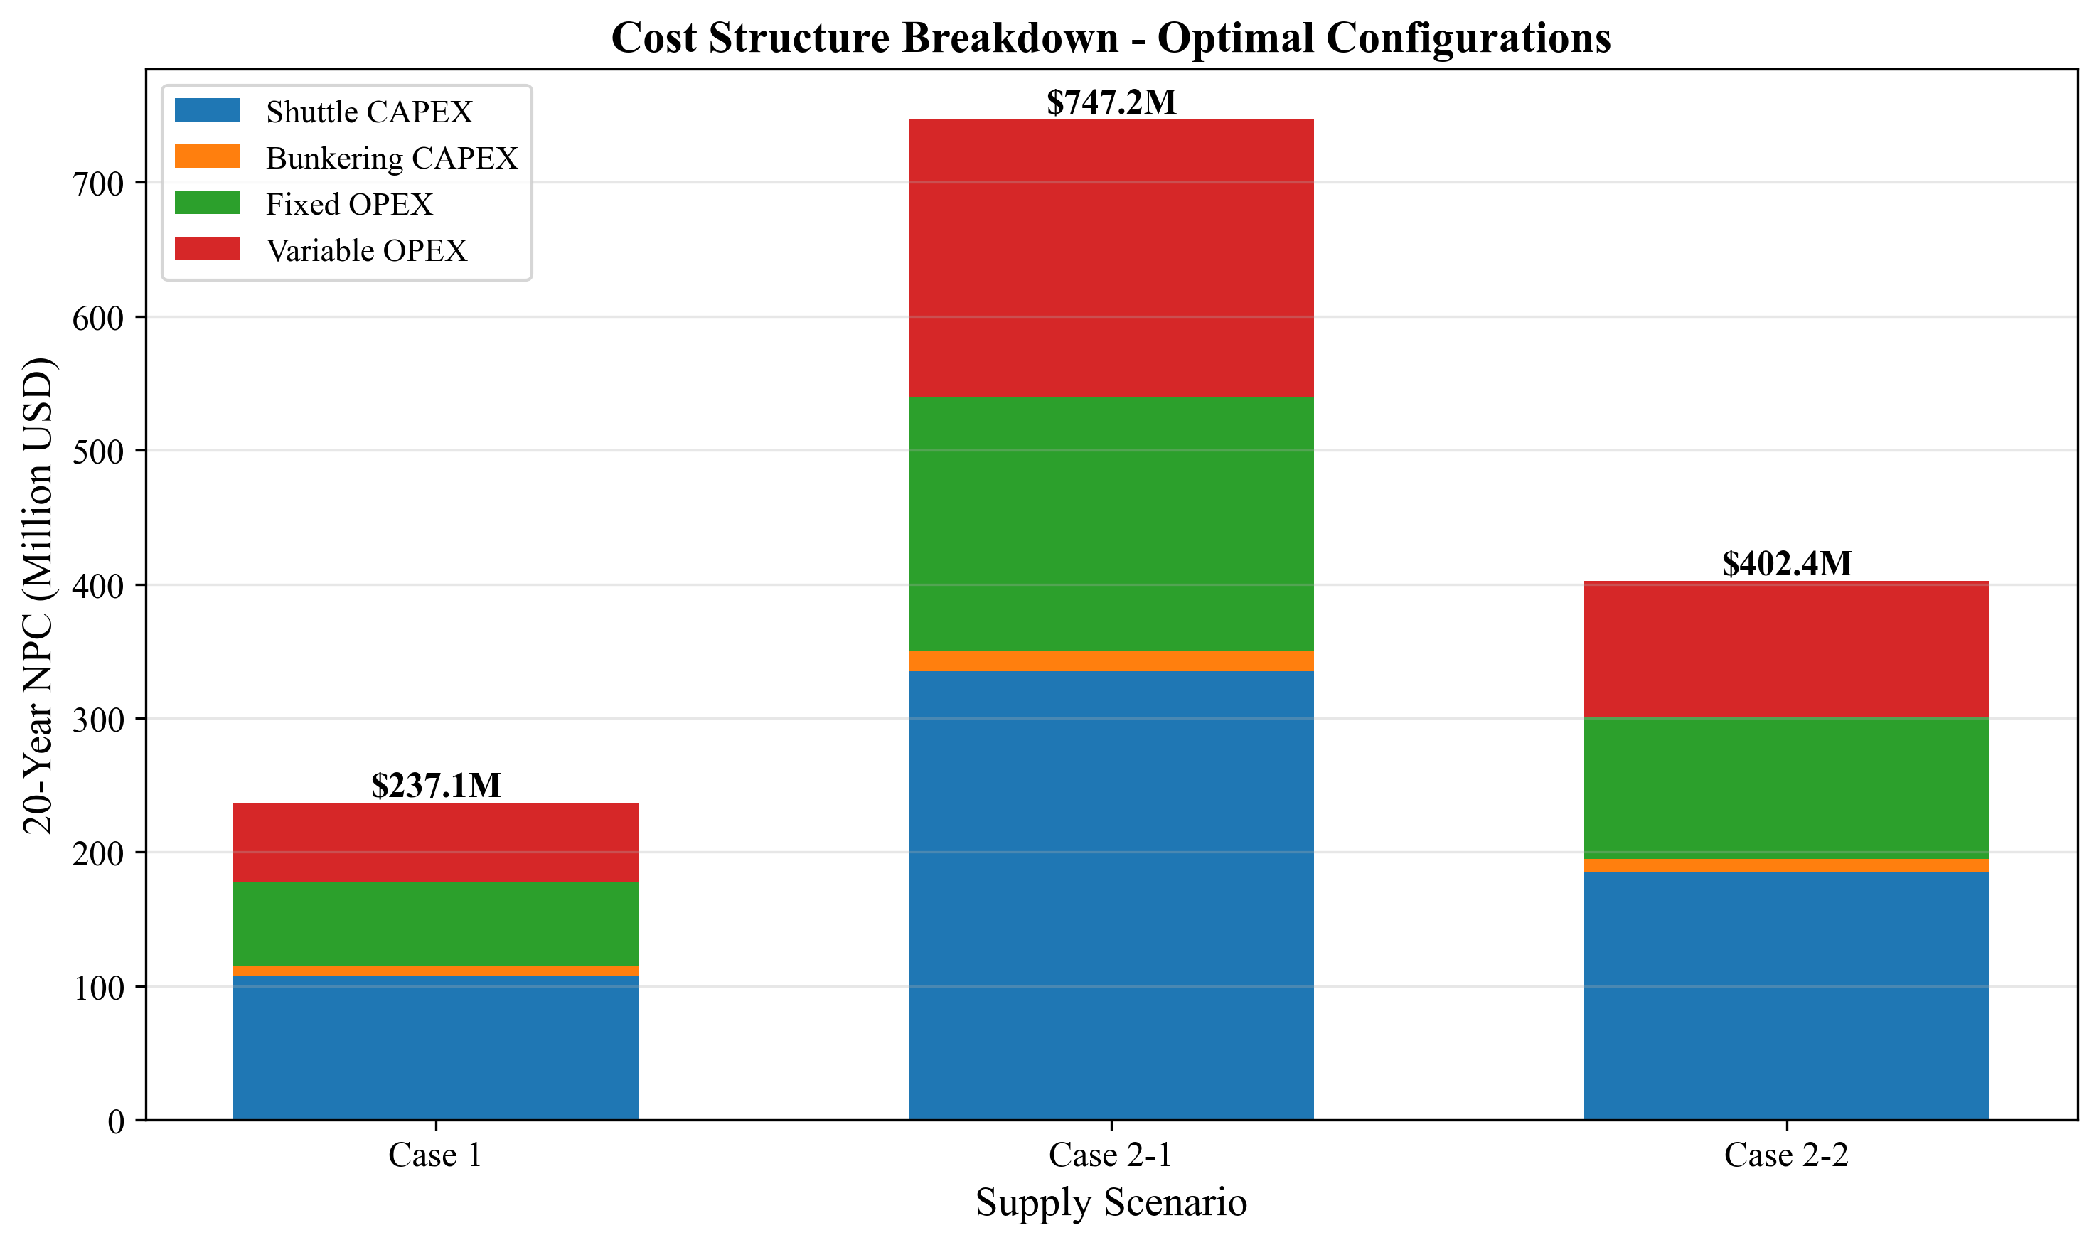
D6: Cost Breakdown
Cost Component | Case 1 | Case 2-1 | Case 2-2
Shuttle CAPEX | 45.5% | 44.9% | 45.9%
Bunkering CAPEX | 3.2% | 2.0% | 2.5%
Shuttle Fixed OPEX | 24.6% | 24.3% | 24.9%
Bunkering Fixed OPEX | 1.8% | 1.1% | 1.4%
Shuttle Variable OPEX | 19.6% | 26.1% | 22.2%
Bunkering Variable OPEX | 5.3% | 1.7% | 3.1%

Figure D7: Cycle Time Comparison
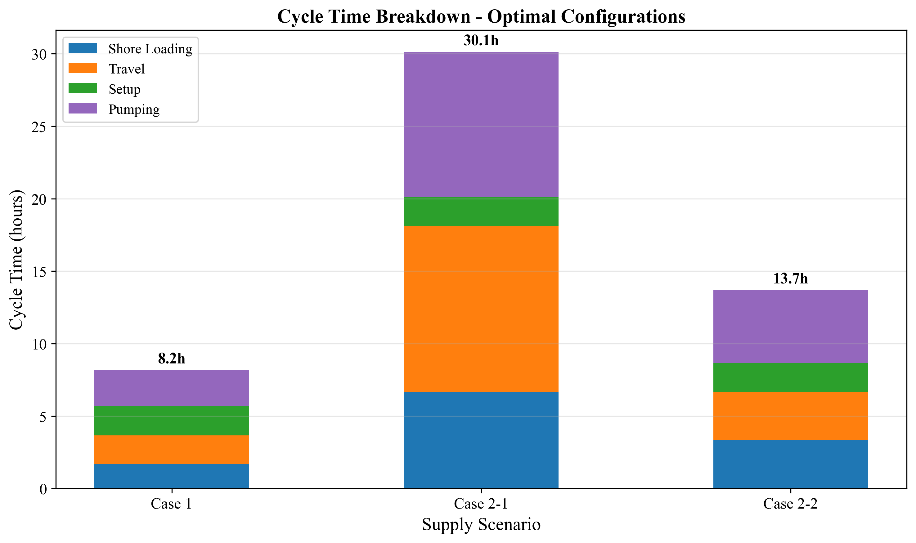
D7: Cycle Time
Case | Optimal Shuttle | Cycle Time | Components
Case 1 | 2,500 m3 | 8.17 hr | Shore 1.67 + Travel 2.0 + Setup 2.0 + Pump 2.5
Case 2-1 | 10,000 m3 | 36.13 hr | Shore 6.67 + Travel 11.46 + Port 2.0 + 2x8.0
Case 2-2 | 5,000 m3 | 16.67 hr | Shore 3.33 + Travel 3.34 + Port 2.0 + 8.0

Figure D9: LCO Comparison
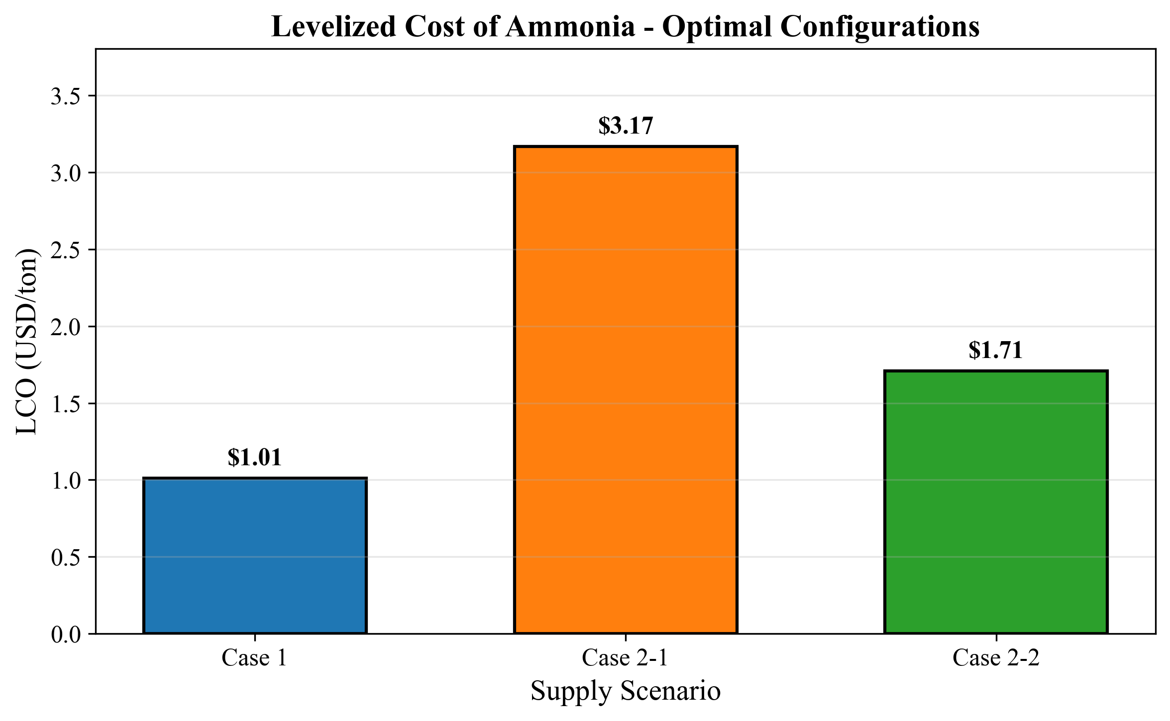
D9: LCO Comparison
Levelized Cost of Ammonia (LCOAmmonia): - Case 1: $1.01/ton (baseline) - Case 2-2: $1.71/ton (+69% premium) - Case 2-1: $3.17/ton (+214% premium)

Figure D10: NPC Case Comparison
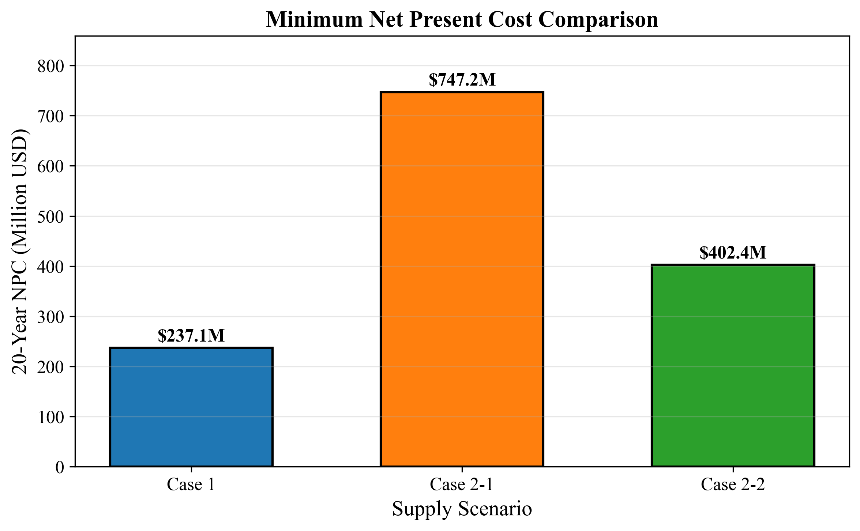
D10: NPC Comparison

6.5 Case-by-Case Analysis

6.5.1 Case 1 vs Case 2-2 (Near Alternative)
Metric | Case 1 | Case 2-2 | Delta
NPC | $237.05M | $402.37M | +$165.32M
LCO | $1.01/ton | $1.71/ton | +$0.70/ton
Premium | - | +70% | -
Travel Time | 2.0 hr RT | 3.34 hr RT | +67%
Conclusion: Case 2-2 (Ulsan) is the best alternative if local storage is infeasible.

6.5.2 Case 1 vs Case 2-1 (Far Alternative)
Metric | Case 1 | Case 2-1 | Delta
NPC | $237.05M | $747.18M | +$510.13M
LCO | $1.01/ton | $3.17/ton | +$2.16/ton
Premium | - | +215% | -
Travel Time | 2.0 hr RT | 11.46 hr RT | +473%
Conclusion: Case 2-1 (Yeosu) should be avoided if possible due to high travel time.

6.5.3 Case 2-1 vs Case 2-2 (Direct Supply Options)
Metric | Case 2-1 | Case 2-2 | Delta
NPC | $747.18M | $402.37M | -$344.81M
LCO | $3.17/ton | $1.71/ton | -$1.46/ton
Savings | - | 46% | -
Distance | 86 nm | 25 nm | -71%
Conclusion: Ulsan is significantly better than Yeosu for direct supply scenarios.

6.6 Shuttle Size Selection Guide
Case | Under-sized | Optimal | Over-sized
Case 1 | 500-2000 m3 (high OPEX) | 2500 m3 | 3000+ m3 (high CAPEX)
Case 2-1 | 2500-5000 m3 (high trips) | 10000 m3 | 15000+ m3 (long cycles)
Case 2-2 | 2500 m3 (2 trips needed) | 5000 m3 | 10000+ m3 (diminishing returns)

6.7 Economic Impact of Distance
Source | Distance | Travel Time | NPC vs Case 1
Busan Storage | 0 nm | 1.0 hr* | Baseline
Ulsan | 25 nm | 1.67 hr | +70%
Yeosu | 86 nm | 5.73 hr | +215%
*Case 1 travel time is port internal movement, not open sea transit.
Rule of Thumb: Each additional 10 nm adds approximately 25% to NPC for this demand profile.

6.8 Decision Matrix
Scenario | Recommended Case | Key Reason
Local storage feasible | Case 1 | Lowest NPC
No local storage, proximity to Ulsan | Case 2-2 | 46% cheaper than Yeosu
No local storage, only Yeosu available | Case 2-1 | Only option
Future demand uncertainty | Case 1 or 2-2 | Smaller shuttles = flexibility

