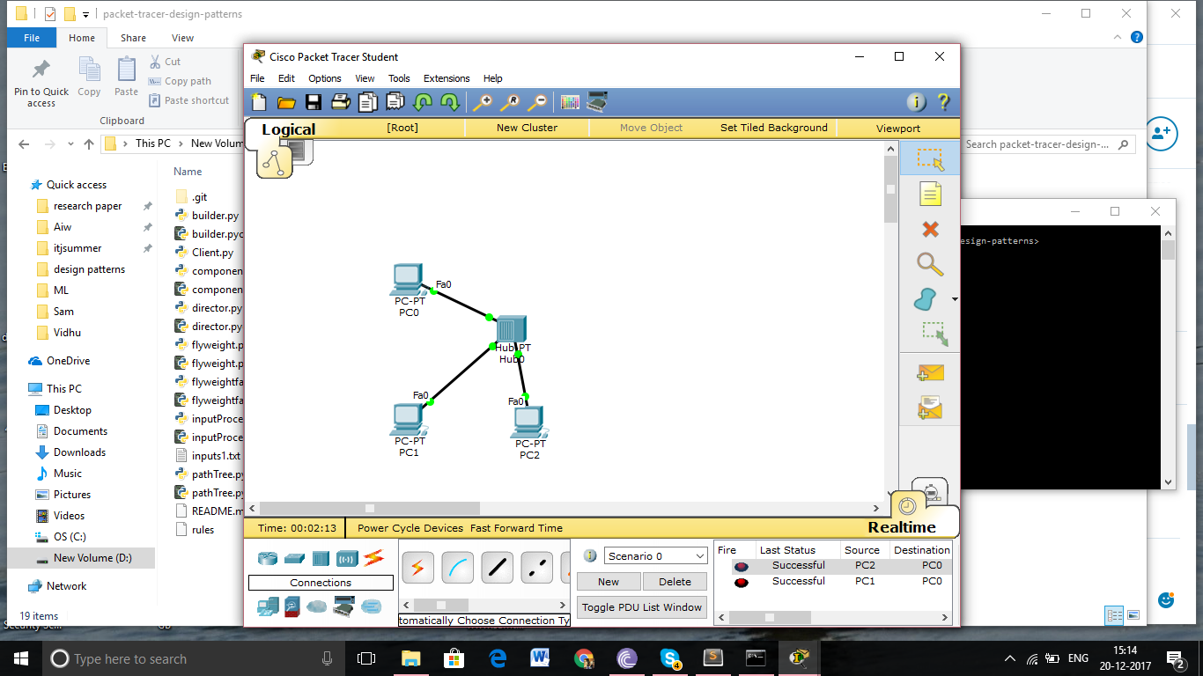

Config 1

Pc a

Gateway: 1.1.1.0

Ip:1.1.1.1

Pc b

Gateway: 1.1.1.0

Ip:1.1.1.2

Pc c

Gateway: 1.1.1.0

Ip:1.1.1.3

Connected via a hub

For direct demo

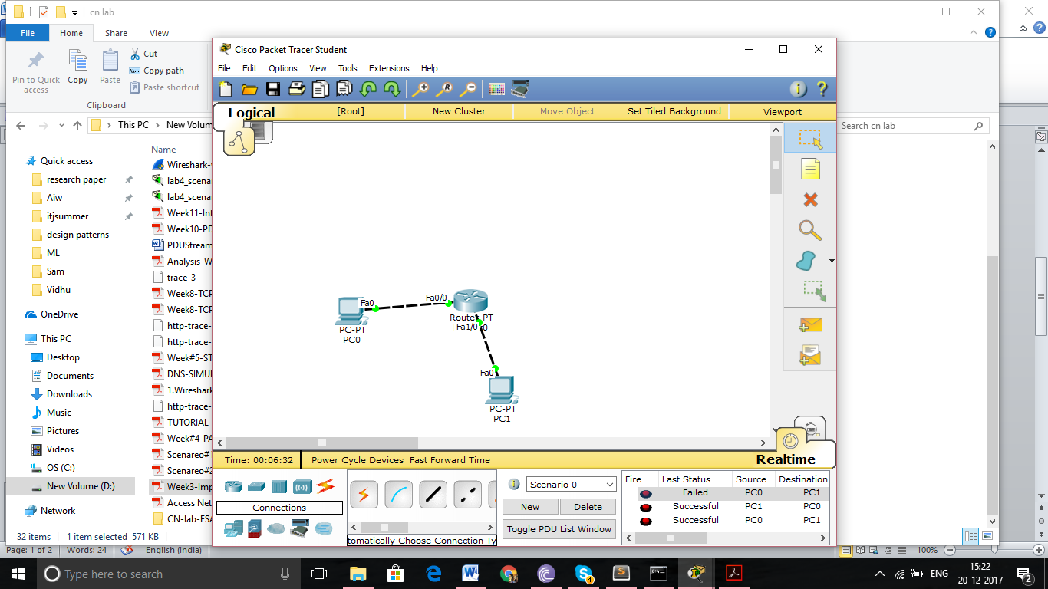

Config

Pc a

Gateway 1.1.1.0

Ip 1.1.1.1

Pc b

Gateway 2.2.2.0

Ip 2.2.2.1

Router

Fa0 ip 1.1.1.0

Fa 1 ip 2.2.2.0

Routing table

Network 1.0.0.0

Mask 255.0.0.0

Hop 2.2.2.1

Network 2.0.0.0

Mask 255.0.0.0

Hop 1.1.1.1

