other salaries got the same salary as the first salary

**code:**

salary_estimate = driver.find_element_by_xpath('.//span[@class="gray salary"]').text

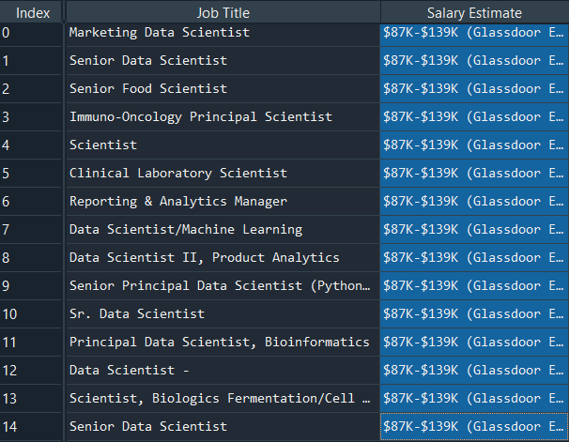

**code:**

salary_estimate = driver.find_element_by_xpath('.//*[@id="HeroHeaderModule"]/div[3]/div[1]/div[4]/span').text

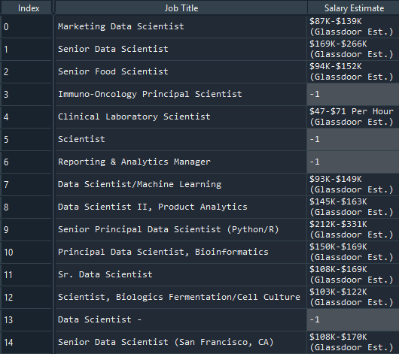

Open GitBash

go to the file “ds_salary_proj” location

enter the following statements:

echo “# ds_salary_proj” >> README.md

git add . 🡪 add all the files in the folder

git commit -m "uploaded scraper and run code"

git remote add origin https://github.com/slothpunch/ds_salary_proj.git

git push -u origin master