HL7 Identification Service

SysML v2 Model Documentation

Computation Independent Model (CIM) and Platform Independent Model (PIM)
Source: HL7 V3 Identification Service (IS) Service Functional Model, Release 1
Transformation: Automated SFM-to-SysMLv2 Pipeline
Date: 2026-03-02
Package: CIM_IS + PIM_IS

Table of Contents

Sommario
SysML v2 Model Documentation 1
Table of Contents 2
1. Introduction 6
1.1 Document Conventions 6
2. Model Overview 7
2.1 Package Hierarchy 7
2.2 Model Statistics Summary 8
3. CIM: Business Domain Ontology 9
3.1 Enumerations 9
3.2 Attribute Definitions (Value Types) 9
3.3 Domain Entities (Item Definitions) 10
3.4 Domain Associations (Connection Definitions) 12
3.4.1 Core Meta-Model Associations 12
3.4.2 Subscription Filter & Service Metadata Associations 13
3.5 Domain Model (Conceptual Instance) 14
4. CIM: Stakeholder Model 15
4.1 Primary Actors 15
4.2 Secondary Actors 15
5. CIM: Business Capabilities (Use Cases) 17
5.1 Identity Management Capabilities (Section 4.3) 17
5.2 Query Capabilities (Section 4.4) 17
5.3 Business Scenarios (Non-Normative) 18
5.3.1 Single-Domain Scenarios 18
5.3.2 Multi-Domain Scenarios 19
6. CIM: Business Rules 20
6.x Identity Uniqueness & Scope Rules 20
6.x Entity Type & Semantic Signifier Rules 20
6.x Merge Rules 20
6.x Link Rules 21
6.x Query & Notification Rules 21
7. CIM: Requirements 22
7.1 Functional Requirements 22
7.1.x Identity Registration & Creation 22
7.1.x Identity Update 22
7.1.x Merge & Unmerge 22
7.1.x Link & Unlink 23
7.1.x Remove 23
7.1.x Query Operations 23
7.1.x Notification 23
7.1.x Cross-Cutting 23
7.2 Quality Requirements 24
7.3 Compliance Requirements 25
8. CIM: Traceability 26
9. PIM: Data Model 27
9.1 Domain Entity Types 27
9.2 Request/Response Pairs 27
10. PIM: Service Contracts 29
10.1 Port Definitions 29
10.2 Interface Definitions 29
11. PIM: Operations 30
12. PIM: Behavioral Flows 32
12.x CreateNewPatientFlow 32
12.x LinkOrMergeEntitiesFlow 32
12.x UpdateDemographicsFlow 32
12.x UnlinkEntityFlow 32
12.x UnattendedEncounterFlow 32
12.x CrossRegionLinkFlow 32
13. PIM: Composition & State Model 34
13.1 System Composition 34
13.1.1 Provider 34
13.1.2 Consumers 34
13.1.3 System-Level Connections 34
13.2 Identity Lifecycle State Machine 34
14. PIM: Traceability 36
15. Transformation Log 37
15.1 Verification Results 37
15.2 Assumptions 37
15.3 Design Decisions 37
15.4 Open Issues 38
Appendix A: Model Statistics 39
Appendix B: Glossary 41
Appendix C: Diagram Placeholder Index 42

1. Introduction
This document presents a comprehensive, human-readable description of the SysML v2 model derived from the HL7 V3 Identification Service (IS) Service Functional Model (SFM), Release 1. The model was produced by an automated multi-agent transformation pipeline that analyzes the SFM specification and generates formal SysML v2 textual notation at two abstraction levels:
- Computation Independent Model (CIM) - business-level concepts, stakeholders, capabilities, rules, and requirements.
- Platform Independent Model (PIM) - data types, service contracts, operations, behavioral workflows, and system composition.
The Identification Service provides capabilities to manage and retrieve identifying information for various kinds of entities (people, organizations, devices, etc.) within and across organizations. It supports identity registration, creation, update, state management, merge/unmerge, link/unlink, removal, query, and notification operations.

1.1 Document Conventions
- SysML v2 code excerpts are shown in Consolas monospace font with indentation.
- Diagram placeholders indicate where MagicDraw diagrams should be inserted after model import.
- Statement references [ST-nnn] trace back to the original SFM specification statements.
- Requirement identifiers follow the pattern FR-nnn (Functional), QR-nnn (Quality), CR-nnn (Compliance).

2. Model Overview
The complete model is organized into two top-level SysML v2 packages:
Package | Level | Contents
CIM_IS | CIM | BusinessDomain, StakeholderModel, BusinessCapabilities, BusinessRules, CIM_Requirements, CIM_Traceability
PIM_IS | PIM | DataModel, ServiceContracts, Operations, BehavioralFlows, Composition, PIM_Traceability

2.1 Package Hierarchy
CIM_IS/
 | BusinessDomain | 13 item defs, 14 attribute defs, 5 enums, 12 connection defs, domain model
 | StakeholderModel | 10 stakeholder part defs (6 primary + 4 secondary actors)
 | BusinessCapabilities | 29 use cases (15 normative + 14 non-normative scenarios)
 | BusinessRules | 42 constraint defs (identity, merge, link, query, notification rules)
 | CIM_Requirements/
 | FunctionalRequirements/ | 41 requirements (FR-001 to FR-041)
 | QualityRequirements/ | 11 requirements (QR-001 to QR-011)
 | ComplianceRequirements/ | 10 requirements (CR-001 to CR-010)
 | CIM_Traceability | 77 derivation connections + diagnostic flags
PIM_IS/
 | DataModel | 45 item defs + 7 enum defs (domain types + request/response pairs)
 | ServiceContracts | 2 port defs + 2 interface defs + 32 flows
 | Operations | 15 action defs (1:1 with normative use cases)
 | BehavioralFlows | 6 workflow action defs (multi-step scenarios)
 | Composition | 5 part defs + 1 state def + 6 interface connections
 | PIM_Traceability | 71 dependency statements
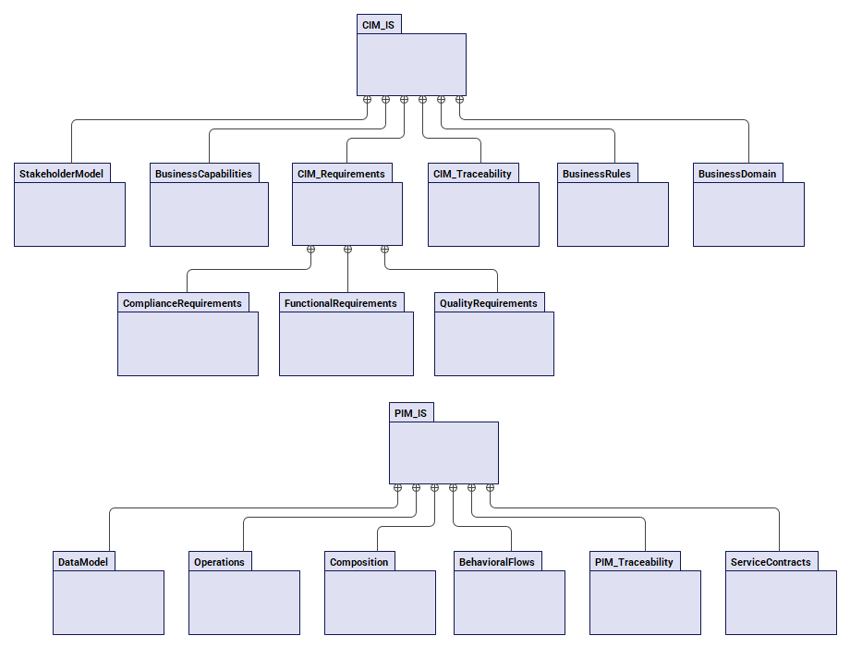
Figure 1 - Model Package Hierarchy Diagram

2.2 Model Statistics Summary
Metric | Count
Total CIM elements | 177
Total PIM elements | 170
Total requirements | 62 (41 FR + 11 QR + 10 CR)
Total traceability links | 225
Normative use cases | 15
Non-normative business scenarios | 14
PIM operations | 15
Behavioral workflow flows | 6
Business rules | 42 (6 formalized, 36 documentary)
Service interfaces | 2 (Management + Query)

3. CIM: Business Domain Ontology
The BusinessDomain package defines the core domain ontology of the Identification Service. It contains five sections: enumerations, attribute definitions (value types), item definitions (domain entities), connection definitions (named associations), and a conceptual domain model with item usages and connection usages. All elements derive from the IS SFM meta-model (Section 4.2) and glossary (Section 5).

3.1 Enumerations
Five enumeration types define the coded value sets used throughout the domain model:
Enumeration | Values | Description | Source
IdentityStatus | ACTIVE, INACTIVE | Lifecycle states for identity instances and metadata | ST-105, ST-106
LinkTypeCategory | PEER_LINK, MERGE_DEPRECATION | Whether linked identities are peers or one is deprecated | ST-220, ST-079
LinkMethodCategory | MANUAL, AUTOMATED | How a link between identities was established | ST-221, ST-081
UpdateMode | OVERWRITE, VALUED, UNSPECIFIED | Mode for identity property update operations | ST-096
MatchQualityTier | DEFINITE_MATCH, PRESUMPTIVE_MATCH, NO_MATCH | Confidence tier of match results | ST-172, ST-205

3.2 Attribute Definitions (Value Types)
Fourteen abstract attribute definitions represent the value types used as properties of domain entities. These are intentionally abstract at CIM level and are resolved to typed String/Boolean/Integer attributes at PIM level.
Attribute Def | Description | Source
DomainDesignation | Human-readable name for domain concepts | ST-069, ST-072, ST-070
DomainDescription | Textual description of domain concepts | ST-069, ST-072, ST-070
VersionDesignation | Version identifier for domain concepts | ST-177
LanguageDesignation | Human language identifier | ST-069
IdentityDesignation | Unique identity instance identifier within scope | ST-091
SemanticSignifierContent | Populated identifying information structure | ST-003, ST-071
SchemaSpecification | Schema definition for EntityType information structure | ST-070, ST-003
ValidationRuleSpecification | Declarative validation rules for schema | ST-070, ST-074
ProvenanceDescription | Administrative info for link/merge actions | ST-080
ReasonDescription | Reason for management actions | ST-077, ST-101
MatchConfidence | Quality of a match result | ST-172, ST-057
SubscriberDesignation | Notification subscriber identification | ST-155, ST-156
NotificationQualifier | Event type for notifications | ST-156, ST-159

3.3 Domain Entities (Item Definitions)
Thirteen item definitions represent the core domain entities of the Identification Service. Relationships between entities are modeled as explicit connection definitions (Section 3.4) rather than embedded references, enabling diagrammable associations in MagicDraw.
Entity | Description | Source | Key Attributes
PolicyDomain | An identity space or sphere of use. May be organizational, geographical, or juri... | ST-030, ST-069 | domainDesignation, description, version, status, forCrossReference[0..1], languagesSupported[0..*], defaultLanguage
EntityConcept | A semantic concept or category (e.g., Person, Device). Enables grouping of diffe... | ST-002, ST-072 | conceptDesignation, description, version
EntityType | A specific entity type at the level of a specific information model (semantic si... | ST-071, ST-070 | typeDesignation, description, status, version, schemaDefinition, validationRuleSet
EntityTypeAssignment | Bridges an EntityType and a PolicyDomain. Enables domain-specific customization ... | ST-074 | status, version, constrainedSchemaDefinition[0..1], constrainedValidationRuleSet[0..1]
IdentityInstance | The actual identity entry in the service. Holds populated identifying informatio... | ST-076, ST-091 | instanceDesignation, version, status, populatedSignifierValues
IdentityLink | A directed relationship between two identity instances for linking (peers) or me... | ST-077, ST-079 | linkType, linkMethod[0..1], reason[0..1], provenance[0..1]
RealWorldEntity | An actual thing (person, device, organization) that the service manages. | ST-002, ST-005 | entityNature
UpdateQualifier | Specifies the mode for identity property updates. | ST-096 | updateMode, updateSchemaReference[0..1]
SearchQualifier | Optional parameters directing search behavior. | ST-146, ST-147 | requestedConfidence[0..1], maximumResultSetSize[0..1], errorIfSizeExceeded[0..1], matchingAlgorithmDesignation[0..1]
NotificationSubscription | A standing request for identity update notifications. | ST-155, ST-159 | subscriber, notificationQualifier[0..1], subscriptionStatus
ServiceMetadata | Metadata delineating the scope of a service instance. | ST-211 | (attributes defined via connections)
HospitalInformationSystem | A clinical system acting as a service consumer. | ST-045, ST-206 | (no domain attributes)
MasterPatientIndex | An application providing identity cross-referencing capabilities. | ST-207 | (no domain attributes)

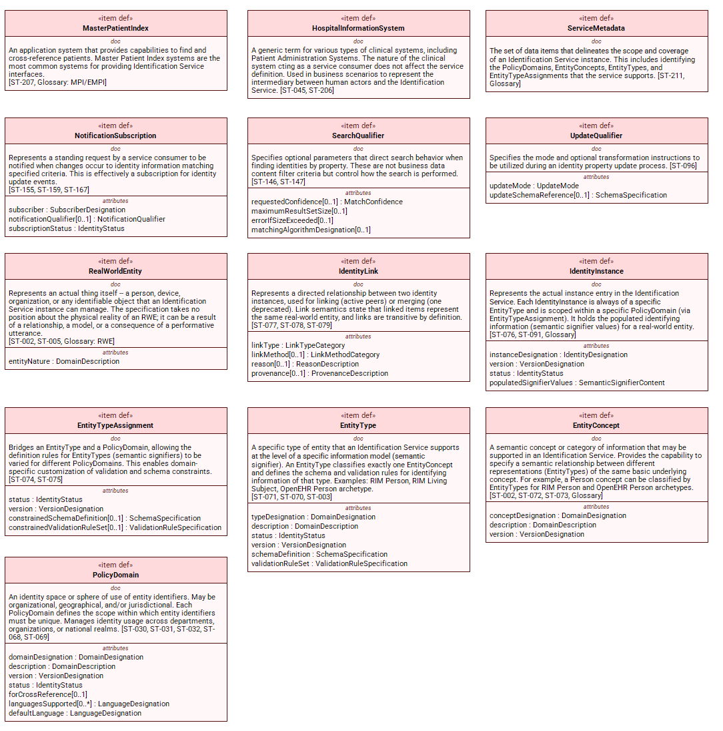
Figure 2 -Domain Entity Class Diagram (def)

3.4 Domain Associations (Connection Definitions)
Twelve connection definitions model the named relationships from the SFM meta-model (Section 4.2). Each connection has typed end features with cardinalities reflecting the specification constraints.

3.4.1 Core Meta-Model Associations
Connection | From | To | Description | Source
Classifies | EntityType [0..*] | EntityConcept [1] | An EntityType classifies exactly one EntityConcept | ST-073
DefinesAssignment | EntityType [1] | EntityTypeAssignment [0..*] | An EntityType has zero or more domain-specific assignments | ST-074
IsAppliedTo | EntityTypeAssignment [0..*] | PolicyDomain [1] | An assignment applies within exactly one PolicyDomain | ST-074
ProvidesRuleFor | IdentityInstance [0..*] | EntityTypeAssignment [1] | An instance is governed by exactly one assignment | ST-076
LinkSource | IdentityLink [0..*] | IdentityInstance [1] | Source identity in a link (deprecated in merge) | ST-077
LinkTarget | IdentityLink [0..*] | IdentityInstance [1] | Target identity in a link (surviving in merge) | ST-077

3.4.2 Subscription Filter & Service Metadata Associations
Connection | From | To | Description
SubscriptionDomainFilter | NotificationSubscription [0..*] | PolicyDomain [0..1] | Optional PolicyDomain filter for subscription
SubscriptionTypeFilter | NotificationSubscription [0..*] | EntityType [0..1] | Optional EntityType filter for subscription
SubscriptionInstanceFilter | NotificationSubscription [0..*] | IdentityInstance [0..1] | Optional specific instance filter
SupportsDomain | ServiceMetadata [0..*] | PolicyDomain [1..*] | PolicyDomains managed by service instance
SupportsEntityType | ServiceMetadata [0..*] | EntityType [1..*] | EntityTypes recognized by service instance
SupportsConcept | ServiceMetadata [0..*] | EntityConcept [1..*] | EntityConcepts recognized by service instance

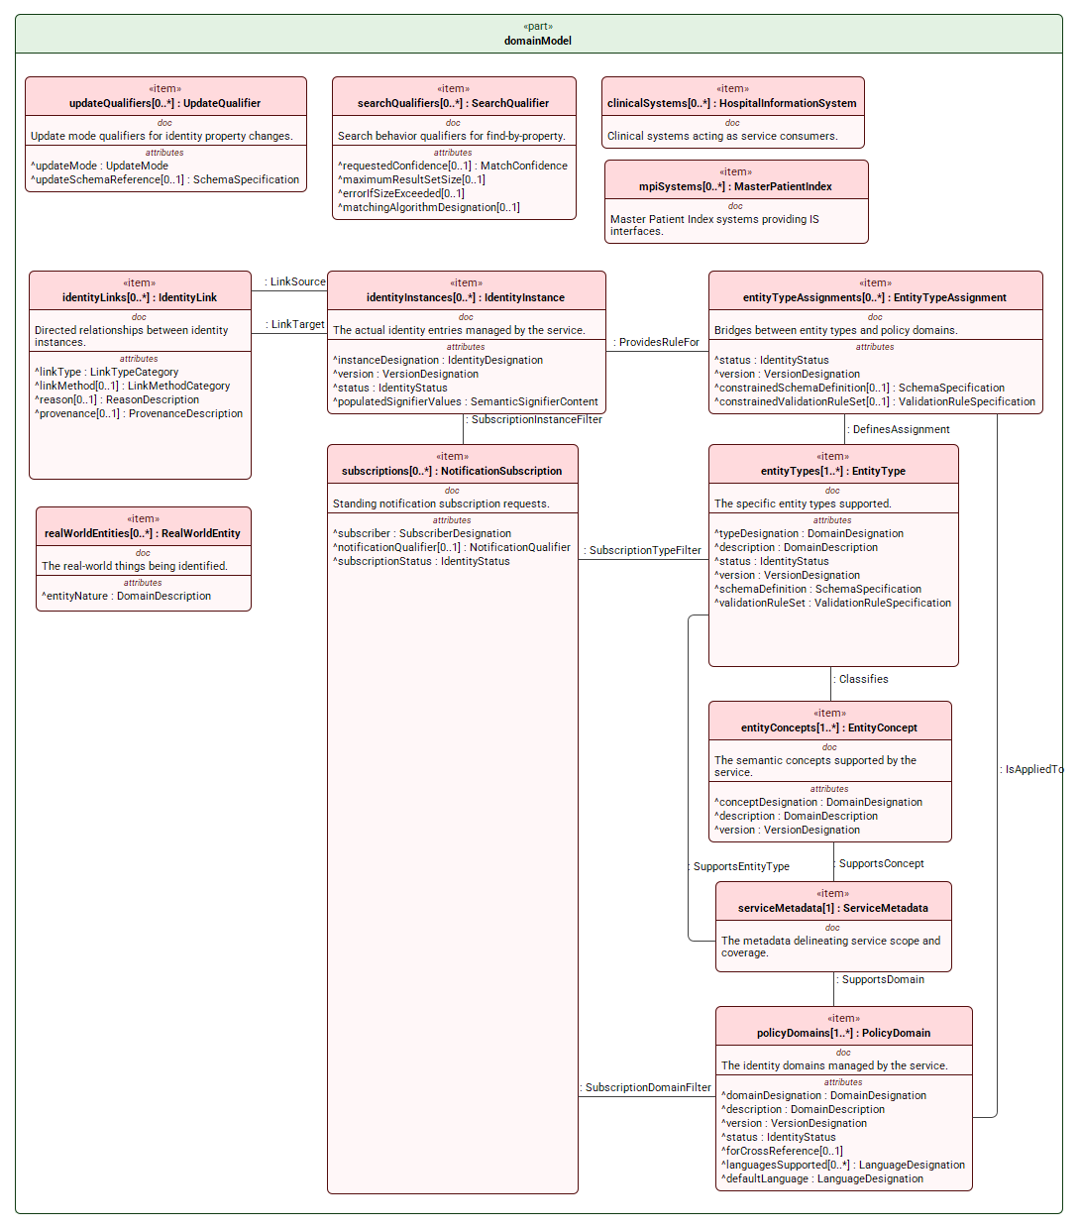
Figure 3 - Domain Ontology Interconnection Diagram

3.5 Domain Model (Conceptual Instance)
The domain model section instantiates all 13 entity types as item usages and all 12 associations as connection usages within a single part definition. This creates a diagrammable conceptual model that can be rendered as an interconnection diagram.

4. CIM: Stakeholder Model
The StakeholderModel package defines all business stakeholders who interact with the Identification Service. Stakeholders are derived from SFM Section 3 (Business Scenarios) primary actors and from roles implied in Section 4 (Detailed Functional Model).

4.1 Primary Actors
Stakeholder | Description | Key Concern | Source
RegistrationClerk | Hospital clerk for admissions | Efficient search, create, update, link, merge | ST-212
ClinicalUser | Healthcare professional (nurse, physician) | Quick/accurate identity lookup | ST-213
LaboratoryClerk | Lab staff processing orders | Reliable identifier resolution including merged IDs | ST-046
IdentityResolutionClerk | Specialized staff for merge/unmerge/link/unlink | Authority to resolve duplicate identities | ST-214
ServiceAdministrator | System administrator | Manage configuration; access all records incl. inactive | ST-215
ExternalSystem | External application (referral, lab, radiology) | Programmatic identity resolution | ST-216

4.2 Secondary Actors
Stakeholder | Description | Source
PolicyDomainOwner | Owner who defines identity policies for a domain | ST-030, ST-180
Patient | Individual who is the subject of identity management | ST-048, ST-002
ReferralSystem | System receiving referral info from external institutions | ST-187
RegionalHealthNetwork | Multi-org network operating cross-domain IS (XIS) | ST-195

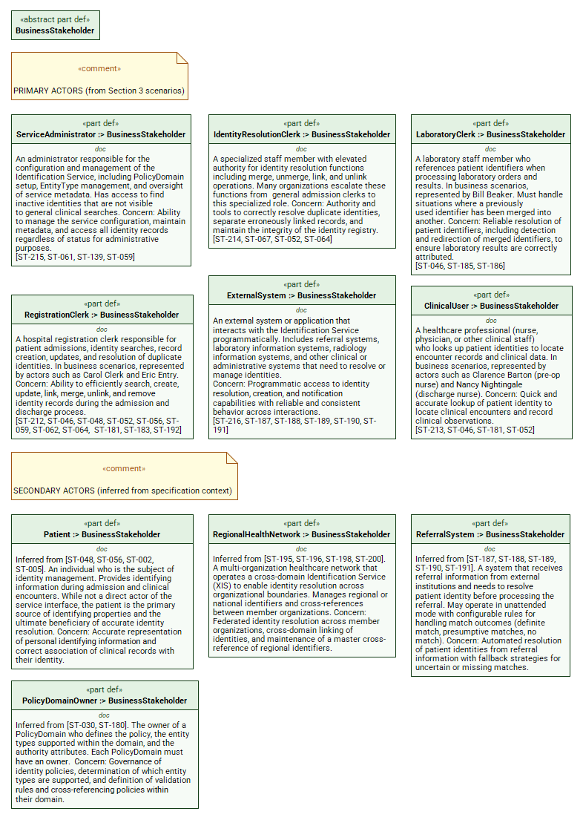
Figure 4 - Stakeholder Diagram

5. CIM: Business Capabilities (Use Cases)
The BusinessCapabilities package models all service capabilities as use case usages, organized into a top-level service capability with two normative capability groups (Identity Management and Query) plus non-normative business scenarios from SFM Section 3.

5.1 Identity Management Capabilities (Section 4.3)
Nine normative operations for creating, modifying, and removing identity data:
Use Case | Description | Source
registerIdentity | Create identity with consumer-supplied unique identifier | ST-082
createIdentity | Create identity with service-generated identifier | ST-088
updateIdentityProperties | Update identifying property values with update qualifier modes | ST-092
updateIdentityState | Change processing state (ACTIVE/INACTIVE) | ST-097
mergeIdentities | Merge two identities within single PolicyDomain | ST-107
unmergeIdentities | Reverse a previous merge | ST-115
linkIdentities | Establish link between identities (within or across domains) | ST-121
unlinkIdentity | Remove a previously established link | ST-129
removeIdentityInstance | Permanently remove an identity instance | ST-133

5.2 Query Capabilities (Section 4.4)
Six normative operations for retrieving identity information and managing notifications:
Use Case | Description | Source
getAllInformationForIdentity | Retrieve all info for a known identity; redirect if merged | ST-140
findIdentitiesByProperty | Search by partial property values with match quality | ST-146
listLinkedIdentities | List identities linked to a specified identity | ST-150
requestIdentityUpdateNotifications | Subscribe to identity change notifications | ST-155
updateNotificationSubscription | Modify or cancel a notification subscription | ST-160
notifyIdentityUpdates | Publish notifications to matching subscribers | ST-164

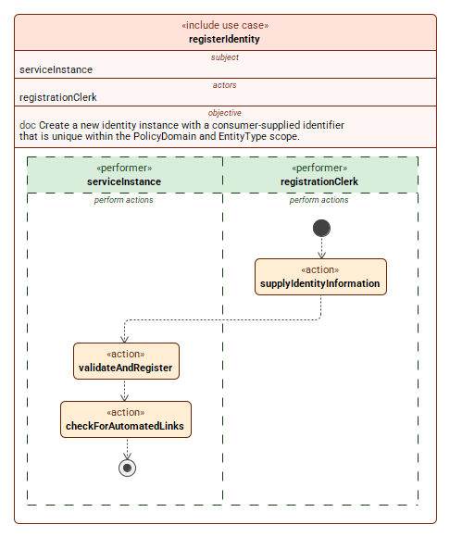
Figure 5 - Use case Diagram (Normative Operations) [[example: the complete set is in the model ad will be inserted subsequently]

5.3 Business Scenarios (Non-Normative)
Fourteen non-normative business scenarios from SFM Section 3 illustrate how the normative operations are composed in realistic clinical workflows. These scenarios are not requirements for conformance (per ST-202) but serve as explanatory examples.

5.3.1 Single-Domain Scenarios
Scenario | Description | Composes Operations | Source
createNewPatient | Carol searches, not found, registers new identity | findByProperty, registerIdentity | ST-048
linkOrMergeEntities | Nancy finds duplicates, links or merges per policy | findByProperty, linkIdentities/mergeIdentities | ST-052
updateDemographics | Carol searches, retrieves, updates address | findByProperty, getAllInfo, updateProperties | ST-056
inactivateEntity | Discharge nurse inactivates patient | updateIdentityState | ST-059
activateEntity | Re-admit and reactivate patient | updateIdentityState | ST-062
unlinkEntity | Discover and remove erroneous link | findByProperty, listLinked, unlinkIdentity | ST-064
lookupSingleEntry | Search returns single definite match | findByProperty | ST-181
lookupMultipleEntries | Search returns multiple candidates | findByProperty | ST-183
mergedEntriesFound | Retrieve merged identity, get redirect | getAllInfo | ST-185
unattendedEncounter | Referral system auto-resolves identity | findByProperty, createIdentity | ST-187
removeEntity | Administrator removes identity | removeIdentityInstance | ST-192

5.3.2 Multi-Domain Scenarios
Scenario | Description | Source
lookupAcrossRegionalNetwork | Search across all member organizations via XIS | ST-196
lookupAtSpecificOrganization | Directed search at specific member organization | ST-198
linkEntitiesAcrossRegions | Register local identity and link to regional master | ST-200

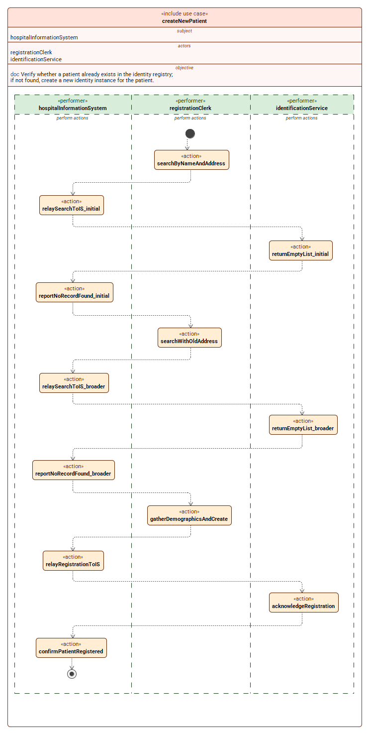
Figure 6 - Scenario Use Case Diagram
[example: the complete set is in the model ad will be inserted subsequently]
)

6. CIM: Business Rules
The BusinessRules package contains 42 constraint definitions derived from the IS SFM Section 4 normative statements and related policy declarations. Rules are organized into functional categories.

6.x Identity Uniqueness & Scope Rules
Rule | Description | Formalization
IdentityUniquenessWithinDomain | Identity identifier must be unique within PolicyDomain + EntityType | Formalized
SingleDomainInteraction | Individual interactions operate within one PolicyDomain | Documentary
PolicyDomainOwnershipRequired | Each PolicyDomain must have an owner | Documentary

6.x Entity Type & Semantic Signifier Rules
Rule | Description | Formalization
UniformInterfaceBehavior | Interface behavior is invariant across EntityTypes | Documentary
EntityTypeSpecializationRequired | Semantic signifier must be specialized per entity type | Documentary
EntityTypeClassifiesOneConcept | Each EntityType classifies exactly one EntityConcept | Formalized
AssignmentConstrainsEntityType | Assignment may only further constrain EntityType rules | Documentary

6.x Merge Rules
Rule | Description | Formalization
MergeWithinSingleDomainOnly | Merge restricted to single PolicyDomain | Formalized
MergeSameEntityConceptRequired | Merge restricted to same EntityConcept | Formalized
MergeAttributeResolution | Empty target attributes filled from source during merge | Documentary
MergeIndicationRequired | Merge must be indicated (link or correlation set) | Documentary

6.x Link Rules
Rule | Description | Formalization
LinkPreconditions | Both identities must exist; target must be active | Formalized
LinkSemanticsAndTransitivity | Links are transitive by definition | Documentary
CrossEntityTypeLinkingAllowed | Different EntityTypes may be linked | Documentary
CrossDomainLinkTopology | Peer-to-peer or master-domain per policy | Documentary

6.x Query & Notification Rules
Rule | Description | Formalization
MergedIdentityRedirect | Warning + surviving ID on merged lookup | Documentary
GetAllInfoInvariant | Query is read-only | Documentary
TwoTieredMatchThreshold | Definite vs. presumptive match tiers | Documentary
NotificationSubscriptionPattern | Subscription is a pub/sub pattern | Documentary

Additionally, 20 rules cover update operations, state changes, unmerge, unlink, remove, and cross-cutting policy concerns (security delegation, authorization, demographic data guidance, versioning, profile-based constraining, etc.).
[DIAGRAM PLACEHOLDER]
Insert: Business Rules Dependency Diagram
(MagicDraw: Requirement Diagram showing constraint defs grouped by category
with derivation links to functional requirements)

7. CIM: Requirements
The CIM_Requirements package contains 62 INCOSE-compliant requirements organized into three sub-packages: Functional (41), Quality (11), and Compliance (10).

7.1 Functional Requirements
Forty-one functional requirements define what the system must do. They are grouped by operational capability area.

7.1.x Identity Registration & Creation
ID | Requirement
FR-001 | Register identity with supplied identifier
FR-002 | Validate supplied identifier uniqueness
FR-003 | Validate properties against schema
FR-004 | Create identity with generated identifier
FR-005 | Trigger automated implicit linking

7.1.x Identity Update
ID | Requirement
FR-006 | Update identity property values
FR-007 | Apply update qualifier modes (OVERWRITE, VALUED, UNSPECIFIED)
FR-008 | Update identity processing state
FR-009 | Enforce state transition validity
FR-010 | Exclude inactive identities from clinical searches
FR-011 | Allow administrators to find inactive identities

7.1.x Merge & Unmerge
ID | Requirement
FR-012 | Merge two identities within single domain
FR-013 | Restrict merge to same entity concept
FR-014 | Resolve attributes during merge
FR-015 | Record merge indication
FR-016 | Unmerge previously merged identities
FR-017 | Flag unmerged identities for manual review

7.1.x Link & Unlink
ID | Requirement
FR-018 | Link identities within or across domains
FR-019 | Enforce link transitivity
FR-020 | Permit cross-entity-type linking
FR-021 | Unlink previously linked identities

7.1.x Remove
ID | Requirement
FR-022 | Remove identity instance
FR-023 | Prevent removal of linked identities
FR-024 | Discourage identifier reuse after removal

7.1.x Query Operations
ID | Requirement
FR-025 | Retrieve all information for known identity
FR-026 | Redirect to surviving identity on merged lookup
FR-027 | Find identities by property
FR-028 | Return match quality with search results
FR-029 | List linked identities

7.1.x Notification
ID | Requirement
FR-030 | Subscribe to identity update notifications
FR-031 | Update or cancel notification subscription
FR-032 | Publish identity update notifications

7.1.x Cross-Cutting
ID | Requirement
FR-033 | Support multiple entity types
FR-034 | Associate domain-specific identifiers in XIS
FR-035 | Provide signifier discoverability
FR-036 | Enforce uniform interface behavior
FR-037 | Scope interactions to single policy domain
FR-038 | Report operation exceptions
FR-039 | Retain removed records for audit (placeholder)
FR-040 | Manage service metadata (placeholder)
FR-041 | Support profile-based constraining

[DIAGRAM PLACEHOLDER]
Insert: Functional Requirements Traceability Matrix
(MagicDraw: Requirements Table showing FR-001 to FR-041 with derivation links
to use cases and business rules)

7.2 Quality Requirements
Eleven quality requirements are derived from gap analysis (the IS SFM contains no explicit quality-of-service requirements). No quantified thresholds are specified at CIM level.
ID | Requirement | Quality Attribute
QR-001 | Service availability during published service hours | Availability
QR-002 | Search response timeliness | Performance
QR-003 | Identity retrieval timeliness | Performance
QR-004 | Scalability for identity volume | Scalability
QR-005 | Concurrent access integrity | Reliability
QR-006 | Notification delivery reliability | Reliability
QR-007 | Match algorithm effectiveness (two-tier) | Accuracy
QR-008 | Version consistency | Data Integrity
QR-009 | Language support within policy domains | Usability
QR-010 | Identity uniqueness guarantee | Data Integrity
QR-011 | Read-only query operations | Data Integrity

7.3 Compliance Requirements
ID | Requirement | Regulatory Source
CR-001 | ISO 21090 data type compliance | ISO 21090:2011
CR-002 | Authentication precondition on all operations | Org security policy (ST-171)
CR-003 | Authorization enforcement for operations | Org authorization policy (ST-067)
CR-004 | Restrict identity resolution privileges | Org role-based access (ST-067)
CR-005 | Restrict removal privileges | Org access control (ST-139)
CR-006 | Audit trail for removed records | Org data retention (ST-194)
CR-007 | Policy domain ownership enforcement | Org governance (ST-030)
CR-008 | Conformance through profiles | HL7 conformance framework
CR-009 | Normative section compliance | HL7 IS SFM Section 4
CR-010 | Entity type assignment constraints | HL7 IS SFM meta-model (ST-074)

8. CIM: Traceability
The CIM_Traceability package contains 77 #derivation connection statements linking requirements to their originating use cases and business rules. It also includes diagnostic flags for completeness auditing.
Traceability Metric | Value
Total #derivation connections | 77
Use case coverage | 15/15 normative use cases linked (100%)
Rule coverage | 22/42 rules linked directly (55%)
Orphan requirements | 5 (FR-040, CR-001, CR-007, CR-008, CR-009) - all justified
Unjustified capabilities | 0 normative, 14 non-normative (by design)
Unrefined rules | 20 (11 exception-list rules + 9 guidance/meta)

[DIAGRAM PLACEHOLDER]
Insert: CIM Traceability Matrix Diagram
(MagicDraw: Requirement Derivation Diagram showing use cases -> requirements
derivation connections with color-coded links by category)

9. PIM: Data Model
The PIM DataModel package contains platform-independent data type definitions derived from CIM BusinessDomain entities. It adds technical identifiers (String-typed IDs), typed attributes (resolving CIM abstract attribute defs to String/Boolean/Integer), and Request/Response pairs for all 15 operations.

9.1 Domain Entity Types
Fourteen domain entity item defs mirror CIM BusinessDomain entities with added technical identifiers:
PIM Type | CIM Origin | Added at PIM | Key Attributes
PolicyDomain | BusinessDomain::PolicyDomain | policyDomainId : String | domainDesignation, description, version, status, forCrossReference, languagesSupported, defaultLanguage
EntityConcept | BusinessDomain::EntityConcept | entityConceptId : String | conceptDesignation, description, version
EntityType | BusinessDomain::EntityType | entityTypeId : String | typeDesignation, description, status, version, schemaDefinition, validationRuleSet, ref classifiedConcept
IdentityInstance | BusinessDomain::IdentityInstance | identityInstanceId : String | instanceDesignation, version, status, populatedSignifierValues, ref governingAssignment
IdentityLink | BusinessDomain::IdentityLink | identityLinkId : String | linkType, linkMethod, reason, provenance, ref sourceInstance, ref targetInstance
ServiceFault | (new at PIM) | faultCode : String | faultMessage, faultCategory (VALIDATION/AUTHORIZATION/NOT_FOUND/BUSINESS_RULE_VIOLATION/INTERNAL)

9.2 Request/Response Pairs
Thirty Request/Response item defs (15 pairs) provide typed payloads for each operation:
Operation | Request Type | Response Type | Key Request Fields
RegisterIdentity | RegisterIdentityRequest | RegisterIdentityResponse | suppliedIdentifier, policyDomainId, entityTypeId, populatedSignifierValues
CreateIdentity | CreateIdentityRequest | CreateIdentityResponse | policyDomainId, entityTypeId, populatedSignifierValues
UpdateIdentityProperties | UpdateIdentityPropertiesRequest | UpdateIdentityPropertiesResponse | identityInstanceId, updatedSignifierValues, updateMode
MergeIdentities | MergeIdentitiesRequest | MergeIdentitiesResponse | sourceIdentityId, targetIdentityId, policyDomainId
LinkIdentities | LinkIdentitiesRequest | LinkIdentitiesResponse | sourceIdentityId, targetIdentityId (cross-domain fields)
FindIdentitiesByProperty | FindIdentitiesByPropertyRequest | FindIdentitiesByPropertyResponse | searchSignifierValues, requestedConfidence, maximumResultSetSize
... | (9 more pairs) | ... | ...

[DIAGRAM PLACEHOLDER]
Insert: PIM Data Model Class Diagram
(MagicDraw: Block Definition Diagram showing all PIM item defs organized
into Domain Entities, Enumerations, and Request/Response sections)

10. PIM: Service Contracts
The ServiceContracts package defines the logical service boundaries. Per SFM Section 2.3.1, two interfaces are defined:

10.1 Port Definitions
Port | Operations | Direction Pattern
IdentificationManagementPort | 9 mutation operations + fault | out request / in response per operation
QueryPort | 6 query/notification operations + fault | out request / in response per operation

10.2 Interface Definitions
Interface | End: requester | End: provider | Flows
IdentificationManagementAPI | ~IdentificationManagementPort | IdentificationManagementPort | 19 flows (9 request + 9 response + 1 fault)
QueryAPI | ~QueryPort | QueryPort | 13 flows (6 request + 6 response + 1 fault)

Each flow is a typed ref flow with explicit "from requester.X to provider.X" direction for requests and "from provider.Y to requester.Y" for responses, using fully qualified PIM_IS::DataModel types.
[DIAGRAM PLACEHOLDER]
Insert: Service Contract Interface Diagram
(MagicDraw: Interface Definition Diagram showing IdentificationManagementAPI and QueryAPI
with port types, conjugation (~), and flow definitions)

11. PIM: Operations
The Operations package contains 15 action definitions, one for each normative CIM use case. Each operation has typed in/out parameters, documented preconditions, and documented postconditions.
Operation | Interface | Satisfies | Key Preconditions | Key Postconditions
RegisterIdentity | Management | FR-001..005 | ID not exists, schema valid, auth | New instance ACTIVE, implicit linking evaluated
CreateIdentity | Management | FR-003..005 | Domain/type recognized, schema valid | New instance with generated ID, ACTIVE
UpdateIdentityProperties | Management | FR-006, FR-007 | Instance exists, schema valid | Properties updated per mode, version incremented
UpdateIdentityState | Management | FR-008..011 | Valid state transition | State changed, other info unchanged
MergeIdentities | Management | FR-012..015 | Same domain, same concept, valid states | Source deprecated, target enriched
UnmergeIdentities | Management | FR-016, FR-017 | Previously merged | Source reinstated, flagged for review
LinkIdentities | Management | FR-018..020 | Both exist, target active | Link created, transitivity applies
UnlinkIdentity | Management | FR-021 | Currently linked | Link removed
RemoveIdentityInstance | Management | FR-022..024 | Exists, not linked, privileged | No longer discoverable, audit retained
GetAllInformation | Query | FR-025, FR-026 | ID recognized | Read-only, redirect if merged
FindIdentitiesByProperty | Query | FR-027, FR-028 | Valid search params | Results with match quality tiers
ListLinkedIdentities | Query | FR-029 | ID exists | All linked IDs returned, transitive
RequestIdentityUpdateNotifications | Query | FR-030 | Valid criteria | Subscription ACTIVE
UpdateNotificationSubscription | Query | FR-031 | Subscription exists | Updated or cancelled
NotifyIdentityUpdates | Query | FR-032 | Change detected, subscriptions match | Notifications delivered

[DIAGRAM PLACEHOLDER]
Insert: Operations Activity Diagram
(MagicDraw: Activity Diagram showing all 15 action defs with their
in/out parameters grouped by Management vs Query interface)

12. PIM: Behavioral Flows
Six behavioral flow action defs model multi-step workflow orchestrations derived from CIM business scenarios that compose multiple normative PIM operations. Only workflows with genuine multi-operation composition are modeled; single-operation scenarios are not given flows.

12.x CreateNewPatientFlow
Source: ST-048
Composition: FindIdentitiesByProperty -> FindIdentitiesByProperty -> RegisterIdentity
Carol searches by name/address (not found), searches with additional info (not found), then registers.

12.x LinkOrMergeEntitiesFlow
Source: ST-052
Composition: FindIdentitiesByProperty -> [decide] -> LinkIdentities | MergeIdentities
Nancy finds duplicates, then based on hospital policy either links or merges them.

12.x UpdateDemographicsFlow
Source: ST-056
Composition: FindIdentitiesByProperty -> GetAllInformation -> UpdateIdentityProperties
Carol searches, retrieves full record, verifies identity, then updates properties.

12.x UnlinkEntityFlow
Source: ST-064
Composition: FindIdentitiesByProperty -> ListLinkedIdentities -> UnlinkIdentity
Carol discovers erroneous link, retrieves alias list, reviews and requests unlink.

12.x UnattendedEncounterFlow
Source: ST-187
Composition: FindIdentitiesByProperty -> [decide] -> CreateIdentity | complete | await
Referral system searches IS: definite match (complete), no match (auto-create or await), presumptive (await).

12.x CrossRegionLinkFlow
Source: ST-200
Composition: FindIdentitiesByProperty -> RegisterIdentity -> LinkIdentities
Eric searches across regions via XIS, registers local identity, then links local to master.
[DIAGRAM PLACEHOLDER]
Insert: Behavioral Flow Activity Diagrams (one per flow)
(MagicDraw: Activity Diagrams for each of the 6 flows showing
action nodes, decision/merge nodes, and succession edges.
Recommended: one diagram per flow for readability.)
Diagrams needed:
- Fig 12.1: CreateNewPatientFlow (sequential, 3 steps)
- Fig 12.2: LinkOrMergeEntitiesFlow (decision branch)
- Fig 12.3: UpdateDemographicsFlow (sequential, 3 steps)
- Fig 12.4: UnlinkEntityFlow (sequential, 3 steps)
- Fig 12.5: UnattendedEncounterFlow (3-way decision)
- Fig 12.6: CrossRegionLinkFlow (sequential, 3 steps)

13. PIM: Composition & State Model

13.1 System Composition
The Composition package defines the logical architecture with a single unified provider exposing both Management and Query endpoints, and three consumer categories derived from SFM Section 3 business scenarios.

13.1.1 Provider
IdentificationServiceProvider exposes two port endpoints:
Port | Type | Operations Exposed
managementEndpoint | IdentificationManagementPort | 9 mutation operations
queryEndpoint | QueryPort | 6 query/notification operations

13.1.2 Consumers
Consumer | Description | CIM Stakeholders | Ports
ClinicalSystemConsumer | HIS operated by clerks/nurses/admins | RegistrationClerk, ClinicalUser, LaboratoryClerk, ServiceAdministrator | ~ManagementPort + ~QueryPort
ReferralSystemConsumer | Unattended referral system | ExternalSystem, ReferralSystem | ~ManagementPort + ~QueryPort
FederatedISConsumer | XIS/RHIO intermediary | RegionalHealthNetwork | ~ManagementPort + ~QueryPort

13.1.3 System-Level Connections
The IdentificationServiceSystem top-level part definition connects all consumers to the provider using typed interface connections (6 total: 2 per consumer).
[DIAGRAM PLACEHOLDER]
Insert: System Composition Internal Block Diagram
(MagicDraw: Internal Block Diagram of IdentificationServiceSystem showing
provider with managementEndpoint and queryEndpoint ports,
3 consumers each with conjugated ports,
and 6 interface connections with typed API references)

13.2 Identity Lifecycle State Machine
A state definition models the lifecycle of identity instances with three states and five transitions:
State | Description | Entry Condition
active | Discoverable in clinical searches | After registration/creation or reactivation
inactive | Excluded from clinical searches, visible to admins | After inactivation
deprecated | Merged into surviving identity | After merge (source identity)

Transition | From | To | Trigger
creation | initial | active | RegisterIdentity or CreateIdentity
inactivation | active | inactive | UpdateIdentityState (requestedStatus=INACTIVE)
reactivation | inactive | active | UpdateIdentityState (requestedStatus=ACTIVE)
mergeDeprecation | active | deprecated | MergeIdentities (source identity)
unmergeReinstatement | deprecated | active | UnmergeIdentities (requires manual review)

[DIAGRAM PLACEHOLDER]
Insert: Identity Lifecycle State Machine Diagram
(MagicDraw: State Machine Diagram for IdentityLifecycleState showing
initial -> active, active <-> inactive, active -> deprecated -> active
with transition names and trigger annotations)

14. PIM: Traceability
The PIM_Traceability package contains 71 dependency statements mapping every PIM element back to its CIM antecedent. Traceability covers nine categories:
Category | Count | Direction
PIM Operations -> CIM Use Cases | 15 | realizes
PIM Domain Data Types -> CIM Business Domain | 11 | derives from
PIM-Derived Data Types -> CIM Supporting Concepts | 3 | derives from
PIM Enumerations -> CIM Domain Enumerations | 7 | derives from
PIM Request/Response Types -> CIM Use Case I/O | 30 | derives from
PIM Service Contracts -> CIM Capability Groups | 4 | exposes
PIM Behavioral Flows -> CIM Business Scenarios | 6 | orchestrates
PIM Composition Parts -> CIM Stakeholders | 5 | serves
PIM State Model -> CIM Rules + Domain Concepts | 1 | implements

Completeness self-check: all PIM elements have at least one CIM traceability link. No orphaned elements detected.
[DIAGRAM PLACEHOLDER]
Insert: Cross-Model Traceability Matrix
(MagicDraw: Matrix showing PIM elements on rows, CIM elements on columns,
with relationship types color-coded. Recommended as a table diagram
or exported matrix report from MagicDraw.)

15. Transformation Log

15.1 Verification Results
Check | Status | Notes
CC-01: FR -> use case derivation | PASS | 40/41 linked; FR-040 justified orphan
CC-02: Use case -> requirement coverage | WARNING | 14 non-normative scenarios not linked (by design)
CC-04: PIM operation -> CIM use case | PASS | 15/15 traced
CC-07: Action def parameters | PASS | All have in + out params
CC-08: Interface def flows | PASS | 32 flows in 2 interfaces
CC-10: CR regulatorySource attribute | ERROR | 10 CRs use doc text instead of formal attribute
SC-09: No imports in nested packages | ERROR | CIM_Traceability has import statement
NC-01..05: Naming conventions | PASS | PascalCase types, camelCase attrs, UPPER_SNAKE enums
DC-01..07: Documentation | PASS | All elements have doc annotations in English

15.2 Assumptions
- ASM-001: The IS SFM document is the sole authoritative source.
- ASM-002: Business scenarios (Section 3) are non-normative per ST-202.
- ASM-003: Security and authentication are delegated per ST-171.
- ASM-004: Exception message formats are delegated per ST-169.
- ASM-005: Data types are abstract at PIM level; ISO 21090 is a recommendation.
- ASM-006: Current version is the default per ST-177.
- ASM-007: Matching algorithms are configurable per organizational policy.
- ASM-008: Minimum state model (ACTIVE/INACTIVE) is mandatory.
- ASM-009: Automated merging is not encouraged per ST-128.

15.3 Design Decisions
- DEC-001: CIM abstract attribute defs resolved to typed String attributes at PIM.
- DEC-002: PIM adds technical identifiers not present in CIM.
- DEC-003: PIM adds ServiceFault and FaultCategory for error handling.
- DEC-006: Two service interfaces (Management + Query) per SFM Section 2.3.1.
- DEC-007: Three consumer categories from SFM Section 3 actors.
- DEC-008: State machine includes "deprecated" beyond minimum ACTIVE/INACTIVE.
- DEC-009: Only 6 of 14 scenarios modeled as behavioral flows (multi-step only).

15.4 Open Issues
Issue | Description | Owner
ISSUE-001 | CC-10: 10 CR requirements lack formal regulatorySource attribute | SA3
ISSUE-002 | SC-09: CIM_Traceability contains import statement in nested package | SA3

Appendix A: Model Statistics
Package | File | Lines | Element Types
CIM_IS.BusinessDomain | BusinessDomain.sysml | 582 | 5 enum defs, 14 attribute defs, 13 item defs, 12 connection defs, 1 domain model
CIM_IS.StakeholderModel | StakeholderModel.sysml | 133 | 1 abstract part def, 9 part defs
CIM_IS.BusinessCapabilities | BusinessCapabilities.sysml | ~1400 | 29 use cases (15 normative + 14 scenarios)
CIM_IS.BusinessRules | BusinessRules.sysml | 562 | 42 constraint defs (6 formalized)
CIM_IS.CIM_Requirements.FR | FunctionalRequirements.sysml | 373 | 41 requirement usages
CIM_IS.CIM_Requirements.QR | QualityRequirements.sysml | 159 | 11 requirement usages
CIM_IS.CIM_Requirements.CR | ComplianceRequirements.sysml | 147 | 10 requirement usages
CIM_IS.CIM_Traceability | CIM_Traceability.sysml | 635 | 77 #derivation connections + diagnostics
PIM_IS.DataModel | DataModel.sysml | 585 | 45 item defs, 7 enum defs
PIM_IS.ServiceContracts | ServiceContracts.sysml | 321 | 2 port defs, 2 interface defs, 32 flows
PIM_IS.Operations | Operations.sysml | 460 | 15 action defs
PIM_IS.BehavioralFlows | BehavioralFlows.sysml | 354 | 6 action defs (workflow flows)
PIM_IS.Composition | Composition.sysml | 262 | 5 part defs, 1 state def, 6 interface connections
PIM_IS.PIM_Traceability | PIM_Traceability.sysml | 619 | 71 dependency statements
Combined | IdentificationService_Complete.sysml | 6592 | All of the above in single file

Appendix B: Glossary
Term | Definition
CIM | Computation Independent Model - business-level abstraction without technical detail
PIM | Platform Independent Model - design-level abstraction without platform specifics
SFM | Service Functional Model - HL7 specification document type
IS | Identification Service - the HL7 service being modeled
PolicyDomain | An identity space or sphere of use (organizational, geographical, jurisdictional)
EntityConcept | A semantic category (e.g., Person, Device) classifying EntityTypes
EntityType | A specific entity type with schema and validation rules (semantic signifier)
EntityTypeAssignment | Bridge customizing an EntityType for a specific PolicyDomain
IdentityInstance | An actual identity entry with populated identifying information
IdentityLink | A directed relationship between two IdentityInstances (link or merge)
Semantic Signifier | The information structure (schema) defining identifying properties
RWE | Real-World Entity - the actual thing being identified
XIS | Cross-domain Identification Service (federated across organizations)
MPI/EMPI | Master Patient Index / Enterprise Master Patient Index
HIS | Hospital Information System - clinical system acting as service consumer
RHIO | Regional Health Information Organization

Appendix C: Diagram Placeholder Index
The following diagram placeholders are included in this document. After importing the SysML v2 model into MagicDraw 2026x, create these diagrams and replace the placeholders with the exported images.
# | Diagram | Type | Section
1 | Model Package Hierarchy | Package Diagram | 2
2 | Domain Entity Class Diagram | Block Definition Diagram | 3.3
3 | Domain Ontology Interconnection | Internal Block Diagram | 3.4
4 | Stakeholder Hierarchy | Block Definition Diagram | 4
5 | Normative Use Cases | Use Case Diagram | 5.2
6 | Business Scenarios | Use Case Diagram | 5.3
7 | Business Rules Dependencies | Requirement Diagram | 6
8 | Requirements Traceability Matrix | Requirements Table | 7.1
9 | CIM Traceability Matrix | Derivation Diagram | 8
10 | PIM Data Model Classes | Block Definition Diagram | 9
11 | Service Contract Interfaces | Interface Diagram | 10
12 | Operations Activity Diagram | Activity Diagram | 11
13a-f | Behavioral Flow Diagrams (6) | Activity Diagrams | 12
14 | System Composition | Internal Block Diagram | 13.1
15 | Identity Lifecycle State Machine | State Machine Diagram | 13.2
16 | Cross-Model Traceability Matrix | Matrix / Table | 14

