Component Specification
SysML v2 Model Repository with Standard APIs, Versioning, and MCP Access for AI Agents

Document type: Architecture & Component Specification
Status: Firs Draft for review
Authors: Claude Opus 4.8
Stefano Lotti
Date: 3 June 2026
Scope: Knowledge base of implemented systems and specification patterns for AI agents, including implementation effort assessment

Contents
Contents 2
1. Introduction and Scope 2
1.1 Design Principles 2
1.2 Glossary 2
2. System Context 4
2.1 Logical Context Diagram 4
2.2 Component Inventory 4
3. Component Specifications 5
3.1 C1 — SysML v2 Repository Service 5
Responsibilities 5
Interfaces (representative) 5
Design decisions 5
3.2 C2 — API Gateway & Identity 5
Responsibilities 5
Design decisions 5
3.3 C3 — Model Store 6
Responsibilities 6
Design decisions 6
3.4 C4 — Semantic Index 6
Responsibilities 6
Design decisions 6
3.5 C5 — MCP Server 7
Responsibilities 7
Representative MCP tool surface 7
Design decisions 7
3.6 C6 — Pattern & Validation Service 7
Responsibilities 7
Design decisions 7
3.7 C7 — Governance & Proposal Workflow 8
Responsibilities 8
Design decisions 8
3.8 C8 — Observability & Audit 8
Responsibilities 8
4. Cross-Cutting Concerns 9
4.1 Versioning Model 9
4.2 Structured vs. Semantic Retrieval 9
4.3 Security and Governance Summary 9
5. Implementation Approach with Claude Code and Opus 10
5.1 Division of Labour 10
5.2 Recommended First Increment 10
6. Feasibility and Open Risks 11
6.1 Feasibility by Component 11
6.2 Principal Risks 11
6.3 Conclusion 11
7. Implementation Effort Assessment 12
7.1 Reuse Baseline from the Reference Implementation 12
7.2 Increment 1 — Read-Only Knowledge Base 12
7.3 Increment 2 — Semantic Retrieval, Proposals, Governance 13
7.4 Totals 13
7.5 Estimate Sensitivities 13
Factors that reduce effort 13
Factors that increase effort (principal risks) 13
7.6 Deploying Claude Code and Opus Effectively 14
7.7 Recommendation 14

1. Introduction and Scope
This document specifies the components of a system whose purpose is to host a SysML v2 model repository exposing standard APIs, to manage model versioning natively, and to make the repository accessible to artificial-intelligence agents through the Model Context Protocol (MCP). The end goal is a curated knowledge base of implemented systems and reusable specification patterns that AI agents can query, reason over, and extend under governance.
The specification is organised by component. For each component it states responsibilities, interfaces, key data, dependencies, and the principal design decisions. A final section addresses the role of Claude Code and Claude Opus in implementation, the deployment topology, and the open risks that must be resolved before construction.

1.1 Design Principles
- Standards first. The repository conforms to the OMG SysML v2 Systems Modeling API and Services specification; bespoke behaviour is confined to layers above the standard API.
- Versioning is intrinsic. The native Project–Commit–Branch–Tag model of the standard is the single source of truth for history; no parallel versioning scheme is introduced.
- Agents are clients, not privileged actors. Agent access is mediated by the MCP layer and is subject to the same authorisation and governance as any other client.
- Reproducibility. Every knowledge-base assertion resolves to an immutable coordinate (project, commit, element), so that retrieval is deterministic and citable.
- Separation of structure and semantics. Deterministic structural queries and approximate semantic retrieval are distinct paths that reconcile on stable element identifiers.

1.2 Glossary
Term | Meaning
SysML v2 | Second-generation OMG systems modelling language, defined on the KerML foundation, designed API-first.
API & Services | The OMG specification defining the REST/HTTP interface and resource model for SysML v2 repositories.
Project | Top-level versioned container of model data in the standard API.
Commit | Immutable snapshot of changes referencing its predecessors, forming a history graph.
Branch / Tag | Named mutable / immutable references into the commit graph.
MCP | Model Context Protocol; exposes resources, tools, and prompts to LLM-based agents.
Pattern | A reusable specification fragment modelled as a SysML v2 definition in a curated library.

2. System Context
The system sits between two communities of clients and one body of persisted knowledge. On one side, human modellers and conventional modelling tools interact through the standard SysML v2 API. On the other, AI agents interact through MCP. Both ultimately operate on the same versioned repository.

2.1 Logical Context Diagram
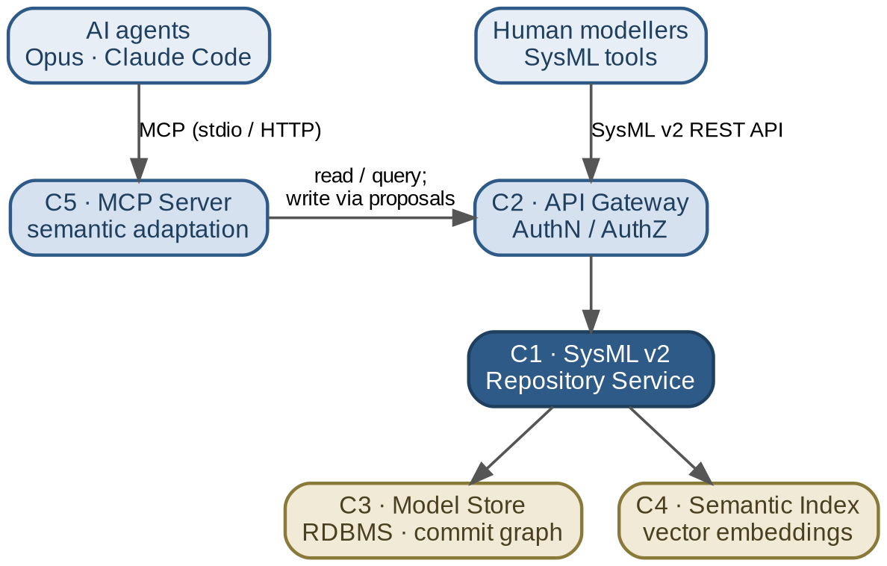
Figure 1 — Logical context: clients, gateway/MCP layer, repository core, and persistence.

2.2 Component Inventory
ID | Component | Primary responsibility
C1 | SysML v2 Repository Service | Standard API, element CRUD, query, commit graph.
C2 | API Gateway & Identity | Authentication, authorisation, rate limiting, audit.
C3 | Model Store | Durable persistence of elements and version history.
C4 | Semantic Index | Embeddings and approximate retrieval over model text.
C5 | MCP Server | Adapts repository capabilities into MCP tools/resources.
C6 | Pattern & Validation Service | Pattern curation, model validation, round-trip checks.
C7 | Governance & Proposal Workflow | Branch-based change proposals, review, promotion.
C8 | Observability & Audit | Logging, metrics, tracing, provenance records.

3. Component Specifications

3.1 C1 — SysML v2 Repository Service

Responsibilities
- Implement the OMG SysML v2 API & Services resource model: Project, Commit, Branch, Tag, Element, Relationship, and Query.
- Maintain the commit graph as an append-only history with predecessor references.
- Serve element retrieval by identifier and structured queries against any commit.
- Accept element changes only as new commits; never mutate prior commits in place.

Interfaces (representative)
Operation | Method & path | Notes
List projects | GET /projects | Catalogue of repositories.
Create project | POST /projects | Initialises empty commit graph.
Get commit | GET /projects/{id}/commits/{cid} | Immutable snapshot.
Create commit | POST /projects/{id}/commits | Carries changed elements + predecessors.
List branches | GET /projects/{id}/branches | Named mutable refs.
Get element | GET /projects/{id}/commits/{cid}/elements/{eid} | Resolves at a specific commit.
Run query | POST /projects/{id}/commits/{cid}/query-results | Structured query execution.

Design decisions
- Adopt the SysML v2 pilot implementation as the baseline rather than building from scratch; extend only where the standard leaves gaps.
- Treat commits as the unit of citation for the knowledge base; the knowledge layer never references mutable branch heads for stored assertions.
Dependencies: C3 (Model Store). Consumed by: C2, C5, C6, C7.

3.2 C2 — API Gateway & Identity

Responsibilities
- Terminate client connections and enforce authentication (OIDC / token-based).
- Apply authorisation policy per project, branch, and operation class (read vs. write vs. promote).
- Enforce rate limits and quotas, with stricter ceilings applied to agent-originated traffic.
- Emit an audit event for every state-changing request.

Design decisions
- Distinguish principals by class (human, tool, agent) so that policy can grant agents read and proposal rights while withholding direct promotion to protected branches.
- Authorisation is centralised here so that C1 remains a faithful implementation of the standard.
Dependencies: identity provider. Consumed by: all external clients.

3.3 C3 — Model Store

Responsibilities
- Persist elements, relationships, and the full commit graph durably and transactionally.
- Support efficient retrieval of an element set as of any commit.
- Guarantee immutability of historical commits.

Design decisions
- A relational database is the baseline, consistent with the pilot implementation; commit-scoped element resolution is the dominant access pattern and must be indexed accordingly.
- Large model libraries are loaded once and referenced by commit, avoiding duplication across patterns that share a baseline.
Dependencies: none (foundational). Consumed by: C1.

3.4 C4 — Semantic Index

Responsibilities
- Maintain vector embeddings of the textual notation and documentation of indexed elements and patterns.
- Answer approximate-similarity queries, returning element/pattern identifiers with scores.
- Track which commit each embedding was derived from, so results can be re-grounded.

Design decisions
- The index never returns content directly; it returns identifiers that the caller resolves through C1. This keeps the structured API authoritative and avoids stale content leaking into answers.
- Re-indexing is triggered by commit events; embeddings are versioned alongside the commit that produced them.
Dependencies: C1 (source content), embedding model. Consumed by: C5, C6.

3.5 C5 — MCP Server

Responsibilities
- Expose repository capabilities to agents as MCP tools, resources, and prompts.
- Translate agent intentions into C1/C4 calls and reconcile structured and semantic results.
- Enforce that any write is expressed as a proposal on a working branch, never a direct promotion.

Representative MCP tool surface
Tool | Kind | Behaviour
list_projects | read | Enumerate available repositories.
get_element | read | Resolve an element at a given commit.
run_structured_query | read | Execute a deterministic query at a commit.
search_patterns | read | Semantic search → identifiers, re-grounded via C1.
diff_commits | read | Summarise changes between two commits.
validate_model_text | read | Parse/validate candidate SysML v2 text (delegates to C6).
propose_change | write* | Create a commit on a working branch for review.
*The propose_change tool produces a proposal only; promotion to a protected branch is performed by C7 under human or policy approval.

Design decisions
- Tools are read-biased by default; the single write tool is constrained to proposal semantics, matching the governance posture in section 1.1.
- Every tool result includes the commit coordinate it was computed against, so an agent can cite its sources.
- Resources expose curated pattern libraries as browsable, read-only context; prompts encode house conventions for authoring SysML v2 text.
Dependencies: C1, C4, C6, C7. Consumed by: AI agents.

3.6 C6 — Pattern & Validation Service

Responsibilities
- Curate the catalogue of specification patterns, modelled as SysML v2 definitions in dedicated, tagged libraries.
- Parse and validate candidate model text against the SysML v2 grammar and project conventions before it is committed.
- Perform round-trip checks: textual notation → API representation → textual notation, flagging divergence.

Design decisions
- A pattern is a parametric definition with documented intent, parameters, and applicability; usages instantiate it. This uses native language mechanisms rather than an external pattern format.
- Validation is a precondition for any proposal reaching review, preventing malformed content from entering the history.
Dependencies: C1, C4. Consumed by: C5, C7.

3.7 C7 — Governance & Proposal Workflow

Responsibilities
- Manage the lifecycle of a change: proposal on a working branch, review, approval or rejection, promotion to a protected branch.
- Require validation success (C6) before a proposal is eligible for review.
- Record the reviewer, decision, and rationale as provenance.

Design decisions
- Protected branches accept changes only through promotion, never through direct agent commits; this is the principal safeguard for agent-originated writes.
- Promotion policy is configurable per project: human approval, automated policy, or both.
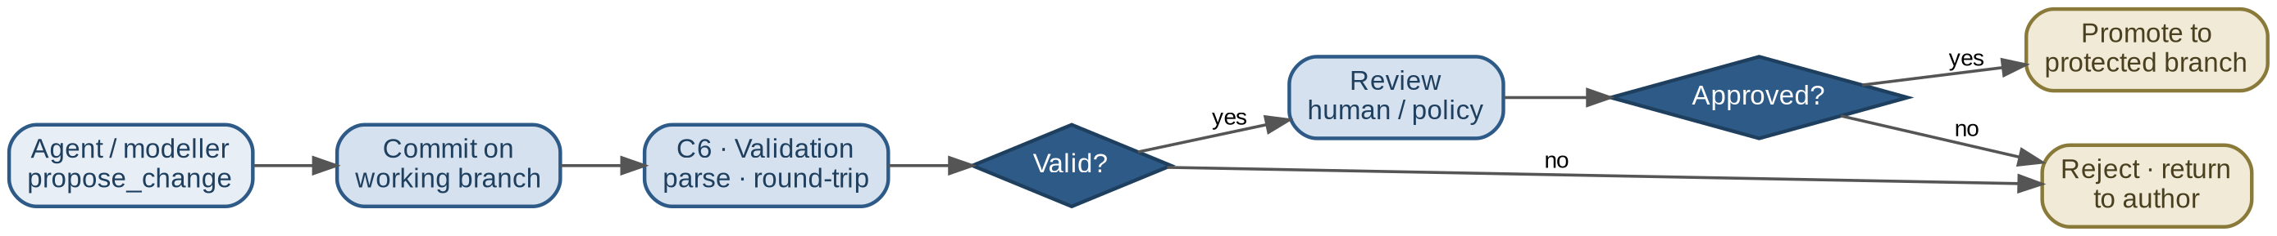
Figure 2 — Change lifecycle: proposal on a working branch, validation, review, and promotion.
Dependencies: C1, C6, C8. Consumed by: C2, C5.

3.8 C8 — Observability & Audit

Responsibilities
- Collect logs, metrics, and traces across all components.
- Maintain an immutable audit trail of state changes and agent actions, including the tool invoked and the commit produced.
- Provide provenance linking each knowledge-base answer to its source commits and the principal that created them.
Dependencies: all components emit to it. Consumed by: operators, auditors.

4. Cross-Cutting Concerns

4.1 Versioning Model
Versioning relies entirely on the standard's commit graph. Working changes occur on branches; stable references are tags. The knowledge base stores assertions against commits, never against mutable branch heads, so that a retrieved pattern is exactly the artefact that existed when the assertion was made.

4.2 Structured vs. Semantic Retrieval
Aspect | Structured (C1) | Semantic (C4)
Query nature | Exact, deterministic | Approximate, similarity-based
Returns | Authoritative content | Identifiers + scores
Grounding | Native | Re-resolved via C1
Use | “Element X with property P” | “Patterns resembling this need”
The two paths reconcile on element identifiers, ensuring that approximate retrieval is always grounded in authoritative, version-pinned content.

4.3 Security and Governance Summary
- Agents may read freely and propose changes; they may not promote to protected branches.
- Validation precedes review; review precedes promotion.
- All agent actions are audited with full provenance.
- Sensitive data is never placed in identifiers, query strings, or tool arguments that are logged.

5. Implementation Approach with Claude Code and Opus
The two tools play complementary roles, matching their respective strengths to the nature of the work.

5.1 Division of Labour
Concern | Tool | Rationale
MCP server scaffolding & API clients | Claude Code | Integration-heavy glue code, tests, iterative build.
Repository deployment & wiring | Claude Code | Filesystem/shell workflow suits infrastructure setup.
Integration test harness | Claude Code | Exercises C1/C5 against the pilot service.
SysML v2 text authoring & critique | Claude Opus | Strong at generating and validating textual notation.
Pattern reasoning & curation | Claude Opus | Reasoning over model structure and intent.
Consuming agent over the knowledge base | Claude Opus | End consumer issuing structured and semantic queries.

5.2 Recommended First Increment
- Stand up the SysML v2 pilot service backed by the Model Store (C1, C3).
- Build a read-only MCP server (C5) exposing element retrieval, structured query, and version-aware navigation.
- Curate a small set of pattern models in tagged libraries (C6).
- Have Opus consume the MCP server to answer questions over the curated patterns.
- Defer write paths, semantic retrieval (C4), and governance (C7) to a second increment once the read chain is validated end to end.
This sequence validates the integration chain before investment in the harder semantic and governance work.

6. Feasibility and Open Risks

6.1 Feasibility by Component
The feasibility ratings below are informed by a review of the OMG Systems-Modeling reference implementation, whose coverage of the lower layers materially reduces the build effort (see Section 7).
Component | Feasibility | Note
C1 Repository | High | ~90% provided by the SysML-v2-API-Services pilot; deploy and configure rather than build.
C2 Gateway | High | Standard identity and policy patterns; built fresh.
C3 Store | High | Provided: PostgreSQL with native commit/branch/tag model.
C4 Semantic Index | Medium | Custom; quality of retrieval is the variable.
C5 MCP Server | High | MCP is purpose-built for this adaptation; the core new artefact.
C6 Pattern/Validation | Medium-High | Pilot parser aids validation; pattern modelling and curation need design.
C7 Governance | Medium | Branch/commit primitives provided; workflow and policy are the effort.
C8 Observability | High | Conventional tooling, assembled fresh.

6.2 Principal Risks
- Specification maturity. SysML v2 and its API are recent; pilot stability and library coverage must be verified against requirements before committing.
- Agent write governance. Allowing proposals raises misuse risk; the proposal-and-promotion gate (C7) is the mitigation and must be enforced without exception.
- Validation round-trip reliability. Generated text must parse, validate, and round-trip faithfully; divergence undermines trust in stored patterns.
- Retrieval grounding. Semantic results must satisfy structural constraints, not merely textual similarity; reconciliation on identifiers is necessary but may not be sufficient without ranking refinement.
- Pattern semantics. Defining a pattern rigorously enough to be reusable, yet flexible enough to apply broadly, is the least standardised and highest-judgement task.

6.3 Conclusion
The system is feasible. Risk concentrates not in the repository or MCP layers, which rest on existing standards and tooling, but in the knowledge-base semantics: defining patterns precisely and making retrieval genuinely useful to agents. A read-only first increment is the prudent way to confirm the integration chain before committing to the harder semantic and governance work.

7. Implementation Effort Assessment
This section estimates the build effort, taking the OMG Systems-Modeling reference implementation as the starting point and assuming one experienced backend engineer working with Claude Code support. Effort is expressed in engineer-weeks. A companion role is assigned to Claude Opus for SysML v2 pattern authoring and as the consuming agent.

7.1 Reuse Baseline from the Reference Implementation
A review of the Systems-Modeling GitHub organisation shows that the lower layers of the architecture already exist as a mature, actively maintained pilot. The principal consequence is that this is not a project to build a SysML v2 repository, but to build an MCP and knowledge layer on top of an existing one. That shifts the bulk of the work from systems-modeling engineering toward integration, orchestration, and semantic tooling — the areas where Claude Code provides the most leverage.
Component | Reference coverage | Implication
C1 Repository | ~90% exists (SysML-v2-API-Services, Java/Play, actively maintained) | Deploy and configure, not build.
C3 Store | Provided: PostgreSQL with commit/branch/tag model | Deploy via Docker; tune indexes.
C1 client access | Provided: official Java and Python API clients | No hand-written client needed.
C2 Gateway | Not provided | Build (standard work).
C4 Semantic Index | Not provided | Build (custom).
C5 MCP Server | Not provided | Build (core new artefact).
C6 Pattern/Validation | Partial: pilot parser; no pattern curation | Build and curate.
C7 Governance | Primitives only (branch/commit) | Build workflow on top.
C8 Observability | Not provided | Assemble from standard tooling.
One caveat shapes the estimate: the repository stack is Scala-sbt, the Play framework, and Java 11. Claude Code is highly effective for deployment, configuration, and client integration against this stack, but provides less leverage if the repository internals must be modified. The estimate therefore assumes C1 is treated as a black box behind its standard API and is not forked.

7.2 Increment 1 — Read-Only Knowledge Base
The first increment delivers a demonstrable, read-only knowledge base: the repository deployed, a curated pattern set loaded, and an MCP server exposing read tools that Opus can consume end to end.
Work item | Unaided | With Claude Code
Deploy C1 + C3 (Docker, PostgreSQL, sbt build, load libraries) | 1.5 | 0.75
Load and curate a small pattern set (C6, partial) | 1.0 | 0.75
MCP server skeleton + read tools (C5) | 3.0 | 1.25
Wire C5 to official API client and C1 | 1.0 | 0.5
Integration tests + thin read-only C2 | 1.5 | 0.75
Opus as consuming agent; end-to-end validation | 1.0 | 0.75
Subtotal (engineer-weeks) | ~9.0 | ~4.75

7.3 Increment 2 — Semantic Retrieval, Proposals, Governance
The second increment adds the custom and judgement-heavy layers: semantic retrieval, proposal-based writes, the governance workflow, full authorisation, and observability, followed by hardening.
Work item | Unaided | With Claude Code
C4 Semantic Index (embeddings, vector store, re-grounding) | 3.0 | 1.5
C6 full validation + round-trip checks | 2.5 | 1.25
C5 propose_change (proposal-only write semantics) | 2.0 | 1.0
C7 Governance workflow (propose → validate → review → promote) | 3.0 | 1.75
C2 full authorisation (principal classes, rate limits) | 1.5 | 0.75
C8 Observability + provenance/audit | 1.5 | 0.75
Hardening, security review, documentation | 2.0 | 1.25
Subtotal (engineer-weeks) | ~15.5 | ~8.25

7.4 Totals
Phase | Unaided | With Claude Code
Increment 1 (demonstrable PoC) | ~9 wk | ~5 wk
Increment 2 (production-leaning) | ~15.5 wk | ~8 wk
Full system | ~24–25 wk | ~13 wk
In calendar terms, the full system is roughly three months for one engineer with Claude Code support, against approximately six unaided. The acceleration is concentrated in the MCP server, gateway, observability, and test scaffolding; it is weakest at repository deployment friction, retrieval-quality iteration, and governance policy design.

7.5 Estimate Sensitivities

Factors that reduce effort
- Using a hosted reference server for early increments nearly eliminates C1/C3 deployment cost for Increment 1.
- Defining “patterns” narrowly at first shrinks C6 curation.

Factors that increase effort (principal risks)
- Scala-sbt / Play friction. Any need to patch C1 internals pulls work into the least AI-leveraged part of the stack; hold a contingency here.
- Retrieval quality (C4). Returning structurally valid patterns rather than merely textually similar ones is open-ended and is the single largest estimate risk.
- Round-trip fidelity (C6). Divergence between textual notation and API representation in edge cases is slow, human-led debugging.
- Specification and version drift. The pilot tracks an evolving standard; pinning a version and resisting mid-build upgrades is essential.

7.6 Deploying Claude Code and Opus Effectively
Leverage is real but uneven. The recommended allocation concentrates AI assistance where it compounds and keeps the human lead on externally-constrained, judgement-heavy work.
Area | Lead | Rationale
C5 MCP server, C2, C8, test harnesses | Claude Code | Pattern-heavy glue and scaffolding; highest acceleration.
Client integration (Java/Python clients) | Claude Code | Existing clients; mechanical wiring.
SysML v2 pattern authoring & critique | Claude Opus | Strong at generating and validating textual notation.
Consuming agent over the knowledge base | Claude Opus | End consumer issuing structured and semantic queries.
C1 deployment debugging, C4 retrieval tuning, C7 policy, round-trip logic | Human engineer | External constraints and judgement limit AI leverage.

7.7 Recommendation
Starting from the reference implementation, the full system is approximately a thirteen engineer-week effort with Claude Code support, with a demonstrable read-only proof of concept reachable in about five weeks. Feasibility is high because the hardest systems-modeling component already exists and is actively maintained; the residual risk lives almost entirely in the new semantic and governance layers. The prudent course is to commit firmly only to Increment 1, then re-estimate Increment 2 once C4 retrieval quality is understood in practice.

