 | Sloud Solutions  [Registered address, City, State, PIN]  Reg. No.: [CIN / Firm registration no. / GSTIN, if applicable]  Email: info@sloudsolutions.com  Web: https://sloudsolutions.com

Ref: SS/PTE/[YYYY]/[NN]
Date: [DD Month YYYY]
To,
[Candidate Name]
[Address, City, State, PIN]
Email: [Email]
Phone: [Phone]
Letter of Part-Time Engagement – [Designation]
Dear [Candidate Name],
Further to our discussions, Sloud Solutions (“the Company”) is pleased to engage you on a part-time basis on the terms set out in this Letter (“this Letter”), which records the complete understanding between us in respect of this engagement.
1. Particulars of the engagement
Designation | [Designation]
Reporting manager | [Reporting Manager Name], [Reporting Manager Designation]
Nature of engagement | Part-time employment
Start date | [Start Date, DD Month YYYY]
Work location | [Work Location]
Fixed days and hours per week | [Fixed Days and Hours Per Week]
Hours | [Guaranteed / Variable, subject to work available]
Compensation | [Compensation Rate and Basis], payable on [Payment Date] of the following month
Notice period | [Notice Period Days] days

2. Nature of the engagement
The Company engages you on a part-time basis as [Designation] with effect from the start date stated in Clause 1, on the fixed days and hours (or, where marked variable, the approximate hours) stated in Clause 1 (“Engagement”).
Where your hours are stated as variable in Clause 1, they will depend on work available with the Company, and the Company does not guarantee any minimum number of hours, assignments or continuity of work during the Engagement.
You are free to take up other employment, business or engagements during the Engagement, provided they do not conflict with your duties to the Company, do not involve a competitor of the Company, and do not affect your availability for the days and hours agreed with the Company.
3. Role and duties
You will perform the duties of your role and any other duties reasonably assigned to you from time to time, and will report to your reporting manager stated in Clause 1, or any other person the Company may designate.
The Company may reasonably vary your duties, schedule or work location within the same city, having regard to business requirements and the days/hours agreed with you.
4. Compensation
You will be paid the rate stated in Clause 1, computed on the actual hours, days or output worked (as applicable), payable on the date stated in Clause 1, subject to deduction of tax at source under the Income Tax Act, 1961, and other statutory deductions as applicable.
Your compensation is pro-rata to the days/hours actually worked and does not include any benefit applicable only to full-time employees, except where you separately meet the eligibility threshold for a statutory benefit (for example, provident fund or state insurance), in which case that benefit will apply strictly as prescribed by the relevant statute.
Reasonable out-of-pocket expenses incurred on Company work, approved in writing in advance, will be reimbursed against valid supporting documents.
5. Confidentiality and data protection
“Confidential Information” means all non-public information of the Company and its clients, prospects and partners, in any form, including business plans, pricing, proposals, client and prospect lists, research, methodologies, technical designs, credentials, marketing plans, and any information marked or reasonably understood to be confidential.
You will keep Confidential Information strictly confidential, use it solely for performing your role, and not disclose, copy, publish or transmit it to any person without the Company's prior written consent.
These obligations apply during the Engagement and continue for three (3) years thereafter, and indefinitely in respect of trade secrets and client data.
You will handle any personal data accessed during the Engagement in accordance with applicable law, including the Digital Personal Data Protection Act, 2023, and only as instructed by the Company. You will not download, retain or transfer such data to personal devices, storage or accounts.
On expiry or earlier termination of the Engagement, you will promptly return or securely delete all Confidential Information, Company documents, devices, files and access credentials, and confirm the same in writing if asked.
6. Intellectual property
All work product created by you during the Engagement in the course of or in connection with your role — including research, reports, data, written content, designs, graphics, code, scripts and presentations (“Work Product”) — will be the sole and exclusive property of the Company.
You hereby assign to the Company, absolutely and for the full term of protection worldwide, all right, title and interest, including copyright, in the Work Product, in accordance with the Copyright Act, 1957, and, to the extent permitted by law, waive any moral rights in the Work Product in favour of the Company.
You will, at the Company's cost, sign any further documents reasonably required to give effect to this assignment.
You confirm that the Work Product will be your original work and will not infringe any third party's rights. Third-party material may be used only with appropriate licence or permission, and the use of generative AI tools must be disclosed to your reporting manager and the output independently verified before use.
7. Conduct and use of Company systems
You will act honestly and professionally, comply with all Company policies communicated to you, and follow all applicable laws.
You will use only Company-approved accounts, systems and channels for Company work, keep credentials confidential, and report any suspected data loss or account compromise immediately.
You will not contact clients or prospects, quote prices, or commit timelines on the Company's behalf without written approval, and will not make any public or social media statement on behalf of or about the Company without prior written approval.
8. Term and termination
The Engagement commences on the start date stated in Clause 1 and continues until terminated by either party by giving the notice stated in Clause 1, or payment in lieu thereof (calculated on your average compensation over the preceding three months).
The Company may terminate the Engagement with immediate effect, without notice, in case of breach of confidentiality or intellectual property obligations, misconduct, misrepresentation, unauthorised use or disclosure of Company or client data, sustained non-performance, prolonged unexplained absence, or conduct prejudicial to the Company's reputation or interests.
On termination, you will immediately hand over all Company property, documents, devices, access cards, credentials and Confidential Information in your possession or control, and your final payment will be processed after completion of hand-over.
Clauses 4, 5, 9 and 10 survive expiry or termination of the Engagement.
9. Non-solicitation
During the Engagement and for a period of twelve (12) months thereafter, you will not directly or indirectly solicit or attempt to solicit, for yourself or any other person, (a) any client or identified prospect of the Company with whom you had dealings during the Engagement, or (b) any employee, intern or contractor of the Company, to terminate or reduce their relationship with the Company. Nothing in this Letter restricts your right to take up employment or engagement of your choice after the Engagement ends.
10. Safe workplace and equal opportunity
The Company is committed to a safe, respectful and inclusive working environment and to equal opportunity irrespective of gender, religion, caste, disability or background. The Company's policy under the Sexual Harassment of Women at Workplace (Prevention, Prohibition and Redressal) Act, 2013 extends to you. Any concern may be raised with [POSH Contact Name] at [POSH Contact Email], and will be addressed in accordance with that policy and applicable law.
11. Governing law and dispute resolution
This Letter is governed by the laws of India. The parties will first attempt to resolve any dispute amicably through discussion. Failing resolution within thirty (30) days, the courts at [Jurisdiction City, State] will have exclusive jurisdiction.
12. General
This Letter records the entire understanding between the parties on this subject and supersedes all prior discussions and correspondence.
Any amendment must be in writing and signed by both parties.
If any provision is held invalid or unenforceable, the remaining provisions continue in full force, and the invalid provision will be read down to the minimum extent necessary.
The Company's failure to enforce any provision at any time will not be a waiver of its rights.
You confirm that the information and documents provided by you during selection are true, and that you are free to accept this Engagement without breaching any obligation to a third party, including any current or previous employer or engager.
Acceptance
If the above is acceptable, please sign and return a scanned copy of this Letter to info@sloudsolutions.com on or before [Acceptance Due Date, DD Month YYYY].
We look forward to working with you.

For Sloud Solutions  Signature:  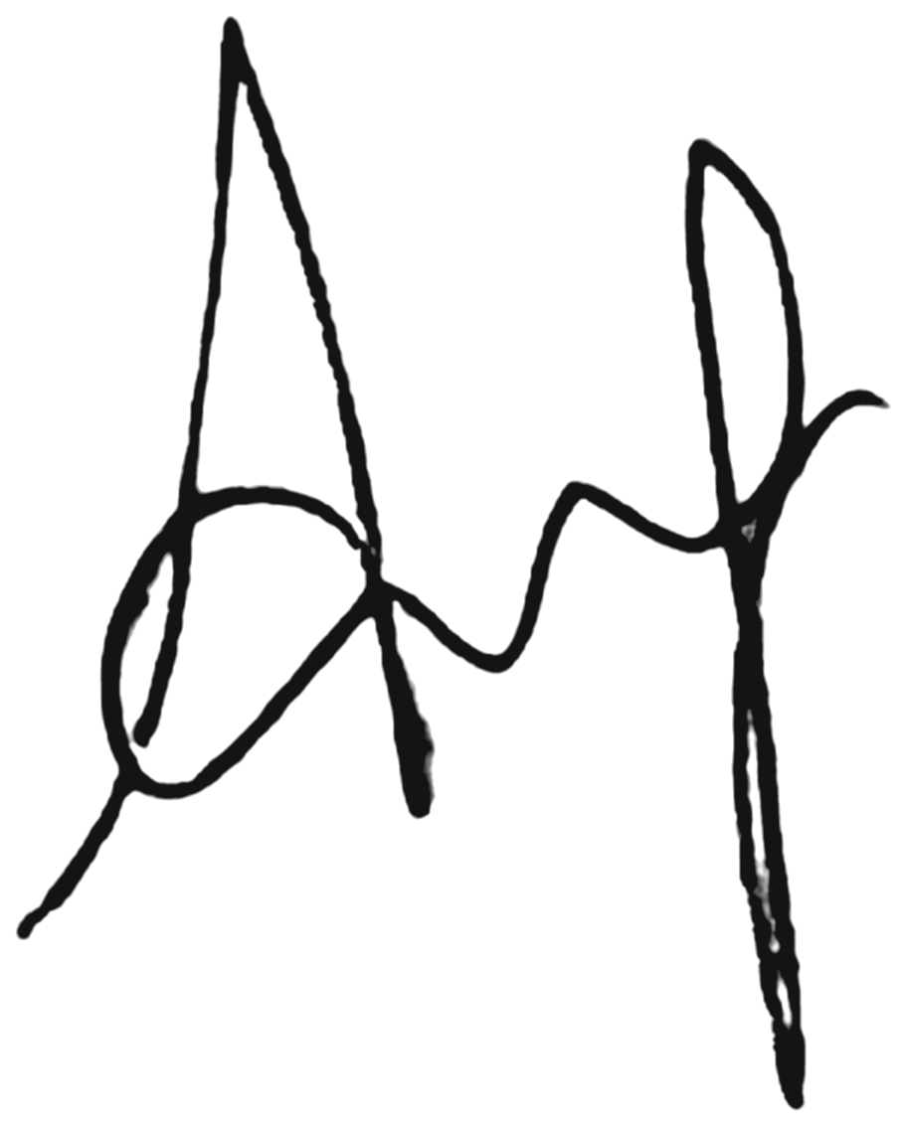  [Signatory Name], [Signatory Designation]  Date: [DD Month YYYY] |  | Accepted  Signature:  ________________________________  [Candidate Name]  Date: ____________________


This document is a template for internal use and does not constitute legal or tax advice. It should be reviewed by a qualified legal professional before issuance.

