* Dataset: 2019 airline delays with weather and airport details in the United States [(Link](https://www.kaggle.com/datasets/threnjen/2019-airline-delays-and-cancellations/data)).
* Is there a relationship between plane age and any of the other features in the dataset?
* Is plane age related to or impacts the occurrence of a delay?
* Is there a relationship between precipitation and the different aged planes that fly in rain?
* Filtered the dataset in the CSV by only including the top five most frequent carriers as well as only looking at instances of the first day of the first month the data collection began.
* In the CSV, columns ‘DEP_TIME_BLK’, ‘SEGMENT_NUMBER’, ‘SNOW’, and ‘SNWD’ were deleted from the CSV. ‘DEP_TIME_BLK’ contained string values representing the ‘DISTANCE_GROUP’ values, which wasn’t need.
* The other columns contained irrelevant statistics like identifying numbers of each plane or different types of precipitation when I only needed the ‘PRCP’ column. After changing the csv, I imported the new CSV file into a pandas data frame in Colab.
* Dropped the 'MONTH’, 'DAY_OF_WEEK', 'DEPARTING_AIRPORT', 'PREVIOUS_AIRPORT' columns since I did not need them for the questions I planned to answer.

**Confusion Matrix:**

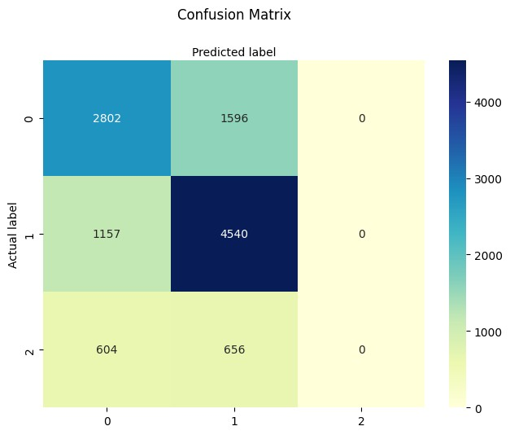

The 0 in the bottom row of this confusion matrix symbolizes that for the old planes, out of the 1,260 old planes, 0 were predicted to be old. For standard planes, out of 5,697 planes, 4,540 were predicted to be standard-aged. Lastly, out of 4,398, 2,802 were predicted to be old for the new planes.

**Classification Report:**

|  |  |  |  |
| --- | --- | --- | --- |
|  | Precision | Recall | F1-score |
| New Plane | 0.61 | 0.64 | 0.63 |
| Standard Plane | 0.67 | 0.80 | 0.73 |
| Old Plane | 0.00 | 0.00 | 0.00 |

The precision, recall, and F1 scores for Old Planes are all zero due to not many planes being old in the data I used. This model is not able to make reliable predictions for these planes due to a lack of sufficient data. For the New Planes the precision is 0.61, the recall is 0.64 and the F1-score is 0.63. For the Standard Planes the precision is 0.67, the recall is 0.80 and the

F1-score is 0.73. This model has the most accuracy in predicting the age of Standard Planes.

**Looking at Different Aged Planes with Precipitation**

# Flights with No Precipitation

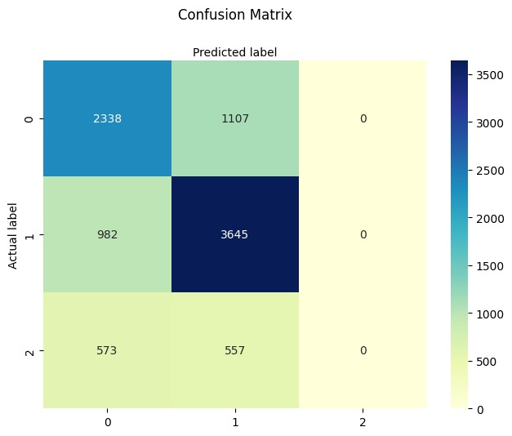

The 0 in the bottom row of this confusion matrix symbolizes that for the old planes, out of the 1,130 old planes, 0 were predicted to be old. For standard planes, out of 4,627 planes, 3,645 were predicted to be standard-aged. Lastly, for the new planes, out of 3,445, 2,338 were predicted to be old.

|  |  |  |  |
| --- | --- | --- | --- |
|  | Precision | Recall | F1-score |
| New Plane | 0.60 | 0.68 | 0.64 |
| Standard Plane | 0.69 | 0.79 | 0.73 |
| Old Plane | 0.00 | 0.00 | 0.00 |

The precision, recall, and F1 scores for Old Planes are all zero due to not many planes being old in the data I used. Similarly to the previous example, this model is not able to make reliable predictions for these planes due to a lack of sufficient data. For the New Planes, the precision is 0.60, the recall is 0.68 and the F1-score is 0.64. For the Standard Planes the precision is 0.69, the recall is 0.79 and the F1-score is 0.73. This model also has the most accuracy in predicting the age of Standard Planes.

# Flights with Precipitation

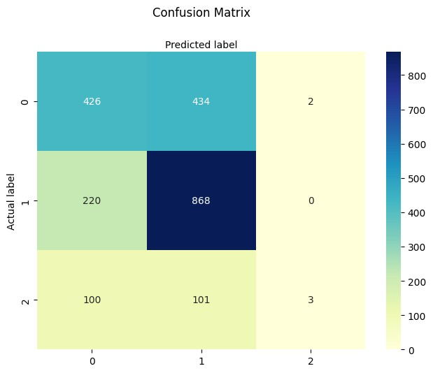

In this confusion matrix for old planes out of the 204 old planes, 3 were predicted to be old. For standard planes, out of 1,088 planes, 868 were predicted to be standard-aged. Lastly, for the new planes, out of 862, 426 were predicted to be old.

|  |  |  |  |
| --- | --- | --- | --- |
|  | Precision | Recall | F1-score |
| New Plane | 0.57 | 0.49 | 0.53 |
| Standard Plane | 0.62 | 0.80 | 0.70 |
| Old Plane | 0.60 | 0.01 | 0.03 |

Similar to the last two models, the precision, recall, and F1 scores for Old Planes are all zero due to only a few planes being old in the dataset. This model is not able to make reliable predictions for these planes due to a lack of sufficient data. For the New Planes the precision is 0.57, the recall is 0.49 and the F1-score is 0.53. For the Standard Planes, the precision is 0.62, the recall is 0.80 and the F1-score is 0.70. This model also has the most accuracy in predicting the age of Standard Planes.

**Looking at Different Aged Planes with Delay**

# No Delay

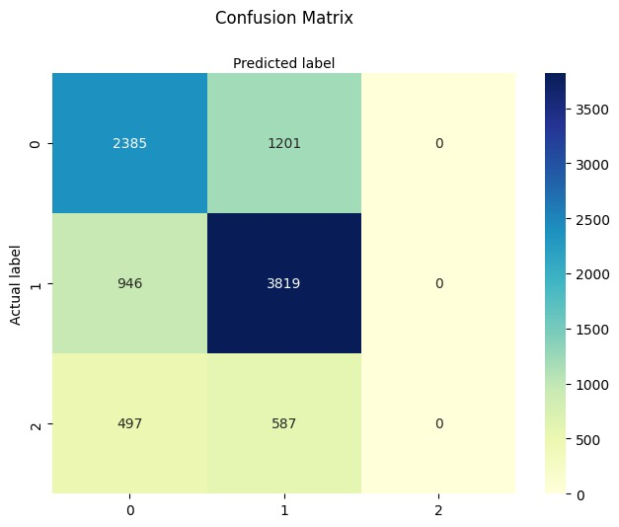

In this confusion matrix for old planes out of the 1,084 old planes, 0 were predicted to be old. For standard planes, out of 4,765 planes, 3,819 were predicted to be standard-aged. Lastly, for the new planes, out of 3,586, 2,385 were predicted to be old.

|  |  |  |  |
| --- | --- | --- | --- |
|  | Precision | Recall | F1-score |
| New Plane | 0.62 | 0.67 | 0.64 |
| Standard Plane | 0.68 | 0.80 | 0.74 |
| Old Plane | 0.00 | 0.00 | 0.00 |

This model also has the precision, recall, and F1 scores for Old Planes as zero due to not much data on old planes in the dataset. For the New Planes the precision is 0.62, the recall is 0.67 and the F1-score is 0.64. For the Standard Planes, the precision is 0.68, the recall is 0.80 and the F1-score is 0.74. This model also has the most accuracy in predicting the age of Standard

Planes, but it is not able to make reliable predictions for Old Planes.

# Delay

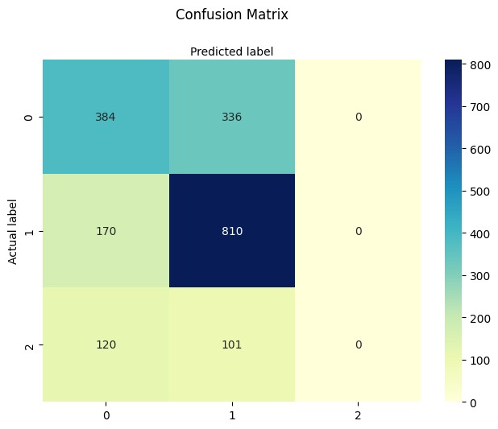

In this confusion matrix for old planes out of the 221 old planes, 0 were predicted to be old. For standard planes, out of 980 planes, 810 were predicted to be standard-aged. Lastly, for the new planes, out of 720, 384 were predicted to be old.

|  |  |  |  |
| --- | --- | --- | --- |
|  | Precision | Recall | F1-score |
| New Plane | 0.57 | 0.53 | 0.55 |
| Standard Plane | 0.65 | 0.83 | 0.73 |
| Old Plane | 0.00 | 0.00 | 0.00 |

Consistent with previous models, this one also has precision, recall, and F1-scores of zero for Old Planes, due to the lack of sufficient data for older planes in the dataset. For New Planes, the model has a precision of 0.57, a recall of 0.53, and an F1-score of 0.55. For Standard Planes, the model has a precision of 0.65, a recall of 0.83, and an F1-score of 0.73. Like all the previous ones, this model also has the highest accuracy in predicting the age of Standard Planes.

## Fairness Analysis

In terms of precision, the New Plane group is relatively moderate suggesting that when a flight is a New Plane there is a moderate chance that is correct. For the Standard Plane there is a higher precision with more accuracy, a larger precision rate. The Old Plane contained a consistently low precision rate implying that the model may struggle to make accurate predictions for this specific group.

In terms of recall, the New Plane group has again a moderate recall rate implying that the model can capture a portion of the instances. The Standard Plane group has an extremely high recall rate showing the model identifies a large portion of the true instances. While again for the Old Plane group there is an exceptionally low rate with the majority of the instances being missed.

In terms of F1-score, the New Plane is again moderate showing there is a balance between precision and recall for that group. In the Standard Plane there is a high score indicating there is also a good balance between precision and recall. While for the Old Plane category there is still a consistent low score showing present challenges between finding balance in precision and recall.

The model performed well with identifying and interpreting the data provided for New and Standard Plane, but for Old Plane there were a lot of present challenges and potential errors that resulted in low precision, recall, and F1 score. This signifies that there may be some limitations present within our existing data.