1. Given the following key values, show what the data structures would look like after insertions

27 53 13 10 138 109 49 174 26 24

(no preprocessing necessary: pk = key)

Linear array of 10 elements using division hashing

and the linear-quotient collision path algorithm

N = 13, 4k+3 prime = 19

LQHashing:

1. ip = pk % N

2. q=pk/N

if (q%N != 0)

offset = q

else

offset = 4k+3 prime

3. While collisions:

ip’ = (ip + offset) % N

4. Set Array[ip]=key

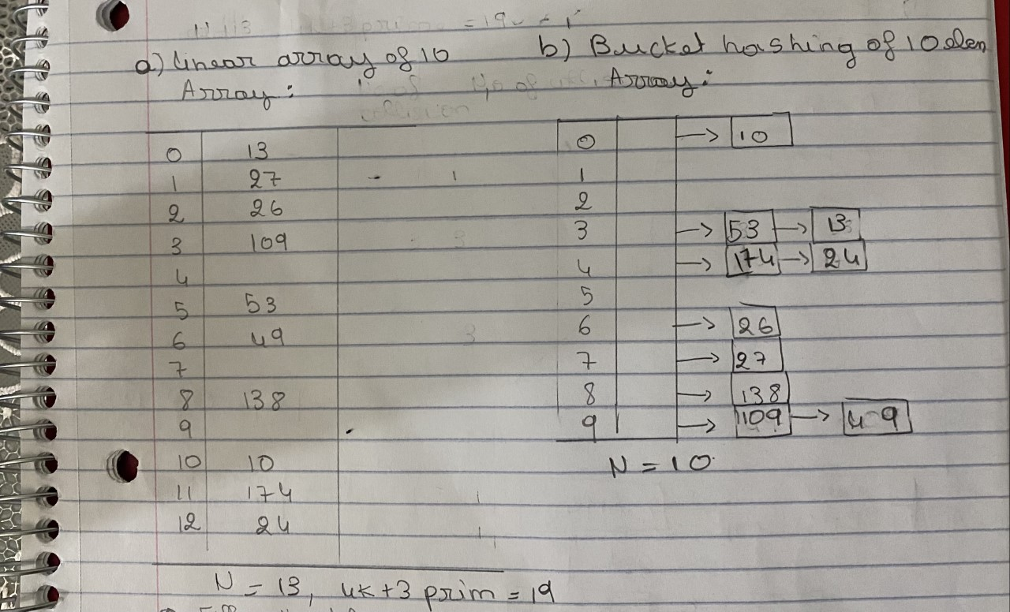

2. Fill in the table based on exercise 1

