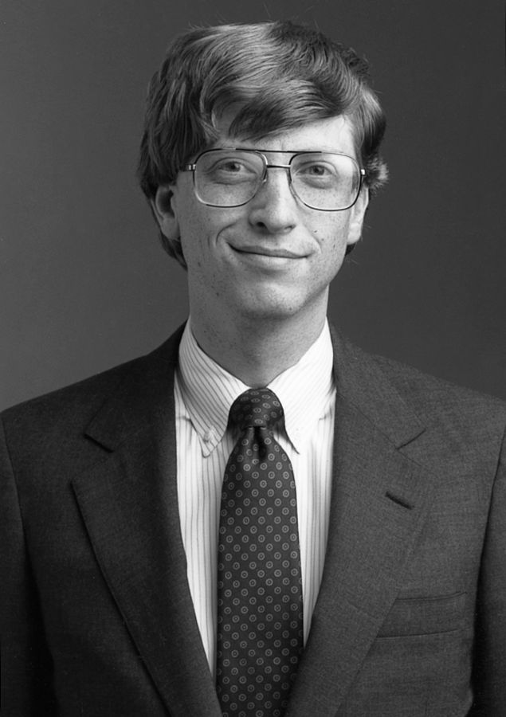**Bill Gates**

As cliché as it may sound, the software engineer that inspired me most is Bill Gates, therefore this report will be about him, his work and his impact on me and the world of computer science.

With an estimated new worth of 95.4 Billion, Bill Gates is reaping the rewards of the legacy he has achieved through creating great software along with his amazing entrepreneurial spirit.

As a lifelong Windows user, the impact of this platform has astounded me.

**Background**

Bill gates, born William Henry Gates III (October 28, 1955), is the main founder and former CEO of the Microsoft Corporation.

He has 3 children and is married to Melinda Gates (born Melinda French).

Bill Gates wrote his first computer program at the age of 13, as written in his autobiography and has always held an unmatched passion for computers and programming.

Gates scored 1590 out of 1600 on his college SAT exam and enrolled at Harvard University in 1973.

**Microsoft**

After 2 years of college, Bill Gates took a leave of absence from Harvard to pursue the microcomputer revolution. Which he, in turn helped accomplish in which home computers made the gradual transition from hobbyists’ “toys” to mainstream usage in every family’s home.

In the year 1975, Bill founded Micro-soft with friend Paul Allen and initially, the company developed and sold BASIC interpreters for the Altair 8800. Micro-soft was a combination of “micro-computer” and “software”. The hyphen was dropped within a year.

Microsoft’s big break, was a trade partnership with IBM in which IBM computers were bundled in with Microsoft operating system, 86-DOS(purchased from Seattle Computer Products).

By 1984, Microsoft was (as quoted from InfoWorld) - “widely recognized as the most influential company in the microcomputer-software industry. Claiming more than a million installed MS-DOS machines, founder and chairman Bill Gates has decided to certify Microsoft's jump on the rest of the industry by dominating applications, operating systems, peripherals and, most recently, book publishing. Some insiders say Microsoft is attempting to be the IBM of the software industry.”

By this point, Bill Gates was already at the forefront of the software industry.

Bill Gates lead from the top with his inhumane work ethic and dedication to his company. He was known to code until he fell asleep at the keyboard, only to wake up sometimes hours later and pick up where he left off, working 16-hour days and staying overnight in the office for days at a time was a frequent occurrence.

Microsoft’s most famous and bestselling software products include: Microsoft Windows OS and Microsoft Office.

**Microsoft Windows OS**

Microsoft Windows was initially a gui operating environment for MS-DOS, while later on being developed as a standalone operating system.

Windows 1.0 was the first of the graphical shells, while Windows 95 was the first operating system.

Windows 1.0 introduced a variety of programs which are still on virtually every Microsoft computer including: Windows Paint, control panel, terminal, clipboard. These concepts are now ingrained in the image of a computer and I can’t imagine an operating system without these functions.

Windows 95 defined an era of operating systems as it came with: start menu, taskbar, Internet Explorer and Windows Explorer.

**Microsoft Office**

Microsoft Office is a set of productivity applications, first announce by Bill Gates in 1988, released as MS Office 1.0 for use with the Operating System Windows 2.0.

This software was compatible with all Microsoft software but not as compatible with other operating systems, leading to Microsoft dominating the operating systems market and having a virtual monopoly.

Initially including, Microsoft Word, Microsoft Excel, and Microsoft PowerPoint, it has since grown in number to include a larger variety of programs in the bundle.  
The latest Microsoft Office release contains all the following applications: Word, Excel, PowerPoint, OneNote, Outlook, Publisher, Access, Skype for Business, Visio Viewer.

With over 18 different versions since release, Office has been a staple in home computing and in the business environment ever since release with versions for Windows OS and Mac.

**After Microsoft**

Bill Gates continued as CEO until the year 2000, where he stepped down to the role of chief software architect, while in 2016 Gates became a part-time employee at Microsoft in order to devote more of his time to charitable endeavours such as the Bill & Melinda Gates Foundation.

Bill now spends his days being a full time philanthropist, donating much of his fortune to charity and causes, including: Alzheimer’s research, flu vaccines, golden rice, water sanitation, fight against Ebola, fight against AIDS and Malaria.

**Personal note**

A ruthless business persona with a true passion for technology, the story of Bill Gates led me to pursuing a career in developing software. Stories of his drive and determination and outright passion for developing various products have often led me to take my own studies more serious and engage more with the subject matter as well as go on a tangent and research into topics that interest me on a personal level. The trait of Bill which I find most inspiring is his thirst for knowledge, always seeking to further himself and learn more to improve as much as he can. He claims that he reads 50 books a year and is always striving to learn additional information. Due to his competitive spirit, he always wanted more and always kept an eye out for the competition.