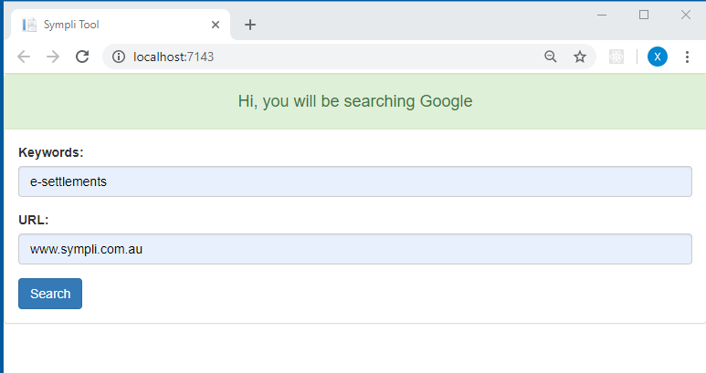

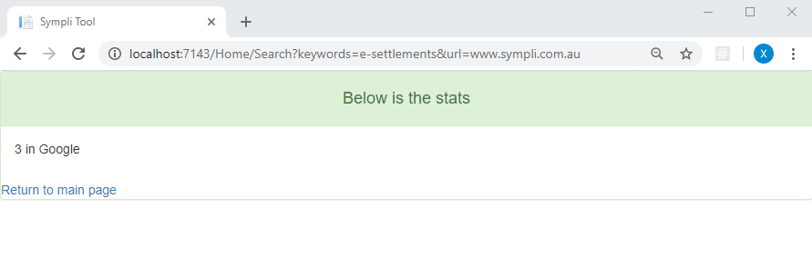

This projects is an ASP.NET Core MVC project. For future extension of other search engines, once they are registered through Dependency injection in startup.cs, the view will be updated accordingly, for example, if Bing service is registered, the heading of the index page will be “Hi, you will be searching Google, Bing”