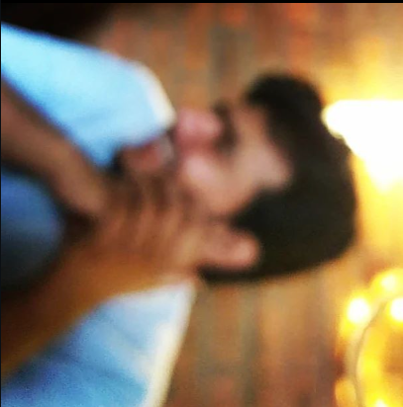

In a world of play pretend,
a world beyond the reaches of "practicality ",
A world which did not punish you,
for being defiantly human,
for allowing yourself to be vulnerable,
in the face of certain heartbreak,

Who would you be?

in a world where you didn't have to be someone to meet someone,
what would you say to them when you met them first?

A world concerned with the worlds within,
a world that made you feel heard,
but hid you when you didn't wish to be seen?

what would you say? where would you be?

If being an adult wasn't just knowing better survival tactics,
what kind of an adult would you be?

I'm sure, you'd be a kid,
a kid with dreams,
a kid who wears their emotions on their sleeves,
a kid who runs behind the curtains to hide,
waiting to be found,
a kid who made friends just like that,
not caring for identities,
a kid who said stupid shit 'cause they felt like it,
a kid who wanted to grow up,
but now wants to go back being a kid,
a person before a battlefield.

