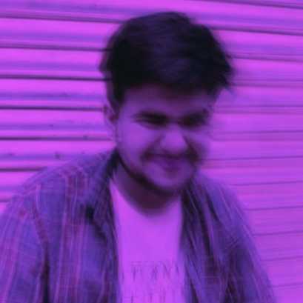
I claim to be a strong man,
but I'm scared of my sadness,
scared of the gaping void that opens up,
as if it's out to swallow this reality,
Veiling my eyes from any light it,
thinks it is an armor and any joy, enemy,

I claim to be a strong man,
but I'm scared of my anger,
scared that it'd,
burn the whole world down,
oblivious to any good it,
indiscriminately incinerates all
that I've held dear,

I claim to be a strong man,
but I'm scared of my madness,
the sheer pandemonic force of atrocious thoughts,
scared if unleashed,
it'd render me unrecognizable,
in ways rationality cannot fathom,

I claim to be a strong man,
But I'm most afraid of my indifference,
of losing what it means to be a man,

maybe, I'm strong because I'm scared,

or, am I scared because,
I claim to be strong?

