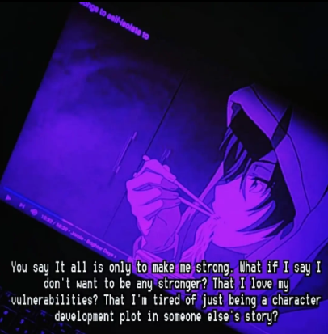
You say that it hapened because I was the only one who could take it,
That I was chosen to face it,
Trust me,
If I had the option, I'd rather erase it,

Because more than just the gift of perception, it is a burden,
I'm not here to be spreading self realised gospels,hell, I feel like a guinea pig of some sadist being which doesn't understand its own creation,
Hamster moving wheels but not really to go anywhere,
Cursed with self-observation ,

You say that it all is only to make me strong, what If I say I don't want to be any stronger?
That I love my vulnerabilities?
That I'm tired of being a character development plot in someone else's story?

Do you realise how strong is this urge to just disappear? To shut my mind, and just go and hide?
But can I really run? When my own thoughts sneak up from behind?

All your methods of rationalisation,
Poems,speeches,texts,calls,letters and apologies,
None really do help,
The world is loud and louder is my head,
And it isn't that of myself I'm getting ahead,
I'm just tired, tired of being left,
Tired of trying, tired of being tired,
Tired of all that has been said,
Tired of nobody actually getting what all truly matters,

I need some self isolation, or maybe, isolation from self.

