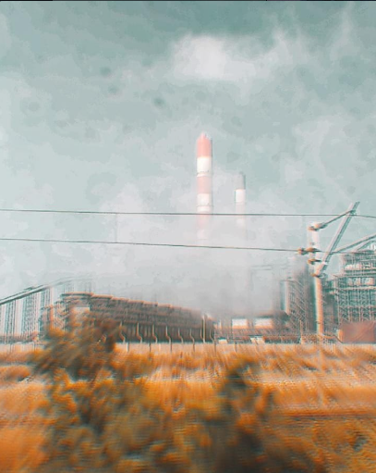

I won't write a word,
No I don't have the strength to,
When the screams went unheard,
What will a pen do?

I won't question, nor will I speak,
Have your ideas intact,
Hold on to your beliefs,
Yes, go on trying to change me,
Change me as you please,
I should just stop resisting,
If it helps you sleep,

"Accept me as I am, let me be me"
While I'm asked to adapt,
"If it's real, you'll try atleast"
Yes I tried, trust me I did,
never even questioned this implicit hypocrisy,
Every question had an answer,
Yours , "personality" , mine "disease",
To sustain is to be a man,
To speak, is to sin,
Insidious is this conditioning,
Conditioned to just give and give,

When your very own problems,
As excuses , are seen,
When you're no more a person,
But a punching bag, it seems,
When everything you do isn't enough,
And you feel your existence,
Is a fallacy,

That's when it all has turned toxic,
Break away, go choose to be free.

