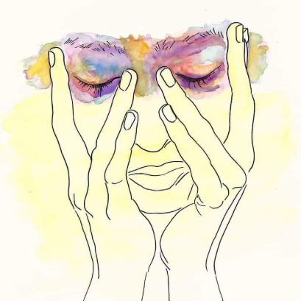

Everyday I wake up,
Put up an expression,
Wear it as make up,
Which makes up,
For my flat thoughts,
I stay,for days,up,
Nights never let me sleep,
Trying to construct emotion,
Avoiding the populace & sun,
See no point to fuel up,
And in rat race run

Can't recognize myself anymore,
My demons had my face burnt,
No more do they bother me,
Looked them into the eye,
As I slayed some,
Only to know
they were trying to protect me,
Twisted defense mechanism,
Toxic symbiotic relationship,
Mind meddling venom,
I see,And I try to feel,
But I only feel,what is extreme,
Hence hard to find motivation,

I don't want to drift away,
Even after my nihilist convictions,
Tearing my layers apart,
I'm a living irony's description,
I don't want to leave,yet,
I'm webbed,into my created fiction,
Struggling to express,faltering diction,
not sick,need no medic, or prescription,
Just motives,to rekindle ambitions,

Everyday,I wake up,
I laceup,to face up,
Social place-hubs,
Misfit mindset masquerading
Multiple makeups,
Everyday,I wake up.

