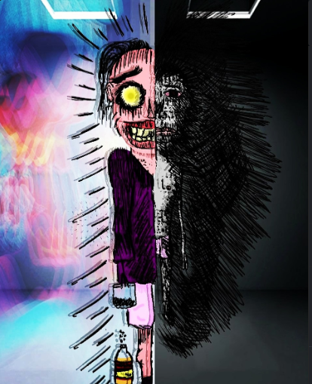
8.40 p.m
Great day at work.The code ran well,No run time errors,and the lines perfectly complied.The target was pretty important,both,for me and the company. I really hope this assignment makes us go global.Boss was pretty happy and I expect a raise.There haven't been any extreme episodes recently,I guess a bottle would be good to celebrate. "A quarter please". Hmm,days like these aren't often.
"Two more"

9 p.m
Pretty cold,let's just take a share cab.It's already dark.
*cab stops,there's a woman in there*
Wow,She's pretty. "Are you new here?"
.
.
•"Hi,I'm James"
.
."Care for a drink at my apartment?"
.
Pretty awesome,a day to celebrate, made a new friend,got the drinks,all that is needed is some good food.
Month end,pretty hard on cash,MC'D looks like a good option.
.
9.13 pm
"What would you like?"
.
.30 minutes gone,still haven't got my package. I'm hungry,and she's on the verge of having her vibe killed
.
."Do you even know how perfect of a day have I been having?"
"You've ruined it,ruined it all"
*grabs the cashier by the collar*
"Get my package done.Get it now,You're making me mad,You're ruining my date,I rarely get lucky,I rarely make friends, you deserve being punished! I'll sue the place,you lethargic sloth."
.
.*the woman leaves*
.
9.23 p.m
She left? Why? I was so exited.I didn't even hurt her or anyone.This simply isn't right. Why do they do it to me.I work well, I earn.The Boss appreciates my work.Why do they keep abandoning me? .
.12 a.m .*the apartment *
I'm alone,again.Why am I this twisted? Why can't I be consistent? They punish me even when it's not my fault. If I tell them, I'd lose the job.
Nevermind,I got three quarters. *Passes out*

