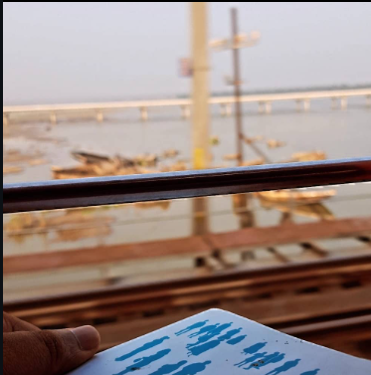

The road to healing is long,
it is long, messy, full of potholes, with no government to complain to. If you do complain, the world will come after you, telling you to stop whining, it will come after you telling you crib too much, and maybe, they're right.

You've just tapped into your expressional self which says the things you can't, you've found a medium to channel what you feel, and trust me that is much, much better than bottling it all up, only to later mistreat those around you.

They're right, so are you, and none have it all figured out.

