Prominent TEXMACS equations features

Unsurpassed typesetting :
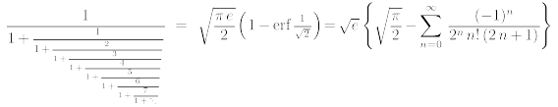

Many fonts available :

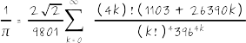

Automatic baseline alignement 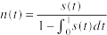 in writer.

Colored equations

