

NAME: Vikhyat Shajee Nambiar
REG NO: 23BCB7137
COURSE CODE: CSE4039
COURSE: Advanced Text and Social Media Analytics
SLOT: L39-L40
FACULTY NAME: Gundimeda Venugopal
LAB 8
TEXT CLUSTERING USING K MEANS

Question:
Perform text document clustering with the K-means algorithm in Scikit-Learn. (A) Cluster news headlines and evaluate whether the discovered groups correspond to the sarcasm labels supplied in the dataset. (B) Cluster national anthems to examine recurring lexical themes such as nationhood, freedom, land, religion, and patriotic imagery.
Dataset and implementation details:
• Sarcasm dataset: 26,709 English news headlines, each with an is_sarcastic label used only for post-clustering evaluation.
• National anthems dataset: 190 anthem texts with country and continent metadata.
• Text representation: TF-IDF vectors with English stop words removed and unigram/bigram features.
• Clustering: KMeans with random_state=42 and multiple initialisations for reproducibility.
• Evaluation: cluster sizes, top centroid terms, cosine silhouette score, and an external label comparison for the sarcasm dataset.
Method:
K-means is an unsupervised method. It does not learn the sarcasm label; it partitions TF-IDF vectors according to lexical similarity. Therefore, the sarcasm label is used only after clustering to measure how closely lexical clusters agree with the provided annotation. This distinction is important because sarcasm often depends on context and pragmatic contrast rather than words alone.

A) Sarcasm headline clustering
Code:
import json
from sklearn.feature_extraction.text import TfidfVectorizer
from sklearn.cluster import KMeans
from sklearn.metrics import silhouette_score
records = json.load(open("sarcasm.json", encoding="utf-8"))
headlines = [row["headline"] for row in records]
labels = [row["is_sarcastic"] for row in records]
vectorizer = TfidfVectorizer(stop_words="english", ngram_range=(1, 2),
min_df=3, max_features=5000)
X = vectorizer.fit_transform(headlines)
kmeans = KMeans(n_clusters=2, n_init=20, random_state=42)
clusters = kmeans.fit_predict(X)
silhouette = silhouette_score(X[:2500], clusters[:2500], metric="cosine")
Working of the code:
• Headlines are converted to 5,000 TF-IDF features. Common English stop words are removed; bigrams retain phrases such as 'donald trump'.
• K=2 is selected because the supplied dataset has two labels: sarcastic and not sarcastic.
• The two cluster labels are compared with the dataset labels through a contingency table; K-means label numbers themselves have no semantic meaning.
Output:
Cluster | Headlines | Not sarcastic | Sarcastic | Top centroid terms
0 | 23,602 | 12,932 | 10,670 | man, area, just, woman, report, year
1 | 3,107 | 2,053 | 1,054 | trump, new, donald, new york, introduces

The cosine silhouette score is 0.0038, which indicates very weak separation between the two lexical clusters. Mapping each cluster to its majority dataset label yields 56.1% agreement, and both clusters are majority non-sarcastic. The result demonstrates that headline vocabulary alone is not a reliable unsupervised detector of sarcasm.
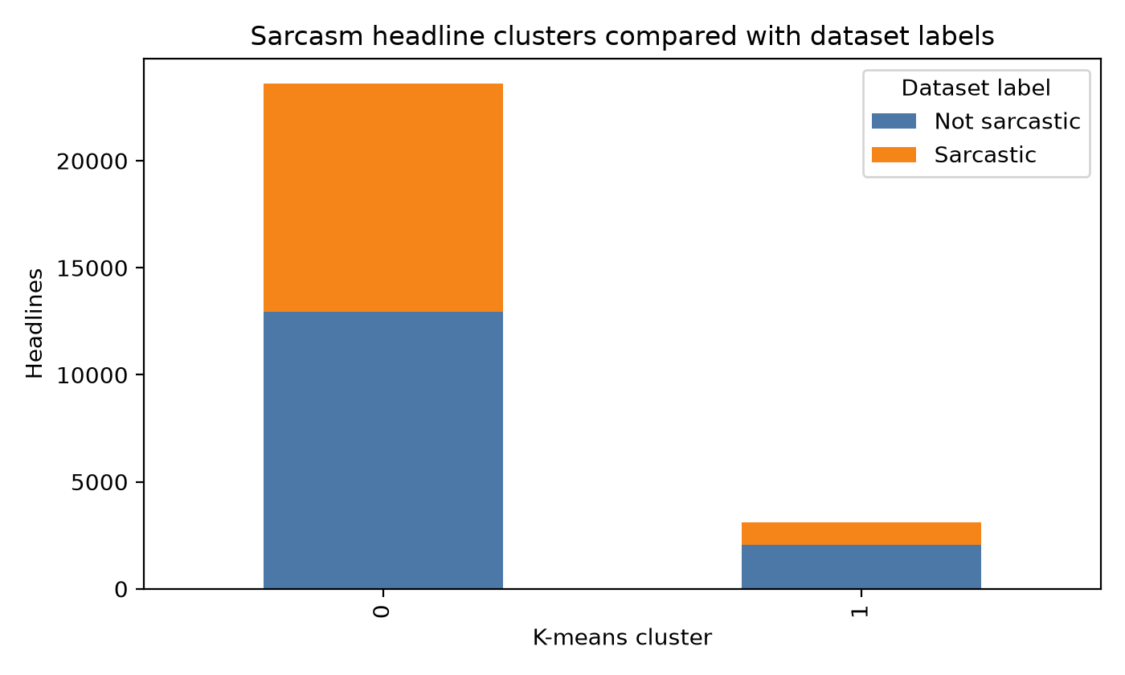
Figure 1. K-means clusters compared with the supplied sarcasm labels.
Interpretation:
The smaller cluster is strongly associated with political vocabulary, especially terms around Donald Trump, rather than a distinct sarcastic class. This is a meaningful diagnostic result: K-means has grouped headlines by subject matter, while sarcasm requires contextual and semantic signals that are not captured well by bag-of-words TF-IDF features.

B) National anthem clustering
Code:
import pandas as pd
from sklearn.decomposition import TruncatedSVD
anthems = pd.read_csv("anthems.csv").dropna(subset=["Anthem"])
vectorizer = TfidfVectorizer(stop_words="english", ngram_range=(1, 2),
min_df=2, max_features=3000)
X = vectorizer.fit_transform(anthems["Anthem"])
kmeans = KMeans(n_clusters=5, n_init=50, random_state=42)
anthems["cluster"] = kmeans.fit_predict(X)
svd = TruncatedSVD(n_components=2, random_state=42)
coordinates = svd.fit_transform(X)
Working of the code:
• The anthem texts are vectorised with 1,830 retained TF-IDF features after preprocessing.
• K=5 creates an interpretable set of broad lexical groups without imposing country or continent labels on the model.
• The highest-weight centroid terms provide a short label for each cluster, while TruncatedSVD projects the sparse document matrix to two dimensions for visual inspection.
Output:
Cluster | Anthems | Top terms | Example countries
0 | 24 | thy, thee, land, god, love | Azerbaijan, Cyprus, France, Greece
1 | 34 | country, flag, people, fatherland, glory | Albania, Armenia, Germany, Malta
2 | 35 | homeland, thou, hail, beloved, sea | Bulgaria, Croatia, Denmark, Hungary
3 | 39 | land, free, home, god, bless | Austria, Belarus, Bosnia and Herzegovina
4 | 58 | freedom, people, africa, nation, liberty | Belgium, Georgia, Ireland, Italy

The five-cluster cosine silhouette score is 0.0127. The low score shows considerable lexical overlap, which is expected because national anthems share ceremonial language. Nevertheless, centroid terms expose recurring themes of homeland, faith, freedom, people, and national symbols.
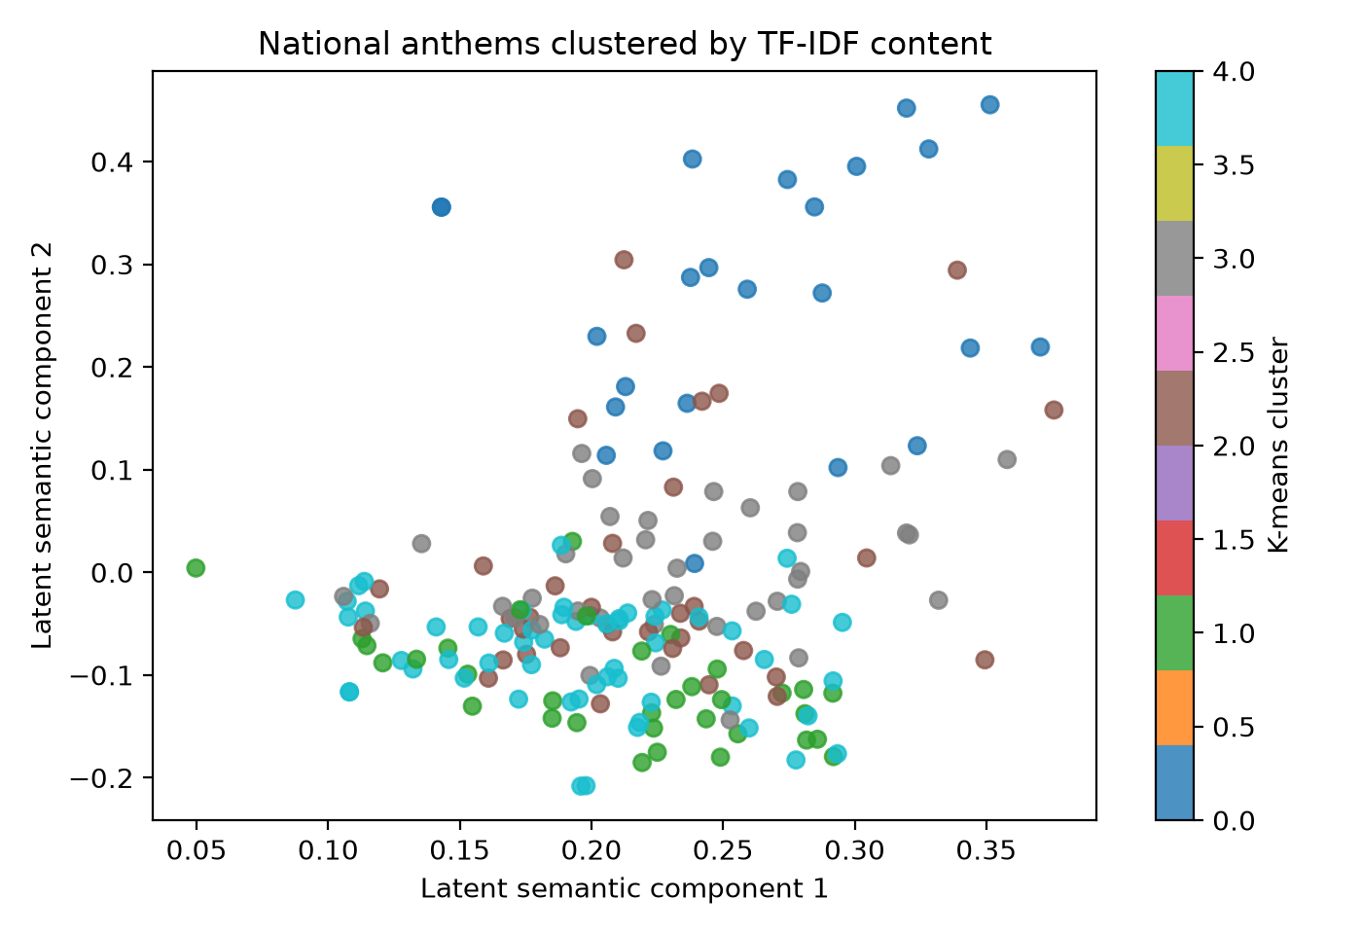
Figure 2. National anthems in a two-dimensional latent-semantic projection, coloured by K-means cluster.

Conclusion:
K-means with TF-IDF provides a transparent first approach to grouping documents by lexical content. For sarcasm headlines, the clusters mainly reflect topic vocabulary and do not align strongly with sarcasm labels, so a supervised contextual model would be more appropriate for detection. For national anthems, the clusters expose broad recurring vocabulary about land, nationhood, freedom, faith, and patriotic identity, although the low silhouette score confirms that these themes overlap across countries.

