Testing: Input for WhatThe comes primarily from querying the host system. Shown are tests run on both Windows and Linux operating systems.

Windows opening screen:

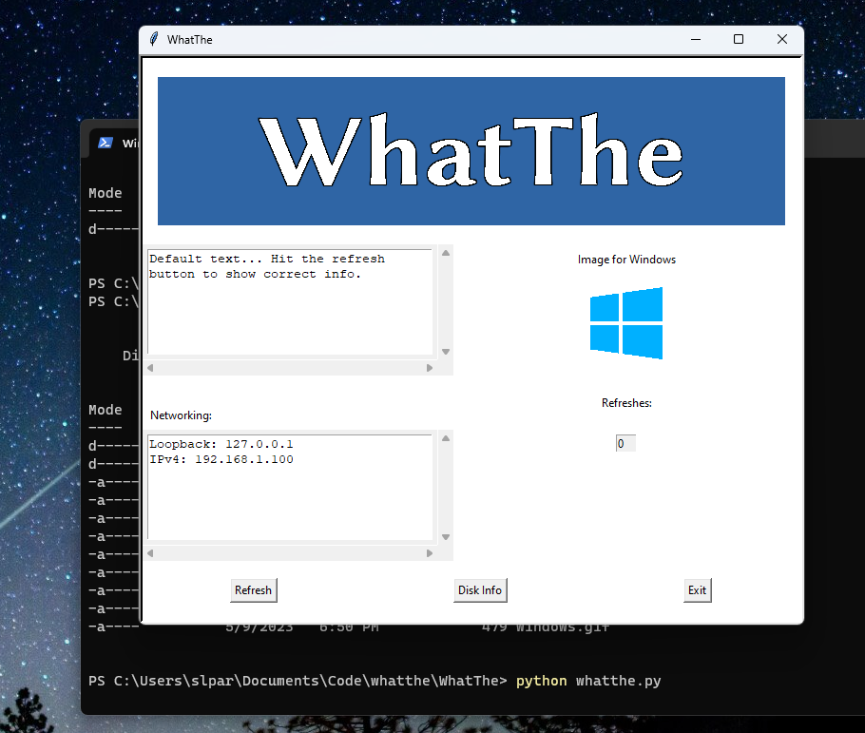

Windows after refreshing once:

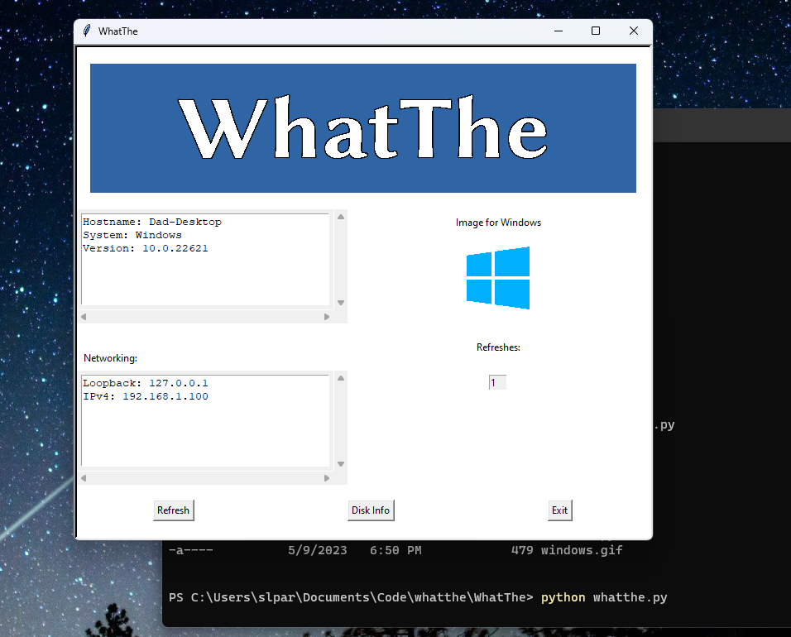

Windows showing disk usage for a secondary disk:

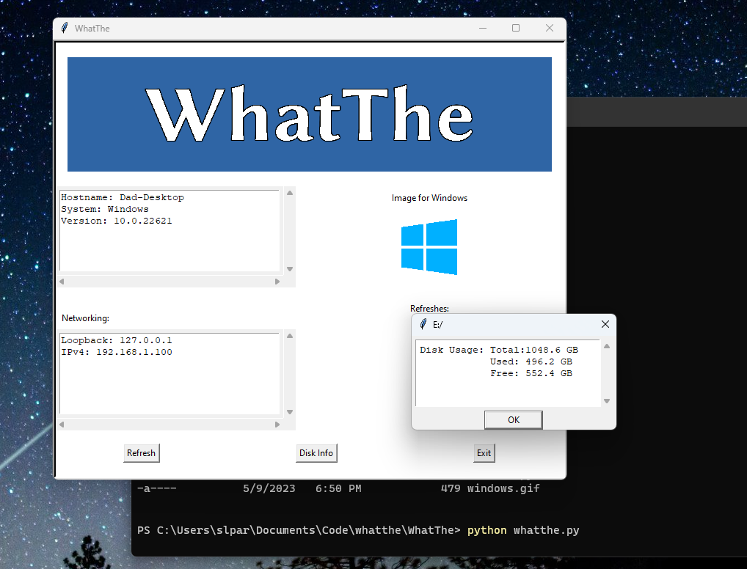

Linux showing opening screen:

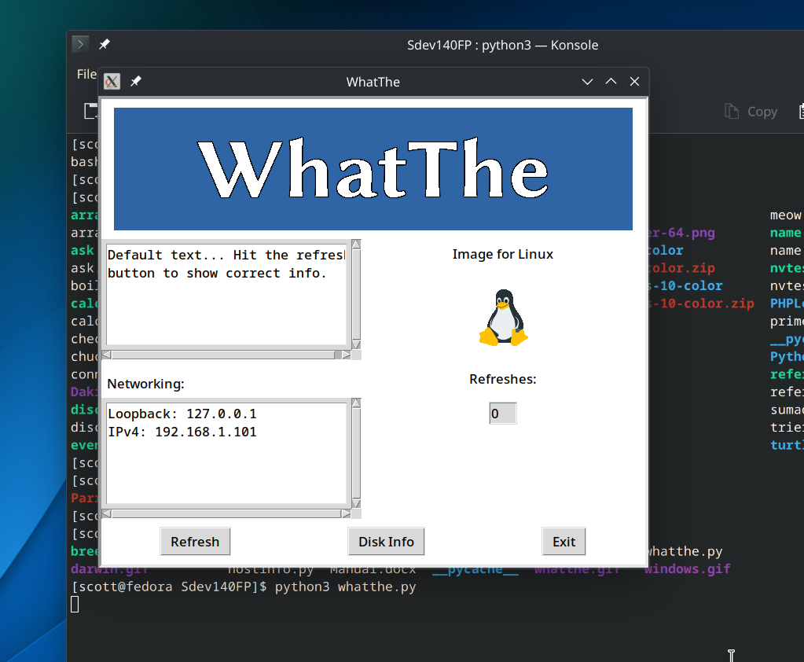

Linux after using refresh button:

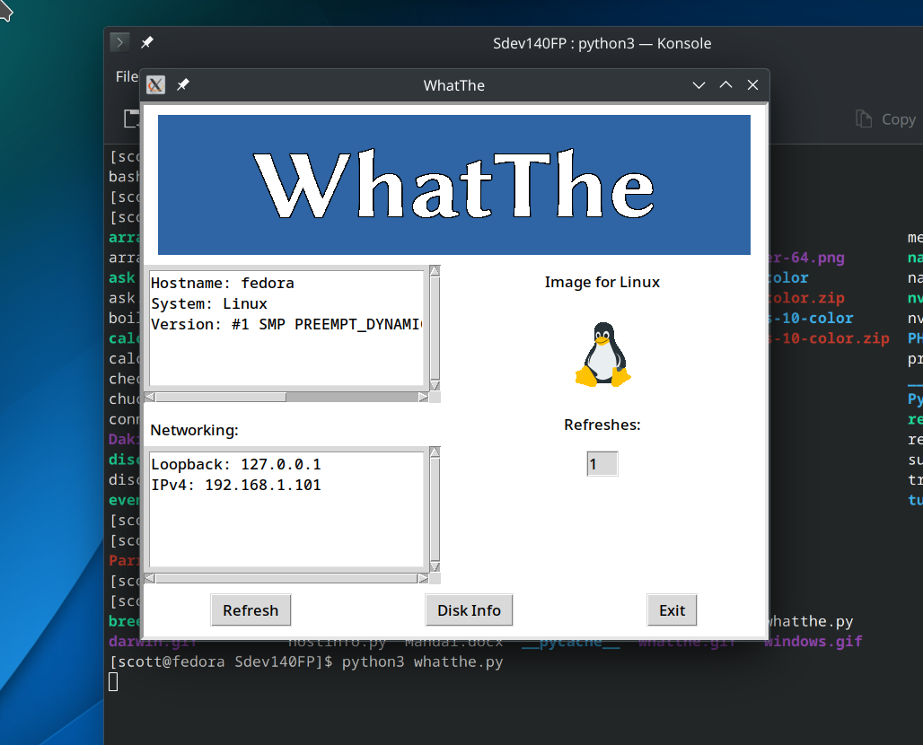

Linux showing disk usage for the sole drive.

