GitLab/Docker CI/CL Lab

Parrish, Scott

11/28/2023

Sdev 220

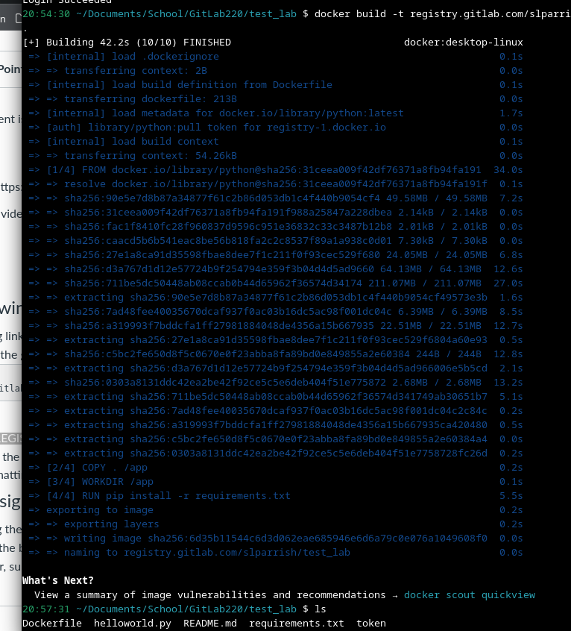

21:01:59 ~/Documents/School/GitLab220/test_lab $ docker run -p 5000:5000 registry.gitlab.com/slparrish/test_lab:latest

* Serving Flask app 'helloworld'

* Debug mode: on

WARNING: This is a development server. Do not use it in a production deployment. Use a production WSGI server instead.

* Running on all addresses (0.0.0.0)

* Running on http://127.0.0.1:5000

* Running on http://172.17.0.2:5000

Press CTRL+C to quit

* Restarting with stat

* Debugger is active!

* Debugger PIN: 897-249-202

172.17.0.1 - - [29/Nov/2023 02:04:08] "GET / HTTP/1.1" 200 -