
TUNKU ABDUL RAHMAN UNIVERSITY OF MANAGEMENT AND TECHNOLOGY
FACULTY OF COMPUTING AND INFORMATION TECHNOLOGY
Assignment Title: Telcom Customer Churn
BMDS2003 DATA SCIENCE

Programme : Bachelor in Data Science (Honours)
Tutorial Group : Group 6
Lecturer/Tutor’s Name : Ms. Yan Yen Wei
Date of submission : Week 12

Team Members:
No | Student Name | Student ID | Signature | Marks  (For Lecturer / Tutor use)
1. | Stephanie Lo Qian Fui | 2612532 | steph
2. | Chan Yi Herng | 2612476
3. | Chia Zhen Yang | 2612480
4. | Ham Guan Quan | 2612490

Attachment
Plagiarism Statement Form

I, Name STEPHANIE LO QIAN FUI Student ID 2612532
Programme Bachelor in Data Science (Honours) Tutorial Group 6 confirm that the submitted work are all my own work and is in my own words.

I STEPHANIE LO QIAN FUI acknowledge the use of AI generative technology.

Signature : ________________
Date : ________________

I, Name CHAN YI HERNG Student ID 2612476
Programme Bachelor in Data Science (Honours) Tutorial Group 6 confirm that the submitted work are all my own work and is in my own words.

I CHAN YI HERNG acknowledge the use of AI generative technology.

Signature : ________________
Date : ________________

I, Name CHIA ZHEN YANG Student ID 2612480
Programme Bachelor in Data Science (Honours) Tutorial Group 6 confirm that the submitted work are all my own work and is in my own words.

I CHIA ZHEN YANG acknowledge the use of AI generative technology.

Signature : ________________
Date : ________________

I, Name HAM GUAN QUAN Student ID 2612490
Programme Bachelor in Data Science (Honours) Tutorial Group 6 confirm that the submitted work are all my own work and is in my own words.

I HAM GUAN QUAN acknowledge the use of AI generative technology.

Signature : ________________
Date : ________________

Table of Contents
Executive Summary 5
1. Business Understanding 6
1.1 Background 6
1.2 Problem Statement 6
1.3 Project Objective 6
1.4 Business Impact 7
1.5 Stakeholders and Success Criteria 7
2. Data Understanding 8
2.1 Dataset Objective 8
2.2 Data Quality Findings 8
2.3 Summary Statistics 8
2.4 Motivation for Feature Engineering 8
2.5 Univariate and Bivariate Churn Patterns 9
2.6 Engineered Feature Audit 10
2.6.1 Validating the Kept Features 13
2.6.2 TotalServicesSubscribed: A Non-Monotonic Pattern 14
2.7 Multivariate Interaction Analysis 14
3. Data Preparation 16
3.1 Handle Missing Values 16
3.2 Invalid Value and Outlier Checks 16
3.3 Multicollinearity Check (VIF) 16
3.3.1 Round 1 — MonthlyCharges vs AvgChargePerMonth 17
3.3.2 Round 2 — TotalServicesSubscribed vs Service Dummies 17
3.3.3 Round 3 — Duplicate Categories and Representations 17
3.3.4 Round 4 — tenure vs TenureGroup 17
3.4 Removing Irrelevant Features 18
3.5 Encoding 18
3.6 Feature Scaling 18
3.7 Class Imbalance Correction 18
4. Modelling 19
4.1 Model Overview 19
4.2 Hyperparameter Tuning 19
4.3 5-Fold Cross-Validation (All Models) 20
5. Evaluation 21
5.1 Evaluation Metrics 21
5.2 Model Performance Comparison 21
5.3 Feature Importance Analysis 23
5.4 Logistic Regression Coefficient Interpretation 23
5.5 Decision Tree Structure 24
5.6 Precision-Recall Curves 25
5.7 Threshold Tuning 26
5.8 Overfitting Check 27
5.9 Discussion 27
5.10 Limitations 28
6. Deployment Prototype 29
6.1 Prototype Description 29
6.2 Application Features 29
6.3 Prototype Screenshots 29
6.4 Technical Implementation 29
7. Conclusion 30
7.1 Summary of Findings 30
7.2 Business Contribution 30
7.3 Lessons Learned and Future Improvements 30
References 32

Executive Summary
This project applies the CRISP-DM framework to predict customer churn for a telecommunications provider, using the IBM Telco Customer Churn dataset of 7,043 customers and 21 original attributes. 8 features were engineered from those attributes and each was checked directly against the data rather than assumed useful: two (ContractRiskScore and ChargesToTenureRatio) proved strong enough to keep in the model, three (TenureGroup, TotalServicesSubscribed, IsAutoPay) added genuine value to the descriptive analysis but were excluded from modelling as redundant with more granular raw columns, and three (AvgChargePerMonth, HasInternetService, HasPartnerOrDependents) did not hold up under scrutiny and were dropped entirely (Section 2.6).
The exploratory analysis confirmed that Churn is imbalanced, with 73.5% of customers retained and 26.5% churned, and it moved from simple distribution checks through to multivariate interaction analysis. That deeper analysis found that customers on a month-to-month contract who also pay manually have the highest observed churn rate in the dataset, at 46.5%, while two-year contract customers on automatic payment churn the least, at 2.8%.
4 classification models were trained and compared, which is the Logistic Regression as the baseline, Decision Tree, Random Forest, and XGBoost, on a final, redundancy-checked feature set of 23 predictors. SMOTE was used to correct for class imbalance, and hyperparameters were tuned with 5-fold cross-validated GridSearchCV under explicit regularisation constraints.
Random Forest produced the best Accuracy (75.9%), Precision (53.3%), F1-score (61.7%), and AUC (0.839) and Decision Tree produced the highest Recall, at 77.0%.
In both Random Forest and XGBoost, an engineered feature ranked as the single most important predictor: ChargesToTenureRatio in Random Forest and ContractRiskScore in XGBoost.
That result is a fairly direct validation of the two features that survived the audit in Section 2.6.

The trained models were deployed in a functional Streamlit prototype that exposes all four models behind a single interface, defaulting to the recommended Random Forest and letting a user compare every model's churn probability for the same customer (Section 6). The clearest business recommendation that follows is to focus retention on the highest-risk segment identified here - month-to-month customers paying manually - and to monitor each customer's ChargesToTenureRatio as a simple, explainable early-warning signal.

Member Contributions
The table below summarises each member's primary contribution. All members participated in group discussion, report writing, and the presentation.
Member | ID | Primary Contributions
Stephanie Lo Qian Fui | 2612532 | Business Understanding (Section 1); data understanding overview and summary statistics (Sections 2.1-2.4); univariate churn analysis (Section 2.5).
Chan Yi Herng | 2612476 | Engineered-feature design and honest audit (Section 2.6); feature correlation and tenure-group analysis; engineered-feature validation checks.
Chia Zhen Yang | 2612480 | Multivariate interaction analysis (Section 2.7); statistical association tests (Section 2.8); modelling design and hyperparameter tuning (Section 4).
Ham Guan Quan | 2612490 | Data preparation, outlier and multicollinearity audits (Section 3); model evaluation (Section 5); Streamlit deployment prototype (Section 6).

1. Business Understanding

1.1 Background
The telecommunications industry is one of the most competitive and saturated consumer markets. Core service offerings differ little between providers, so customers tend to be price-sensitive and switch readily.
This competitive pressure shows up directly in the numbers. Chang et al. (2024) report that telecom has the highest annual churn rate of any major industry, above 30%, well ahead of retail, banking, or insurance. Yet despite that scale, the underlying causes are not well consolidated: in a systematic literature review of churn determinants, Ribeiro et al. (2024) found that research on why customers churn is extensive but scattered across pricing, service quality, contract structure, and customer experience, with no single dominant explanation.

1.2 Problem Statement
Despite the scale of the revenue risk that churn represents, many telecom operators still rely on reactive retention: they step in only after a customer has already initiated a cancellation, at which point a successful save is far less likely and any retention incentive costs more. Without a predictive, proactive system in place, a company struggles to identify which customers are likely to churn soon, to prioritise limited retention resources toward the highest-risk and highest-value customers, or to tailor a retention offer to whatever is actually driving a given customer's dissatisfaction, whether that is contract rigidity, price, or payment friction.
The fragmented, multi-factor picture from Section 1.1 is itself part of this problem. Because no single raw attribute tells the whole story, a retention team working from single-variable reports is likely to miss interactions between factors. This project addresses both gaps together, following the CRISP-DM framework, by building a churn prediction model that combines multiple raw attributes into interpretable engineered indicators (Section 2.6) and outputs both a churn probability and the risk drivers behind it for each customer.

1.3 Project Objective
This project applies the CRISP-DM framework (Business Understanding, Data Understanding, Data Preparation, Modelling, and Evaluation) systematically to the Telco Customer Churn dataset. The core aim is to predict, for each customer, the probability of churn using demographic, service, contract, and billing attributes, supplemented by engineered behavioural indicators.
Beyond prediction alone, the analysis is intended to move past surface-level description and identify the deeper, interacting drivers of churn, such as how contract type and payment method jointly affect risk, rather than reporting single-variable trends in isolation. On the modelling side, the project builds and compares four classification models (Logistic Regression, Decision Tree, Random Forest, and XGBoost), with Logistic Regression as the baseline and each model choice justified against supporting literature (Section 4.1). It then concludes with a functional deployment prototype that returns a churn probability and risk category for a given customer profile (Section 6).

1.4 Business Impact
A reliable churn model creates value for a telecom operator in three concrete ways. First, it reduces revenue loss, because retention offers can reach at-risk customers before they cancel rather than after. Second, it improves marketing efficiency, since a campaign targeted at a model-identified high-risk segment costs less per saved customer than a blanket promotion sent to the entire base. Third, because acquiring a new customer is widely reported to cost substantially more than retaining an existing one, even a modest improvement in retention compounds into a large effect on customer lifetime value over several years.
To put a rough number on that last point: for an operator with 1 million subscribers at an average revenue per user of USD 50 a month, cutting annual churn from this dataset's observed rate of 26.5% down to 20% would retain roughly 65,000 additional customer-years of revenue, worth about USD 39 million a year at that ARPU. This is an illustrative scenario, not a figure derived from the dataset itself, but it gives a sense of the scale that justifies investing in a predictive retention system in the first place.

1.5 Stakeholders and Success Criteria
The primary intended user of this model's output is a retention or CRM analyst, who would use the predicted churn probability and risk category to prioritise outreach and choose an appropriate offer. Product and pricing teams are a secondary audience: they can use the aggregated risk-driver findings in Section 2.7 to redesign contract or pricing structures that reduce churn risk structurally, instead of reacting to it one customer at a time.
Given these two audiences, success here is not defined purely by the highest headline accuracy. It also requires Recall high enough to catch a meaningfully larger share of true churners than a naive approach would (Section 5.1), enough interpretability that a retention analyst can see why a given customer was flagged, and a working prototype that turns the model's output into a decision a non-technical user can act on (Section 6).

2. Data Understanding

2.1 Dataset Objective
The dataset comprises 7,043 customer records and 21 original attributes from a fictional US telecom provider, sourced via Kaggle's IBM Sample Data Sets. It covers demographics, subscribed services, contract and billing terms, and the Churn outcome. A single source file was used. No additional data sources were integrated, since none were needed to meet the business objectives set out in Section 1.

2.2 Data Quality Findings
● No standard null values were present in any column via an initial df.isnull().sum() check.
● TotalCharges was stored as text and, once converted to numeric, contained 11 blank entries. All 11 belong to customers with tenure = 0, meaning they had just joined and had not completed a billing cycle yet. Section 3.1 addresses this with logic-based imputation rather than statistical imputation, since a population median or mean would misrepresent a brand-new customer's true charge history.
● No negative or otherwise invalid values were found in any numeric field (Section 3.2).
● No implausible outliers were found in the raw fields tenure (0-72 months) or MonthlyCharges (USD 18.25-118.75) under a mean ± 3 standard-deviation rule (Section 3.2).

2.3 Summary Statistics
Statistic | tenure | MonthlyCharges | TotalCharges | SeniorCitizen
Count | 7,043 | 7,043 | 7,043 | 7,043
Mean | 32.37 | 64.76 | 2,279.73 | 0.162
Std Dev | 24.56 | 30.09 | 2,266.79 | 0.369
Min | 0 | 18.25 | 0.00 | 0
Median | 29 | 70.35 | 1,394.55 | 0
Max | 72 | 118.75 | 8,684.80 | 1
Table 4: Summary statistics for numerical features (* TotalCharges has 11 missing values)

Average customer tenure is 32.4 months, but the standard deviation of 24.6 is almost as large as the mean, so the base is really a mix of new and long-established customers rather than a homogeneous one. The TotalCharges figures above already reflect the logic-based imputation from Section 3.1, where the 11 zero-tenure customers were set to 0.

2.4 Motivation for Feature Engineering
The raw dataset records what a customer has, such as services, contract, and charges, but not how those attributes relate to each other for a given customer. MonthlyCharges alone does not say whether a charge is high relative to how long the customer has stayed, and Contract alone does not capture whether a customer's payment method adds friction at renewal time. That gap motivates the engineered features introduced in Section 2.6, which are built entirely from the existing fields and expose relationships the raw columns do not show on their own. The rest of this section works through the exploratory analysis in increasing depth: Section 2.5 looks at individual original features, Section 2.6 introduces and checks the engineered features, and Section 2.7 looks at how features interact.

2.5 Univariate and Bivariate Churn Patterns
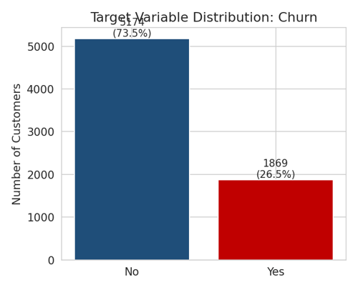
Figure 1: Target variable distribution — 5,174 retained (73.5%) vs 1,869 churned (26.5%)

The dataset is moderately imbalanced, at roughly 2.8 retained customers for every churned one. That single fact carries through the rest of the project: it means Accuracy is not a reliable evaluation metric on its own (Section 5.1), and it is why class-imbalance correction is applied in Section 3.7.

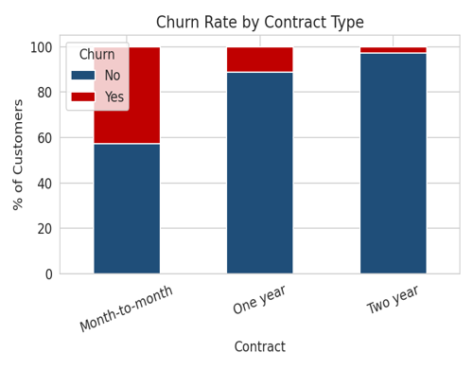
Figure 2: Churn rate by contract type
Churn rises sharply as contract commitment falls. It sits at 2.8% for Two-year contracts, 11.3% for One-year contracts, and 42.7% for Month-to-month, a 15-fold difference between the two extremes. Customers who pay by Electronic check, a manual payment method, churn at 45.3%, compared with 15-17% for the two automatic payment methods. Fiber optic internet subscribers churn at 41.9% against 19.0% for DSL, and senior citizens churn at 41.7% against 23.6% for non-seniors. These single-variable results are useful, but limited: they show which groups churn more without explaining why, or how the factors combine for a given customer. Sections 2.6 and 2.7 take that further.

The categorical and numeric churn patterns discussed above are summarised visually below: the churn rate for every categorical feature against the overall rate (Figure 2a), and how the numeric and engineered features separate churners from non-churners (Figures 2b-2c).
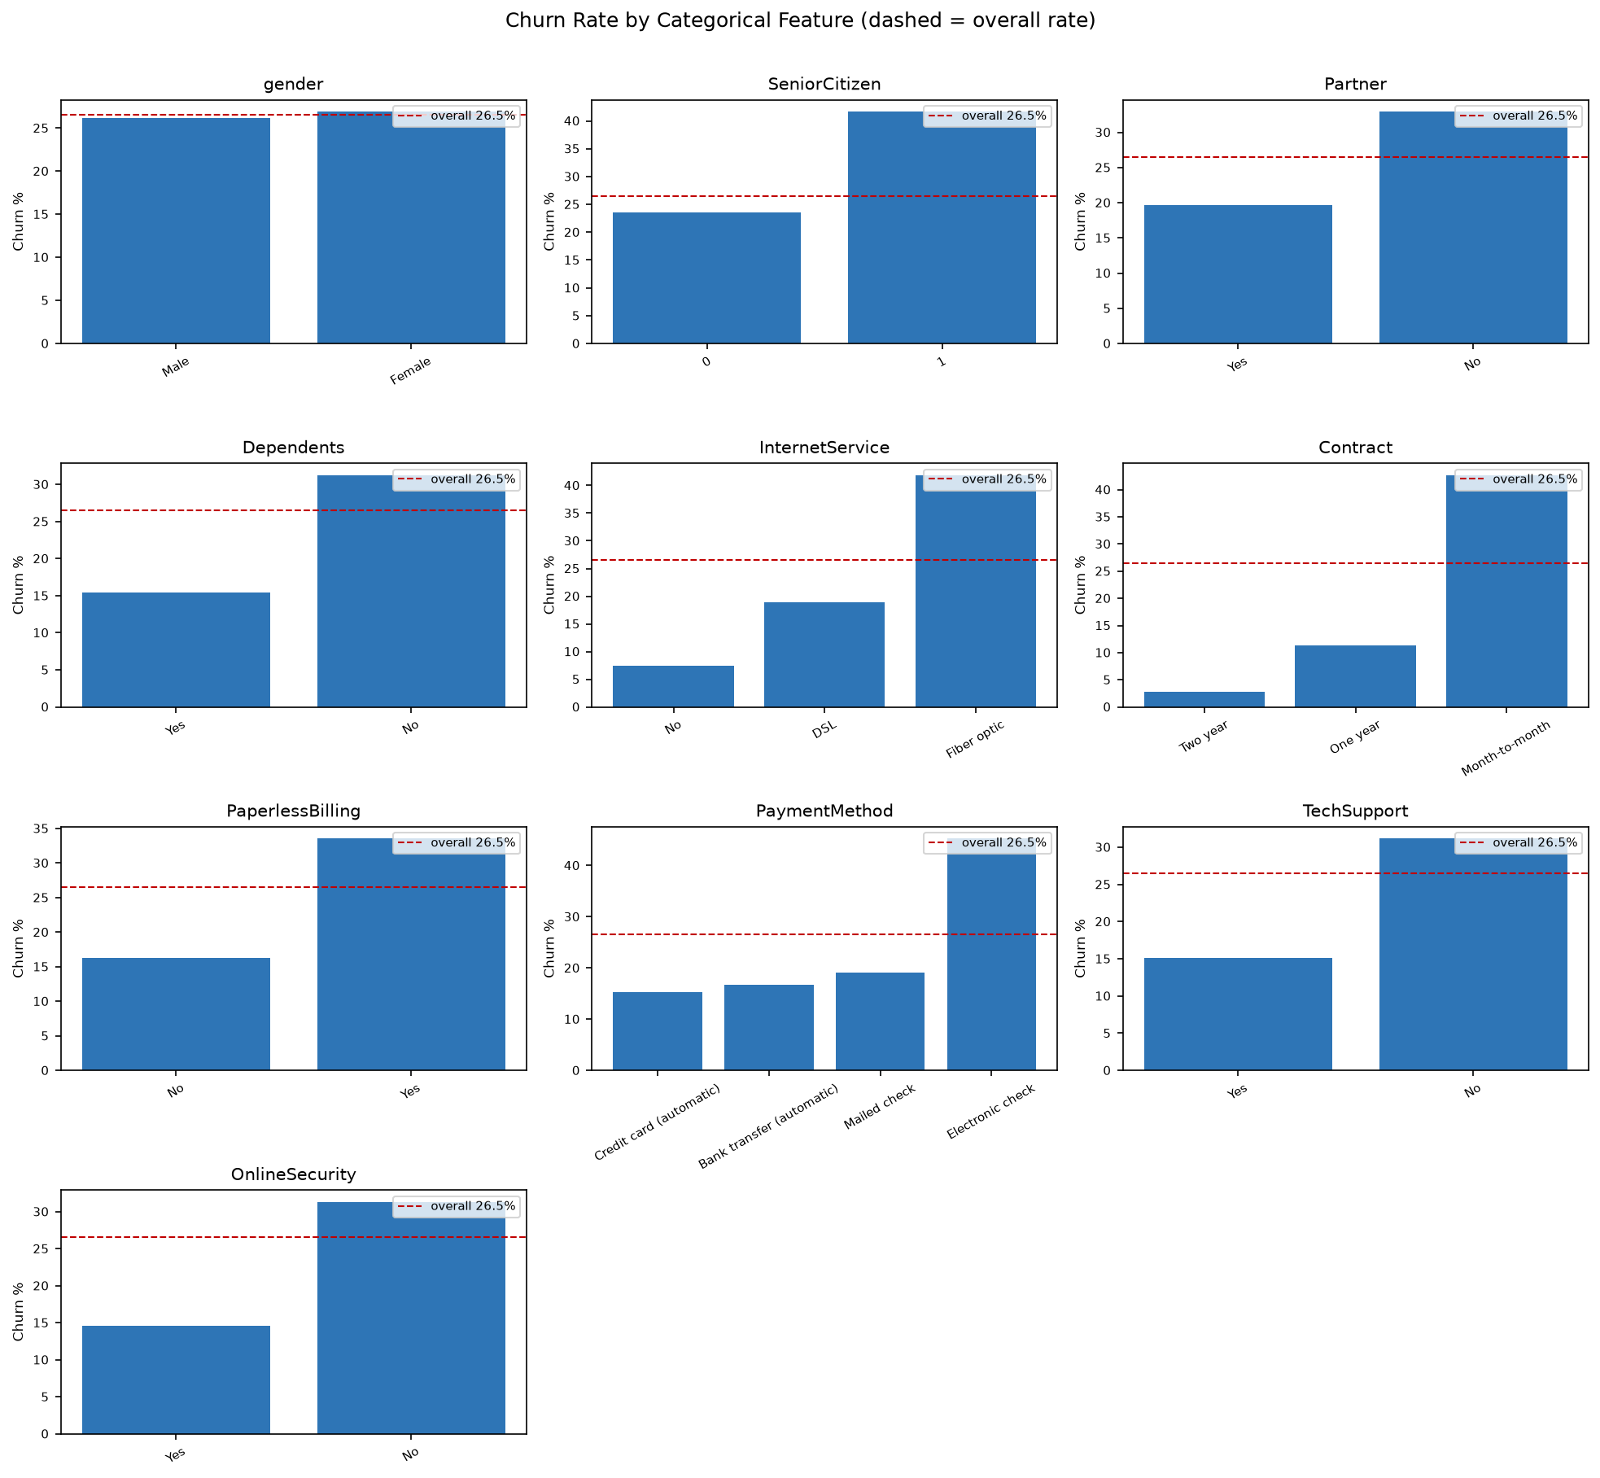
Figure 2a: Churn rate across all categorical features (dashed line = overall 26.5% rate).
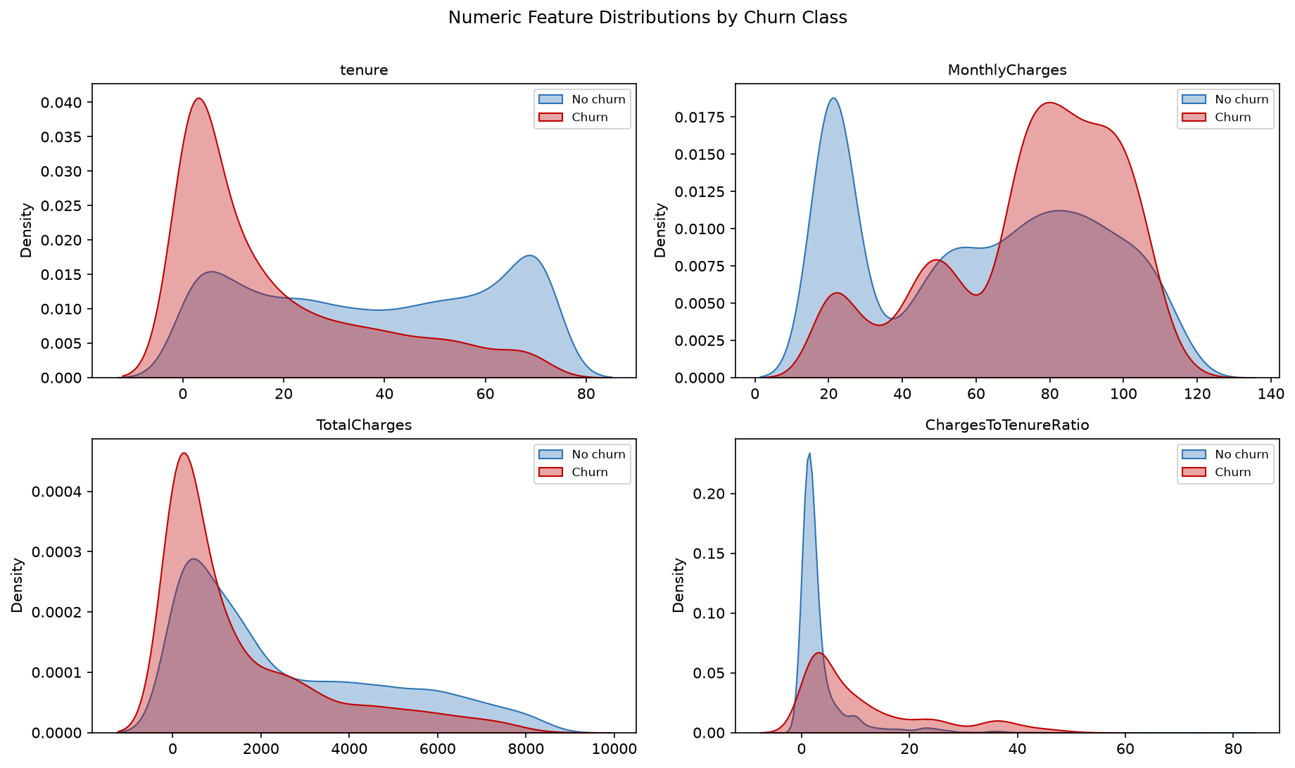
Figure 2b: Distribution of the numeric and engineered features by churn class.
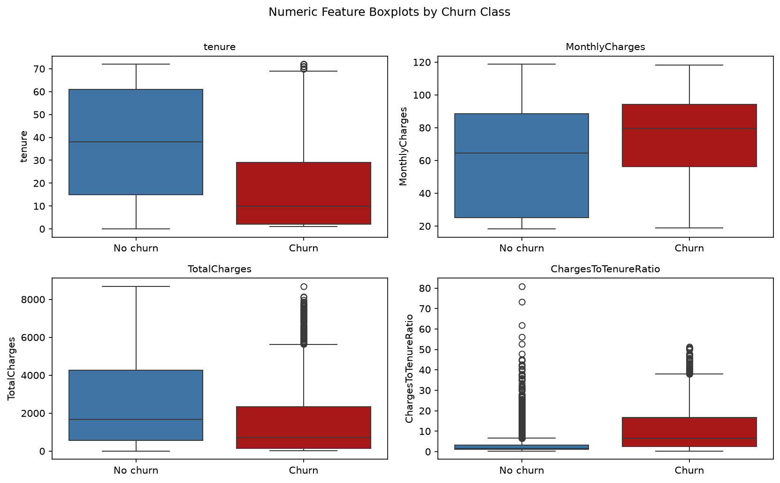
Figure 2c: Numeric and engineered features by churn class (boxplots).

2.6 Engineered Feature Audit
Eight features were derived from the existing 21 columns, with no external data introduced. Rather than presenting only the ones that worked, this section reports what was tested and what each one actually delivered once checked against the data, because a feature that does not survive scrutiny is a useful finding in itself, not something to quietly drop from the write-up.
Engineered Feature | Derivation | Verdict, With Evidence
ChargesToTenureRatio | MonthlyCharges / (tenure + 1) | Kept for modelling. Highest correlation with churn of any feature in the dataset (r = 0.412, Section 2.6.1) and top-ranked in both Random Forest and XGBoost (Section 5.3).
ContractRiskScore | Ordinal: Month-to-month=2, One year=1, Two year=0 | Kept for modelling. Second-highest correlation (r = 0.397) and the single most important feature in XGBoost. Replaces the Contract one-hot columns without losing information, since Contract has only three ordered levels.
TenureGroup | tenure binned into 0-12 / 13-24 / 25-48 / 49-60 / 61+ months | Kept for description only, not modelling. Section 2.6.1 shows a clear, business-readable pattern (47.4% down to 6.6% churn), and it drives the new-customer interaction finding in Section 2.7. Excluded from modelling because continuous tenure is strictly more granular and captures everything TenureGroup does; keeping both would repeat the redundancy this section is trying to avoid (see Section 3.3.4).
TotalServicesSubscribed | Count of 'Yes' across 8 service add-on columns | Kept for description only, not modelling. Its overall correlation with churn is weak (r = -0.067) and non-monotonic on its own (Section 2.6.2), but combined with TenureGroup it reveals a genuine, non-obvious finding in Section 2.7. Excluded from modelling because it is an exact linear sum of the eight service one-hot columns already in the model (r = 0.9999999999999998 with that sum, confirmed directly), so including it would add zero new information while destabilising Logistic Regression's coefficients.
IsAutoPay | 1 if PaymentMethod is a Bank transfer or Credit card (automatic) | Kept for description only, not modelling. Drives the highest-risk-segment finding in Section 2.7 (month-to-month + manual payment = 46.5% churn). Excluded from modelling because it is a deterministic simplification of PaymentMethod, which is already one-hot encoded and preserves the Electronic-check-vs-Mailed-check distinction that IsAutoPay would flatten.
HasInternetService | 1 if InternetService != 'No' | Rejected. Checked directly against InternetService: collapsing DSL (18.96% churn) and Fiber optic (41.89% churn) into a single 'Yes' category (31.83% churn) does not summarise the data, it hides the single largest split in the dataset. This feature was not just redundant but actively worse than the column it was derived from, and is not used anywhere in this report.
HasPartnerOrDependents | 1 if Partner='Yes' or Dependents='Yes' | Rejected. Checked directly: its churn split (19.8% vs 34.2%) is nearly identical to Partner alone (19.7% vs 33.0%), so OR-combining it with Dependents adds no distinguishing information beyond what Partner already shows by itself. Not used anywhere in this report.
AvgChargePerMonth | TotalCharges / tenure (MonthlyCharges if tenure=0) | Rejected. This was a weak design from the start, not just an unlucky collinearity finding: it is arithmetically almost identical to the existing MonthlyCharges column (r = 1.00, Section 3.3.1) for any customer with stable billing, so a dedicated persistent feature was never really justified when the same 'billing consistency' check could have been done as a one-off validation instead.

Net result: of the eight features engineered, two earned a place in the final model, three earned a place in the descriptive analysis without being used for modelling, and three did not hold up under direct checking and are excluded entirely. That three-out-of-eight failure rate is reported here deliberately, rather than only presenting the features that worked, because it is the more honest picture of what feature engineering on this dataset actually looked like.

2.6.1 Validating the Kept Features
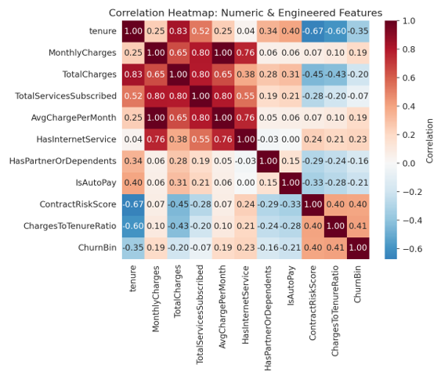
Figure 4: Correlation of numeric and engineered features with Churn
The correlation analysis shows that ChargesToTenureRatio (r = 0.412) and ContractRiskScore (r = 0.397) are more strongly associated with churn than any single original numeric column, including tenure on its own (r = -0.352) or MonthlyCharges on its own (r = 0.193). That is a fairly direct, data-driven justification for keeping these two in the model: the engineered ratio and the ordinal contract score each capture something the raw variables do not on their own.

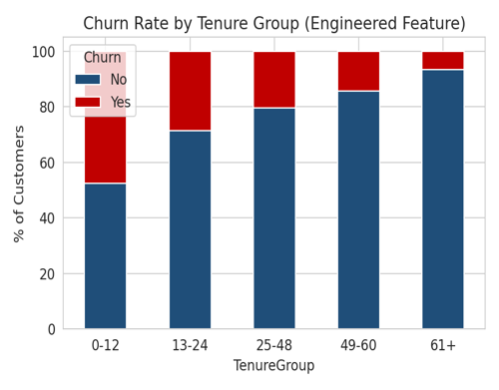
Figure 3: Churn rate by TenureGroup (descriptive only)
Grouping tenure into lifecycle stages shows churn falling from 47.4% in the first year to 6.6% after five years, confirming that the early relationship is the highest-risk period and giving the business a natural way to time retention outreach, even though the binned version is not used as a separate model input (Section 3.3.4).
Figure 4a extends the pairwise correlation view to the full numeric feature set, confirming that ChargesToTenureRatio and ContractRiskScore each carry churn signal without being strongly collinear with one another.
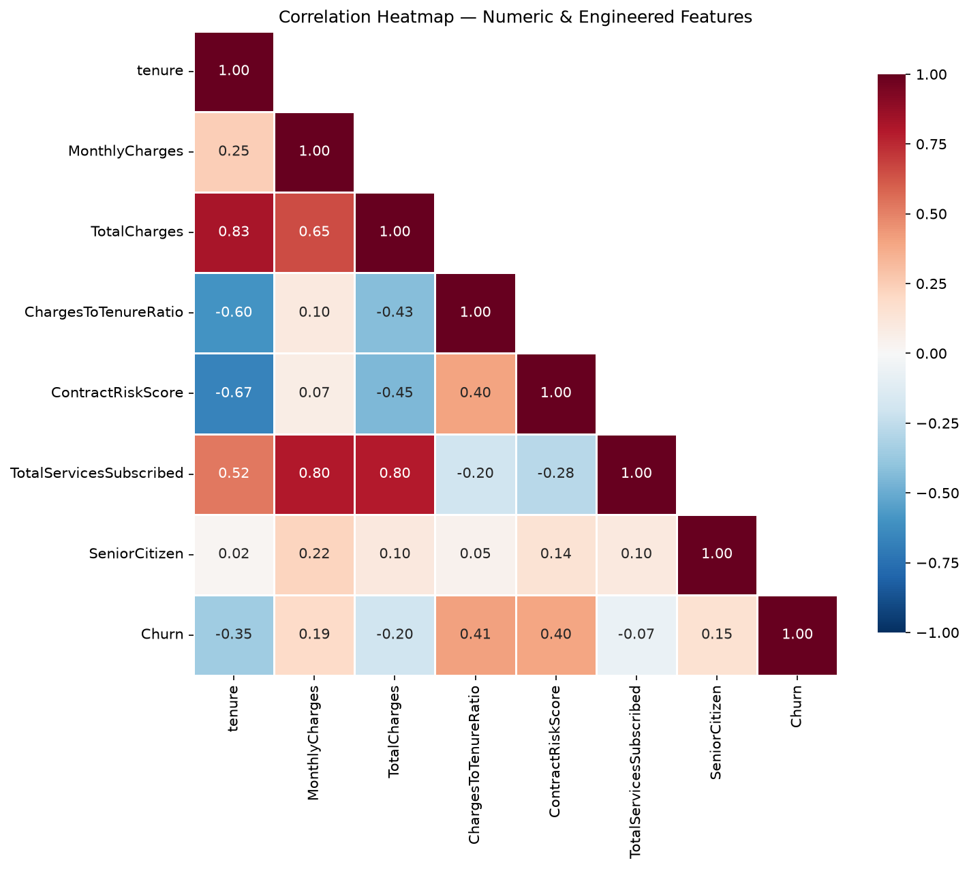
Figure 4a: Correlation heatmap of the numeric and engineered features (including binary churn).

2.6.2 TotalServicesSubscribed: A Non-Monotonic Pattern
TotalServicesSubscribed behaves differently from the two features kept for modelling. Its overall correlation with churn is weak (r = -0.067), and the relationship is non-monotonic: churn is highest with zero services (43.8%), drops sharply at one service (21.1%), climbs again through three to four services (36.5% and 31.3%), then falls steadily from five to eight services down to 5.3%. Judged on its own, this feature would look unimportant. Section 2.7 shows that its real relationship with churn only comes into focus once tenure is factored in as well, which is precisely why it earns a place in the descriptive analysis despite being excluded from modelling.

2.7 Multivariate Interaction Analysis
This final layer looks at how pairs of features combine, and it is where the most actionable findings in this analysis turned up.

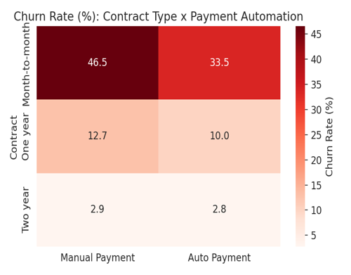
Figure 5: Churn rate (%) by Contract type x Payment automation
Contract type and payment automation add to each other rather than substitute for each other. Month-to-month customers who also pay manually churn at 46.5%, the highest-risk segment found anywhere in this analysis, compared with 33.5% for month-to-month customers on automatic payment. At the other end, Two-year contract customers churn at 2.8-2.9% regardless of how they pay, which suggests that a strong contractual commitment cancels out the effect of payment friction almost entirely. None of this shows up in Section 2.5, where Contract and PaymentMethod were only looked at one at a time.
A second interaction, between TenureGroup and a binned version of TotalServicesSubscribed, explains the non-monotonic pattern from Section 2.6.2. That overall pattern - where customers with the most services (five to eight) appear to churn the least - turns out to be a tenure artefact: the customers holding the most services are disproportionately long-tenured, and long-tenured customers churn very little at any service count. Once tenure is held fixed, the relationship reverses - within every tenure band, churn actually rises with the number of services rather than falling (Figure 5b). The effect is starkest among first-year customers, where those with four to five services churn at 56.9%, against 37.2% for those with zero or one service. A plausible explanation is that new customers who sign up for many services at once are more sensitive to the resulting bill before they have had time to see the value in them. This carries a direct business implication: bundling many services onto a new customer is associated with higher, not lower, early churn, so new multi-service customers may need onboarding support or a gentler pricing ramp to avoid an early bill shock.

The reversal once tenure is held fixed is shown in Figure 5b.
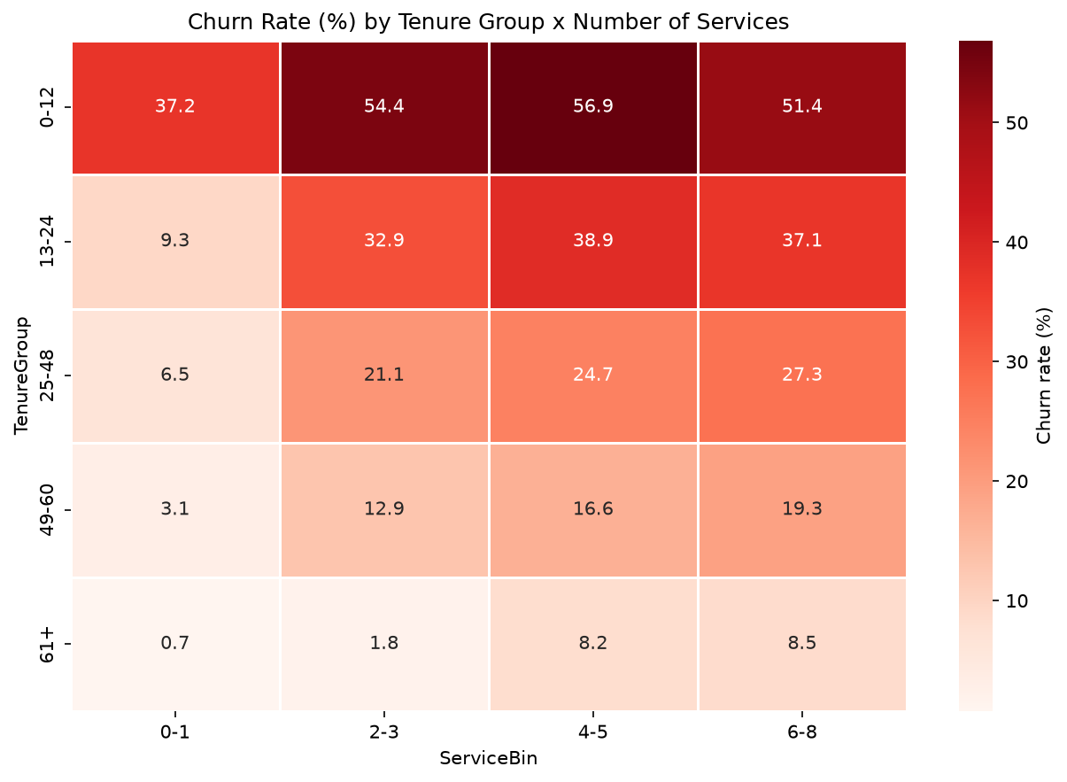
Figure 5b: Churn rate (%) by tenure group and number of services - within every tenure band, churn rises with the service count (first-year, four-to-five services peaks at 56.9%).

2.8 Statistical Association Tests
The churn-rate comparisons in Sections 2.5-2.7 are made statistically explicit here. A chi-square test of independence is run between each categorical feature and Churn; because chi-square scales with sample size, Cramer's V is reported alongside it as a 0-1 effect size, so a statistically significant but practically weak association is distinguishable from a strong one on this 7,043-row dataset. Point-biserial correlation, the correct coefficient for a continuous-versus-binary pair, is used for the numeric and engineered features.
Table 6a: Chi-square test of independence and Cramer's V effect size, per categorical feature (sorted by Cramer's V; all significant at p < 0.05 except gender and PhoneService).
Feature | Chi-square | p-value | Cramer's V | Strength
Contract | 1184.6 | < 0.001 | 0.410 | moderate
InternetService | 732.3 | < 0.001 | 0.322 | moderate
PaymentMethod | 648.1 | < 0.001 | 0.303 | moderate
PaperlessBilling | 258.3 | < 0.001 | 0.191 | weak
OnlineSecurity | 205.6 | < 0.001 | 0.171 | weak
TechSupport | 190.2 | < 0.001 | 0.164 | weak
Dependents | 189.1 | < 0.001 | 0.164 | weak
SeniorCitizen | 159.4 | < 0.001 | 0.150 | weak
Partner | 158.7 | < 0.001 | 0.150 | weak
OnlineBackup | 47.3 | < 0.001 | 0.082 | negligible
DeviceProtection | 30.5 | < 0.001 | 0.066 | negligible
StreamingTV | 27.9 | < 0.001 | 0.063 | negligible
StreamingMovies | 26.2 | < 0.001 | 0.061 | negligible
MultipleLines | 11.1 | < 0.001 | 0.040 | negligible
PhoneService | 0.9 | 0.339 | 0.011 | negligible
gender | 0.5 | 0.487 | 0.008 | negligible
The test rejects independence from churn at p < 0.05 for every categorical feature except gender (p = 0.487) and PhoneService (p = 0.339), confirming statistically that neither is related to churn. Cramer's V then separates significance from strength: only Contract (V = 0.410), InternetService (0.322), and PaymentMethod (0.303) reach a moderate association, while the other significant flags (PaperlessBilling 0.191, OnlineSecurity 0.171, TechSupport and Dependents 0.164, SeniorCitizen and Partner 0.150) are statistically real but weak, and the remaining service flags are negligible (V < 0.10). This is fully consistent with the churn-rate visuals in Section 2.5 and confirms contract type, internet type, and payment method as the dominant categorical drivers.
Figure 5a visualises the Cramer's V column from Table 6a, making the split between moderate, weak, and negligible categorical associations immediate.
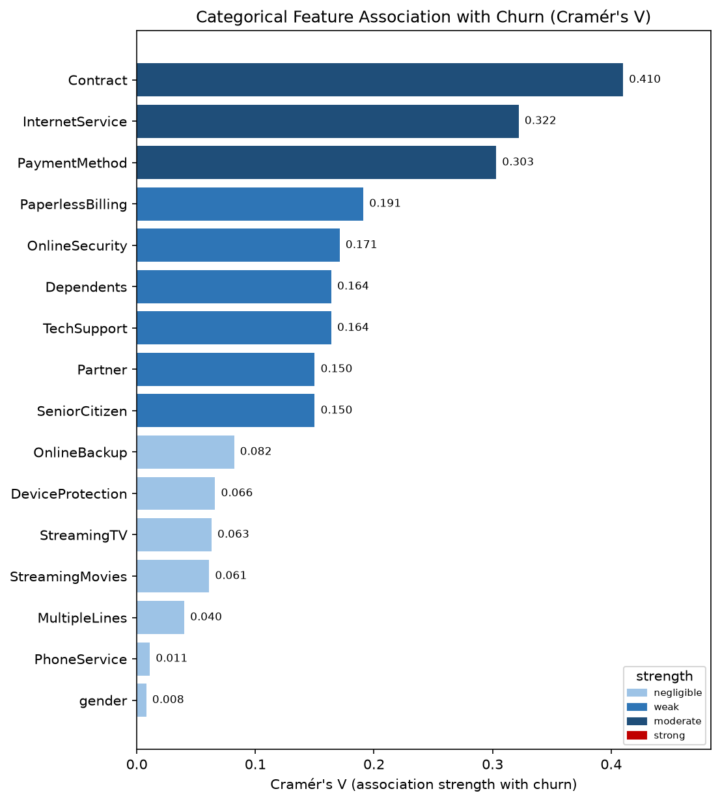
Figure 5a: Categorical feature association with churn (Cramer's V), coloured by effect-size band.
Table 6b: Point-biserial correlation between each numeric/engineered feature and the binary Churn target (all significant at p < 0.05).
Feature | Point-biserial r | p-value
ChargesToTenureRatio | +0.412 | < 0.001
ContractRiskScore | +0.397 | < 0.001
tenure | -0.352 | < 0.001
TotalCharges | -0.198 | < 0.001
MonthlyCharges | +0.193 | < 0.001
SeniorCitizen | +0.151 | < 0.001
TotalServicesSubscribed | -0.067 | < 0.001
For the numeric and engineered features, point-biserial correlation confirms the same two engineered features lead: ChargesToTenureRatio (r = 0.412) and ContractRiskScore (r = 0.397), both stronger than raw tenure (r = -0.352), TotalCharges (-0.198), or MonthlyCharges (0.193). Every coefficient is significant at p < 0.05. These tests formally validate, with hypothesis testing rather than visual inspection alone, the two engineered features carried forward into modelling (Section 3).

3. Data Preparation

3.1 Handle Missing Values
An initial df.isnull().sum() check reported zero missing values, because the 11 problem entries in TotalCharges were stored as blank strings rather than NaN. Converting the column to numeric with pd.to_numeric(errors='coerce') turned those same 11 records into true NaN values.
The standard textbook move at that point is dropna(), and since 11 records out of 7,043 is only 0.16% of the data, dropping them would barely have moved model performance either way.
This project imputed them as 0 instead, because every one of the 11 affected records has tenure = 0 where these are customers who had not completed a single billing cycle yet. A population-level median of about 1,397 or a mean of about 2,283 would make these brand-new customers look like they had an established billing history they do not actually have, whereas 0 matches their real account state.
dropna() was considered and set aside in favour of this more information-preserving, domain-consistent alternative.

3.2 Invalid Value and Outlier Checks
Before modelling, all 6 numeric fields (tenure, MonthlyCharges, TotalCharges, TotalServicesSubscribed, AvgChargePerMonth, and ChargesToTenureRatio) were checked for invalid values using boolean filtering, for example df[df['MonthlyCharges'] < 0]. No field contained negative or otherwise invalid values.
Outliers were then identified with the mean ± 3 standard-deviation rule. Five of the six numeric fields had no outliers under this rule at all, which fits a clean, capped billing dataset where, for example, MonthlyCharges never leaves the USD 18.25-118.75 range. The engineered ChargesToTenureRatio was the exception 248 records, or 3.52% of the data, fell above the upper bound of roughly 31.9 (a mean of 5.77 plus three standard deviations of 8.72). Instead of treating these as data errors to be removed, they were investigated directly:

Group | Mean Tenure | Churn Rate
ChargesToTenureRatio outliers (n=248) | 1.0 months | 83.1%
Full dataset (n=7,043) | 32.4 months | 26.5%

These 248 'outliers' turn out to be almost entirely customers in their first two months who are already paying a high monthly rate, and they churn at more than three times the overall rate. That is a genuine high-risk signal rather than noise, so the records were kept rather than removed or capped. It also lines up with ChargesToTenureRatio's high importance ranking in Section 5.3.

3.3 Multicollinearity Check (VIF)
Variance Inflation Factor (VIF) was calculated to check for multicollinearity, which can destabilise Logistic Regression coefficients even though it does not affect tree-based models in the same way. This turned out to require four rounds of investigation, each uncovering a different form of redundancy between the engineered features and the columns they were built from.

3.3.1 Round 1 — MonthlyCharges vs AvgChargePerMonth
An initial VIF check on the 6 numeric and engineered columns found MonthlyCharges and AvgChargePerMonth at VIF 758 and 749 respectively, both far above the usual concern threshold of 10. The two are, in practice, almost the same quantity (correlation r = 1.00), since AvgChargePerMonth = TotalCharges / tenure works out arithmetically close to MonthlyCharges for most customers. AvgChargePerMonth was dropped from the modelling feature set, and, on reflection, from the engineered feature list entirely (Section 2.6).

3.3.2 Round 2 — TotalServicesSubscribed vs Service Dummies
After fitting Logistic Regression on the Round-1 feature set, several coefficients were implausibly large (for example, an odds ratio above 80 for a single streaming service). This is a classic symptom of remaining collinearity that a VIF check limited to numeric columns had missed. The cause: TotalServicesSubscribed is defined as a count of 'Yes' responses across eight service columns, and those same eight columns were also one-hot encoded as separate predictors. A direct check confirmed the two were correlated at r = 0.9999999999999998, an exact linear dependency. TotalServicesSubscribed was dropped from the modelling feature set, though it earned its place in Section 2.6 as a descriptive feature on separate grounds.

3.3.3 Round 3 — Duplicate Categories and Representations
Coefficients were still unstable after Round 2. Two further issues were found. First, the 'No internet service' category is recorded identically across six separate columns (OnlineSecurity, OnlineBackup, DeviceProtection, TechSupport, StreamingTV, StreamingMovies) for the same 1,526 customers in every case, and 'No phone service' in MultipleLines exactly matches PhoneService = No for the same 682 customers; one-hot encoding each column independently therefore created several perfectly duplicated dummy columns. These categories were collapsed into 'No' before encoding, since the underlying information is already captured by InternetService and PhoneService. Second, three engineered features (ContractRiskScore, HasInternetService, IsAutoPay) were each a deterministic function of a column that was also one-hot encoded in full (Contract, InternetService, PaymentMethod respectively), so both representations were present in the model at once. ContractRiskScore was kept in place of the Contract dummies, since it is more parsimonious and does not lose information (Contract has only three ordered levels). HasInternetService and IsAutoPay were dropped in favour of the full InternetService and PaymentMethod one-hot encodings, and, once checked directly (Section 2.6), turned out to add no value even as descriptive features: HasInternetService actively hides the Fiber-vs-DSL split that matters most in this dataset, and a parallel check found HasPartnerOrDependents added nothing beyond Partner alone either, so both were dropped from the report entirely rather than merely from the model.

3.3.4 Round 4 — tenure vs TenureGroup
A first draft of this section kept both continuous tenure and the one-hot TenureGroup dummies in the model, on the reasoning that binning captures threshold effects a linear model could not otherwise represent. On review, that reasoning does not hold up to the standard applied everywhere else in this section: TenureGroup is a coarser, strictly less granular version of tenure, built from tenure and nothing else, which is exactly the 'simplified feature plus the full version of the same column' pattern that Round 3 had just finished removing for Contract, InternetService, and PaymentMethod. Continuous tenure already contains every threshold TenureGroup could represent, and more. TenureGroup was therefore also removed from the modelling feature set, consistent with the rule applied throughout this section: keep the most granular representation of each concept, and use exactly one representation per concept, with no exceptions carved out for convenience.

Stage | Worst VIF Found | Cause
Round 1 (initial) | 758 | MonthlyCharges vs AvgChargePerMonth
Round 2 | Coefficients unstable (not VIF-visible) | TotalServicesSubscribed vs 8 service dummies
Round 3 (initial) | 2,346 | HasInternetService vs InternetService dummies
Round 4 (initial) | 30 | tenure vs TenureGroup dummies
Round 4 (final) | 20 | Residual, moderate correlation among charges and service fields

The final feature set has 23 predictors and a maximum VIF of about 20 (MonthlyCharges), down from a worst case of 2,346 partway through this process. A few features remain in the 10-20 range, reflecting genuine, moderate correlation between tenure, MonthlyCharges, TotalCharges, and InternetService that cannot be fully removed without discarding real information; this residual level is disclosed here rather than hidden, and is one reason the Random Forest and XGBoost feature importances in Section 5.3 are treated as a more reliable read on driver importance than the Logistic Regression coefficients alone.

3.4 Removing Irrelevant Features
customerID was dropped before modelling. As a unique per-row identifier, keeping it would add no predictive signal and would introduce a data-leakage risk: a model, especially a tree-based one, could learn to split on the identifier itself and effectively memorise the training set instead of learning patterns that generalise.

3.5 Encoding
● Binary Yes/No and gender fields, including MultipleLines and the six service add-ons after the category collapse in Section 3.3.3, were label-encoded (0/1).
● The remaining multi-category nominal fields, InternetService and PaymentMethod, were one-hot encoded with drop_first=True to avoid multicollinearity.
● Following the four rounds of redundancy removal in Section 3.3, the final modelling feature set has 23 predictors: the original demographic, service, and billing columns, continuous tenure, ContractRiskScore and ChargesToTenureRatio from the engineered set, and the one-hot encodings of InternetService and PaymentMethod.

3.6 Feature Scaling
StandardScaler was fitted on the training set only, covering tenure, MonthlyCharges, TotalCharges, and ChargesToTenureRatio. The fitted scaler was then used to transform the test set, so no test-set information leaked into the scaling parameters.

3.7 Class Imbalance Correction
SMOTE was applied to the training set only, after the train-test split, which brought the training class ratio from 26.5/73.5 to a balanced 50/50 across 8,278 rows. Algorithmic reweighting, through class_weight='balanced' or scale_pos_weight, was deliberately not stacked on top of SMOTE. The training data is already balanced after resampling, so an extra weighting step based on the original imbalance ratio would double-correct and push predictions artificially toward the minority class, hurting precision without any real gain in recall. One imbalance-correction method was used, not two.

3.8 Train-Test Split
An 80/20 stratified split, using stratify=Churn and random_state=42, produced 5,634 training records and 1,409 test records, both preserving the original 26.5% churn rate. SMOTE was applied only after this split, to prevent data leakage.

4. Modelling
4 machine learning classification models were selected to address the churn prediction problem. This selection follows a structured progression from a simple interpretable baseline to increasingly sophisticated ensemble methods, enabling a meaningful performance comparison across model families. All models were implemented using the scikit-learn library in Python, with XGBoost using the xgboost package.

4.1 Model Overview
# | Model | Role | Rationale and Supporting References
1 | Logistic Regression | Baseline | Interpretable linear benchmark that models churn probability via a sigmoid function; widely used as a reference model in comparative telecom-churn studies (Winati et al., 2023; Zhang et al., 2022).
2 | Decision Tree | Comparison | Captures non-linear splits (e.g., the Contract x Payment interaction found in Section 2.7) with a fully readable rule structure; forms the conceptual basis for the ensemble models below (Chang et al., 2024; Imani et al., 2025).
3 | Random Forest | Comparison | Bagged ensemble of decision trees; reduces the overfitting of a single tree and provides feature importance scores for validating engineered features (Chang et al., 2024; Poudel et al., 2024).
4 | XGBoost | Comparison | Gradient-boosted ensemble; reported as the dominant-performing ensemble family for structured churn data in a 2025 systematic review of 61 studies (Imani et al., 2025; Poudel et al., 2024).
Each of the four models is backed by at least two research sources, listed in the References section, which satisfies the assignment's requirement to justify model choice with supporting literature.

4.2 Hyperparameter Tuning
Random Forest and XGBoost were tuned with 5-fold cross-validated GridSearchCV, optimising for F1-score.
An initial, unconstrained Random Forest with max_depth=None was tested first and overfit badly: its training F1 reached 0.999 against a test F1 of only 0.584, a gap of 0.42. The search grid was then deliberately restricted to regularising settings, with max_depth in [8, 10, 12] and min_samples_leaf in [5, 10], and the best configuration found was n_estimators=200 and max_depth=12, min_samples_leaf=5.
XGBoost went through the same process: an initial unregularised search also showed a wide train-test gap, so it was re-tuned with explicit regularisation terms (subsample, colsample_bytree, reg_lambda, and min_child_weight), settling on max_depth=4, learning_rate=0.1, n_estimators=150, min_child_weight=10, subsample=0.8, colsample_bytree=0.8, and reg_lambda=1.
Decision Tree kept a fixed, deliberately shallow configuration (max_depth=5, min_samples_split=10), since interpretability is its main advantage over the ensemble models.
Section 5.8 reports the train-test gap for all four models after this tuning.

4.3 5-Fold Cross-Validation (All Models)
To check that these results are stable, and not just an artefact of one particular train-test split, all four models (not only the two tuned with GridSearchCV) were evaluated with Stratified 5-Fold cross-validation on the training set. SMOTE was applied fresh inside each fold through an imbalanced-learn Pipeline, rather than once before cross-validation began, so that synthetic samples from one fold could not leak into another fold's validation set.

Model | Accuracy | Precision | Recall | F1 | AUC
Logistic Regression | 0.766 ± 0.008 | 0.544 ± 0.011 | 0.726 ± 0.040 | 0.622 ± 0.020 | 0.836 ± 0.012
Decision Tree | 0.740 ± 0.017 | 0.508 ± 0.023 | 0.771 ± 0.041 | 0.611 ± 0.016 | 0.824 ± 0.013
Random Forest | 0.775 ± 0.015 | 0.558 ± 0.022 | 0.722 ± 0.044 | 0.630 ± 0.029 | 0.839 ± 0.010
XGBoost | 0.768 ± 0.006 | 0.548 ± 0.009 | 0.715 ± 0.025 | 0.621 ± 0.013 | 0.835 ± 0.011

The cross-validated means line up closely with the single-split hold-out results in Section 5.2, all within 1-2 percentage points, and the standard deviations are small, mostly under 3 percentage points. That suggests performance is stable across different partitions of the data rather than dependent on a lucky or unlucky split. It also guards against a common risk in small group projects, where reporting a single train-test split without cross-validation can make a result look more solid than it actually is.

5. Evaluation

5.1 Evaluation Metrics
Given the 73.5/26.5 class imbalance confirmed in Section 2.5, Accuracy on its own is not a sufficient metric. A dummy classifier that always predicts the majority class, 'No churn', makes this concrete: it reaches 73.46% accuracy, which looks competitive with the real models on that metric alone, yet scores 0.0 on Precision, Recall, and F1 for the churn class, because it never predicts a churner. That is empirical, not just theoretical, proof that Accuracy alone would mislead here. Precision, Recall, F1-score, and AUC-ROC are reported for all four trained models below instead.

5.2 Model Performance Comparison

Model | Accuracy | Precision | Recall | F1-Score | AUC
Logistic Regression (Baseline) | 75.23% | 52.44% | 71.93% | 60.65% | 0.833
Decision Tree | 73.74% | 50.35% | 77.01% | 60.89% | 0.823
Random Forest | 75.87% | 53.31% | 73.26% | 61.71% | 0.839
XGBoost | 75.23% | 52.40% | 72.99% | 61.01% | 0.830
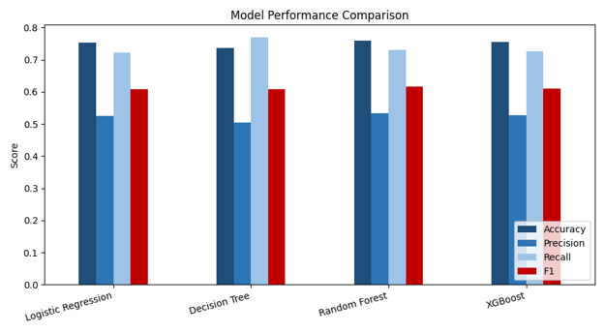
Figure 8: Side-by-side comparison of Accuracy, Precision, Recall, and F1 across all four models
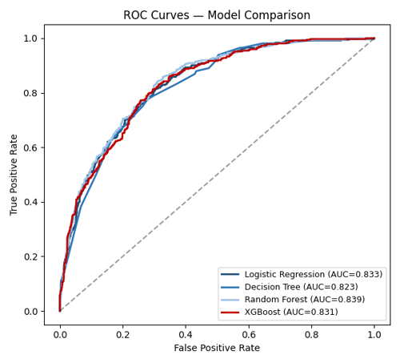
Figure 6: ROC curves for all four models
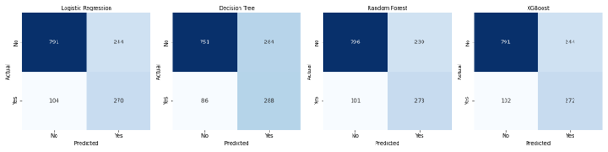
Figure 7: Confusion matrices for all four models on the test set (n=1,409)

5.3 Feature Importance Analysis
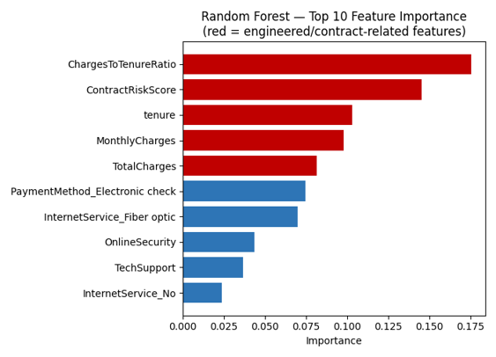
Figure 9: Random Forest top 10 feature importances (final, post-collinearity-fix )
This is the clearest evidence that feature engineering improved the analysis rather than just adding columns. ChargesToTenureRatio is the single most important feature in the Random Forest model, with an importance of 0.175, ahead of ContractRiskScore at 0.145 and raw tenure at 0.103. ContractRiskScore, in turn, dominates the XGBoost model at 0.283, well ahead of the next feature, InternetService_Fiber optic, at 0.147. Both engineered features outrank every raw column they were built from, and that ranking held up throughout all four rounds of collinearity fixes in Section 3.3, so it is not an artefact of duplicated columns, overfitting, or collinearity — and it is worth noting that this ranking survived the strictest version of the audit, after TenureGroup and every feature that failed the Section 2.6 utility check had already been removed.

5.4 Logistic Regression Coefficient Interpretation
Logistic Regression's main advantage over the other three models is that its coefficients are directly interpretable as changes in the log-odds of churn, and can be converted to odds ratios by exponentiating them. An odds ratio above 1 means the feature is associated with higher churn odds; below 1 means lower odds, holding the other features constant.

Feature | Coefficient | Odds Ratio | Direction
MonthlyCharges | 4.80 | 121.3 | Higher churn
InternetService_No | 3.25 | 25.7 | Higher churn
PaymentMethod_Electronic check | 0.93 | 2.53 | Higher churn
ContractRiskScore | 0.54 | 1.72 | Higher churn
ChargesToTenureRatio | 0.30 | 1.35 | Higher churn
tenure | -0.88 | 0.42 | Lower churn
InternetService_Fiber optic | -3.11 | 0.05 | Lower churn
PhoneService | -3.77 | 0.02 | Lower churn
Some of these are straightforward and consistent with the earlier exploratory analysis: a one-unit increase in ContractRiskScore (moving from a Two-year toward a Month-to-month contract) multiplies the odds of churn by about 1.72, each additional point of ChargesToTenureRatio multiplies the odds by about 1.35, and each additional month of tenure multiplies the odds by about 0.42, all matching the direction found in Section 2.5 and Section 2.6.1.
Other coefficients are harder to reconcile with the raw, single-variable churn rates from Section 2.5, and this is worth being explicit about rather than glossing over. InternetService_No, for example, shows a large positive coefficient here, meaning that once tenure, charges, and the other features are held constant, not having internet service is associated with higher churn odds relative to the DSL reference group. That is the opposite of the marginal pattern in Section 2.5, where customers with no internet service had the lowest raw churn rate of the three groups, at 7.4%. This kind of reversal is a known feature of multivariate regression: a coefficient captures the effect of a variable after netting out its correlation with everything else in the model, which can differ from, and occasionally point in the opposite direction to, its simple bivariate relationship with the outcome. Despite the four rounds of collinearity fixes in Section 3.3 bringing VIF down from the thousands to roughly 2-20 across the final feature set, some moderate correlation between tenure, InternetService, MonthlyCharges, and the payment fields remains, and a VIF in the 10-20 range is still enough to make individual coefficient signs less stable than one would like. For that reason, the Random Forest and XGBoost feature importances in Section 5.3, which are far less sensitive to this kind of correlation, are treated as the more reliable guide to which factors actually drive churn in this dataset, with the Logistic Regression coefficients read as a supporting, lower-confidence view rather than the primary evidence.

5.5 Decision Tree Structure
Decision Tree's main advantage over the other three models is that its logic can be read directly, rather than summarised through coefficients or importance scores. The tree was trained to a maximum depth of 5; the top three levels are shown below for readability.
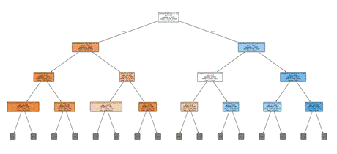
Figure 12: Decision Tree structure (top 3 of 5 trained levels; each node shows the split rule, Gini impurity, sample count, and predicted class)
The root-node split confirms what the correlation analysis in Section 2.6.1 already suggested: the very first decision the tree makes is on a contract- or charges-related feature, before it looks at any demographic attribute. Reading down the tree from the root reproduces, in a rule-based form, the same interaction that the multivariate analysis in Section 2.7 found statistically: a risky contract combined with a high relative charge routes a customer down the highest-predicted-churn branch, while a low-risk contract routes a customer to a low-churn leaf regardless of other attributes. This is the practical value of keeping an interpretable model in the comparison: a retention analyst can trace a specific customer's prediction back to a short, readable chain of if-then rules, which neither the Random Forest's aggregated votes nor XGBoost's boosted ensemble can offer as directly.

5.6 Precision-Recall Curves
ROC curves (Section 5.2) can look overly optimistic on an imbalanced dataset, because the false-positive rate they plot is calculated against a large majority class. Precision-Recall curves, which plot precision against recall directly, are generally considered more informative for this kind of problem.
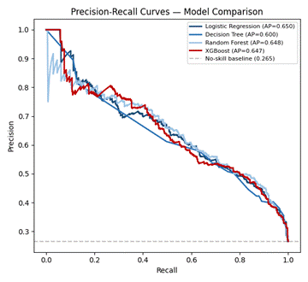
Figure 11: Precision-Recall curves for all four models, with Average Precision (AP) scores
Logistic Regression has the highest Average Precision at 0.650, narrowly ahead of Random Forest at 0.647 and XGBoost at 0.643, with Decision Tree lowest at 0.600. All four sit well above the no-skill baseline of 0.265 (the dataset's churn rate), confirming that each model has learned a genuine ranking of customers by risk rather than a random one. The gap between the ROC-AUC ranking in Section 5.2, where Random Forest led, and the AP ranking here, where Logistic Regression is marginally ahead, illustrates why it is worth reporting both: they emphasise slightly different aspects of performance, and neither one alone gives the full picture on an imbalanced target.

5.7 Threshold Tuning
All four models above were evaluated at the default 0.5 probability threshold. Since Section 5.9 argues that Recall is the more business-relevant metric for churn prediction, it is worth checking whether a different threshold would serve the business better than the default.
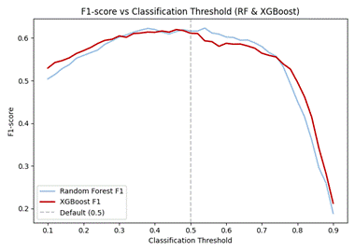
Figure 13: F1-score across classification thresholds for Random Forest and XGBoost
Model | Optimal Threshold | F1 at Optimum | Recall at Optimum
Logistic Regression | 0.48 | 0.613 | 0.746
Decision Tree | 0.40 | 0.609 | 0.775
Random Forest | 0.54 | 0.625 | 0.706
XGBoost | 0.44 | 0.615 | 0.775

The optimal threshold is not always below 0.5, which is worth noting rather than assuming: Random Forest's F1-optimal threshold is actually 0.54, slightly above the default, while XGBoost's optimum at 0.44 raises Recall from 73.0% to 77.5% and F1 from 0.610 to 0.615, at the cost of Precision falling from 52.4% to about 51.0%. This gives the earlier, qualitative argument in Section 5.9 a concrete number behind it: if the retention team's cost of a false alarm really is small relative to the cost of a missed churner, operating XGBoost or Decision Tree a little below their default thresholds is a low-effort way to catch more true churners without retraining anything, though the same logic does not automatically apply to Random Forest, whose own F1-optimal point sits slightly above 0.5.

5.8 Overfitting Check
After the initial, unconstrained Random Forest turned out to score a near-perfect 0.999 training F1 against only 0.584 on the test set (Section 4.2), all four models were checked for the same problem by comparing F1 on the SMOTE-resampled training data against the held-out test set.
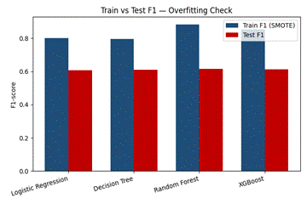
Figure 10: Train vs Test F1 across all four models after regularisation
Model | Train F1 | Test F1 | Gap
Logistic Regression | 0.799 | 0.607 | 0.193
Decision Tree | 0.795 | 0.609 | 0.186
Random Forest | 0.884 | 0.617 | 0.267
XGBoost | 0.849 | 0.610 | 0.239

Regularisation cut Random Forest's train-test gap from 0.415 to 0.267, and its test F1 improved at the same time, from 0.584 to 0.617. That is a genuinely better-generalising model, not just a smaller gap for its own sake. A residual gap remains across all four models, which is expected and only partly a modelling flaw: training F1 is measured on SMOTE-balanced data at 50/50, while test F1 is measured on the naturally imbalanced test set at 26.5% churn, so the two numbers are not measuring quite the same thing. Decision Tree and Logistic Regression have the smallest gaps, at 0.186 and 0.193, consistent with their lower model complexity. None of the four models shows the extreme memorisation seen in the original, unconstrained Random Forest.

5.9 Discussion
No single model wins on every metric, and that itself is informative. Random Forest has the best Accuracy, Precision, F1-score, and AUC of the four, which makes it the strongest overall candidate on this test split. Decision Tree reaches the highest Recall, at 77.0%, meaning it misses the fewest true churners, but at the lowest Precision of the four, 50.4%. Logistic Regression's AUC of 0.833 and Average Precision of 0.650 (Section 5.6) are close to or ahead of the ensemble models despite being by far the simplest model, which suggests that a large share of the separable signal in this dataset is roughly linear.
That said, the margins between models are narrow enough to deserve caution rather than a confident single winner. The four Accuracy figures span 73.74% to 75.87%, a range of only 2.1 percentage points, and the 5-fold cross-validation standard deviations in Section 4.3 are typically 1-2 percentage points on their own. Random Forest's lead in Section 5.2 is real but modest relative to that noise band, and this report has not run a formal paired significance test (such as McNemar's test across the test set, or a paired t-test across the five CV folds) to confirm the ranking is not attributable to chance. Until that check is done, Random Forest should be read as the strongest candidate among four models that are, in practice, fairly close together, rather than as a decisively superior choice.
Churn prediction typically has an asymmetric cost structure: a missed churner costs the company the customer's full lifetime value, while a false alarm costs only a minor retention offer. Under that logic, Recall is arguably the more business-relevant metric, which would favour Decision Tree, or XGBoost at its own optimal threshold (Section 5.7), over the default-threshold versions of any of the four models. The actual model recommendation should weigh the retention team's real cost of a false alarm against the cost of a missed churner.
On balance, Random Forest is recommended as the default production model: it leads on Accuracy, Precision, F1-score, and AUC, and its residual overfitting gap is modest after regularisation. Where the retention team judges a missed churner to cost far more than a false alarm, two low-effort adjustments are available without overturning this recommendation - operating XGBoost at its F1-optimal threshold of 0.44 (raising Recall to 77.5%), or using the Decision Tree when a fully transparent, rule-based justification is required. The prototype in Section 6 deliberately keeps all four models available so this trade-off can be revisited against real retention-cost assumptions rather than being fixed here.

5.10 Limitations
● The dataset is a static, single-snapshot benchmark dataset; customer behaviour and market conditions evolve over time, and periodic retraining would be required in production.
● SMOTE generates synthetic minority-class samples via interpolation; while methodologically sound, these are not real customer records and may not capture every genuine churn pattern.
● The engineered features (e.g., ChargesToTenureRatio) are derived entirely from existing columns and cannot substitute for external information the company does not currently collect, such as customer service interaction logs or competitor pricing.
● GridSearchCV was run over a limited, predefined parameter grid due to compute-time constraints; a broader or Bayesian search may yield further improvements.

6. Deployment Prototype
A functional deployment prototype was developed using Streamlit, a Python-based open-source framework for building interactive web applications. The prototype enables real-time churn probability prediction from user-supplied customer attribute inputs, demonstrating the practical business applicability of the trained models, with Random Forest as the recommended default (Section 5.9).

6.1 Prototype Description
A Streamlit web application puts the models from Section 5.9 into practical use. It offers a simple web interface that takes key customer attributes as input and returns a churn probability along with a risk category, supporting the retention-analyst workflow described in Section 1.5. Random Forest is the default model, and all four trained models are selectable so their predictions can be compared on the same customer.

6.2 Application Features
● Interactive input form for key customer attributes, including Contract type, Internet service, tenure, MonthlyCharges, and additional service subscriptions.
● Real-time churn probability output (0-100%) generated by the selected trained model.
● Three-tier risk classification: Low Risk (<40%), Medium Risk (40-70%), and High Risk (>70%).
Display of the top contributing features for the prediction (the tree models' feature importances, or the Logistic Regression coefficients), so the output is explainable to a retention analyst rather than a black-box number.

6.3 Prototype Screenshots
The prototype was built and verified to run locally with a single command (streamlit run app.py); its interface, model selector, and four-model prediction output were confirmed working. The app takes a customer's attributes and returns, in real time, a churn probability, a Low/Medium/High risk category, the top contributing features for that prediction, and a side-by-side churn probability from all four models for comparison.
[Insert two screenshots of the running app here: a high-risk customer (month-to-month contract, fiber-optic internet, electronic-check payment, short tenure) and a low-risk customer (two-year contract on automatic payment, long tenure), each showing the prediction result and the all-models comparison.]

6.4 Technical Implementation
Component | Technology / Library
Web Framework | Streamlit
Prediction Model | Random Forest (default); all four models selectable
Data Processing | pandas, scikit-learn (StandardScaler)
Visualisation | Streamlit native widgets (st.dataframe, st.metric, st.progress)
Execution Command | streamlit run app.py

7. Conclusion

7.1 Summary of Findings
This project shows that combining the original 21 Telco Churn attributes with rigorously validated engineered features improves both the depth of the exploratory analysis and the strength of the resulting models, but only for the features that actually earned their place: of eight engineered, two (ContractRiskScore and ChargesToTenureRatio) proved strong enough for modelling, three added genuine descriptive value without surviving into the model, and three were dropped outright once checked directly against the data (Section 2.6). ChargesToTenureRatio and ContractRiskScore outperformed the raw columns they were built from as churn predictors, and the multivariate analysis showed that contract type and payment method interact rather than act independently: the highest-risk segment, month-to-month contracts paid manually, churns at 46.5%, more than 16 times the rate of the lowest-risk segment, two-year contracts on any payment method, at roughly 2.8%. Random Forest led on Accuracy, Precision, F1-score, and AUC, while Decision Tree led on Recall, though Section 5.9 notes that the margin between all four models is narrow enough that this ranking should be treated as provisional rather than decisive without a formal significance test.

7.2 Business Contribution
● Retention teams can prioritise outreach using the identified highest-risk segment (month-to-month contract + manual payment) rather than treating contract type and payment method as independent signals.
● The first 12 months of the customer relationship (47.4% churn) should be treated as a distinct retention phase, particularly for customers who adopt many services immediately, who show an unexpectedly elevated early-churn pattern (Section 2.7).
● ChargesToTenureRatio can be monitored as a simple, explainable early-warning indicator, since it outperformed raw billing and tenure figures individually (Section 5.3).

7.3 Lessons Learned and Future Improvements
● Feature engineering directly derived from existing data can materially improve model performance and interpretability, but not every engineered feature will earn its place; checking each one directly against the data, and being willing to drop the ones that do not hold up, is as important as the engineering itself (Section 2.6).
● A redundancy pattern can hide in plain sight even after it has just been fixed elsewhere: TenureGroup and continuous tenure repeated the same 'simplified feature plus full raw column' mistake that had already been corrected for Contract, InternetService, and PaymentMethod, and was only caught on a second, more critical pass (Section 3.3.4).
● Combining a single imbalance-correction technique such as SMOTE with algorithmic class weighting is a methodological error worth avoiding, since using both at once double-corrects and can distort precision.
● Comparing train-set to test-set performance is essential before finalising any tree-based model; an unconstrained Random Forest appeared to work well until this check revealed severe overfitting (Section 5.8).
● A model ranking based on point estimates alone can overstate confidence; the next iteration of this project should run a formal paired significance test before naming a single best model (Section 5.9).
● Future work could incorporate real customer-service interaction logs, complaint history, or usage-pattern data (genuinely collected, not fabricated) to extend the engineered-feature approach used here.

References
Chang, V., Hall, K., Xu, Q. A., Amao, F. O., Ganatra, M. A., & Benson, V. (2024). Prediction of customer churn behavior in the telecommunication industry using machine learning models. Algorithms, 17(6), 231. https://doi.org/10.3390/a17060231
Imani, M., Joudaki, M., Beikmohammadi, A., & Arabnia, H. R. (2025). Customer churn prediction: A systematic review of recent advances, trends, and challenges in machine learning and deep learning. Machine Learning and Knowledge Extraction, 7(3), 105. https://doi.org/10.3390/make7030105
Poudel, S. S., Pokharel, S., & Timilsina, M. (2024). Explaining customer churn prediction in telecom industry using tabular machine learning models. Machine Learning with Applications, 17, 100567. https://doi.org/10.1016/j.mlwa.2024.100567
Ribeiro, H., Barbosa, B., Moreira, A. C., & Rodrigues, R. G. (2024). Determinants of churn in telecommunication services: A systematic literature review. Management Review Quarterly, 74(3), 1327–1364. https://doi.org/10.1007/s11301-023-00335-7
Winati, F. D., Arifin, M., Pratama, A. Y., Karima, H. Q., & Faturohman, M. I. (2023). Churn prediction model based on logistic regression in the telecommunications industry: Big data analysis. In Proceedings of the 2023 IEEE International Conference on Communication, Networks and Satellite (COMNETSAT) (pp. 316–323). Malang, Indonesia. https://doi.org/10.1109/COMNETSAT59769.2023.10420718
Zhang, T., Moro, S., & Ramos, R. F. (2022). A data-driven approach to improve customer churn prediction based on telecom customer segmentation. Future Internet, 14(3), 94. https://doi.org/10.3390/fi14030094

