Official project name : Tourism development application.

Project sponsor : Ministry of tourism.

Project manager : Ghada helal

Purpose of the project : Facilitating Egyptian tourism for tourists through technology sites.

Business case:

Designing an application through which places are booked on trips that have been previously announced in different places \*Contracting with a chain of hotels in different tourist places \*Contracting with bus companies.

The announced flights are booked through the electronic application and payment is made electronically through the application. View the list of trips through the application.

Key deliverables:

Tourism development application that will work on both android and IOS.

Project milestones :

Requirements review : Requirements specifications are complete, correct, approved and suitable. By 1/1/2022

Critical design review: Detailed designs fully implement the system architecture, are approved and are suitable for input into the development of code.

System test review : The software product has passed system testing and is suitable for input into acceptance testing.

Product operational: The software is in use in its target operational environment . by 27/11/2021

Project Resources Staff: 10 Android developers, 10 IOS developers, 10 Back-end developers Hardware: 20 Laptops, 3 Software servers: Software licenses (Editors: gava )

Budget

Get allocated for this project is 150000 L.E.

Constraints This project must be delivered within the specified budget. This project must be delivered by 1/1/2023 Any ordered laptops or computers must be purchased from HP.

Assumptions:

Will get all resources required.

All important stakeholders will come to the specified meetings.

All team members continue to the end of the project.

High level risks:

• An imbalance in the budget.

• Exploitation of street vendors for tourists, lack of good organization, and failure of workers to perform their duties.

• Inaccurate estimates.

• Scope creep : uncontrolled changes and continuous growth of the scope.or scope is ill defined.

• Project team misunderstand requirements.

• Loss of key personnel

• Customer will not accept the software as delivered even though it meets all specifications

• Selected technology is a poor match to the problem or customer

• Project key success criteria not clearly defined to verify the successful completion of each project phase.

• Projects within the program often need the same resources at the same time.

Project scope

Project scope description :

\*A program that makes it easier for tourists to visit Egypt, where the tourist can book and know trips inside Egypt

\*Contributes to the development of tourism to Egypt and the provision of hard currency. .

\*Show new services for tourists that facilitate tourism through modern technology.

Project acceptance criteria:

Beutifull user interface\*

Easy to use, faster and comfortable. \*

\*Effective and content.

Project deliverables:

Save time, effort and money for the tourist. \*

Project plan and reports on the program and method of implementation

Project Exclusions :

\* The customer enters the application and through it he books the flight he wants and books the hotel that he is forced to stay in and pays the trip fees through the site also, then fills in his personal data and has booked the trip he wants in Egypt before coming to it.

Project constraints:

\* budget

\*Time of submit

Project assumptions:

This application canrun only on The IOS and Android Operating system.

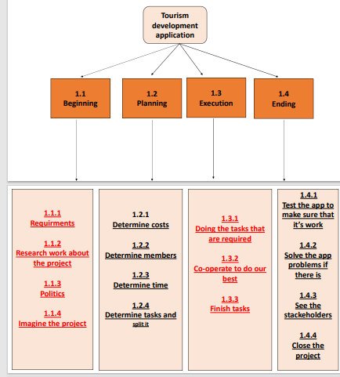

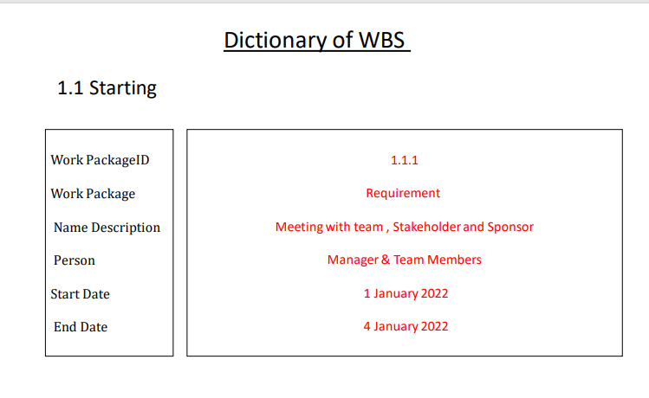

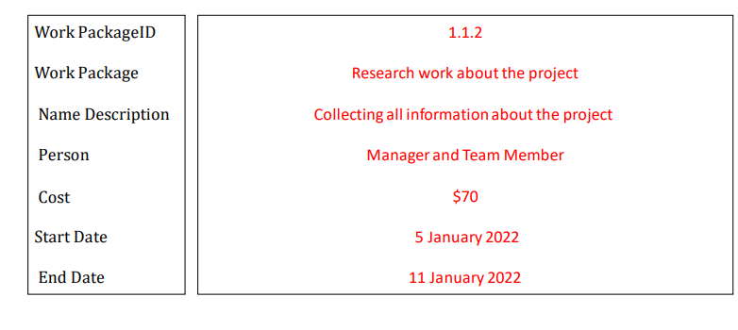

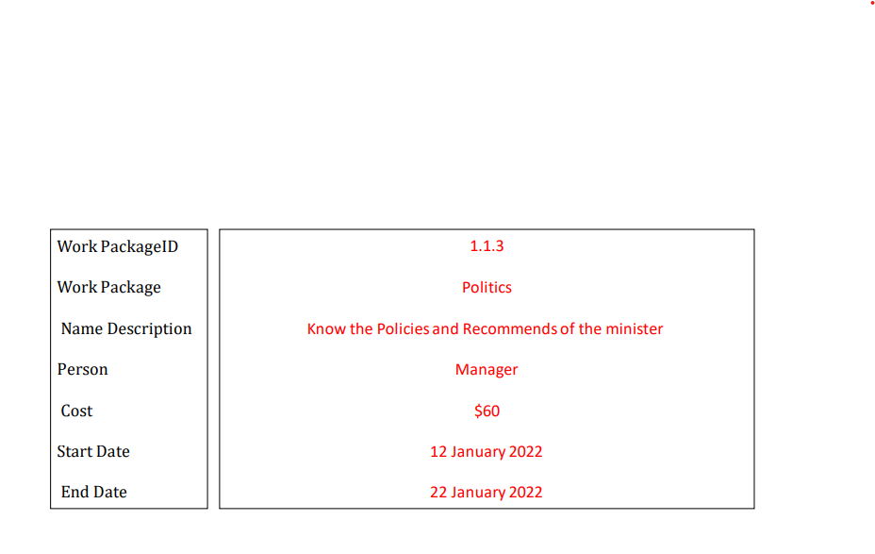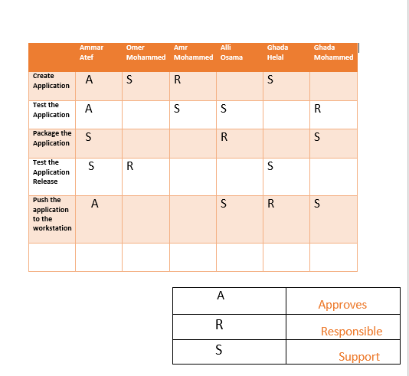.,

\* Network \*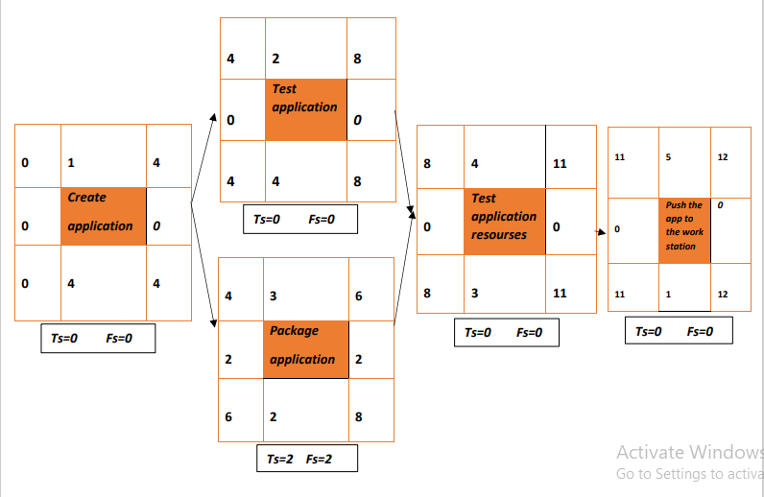

\* Resource-constrained\*

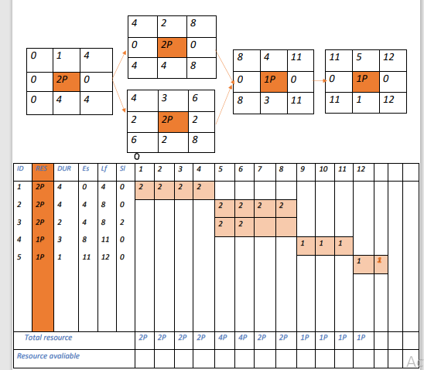

\*Budget \*

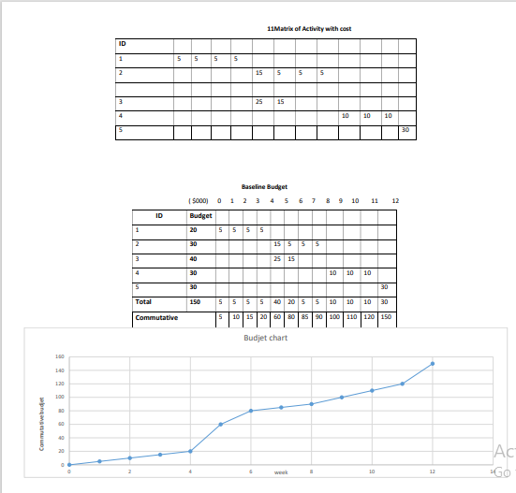

\*Risk\*

Negative Risk

1) Hackers that can hack the app

. 2) Insufficient budget

. 3) Inaccurate information.

4) Internet disconnection.

5) Exploration of street vendors for our tourists ,lack of good organization, and failure of the work ers to do their duites.

6) Lack of confidentiality between workers.

Positive risk

1) Make a change on the app to improve it by keeping up with technology.

2) Hirring some secret workers to ensure the safety of the employees.

3) App that can work on both ios and android.

Solution for risk

1)we can nomination professional programmers to protect the security of the app

. 2)We can have partner in my project to avoid insufficient budget.

3)We can test the information by professional employees to make sure that the information are correct.

4)We can make the app avaliable without internet dis connect.

5)We should spread the principle of cooperation to avoid any problems between workers to do their best and that project.

we can monitor our project by seeing all the tasks that had done and seeing all the work frequently.

Team Members

Ghada Mohammed

Ghada Helal

Ali Osama

. Ammar atef

. omar Mohammed.

Amr Mohammed