Good morning...like I promised, a data dump! LOL I want to first apologize for being late with the data, which corresponds to the second....I was led to believe that our entire historical cephalopod data set was updated, however, that was not the case. I had to spend some time with our zooplankton expert to pull as much data as we had available at this time...hence the longer than expected delay.
So what I have included here is all the entered cephalopoda data we have in our current database (2007 - 2016). Unfortunately, prior to 2020, all cephalopod data was a side note on a paper data sheet. We have over the past few years worked on getting this information, along with our zooplankton data, into electronic form. There is still data that we are working on to get into usable form, so remember, this is only a small chunk of what is available. If it looks like we need to access some of the older data, which goes back to 1982, we can prioritize some of those years.
The SEAMAP plankton surveys historically sampled the Gulf 4-5 times a year depending on funding. We went out in winter (Jan-Mar) sampling shelf and shelf break waters, Spring (April-May) sampling offshore waters off the continental shelf, Summer (June-July) sampling shelf waters typically up to Mobile Bay, Early Fall (Aug-Sept) sampling shelf waters across the Gulf, and Fall (Oct-Nov) sampling shelf waters typically up to Mobile Bay. Some of our Summer and Fall surveys did get over into Florida waters. However, after 2014 we no longer sampled in the Fall and the same with Summer after 2016. I've attached some maps to show you our general gridded universe for each survey (Summer is the same as Fall and the one labeled Fall is our Early Fall survey...sorry for the confusion). Our goal is to try and sample each of those dots every year, so we sample the same location every year. So the data you have will have season and year so you can see what we have in the database for those years. There may be more data, for example, in 2016 we sampled 59 stations during the Summer survey, but that data has not been entered yet. I wanted to at least give you a general idea of what is eventually available.
OK...gear! So I divided the data into our gear types. Our two standard gear types are bongo and neuston. We use these two on every single one of our surveys, so these will be the most consistent ones throughout the time series (1982-current). The bongo is a two 61cm diameter opening frame with a 0.333mm mesh and samples in an oblique tow from the surface down to 200m or ~2m above bottom on shallow stations. The neuston is a 1x2m frame outfitted with a 0.950mm mesh net that is towed half submerged at the surface for 10 minutes.. The other gears are a dual mesh net which uses the bongo frame but is outfitted with a 0.202mm mesh net. The Spanish neuston is the same frame, but uses a 0.505mm mesh net and the tow is multiple oblique tows from the surface down to 10m for 10 minutes. The MOCNESS is a Multiple Opening and Closing Nets and Environmental Sampling System that utilizes 9-0.505mm mesh nets. The Spanish neuston and dual mesh were only used on a handful of surveys. The MOCNESS has been used more frequently, but not as much as the standard bongo or neuston.
Here are the variable descriptions for the data:
VESSEL= Vessel number (I can give you a list if you want)
CRUISE_NO = Cruise number
P_STA_NO = Sequential station number for that cruise
SEAMAP = Designated standard grid number
SAMPLE_NO = Unique sample number
CEPH_COUNT = number of cephalopods counted/pulled
GEAR_ICD = Gear designation (01=bongo, 03=nesuton, 09=MOCNESS, etc.)
GEAR_LOC = sample location (mainly for bongos, R or L)
MESH_ICD = Mesh size (03=0.333mm...I can give you a lst if you need it)
NET_NO = Net number - Mainly for the MOCNESS tows
S_LAT= Latitude in decimal degrees
S_LON = Longitude in decimal degrees
GEAR_IN = Time the gear went into the water (started fishing) in GMT
GEAR_OUT = Time the gear came out of the water (stopped fishing) in GMT
TOWTIME = Time gear was towed (decimal minutes)
MONTH = Month
YEAR = Year
SEASON = Survey season
VESSEL_SPD = vessel speed (knots)
VOL_FILT = volume filtered by the nets (cubic meters)
DEPTH_IBEG = depth of the beginning of the tow (meters)
DEPTH_IEND = depth at the end of the tow (meters)
DEPTH_IMAX = maximum depth of the tow (meters)
VOL_DISP = volume displacement of the sample prior to processing (milliliters)
DEPTH_SSTA = station depth (fathoms)
TEMP_SSURF = surface water temp in Celsius
TEMP_BOT = bottom water temp in Celsius
TEMP_SAIR = air temp in Celsius
B_PRSSR = barometric pressure (millibars)
ITS_CODE = survey code
V_C_P = concatenation of vessel, cruise, and station number
V_C_P_S = concatenation of vessel, cruise, station number. and sample number

I think that's about it for now. I'm sure there will be some questions so we can plan a call/video later if that works for you. You can plot the stations to see years where we may have not gotten full coverage due to hurricanes or ship issues to get an idea of the scope of sampling over the years. Please don't hesitate to contact me with any questions about the data or if you found something that looks crazy. It may very well be crazy, but it could also be an error my code didn't catch and I can fix it. Also, there are some environmental variables that are available for the surveys from after 2000. We conduct a CTD cast at the end of every station so we have corresponding temp, salinity, DO, transmissivity, and fluorescence profiles for samples. Some years may be missing data due to problems with the CTD, but we try and make sure the CTD is working before we leave the dock, but we all know how that can work out! Enjoy and we can talk later!
Cheers,
Glenn

Glenn Zapfe
Research Fishery Biologist
National Oceanic and Atmospheric Administration
National Marine Fisheries Service
Southeast Fisheries Science Center
Mississippi Laboratories
3209 Frederic St.
Pascagoula, MS 39567
228-549-1650

Sorry I forgot to explain that part of the data…it is all presence/absence. So if there were no cephalopod caught the Cephalopod count will be 0 and then if there were paralarvae present then the number will correspond to the number caught. I wanted to make sure you had data from the whole survey. Hope that helps.
Thanks,
Glenn

Yes, all the cephalopods are pulled and are in individual vials for each sample. So for example, if a sample had 3 cephalopods, the vial for that sample will have all 3 paralarvae.
So for the MOC net depths, use DEPTH_IBEG (column U) and DEPTH_IEND (column V) to determine the depths sampled by that particular net. DEPTH_IBEG will be where the net opened (deeper depth unless it is net 0 which will be depth 0 meters) and the DEPTH_IEND will be where the net closed (shallower depth). All those measurements are in meters. GEAR_LOC has the net number, but it doesn't correspond to a standard depth because our tows are done in a wide range of water depths depending on the survey.
There will be CTD data available, but I would like to talk to you about it first.

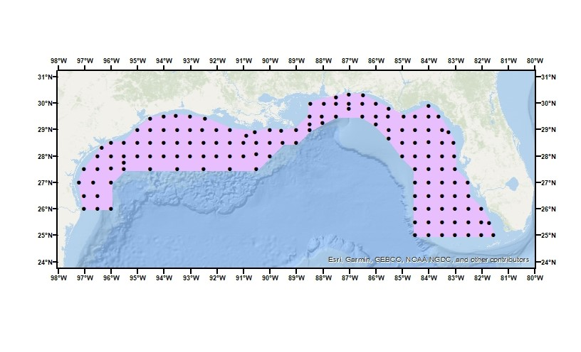
Figure 1 GOM Map Fall (actually early fall) Survey Areas

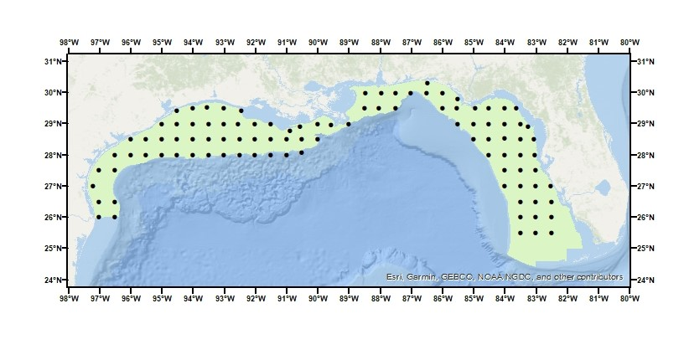
Figure 2 GOM Map Summer (same as Fall) Survey Areas

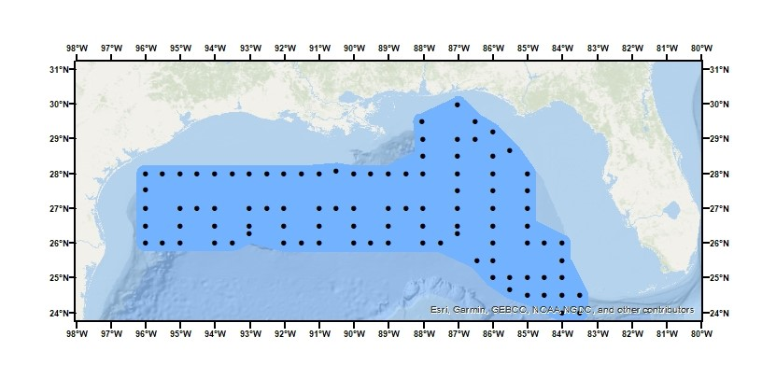
Figure 3 GOM Map Spring Survey Areas

There were no cephalopods sampled at all in winter 2007, so I’ll delete all those samples from my cephs_winter.xlsx file.
There were no cephalopods sampled at all in spring 2011, so I’ll delete all those samples from my cephs_spring.xlsx file.
There were no cephalopods sampled at all in early fall 2012 or 2013, so I’ll delete all those samples from my cephs_earlyFall.xlsx file.

Winter sampling (3 surveys): 2007 (no cephs), 2009, 2012
Spring sampling (3 surveys): 2011 (no cephs), 2012, 2013
Early fall sampling (6 surveys): 2009, 2010, 2011, 2012 (no cephs), 2013 (no cephs), 2016
Year | Winter | Spring | Early Fall
2007 | 25 sites (no cephs) (5 sites w/o SEAMAP sta no) | - | -
2008 | - | - | -
2009 | 45 sites (all SEAMAP sta no) | - | 9 sites (all SEA sta no)
2010 | - | - | 27 sites (6 w/o SE sta no)
2011 | - | 8 sites (no cephs) (2 w/o st no) | 12 sites (all SEA sta no)
2012 | 17 sites (all SEAMAP sta no) | 23 sites (9 w/o SEAMAP sta no) | 11 sites (no cephs)(all no)
2013 | - | 15 sites (all SEAMAP sta no) | 17 sites (no cephs)(1 w/o)
2014 | - | - | -
2015 | - | - | -
2016 | - | - | 20 sites (all SEA sta no)

Overall: 119 unique sites were occupied during all of the cruises

Survey overlaps – need to update
How many winter sites overlap: 2009 vs. 2012 - 12 sites, 2007 vs. 2009 - 21 sites, 2007 vs. 2012 - 11 sites
2009 vs. 2012 - 12 sites, 2007 vs. 2009 - 16 sites, 2007 vs. 2012 - 7 sites
How many spring sites overlap: 2011 vs. 2012 - 1 site, 2011 vs. 2013 - 0 sites, 2012 vs. 2013 - 1 site
How many early fall sites overlap: 2009 vs. 2010 - 0 sites, 2009 vs. 2011 - 5 sites, 2009 vs. 2012 - 3 sites,
2009 vs. 2013 - 0 sites, 2009 vs. 2016 - 8 sites, 2010 vs. 2011 - 0 sites, 2010 vs. 2012 - 0 sites, 2010 vs. 2013 - 4 sites, 2010 vs. 2016 - 1 site, 2011 vs. 2012 - 3 sites, 2011 vs. 2013 - 1 site, 2011 vs. 2016 - 10 sites, 2012 vs. 2013 - 2 sites, 2012 vs. 2016 - 6 sites, 2013 vs. 2016 - 7 sites

Gave winter 2007 station number 00039 the SEAMAP label B150
Gave winter 2007 station number 00041 the SEAMAP label B144
Gave winter 2007 station number 00042 the SEAMAP label B154
Gave winter 2007 station number 00043 the SEAMAP label B169
Gave winter 2007 station number 00044 the SEAMAP label B171
Spring 2011 station numbers 00224 and 00228 don’t match any SEAMAP sites, so gave them the numbers A001 and A002 respectively
Gave spring 2012 station number 00132 the SEAMAP label B249
The other spring 2012 station numbers don’t match any SEAMAP sites, so gave them the following numbers: 00130 – A003, 00134 – A004, 00142 – A005, 00165 – A006, 00184 – A007, 00185 – A008, 00202 – A009, 00208 – A010
Gave early fall 2010 station number 00145 the SEAMAP label B131
Gave early fall 2010 station number 00093 the SEAMAP label B160
Gave early fall 2010 station number 00072 the SEAMAP label B170
Gave early fall 2010 station number 00082 the SEAMAP label B165
Early Fall 2010 station numbers 00142 and 00054 don’t match any SEAMAP sites, so gave them the numbers A011 and A012 respectively
Early Fall 2010 station number 00174 doesn’t match any SEAMAP site, so gave it the number A013

930/1235 samples have volume displaced measurements – will use linear interpolation to fill in the rest (305 samples, which is 25% of the samples)

