Supplementary Materials: Distribution of genetic paternity in primate groups
Stacy Rosenbaum, Nicholas Grebe, and Joan B. Silk

1. Bayesian model diagnostics
Table S1 summarizes convergence diagnostics for the Bayesian models reported in the main text. Q1 refers to the models used to answer Question 1 in the results in the main text; Q2/A1 and Q2/A2 refer to Question 2, Analysis 1 and 2 respectively, and Q3 refers to Question 3. Figures S1–S5 show the posterior predictive checks for each of these models. In each plot, the dark blue line represents the observed data distribution, and the lighter blue lines represent distributions simulated from the fitted model’s posterior. Significant overlap between the observed and simulated distributions indicates that the model captured the important features of the data.
Table S1. Bayesian model convergence diagnostics
Model
MaxRhat
MinBulk ESS
MinTail ESS
Divergenttransitions
Q1: Phylogeny (Intercept-only, max)
1.0011
3414
5076
0
Q1: Phylogeny (Intercept-only, min)
1.0029
2341
3157
0
Q2/A1: Group composition
1.0003
3915
4164
0
Q2/A2: Competition/seasonality
1.0004
4176
4588
0
Q3: Paternity loss source
1.0002
4187
4666
0

Posterior Predictive Checks
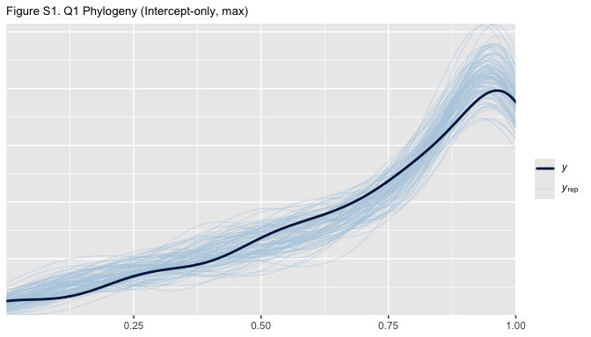
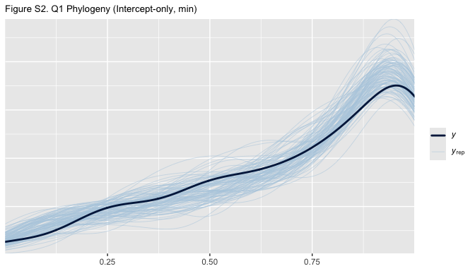
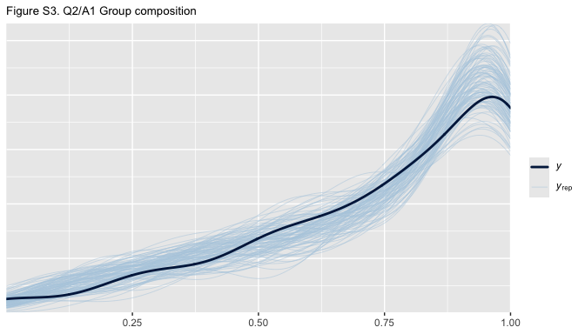
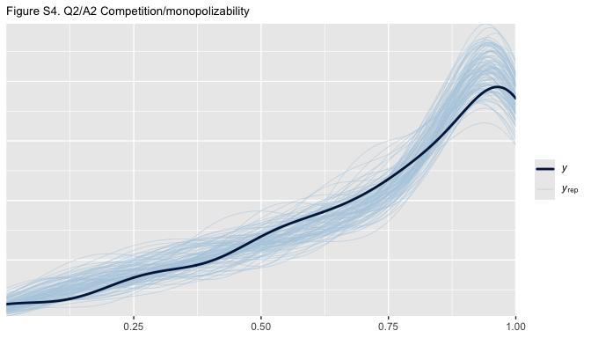
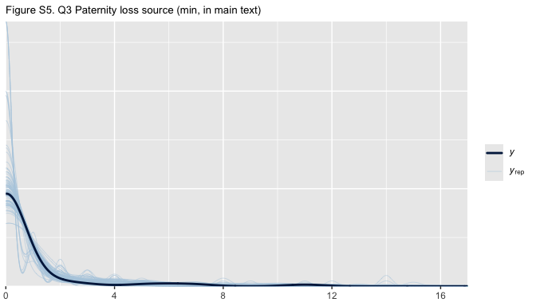

2. Sensitivity analysis: assignment of uncertain paternities

A. The effects of group composition (Question 2, Analysis 1 in main text)
In the main text the models for Question 2 use the maximum possible estimate of primary male paternity share. I.e., all uncertain paternities are assigned to primary males. For comparison purposes, here we present results from those models alongside results from models using minimum estimates, in which none of the uncertain paternities are assigned to primary males.
Table S2. Model results: Maximum primary male paternity share (in main text)
Parameter
Estimate
Est.Error
l-95% CI
u-95% CI
Rhat
Bulk_ESS
Tail_ESS
Intercept (Multi-male)
0.405
0.476
−0.622
1.286
1.000
17,269
13,670
Pair-living
0.482
0.300
−0.096
1.074
1.000
26,371
15,790
Single-male/multi-female
0.964
0.172
0.628
1.307
1.000
29,322
14,819
Table S3. Model results: Minimum primary male paternity share
Parameter
Estimate
Est.Error
l-95% CI
u-95% CI
Rhat
Bulk_ESS
Tail_ESS
Intercept (Multi-male)
0.244
0.434
−0.723
1.032
1.001
12,258
10,985
Pair-living
0.705
0.291
0.136
1.277
1.000
19,555
15,331
Single-male/multi-female
1.333
0.165
1.010
1.660
1.000
23,841
15,093
Table S4. Predicted paternity share using maximum estimate (in main text)
Group type
Mean
95% CI
Multi-male
59.6%
34.9% - 78.3%
Pair-living
69.9%
46.2% - 85.6%
Single-male/multi-female
78.6%
57.9% - 90.8%
Table S5. Predicted paternity share using minimum estimate
Group type
Mean
95% CI
Multi-male
55.9%
32.7% - 73.7%
Pair-living
71.3%
49.2% - 85.4%
Single-male/multi-female
82.0%
63.9% - 91.6%

B. The effects of in-group competition and seasonality (Question 2, Analysis 2 in main text)
Table S6. Model results: Maximum primary male paternity share (in main text)
Parameter
Estimate
Est.Error
l-95% CI
u-95% CI
Rhat
Bulk_ESS
Tail_ESS
Intercept
−0.332
0.958
−2.214
1.542
1.000
23,627
15,987
Competition1
0.780
0.479
−0.152
1.702
1.000
21,751
14,993
Seasonality
0.649
0.824
−0.968
2.249
1.000
20,675
15,702
Seasonality^2
−0.162
0.214
−0.578
0.263
1.000
18,262
15,203
Competition*Seasonality
0.051
0.239
−0.415
0.524
1.000
21,846
14,552
1 Single-male versus multi-male group
Table S7. Model results: Minimum primary male paternity share
Parameter
Estimate
Est.Error
l-95% CI
u-95% CI
Rhat
Bulk_ESS
Tail_ESS
Intercept
−0.208
0.953
−2.075
1.687
1.000
16,474
14,827
Competition1
0.908
0.458
0.014
1.809
1.000
15,966
14,648
Seasonality
0.493
0.809
−1.118
2.068
1.000
14,675
14,878
Seasonality^2
−0.177
0.204
−0.576
0.229
1.000
13,414
13,925
Competition*Seasonality
0.169
0.230
−0.281
0.617
1.000
15,660
14,594
1 Single-male versus multi-male group
Comparing the conditional effect of in-group competition between models Because the competition/seasonality models presented above contain interaction terms, the main effect of competition cannot be interpreted in isolation. In the below tables we compute the conditional effect of competition (i.e., the difference in predicted paternity share between single-male and multi-male groups) at different levels of seasonality for both the maximum and minimum paternity share models. The purpose of this is to determine whether the difference in the main effect coefficient on the competition parameter leads to a substantively different conclusion.
Table S8. Conditional effect of competition (maximum estimate)
Seasonality
Multi-male predicted
Single-male predicted
Difference
95% CI
Most seasonal
53.7%
71.6%
17.9%
6.2% to 30.3%
Moderately seasonal
57.6%
75.8%
18.2%
9.8% to 27.0%
Least seasonal
53.7%
73.0%
19.3%
6.1% to 33.9%
Table S9. Conditional effect of competition (minimum estimate)
Seasonality
Multi-male predicted
Single-male predicted
Difference
95% CI
Most seasonal
52.5%
75.3%
22.8%
10.9% to 34.8%
Moderately seasonal
51.7%
77.8%
26.1%
16.7% to 35.0%
Least seasonal
42.7%
73.1%
30.4%
16.1% to 44.0%
Interpretation In both models, competition has a meaningful effect on primary male paternity share: males in single-male groups are predicted to obtain a substantially higher share of paternities than males in multi-male groups at all levels of seasonality. However, the minimum estimate model produces larger point estimates for this effect (~23-30% difference versus ~18-19% difference in the maximum estimate model). This is not surprising. Reassigning uncertain paternities away from primary males disproportionately reduces the predicted primary male paternity share in multi-male groups, where most of the ambiguity in paternity assignment occurs. However, there is considerable overlap in the 95% credible intervals between the two models at every level of seasonality. Thus, these two different methods of operationalizing primary male paternity share do not ultimately yield distinguishable estimates of the effect of competition. The qualitative conclusion (that competition is an important predictor of primary male paternity share, while seasonality is not) is robust to the decisions we made about how to handle uncertain paternities.

C. Source of paternity losses in multi-male groups (Question 3 in main text)
In the main text we model the proportion of lost paternities attributable to extra-group males versus non-primary resident males using the minimum extra-group paternity (EGP) count (i.e., only confirmed extra-group paternities). Here we present that model alongside a model using the maximum possible EGP count, in which ambiguous paternities are assigned to extra-group males. Results are qualitatively similar regardless of which choice is made.
Table S10. Paternity loss source model: Minimum EGP count (in main text)
Parameter
Estimate
Est.Error
l-95% CI
u-95% CI
Rhat
Bulk_ESS
Tail_ESS
Intercept
−1.294
1.060
−3.290
0.823
1.000
9,531
10,218
Table S11. Paternity loss source model: Maximum EGP count
Parameter
Estimate
Est.Error
l-95% CI
u-95% CI
Rhat
Bulk_ESS
Tail_ESS
Intercept
−1.055
0.889
−2.620
0.818
1.000
6,798
12,667
Table S12. Predicted paternity loss source: Minimum EGP count (in main text)
Loss source
Mean
95% CI
Extra-group males
25.7%
3.6% - 69.5%
Non-primary resident males
74.3%
30.5% - 96.4%
Table S13. Predicted paternity loss source: Maximum EGP count
Loss source
Mean
95% CI
Extra-group males
28.6%
6.8% - 69.4%
Non-primary resident males
71.4%
30.6% - 93.2%

