Template Name | Public Transport Harassment Reporting System
Goals & Objective | The goal of this mobile application is to provide a safe, simple, and anonymous platform for reporting harassment in public transport and ensuring quick emergency support.  From this website, users/miners can :  -Report harassment incidents quickly and anonymously  -Access emergency support (999)  -View safety alerts and high-risk areas  -Manage user profile
Client Information
Product Type | Mobile Application
Domain | Web2
Access Layers | User, admin
Design Required | Yes

Phase | Item No | Specification [Role] | Screen Definition | User Story | Acceptance Criteria | UI Screen / Wireframe | Tags
Feature: 1 |  | Auth Feature
phase 1 | 1 | Signup [admin] [User] | <Form>  <input: filename>  <input: email>  <input: phone>  <input: password>  <input: confirm password>  <button: create account>  <button: continue anonymous>  <link: login> | As a new user I want to create an account using my phone/email  So that I can access the service platform. | Full Name field must not be empty.  → Show error: “Full name is required”  Email field must accept only valid email format.  → Show error: “Enter a valid email address”  → If already registered: “Email already in use”  Phone Number must be valid (11 digits, numeric).  → Show error: “Enter a valid phone number”  Password must be at least 8 characters long.  → Should include letters and numbers  → Show error if invalid: “Password must be at least 8 characters”  Confirm Password must match Password.  → Show error: “Passwords do not match”  Password strength indicator should update dynamically (Weak / Medium / Strong)  All required fields must be filled before enabling Create Account button  On clicking Create Account:  If all inputs are valid → account is created successfully  User is redirected to dashboard / home screen  On clicking Continue as Anonymous:  User is redirected to app without registration  On clicking Login:  User is redirected to Login screen  System should store user data securely in database | 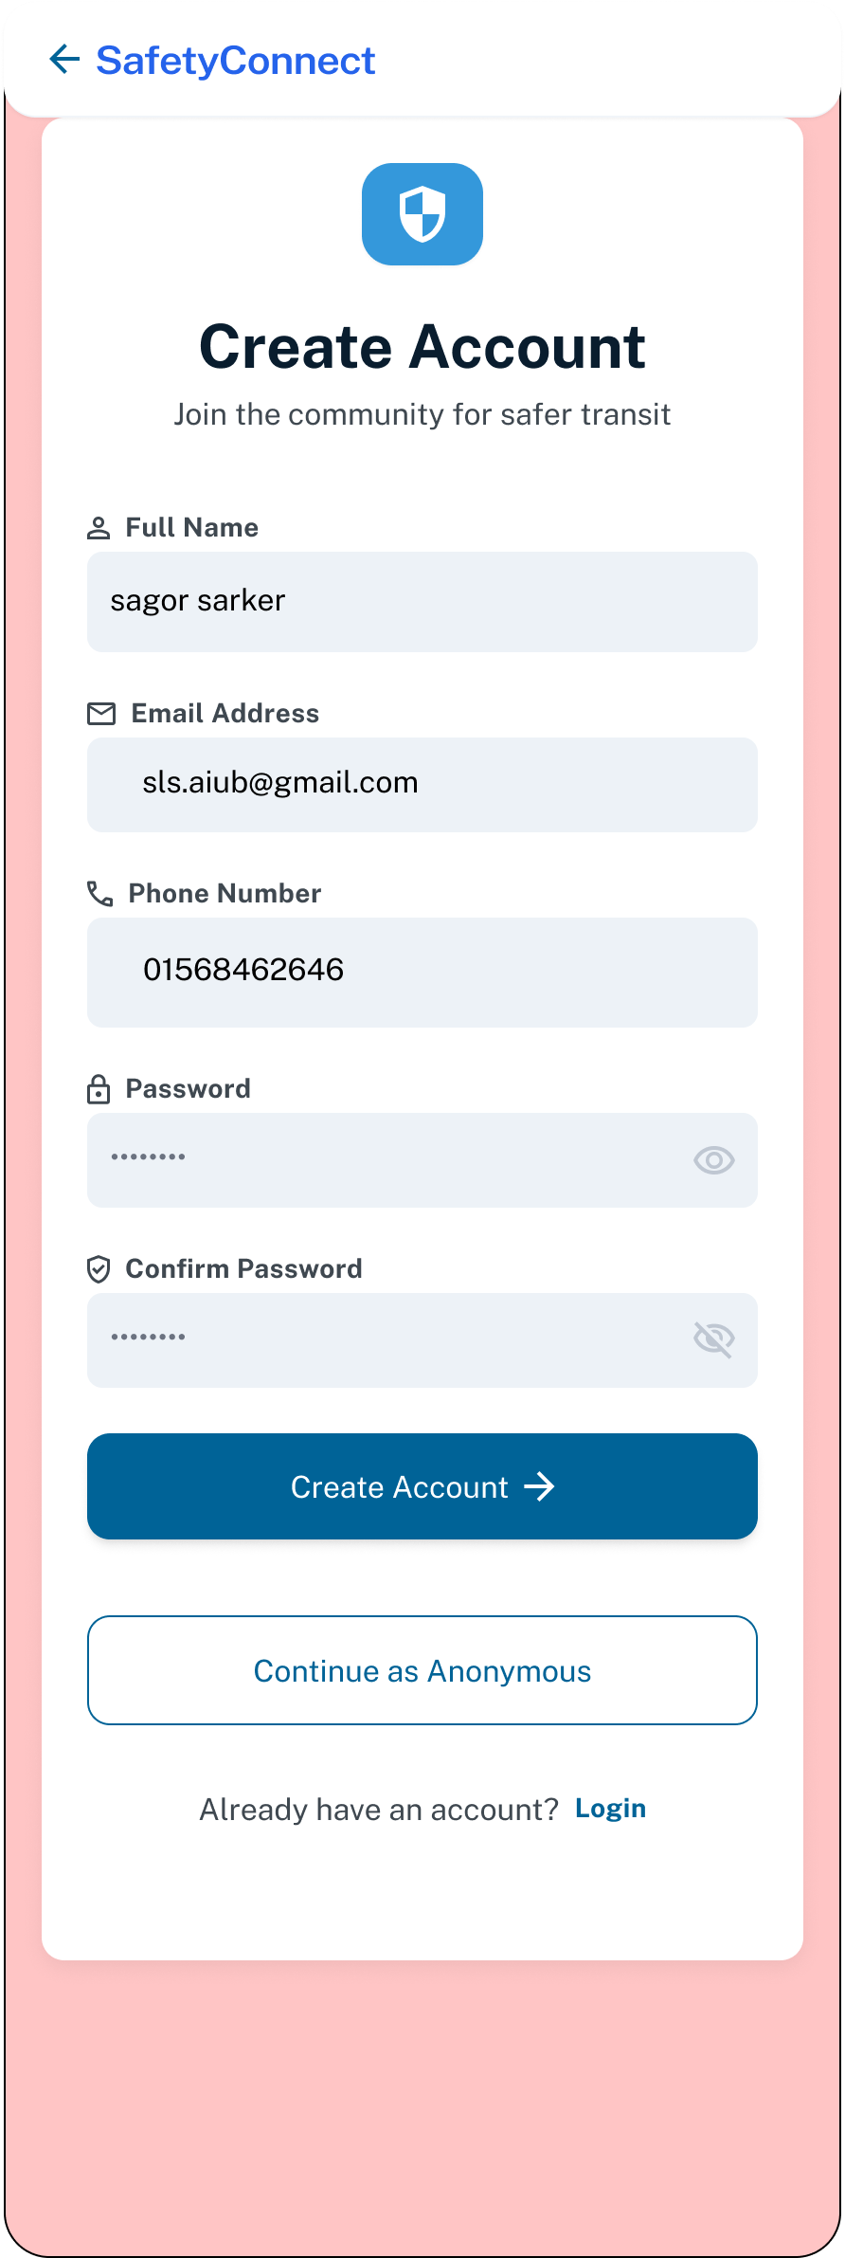 | signup
phase 1 | 2 | Sign in [admin] [User] | <Form>  <input: email_or_phone>  <input: password>  <button: login>  <button: continue anonymous>  <link forgot password>  <link: signup> | As a registered user  I want to log in securely with my credentials So that I can access my dashboard. | Email/Phone field must not be empty  → Show error: “Email or phone number is required”  User can login using:  Registered email OR  Registered phone number  Password field must not be empty  → Show error: “Password is required”  Password input should be hidden/masked by default  Invalid credentials should show error  → “Invalid email/phone or password”  On successful login:  User is redirected to dashboard/home screen  Session/token is created  Clicking “Forgot Password” redirects user to password recovery screen  Clicking “Continue as Anonymous” allows guest access  Clicking “Sign Up” redirects user to registration screen  System should securely validate user credentials from database  Login button should work only when required fields are filled | 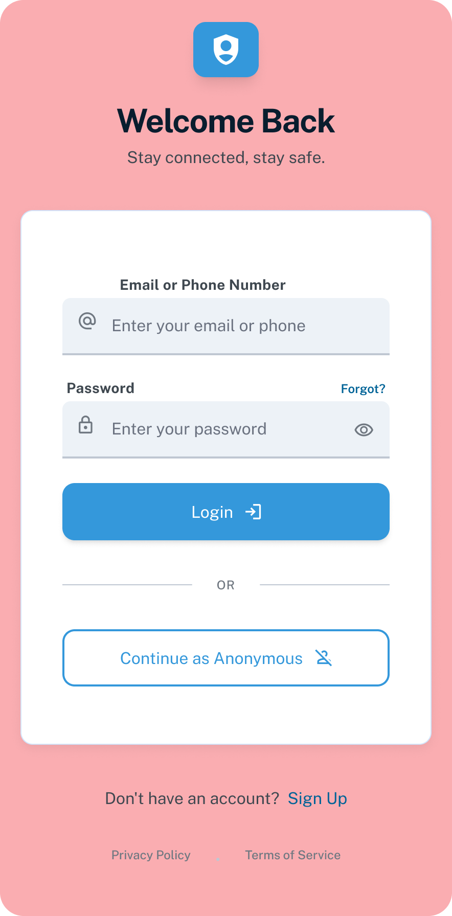 | signin
phase 1 | 3 | Forgot password[admin] [User] | <Form>  <input: email_or_phone>  <button: send_otp_reset_link>  <link: back_to_login> | As a user I want to reset my forgotten password  So that I can recover access to my account’s | Email/Phone field must not be empty  → Show error: “Email or phone number is required”  System should accept:  Registered email OR  Registered phone number  Invalid or unregistered input should show error  → “Account not found”  Email format should be validated if email is entered  On clicking “Send OTP / Reset Link”:  OTP or reset link is sent successfully  Success message displayed to user  User should be redirected to OTP Verification or Reset Password screen  Clicking “Back to Login” redirects user to Login screen  Reset link or OTP should expire after a limited time  System should securely handle password recovery requests | 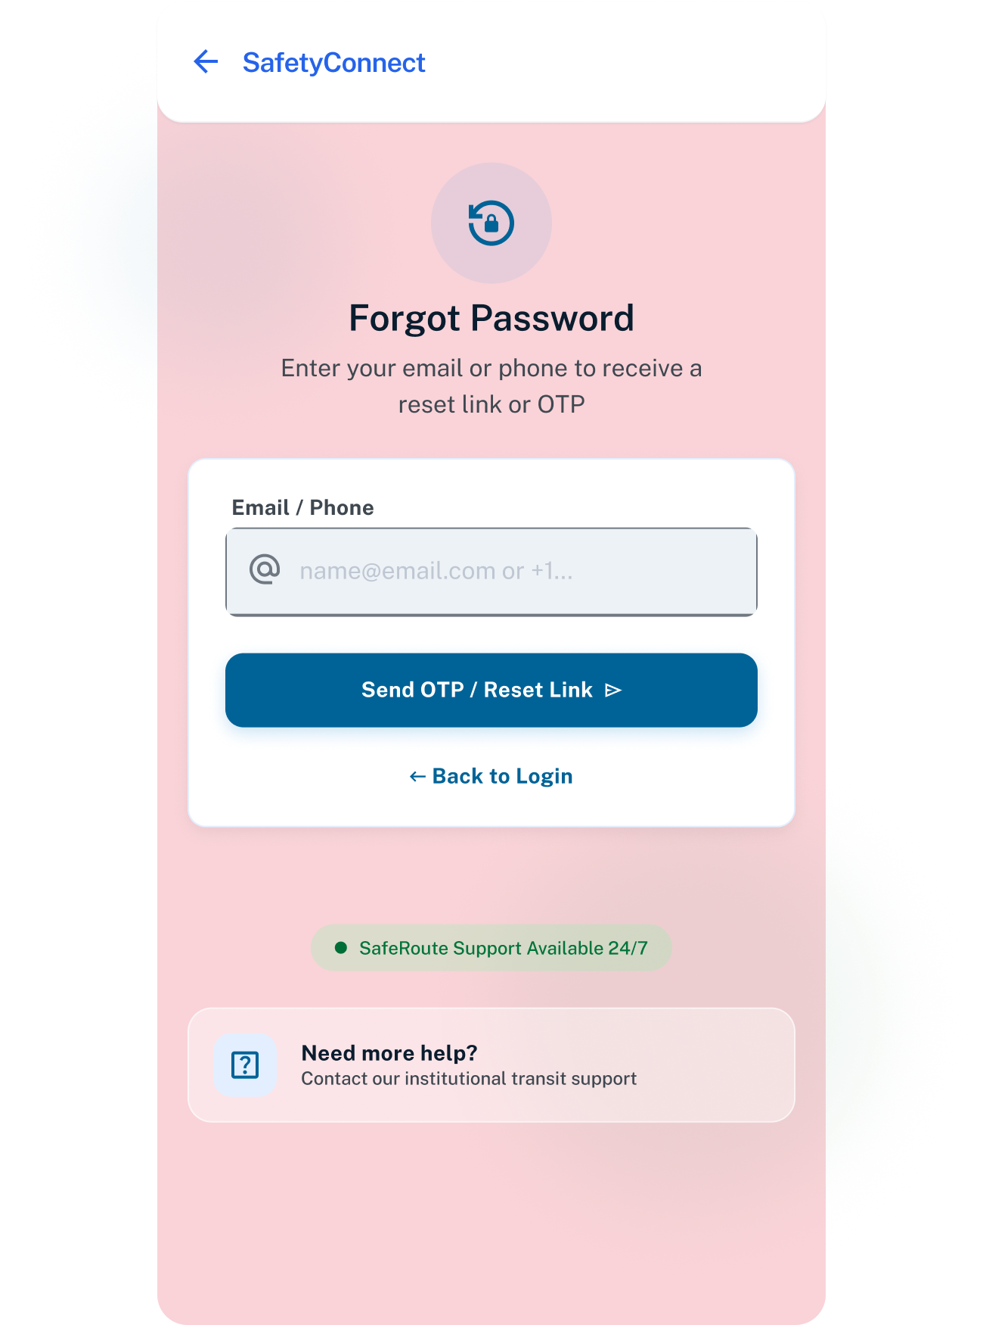 | forgot password
Feature: 2 |  | Dashboard
phase 1 | 4 | Menu [User] | <Dashboard>  <section: welcome header>  <section: safety status>  <card: safe_route_finder>  <button: find_best_route>  <card: report incident>  <card: safety heatmap>  <card: my reports>  <section: recent alerts>  <link: view_all_alerts> | As a general user, I want to see and access all essential features from the menu after login, so that I can easily report incidents, view safety information, and manage my profile. | -User name should display correctly after login  Current safety status should be visible and updated dynamically  Safe Route Finder card should open route/navigation feature  “Find Best Route” button should navigate user to route selection/map screen  “Report Incident” card should redirect user to incident reporting screen  “Safety Heatmap” card should open crime/safety heatmap view  “My Reports” card should display previously submitted reports  Recent alerts section should display latest safety notifications  Clicking “View All Alerts” should open full alerts/history page  Dashboard data should load successfully from server/database  Screen should be responsive and accessible on mobile devices | 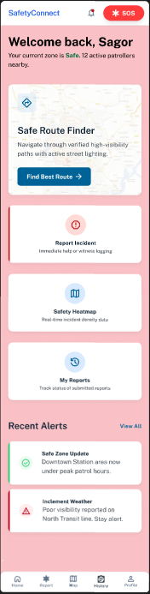 | Menu
phase 1 | 5 | Menu[admin] | <Dashboard>  <card: total reports>  <card: active cases>  <card: high_risk_zones>  <section: weekly_trend_chart>  <section: recent alerts>  <link: view_all_alerts>  <button: floating_action_button> | As an admin, I want to access administrative tools from the menu, so that I can monitor reports, manage users, and analyze system data effectively. | -Dashboard should display current system status correctly  Total Reports card should show total submitted reports count  Active Cases card should display ongoing case count  High Risk Zones card should display total critical zones  Weekly Trend chart should visualize report/activity trends dynamically  Recent Alerts section should display latest incident alerts  “View All” should redirect admin to complete alerts/history page  Floating Action Button should open quick action menu or report creation screen  Dashboard data should load from database/server successfully  Statistical data should update in real time or after refresh  Screen should be responsive and accessible on mobile devices | 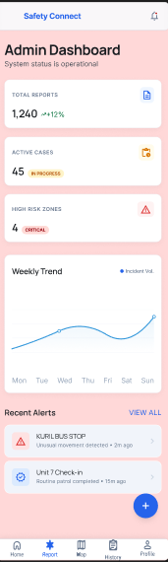
phase 1 | 6 | Dashboard [admin] [User] | <Incident Reports>  <navbar>  <tabs>  - all reports  - active alerts  - reviewing  - flagged  <report card>  <button: mark reviewing>  <button: flag emergency>  <button: view details>  <button: archive>  <floating_action_button> | As a user/admin, I want to see a role-based dashboard after login, so that I can quickly understand relevant information and take actions. | - User should see recent reports after login  - User should see safety alerts  - Emergency button must be visible and clickable  - Emergency button must initiate call to 999  - Admin should see total reports  - Admin should see high-risk areas  - Admin should see time-based analysis  - Admin should access detailed reports  - System must show different content based on role  - Dashboard should load successfully after login. | 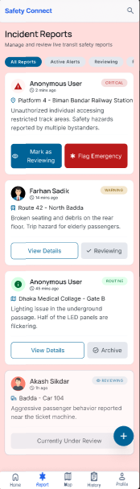
Feature: 3 |  | Top bar and Bottom Bar
phase 1 | 7 | Top Bar [User/Admin] | <logo: SafetyConnect>  <icon: notifications>  <button: sos> | As a user I want quick navigation and emergency access so that I can use system efficiently | - Logo click → redirect to home page  - Navigation links must work correctly  - Notification icon shows unread alerts count  - Clicking notification shows recent alerts list  - Panic button always visible & clickable  - Panic click → triggers emergency alert instantly  - Show logged-in username dynamically  - Profile dropdown must work (profile/settings/logout)  - Logout → clear session/token/cookie  - After logout → restricted pages inaccessible | 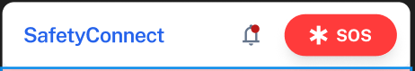
phase 1 | 8 | Bottom Bar [All] | <nav_bottom>  <menu: home>  <menu: report>  <menu: map>  <menu: history>  <menu: profile> | As a user I want access to support and legal info so that I feel secure using the system | - All menu items display correctly  - Navigation redirects properly  - Active menu highlights correctly  - Bottom bar remains fixed  - Responsive on mobile devices | 
Feature: 4 |  | Dual-Mode Reporting System
phase 2 | 9 | Report Incident [user] | <input = location (auto GPS)>  <input = incident type>  <input = time (auto)>  <input = description>  <input = upload evidence (optional)>  <button = emergency (call 999)>  <button = submit report> | As a user, I want to quickly report an incident using automatic location and minimal input, so that I can inform authorities efficiently, even in emergency situations. | - Navigation buttons work properly  - Transport type selection works  - GPS/manual location input works  - Incident description is required  - Incident tag selection works  File Upload:  - Photo: .jpg, .jpeg, .png (Max 5 MB)  - Video: .mp4, .mov, .avi (Max 20 MB)  - Audio: .mp3, .wav, .m4a (Max 10 MB)  - Invalid format/size shows error message  - Anonymous reporting toggle works  - Submit button works after valid input  - Report stores successfully in database  - Responsive on mobile devices | 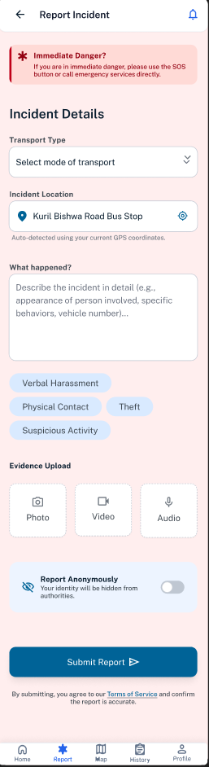
Feature: 10 |  | Profile
phase 1 | 15 | View Profile[admin][user] | <table>  Name  Email  Phone  Date of Birth  gender  user type  edit | As a user/admin, I want to view my profile information, so that I can check my personal details and account information. | - No null values  - Edit button should take user to edit page | 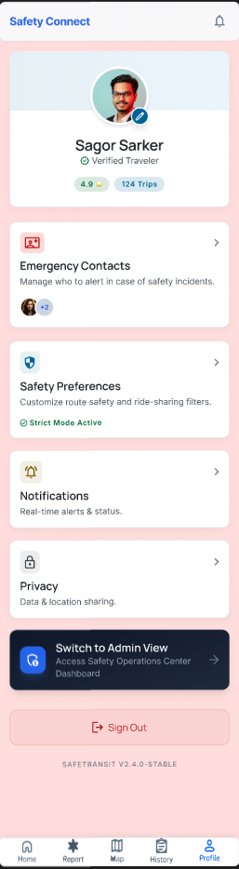
phase 1 | 16 | Edit Profile[admin][user] | <table>  <input = Name >  <input = Email >  <input = Phone >  <date input = Date of Birth >  <radio button = gender >  <button = save > | As a user/admin  I want to edit my personal details (name, phone number, email, address) So that my profile stays accurate and updated. | - No null values  - email should be in correct format [xyz@abc.com]  - phone number should be in correct format [11 digits]  - date of birth should be in at least 15 years  - clicking save button will either promt with an error if above rules do not meet or a promt notifying the user about successful change
phase 1 | 17 | Change Profile Photo[admin][user] | <table>  <current image>  <input type="file">  <button = confirm> | As a user/admin I want to upload or change my  profile photo So that I can personalize my account and help service providers identify me. | - current image/ default image is shown  - input file should be an image and not any other format [png,jpg format]  - cofirm button should redirect user to view profile page
phase 1 | 18 | Change Password[admin][user] | <table>  <input type="password"> current password  <input type="password"> new password  <input type="password"> confirm password  <button=change> | As a user/admin I want to  change my password from the  profile/settings section So that I can maintain my account’s security. | - user can type current password [it should match database password]  - Password (input) should be minimum 8 characters long. Otherwise show an invalid message.  - Re-password (input) should match password. Otherwise show 'password do not match' message.  - On clicking signup button, credential will be stored in database, user will be prompted with a message. [successfully changed / something went wrong]

2.3.2 Non-Functional Requirements
Req ID | Requirement Type | Category | Description | Priority
NFR-01 | Non-Functional | Performance | Incident reports shall be submitted within ≤ 3 seconds under normal internet conditions | High
NFR-02 | Non-Functional | Performance | Safe route recommendation results shall load within ≤ 5 seconds | High
NFR-03 | Non-Functional | Integrity | System shall use secure user authentication and encrypted passwords | High
NFR-04 | Non-Functional | Availability | System shall remain operational during peak usage hours without major downtime | High
NFR-05 | Non-Functional | Flexibility | System shall support future integration of new transport services and safety features | Medium
NFR-06 | Non-Functional | Integrity | Uploaded evidence files shall remain unchanged and securely stored | High
NFR-07 | Non-Functional | Reliability | The application shall recover automatically after minor crashes or interruptions | High
NFR-08 | Non-Functional | Robustness | System shall handle invalid inputs and unexpected user actions without crashing | High
NFR-09 | Non-Functional | Scalability | New users shall be able to understand core features without training | High
NFR-10 | Non-Functional | Maintainability | Developers shall be able to modify modules independently without affecting the entire system | Medium
NFR-11 | Non-Functional | Portability | The application shall support installation on different Android device brands | Medium
NFR-12 | Non-Functional | Reusability | Authentication and notification modules shall be reusable in future projects | Medium
NFR-13 | Non-Functional | Flexibility | System shall support future feature updates without major downtime | Medium
NFR-14 | Non-Functional | Testability | System modules shall support unit testing and integration testing | Medium
NFR-15 | Non-Functional | Performance | Uploaded media files shall be processed without significant delay | Medium
NFR-16 | Non-Functional | Interoperability | System shall integrate properly with GPS, Map APIs, and notification services | High
NFR-17 | Non-Functional | Scalability | System shall support increasing database size without major performance degradation | Medium
NFR-18 | Non-Functional | Privacy | Personal and location data shall be anonymized and protected | High
NFR-19 | Non-Functional | Efficiency | Application screens shall load smoothly without noticeable lag | Medium
NFR-20 | Non-Functional | Usability | Navigation between screens shall be intuitive and easy for all users | Medium

