Samantha Sevilla

BINF690

Chapter 25.5

Homework

Solve equation using:

1. Heun’s method without corrector (AKA Euler’s Method)

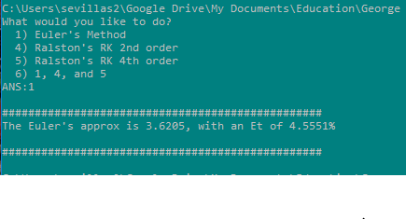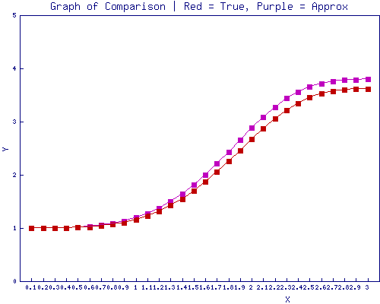

1. Ralstons’ 2nd order RK method

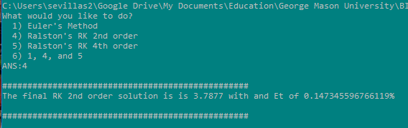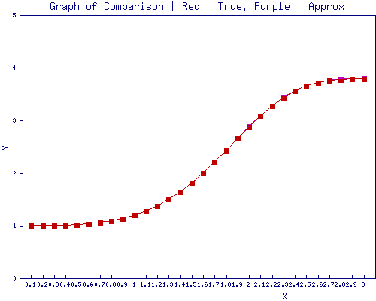

1. Ralstons’ 4th order RK method

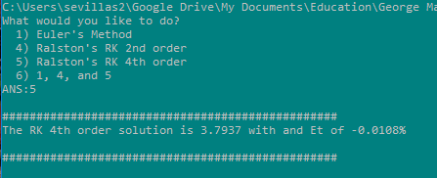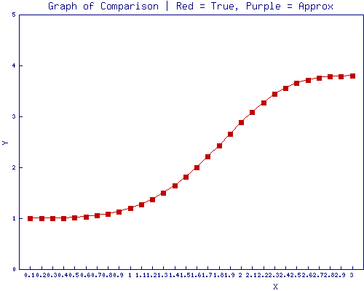

1. Graph all the solutions

