

1960's Topper Coat

Intermediate level

This stylish coat is a design from the early 1960's.
You will enjoy wearing it for many years!

Each step is beginner to intermediate.

This pattern has an unusual neckline, an inset pocket, and a full lining,
so there are more than the usual number of steps,
and more than the usual number of pattern pieces.

Some hand sewing is required.
Hem the coat by hand or machine blind stitch.
Hem the coat and sleeve lining by hand or machine straight stitch.
Hand catch the inner cuffs to the inside of sleeves.
There are no buttons, buttonholes, or belts.

You will need a steam iron, filtered water for steam, press cloth,
and sleeve ham (or stuffed sock)

Notions: Hem tape

Please send any comments and questions to Seamly Patterns on Etsy https://www.etsy.com/shop/SeamlyPatterns

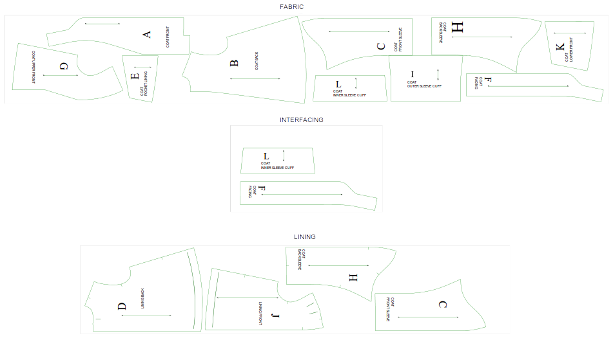

This is a sample layout for someone with height 5'6”, bust 42”, hips 48”.
Fabric width is 44” wide, folded lengthwise with selvedges together.

________________________________________________________________
CUTOUT PATTERN PIECES

Cut out and arrange paper pattern pieces to determine how much fabric you need, based on fabric width halved down center, selvedge edges together.

Measure the lower hem edges of Front A, Lower Front K, and Back B.
(A hem + B hem + K hem) x 2.1 = amount of hem tape you will need (with 10% extra)

Cut out pattern pieces for Coat fabric:
A Coat Front, fabric = 2 G Coat Upper Front, fabric = 2
B Coat Back, fabric = 2 H Sleeve Front, fabric = 2
C Coat Sleeve Back, fabric = 2 I Sleeve Outer Cuff, fabric = 2
E Coat Pocket Lining, fabric = 2 K Front Lower, fabric = 2
F Coat Front Facing, fabric = 2 L Sleeve Inner Cuff, fabric = 2

Cut out pattern pieces for Lining:
C Sleeve Back, lining = 2
D Back Lining, lining = 2
F Facing, lining = 2
H Sleeve Front, lining = 2
J Lining Front, lining = 2

Cut out pattern pieces for Interfacing:
F Facing, interfacing = 2
I Sleeve Outer Cuff, interfacing = 2
________________________________________________________________

Prepare the Coat Shell pattern pieces
- Mark hemlines with carbon or tracing paper, chalk, or basting stitches
- Stay stitch around neckline, armscyes, and sleeve caps
- Optional – Serge (do not trim) around all pattern pieces

Prepare the Coat Lining pattern pieces:
- Mark hemlines with carbon paper, chalk, or stay stitching
- Mark tuck line at Back Lining D center back
- Mark tuck lines at Front Lining J shoulder seams.
- Sew Back Lining pleat – Pin with right sides together then stitch from neck to end of pleat, backstitch to secure end of seam. Flatten pleat to lining, centering pleat over center of back lining, press pleat edges in place. Baste along top of pleat.
- Sew Shoulder tucks – Pin with right sides together then stitch from shoulder seam to end of tuck, backstitch to secure end of seam. Fold tuck toward Neck Side and press. Stay stitch top of tuck along shoulder seam line
- Stay stitch around neckline, armscyes, and sleevecaps
- Optional – Serge (do not trim) around all pattern pieces
________________________________________________________________
COAT SHELL:
Repeat each step for both right & left pattern pieces

Create Pocket Unit:
- Match notches and sew top edge of Lower Front K to top edge of Pocket E to create top of pocket edge. Press seam open. Fold seam with wrong sides together. Press along fold using presscloth.
Create Front Unit:
- Match notches and sew bottom edge of Upper Front G to bottom edge of Pocket E in Pocket unit. Press seam to set.
- Baste stitch K, E, and G together along their loose edges.
Create Front & Back Unit:
- Match notches and sew Front Unit to Back B along shoulder seam only (not side seam). Press to set seam, then press seam allowance to point towards Back B.
Create Coat Half Unit:
- Match notches and sew Front & Back Unit to Front A, from Neck Back down to hem. Clip seam allowances along back neck curve to relieve stress. Press to set seam then press seam toward Front A.
Create Coat Shell:
- Match notches and sew Coat Half Units together down the back seam, from Neck Back down to hem. Press to set seam then press seam open.
________________________________________________________________

SLEEVES:
Repeat each step for both right & left pattern pieces

Create Cuff Unit:
- Sew or fuse interfacing to fabric Inner Cuff L.
- Match notches and sew Inner Cuff L to Sleeve Unit wrist. Press seam to set, then press seam allowance toward sleeve.
- Match notches with right sides together sew Outer Cuff I to Inner Cuff L.

Create Sleeve Unit:
- Match notches and sew Sleeve Front C to Sleeve Back H down their long center seam (not the shorter deeply curved under sleeve seam). Press to set seam then press seam open.
Sew Cuffs to Sleeve Unit:
- Match notches and sew Cuff Unit to Sleeve Unit along wrist seam.

Sew Sleeve Unit to Coat Unit:
- Match notches and sew Sleeve Unit sleeve cap to Coat Shell armscye, matching Sleeve Unit center seam to Coat Shell shoulder seam. Clip seam allowances along curves. Press seam to set then press seam allowance toward Coat Shell.
- Match notches and underarm points, and sew from Coat Shell hem to Sleeve unit wrist to end of Cuff Unit as one long seam. Press seam to set, then press seam allowance towards Coat back.

- Match notches with right sides together sew Outer Cuff I to Inner Cuff L, matching at under sleeve seams. Using sleeve ham press to set seam, then fold and press with press cloth to form top edge of Cuff.
- Match notches and sew Outer Cuff I's free edge in 'Cuff Unit' onto Sleeve wrist, right sides together, matching at underarm seams. Press to set seam, then press seam open. Fold along seam with right sides together and press along fold.
- Optional – If cuff edges are not serged or otherwise finished, hem the long cuff's loose edge by folding and pressing 1cm or 1/4” away from edge. Then fold and press again at 2cm or 1/2” then stitch.
- Fold short side of Cuff up along Sleeve, and pin along Cuff top edge. Smooth the long side of Cuff down to wrist then up into Sleeve. Smooth Sleeve and Cuff together, then pin and tack Cuff in place several places along the underarm seam. Lightly press or steam Cuff in place.

Sew Lining:
Repeat each step for both right & left pattern pieces:
1. Match notches and sew Back Sleeve C lining to Back Lining D. Press to set seam, then press seam toward Back Lining D – this is 'Back Lining unit'
2. Match notches and sew Front Sleeve H lining to Front Lining J. Press to set seam, then press seam toward Front Lining J – 'Front Lining unit'
3. Match notches and sew 'Back Lining unit' to 'Front Lining unit' from Neck Side down to wrist, matching seams at armscye curve. Press to set seam, then press seam open
4. Match notches and sew 'Back Lining unit' to 'Front Lining unit' from wrist to underarm to hem, matching seams at underarm. Press to set seam, then press seam open
5. Option 1 – Sew hem tape to sleeve lining hems and coat lining hem.
Sew Lining (continued):
5. Option 2 – Fold and press sleeve lining hems and coat lining hem 1cm or 1/4”.
6. Fold and press along marked or stitched hemlines. For coat: manually hem or use machine blindstitch. For lining: manually hem, machine straight stitch, or machine blindstitch.

Sew Facings:
1. Sew Front Facing F pieces together at Neck Back, right sides together. Press to set seam, then press seam open – this is 'Facing Unit'
2. Match notches and sew 'Facing unit' to 'Lining unit', matching at back seams, start sewing from midpoint of the seam at Neck Back down toward one side hem, then again from Neck Back down toward other side hem. 'Lining unit' will appear to be too short – it is the correct length. enough to Press to set seam, then press seam toward 'Lining unit'

Sew Facing/Lining unit to Coat Shell:
1. Place 'Facing/Lining unit's front edge right sides together with 'Coat Shell's front edge, matching at notches and at back center seam. Sew from Neck Back down to one side hem, turning corner at hem and sewing along hem line then again from Neck Back down to other side hem and along hem line. Clip seam along curves. Press to set seam, then press toward Lining. Grade seams, trim corner. Turn garment right side out, using pointed tool to turn out corner. Fold and press along seam, wrong sides together, using press cloth.
2. Manually tack Lining close to Coat Shell at Neck Back using tack stitch
3. Manually tack Lining close to Coat Shell at Neck Sides using tack stitch
4. Manually catch Lining loosely to Coat Shell at shoulder tips and underarm points using catch stitch
5. Manually catch Sleeve Lining hem to Cuffs at undersleeve seam using catch stitch
6. Manually catch Coat Lining hem to Coat hem at side seams using catch stitch

