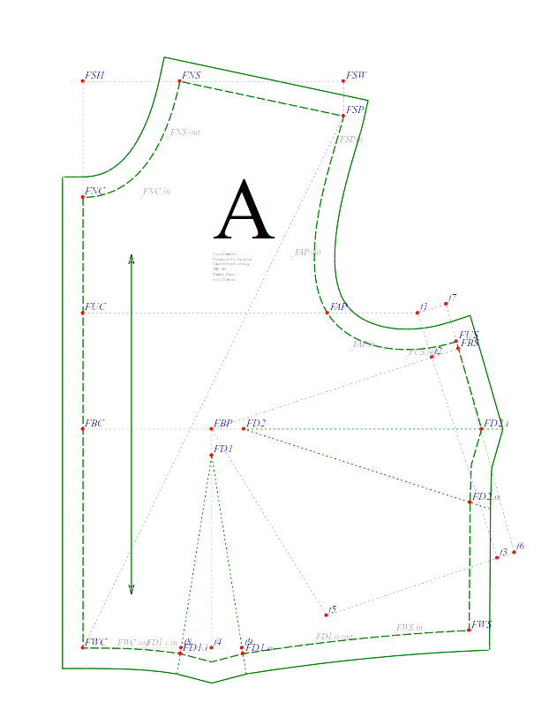
Instructions
total bust ease is 1/12 or 8.3% of bust circumference (3” for 36” bust)
front bust ease is ¼ or 25% of total bust ease
back bust ease is ¼ or 25% of total bust ease
total waist ease is 1/16 or 6.25% of waist circumference (1.5” for 24” waist)
front waist ease is ¼ or 25% of total waist ease
back waist ease is ¼ or 25% of total waist ease

Front Neck Center – FNC is at (0, 0)
Front Waist Center – FWC is front_waist_length squared down from FNC
Front Underarm Center – FUC is front_underarm_height squared down from FNC
Front Bust Center – FBC is front_bust_height squared down from FNC
Front Shoulder Height – FSH is front_shoulder_height squared up from FWC
Front Shoulder Width – FSW is half of front_shoulder_width squared right from FSH

Draw line from FNC to FWC
Square a line right from FSH to FSW
Square a line down from FSW+
Draw arc from FWC with radius front_shoulder_balance
Front Shoulder Point – FSP is where arc intersects the line squared down from FSW
Draw arc from FSP with radius shoulder_length
Front Neck Side - FNS is where the arc intersects line FSH-FSW
Draw a line from FSP to FNS
Curve line from FNS to FNC

Front Bust Point – FBP is half of bust_distance squared right from FBC
Front Armscye Point – FAP is half of across_chest squared right from FBC
fus_t1 is half of front_underarm squared right from FUC
fbs_t1 is half of front_bust squared right from FBC
Draw an arc from FBP with radius length from FBP to fbs_t1
Draw a line from fus_t1 which meets arc at tangent
fbs_t2 is intersection of line & arc

Front Bust Side – FBS – extend line FBP to fbs_t1 out by front_bust_ease
Draw a line from FBS parallel to line fus_t1-fbs_t1
Draw a line from fus_t1 parallel to line FBP-FBS
fus_t2 is where the lines intersect
Front Underarm Side – FUS is 1/12 or 8.3% of side_length on line fus_t2-FBS
Front Waist Side – FWS is side_length on line FUS-FBS

Draw a curve from FSP to FAP to FUS, and a line from FUS to FWS
Front Waist Dart – FD1 is 12% distance from FBC to FWC squared down from FBP
Dart inside leg – FD1.i is (FD1.x, FWC.y)
Draw an arc from FD1 with radius length FD1 to FD1.i
Draw an arc from FWS with radius length (front_waist/2.0) + front_waist_ease – length from FD1.i to FWC
Dart outside leg – FD1.o is where the arcs intersect
Fold dart toward front center, and mark where foldline would cross waistline
Front Waist Dart midpoint – FD1.m is distance from FD1 to mark, squared down from FD1
Draw a line from FWC to FD1.i to FD1.m to FD1.o to FWS

#smooth dart at waistline
Extend dart legs by 1/4”
Square a line from extended inside dart leg to waist line toward FWC, curving to merge into waistline
Square a line from extended outside dart leg to waist line toward FWS, curving to merge into waistline
Draw line from extended dart inside leg to FD1.m to extended dart outside leg

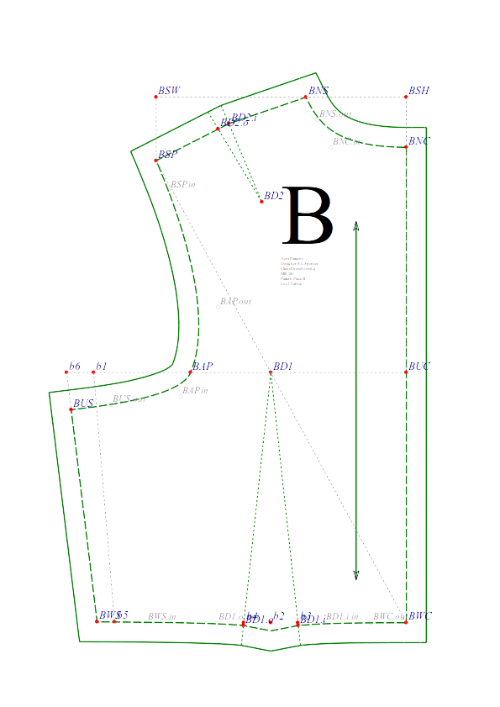
#---Back B---#
Back Neck Center – BNC is (0,0)
Back Waist Center – BWC is back_waist_length squared down from BNC
Back Underarm Center – BUC is back_underarm_height squared down from BNC
Back Shoulder Height – BSH is back_shoulder_height squared up from BWC
Back Shoulder Width – BSW is half of back_shoulder_width squared left from BNC
Draw line from BSW to BSH to BWC
Square a line down from BSW
Draw arc from BWS with radius back_shoulder_balance
Back Shoulder Point – BSP is where arc crosses line squared down from BSW
Draw arc from BSP with radius 1.1 * shoulder_length
Back Neck Side – BNS is where arc crosses line BSH-BSW
Back Armscye Point – BAP is half of across_back, squared left from BUC
bus_t – half of back_underarm, squared left from BUC
Draw line from BSP to BNS, curve BNS to BNC, line from BNC to BWC

Draw line from BUC to BAP and line from BWC to BSP
Back Waist Dart – BD1 is where lines intersect
Draw line squared left from BWC
Draw line squared down from BD1 and intersect waistline
Back waist dart inside leg – BD1.i is 1/5 or 20% length from intersection to BWC squared right from intersection
Back waist dart outside leg – BD1.o is length from intersection to BD1.i squared left from intersection
Fold dart toward back center
Mark where foldline would intersect with waistline
Back waist dart midpoint – BD1.m is length from BD1 to mark, squared down from BD1

Draw arc from bus_t with radius side_length
Draw arc from extended dart outside leg with radius (back_waist/2.0) + back_waist_ease – distance from BD1.i
Back waist side – BWS is intersection of arcs
Back Underarm Side – BUS is distance FWS-FUS BWS-bus-t

Extend dart legs by 1/4”
Square a line from extended inside dart leg to waist line toward BWC, curving to merge into waistline
Square a line from extended outside dart leg to waist line toward BWS, curving to merge into waistline

Draw curve from BSP to BAP to BUS to BWS
Draw line from BWS to extended dart outside leg to BD1.m to extended dart inside leg to BWC

dart_width – distance BSP-BNS minus distance FSP-FNS
midpoint – midpoint between BSP and BNS
Draw line from BNS to BAP
Square a line from midpoint, perpendicular to BSP-BNS, intersecting with BNS-BAP
Back Shoulder Dart – BD2 is where lines intersect
Back Shoulder Dart inside leg – BD2.i is half of dart_width on line from midpoint to BNS
Back Shoulder Dart outside leg – BD2.o is half of dart_width on line from midpoint to BSP
Fold dart toward BNS and mark where foldline would intersect with shoulder seam
Back shoulder dart midpoint – BD2.m is length of BD2 to mark, on line from BD2 to midpoint
Extend dart legs by 1/8”
Draw line from extended dart inside leg to BD2.m to extended dart outside leg
Draw a line perpendicular to extended inside dart leg then curve line down to BNS
Draw a line perpendicular to extended outside dart leg then curve line down to BSP

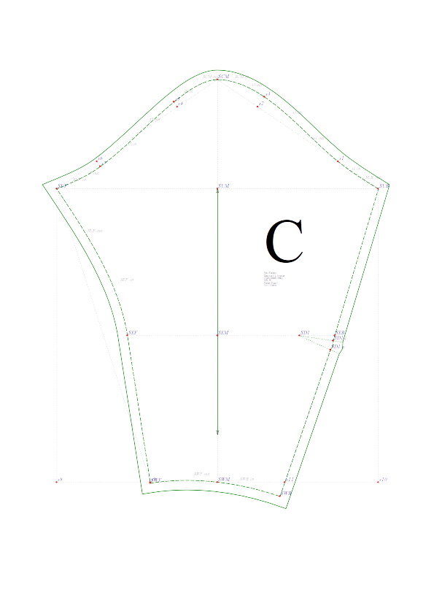
#--Sleeve C--#
Measure front and back armscye curves
sleevecap_length - lengths of front armscye curve and back armscye curve added together
#middle line
Sleeve Cap Middle – SCM is (0,0)
Sleeve Wrist Middle – SWM is oversleeve_length + 6*CM, squared down from SCM
#underarm
Sleeve Underarm Middle – SUM is 1/3 sleevecap_length, squared down from SCM
Sleeve Underarm Back – SUB is half of sleevecap_length – 0.5*CM, squared right from SUM
Sleeve Underarm Front – SUF is half of sleevecap_length + 0.5*CM, squared left from SUM
#elbow
Sleeve Elbow Middle – SEM is midpoint between SUM & SWM
Sleeve Elbow Back - SEB is 0.65*elbow squared right from SEM
Sleeve Elbow Front – SEF is 0.5*elbow squared left from SEM
#wrist back temp points
swb1 – (SUB.x, SWM.y)
swb3 – 0.7 length of line SWM-swb1
swb2 – midpoint swb1, swb3
#wrist front temp points
swf1 – (SUF.x, SWM.y)
swf3 – 0.7 length of line SWM-swf1
swf2 – midPoint swf1-swf3
#sleevecap points
s1 is distance SUB-SCM on line SUB-SCM
s2_t – ¾ length on line SUB-SCM
s2 is 2*cm from s2_t, perpendicular out from line SUB-SCM
s3_t – ¾ length on line SUF-SCM
s3 is 1*CM from s3_t, perpendicular out from line SUF-SCM
s4_t – ¼ length on line SUF-SCM
s4 is 1*CM from s4_t, perpendicular in from line SUF-SCM
#elbow dart
Sleeve Dart – SD1 is 1/3 distance SEB-SEM
Draw line from SUB to SEB
Draw line from SD1 perpendicular to line SUB-SEB
midpoint – intersection of lines
Sleeve dart inside leg – SD1.i is 1.5*CM up from midpoint on line midpoint-SUB
Sleeve dart outside leg – SD1.o is 1.5*CM down from midpoint on line midpoint-SUB
Fold dart toward SUB and mark where foldline would intersect with seamline
Sleeve dart midpoint – SD1.m is length of SD1 to mark, on line from SD1 to midpoint
#extend sleeve wrist
Draw line from SWM perpendicular to line SD1.o-swb3
Sleeve Wrist Back – SWB is distance SD1.i-SD1.o down from swb3 on line SD1.o-swb3
#adjust front sleeve seam length to match back
Measure SUB-SD1.i, SD1.o-SWB, and SUF-SEF
diff - subtract length SUF-SEF from lengths SUB-SD1.i plus SD1.o-SWB
Sleeve Wrist Front – SWF is diff on line SEF-swf3

# !/usr/bin/python
#
# spencer_bodice_short.py
# Copyright (C) 2010, 2011, 2012 Susan Spencer, Steve Conklin <www.taumeta.org>

'''
Licensing paragraph :

1. CODE LICENSE : GPL 2.0 +
This program is free software; you can redistribute it and/or modify
it under the terms of the GNU General Public License as published by
the Free Software Foundation; either version 2 of the License, or
(at your option) any later version.

This program is distributed in the hope that it will be useful,
but WITHOUT FNY WARRFNTY; without even the implied warranty of
MERCHFNTABILITY or FITNESS FOR A PARTICULAR PURPOSE. See the
GNU General Public License for more details.

You should have received a copy of the GNU General Public License
along with this program; if not, write to the Free Software
Foundation, Inc., 59 Temple Place, Suite 330, Boston, MA 02111 - 1307 USA

2. PATTERN LICENSE : CC BY - NC 3.0
The output of this code is a pattern and is considered a
visual artwork. The pattern is licensed under
Attribution - NonCommercial 3.0 (CC BY - NC 3.0)
<http : //creativecommons.org/licenses/by - nc/3.0/>
Items made from the pattern may be sold;
the pattern may not be sold.

End of Licensing paragraph.
'''

from tmtpl.designbase import *
from tmtpl.document import *
from tmtpl.pattern import *
from tmtpl.patternmath import *
from tmtpl.constants import *
from tmtpl.utils import *

class Design(designBase):

def pattern(self) :
"""
Method defining a pattern design. This is where the designer places
all elements of the design definition
"""

# The designer must supply certain information to allow
# tracking and searching of patterns
#
# This group is all mandatory
#
self.setInfo('patternNumber', 'MR_B1')
self.setInfo('patternTitle', 'Spencer Bodice Short')
self.setInfo('companyName', 'Next Patterns')
self.setInfo('designerName', 'S.L.Spencer')
self.setInfo('patternmakerName', 'S.L.Spencer')
self.setInfo('description', """Women's bodice block pattern with medium ease, includes long sleeve with elbow dart.""")
self.setInfo('category', 'Shirt/TShirt/Blouse')
self.setInfo('type', 'Block')
#
# The next group are all optional
#
self.setInfo('gender', 'F') # 'M', 'F', or ''
self.setInfo('yearstart', '1900')
self.setInfo('yearend', '')
self.setInfo('culture', 'European')
self.setInfo('wearer', '')
self.setInfo('source', '')
self.setInfo('characterName', '')
self.setInfo('recommendedFabric', '')
self.setInfo('recommendedNotions', '')

#get client data
CD = self.CD #client data is prefaced with CD

#create a pattern named 'bodice'
bodice = self.addPattern('bodice')

#create pattern pieces, assign an id lettercd ..
A = bodice.addPiece('Bodice Front', 'A', fabric = 2, interfacing = 0, lining = 0)
B = bodice.addPiece('Bodice Back', 'B', fabric = 2, interfacing = 0, lining = 0)
C = bodice.addPiece('Bodice Sleeve', 'C', fabric = 2, interfacing = 0, lining = 0)

#pattern points
# x, y coordinates are always passed as a two-item list like this: (23.6, 67.0)
# points are always in the 'reference' group, and always have style='point_style'

#---Front A---#
f_bust_ease = 0.083 * CD.bust/4.0
b_bust_ease = f_bust_ease
f_waist_ease = 0.0625 * CD.waist/4.0
b_waist_ease = f_waist_ease

f_underarm_height = 9.0 * CM
f_bust_height = 18 * CM
b_underarm_height = 18.0 * CM

FNC = A.addPoint('FNC', (0.0, 0.0)) #front neck center
FWC = A.addPoint('FWC', down(FNC, CD.front_waist_length)) #front waist center
FSH = A.addPoint('FSH', up(FWC, CD.front_shoulder_height)) #front shoulder height
FSW = A.addPoint('FSW', right(FSH, 0.5 * CD.front_shoulder_width)) #front shoulder width
FSP = A.addPoint('FSP', highestP(onCircleAtX(FWC, CD.front_shoulder_balance, FSW.x))) #front shoulder point
FNS = A.addPoint('FNS', leftmostP(onCircleAtY(FSP, CD.shoulder, FSH.y))) #front neck side
FUC = A.addPoint('FUC', down(FNC, f_underarm_height)) #front underarm center
FBC = A.addPoint('FBC', down(FNC, f_bust_height)) #bust center
FBP = A.addPoint('FBP', right(FBC, 0.5 * CD.bust_distance)) #bust point
FAP = A.addPoint('FAP', right(FUC, CD.across_chest / 2.0)) #temp front armscye point
f1 = A.addPoint('f1', right(FUC, CD.front_underarm / 2.0)) #temp front underarm side
f2 = A.addPoint('f2', rightmostP(onCircleTangentFromOutsidePoint(FBP, (CD.front_bust - CD.bust_distance) / 2.0, f1))) #temp front bust side
f3 = A.addPoint('f3', onLineAtLength(f1, f2, CD.side)) #temp front waist side
f4 = A.addPoint('f4', (FBP.x, FWC.y)) #temp dart inside leg
f5 = A.addPoint('f5', lowestP(intersectCircles(FBP, distance(FBP, f4), f3, CD.front_waist/2.0 - distance(FWC, f4)))) #temp dart outside leg
FBS = A.addPoint('FBS', extendLine(FBP, f2, f_bust_ease)) #front bust side, incl. ease
f6 = A.addPoint('f6', polar(f3, f_waist_ease, angleOfLine(FBP, FBS))) #temp front waist side, incl. ease
f7 = A.addPoint('f7', onLineAtLength(f6, FBS, CD.side)) #temp front underarm side, incl. ease
FUS = A.addPoint('FUS', onLineAtLength(f7, FBS, 0.15 * CD.side)) #front underarm side
#rotate waist point
total_dart_angle = angleOfVector(f5, FBP, f4)
FWS = A.addPoint('FWS', rotate(FBP, f6, total_dart_angle / 2.0)) #front waist side
#create bust side dart
FD2 = A.addPoint('FD2', FBP) #set to be FBP temporarily
FD2.i = A.addPoint('FD2.i', onLineAtY(f6, f7, FBP.y)) #bust side dart inside leg - fold up toward FUS
FD2.o = A.addPoint('FD2.o', rotate(FBP, FD2.i, total_dart_angle / 2.0)) #bust side dart outside leg
updatePoint(FD2, polar(FBP, 0.12 * distance(FBP, FD2.o), angleOfLine(FBP, FD2.i) / 2.0)) #move FD2
#reduce & rotate bust waist point
f8 = A.addPoint('f8', intersectLineRay(FWC, f4, FBP, ANGLE90 + total_dart_angle / 4.0))
f9 = A.addPoint('f9', intersectLineRay(FWC, f4, FBP, ANGLE90 - total_dart_angle / 4.0))
FD1 = A.addPoint('FD1', down(FBP, 0.12 * abs(FBP.y - FWC.y))) #front dart point
FD1.i = A.addPoint('FD1.i', f8) #bust waist dart inside leg - fold in toward FWC
FD1.o = A.addPoint('FD1.o', f9) #bust waist dart outside leg
#extend leg lengths to smooth seamline at dart, then extend middle length so foldline meets seamline
extendDart(FWC, FD1, FWS)
foldDart(FD1, FWC) #creates FD1.m for seamline, FD1.ic & FD1.oc for dartline
extendDart(FUS, FD2, FWS)
foldDart(FD2, FUS) #creates FD2.m for seamline, FD2.ic & FD2.oc for dartline

#front control points
#b/w FNS & FNC
FNS.addOutpoint(polar(FNS, 0.5 * abs(FNC.y - FNS.y), angleOfLine(FNS, FSP) + ANGLE90))
FNC.addInpoint(right(FNC, 0.6 * abs(FNC.x - FNS.x)))
#b/w FWC & FD1.i
FWC.addOutpoint(right(FWC, 0.33 * distance(FWC, FD1.i)))
FD1.i.addInpoint(intersectLineRay(FWC, f8, FD1.i, angleOfLine(FD1, FD1.i) + ANGLE90))
#b/w FD1.o & FWS
FD1.o.addOutpoint(intersectLineRay(FWS, f9, FD1.o, angleOfLine(FD1.o, FD1) + ANGLE90))
FWS.addInpoint(polar(FWS, 0.33 * distance(FD1.o, FWS), angleOfLine(FUS, FWS) + ANGLE90))
#b/w FUS & FAP
FUS.addOutpoint(polar(FUS, 0.4 * distance(FUS, FAP), angleOfLine(FBS, FBP)))
FAP.addInpoint(polar(FAP, 0.33 * distance(FUS, FAP), angleOfLine(FNS, FAP)))
#b/w FAP & FSP
FAP.addOutpoint(polar(FAP, 0.33 * distance(FAP, FSP), angleOfLine(FAP, FNS)))
FSP.addInpoint(polar(FSP, 0.15 * distance(FAP, FSP), angleOfLine(FSP, FNS) - ANGLE90))

#---Back B---#
BNC = B.addPoint('BNC', (0.0, 0.0)) #back neck center
BWC = B.addPoint('BWC', down(BNC, CD.back_waist_length)) #back waist center
BSH = B.addPoint('BSH', up(BWC, CD.back_shoulder_height)) #back shoulder height
BSW = B.addPoint('BSW', left(BSH, 0.5 * CD.back_shoulder_width)) #back shoulder width
BSP = B.addPoint('BSP', highestP(onCircleAtX(BWC, CD.back_shoulder_balance, BSW.x))) #back shoulder point
BNS = B.addPoint('BNS', rightmostP(onCircleAtY(BSP, CD.shoulder, BSH.y))) #back neck side
BUC = B.addPoint('BUC', down(BNC, b_underarm_height)) #back underarm center
BAP = B.addPoint('BAP', left(BUC, CD.across_back / 2.0)) #tmp back armscye point
b1 = B.addPoint('b1', left(BUC, CD.back_underarm / 2.0)) #temp back underarm side
#back waist dart
BD1 = B.addPoint('BD1', intersectLines(BWC, BSP, BUC, BAP)) #back waist dart point
b2 = B.addPoint('b2', (BD1.x, BWC.y)) #temp dart midpoint at waist
b3 = B.addPoint('b3', right(b2, 0.2 * abs(BD1.x - BWC.x))) #temp back waist dart inside leg
b4 = B.addPoint('b4', left(b2, 0.2 * abs(BD1.x - BWC.x))) #temp back waist dart inside leg
BD1.i = B.addPoint('BD1.i', b3) #back waist dart inside leg
BD1.o = B.addPoint('BD1.o', b4) #back waist dart outside leg
#back waist side & bust side
b5 = B.addPoint('b5', lowestP(intersectCircles(b1, CD.side, BD1.o, CD.back_waist / 2.0 - distance(BWC, BD1.i)))) #temp back waist side
b6 = B.addPoint('b6', left(b1, b_bust_ease)) #temp back underarm side
BWS = B.addPoint('BWS', left(b5, b_waist_ease)) #temp back waist side
BUS = B.addPoint('BUS', onLineAtLength(b6, BWS, 0.15 * CD.side))
#smooth dart at waist
extendDart(BWC, BD1, BWS)
foldDart(BD1, BWC)

#back shoulder dart
dart_width = distance(BSP, BNS) - distance(FSP, FNS)
pnt_m = midPoint(BSP, BNS) #midpoint of shoulder dart at shoulder seam
BD2 = B.addPoint('BD2', intersectLineRay(BNS, BAP, pnt_m, angleOfLine(BSP, BNS) + ANGLE90)) #back shoulder dart point
BD2.i = B.addPoint('BD2.i', pnt_m) #back shoulder dart inside leg
BD2.o = B.addPoint('BD2.o', rotate(BD2, pnt_m, angleOfDegree(-8))) #back shoulder dart inside leg
extendDart(BSP, BD2, BNS, extension=1) #smooth shoulder seam at dart
foldDart(BD2, BNS) #fold dart toward BNS

#back control points
#b/w BNS & BNC
BNC.addInpoint(left(BNC, 0.75 * abs(BNC.x - BNS.x)))
BNS.addOutpoint(polar(BNS, 0.5 * abs(BNC.y - BNS.y), angleOfLine(BNS, BNC.inpoint)))
#b/w BWC & BD1.i
BWC.addOutpoint(left(BWC, 0.33 * distance(BWC, BD1.i)))
BD1.i.addInpoint(intersectLineRay(BWC, b3, BD1.i, angleOfLine(BD1.i, BD1) + ANGLE90))
#b/w BD1.o & BWS
BD1.o.addOutpoint(intersectLineRay(BWS, b4, BD1.o, angleOfLine(BD1, BD1.o) + ANGLE90))
BWS.addInpoint(polar(BWS, 0.33 * distance(BD1.o, BWS), angleOfLine(BWS, b4)))
#b/w BUS & BAP
BUS.addOutpoint(polar(BUS, 0.33 * abs(BUS.x - BAP.x), angleOfLine(BWS, BUS) + ANGLE90))
#BAP.addInpoint(polar(BAP, 0.5 * abs(BUS.y - BAP.y), angleOfLine(BNS, BAP)))
BAP.addInpoint(intersectLineRay(BUS, BUS.outpoint, BAP, angleOfLine(BNS, BAP)))
#b/w BAP & BSP
BAP.addOutpoint(polar(BAP, 0.33 * distance(BAP, BSP), angleOfLine(BAP, BNS)))
BSP.addInpoint(polar(BSP, 0.15 * distance(BAP, BSP), angleOfLine(BSP, BNS) + ANGLE90))

#---Sleeve C---#
#get front & back armcye length
back_armscye = points2List(BUS, BUS.outpoint, BAP.inpoint, BAP, BAP.outpoint, BSP.inpoint, BSP)
front_armscye = points2List(FUS, FUS.outpoint, FAP.inpoint, FAP, FAP.outpoint, FSP.inpoint, FSP)
sleevecap_girth = curveLength(back_armscye) + curveLength(front_armscye)
SCM = C.addPoint('SCM', (0.0, 0.0)) #sleeve cap midpoint - top of sleeve
#SUM = C.addPoint('SUM', (SCM.x, SCM.y + sleevecap_girth / 4.0 + 1.5 * CM)) #sleeve underarm midpoint
SUM = C.addPoint('SUM', down(SCM, sleevecap_girth / 3.0)) #sleeve underarm midpoint
SWM = C.addPoint('SWM', (SCM.x, SCM.y + CD.oversleeve_length + 6 * CM)) #sleeve wrist midpoint
SEM = C.addPoint('SEM', midPoint(SUM, SWM)) #sleeve elbow midpoint
SUB = C.addPoint('SUB', (SUM.x + (sleevecap_girth / 2.0 - 0.5 * CM), SUM.y)) #sleeve underarm back
SUF = C.addPoint('SUF', (SUM.x - (sleevecap_girth / 2.0 - 0.5 * CM), SUM.y)) #sleeve underarm front
SEB = C.addPoint('SEB', right(SEM, 0.65 * CD.elbow)) #sleeve elbow back
SEF = C.addPoint('SEF', left(SEM, 0.5 * CD.elbow)) #sleeve elbow front

#back armscye points
s1 = C.addPoint('s1', onLineAtLength(SUB, SCM, distance(SUB, SCM) / 4.0)) #sleeve cap back 1
s2 = C.addPoint('s2', onLineAtLength(SUB, SCM, 0.75 * distance(SUB, SCM)))
s3 = C.addPoint('s3', polar(s2, 2 * CM, angleOfLine(SUB, SCM) + ANGLE90)) #sleeve cap back 3
#front armscye points
s4 = C.addPoint('s4', onLineAtLength(SUF, SCM, 0.75 * distance(SUF, SCM)))
s5 = C.addPoint('s5', polar(s4, 1 * CM, angleOfLine(SUF, SCM) - ANGLE90)) #sleeve cap front 3
s6 = C.addPoint('s6', onLineAtLength(SUF, SCM, distance(SUF, SCM) / 4.0))
s7 = C.addPoint('s7', polar(s6, 1 * CM, angleOfLine(SUF, SCM) + ANGLE90)) #sleeve cap front 1
#wrist
s8 = C.addPoint('s8', (SUF.x, SWM.y)) #sleeve wrist line 1
s9 = C.addPoint('s9', onLineAtLength(SWM, s8, 0.7 * CD.wrist)) #sleeve wrist line 2
s10 = C.addPoint('s10', (SUB.x, SWM.y)) #back wrist line 1
s11 = C.addPoint('s11', onLineAtLength(SWM, s10, 0.7 * CD.wrist)) #back wrist line 2

#elbow dart
SD1 = C.addPoint('SD1', left(SEB, 0.3 * distance(SEB, SEM))) #elbow dart point
pnt = intersectLineRay(SUB, SEB, SD1, angleOfLine(SUB, SEB) - ANGLE90)
SD1.i = C.addPoint('SD1.i', intersectLineRay(SUB, SEB, SD1, angleOfLine(SD1, pnt) - angleOfDegree(8))) #elbow dart inside leg
SD1.o = C.addPoint('SD1.o', intersectLineRay(SUB, SEB, SD1, angleOfLine(SD1, pnt) + angleOfDegree(8))) #elbow dart outside leg
foldDart(SD1, SEB) #creates SD1.m, SD1.oc, SD1.ic; dart folds up towards elbow

#Sleeve C control points
cArray = points2List(SUB, s1, s3, SCM, s5, s7, SUF)
C1, C2 = controlPoints('sleeve_cap', cArray)
SUB.addOutpoint(C1[0])
s1.addInpoint(C2[0])
s1.addOutpoint(C1[1])
s3.addInpoint(C2[1])
s3.addOutpoint(C1[2])
#SCM.addInpoint(C2[2])
#SCM.addOutpoint(C1[3])
SCM.addInpoint(right(SCM, 0.33 * distance(SCM, s3)))
SCM.addOutpoint(left(SCM, 0.33 * distance(SCM, s4)))
s5.addInpoint(polar(s5, 0.33 * distance(s5, SCM.outpoint), angleOfLine(s5, SCM.outpoint)))
s5.addOutpoint(polar(s5, 0.33 * distance(s5, s7), angleOfLine(SCM.outpoint, s5)))
s7.addInpoint(C2[4])
s7.addOutpoint(C1[5])
SUF.addInpoint(C2[5])
SEF.addInpoint(extendLine(s9, SEF, 0.33*distance(SUF, SEF)))
SUF.addOutpoint(polar(SUF, 0.33*distance(SUF, SEF), angleOfLine(SUF, SEF.inpoint)))

#extend sleeve wrist
SWB = C.addPoint('SWB', extendLine(SD1.o, s11, distance(SEB, SD1.o))) #sleeve extended at back wrist to allow for elbow dart
total_back_sleeve_length = distance(SUB, SD1.i) + distance(SD1.o, SWB)
upper_front_sleeve_length = curveLength(points2List(SUF, SUF.outpoint, SEF.inpoint, SEF))
diff_length = total_back_sleeve_length - upper_front_sleeve_length
SWF = C.addPoint('SWF', onLineAtLength(SEF, s9, diff_length))

#control points b/w s9 front wrist & SWB back wrist
SWF.addOutpoint(polar(SWF, distance(SWF, SWB)/3.0, angleOfLine(SEF, SWF) - ANGLE90)) #handle is perpendicular to sleeve seam
SWB.addInpoint(polar(SWB, distance(SWF, SWB)/3.0, angleOfLine(SD1.o, SWB) + ANGLE90)) #handle is perpendicular to sleeve seam

#Bodice Front A
pnt1 = dPnt((FNC.x + abs(FNC.x - FSP.x)/2.0, FNC.y + abs(FUC.y - FNC.y)/2.0))
A.setLabelPosition(pnt1)
pnt2 = up(pnt1, 0.5*IN)
A.setLetter(pnt2, scaleby = 10.0)
AG1 = dPnt((FNC.x + abs(FNS.x - FNC.x)/2.0, abs(FUC.y - FNC.y)/2.0))
AG2 = down(AG1, 0.75 * CD.front_waist_length)
A.addGrainLine(AG1, AG2)
A.addGridLine(['M', FWC, 'L', FSP, 'L', FSW, 'L', FSH, 'L', FNC, 'M', FBC, 'L', FBP, 'L', FBS, 'M', FUC, 'L', f1, 'L', f7, 'L', f6, 'L', f3, 'L', f1, 'M', FWC, 'L', f4, 'L', FBP, 'L', f5, 'L', f3, 'M', FBP, 'L', FD2])
A.addDartLine(['M', FD1.ic, 'L', FD1, 'L', FD1.oc, 'M', FD2.ic, 'L', FD2, 'L', FD2.oc])
pth = (['M', FNC, 'L', FWC, 'C', FD1.i, 'L', FD1.m, 'L', FD1.o, 'C', FWS, 'L', FD2.o, 'L', FD2.m, 'L', FD2.i, 'L', FUS, 'C', FAP, 'C', FSP, 'L', FNS, 'C', FNC])
A.addSeamLine(pth)
A.addCuttingLine(pth)

#Bodice Back B
pnt1 = dPnt((BNC.x - abs(BNC.x - BSP.x)/2.0, BNC.y + abs(BUC.y - BNC.y)/2.0))
B.setLabelPosition(pnt1)
pnt2 = up(pnt1, 0.5*IN)
B.setLetter(pnt2, scaleby = 10.0)
BG1 = dPnt((BNC.x - abs(BNS.x - BNC.x)/2.0, abs(BUC.y - BNC.y)/3.0))
BG2 = down(BG1, 0.75 * CD.back_waist_length)
B.addGrainLine(BG1, BG2)
B.addGridLine(['M', BWC, 'L', BSP, 'L', BSW, 'L', BSH, 'L', BUC, 'L', b6, 'L', BUS, 'M', b1, 'L', b5, 'L', BWS])
B.addDartLine(['M', BD1.oc, 'L', BD1, 'L', BD1.ic, 'M', BD2.oc, 'L', BD2, 'L', BD2.ic])
pth = (['M', BNC, 'L', BWC, 'C', BD1.i, 'L', BD1.m, 'L', BD1.o, 'C', BWS, 'L', BUS, 'C', BAP, 'C', BSP, 'L', BD2.o, 'L', BD2.m, 'L', BD2.i, 'L', BNS, 'C', BNC])
B.addSeamLine(pth)
B.addCuttingLine(pth)

#Sleeve C
Cg1 = dPnt((SUM.x, SUM.y))
Cg2 = dPnt((Cg1.x, SWM.y - 8.0 * CM))
C.addGrainLine(Cg1, Cg2)
pnt1 = dPnt(midPoint(SUM, SEM))
C.setLetter((s3.x, pnt1.y), scaleby=15.0)
C.setLabelPosition((s3.x, pnt1.y + 2.0 * CM))
C.addGridLine(['M', SCM,'L', SWM, 'M', SUB, 'L', SCM, 'L', SUF, 'M', SUB, 'L', SUF, 'M', SEB, 'L', SEF, 'M', SUF, 'L', s8, 'L', s10, 'L', SUB, 'M', SEB, 'L', s11, 'M', SUF, 'L', s9, 'M', s2, 'L', s3, 'M', s4, 'L', s5, 'M', s6, 'L', s7])
C.addDartLine(['M', SD1.ic, 'L', SD1, 'L', SD1.oc])
pth = (['M', SUB, 'C', s1, 'C', s3, 'C', SCM, 'C', s5, 'C', s7, 'C', SUF, 'C', SEF, 'L', SWF, 'C', SWB, 'L', SD1.o, 'L', SD1.m, 'L', SD1.i, 'L', SUB])
C.addSeamLine(pth)
C.addCuttingLine(pth)

#call draw() to generate svg file
self.draw()

return

