MAJOR ACTIVITIES

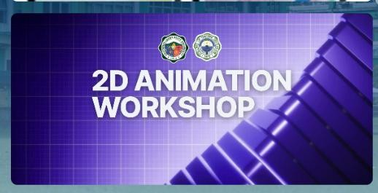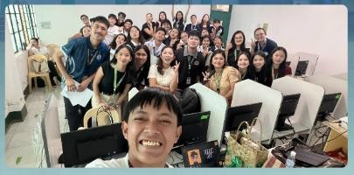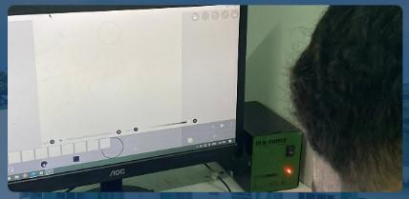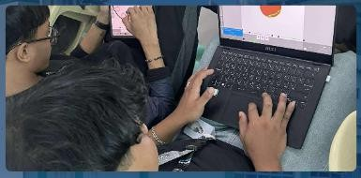
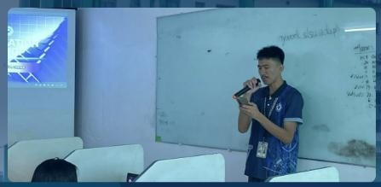
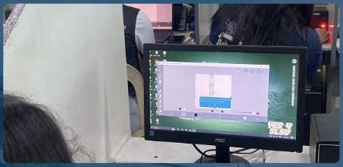

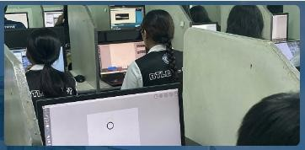
Animation is the process of creating the illusion of movement by displaying a sequence of images rapidly one after another. The image demonstrates how individual pictures are arranged and played in quick succession to produce motion. This technique requires careful planning, timing, and creativity to bring characters and scenes to life. Animation is widely used in movies, cartoons, video games, and digital media to tell stories and create engaging visual experiences.

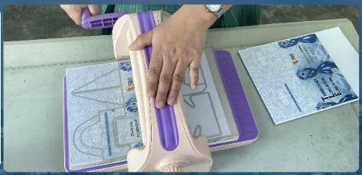

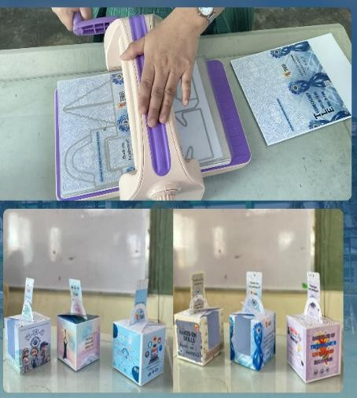
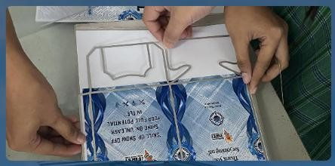
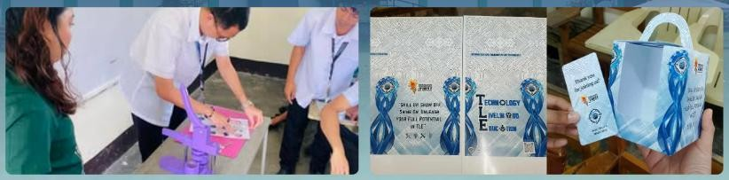
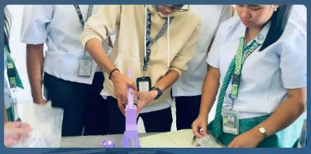

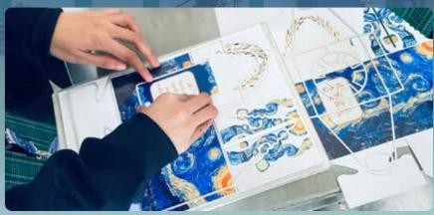
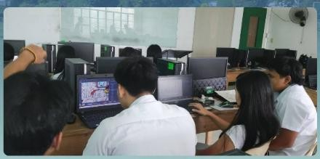
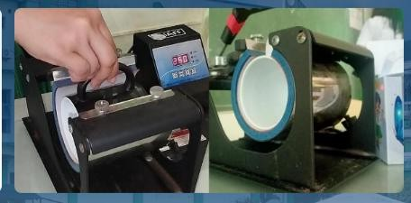
Mug design is the process of creating an image or artwork that will be printed onto the surface of a mug. The illustration shows how a design is carefully arranged to fit the size and curved shape of the mug. This process requires attention to layout, proportion, and clarity to ensure the final print appears neat and visually appealing. Mug design is commonly used for personalized gifts, promotional items, and decorative drinkware

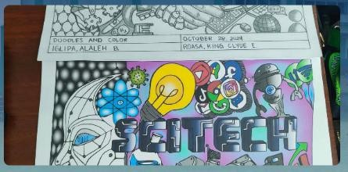
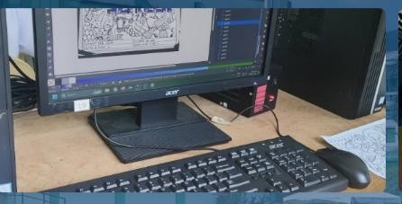
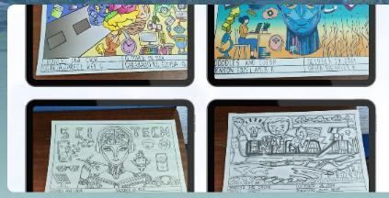


Digital drawing is the practice of creating artwork using electronic devices such as a computer, tablet, or smartphone. The image demonstrates how artists use specialized drawing applications instead of traditional paper and pencil. This method allows for easy editing, coloring, and refining of designs using various digital tools and features. Digital drawing also makes it convenient to save, share, and publish artwork online, making it widely used in modern art and design.

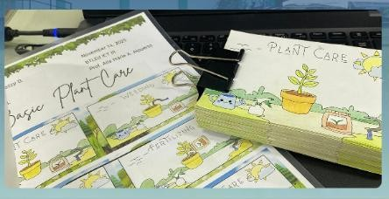
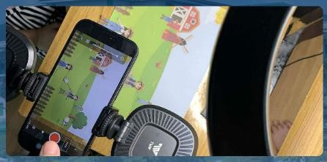
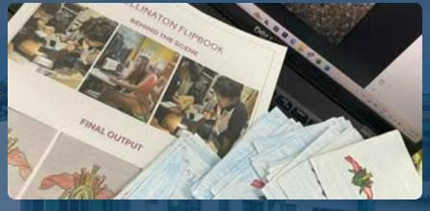

A storyboard is a visual planning tool that presents a sequence of drawings arranged in order to show how a story will unfold. The illustration demonstrates how each frame represents a scene or important moment in the project. This method helps creators organize ideas, plan camera angles, and visualize the flow of events before producing a video or animation. Storyboards serve as a guide to ensure that the final project follows a clear and well-structured storyline.
Traditional drawing is the practice of creating artwork using materials such as pencils, pens, or paint on paper or other physical surfaces. The image illustrates how artists produce designs by hand without the use of digital tools or devices. This method highlights the artist’s control, technique, and attention to detail while working with traditional materials. Traditional drawing reflects creativity and craftsmanship through manual skill and artistic expression.


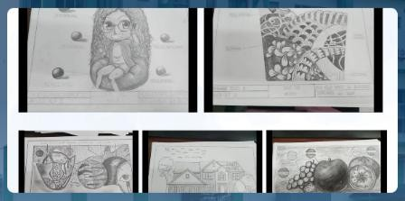
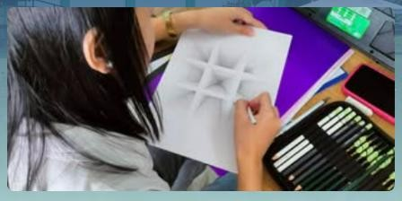
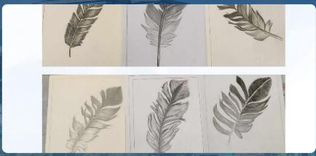
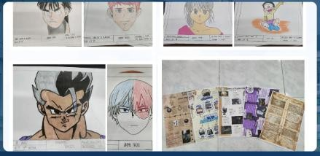

Teaching Demonstration

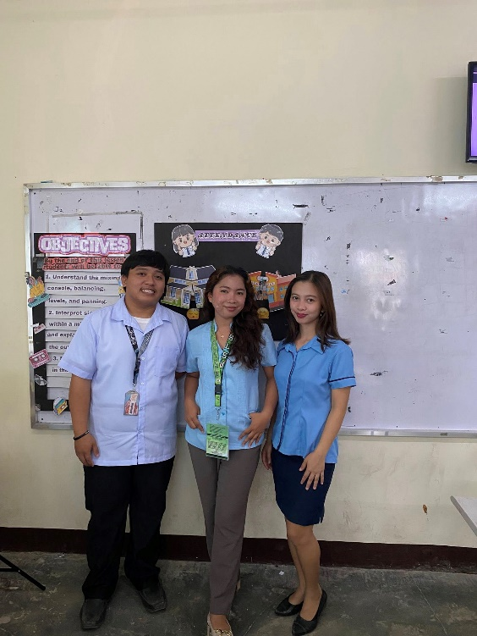
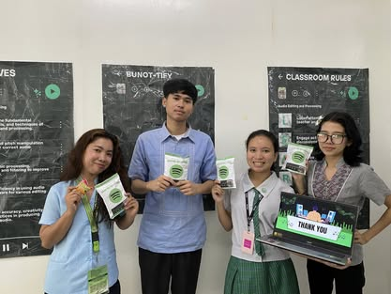
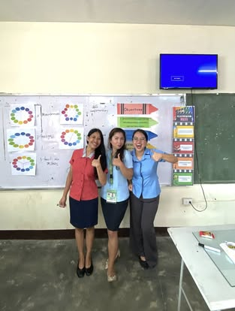

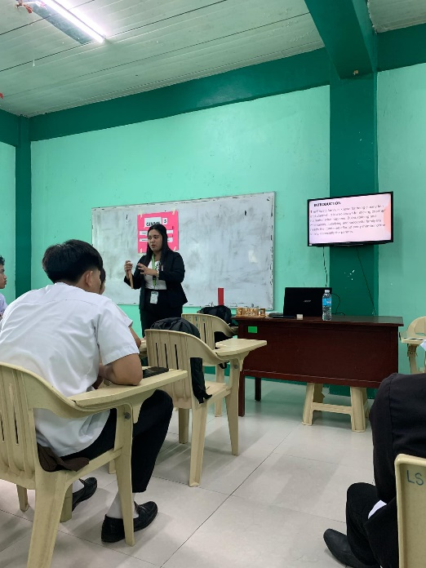
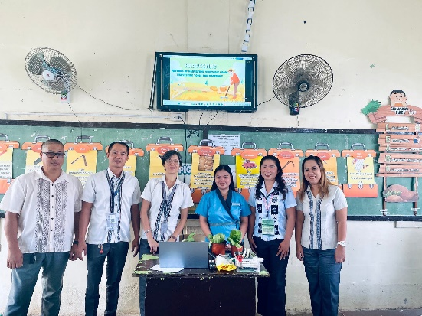
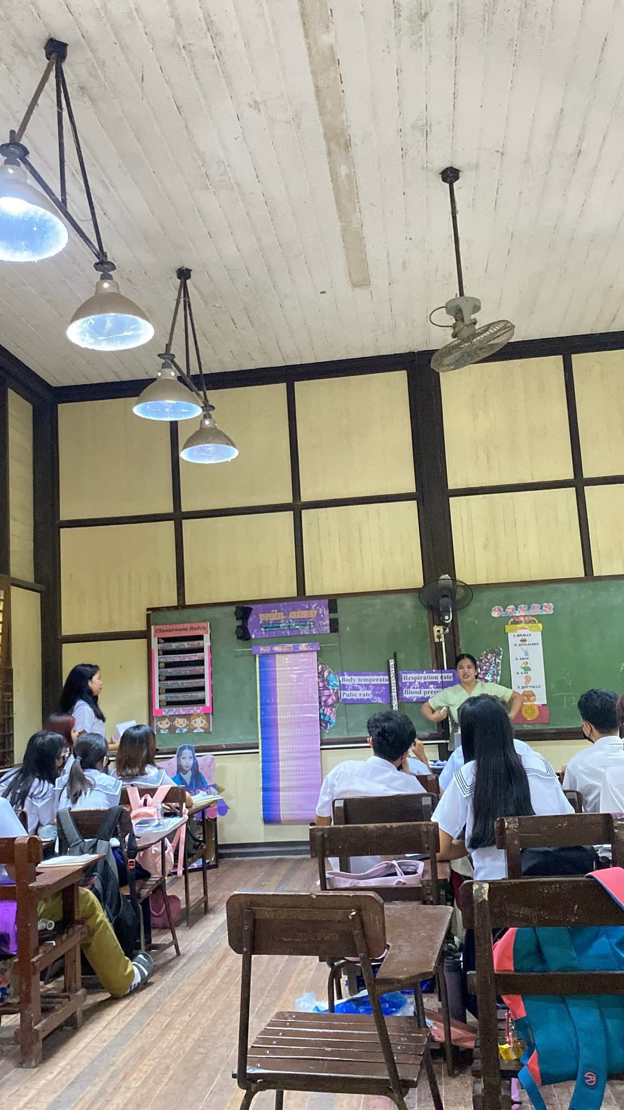
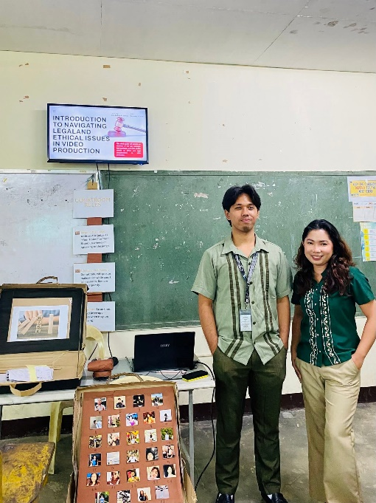
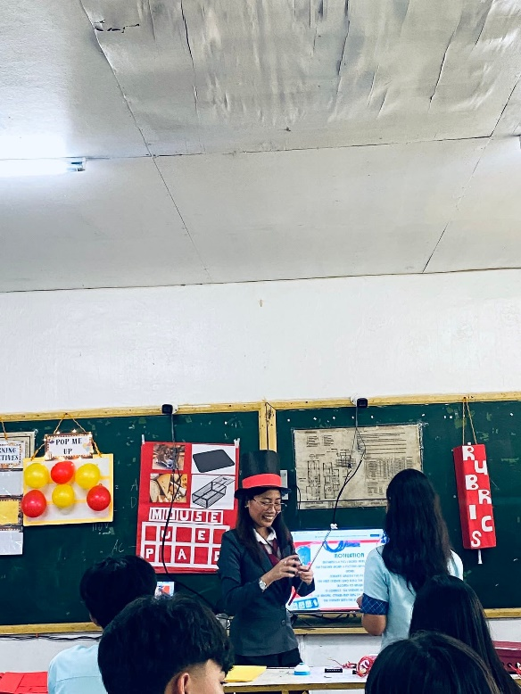
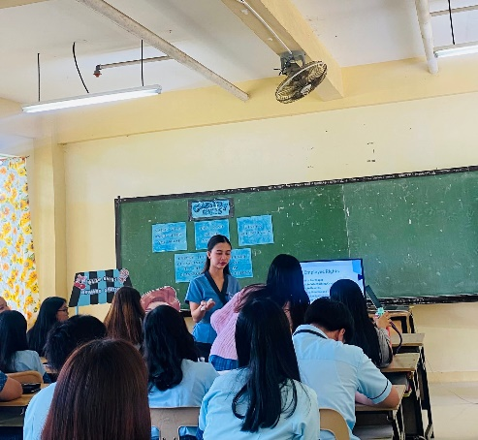
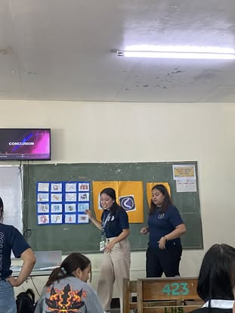
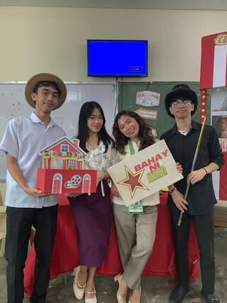
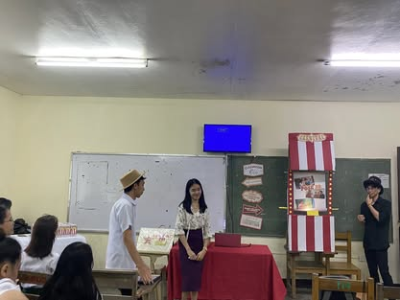
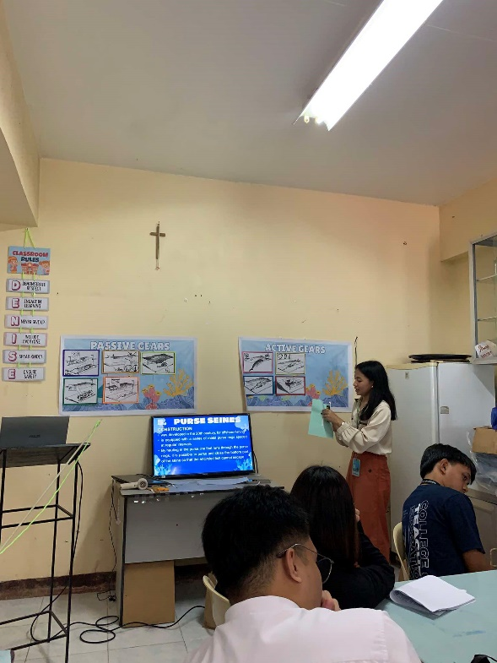
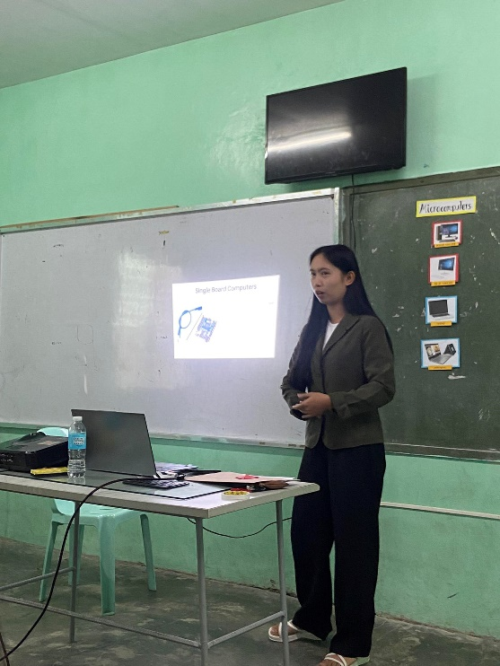
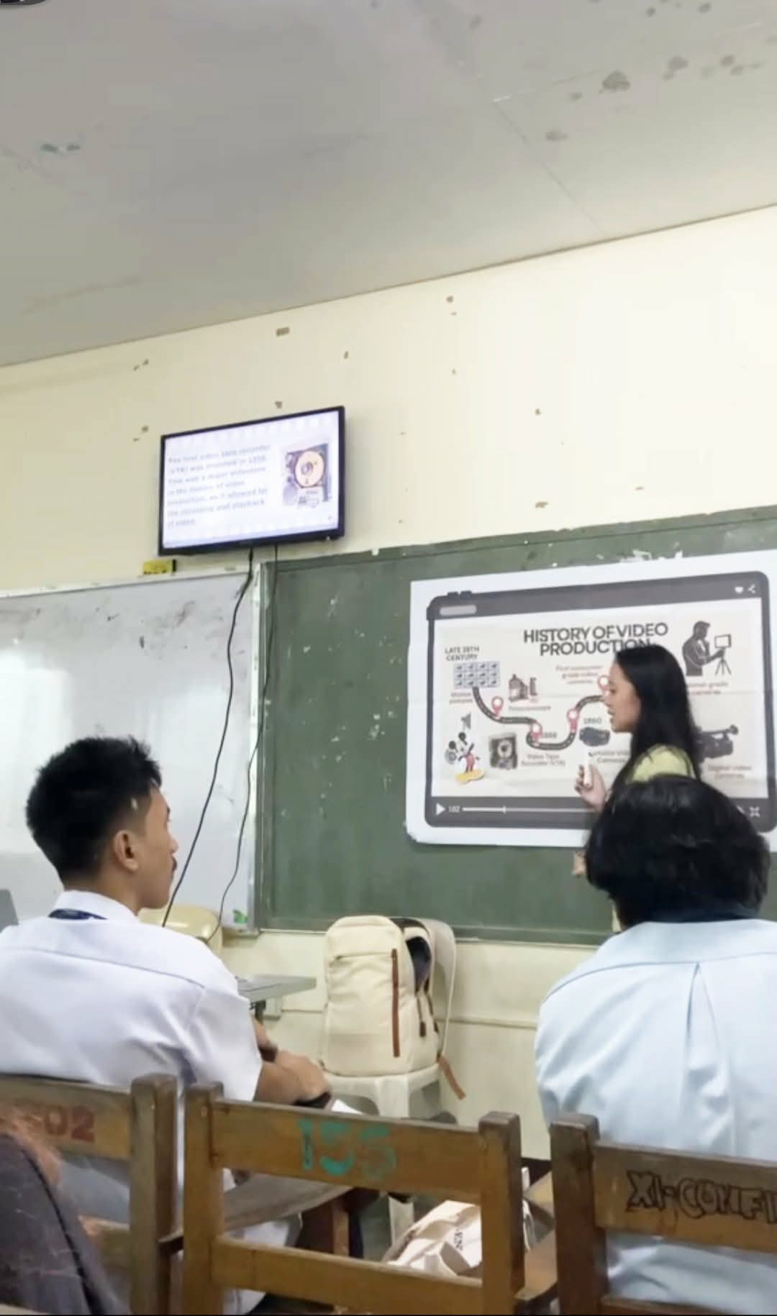
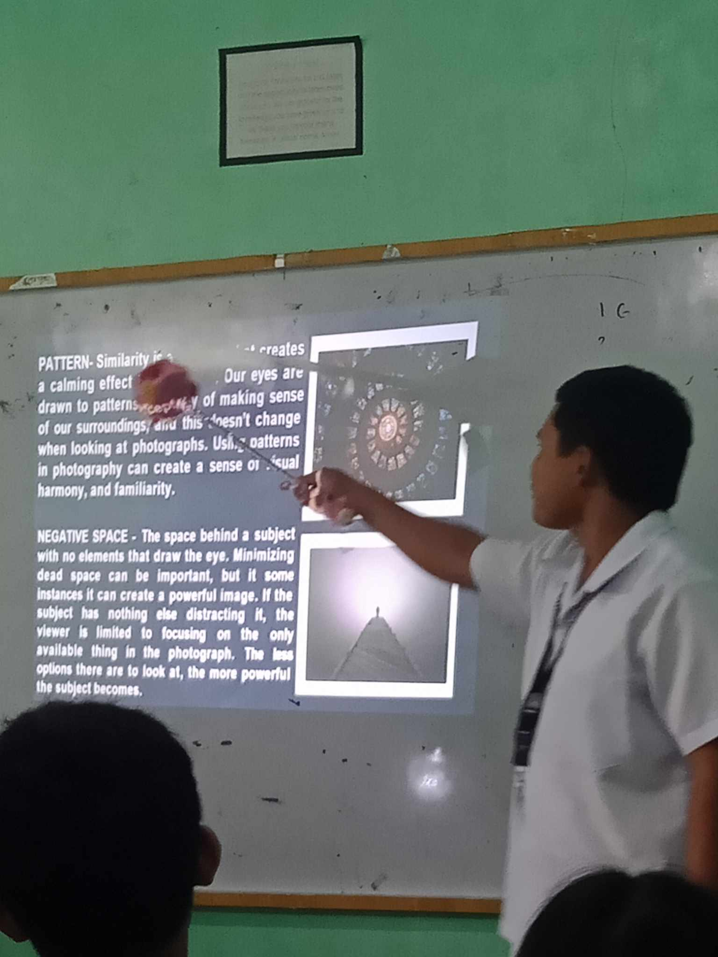

A teaching demonstration is the process of presenting a sample lesson to show how a topic can be taught effectively in the classroom. The image illustrates college students majoring in BTLEd (Bachelor of Technology and Livelihood Education) conducting a demonstration activity as part of their training. This activity allows future teachers to practice lesson delivery, classroom management, and instructional strategies. Teaching demonstrations help develop confidence, communication skills, and professional teaching competence.

OTHER ACTIVITIES

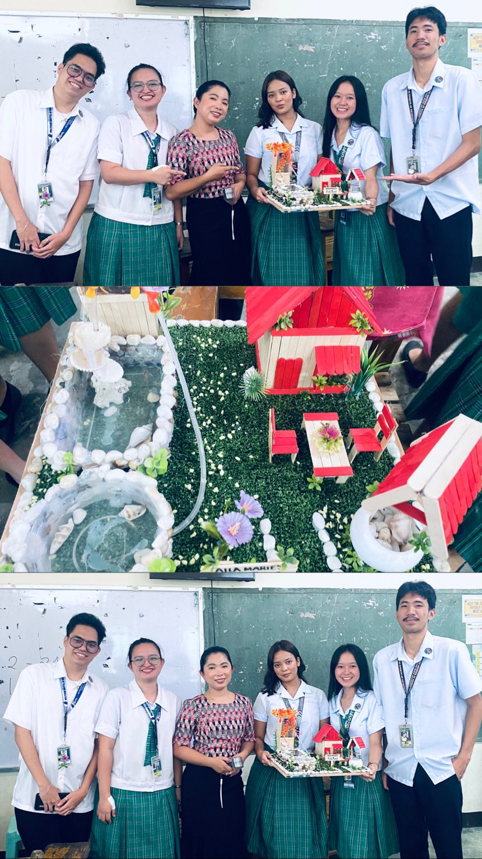
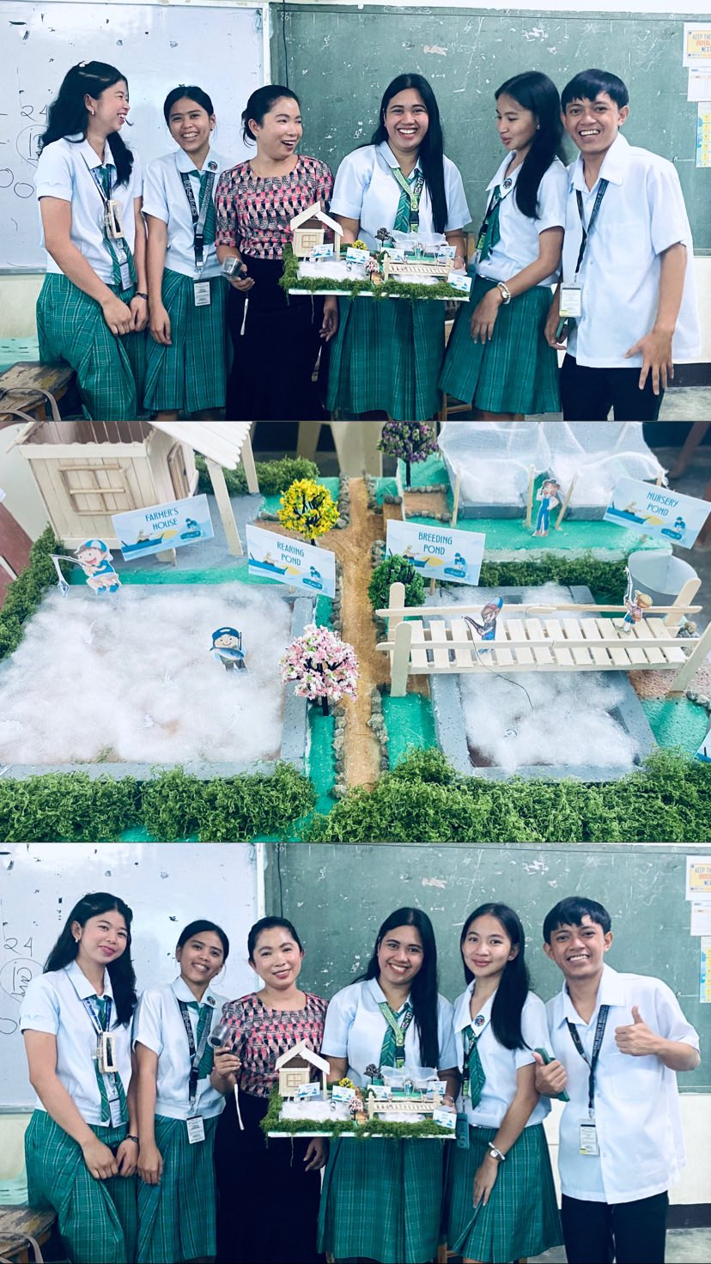

This is the process of students making a model of a farm in the Agrifishery subject to understand agricultural systems. The activity involves constructing a miniature layout using materials like clay, cardboard, sticks, and toy animals to represent crops, livestock, irrigation, fish ponds, and farm structures. This technique is commonly used in vocational classes to teach sustainable farming practices, crop rotation, and integrated agri-fishery techniques for real-world food production.

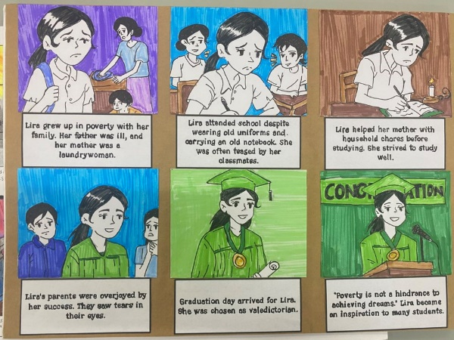
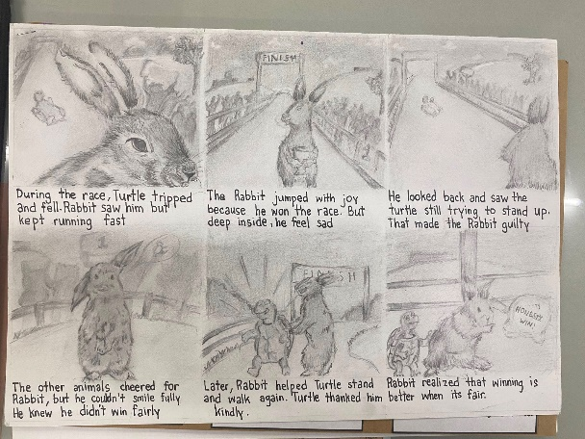
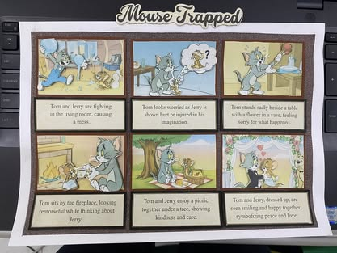

Storyboard creation is the process of students developing a series of drawings to visually organize and sequence a story. The illustration shows how each frame represents a scene or key moment in a project. This activity helps students plan the flow of events, ideas, and transitions before producing videos or animations. Creating a storyboard encourages creativity, organization, and clear visualization of the final project.

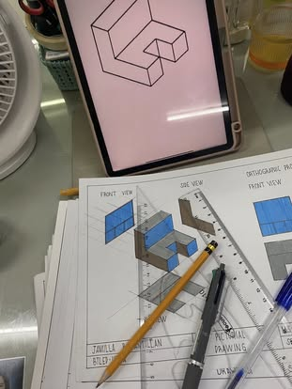
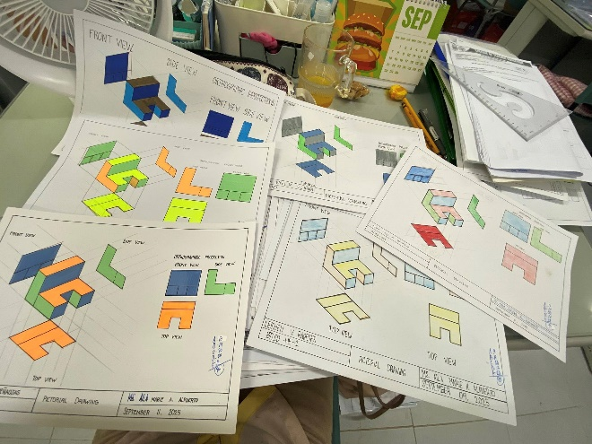

Pictorial drawing is the process of creating illustrations that represent three-dimensional objects in a realistic and visual manner. The image demonstrates how students draw objects in a way that shows depth, shape, and proportion on a flat surface. This activity helps learners understand how objects appear in real life and how they can be represented clearly through drawing. Pictorial drawings are commonly used in design, technical work, and visual presentations to communicate ideas effectively.

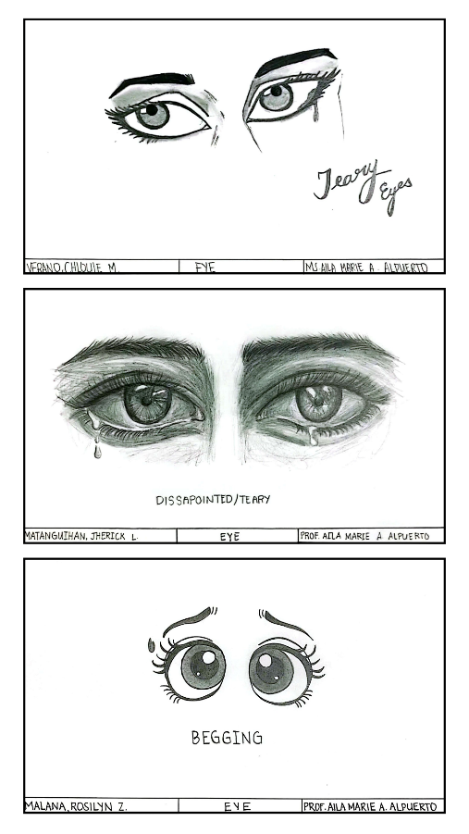
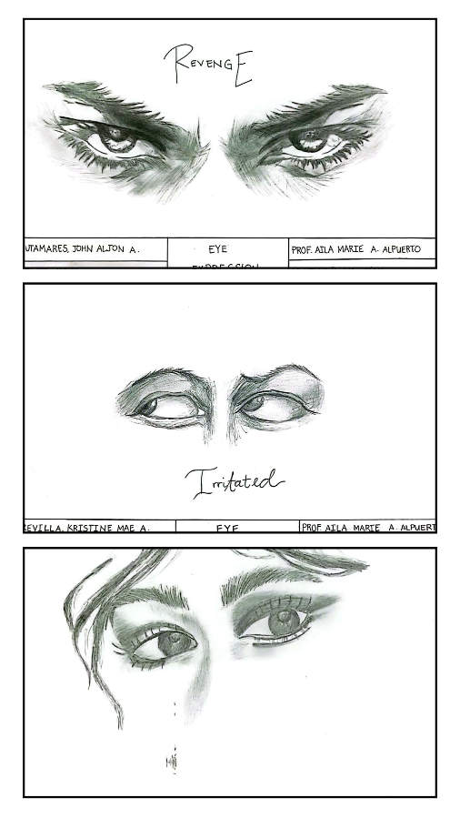

Eye expression drawing is the process of practicing how to illustrate eyes in a way that clearly shows different emotions. The image demonstrates how students focus on the details of the eyes, such as shape, lines, and shading, to express feelings like happiness, sadness, or surprise. This activity helps develop observation skills, precision, and artistic creativity. Eye expression drawing is important in art and animation because it helps convey emotions and bring characters to life.

Brief Description of ICT

ICT, or Information and Communication Technology, is a field of study that focuses on the knowledge and skills necessary for digital problem-solving, computing, and technological applications. It includes areas such as computer programming, web development, networking, multimedia design, and data management. The discipline aims to develop technical skills, digital literacy, and competencies that prepare individuals to create, manage, and utilize information systems effectively while contributing to modern industries and connected communities.

