MAJOR ACTIVITES IA

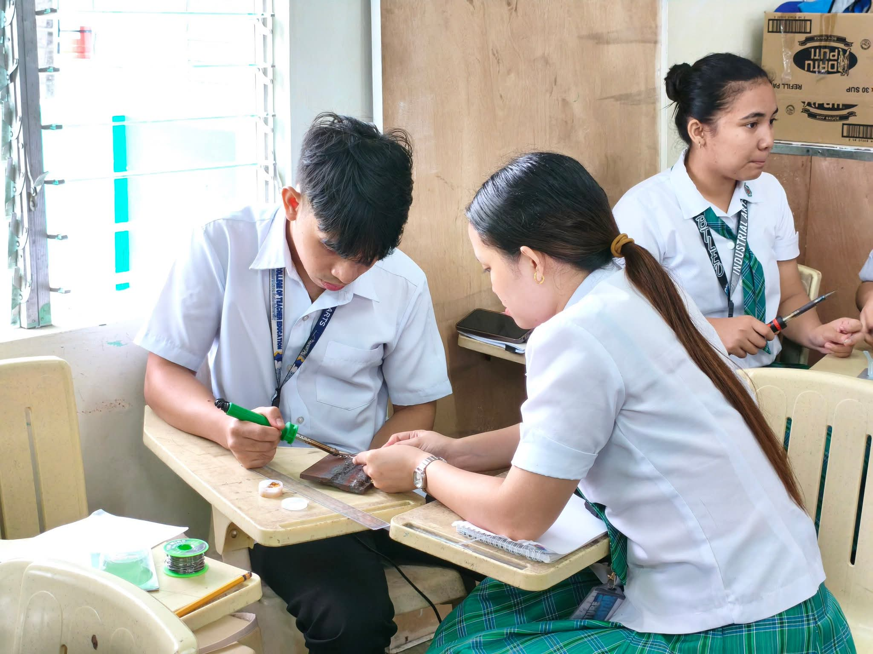
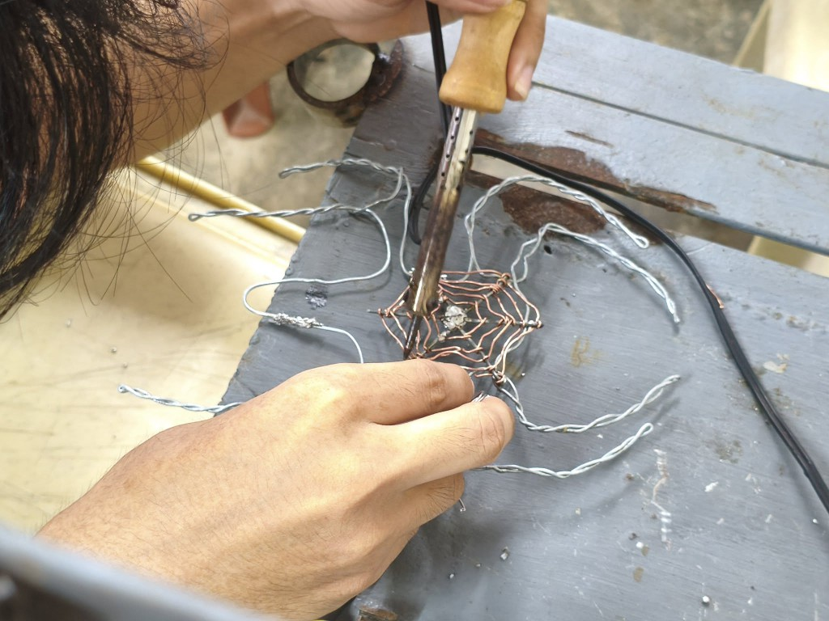
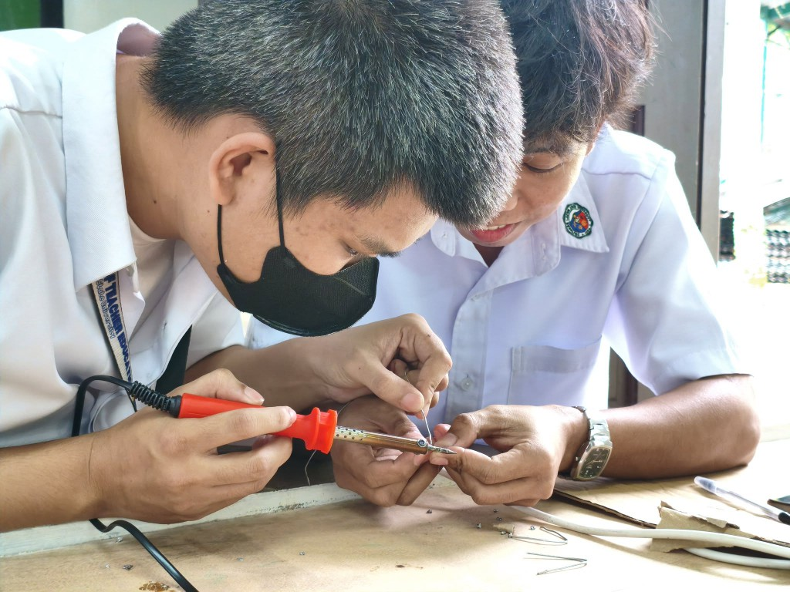

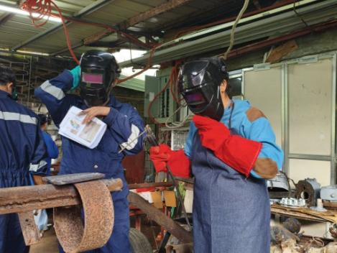
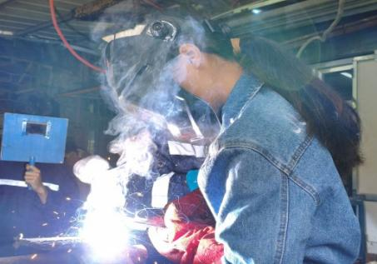
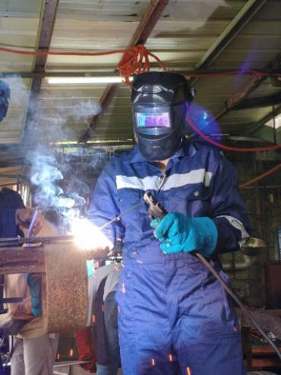
Soldering is the process of joining metal wires together using a soldering iron and melted solder. The image demonstrates how the heated tip of the soldering iron melts the solder, allowing it to bond copper wires and other metal components securely. This technique requires careful handling, precision, and proper heat control to create strong and reliable connections. Soldering is commonly used in electronics and craft projects to form stable electrical connections and assemble small wire structures.

Welding is the process of joining metal pieces together by applying high heat to melt the edges of the materials. The image illustrates how a welding tool produces intense heat that fuses the metal parts into a single, strong joint. This technique requires proper skill, safety precautions, and precise control to ensure a durable connection. Welding is commonly used in construction, manufacturing, and repair work to build or fix metal structures such as frames, machinery, and structural components.
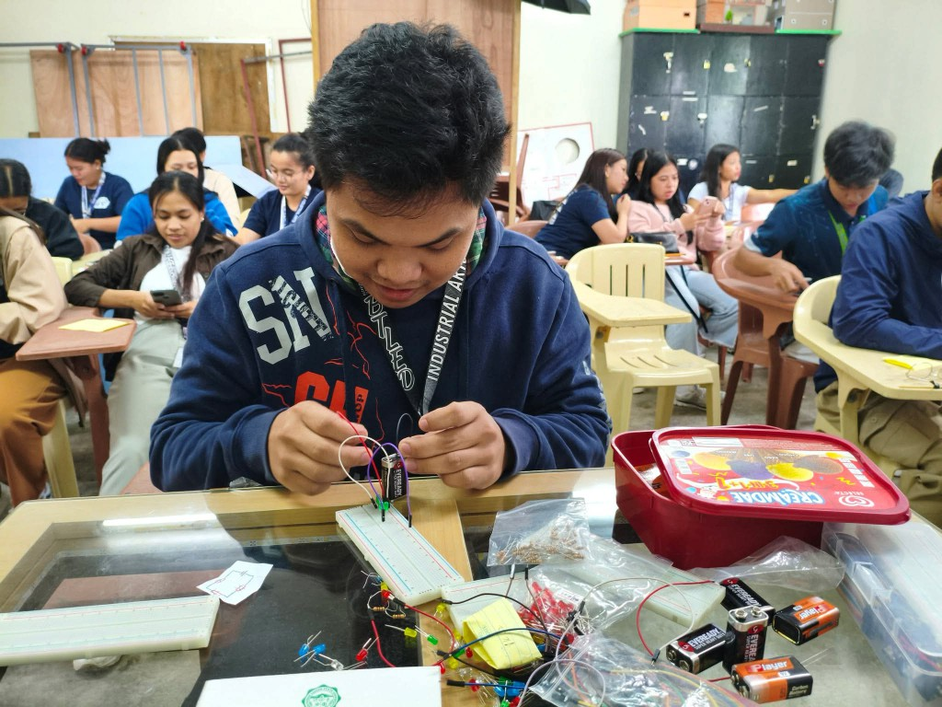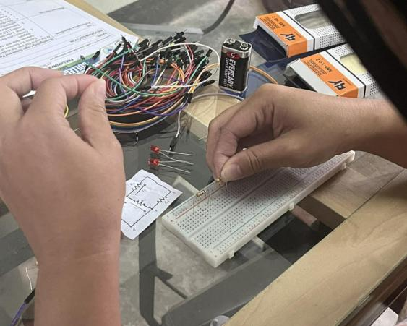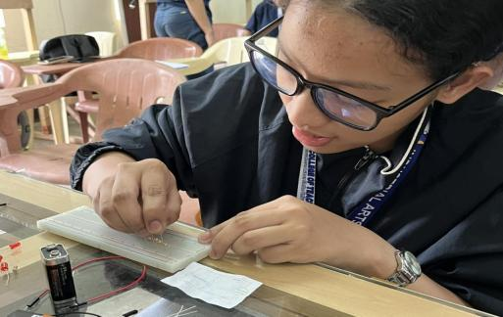

Circuit building on a breadboard is the process of assembling a simple electronic circuit using components such as resistors, LEDs, and connecting wires. The image demonstrates how these parts are arranged and connected based on a circuit diagram to form a working electrical system. This activity allows students to experiment with different connections without permanently attaching the components. Building circuits on a breadboard helps learners understand how electricity flows and how basic electronic devices function.

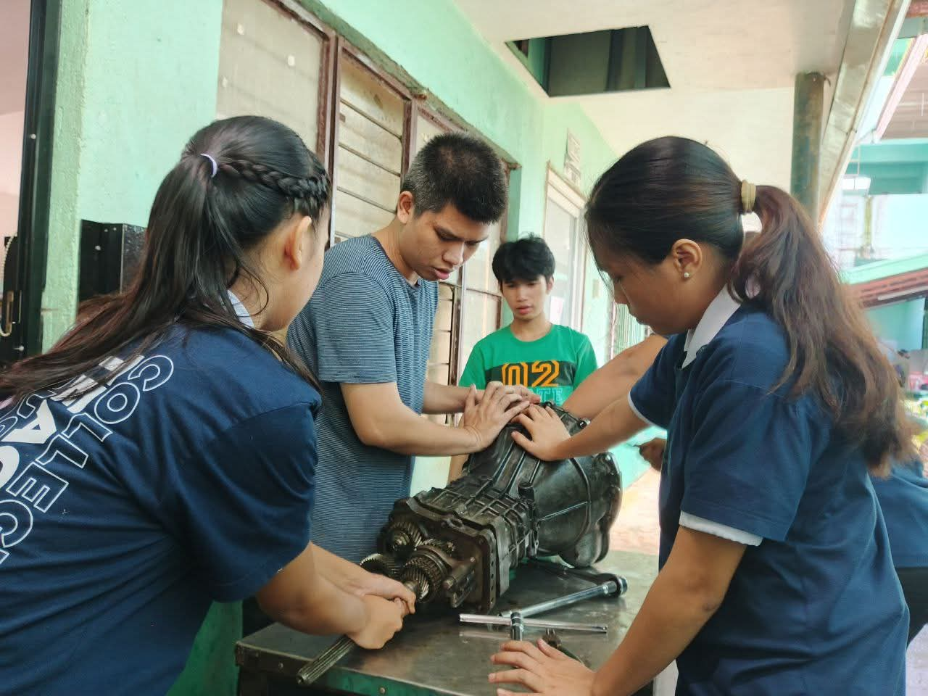
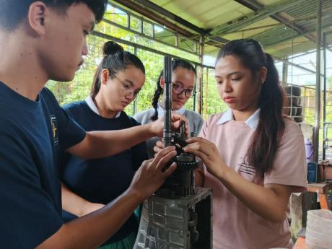
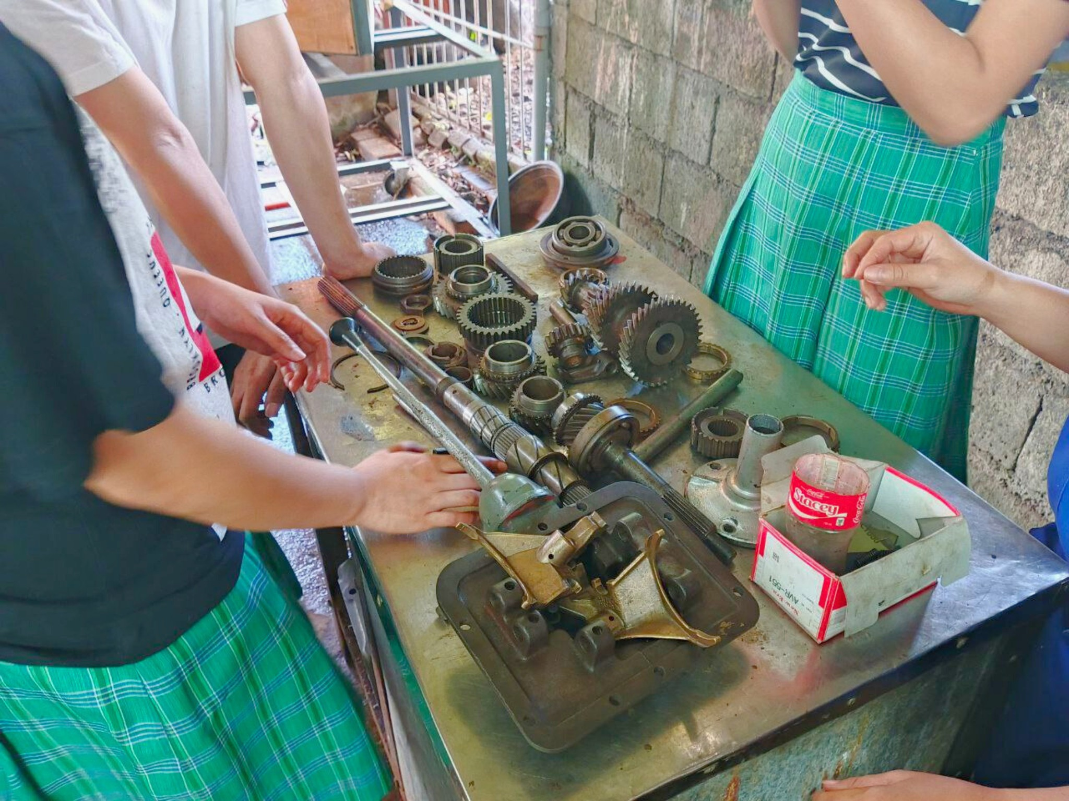

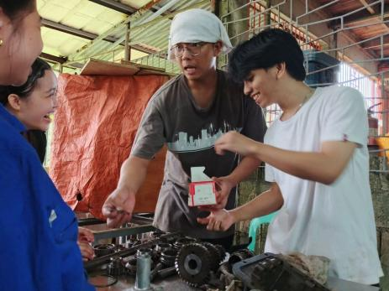
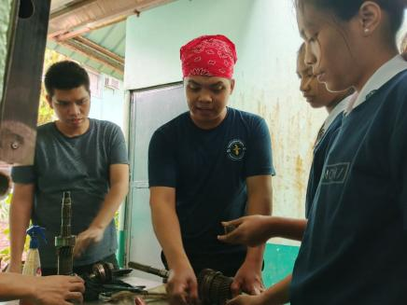

Gearbox disassembly is the process of taking apart a transmission unit to examine its internal components. The image demonstrates how students use basic hand tools to carefully remove parts such as gears, shafts, bearings, and synchronizers from the transmission housing. This activity allows learners to observe the condition of the components, count gear teeth for ratio analysis, and understand how the parts work together inside the mechanism. Gearbox disassembly is commonly used in industrial arts and vocational training to develop knowledge in automotive repair, machinery maintenance, and gear train principles.

OTHER ACTIVITES IA
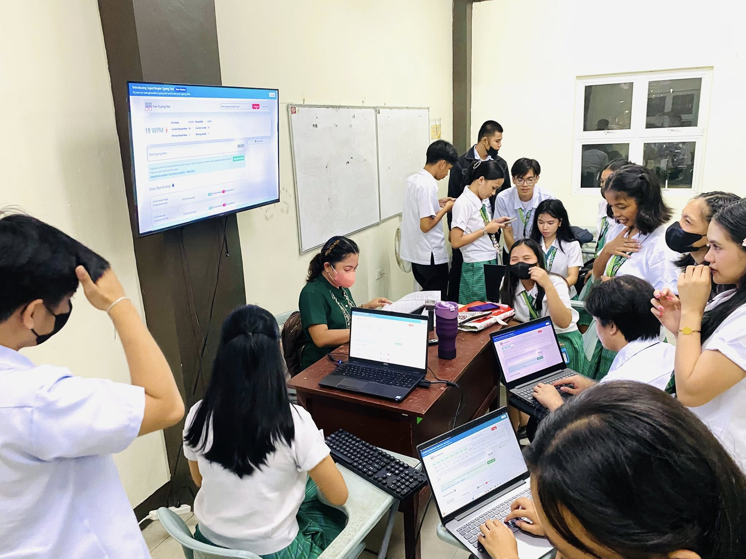
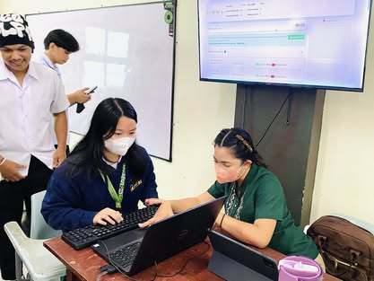
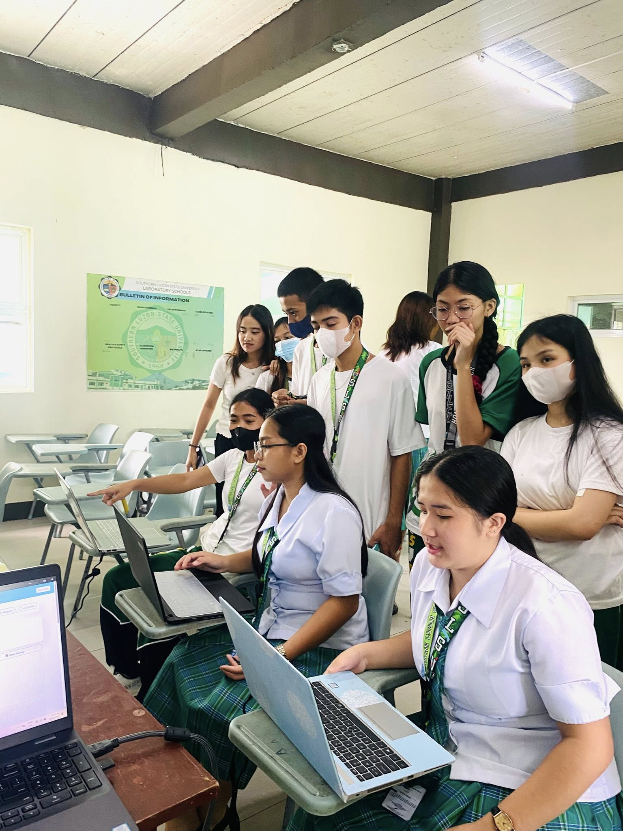
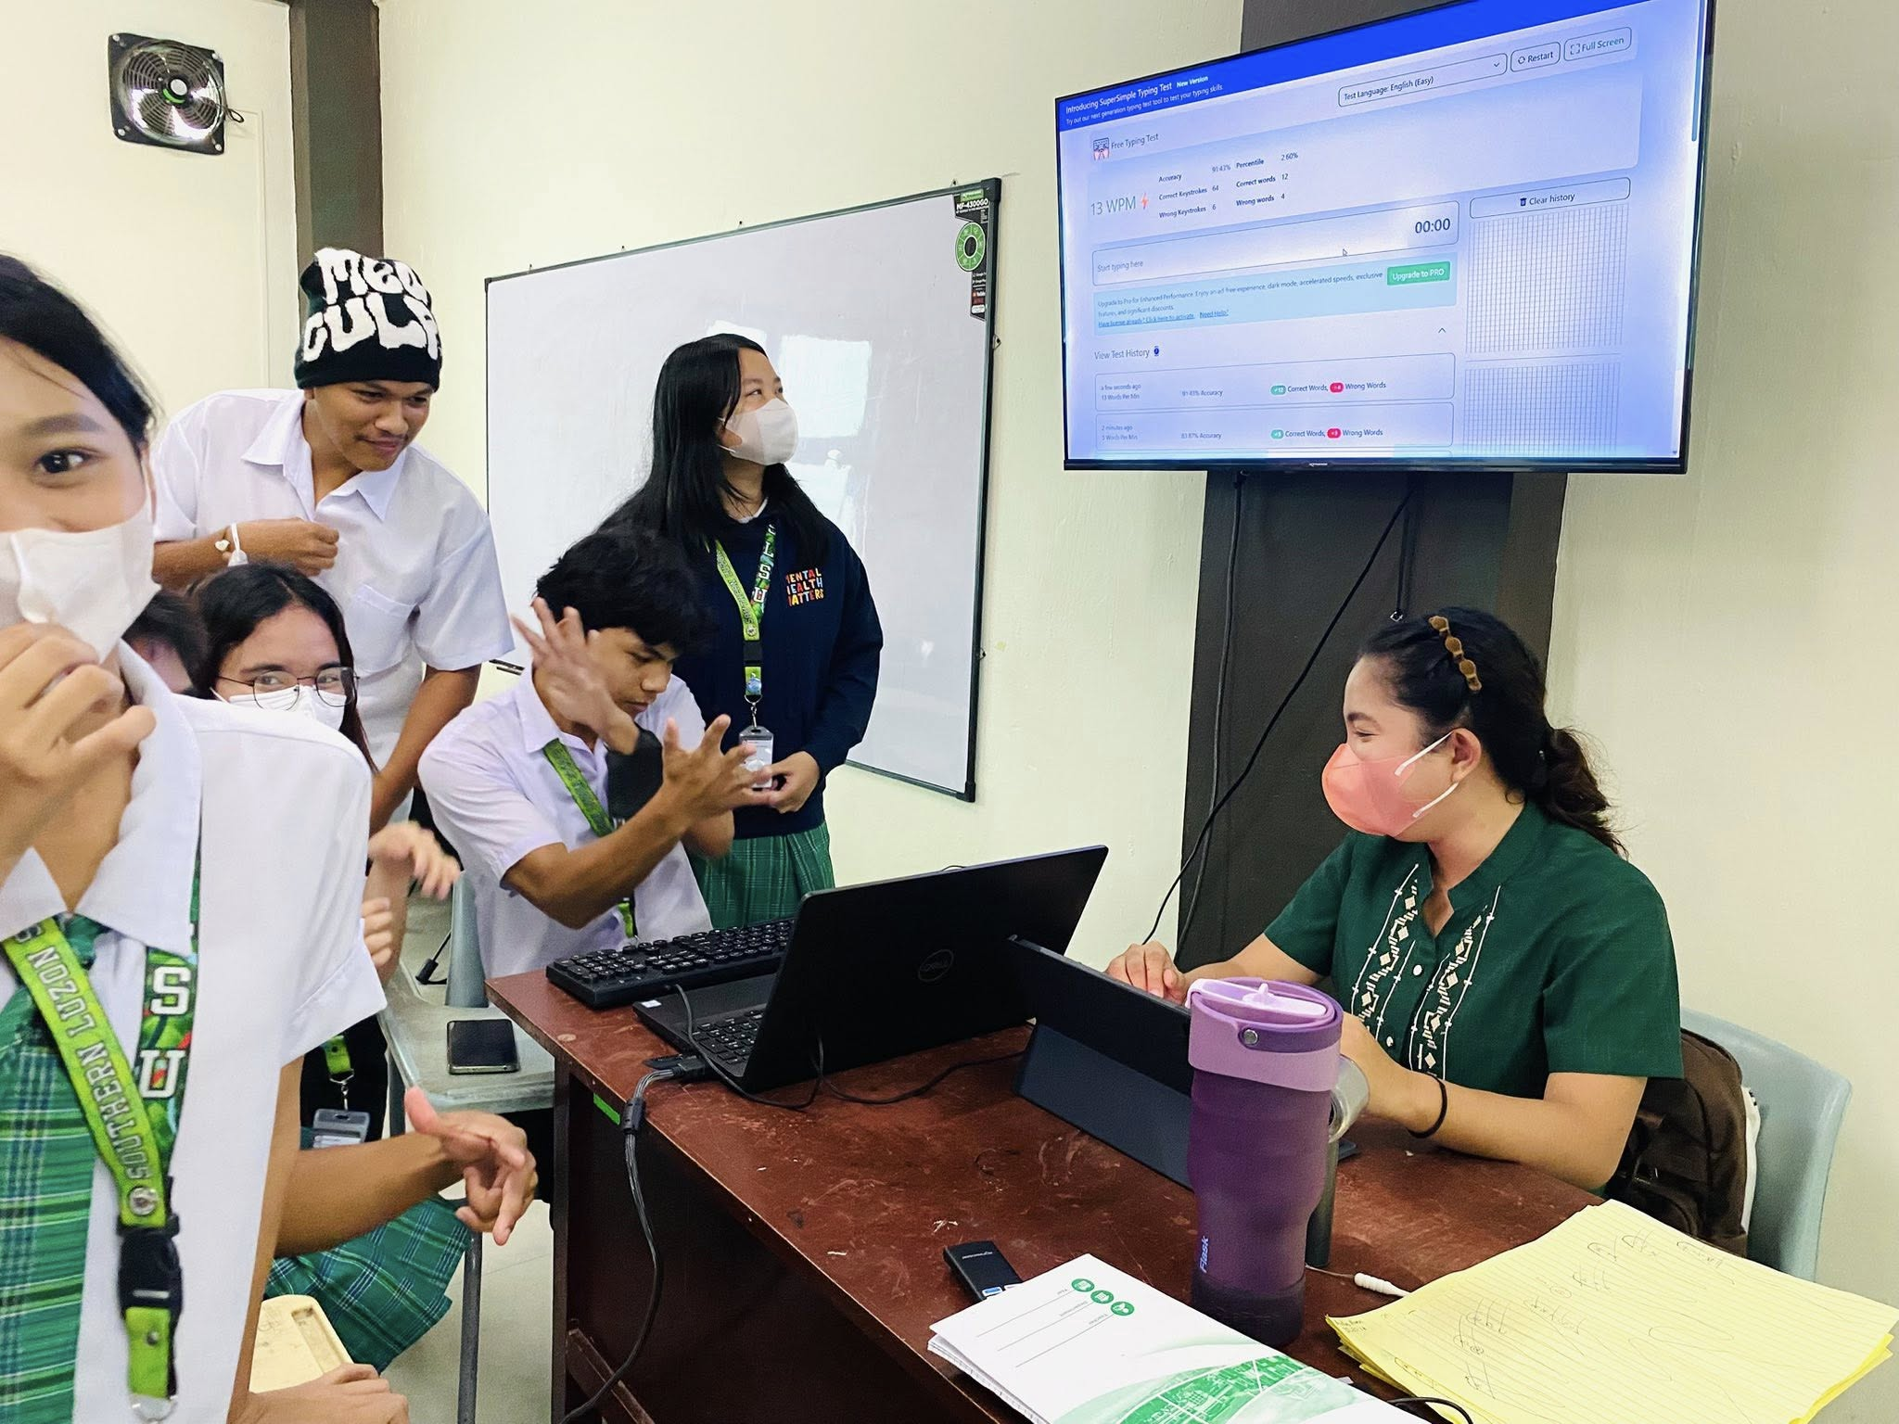

Typing practice is the process of students completing a simple typing test to improve their keyboard skills and typing speed. The image illustrates learners typing words, sentences, or short passages on a computer within a set time limit. During the activity, their words per minute (WPM) and accuracy are measured to track progress and develop proficiency. Typing practice is commonly used in computer classes and school activities to strengthen digital literacy, office skills, and efficient data entry for everyday tasks.
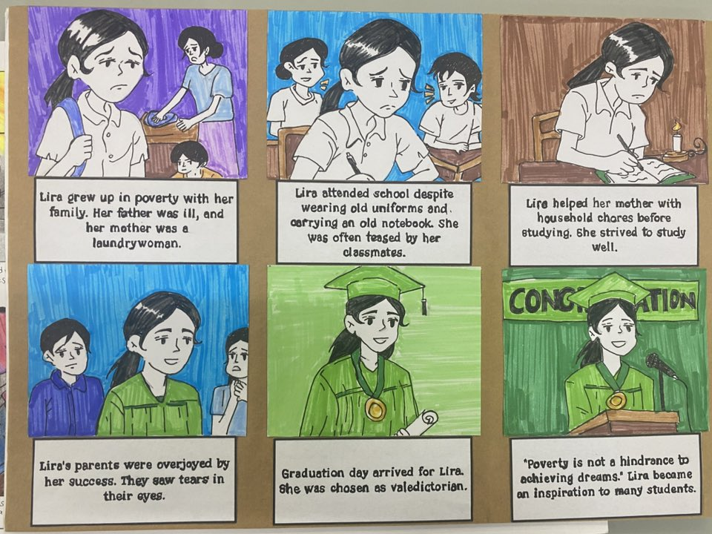
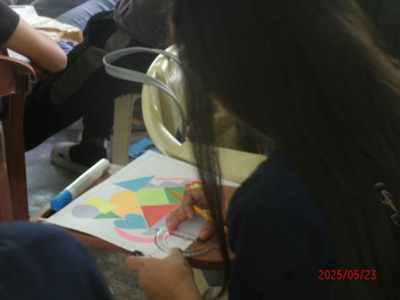
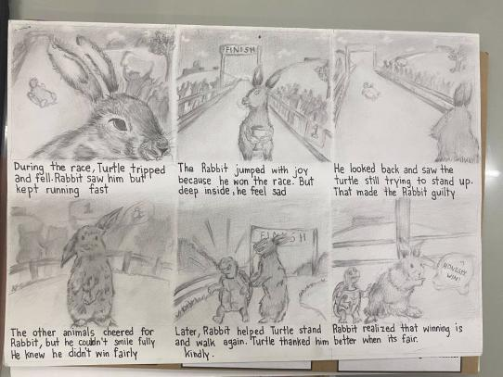

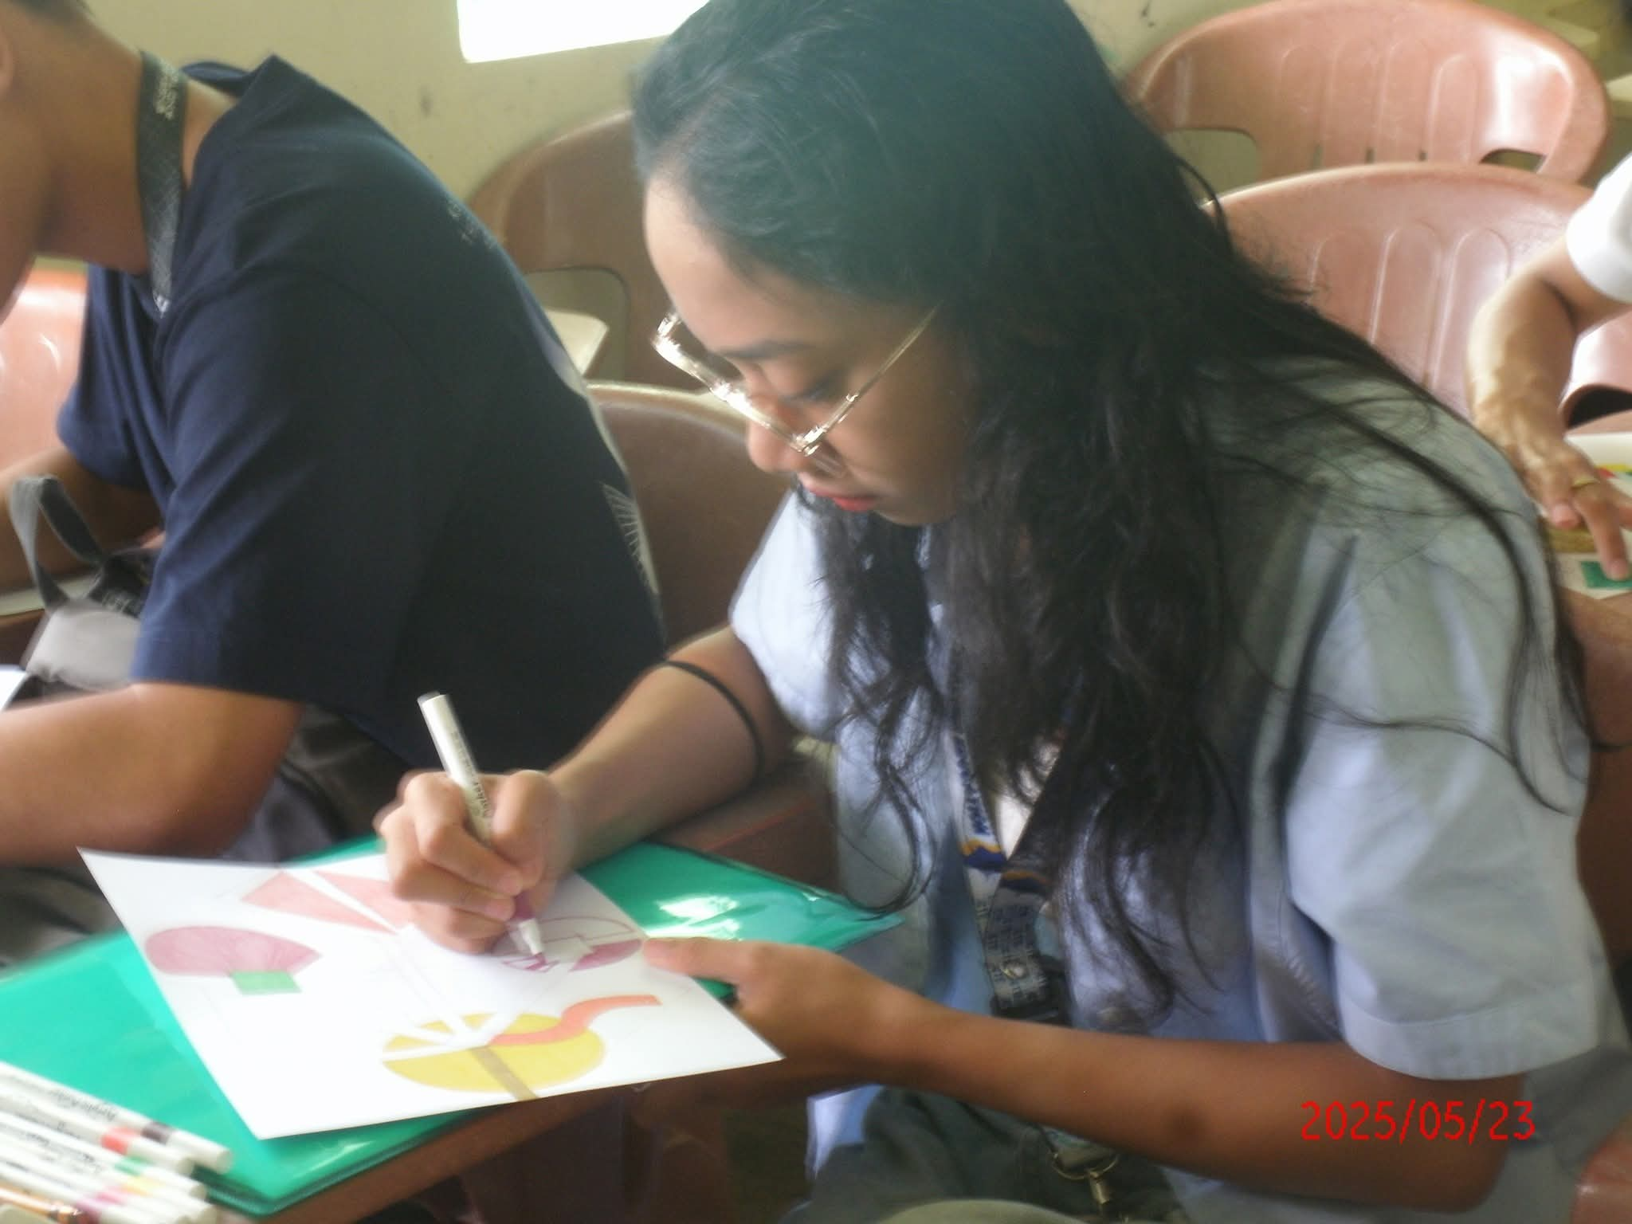
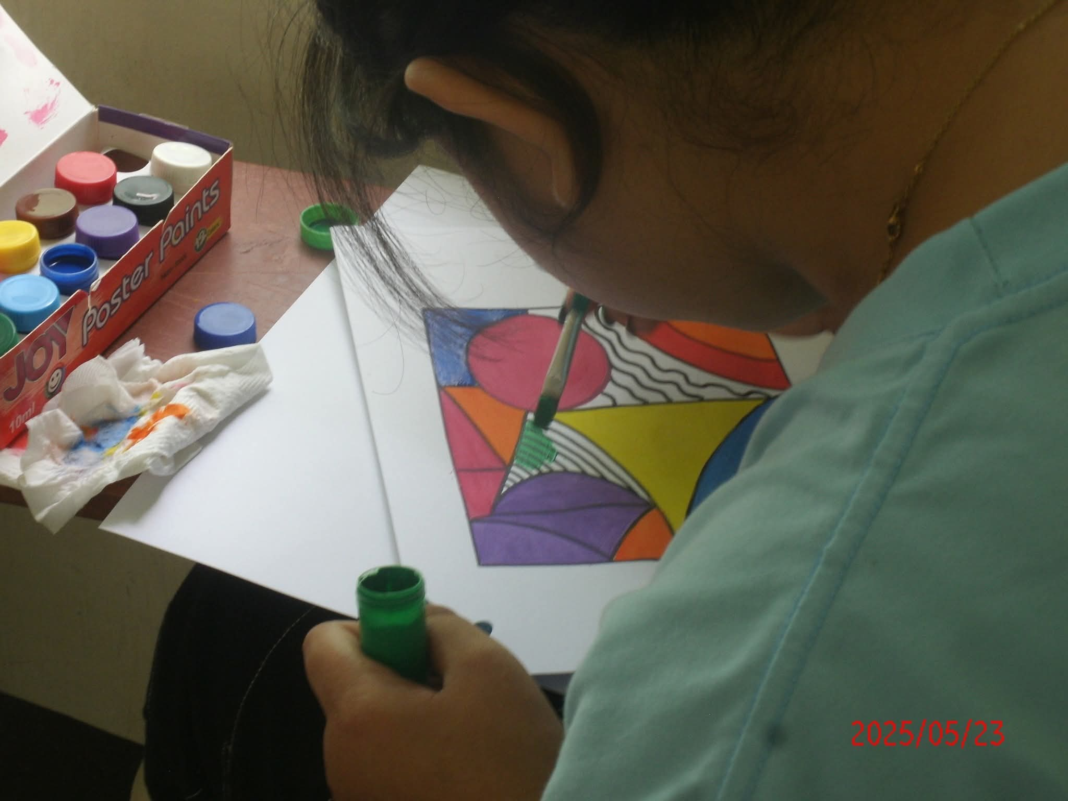
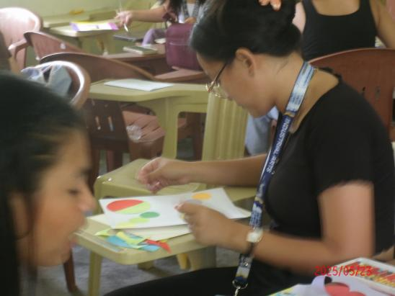

Art creation through painting and storyboard development is the process of students expressing ideas and telling visual stories using drawings and color. The image illustrates how learners sketch rough layouts, apply colors with brushes or markers on paper or canvas, and arrange panels in sequence to form a narrative. This activity helps students organize their concepts and visualize scenes for projects such as comics or animations. It is commonly used in art classes and creative projects to develop imagination, design skills, and visual storytelling for school presentations or media production.

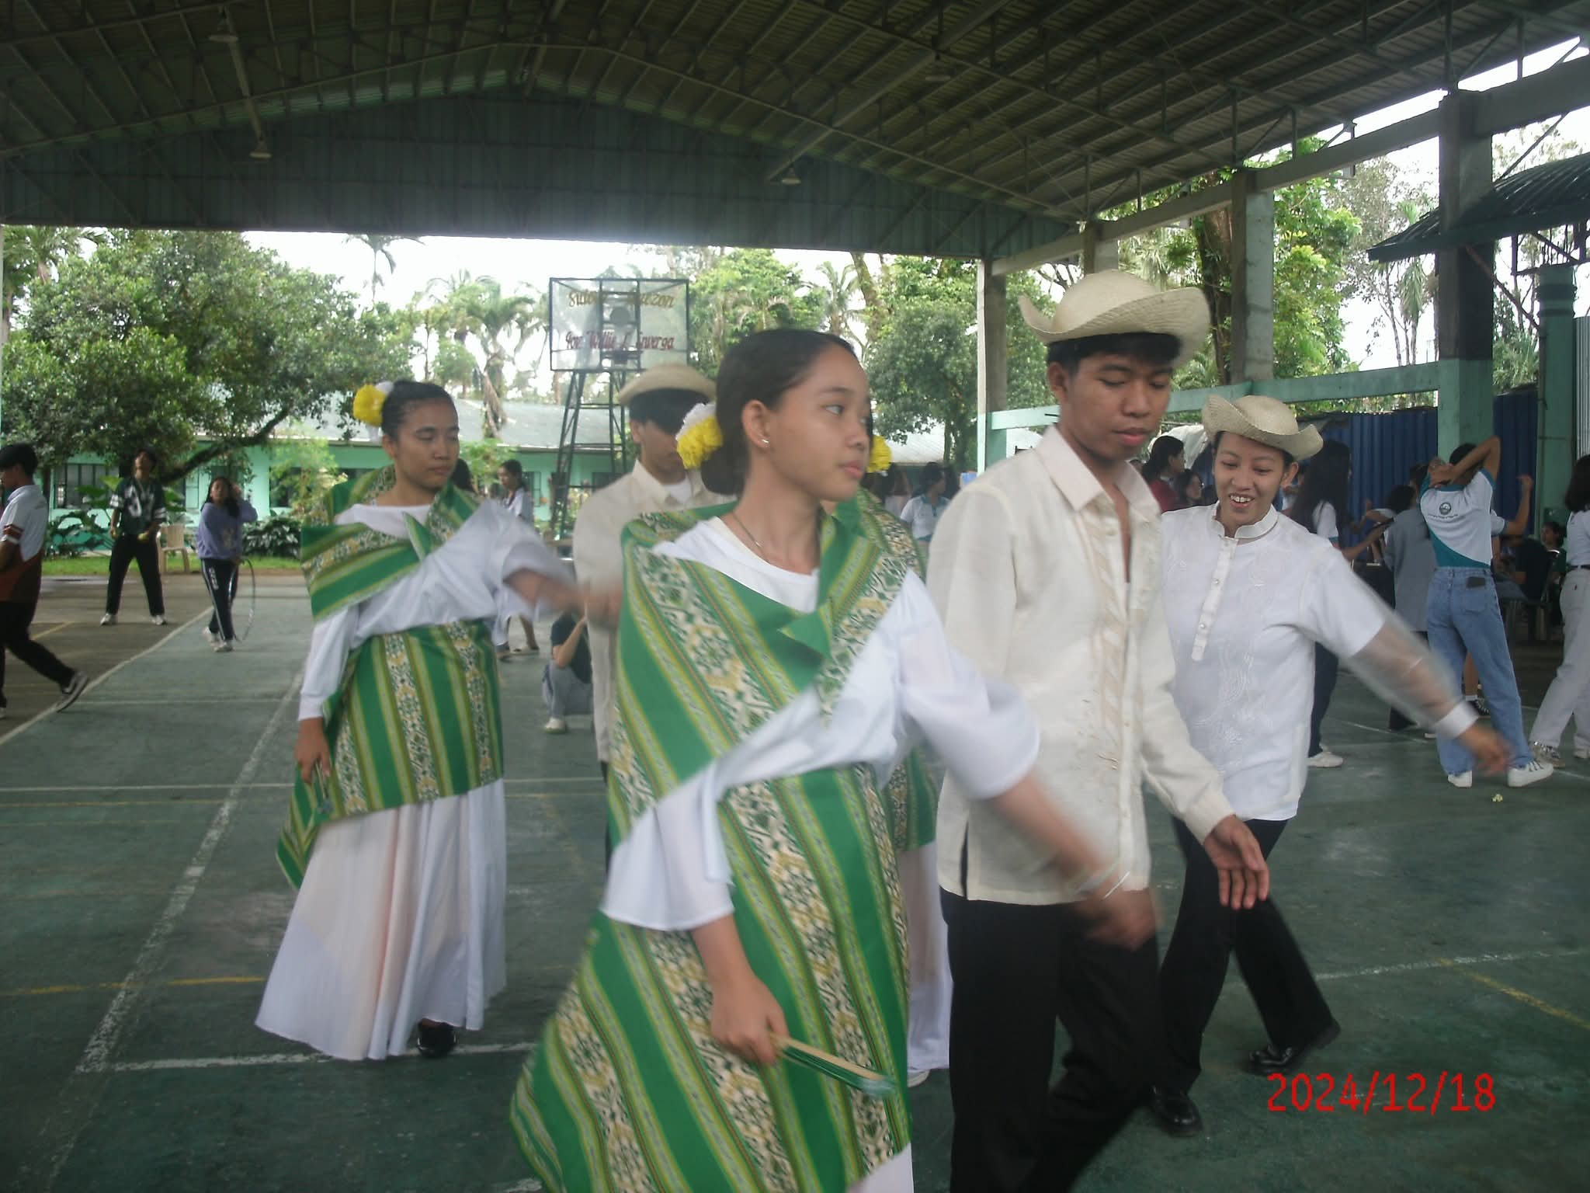
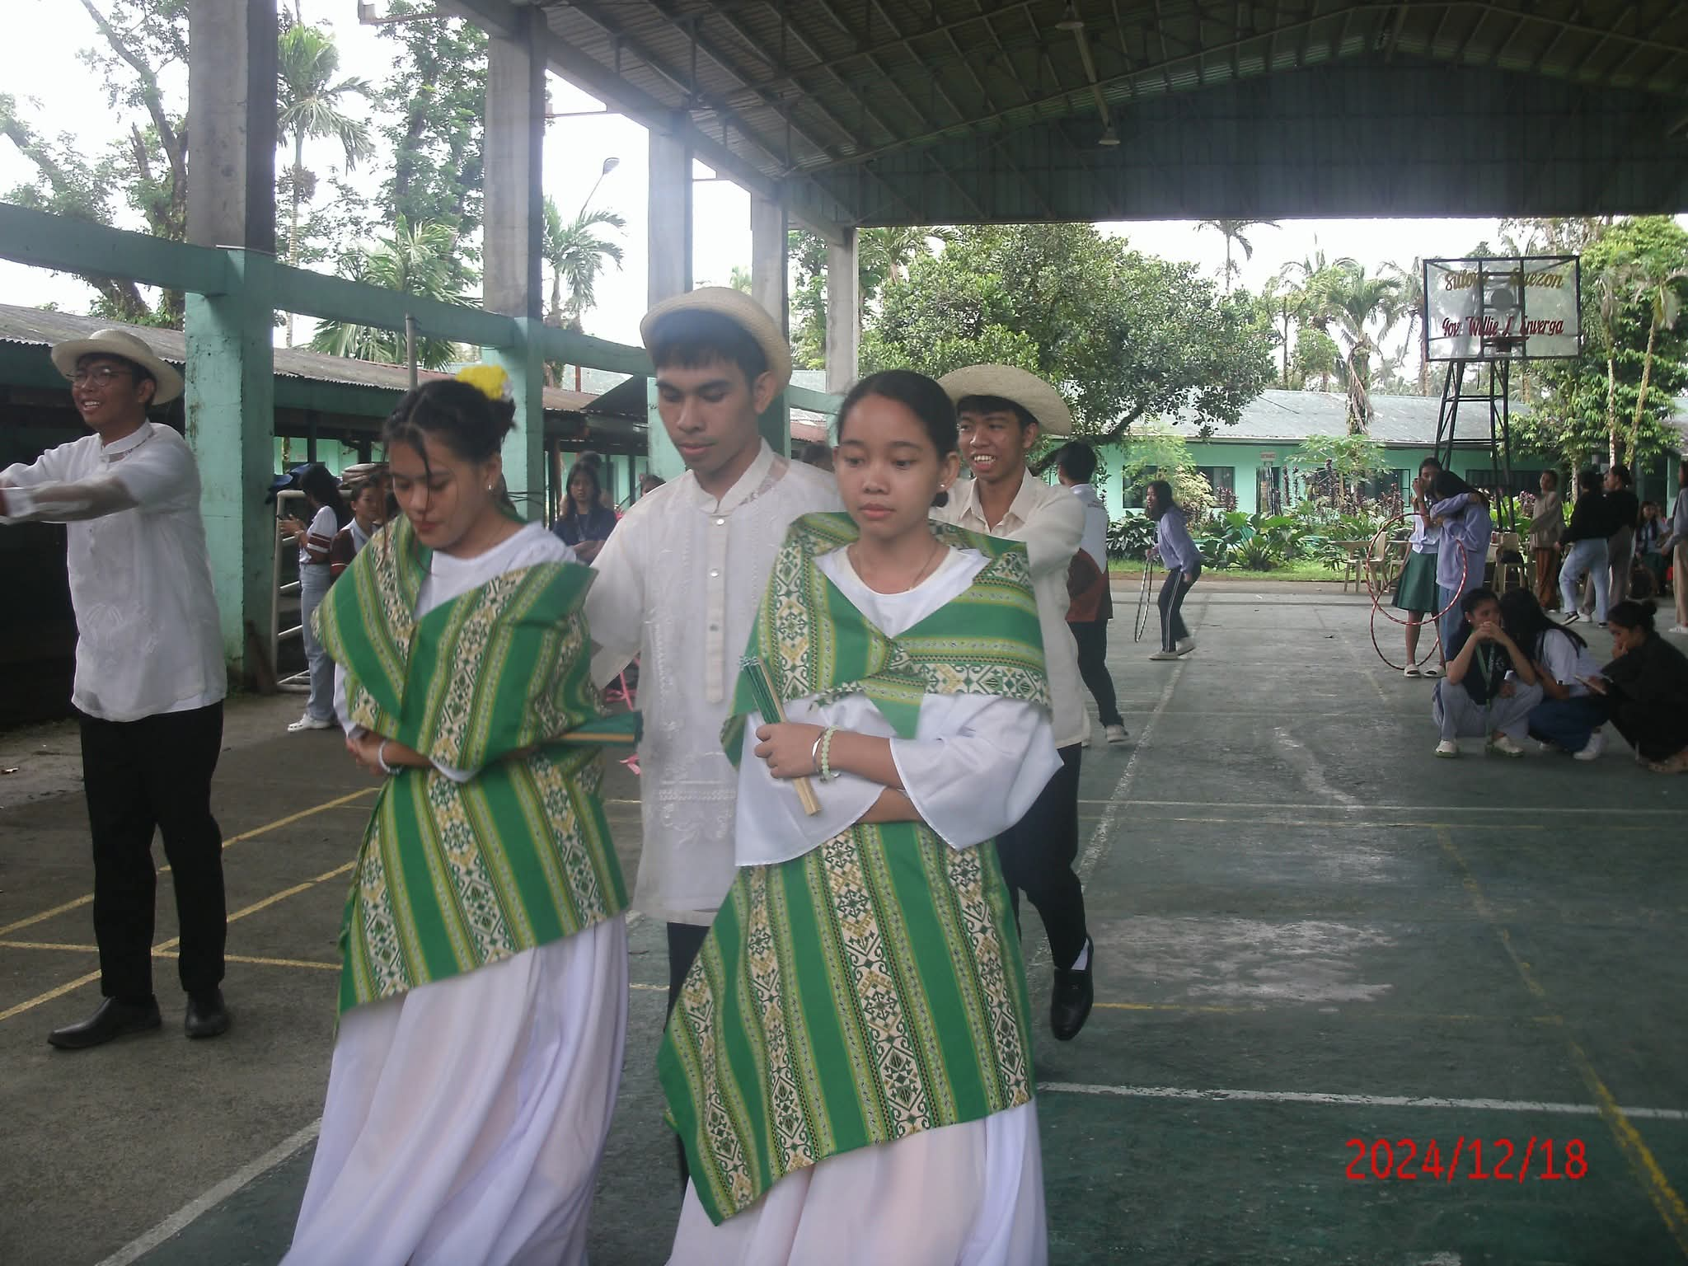
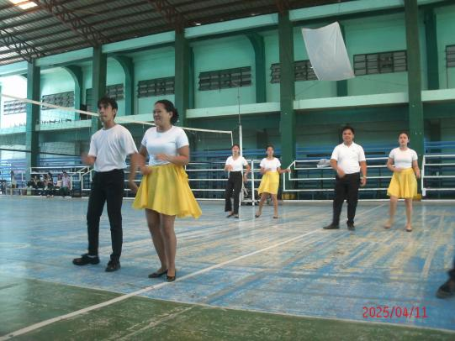

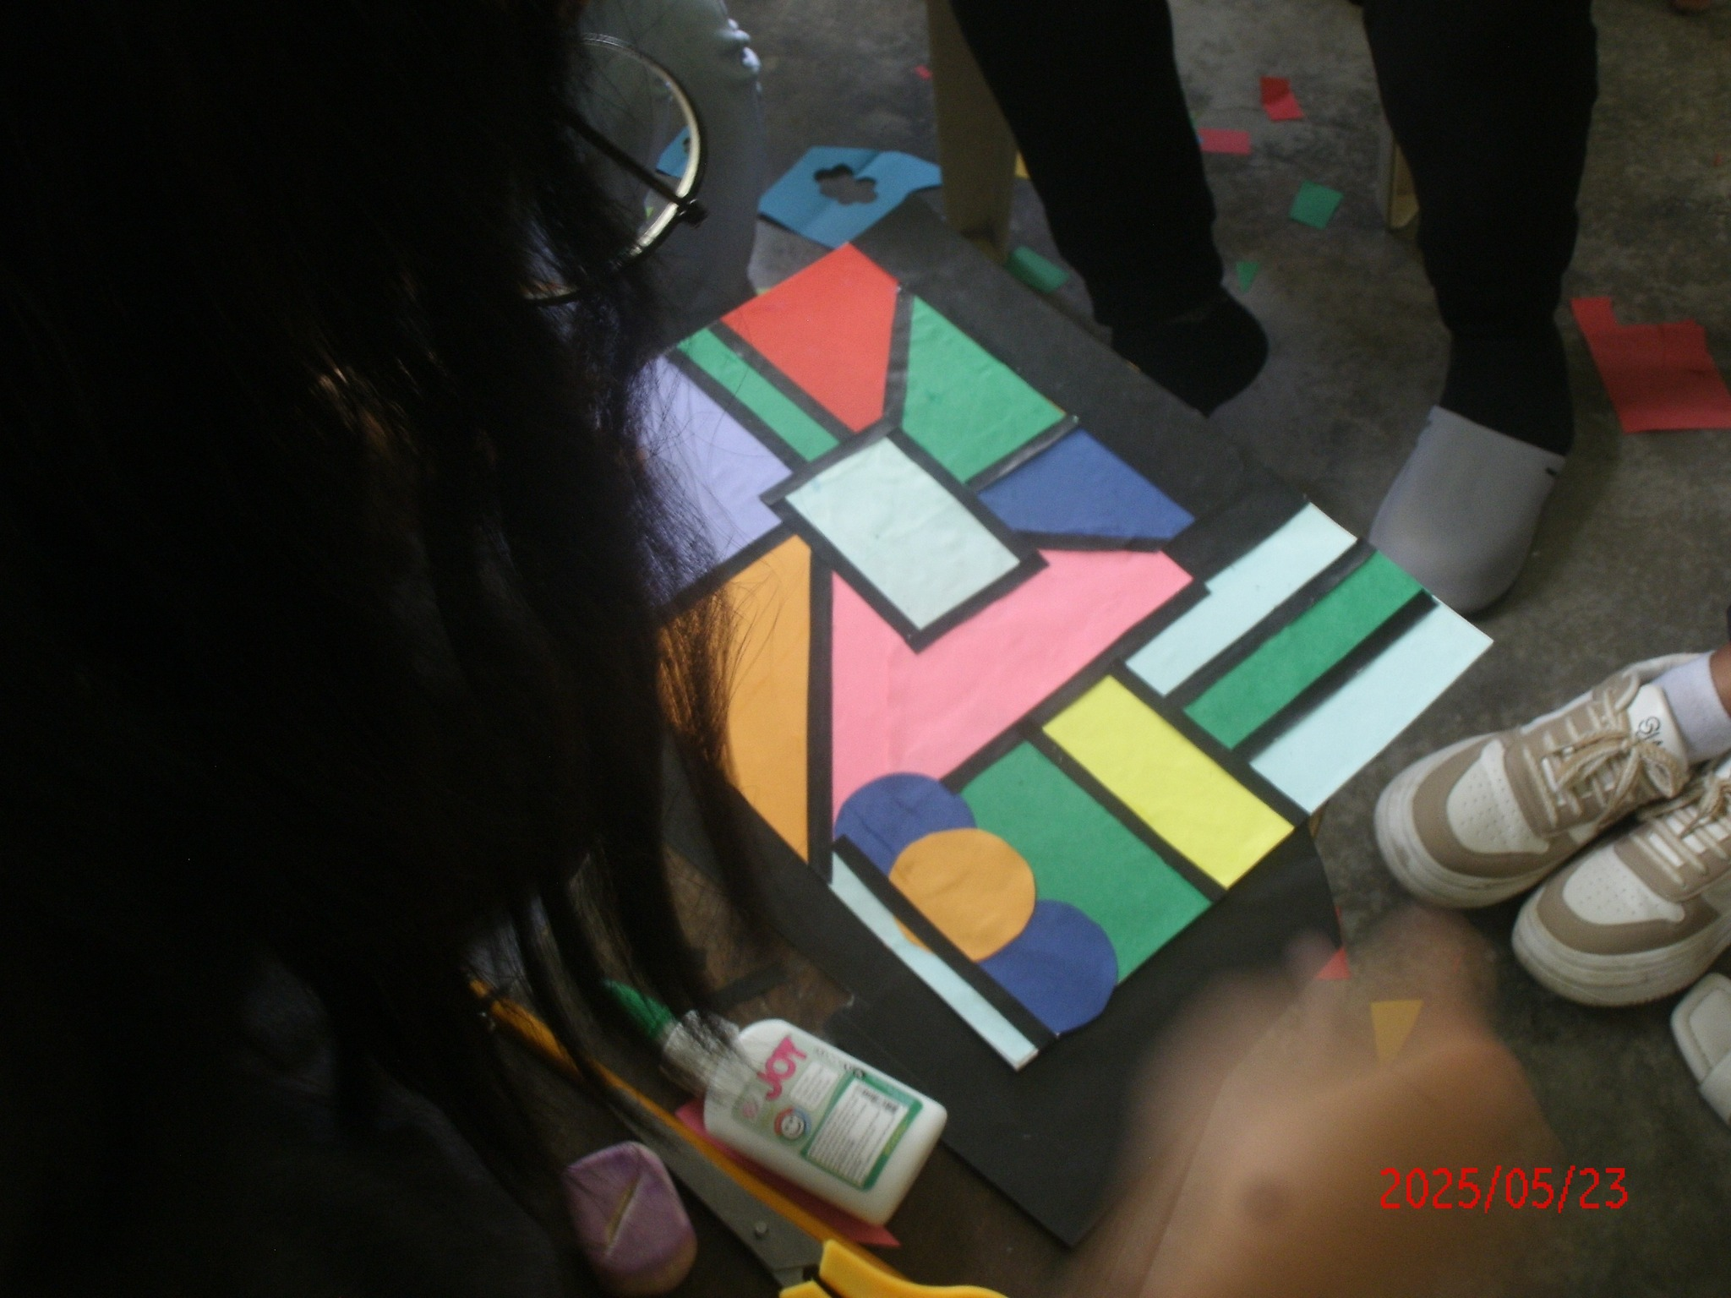
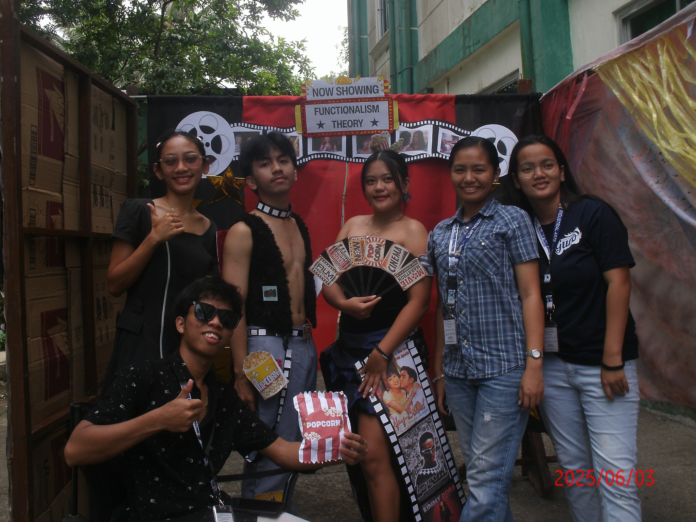
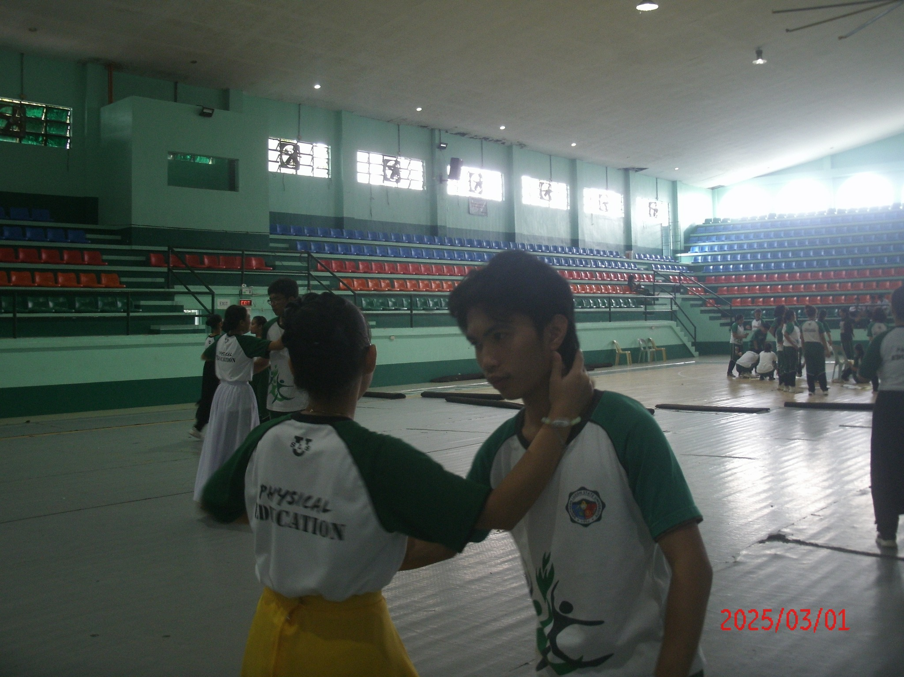

Performance activities such as folk dancing and fashion show preparation involve students expressing creativity while developing physical coordination and confidence. The image illustrates learners practicing rhythmic dance steps, formations, and traditional movements to music as part of a folk dance routine. At the same time, students prepare to model outfits on a runway, demonstrating design concepts and presentation skills. These activities are commonly used in physical education classes and school programs to promote physical fitness, cultural appreciation, creativity, teamwork, and self-confidence.

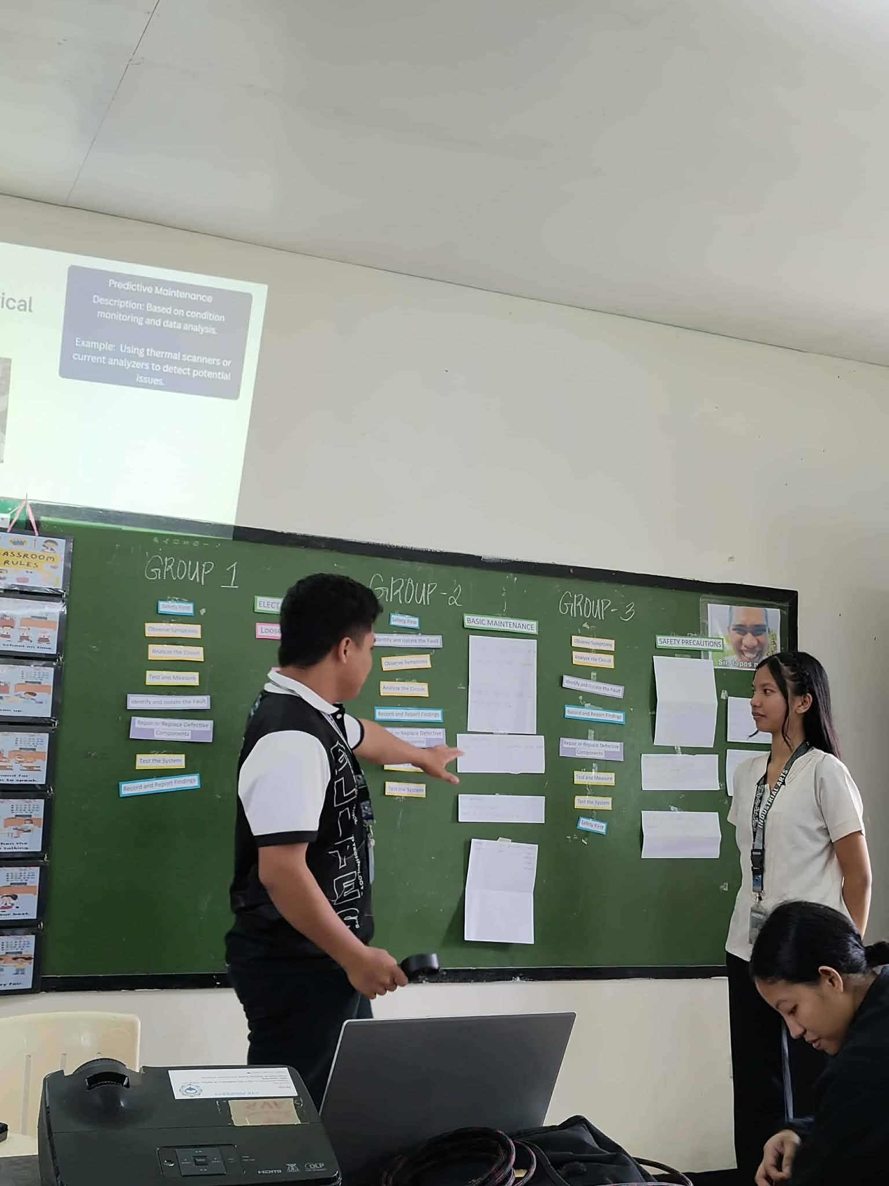
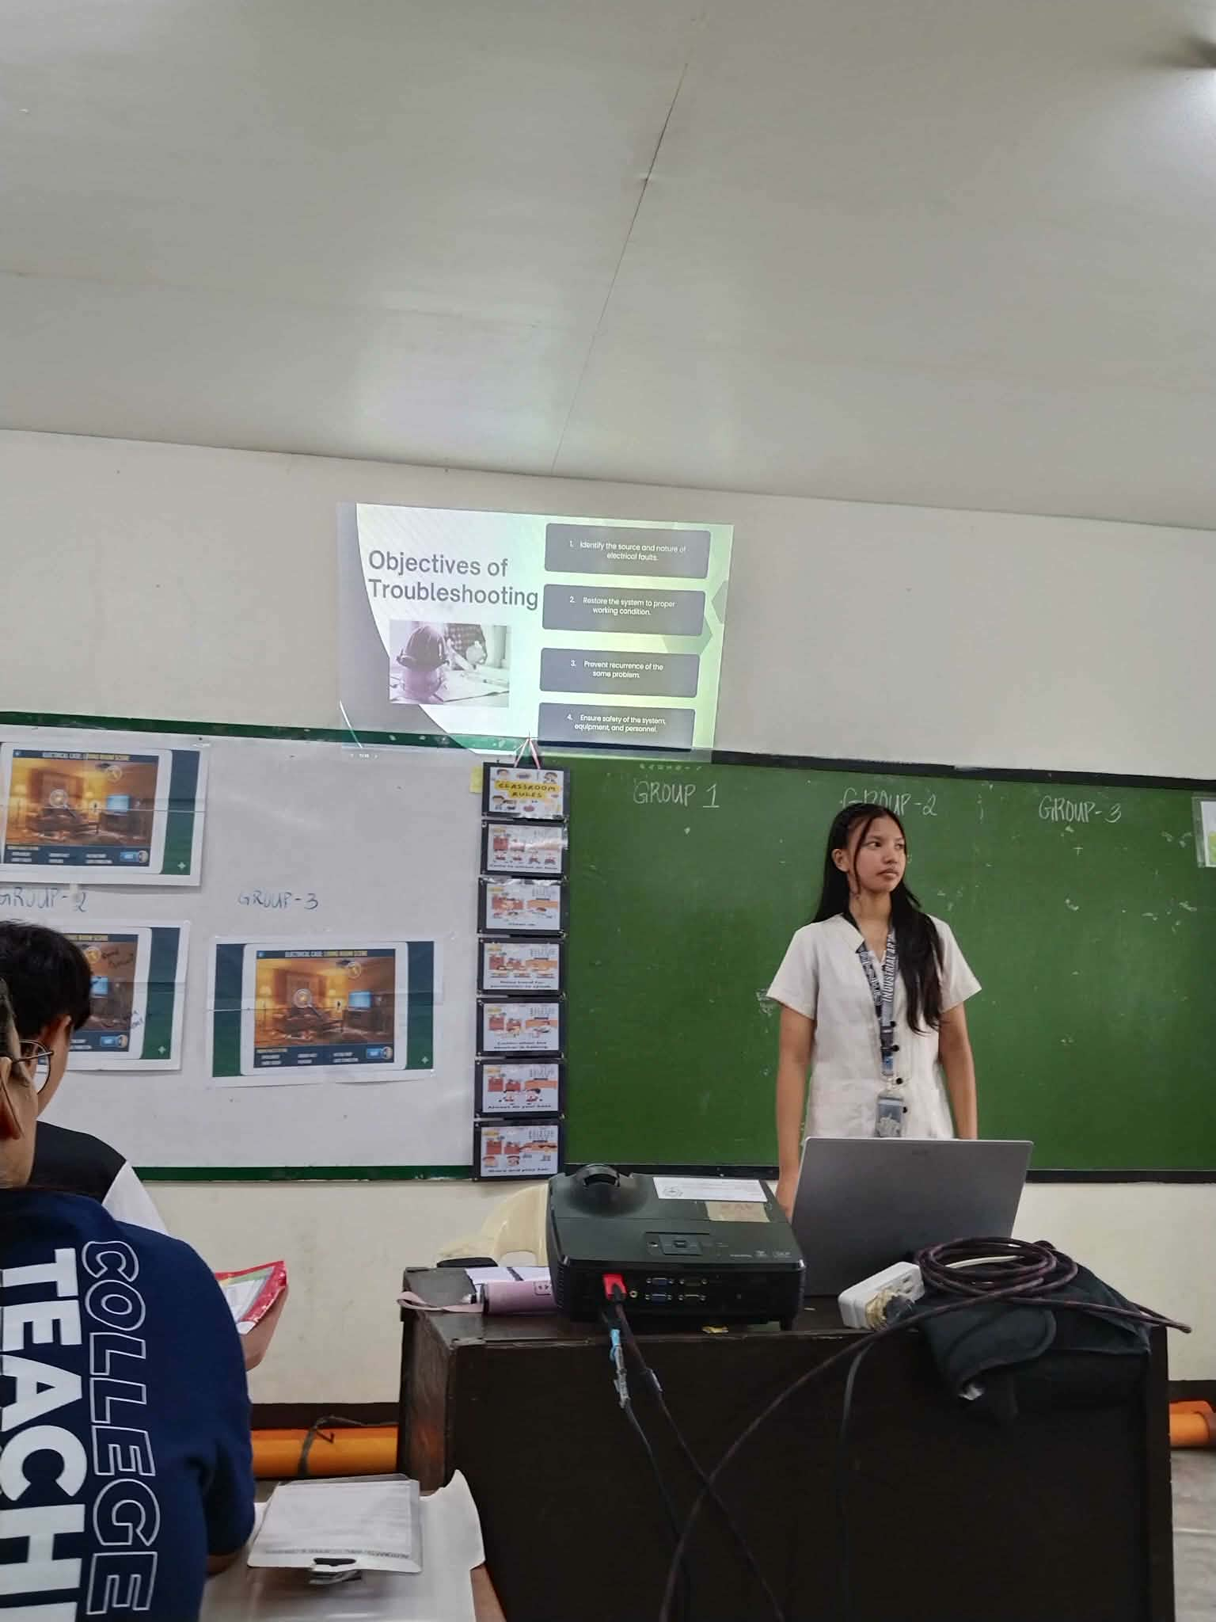
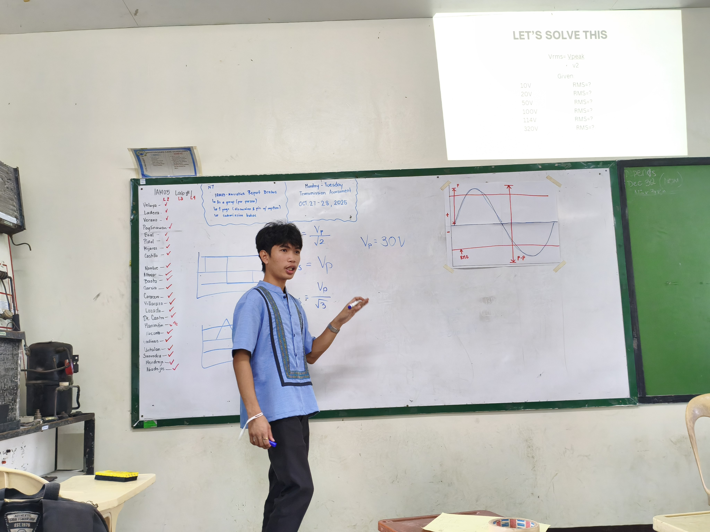
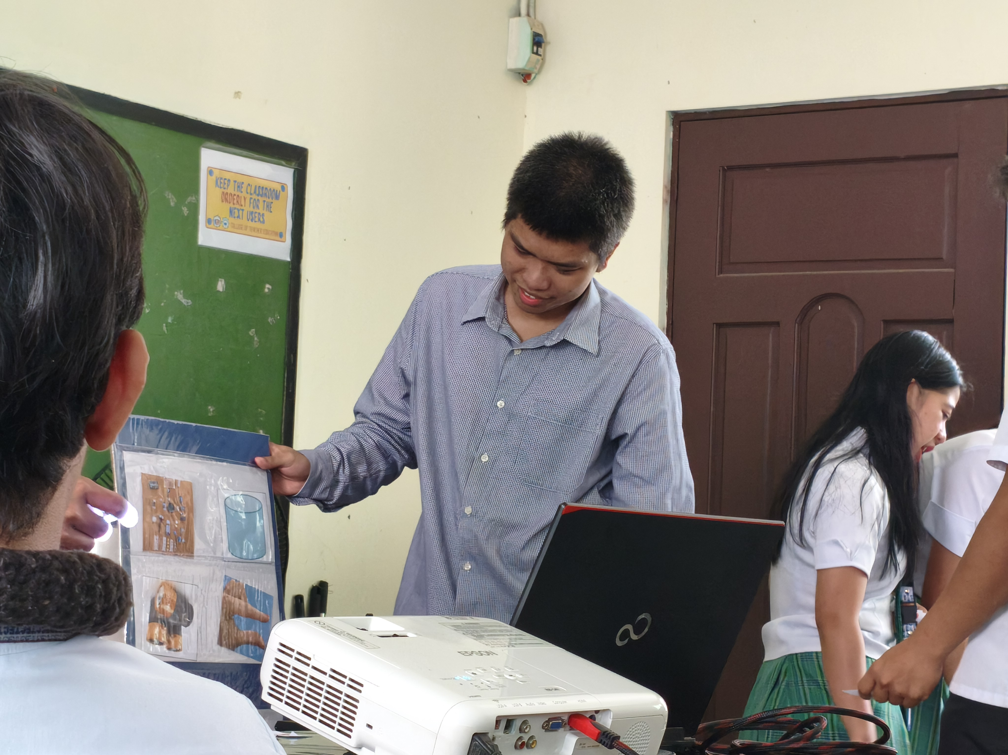
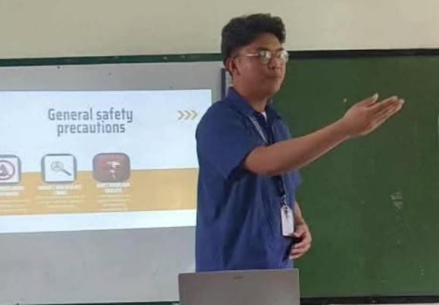

TEACHING DEMONSTRATION

An Industrial Arts teaching demonstration is the process of instructing students on practical mechanical skills through guided, hands-on activities. The image illustrates an instructor demonstrating tasks such as gearbox disassembly while explaining the functions of parts like gears, shafts, and other transmission components. Students observe and practice using proper hand tools to separate and inspect the parts, check for wear, and understand the steps for reassembly. This method is commonly used in vocational classrooms to promote safe work practices, strengthen technical knowledge, and prepare learners for real-world repair and maintenance tasks.

Brief Description of Industrial Arts
Industrial Arts is a field of study that focuses on the knowledge and skills necessary for practical problem-solving, craftsmanship, and technological applications. It includes areas such as woodworking, metalworking, drafting, electronics, and basic engineering. The discipline aims to develop technical skills, creativity, and competencies that prepare individuals to design, build, and maintain functional projects and contribute effectively to industries and communities

