**This is for sentiment analysis**

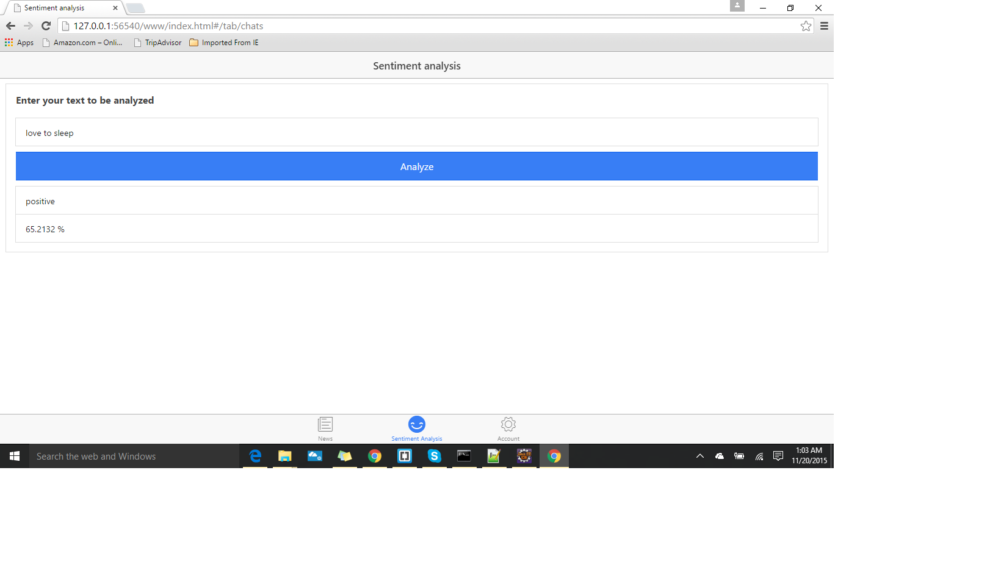

**The below screenshot is for getting news from service**

