**Shift Registe | DVVSD2019**

Integrantes:

* José Andrés Hernandez Hernandez
* Carem Angélica Bernabe Acosta

**Github link:** https://github.com/sltm-14/DVVSD2019/tree/master/T05

**Universal Shift Registe**

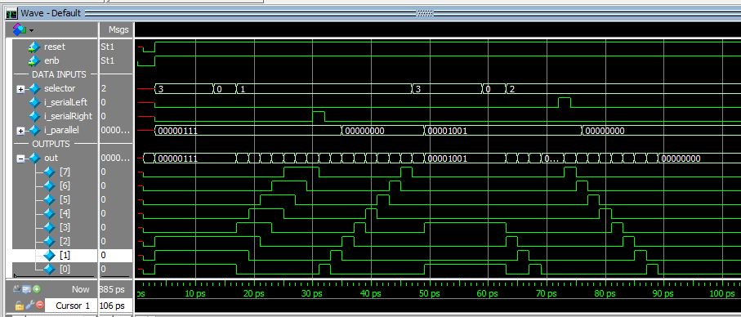

**PISO**

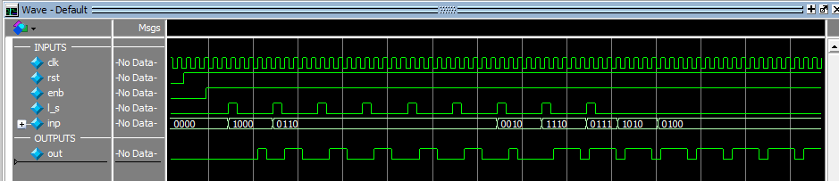

**SIPO**

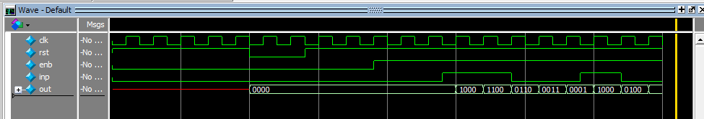

**SISO**

